**Video link:** [**https://www.youtube.com/watch?v=SDPQaG6ifS8**](https://www.youtube.com/watch?v=SDPQaG6ifS8)

**C++ CODE**

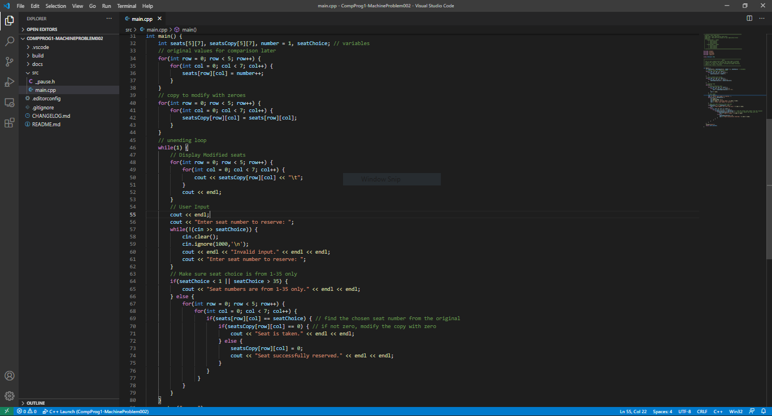

**SAMPLE OUTPUTS**

1. Successful reservation (input 25)

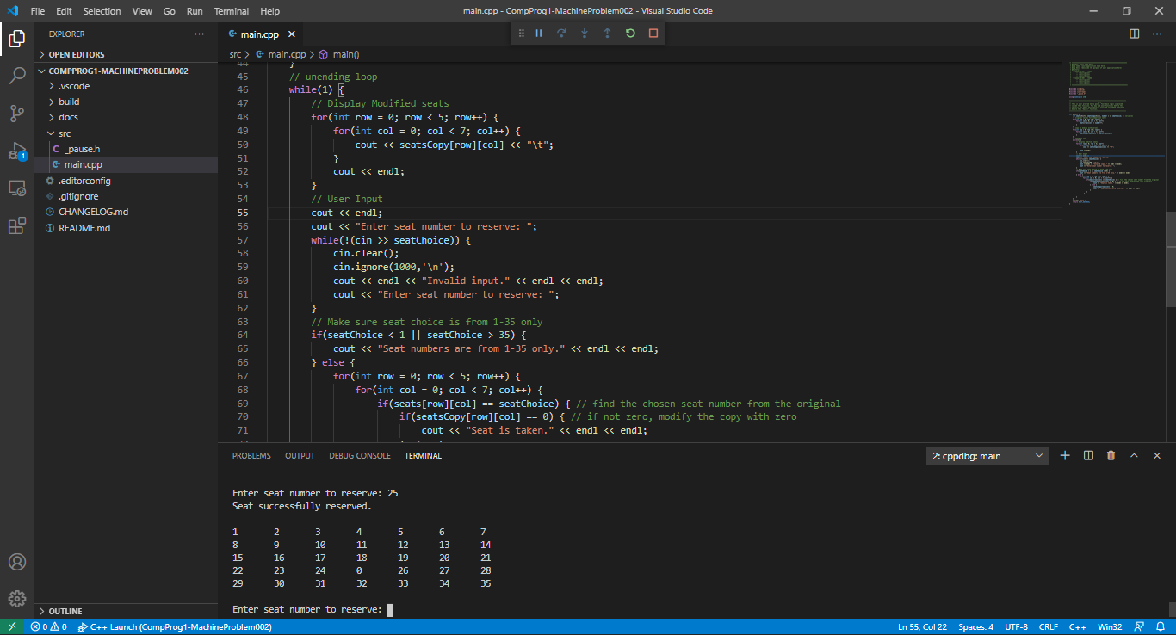

1. Seat is taken (input 25)

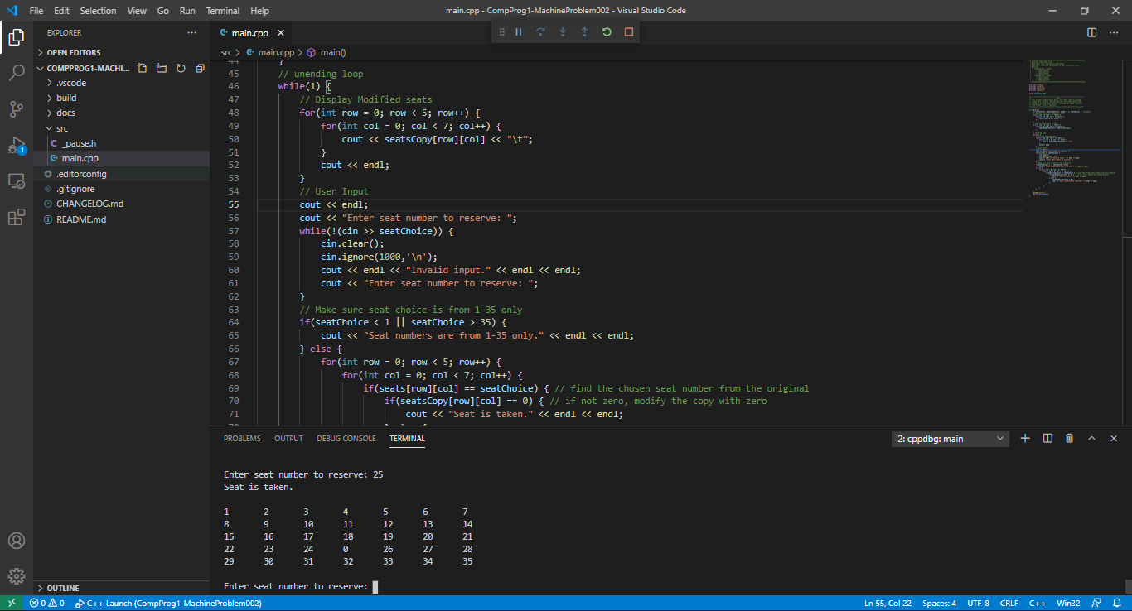

1. Another successful reservation (input 35)

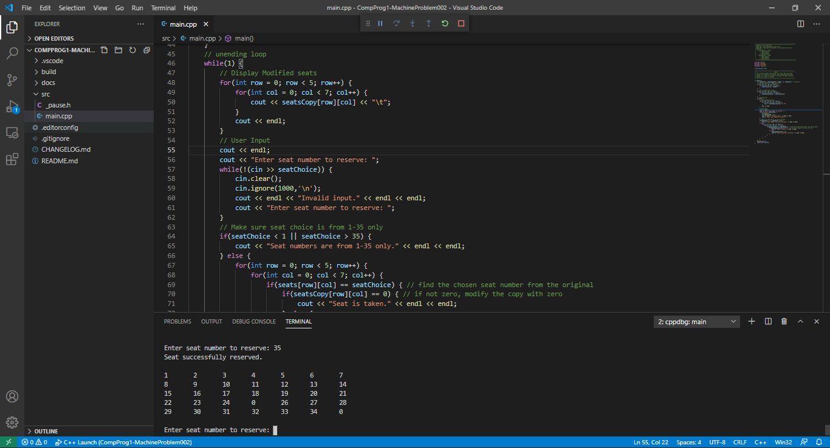

1. Invalid input – not within 1-35 (input 36)

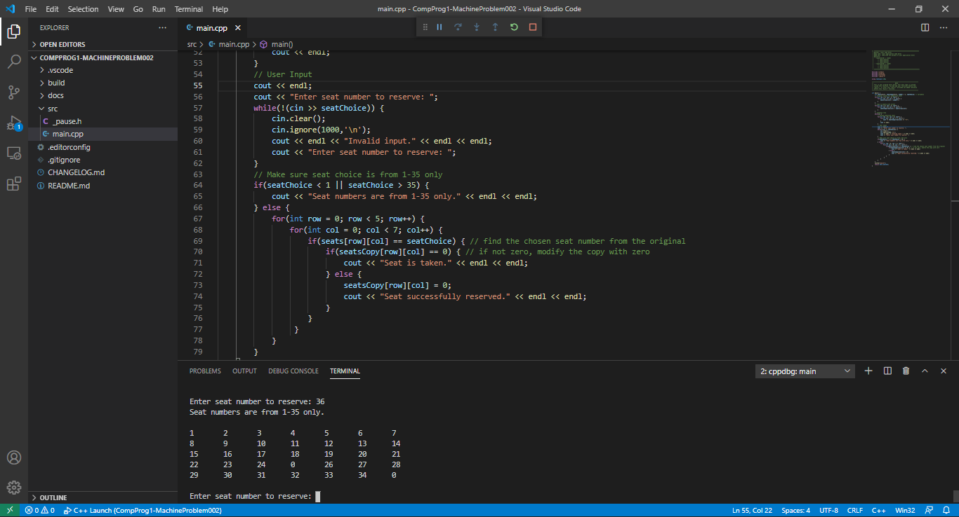

1. Invalid input – non-integer (input “happy new year”)

