**Video Link: https://www.youtube.com/watch?v=-PMDnRKPAr4**

**PROGRAM OUTPUT**

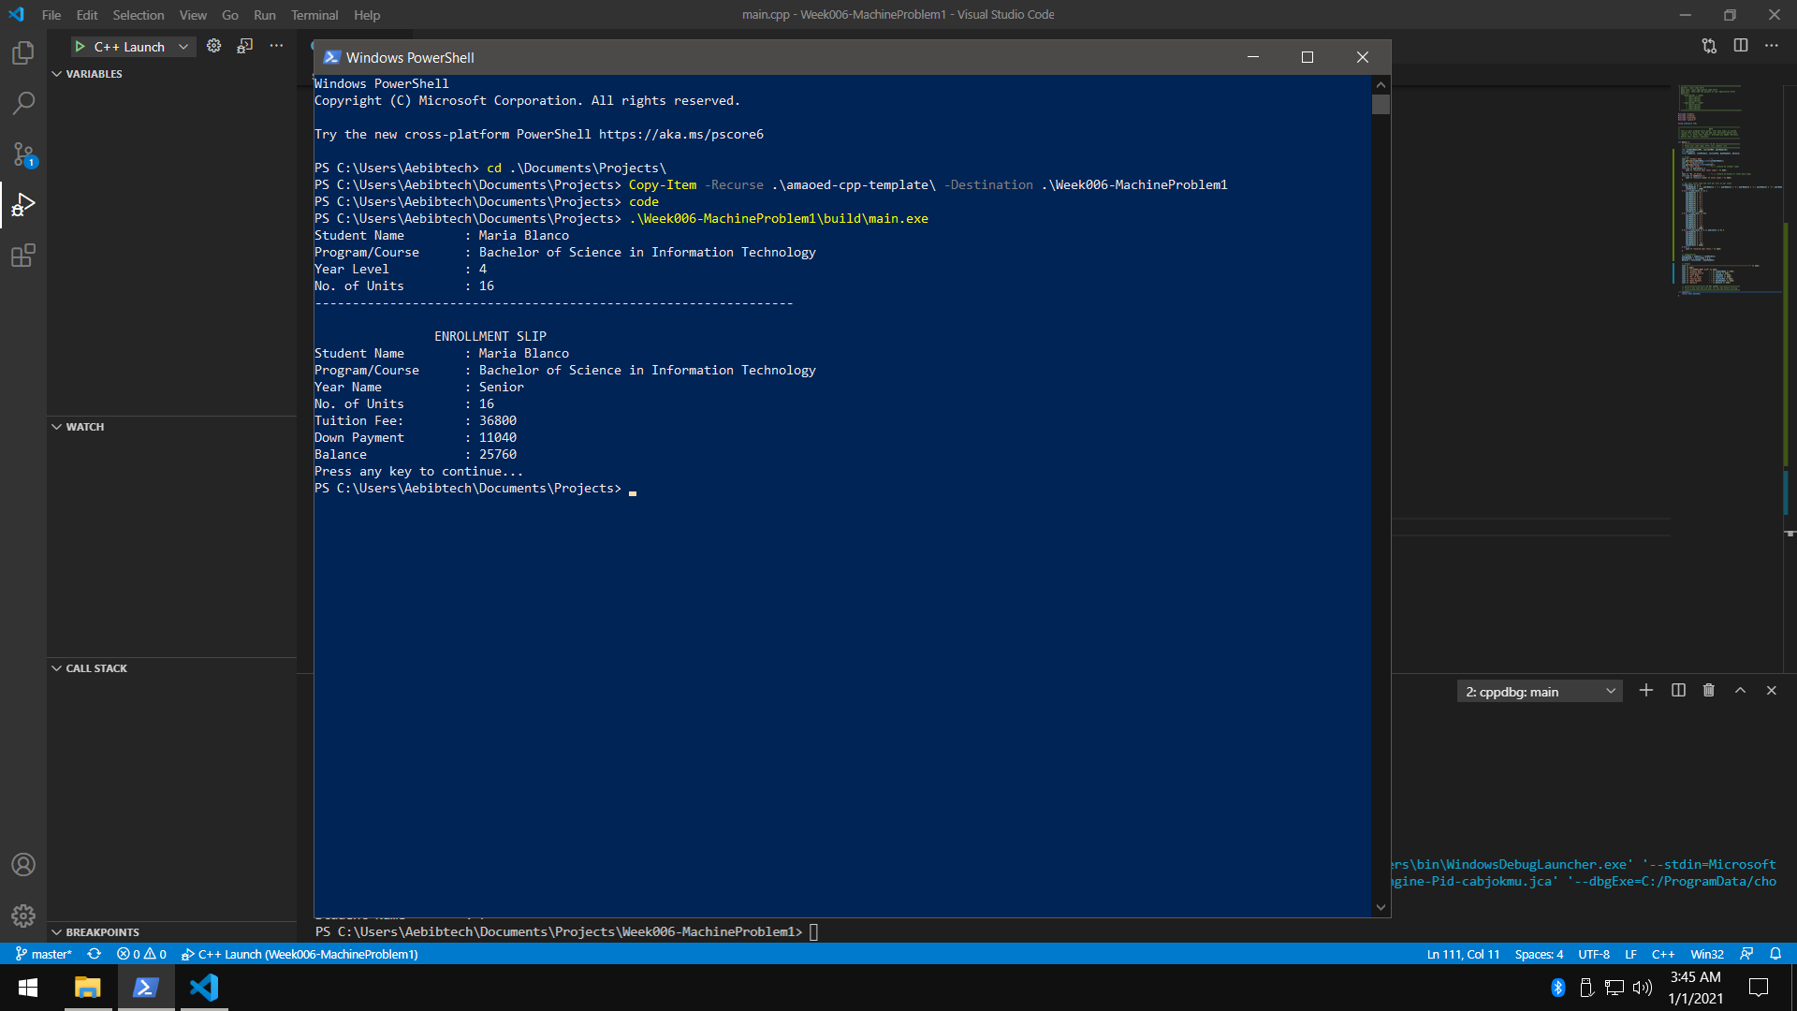

**CODE**

* Variables and Input Code

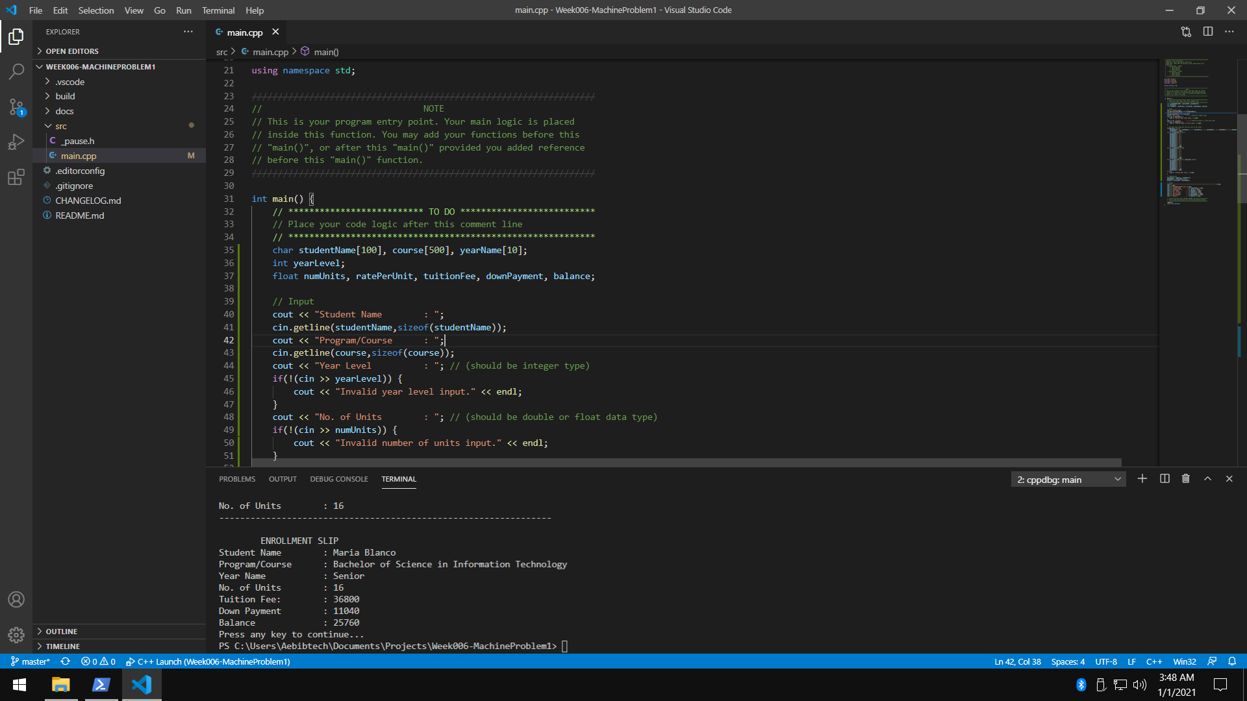

* Logic for Year Name and Rate per Unit

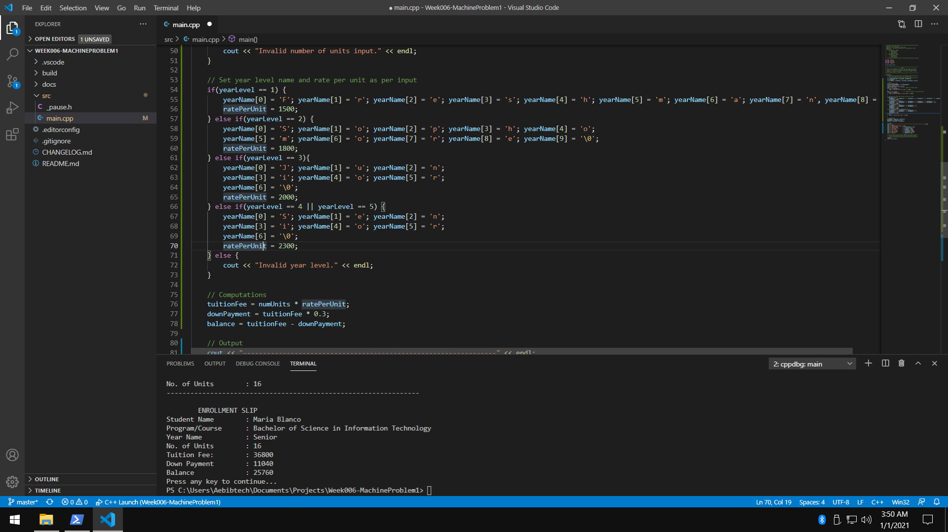

* Output Code

