Images were taken every 15min, two channels Bright field and GFP

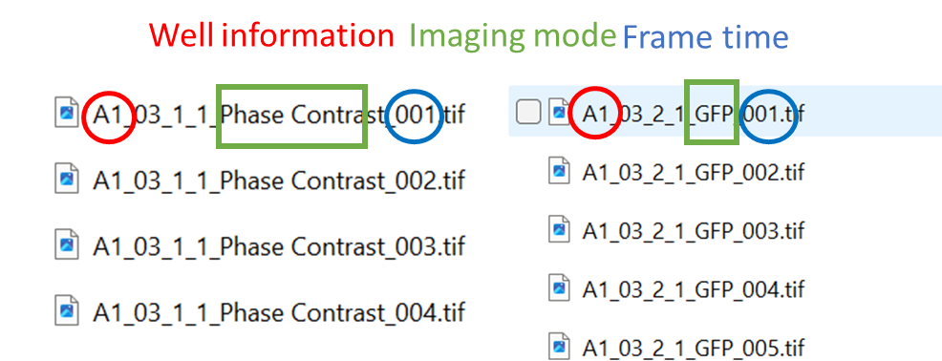

Wells Information: 4 conditions and 6 duplicates

|  |  |  |  |  |  |
| --- | --- | --- | --- | --- | --- |
| A1) Treatment with MEndoB | Treatment with MEndoB | Treatment with MEndoB | Treatment with MEndoB | Treatment with MEndoB | A6)Treatment with MEndoB |
| B1)Treatment with Vancomycin | Treatment with Vancomycin | Treatment with Vancomycin | Treatment with Vancomycin | Treatment with Vancomycin | B6)Treatment with Vancomycin |
| C1)Control PBS with infection | Control PBS | Control PBS | Control PBS | Control PBS | C6)Control PBS |
| D1) |  |  | Blank  OHNE INFECTION ONLY ZF | Blank | D6)Blank |