Appendix A: Extreme Cases Lorenz Curves

A1.1: Lowest simulated difference
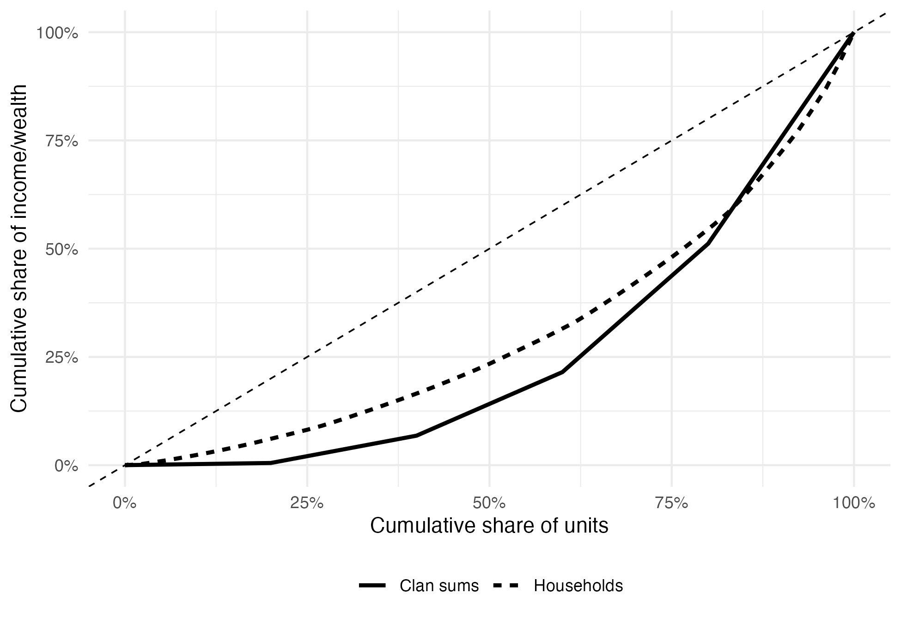

A1.2: Highest simulated difference
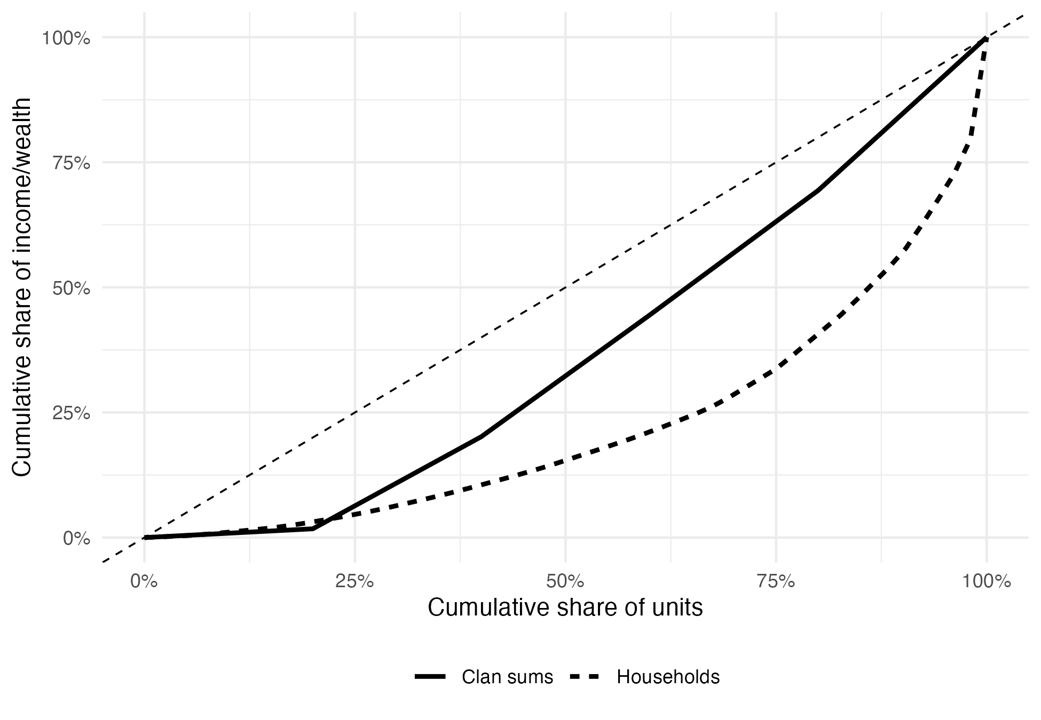

Appendix A2: Extreme Case Summaries
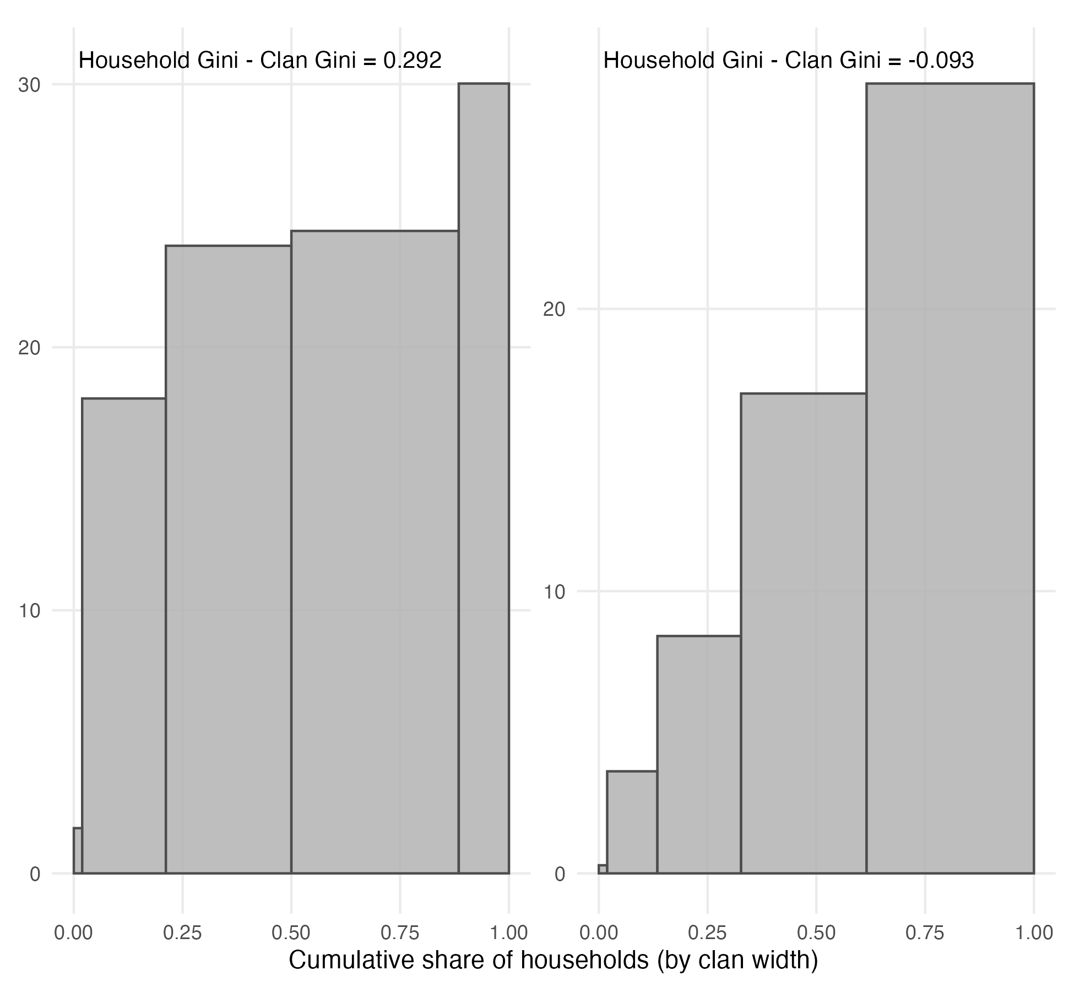

Appendix B
Table B1: Comparison of Gini coefficient for income with other Gini coefficients in available studies

Year | FRED | U.S. Census | Our Results  (All HH)
1,969 | 0.391 |  | 0.376
1,979 | 0.404 |  | 0.402
1,989 | 0.431 |  | 0.449
1,999 | 0.458 | 0.46 | 0.466
2,009 | 0.468 | 0.47 | 0.482
2,019 | 0.484 | 0.48 | 0.486
Sources: FRED data and Census data

Table B2: Comparison of Gini coefficient for wealth with other Gini coefficients in available studies

Year | Gini from the SCF or PSID | Our Results  (All HH)
1989 | 0.832 | 0.824
1998 / 1999 | 0.803 | 0.842
2003 | 0.813 | 0.840
2007 | 0.833 | 0.853
2009 | 0.893 | 0.881
2011 | 0.883 | 0.852
2021 / 2022 | 0.834
Sources: SCF Wolff (2006); SCF Budria et al. (2002); PSID Pfeffer et al. (2013); SCF Rios-Rull and Kuhn (2025)

Appendix C
Table C1: Comparison of Gini coefficients with and without negative values

 | Excluding Negative Values |  |  | Including Negative Values |  |  | Difference Overall
Year | HH | Clans | Diff | HH | Clans | Diff | Diff
1969 | 0.388 | 0.297 | 0.091 | 0.388 | 0.297 | 0.091 | 0.000
1970 | 0.372 | 0.289 | 0.083 | 0.372 | 0.289 | 0.083 | 0.000
1971 | 0.375 | 0.276 | 0.099 | 0.375 | 0.276 | 0.099 | 0.000
1972 | 0.371 | 0.281 | 0.090 | 0.371 | 0.281 | 0.090 | 0.000
1973 | 0.368 | 0.280 | 0.088 | 0.368 | 0.280 | 0.088 | 0.000
1974 | 0.375 | 0.289 | 0.086 | 0.375 | 0.289 | 0.086 | 0.000
1975 | 0.375 | 0.301 | 0.074 | 0.375 | 0.301 | 0.074 | 0.000
1976 | 0.375 | 0.305 | 0.070 | 0.375 | 0.305 | 0.070 | 0.000
1977 | 0.381 | 0.313 | 0.068 | 0.381 | 0.313 | 0.068 | 0.000
1978 | 0.375 | 0.310 | 0.065 | 0.375 | 0.310 | 0.065 | 0.000
1979 | 0.378 | 0.316 | 0.062 | 0.378 | 0.316 | 0.062 | 0.000
1980 | 0.386 | 0.320 | 0.066 | 0.386 | 0.320 | 0.066 | 0.000
1981 | 0.410 | 0.333 | 0.077 | 0.410 | 0.333 | 0.077 | 0.000
1982 | 0.399 | 0.332 | 0.067 | 0.399 | 0.332 | 0.067 | 0.000
1983 | 0.399 | 0.338 | 0.061 | 0.399 | 0.338 | 0.061 | 0.000
1984 | 0.406 | 0.350 | 0.056 | 0.406 | 0.350 | 0.056 | 0.000
1985 | 0.408 | 0.354 | 0.054 | 0.408 | 0.354 | 0.054 | 0.000
1986 | 0.417 | 0.359 | 0.058 | 0.417 | 0.359 | 0.058 | 0.000
1987 | 0.422 | 0.364 | 0.058 | 0.422 | 0.364 | 0.058 | 0.000
1988 | 0.433 | 0.373 | 0.060 | 0.433 | 0.373 | 0.060 | 0.000
1989 | 0.437 | 0.381 | 0.056 | 0.437 | 0.381 | 0.056 | 0.000
1990 | 0.439 | 0.383 | 0.056 | 0.439 | 0.383 | 0.056 | 0.000
1991 | 0.433 | 0.379 | 0.054 | 0.433 | 0.379 | 0.054 | 0.000
1992 | 0.441 | 0.385 | 0.056 | 0.441 | 0.385 | 0.056 | 0.000
1993 | 0.448 | 0.387 | 0.061 | 0.448 | 0.387 | 0.061 | 0.000
1994 | 0.473 | 0.409 | 0.064 | 0.475 | 0.411 | 0.064 | 0.000
1995 | 0.469 | 0.405 | 0.064 | 0.469 | 0.405 | 0.064 | 0.000
1996 | 0.457 | 0.399 | 0.058 | 0.457 | 0.399 | 0.058 | 0.000
1997 | 0.449 | 0.392 | 0.057 | 0.449 | 0.392 | 0.057 | 0.000
1999 | 0.461 | 0.405 | 0.056 | 0.462 | 0.406 | 0.056 | 0.000
2001 | 0.476 | 0.420 | 0.056 | 0.477 | 0.420 | 0.057 | 0.001
2003 | 0.461 | 0.403 | 0.058 | 0.462 | 0.406 | 0.056 | -0.002
2005 | 0.490 | 0.419 | 0.071 | 0.490 | 0.419 | 0.071 | 0.000
2007 | 0.483 | 0.417 | 0.066 | 0.483 | 0.417 | 0.066 | 0.000
2009 | 0.480 | 0.433 | 0.047 | 0.480 | 0.433 | 0.047 | 0.000
2011 | 0.476 | 0.439 | 0.037 | 0.476 | 0.439 | 0.037 | 0.000
2013 | 0.485 | 0.443 | 0.042 | 0.485 | 0.443 | 0.042 | 0.000
2015 | 0.479 | 0.436 | 0.043 | 0.479 | 0.436 | 0.043 | 0.000
2017 | 0.482 | 0.440 | 0.042 | 0.482 | 0.440 | 0.042 | 0.000
2019 | 0.489 | 0.450 | 0.039 | 0.490 | 0.450 | 0.040 | 0.001
2021 | 0.505 | 0.460 | 0.045 | 0.508 | 0.459 | 0.049 | 0.004
2023 | 0.516 | 0.465 | 0.051 | 0.517 | 0.465 | 0.052 | 0.001

Table C2: Comparison of Gini coefficients with and without negative values (wealth excludes home equity)

 | Excluding Negative Values |  |  | Including Negative Values |  |  | Difference Overall
Year | HH | Clans | Diff | HH | Clans | Diff | Diff
1984 | 0.837 | 0.731 | 0.106 | 0.858 | 0.745 | 0.113 | 0.007
1989 | 0.836 | 0.721 | 0.115 | 0.856 | 0.736 | 0.120 | 0.005
1994 | 0.823 | 0.692 | 0.131 | 0.846 | 0.705 | 0.141 | 0.010
1999 | 0.839 | 0.728 | 0.111 | 0.858 | 0.739 | 0.119 | 0.008
2001 | 0.827 | 0.702 | 0.125 | 0.848 | 0.714 | 0.134 | 0.009
2003 | 0.840 | 0.713 | 0.127 | 0.866 | 0.726 | 0.140 | 0.013
2005 | 0.840 | 0.709 | 0.131 | 0.863 | 0.720 | 0.143 | 0.012
2007 | 0.854 | 0.722 | 0.132 | 0.883 | 0.737 | 0.146 | 0.014
2009 | 0.882 | 0.771 | 0.111 | 0.915 | 0.793 | 0.122 | 0.011
2011 | 0.852 | 0.729 | 0.123 | 0.898 | 0.758 | 0.140 | 0.017
2013 | 0.854 | 0.732 | 0.122 | 0.902 | 0.760 | 0.142 | 0.020
2015 | 0.862 | 0.747 | 0.115 | 0.912 | 0.780 | 0.132 | 0.017
2017 | 0.859 | 0.732 | 0.127 | 0.916 | 0.764 | 0.152 | 0.025
2019 | 0.858 | 0.743 | 0.115 | 0.907 | 0.772 | 0.135 | 0.020
2021 | 0.856 | 0.745 | 0.111 | 0.896 | 0.765 | 0.131 | 0.020

Appendix D
Table D1: Comparison of Gini coefficients for wealth with and without home equity

 | Excluding Home Equity |  |  | Including Home Equity |  |  | Difference Overall
Year | HH | Clans | Diff | HH | Clans | Diff | Diff
1984 | 0.837 | 0.731 | 0.106
1989 | 0.836 | 0.721 | 0.115
1994 | 0.823 | 0.692 | 0.131
1999 | 0.839 | 0.728 | 0.111
2001 | 0.827 | 0.702 | 0.125
2003 | 0.840 | 0.713 | 0.127
2005 | 0.840 | 0.709 | 0.131
2007 | 0.854 | 0.722 | 0.132
2009 | 0.882 | 0.771 | 0.111 | 0.850 | 0.717 | 0.133 | 0.022
2011 | 0.852 | 0.729 | 0.123 | 0.835 | 0.689 | 0.146 | 0.023
2013 | 0.854 | 0.732 | 0.122 | 0.836 | 0.691 | 0.145 | 0.023
2015 | 0.862 | 0.747 | 0.115 | 0.838 | 0.702 | 0.136 | 0.021
2017 | 0.859 | 0.732 | 0.127 | 0.831 | 0.680 | 0.151 | 0.024
2019 | 0.858 | 0.743 | 0.115 | 0.821 | 0.688 | 0.133 | 0.018
2021 | 0.856 | 0.745 | 0.111 | 0.805 | 0.680 | 0.125 | 0.014

Appendix E
Table E1: Comparison of Gini coefficients with and without single-household clans

 | Including Single-HH Clans |  |  | Excluding Single-HH Clans (Robust) |  |  | Difference Overall
Year | HH | Clans | Diff | HH | Clans | Diff | Diff
1969 | 0.376 | 0.380 | -0.004 | 0.388 | 0.297 | 0.091 | 0.095
1970 | 0.379 | 0.384 | -0.005 | 0.372 | 0.289 | 0.083 | 0.088
1971 | 0.384 | 0.391 | -0.007 | 0.375 | 0.276 | 0.099 | 0.106
1972 | 0.384 | 0.399 | -0.015 | 0.371 | 0.281 | 0.090 | 0.105
1973 | 0.385 | 0.406 | -0.021 | 0.368 | 0.280 | 0.088 | 0.109
1974 | 0.389 | 0.417 | -0.028 | 0.375 | 0.289 | 0.086 | 0.114
1975 | 0.392 | 0.430 | -0.038 | 0.375 | 0.301 | 0.074 | 0.112
1976 | 0.394 | 0.434 | -0.040 | 0.375 | 0.305 | 0.070 | 0.110
1977 | 0.399 | 0.446 | -0.047 | 0.381 | 0.313 | 0.068 | 0.115
1978 | 0.397 | 0.447 | -0.050 | 0.375 | 0.310 | 0.065 | 0.115
1979 | 0.402 | 0.462 | -0.060 | 0.378 | 0.316 | 0.062 | 0.122
1980 | 0.405 | 0.467 | -0.062 | 0.386 | 0.320 | 0.066 | 0.128
1981 | 0.426 | 0.481 | -0.055 | 0.410 | 0.333 | 0.077 | 0.132
1982 | 0.415 | 0.474 | -0.059 | 0.399 | 0.332 | 0.067 | 0.126
1983 | 0.421 | 0.478 | -0.057 | 0.399 | 0.338 | 0.061 | 0.118
1984 | 0.420 | 0.480 | -0.060 | 0.406 | 0.350 | 0.056 | 0.116
1985 | 0.430 | 0.485 | -0.055 | 0.408 | 0.354 | 0.054 | 0.109
1986 | 0.434 | 0.487 | -0.053 | 0.417 | 0.359 | 0.058 | 0.111
1987 | 0.433 | 0.490 | -0.057 | 0.422 | 0.364 | 0.058 | 0.115
1988 | 0.443 | 0.498 | -0.055 | 0.433 | 0.373 | 0.060 | 0.115
1989 | 0.449 | 0.508 | -0.059 | 0.437 | 0.381 | 0.056 | 0.115
1990 | 0.449 | 0.507 | -0.058 | 0.439 | 0.383 | 0.056 | 0.114
1991 | 0.444 | 0.503 | -0.059 | 0.433 | 0.379 | 0.054 | 0.113
1992 | 0.450 | 0.505 | -0.055 | 0.441 | 0.385 | 0.056 | 0.111
1993 | 0.458 | 0.512 | -0.054 | 0.448 | 0.387 | 0.061 | 0.115
1994 | 0.483 | 0.528 | -0.045 | 0.473 | 0.409 | 0.064 | 0.109
1995 | 0.477 | 0.521 | -0.044 | 0.469 | 0.405 | 0.064 | 0.108
1996 | 0.465 | 0.517 | -0.052 | 0.457 | 0.399 | 0.058 | 0.110
1997 | 0.457 | 0.545 | -0.088 | 0.449 | 0.392 | 0.057 | 0.145
1999 | 0.466 | 0.543 | -0.077 | 0.461 | 0.405 | 0.056 | 0.133
2001 | 0.482 | 0.546 | -0.064 | 0.476 | 0.420 | 0.056 | 0.120
2003 | 0.471 | 0.534 | -0.063 | 0.461 | 0.403 | 0.058 | 0.121
2005 | 0.493 | 0.533 | -0.040 | 0.490 | 0.419 | 0.071 | 0.111
2007 | 0.484 | 0.524 | -0.040 | 0.483 | 0.417 | 0.066 | 0.106
2009 | 0.482 | 0.524 | -0.042 | 0.480 | 0.433 | 0.047 | 0.089
2011 | 0.479 | 0.523 | -0.044 | 0.476 | 0.439 | 0.037 | 0.081
2013 | 0.489 | 0.532 | -0.043 | 0.485 | 0.443 | 0.042 | 0.085
2015 | 0.484 | 0.520 | -0.036 | 0.479 | 0.436 | 0.043 | 0.079
2017 | 0.484 | 0.526 | -0.042 | 0.482 | 0.440 | 0.042 | 0.084
2019 | 0.486 | 0.568 | -0.082 | 0.489 | 0.450 | 0.039 | 0.121
2021 | 0.503 | 0.573 | -0.070 | 0.505 | 0.460 | 0.045 | 0.115
2023 | 0.518 | 0.575 | -0.057 | 0.516 | 0.465 | 0.051 | 0.108

Table E2: Comparison of Gini coefficients with and without single-household clans (wealth excludes home equity)

 | Including Single-HH Clans |  |  | Excluding Single-HH Clans (Robust) |  |  | Difference Overall
Year | HH | Clans | Diff | HH | Clans | Diff | Diff
1984 | 0.839 | 0.784 | 0.055 | 0.837 | 0.731 | 0.106 | 0.051
1989 | 0.824 | 0.753 | 0.071 | 0.836 | 0.721 | 0.115 | 0.044
1994 | 0.813 | 0.727 | 0.086 | 0.823 | 0.692 | 0.131 | 0.045
1999 | 0.842 | 0.790 | 0.052 | 0.839 | 0.728 | 0.111 | 0.059
2001 | 0.830 | 0.766 | 0.064 | 0.827 | 0.702 | 0.125 | 0.061
2003 | 0.840 | 0.770 | 0.070 | 0.840 | 0.713 | 0.127 | 0.057
2005 | 0.842 | 0.766 | 0.076 | 0.840 | 0.709 | 0.131 | 0.055
2007 | 0.853 | 0.771 | 0.082 | 0.854 | 0.722 | 0.132 | 0.050
2009 | 0.881 | 0.803 | 0.078 | 0.882 | 0.771 | 0.111 | 0.033
2011 | 0.852 | 0.765 | 0.087 | 0.852 | 0.729 | 0.123 | 0.036
2013 | 0.853 | 0.766 | 0.087 | 0.854 | 0.732 | 0.122 | 0.035
2015 | 0.863 | 0.778 | 0.085 | 0.862 | 0.747 | 0.115 | 0.030
2017 | 0.859 | 0.766 | 0.093 | 0.859 | 0.732 | 0.127 | 0.034
2019 | 0.860 | 0.805 | 0.055 | 0.858 | 0.743 | 0.115 | 0.060
2021 | 0.855 | 0.798 | 0.057 | 0.856 | 0.745 | 0.111 | 0.054

Appendix F
Table F1: Comparison of Gini coefficients for income with and without weights

 | Unweighted |  |  | Weighted |  |  | Difference Overall
Year | HH | Clans | Diff | HH | Clans | Diff | Diff
1969 | 0.404 | 0.318 | 0.086 | 0.388 | 0.297 | 0.091 | 0.005
1970 | 0.380 | 0.306 | 0.074 | 0.372 | 0.289 | 0.083 | 0.009
1971 | 0.386 | 0.308 | 0.078 | 0.375 | 0.276 | 0.099 | 0.021
1972 | 0.383 | 0.311 | 0.072 | 0.371 | 0.281 | 0.090 | 0.018
1973 | 0.377 | 0.304 | 0.073 | 0.368 | 0.280 | 0.088 | 0.015
1974 | 0.380 | 0.310 | 0.070 | 0.375 | 0.289 | 0.086 | 0.016
1975 | 0.379 | 0.317 | 0.062 | 0.375 | 0.301 | 0.074 | 0.012
1976 | 0.380 | 0.323 | 0.057 | 0.375 | 0.305 | 0.070 | 0.013
1977 | 0.393 | 0.336 | 0.057 | 0.381 | 0.313 | 0.068 | 0.011
1978 | 0.386 | 0.329 | 0.057 | 0.375 | 0.310 | 0.065 | 0.008
1979 | 0.386 | 0.330 | 0.056 | 0.378 | 0.316 | 0.062 | 0.006
1980 | 0.389 | 0.333 | 0.056 | 0.386 | 0.320 | 0.066 | 0.010
1981 | 0.406 | 0.345 | 0.061 | 0.410 | 0.333 | 0.077 | 0.016
1982 | 0.407 | 0.347 | 0.060 | 0.399 | 0.332 | 0.067 | 0.007
1983 | 0.413 | 0.352 | 0.061 | 0.399 | 0.338 | 0.061 | 0.000
1984 | 0.420 | 0.363 | 0.057 | 0.406 | 0.350 | 0.056 | -0.001
1985 | 0.422 | 0.366 | 0.056 | 0.408 | 0.354 | 0.054 | -0.002
1986 | 0.424 | 0.368 | 0.056 | 0.417 | 0.359 | 0.058 | 0.002
1987 | 0.427 | 0.369 | 0.058 | 0.422 | 0.364 | 0.058 | 0.000
1988 | 0.435 | 0.376 | 0.059 | 0.433 | 0.373 | 0.060 | 0.001
1989 | 0.435 | 0.380 | 0.055 | 0.437 | 0.381 | 0.056 | 0.001
1990 | 0.441 | 0.384 | 0.057 | 0.439 | 0.383 | 0.056 | -0.001
1991 | 0.439 | 0.382 | 0.057 | 0.433 | 0.379 | 0.054 | -0.003
1992 | 0.447 | 0.386 | 0.061 | 0.441 | 0.385 | 0.056 | -0.005
1993 | 0.458 | 0.389 | 0.069 | 0.448 | 0.387 | 0.061 | -0.008
1994 | 0.477 | 0.403 | 0.074 | 0.473 | 0.409 | 0.064 | -0.010
1995 | 0.470 | 0.401 | 0.069 | 0.469 | 0.405 | 0.064 | -0.005
1996 | 0.462 | 0.398 | 0.064 | 0.457 | 0.399 | 0.058 | -0.006
1997 | 0.449 | 0.398 | 0.051 | 0.449 | 0.392 | 0.057 | 0.006
1999 | 0.453 | 0.409 | 0.044 | 0.461 | 0.405 | 0.056 | 0.012
2001 | 0.468 | 0.423 | 0.045 | 0.476 | 0.420 | 0.056 | 0.011
2003 | 0.456 | 0.408 | 0.048 | 0.461 | 0.403 | 0.058 | 0.010
2005 | 0.472 | 0.418 | 0.054 | 0.490 | 0.419 | 0.071 | 0.017
2007 | 0.473 | 0.416 | 0.057 | 0.483 | 0.417 | 0.066 | 0.009
2009 | 0.473 | 0.429 | 0.044 | 0.480 | 0.433 | 0.047 | 0.003
2011 | 0.478 | 0.433 | 0.045 | 0.476 | 0.439 | 0.037 | -0.008
2013 | 0.485 | 0.432 | 0.053 | 0.485 | 0.443 | 0.042 | -0.011
2015 | 0.476 | 0.427 | 0.049 | 0.479 | 0.436 | 0.043 | -0.006
2017 | 0.471 | 0.430 | 0.041 | 0.482 | 0.440 | 0.042 | 0.001
2019 | 0.477 | 0.435 | 0.042 | 0.489 | 0.450 | 0.039 | -0.003
2021 | 0.496 | 0.450 | 0.046 | 0.505 | 0.460 | 0.045 | -0.001
2023 | 0.504 | 0.453 | 0.051 | 0.516 | 0.465 | 0.051 | 0.000

Table F2: Comparison of Gini coefficients for wealth with and without weights

 | Unweighted |  |  | Weighted |  |  | Difference Overall
Year | HH | Clans | Diff | HH | Clans | Diff | Diff
1984 | 0.867 | 0.776 | 0.091 | 0.837 | 0.731 | 0.106 | 0.015
1989 | 0.851 | 0.749 | 0.102 | 0.836 | 0.721 | 0.115 | 0.013
1994 | 0.845 | 0.716 | 0.129 | 0.823 | 0.692 | 0.131 | 0.002
1999 | 0.858 | 0.753 | 0.105 | 0.839 | 0.728 | 0.111 | 0.006
2001 | 0.854 | 0.735 | 0.119 | 0.827 | 0.702 | 0.125 | 0.006
2003 | 0.860 | 0.738 | 0.122 | 0.840 | 0.713 | 0.127 | 0.005
2005 | 0.864 | 0.732 | 0.132 | 0.840 | 0.709 | 0.131 | -0.001
2007 | 0.876 | 0.747 | 0.129 | 0.854 | 0.722 | 0.132 | 0.003
2009 | 0.899 | 0.795 | 0.104 | 0.882 | 0.771 | 0.111 | 0.007
2011 | 0.882 | 0.756 | 0.126 | 0.852 | 0.729 | 0.123 | -0.003
2013 | 0.882 | 0.757 | 0.125 | 0.854 | 0.732 | 0.122 | -0.003
2015 | 0.891 | 0.770 | 0.121 | 0.862 | 0.747 | 0.115 | -0.006
2017 | 0.886 | 0.754 | 0.132 | 0.859 | 0.732 | 0.127 | -0.005
2019 | 0.886 | 0.766 | 0.120 | 0.858 | 0.743 | 0.115 | -0.005
2021 | 0.879 | 0.759 | 0.120 | 0.856 | 0.745 | 0.111 | -0.009

Appendix G
Table G1: Average nuclear family indices (C1, C2, C3) for income and wealth

 | C1 |  | C2 |  | C3
 | HH | Clans | HH | Clans | HH | Clans
Income | 0.567 | 0.493 | 0.431 | 0.369 | 0.360 | 0.304
Wealth (No House) | 0.912 | 0.825 | 0.848 | 0.727 | 0.798 | 0.661

