Figure 2A. Income Summary Statistics
Unit | N | Unique Clans | Mean (Wtd.) | Mean (Unwtd.)
Household | 233,710 | 2,892 | 98,054 | 81,062
Clan | 62,682 | 2,892 | 373,630 | 302,246

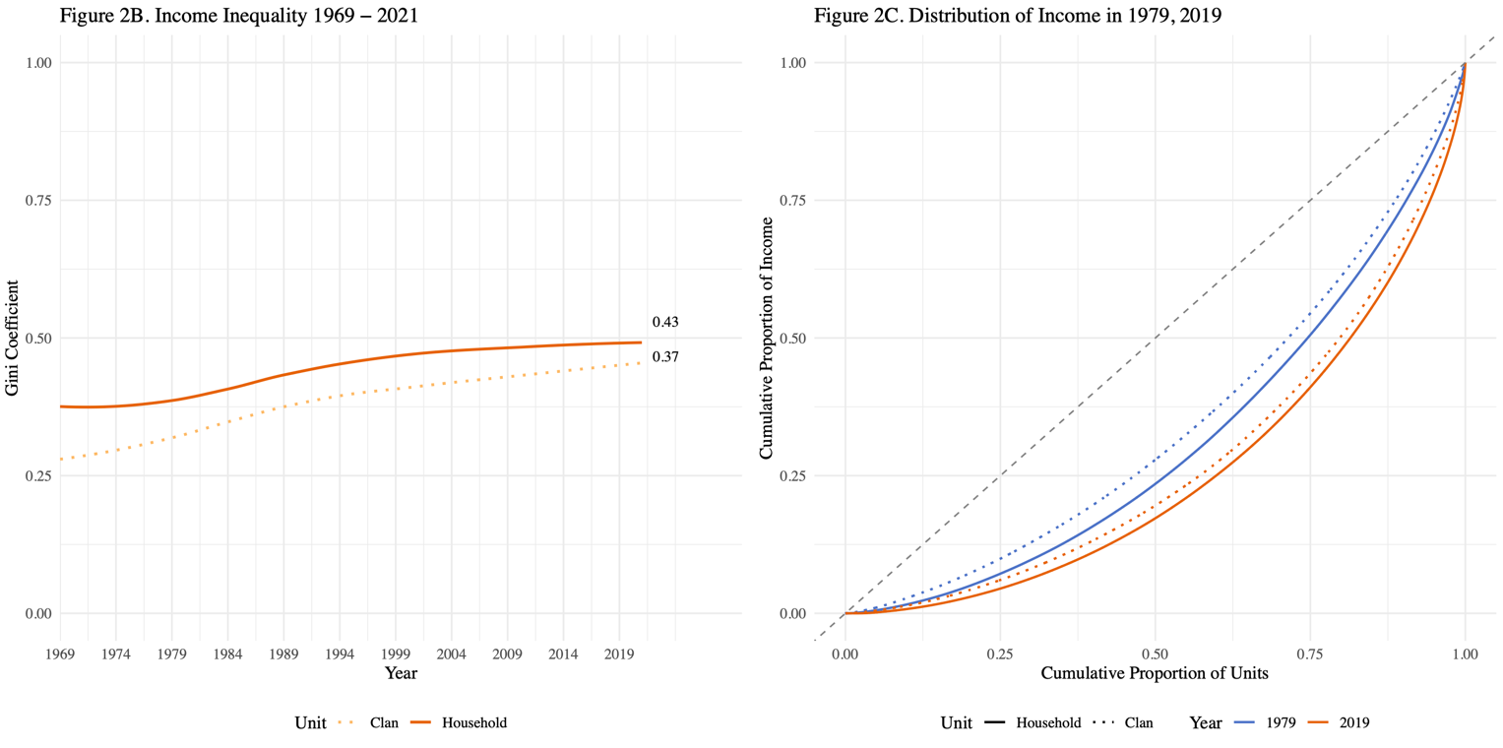
Note: Gini coefficients and distributions based on weighted data using PSID family and clan weights.

