Figure 3A. Wealth Summary Statistics
Unit | N | Unique Clans | Mean (Wtd.) | Mean (Unwtd.)
Household | 113,579 | 2,622 | 490,457 | 309,391
Clan | 25,045 | 2,622 | 1,884,939 | 1,402,729

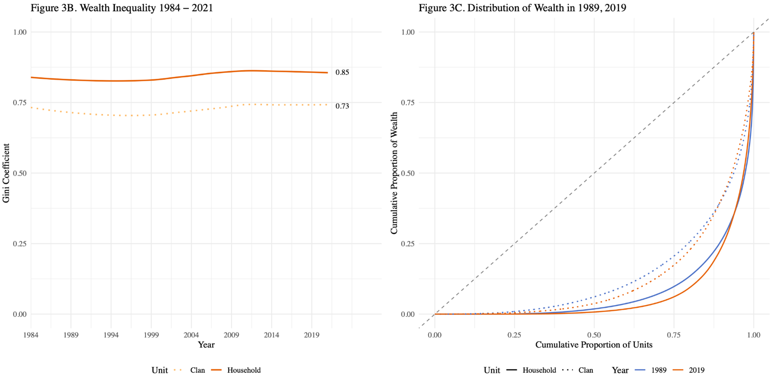

Note: Gini coefficients and distributions based on weighted data using PSID family and clan weights. Wealth is measured exclusive of home equity.

