An Extended Family Approach to Income and Wealth Inequality in the U.S.
Author Name(s)
February 19, 2026

1 Abstract
Most macro-level studies of inequality treat households as the primary unit of analysis. As a result, we know far less about inequality across extended families. Building on research highlighting the importance of intergenerational family ties, we examine income and wealth inequality in the United States using both households and intergenerational extended families, which we term clans, as units of analysis. Using data from the Panel Study of Income Dynamics (PSID), we calculate Gini coefficients for income and wealth at the household and clan levels from 1969 to 2023. We find that inequality is substantially lower when measured at the clan rather than the household level. The income Gini declines by 0.06 points (from 0.43 to 0.37), a 14.35% reduction, while the wealth Gini declines by 0.12 points (from 0.85 to 0.73), or about 14.2%. Inequality between households is not only higher than inequality between clans in the aggregate but consistently higher across all survey years for both income and wealth. Over time, trends in household and clan inequality are similar for wealth, but diverge for income: clan-level income inequality has increased more rapidly than household-level income inequality (56.57% vs. 32.99% since 1969). Together, these findings demonstrate the importance of considering extended families—in addition to households—when exploring contemporary patterns of inequality in the U.S.

2 Significance Statement
Economic inequality in the United States is typically measured across households, overlooking the role of extended families in shaping inequality. Using more than five decades of data from the Panel Study of Income Dynamics, we show that income and wealth inequality are substantially lower when measured across intergenerational extended families rather than households, a finding that holds across all survey years. However, income inequality across extended families has increased more rapidly than household income inequality over time. Together, these findings demonstrate the importance of considering extended families—in addition to households—when exploring contemporary patterns of inequality.

3 Introduction
Income and wealth inequality have increased sharply in the United States from the 1960s to the present. This trend is evident in the Gini index, a widely used measure of inequality ranging from 0 (perfect equality) to 1 (perfect inequality). For instance, the U.S. household-level income Gini rose from 0.369 in 1967 to 0.418 in 2023 [1]. Similarly, the U.S. household-level wealth Gini increased from 0.79 to 0.85 from 1989 to 2019 [2, 3].
The Gini—like most measures of inequality—is typically calculated at the household level [4, 5]. As a result, research on inequality typically focuses on differences between households [6]. This emphasis aligns with broader social-science practice, where households serve as the main unit of analysis. In doing so, scholars are largely centering nuclear families, reflecting longstanding assumptions about the primacy of the nuclear family and the diminished role of extended kin in the U.S. and other high-income industrialized nations [7, 8]. Data availability reinforces this orientation: most large surveys, including the Survey of Income and Program Participation and the Survey of Consumer Finances, are designed around households, limiting researchers’ ability to study inequality beyond the nuclear family.
Yet this predominant focus on households contrasts with a growing body of research suggesting that social scientists have underestimated the importance of extended family in studies of inequality [5, 10–12]. Mare [10], for example, argues that intergenerational mobility has likely been overstated because analyses typically ignore the influence of ancestors and extended kin. Research on elites similarly highlights the importance of extended family networks in maintaining wealth across generations. For example, O’Brien’s [11] study of elite families in Dallas shows that focusing solely on parent–child dyads obscures how these dyads are embedded within interconnected kin networks, where intermarriage among elite families is common and wealth circulates within a small number of extended lineages. Narrow attention to households therefore makes society appear more mobile than it truly is. Such insights have prompted renewed attention to the role extended family members play in the transmission of (dis)advantage. Scholars show that extended family members such as grandparents, aunts, uncles, and cousins transfer resources to individuals that impact their socioeconomic status [13–15], and that these resource flows often continue even when family members live geographically far apart [16]. Yet despite these insights, most macro-level studies of inequality—such as those relying on the Gini coefficient—continue to treat households, or occasionally individuals, as the primary unit of analysis. Consequently, scholars have documented patterns of inequality across households, but know little about inequality across extended families.
Drawing on scholarship showing the importance of extended families, we ask: what do income and wealth inequality in the U.S. look like when examined not only at the household level but also at the level of the intergenerational extended family—what we refer to as the clan [17]. In our empirical analyses, we use data from the Panel Study of Income Dynamics (PSID), a nationally representative longitudinal survey that has followed American households and their descendants since 1968. In the PSID, households include economically interdependent individuals living in the same dwelling, while clans include all descendants linked to an original household through a family identifier. In practice, this means that clans are comprised of households linked by birth, marriage, and adoption spanning multiple generations and extended kin ties (grandparents, aunts, uncles, and cousins and in some cases great-grandparents, great-uncles, second cousins, and so on).
We calculate Gini coefficients for both income and wealth at the household and clan levels from 1969 to 2023. Conceptually, the Gini can be understood as the average difference between any two units in a population. Arithmetically, it is the average absolute difference between all pairs of observations, normalized by the mean. The Gini is often illustrated with the Lorenz curve, which plots the cumulative share of income or wealth against the cumulative share of the population—whether defined as households or clans. Perfect equality appears as a 45° line where income or wealth is distributed evenly; greater inequality pulls the curve farther below this line. The Gini summarizes this deviation from perfect equality. Comparing household- and clan-level Ginis therefore shows whether the average difference between households is larger or smaller than the average difference between clans.
Using clans as the unit of analysis requires aggregating households. One may think that aggregating units smooths variation and will inherently lead to a Gini coefficient representing less inequality. However, this is not the case. Using simulated data, we show that it is possible to obtain clan-level Gini coefficients equal to or higher than a household-level Gini coefficient (see Appendix Table A). Whether the Gini coefficient increases or decreases from the household to the clan-level depends on the relationship between clan size, the overall distribution of resources, and the selection of households into clans.

4 Results
Comparing Gini coefficients at the household and clan levels. Figure 1 depicts income and wealth inequality for all households and clans over time. Reflecting available data, Panel A plots income Gini coefficients from 1969 to 2023 and Panel B plots wealth Gini coefficients from 1984 to 2023. Inequality is lower when using clans as the unit of analysis rather than households. The Gini coefficient for income falls by 0.06 points (from 0.43 to 0.37), a 14.35% decline, while the wealth Gini falls by 0.12 points (from 0.85 to 0.73), also about a 14.2% decrease. Taken together, these results indicate that both wealth and income inequality are higher when measured by households versus extended family units.
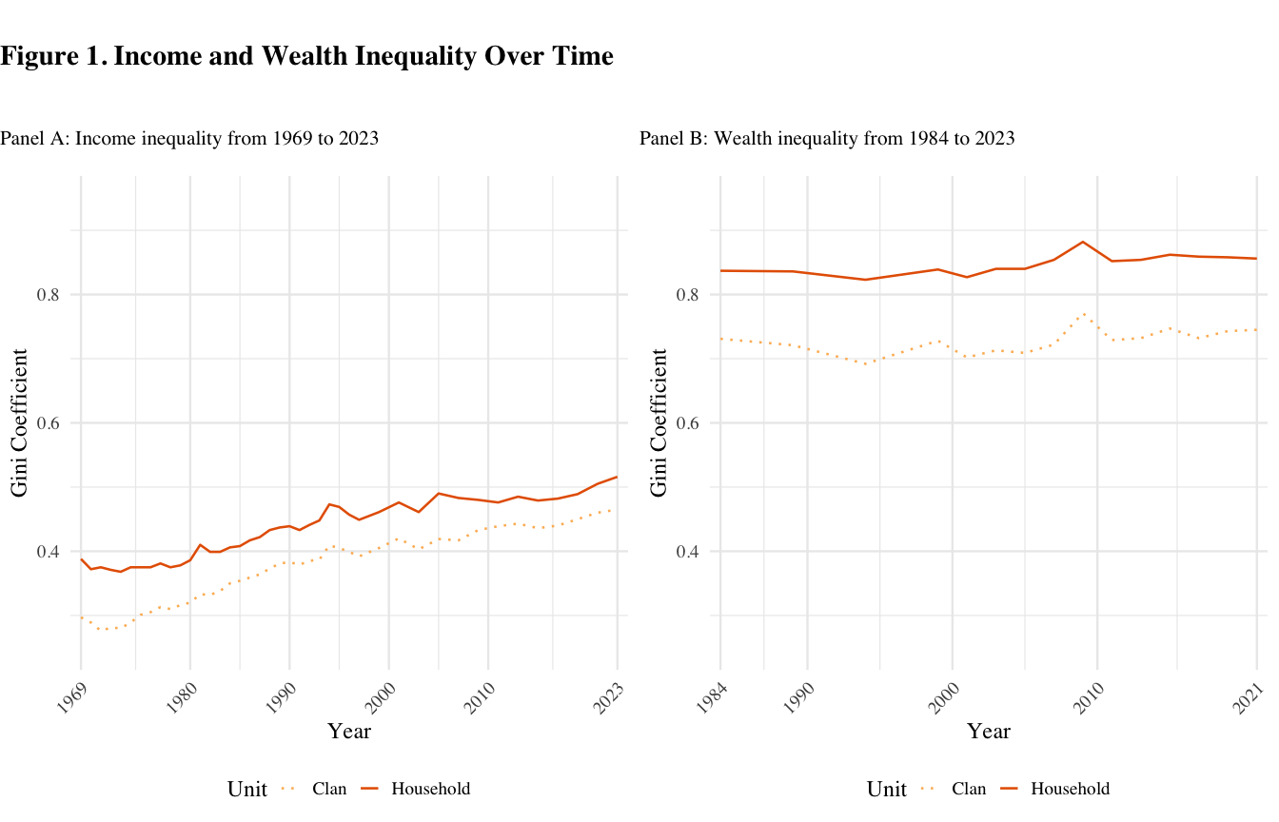

Figure 1 shows that inequality between households is consistently higher than inequality between clans across all survey years for both income and wealth. This means that if two clans were randomly selected and compared by income or wealth in any available year, they would, on average, differ less than two randomly selected households.
We find inequality is higher for wealth than for income. This finding is consistent with prior research showing how wealth accumulates over time and generations, retaining the imprint of earlier opportunities and constraints in a way that income does not [5, 18]. As such, wealth reflects long-run inequality and intergenerationally accumulated advantages and disadvantages.
Changes over time in household and clan inequality are similar for wealth, but not for income. Income inequality measured at the household level rose by 33.0% from 0.39 in 1969 to 0.52 in 2023. Income inequality measured at the clan level, meanwhile, rose 56.6% from 0.30 to 0.47 over the same period. As both measurements are trending upwards, this means that clan income inequality is increasing at a faster pace than household income inequality. If we were to project these trends linearly into the future, by 2092 household and clan income inequality would appear identical. Put another way, these trends reflect a narrowing of income inequality between households and clans over time: in 1969 the gap between the two was 0.09. By 2023 it had decreased to 0.05.
Unlike income inequality, the gap between household and clan wealth inequality has remained remarkably consistent. Wealth inequality typically exhibits greater temporal stability, whereas income inequality is more dynamic, because income is a flow that responds more quickly to labor-market conditions and policy shifts. Household wealth Gini has increased only slightly from 0.84 in 1984 to NA in 2023, a NA% increase. At the clan level, it rose from 0.73 to NA over the same period, which also constitutes a NA% increase. In other words, the clan-household gap in wealth inequality as measured by the Gini coefficient has remained stable, moving from 0.11 in 1984 to NA in 2023. These trends should be interpreted as inequality that excludes the wealthy. The PSID does not adequately sample the top of the wealth distribution [add cite], which drives much of the inequality in wealth [add cite]. Therefore, these patterns indicate stable wealth inequality, for both households and clans, among the bottom 95% [change number depending on cites], not for society as a whole.
Comparing household and Clan Distributions. Figure 2 illustrates differences in income and wealth inequality estimates using Lorenz curves at two points in time: 1984 (blue) and 2023 (orange). These curves teach us two things about the differences between household and clan inequality: first, the differences between inequality measured through the two units are driven by different parts of the distribution for income and wealth. In both 1984 and 2023, the clan lines (dotted) separate from the household lines (solid) across the entire distribution for income (Panel A), but mostly in the middle of the distribution for wealth (Panel B). These differences, which are partially but not entirely generated by the greater prevalence of zero wealth than zero income, mean that the gap between household and clan wealth inequality are driven by those at the middle of the wealth distribution, whereas the gap between household and clan income inequality capture differences between units across the entire distribution—from those with the lowest incomes to those with the highest 95th percentile [change number depending on cites] incomes.
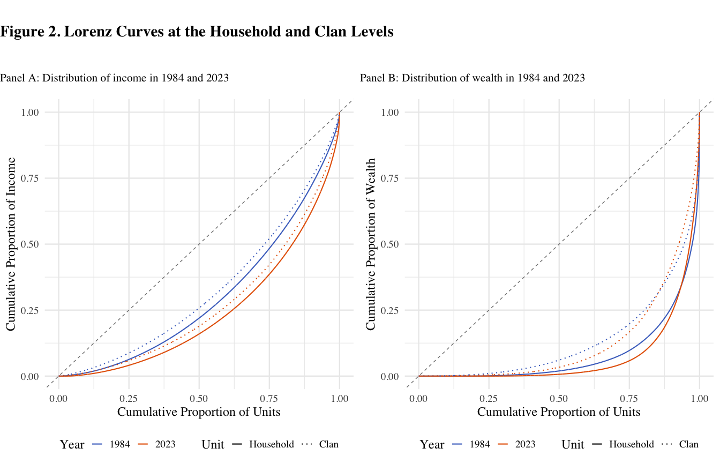

Second, the Lorenz curves bring into focus the different scales of the differences between household inequality and clan inequality for income and wealth. For income inequality (Panel A), the difference between household and clan inequality appears smaller compared with changes in inequality between 1984 and 2023. That both 1984 curves are closer to the line of equality than both 2023 curves means that the increase of income inequality over time is starker than differences in unit of analysis. But for wealth inequality (Panel B) this is not the case. For wealth inequality, both clan (dotted) lines are closer to the line of equality than both household (solid) lines. This means that the difference across unit of measurement is starker than the change over time.
Sensitivity of difference between household- and clan-level Gini coefficients. Across all specifications, estimated inequality is lower when using clans rather than households as the unit of analysis. This finding is present by race, across different measures of wealth, for different samples, and when using alternative measures of inequality. Each of these are discussed in turn.
Scholars document a persistent racial wealth gap between Black and non-Black households [5, 19], while also highlighting the unique role of kinship networks in shaping economic outcomes by race [20, 21]. Given these findings, one might expect the choice of unit of analysis to affect inequality estimates differently across racial groups. While there is higher inequality among Black households and clans overall, the direction of the household–clan difference in Gini coefficients is consistent across racial groups (Table 1).
Table 1. Differences in Inequality by Race
Measure | Black HH | Black Clans | Diff. (Black) | Non-Black HH | Non-Black Clans | Diff. (Non-Black)
Income | 0.444  (SE = 0.013) | 0.376  (SE = 0.020) | 0.068  (SE = 0.024) | 0.420  (SE = 0.009) | 0.360  (SE = 0.010) | 0.060  (SE = 0.013)
Wealth | 0.878  (SE = 0.016) | 0.740  (SE = 0.031) | 0.138  (SE = 0.035) | 0.833  (SE = 0.012) | 0.709  (SE = 0.019) | 0.124  (SE = 0.022)

For income, the difference between household and clan Gini coefficients is 0.07 for Black respondents and 0.06 for non-Black respondents (Table 1). For wealth, the difference between household and clan Gini coefficients is 0.14 for Black respondents and 0.12 for non-Black respondents (Table 1). These differences indicate that the unit of analysis has a slightly larger effect on measured wealth inequality by race than on income inequality, with inequality lower when using clans as the unit of analysis, especially for Black respondents. Nonetheless, the direction of the difference is consistent across all sub-groups, with wealth inequality lower than income inequality.
Values for income and wealth exclude negative values. Therefore, Gini coefficients presented here underestimate the extent of inequality at both the household and clan levels. When negative values are included, the difference in equality at the clan and household levels widens (see Appendix Table C1 and C2).
The measures of wealth employed in our results excludes home equity. As a sensitivity analysis, we compare Gini coefficients for measures of wealth including and excluding home equity (see Appendix Table D). When wealth is measured including home equity, estimated inequality is higher at both the household and clan level, therefore estimates presented here are conservative, potentially understating differences in inequality between households and clans.
Additionally, although all households belong to a clan, not all extended family members are observed in the PSID in every year. In some cases, clans consist of only a single observed household, rendering household and clan-level measures identical. These observations are excluded from the main analyses because they do not capture extended family dynamics and are a result of survey limitations, rather than social reality. Including these single household clans eliminates the household–clan inequality gap for income but not for wealth (see Appendix Tables E1 and E2), further underscoring the importance of extended family networks in measuring wealth inequality in particular.
Finally, while the Gini index is a widely-used measure of inequality, it has well-known limitations. In particular, the Gini places greater weight on differences around the middle of the income or wealth distribution [22–24]. To assess whether our results depend on where inequality is concentrated along the distribution, we also examine two related measures, referred to as the Gini’s “nuclear family”: the Bonferroni coefficient (C1), which places greater weight on the lower tail of the distribution, and the third moment of the scaled conditional mean curve (C3), which places greater weight on the upper tail [25]. Taken together, these three measures capture inequality across the lower, middle, and upper portions of the income or wealth distribution. Across all three measures, we find that estimated inequality is consistently lower when measured at the clan level than at the household level for both income and wealth (see Appendix Table G).

5 Discussion
Our analyses explored what income and wealth inequality in the U.S. look like when examined not only at the household level but also at the level of intergenerational extended families. We found that both income and wealth inequality were more extreme, as per Gini coefficients, when examining society as a collection of households (the standard of the literature) rather than a collection of clans. Income inequality was about 6 points higher for households than for clans, and wealth inequality was about 12 points higher, indicating fewer disparities on average between extended family networks than between households. In other words, an individual’s extended family was more economically similar on average to other extended families than their household was to other households. Our analyses over time reveal that inequality between households was not only higher than inequality between clans in the aggregate but consistently higher across all survey years for both income and wealth.
Our analyses provided an important complement to existing scholarship on income and wealth inequality that typically measures inequality at the household level (or in some cases the individual level). Our aim is not to downplay the importance of households as units of analysis, but rather to show that considering multiple units of analysis—including households and clans— is helpful for fully understanding inequality as a complex societal phenomenon. The choice of analytical unit matters in part because different historical periods generate changes in inequality at some levels more than others. For example, our analyses showed that clan-level income inequality has increased more rapidly than household-level income inequality over the study period. We speculate that concurrent declines in social mobility may help explain this pattern: lower mobility would be expected to produce greater homogeneity within clans, whereas higher mobility would have the opposite effect. By contrast, trends in household and clan inequality were similar for wealth over time. This may reflect the cumulative nature of wealth, which is more durably concentrated within kinship networks [11, 13, 26], or limitations of the PSID’s coverage of the top of the wealth distribution, where much wealth inequality is generated. Together, these patterns reinforce the importance of examining inequality at multiple levels of social organization.
Although our analyses focused on the macro level, they highlighted a clear need for additional research on how extended families structured social life at the micro level. One key question raised by our findings concerns the prevalence and scale of resource transfers within extended families, an issue beyond the scope of this study. Methodologically, our project suggests the need for data and research designs that capture resource flows across kinship networks rather than limiting analysis to households. Taken together, our findings demonstrate that understanding economic inequality requires moving beyond a sole focus on households to also account for the extended family structures through which resources, advantage, and disadvantage are transmitted across generations.

6 Materials and Methods
Data and sample. We use the genealogical design of the Panel Study of Income Dynamics (PSID) to compare estimates of inequality when using the household or clan as a unit of analysis. The PSID began in 1968, surveying families annually until 1997 and biennially thereafter. It follows descendants of the original sample across generations and maintains national representativeness. Data from the PSID produce estimates that mostly align with other national surveys [27].
The PSID defines two linked units of analysis: households and clans. Households consist of economically interdependent individuals living in the same dwelling, with one member reporting data on income and wealth for all members. Household composition changes over time with transitions such as divorce or relocation; individuals who leave receive a new household identifier. As a result, unique households cannot be identified over time in the PSID. In contrast, clans include all descendants of households sampled in 1968, linked through a PSID-generated identifier, which we refer to as a clan identifier. Households added after 1968 receive their own clan identifier upon entry. Unlike household identifiers, clan membership remains fixed for individuals and can be compared over time. A small number of households (134 household-years) contain couples belonging to different clans; these cases were assigned to both clans.
The PSID has collected income data since its inception but began collecting wealth data only in 1984. As a result, analytic samples differ: income analyses include 242,200 household-years and 64,292 clan-years, representing 2,906 unique clans; wealth analyses include 113,579 household-years and 26,655 clan-years, representing 2,636 unique clans
Measures of income and wealth. We measure both income and wealth to capture distinct dimensions of economic inequality. This choice follows from research identifying divergent patterns depending on choice of financial indicator because mechanisms driving wealth inequality are distinct from those driving income inequality [5, 18, 26]. The PSID began collecting wealth data in 1984, so our wealth analyses cover 1984 to 2023. Aggregate measures for income and wealth are provided by the PSID. Income includes earnings, asset income, transfers, and income from farming and gardening. Wealth includes non-primary real estate, business equity, stocks, bonds, vehicles, retirement accounts, and bank accounts, and excludes home equity.
Missing data for components of income and wealth are imputed by the PSID. Concerns about measurement error, especially for wealth, are minimal, as imputation methods utilized by the PSID explain little of the variation in wealth over time [26, 28]. All income and wealth values are adjusted for inflation. Additionally, analyses set negative values of income and wealth to zero so that Gini coefficients remain in the 0 to 1 range. Including negative values for income and wealth does not change the results (see Appendix Table C1 and C2). To construct clan-level measures, we aggregate household income and wealth for all households in a clan within each clan-year.
All results presented are weighted. Using weights does not meaningfully change results (see Appendix Table F1 and F2). Household-level weights are provided by the PSID. The PSID constructs family weights from individual weights using the fair shares method, which assumes that the probability of observing any individual within a family equals the probability of observing the family itself. We extend this approach to construct clan-level weights using the same fair shares principle. Clan weights assume that the probability of observing a family within a clan equals the probability of observing the clan itself. These weights are applied to total clan income or wealth (rather than mean income or wealth) to avoid double standardization by household counts. In effect, clan weights already incorporate the number of households within a clan. As a result, each clan’s influence reflects the representation of the average household within that clan, rather than scaling mechanically with the clan’s total number of households.
Measures of race. The PSID collects race data from household heads and, in some years, from spouses. If a respondent ever identifies as Black, then that value is imputed for all years that respondent appears in the data [29]. Black households are all households with a Black head of household. Black clans are clans in which more than half of the households within it identify as Black. Analyses by race and ethnicity are limited to Black and non-Black categories because there are relatively few clans in the PSID data (2,906 for income and 2,636 for wealth). Additionally, the genealogical design of the PSID reflects the demographics of the United States at the time the survey began in 1968, which constrains analyses of clans for demographic groups that were not prominent at that time. Although the PSID incorporated additional samples over time to reflect the changing demographics of the United States in the PSID sample, ethnicity analyses remain limited because Hispanic/Latino households do not form consistent multigenerational lineages over the full panel and therefore have limited clans.
Indexing inequality with the Gini coefficient. Inequality is measured using the standard Gini coefficient, which ranges from 0 (perfect equality) to 1 (perfect inequality). Although widely used, the Gini has well-known limitations: it cannot distinguish between different inequality patterns and is most sensitive to variation in the middle of the income or wealth distribution [23–25]. These features make it well suited to the PSID, which underrepresents wealthy households compared with surveys such as the Survey of Consumer Finance.
More generally, as emphasized by Atkinson, any measure of inequality embeds normative judgments about where in the income or wealth distribution inequality matters most [22]. The Gini implicitly places greater weight on differences near the center of the distribution rather than on disparities at the top or bottom. To assess whether our results depend on these implicit weighting choices, we complement the Gini with measures from its “nuclear family” that place greater weight on the lower and upper tails of the distribution [25] (see Appendix Table G). Together, this approach balances leveraging comparability with the wider inequality literature, and robustness to alternative inequality measures.
Gini coefficients are calculated separately for income and wealth to reflect their distinct dimensions of inequality. Estimates of Gini coefficients in our data are comparable to estimates that other studies have found, though there is more variation in wealth coefficients, likely because the PSID excludes wealthy households (see Appendix Table B1 and B2).

7 Appendix

7.1 Appendix A: Simulating Gini Coefficients
Appendix A illustrates extreme cases from simulated household and clan data. The simulation demonstrates that clan-level Gini coefficients are not necessarily lower than household-level Gini coefficients. The direction of the difference depends on the relationship between clan size, the overall distribution of resources, and the selection of households into clans. Appendix A1 shows the minimum possible difference between clan and household Gini coefficients in the simulated data, while Appendix A2 shows the maximum possible difference. Curves show that Gini coefficients at the clan level can exceed those of households. Appendix A3 illustrates that, while it is more likely for Gini coefficients at the household level to exceed Gini coefficients at the clan level, whether this effect is observed depends on the combination between clan size and income or wealth distribution.

Appendix A1: Case with lowest simulated clan-household Gini difference 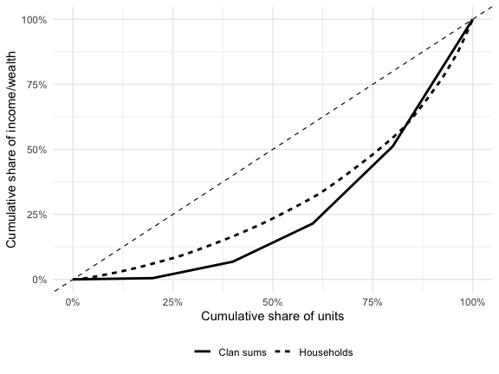
Appendix A2: Case with highest simulated clan-household Gini difference 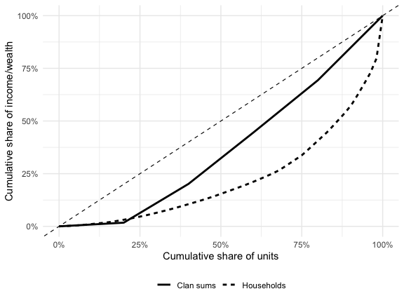

Appendix A3: Summary of extreme cases 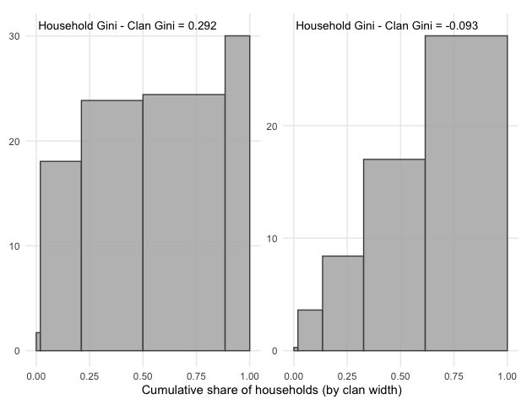

7.2 Appendix B: Comparison with External Estimates
Appendix B compares Gini coefficients at the household level calculated for income and wealth with Gini coefficients from other researchers. Gini coefficients in Appendix B are calculated using the full sample of households in the PSID, rather than just the households who belong to a clan with at least one other household (which are the results presented in the main paper).
Gini coefficients are not available for all years in other sources, so only years available are presented. Gini coefficient benchmarks for income rely on estimates from the Federal Reserve Bank of St. Louis (FRED) and the U.S. Census [1, 30]. FRED uses data from the World Bank on U.S. households and the Census uses data from the Current Population Survey (CPS). Gini coefficient benchmarks for wealth rely on estimates from research papers based on data from the PSID or Survey of Consumer Finances (SCF) [31, 32].
Appendix B1. Comparison of income Gini coefficients
Year | FRED | U.S. Census | Our Results  (All HH)
1969 | 0.391 | 0.349 | 0.376
1979 | 0.404 | 0.365 | 0.402
1989 | 0.431 | 0.401 | 0.449
1999 | 0.458 | 0.429 | 0.466
2009 | 0.468 | 0.443 | 0.482
2019 | 0.484 | 0.454 | 0.486
Appendix Table B2. Comparison of wealth Gini coefficients with external estimates
Year | SCF | PSID | Our Results
1983 | 0.760
1984 |  | 0.739 | 0.839
1989 | 0.781 | 0.742 | 0.824
1992 | 0.770
1994 |  | 0.732 | 0.813
2003 |  | 0.810 | 0.840
2004 | 0.809
2007 |  | 0.830 | 0.853
2009 |  | 0.890 | 0.881
2010 | 0.846
2011 |  | 0.880 | 0.852

7.3 Appendix C: Sensitivity to Negative Values
Results presented in the main text exclude negative values for income and wealth. Appendix C1 and C2 show Gini coefficients when negative values are included, and report the difference between Gini coefficients at the household and clan levels. The last column shows how the gap between household and clan-level Gini coefficients changes when negative values are included. While including negative values makes estimated inequality higher, it does not change the observed difference between household and clan Gini coefficients.
Appendix C1. Income Gini coefficients with and without negative values
 | Excluding Negative Values |  |  | Including Negative Values |  |  | Change in Gap
Year | HH | Clans | HH - Clan | HH | Clans | HH - Clan | Excl. - Incl.
1969 | 0.388 | 0.297 | 0.091 | 0.388 | 0.297 | 0.091 | 0.000
1970 | 0.372 | 0.289 | 0.083 | 0.372 | 0.289 | 0.083 | 0.000
1971 | 0.375 | 0.276 | 0.099 | 0.375 | 0.276 | 0.099 | 0.000
1972 | 0.371 | 0.281 | 0.090 | 0.371 | 0.281 | 0.090 | 0.000
1973 | 0.368 | 0.280 | 0.088 | 0.368 | 0.280 | 0.088 | 0.000
1974 | 0.375 | 0.289 | 0.086 | 0.375 | 0.289 | 0.086 | 0.000
1975 | 0.375 | 0.301 | 0.074 | 0.375 | 0.301 | 0.074 | 0.000
1976 | 0.375 | 0.305 | 0.070 | 0.375 | 0.305 | 0.070 | 0.000
1977 | 0.381 | 0.313 | 0.068 | 0.381 | 0.313 | 0.068 | 0.000
1978 | 0.375 | 0.310 | 0.065 | 0.375 | 0.310 | 0.065 | 0.000
1979 | 0.378 | 0.316 | 0.062 | 0.378 | 0.316 | 0.062 | 0.000
1980 | 0.386 | 0.320 | 0.066 | 0.386 | 0.320 | 0.066 | 0.000
1981 | 0.410 | 0.333 | 0.077 | 0.410 | 0.333 | 0.077 | 0.000
1982 | 0.399 | 0.332 | 0.067 | 0.399 | 0.332 | 0.067 | 0.000
1983 | 0.399 | 0.338 | 0.061 | 0.399 | 0.338 | 0.061 | 0.000
1984 | 0.406 | 0.350 | 0.056 | 0.406 | 0.350 | 0.056 | 0.000
1985 | 0.408 | 0.354 | 0.054 | 0.408 | 0.354 | 0.054 | 0.000
1986 | 0.417 | 0.359 | 0.058 | 0.417 | 0.359 | 0.058 | 0.000
1987 | 0.422 | 0.364 | 0.058 | 0.422 | 0.364 | 0.058 | 0.000
1988 | 0.433 | 0.373 | 0.060 | 0.433 | 0.373 | 0.060 | 0.000
1989 | 0.437 | 0.381 | 0.056 | 0.437 | 0.381 | 0.056 | 0.000
1990 | 0.439 | 0.383 | 0.056 | 0.439 | 0.383 | 0.056 | 0.000
1991 | 0.433 | 0.379 | 0.054 | 0.433 | 0.379 | 0.054 | 0.000
1992 | 0.441 | 0.385 | 0.056 | 0.441 | 0.385 | 0.056 | 0.000
1993 | 0.448 | 0.387 | 0.061 | 0.448 | 0.387 | 0.061 | 0.000
1994 | 0.473 | 0.409 | 0.064 | 0.475 | 0.411 | 0.064 | 0.000
1995 | 0.469 | 0.405 | 0.064 | 0.469 | 0.405 | 0.064 | 0.000
1996 | 0.457 | 0.399 | 0.058 | 0.457 | 0.399 | 0.058 | 0.000
1997 | 0.449 | 0.392 | 0.057 | 0.449 | 0.392 | 0.057 | 0.000
1999 | 0.461 | 0.405 | 0.056 | 0.462 | 0.406 | 0.056 | 0.000
2001 | 0.476 | 0.420 | 0.056 | 0.477 | 0.420 | 0.057 | -0.001
2003 | 0.461 | 0.403 | 0.058 | 0.462 | 0.406 | 0.056 | 0.002
2005 | 0.490 | 0.419 | 0.071 | 0.490 | 0.419 | 0.071 | 0.000
2007 | 0.483 | 0.417 | 0.066 | 0.483 | 0.417 | 0.066 | 0.000
2009 | 0.480 | 0.433 | 0.047 | 0.480 | 0.433 | 0.047 | 0.000
2011 | 0.476 | 0.439 | 0.037 | 0.476 | 0.439 | 0.037 | 0.000
2013 | 0.485 | 0.443 | 0.042 | 0.485 | 0.443 | 0.042 | 0.000
2015 | 0.479 | 0.436 | 0.043 | 0.479 | 0.436 | 0.043 | 0.000
2017 | 0.482 | 0.440 | 0.042 | 0.482 | 0.440 | 0.042 | 0.000
2019 | 0.489 | 0.450 | 0.039 | 0.490 | 0.450 | 0.040 | -0.001
2021 | 0.505 | 0.460 | 0.045 | 0.508 | 0.459 | 0.049 | -0.004
2023 | 0.516 | 0.465 | 0.051 | 0.517 | 0.465 | 0.052 | -0.001

Appendix C2. Wealth Gini coefficients with and without negative values
 | Excluding Negative Values |  |  | Including Negative Values |  |  | Change in Gap
Year | HH | Clans | HH - Clan | HH | Clans | HH - Clan | Excl. - Incl.
1984 | 0.837 | 0.731 | 0.106 | 0.858 | 0.745 | 0.113 | -0.007
1989 | 0.836 | 0.721 | 0.115 | 0.856 | 0.736 | 0.120 | -0.005
1994 | 0.823 | 0.692 | 0.131 | 0.846 | 0.705 | 0.141 | -0.010
1999 | 0.839 | 0.728 | 0.111 | 0.858 | 0.739 | 0.119 | -0.008
2001 | 0.827 | 0.702 | 0.125 | 0.848 | 0.714 | 0.134 | -0.009
2003 | 0.840 | 0.713 | 0.127 | 0.866 | 0.726 | 0.140 | -0.013
2005 | 0.840 | 0.709 | 0.131 | 0.863 | 0.720 | 0.143 | -0.012
2007 | 0.854 | 0.722 | 0.132 | 0.883 | 0.737 | 0.146 | -0.014
2009 | 0.882 | 0.771 | 0.111 | 0.915 | 0.793 | 0.122 | -0.011
2011 | 0.852 | 0.729 | 0.123 | 0.898 | 0.758 | 0.140 | -0.017
2013 | 0.854 | 0.732 | 0.122 | 0.902 | 0.760 | 0.142 | -0.020
2015 | 0.862 | 0.747 | 0.115 | 0.912 | 0.780 | 0.132 | -0.017
2017 | 0.859 | 0.732 | 0.127 | 0.916 | 0.764 | 0.152 | -0.025
2019 | 0.858 | 0.743 | 0.115 | 0.907 | 0.772 | 0.135 | -0.020
2021 | 0.856 | 0.745 | 0.111 | 0.896 | 0.765 | 0.131 | -0.020

7.4 Appendix D: Sensitivity to Home Equity
Results presented in the main text exclude home equity for measures of wealth. Appendix D shows Gini coefficients when home equity is included, and report the difference between Gini coefficients at the household and clan levels. The last column shows how the gap between household and clan-level Gini coefficients changes when home equity is included. Including home equity makes estimated inequality higher and magnifies the observed difference between household and clan Gini coefficients. Therefore, the difference in estimated inequality at the household versus clan level reported in the main paper is conservative.
Appendix D. Wealth Gini coefficients with and without home equity
 | Excluding Home Equity |  |  | Including Home Equity |  |  | Change in Gap
Year | HH | Clans | HH - Clan | HH | Clans | HH - Clan | Excl. - Incl.
1984 | 0.837 | 0.731 | 0.106 | 0.768 | 0.631 | 0.137 | -0.031
1989 | 0.836 | 0.721 | 0.115 | 0.783 | 0.649 | 0.134 | -0.019
1994 | 0.823 | 0.692 | 0.131 | 0.770 | 0.624 | 0.146 | -0.015
1999 | 0.839 | 0.728 | 0.111 | 0.788 | 0.664 | 0.124 | -0.013
2001 | 0.827 | 0.702 | 0.125 | 0.771 | 0.638 | 0.133 | -0.008
2003 | 0.840 | 0.713 | 0.127 | 0.784 | 0.646 | 0.138 | -0.011
2005 | 0.840 | 0.709 | 0.131 | 0.779 | 0.639 | 0.140 | -0.009
2007 | 0.854 | 0.722 | 0.132 | 0.800 | 0.652 | 0.148 | -0.016
2009 | 0.882 | 0.771 | 0.111 | 0.850 | 0.717 | 0.133 | -0.022
2011 | 0.852 | 0.729 | 0.123 | 0.835 | 0.689 | 0.146 | -0.023
2013 | 0.854 | 0.732 | 0.122 | 0.836 | 0.691 | 0.145 | -0.023
2015 | 0.862 | 0.747 | 0.115 | 0.838 | 0.702 | 0.136 | -0.021
2017 | 0.859 | 0.732 | 0.127 | 0.831 | 0.680 | 0.151 | -0.024
2019 | 0.858 | 0.743 | 0.115 | 0.821 | 0.688 | 0.133 | -0.018
2021 | 0.856 | 0.745 | 0.111 | 0.805 | 0.680 | 0.125 | -0.014

7.5 Appendix E: Sensitivity to Single-Household Clans
In reality, all households belong to a clan. However, because of attrition, some households are “clanless” in the PSID, meaning that their family members in other households did not respond in a given survey year. Because this limitation is imposed by the survey design, not social reality, we exclude household-years where households are not observed in a clan with at least one other household. When including single-household clans, or “clanless” households, the difference in Gini coefficients at the household and clans levels is reversed for income and minimized for wealth.
Appendix E1. Income Gini coefficients with and without single-household clans
 | Excluding Single-HH Clans (Robust) |  |  | Including Single-HH Clans |  |  | Change in Gap
Year | HH | Clans | HH - Clan | HH | Clans | HH - Clan | Excl. - Incl.
1969 | 0.388 | 0.297 | 0.091 | 0.376 | 0.380 | -0.004 | 0.095
1970 | 0.372 | 0.289 | 0.083 | 0.379 | 0.384 | -0.005 | 0.088
1971 | 0.375 | 0.276 | 0.099 | 0.384 | 0.391 | -0.007 | 0.106
1972 | 0.371 | 0.281 | 0.090 | 0.384 | 0.399 | -0.015 | 0.105
1973 | 0.368 | 0.280 | 0.088 | 0.385 | 0.406 | -0.021 | 0.109
1974 | 0.375 | 0.289 | 0.086 | 0.389 | 0.417 | -0.028 | 0.114
1975 | 0.375 | 0.301 | 0.074 | 0.392 | 0.430 | -0.038 | 0.112
1976 | 0.375 | 0.305 | 0.070 | 0.394 | 0.434 | -0.040 | 0.110
1977 | 0.381 | 0.313 | 0.068 | 0.399 | 0.446 | -0.047 | 0.115
1978 | 0.375 | 0.310 | 0.065 | 0.397 | 0.447 | -0.050 | 0.115
1979 | 0.378 | 0.316 | 0.062 | 0.402 | 0.462 | -0.060 | 0.122
1980 | 0.386 | 0.320 | 0.066 | 0.405 | 0.467 | -0.062 | 0.128
1981 | 0.410 | 0.333 | 0.077 | 0.426 | 0.481 | -0.055 | 0.132
1982 | 0.399 | 0.332 | 0.067 | 0.415 | 0.474 | -0.059 | 0.126
1983 | 0.399 | 0.338 | 0.061 | 0.421 | 0.478 | -0.057 | 0.118
1984 | 0.406 | 0.350 | 0.056 | 0.420 | 0.480 | -0.060 | 0.116
1985 | 0.408 | 0.354 | 0.054 | 0.430 | 0.485 | -0.055 | 0.109
1986 | 0.417 | 0.359 | 0.058 | 0.434 | 0.487 | -0.053 | 0.111
1987 | 0.422 | 0.364 | 0.058 | 0.433 | 0.490 | -0.057 | 0.115
1988 | 0.433 | 0.373 | 0.060 | 0.443 | 0.498 | -0.055 | 0.115
1989 | 0.437 | 0.381 | 0.056 | 0.449 | 0.508 | -0.059 | 0.115
1990 | 0.439 | 0.383 | 0.056 | 0.449 | 0.507 | -0.058 | 0.114
1991 | 0.433 | 0.379 | 0.054 | 0.444 | 0.503 | -0.059 | 0.113
1992 | 0.441 | 0.385 | 0.056 | 0.450 | 0.505 | -0.055 | 0.111
1993 | 0.448 | 0.387 | 0.061 | 0.458 | 0.512 | -0.054 | 0.115
1994 | 0.473 | 0.409 | 0.064 | 0.483 | 0.528 | -0.045 | 0.109
1995 | 0.469 | 0.405 | 0.064 | 0.477 | 0.521 | -0.044 | 0.108
1996 | 0.457 | 0.399 | 0.058 | 0.465 | 0.517 | -0.052 | 0.110
1997 | 0.449 | 0.392 | 0.057 | 0.457 | 0.545 | -0.088 | 0.145
1999 | 0.461 | 0.405 | 0.056 | 0.466 | 0.543 | -0.077 | 0.133
2001 | 0.476 | 0.420 | 0.056 | 0.482 | 0.546 | -0.064 | 0.120
2003 | 0.461 | 0.403 | 0.058 | 0.471 | 0.534 | -0.063 | 0.121
2005 | 0.490 | 0.419 | 0.071 | 0.493 | 0.533 | -0.040 | 0.111
2007 | 0.483 | 0.417 | 0.066 | 0.484 | 0.524 | -0.040 | 0.106
2009 | 0.480 | 0.433 | 0.047 | 0.482 | 0.524 | -0.042 | 0.089
2011 | 0.476 | 0.439 | 0.037 | 0.479 | 0.523 | -0.044 | 0.081
2013 | 0.485 | 0.443 | 0.042 | 0.489 | 0.532 | -0.043 | 0.085
2015 | 0.479 | 0.436 | 0.043 | 0.484 | 0.520 | -0.036 | 0.079
2017 | 0.482 | 0.440 | 0.042 | 0.484 | 0.526 | -0.042 | 0.084
2019 | 0.489 | 0.450 | 0.039 | 0.486 | 0.568 | -0.082 | 0.121
2021 | 0.505 | 0.460 | 0.045 | 0.503 | 0.573 | -0.070 | 0.115
2023 | 0.516 | 0.465 | 0.051 | 0.518 | 0.575 | -0.057 | 0.108

Appendix E2. Wealth Gini coefficients with and without single-household clans
 | Excluding Single-HH Clans (Robust) |  |  | Including Single-HH Clans |  |  | Change in Gap
Year | HH | Clans | HH - Clan | HH | Clans | HH - Clan | Excl. - Incl.
1984 | 0.837 | 0.731 | 0.106 | 0.839 | 0.784 | 0.055 | 0.051
1989 | 0.836 | 0.721 | 0.115 | 0.824 | 0.753 | 0.071 | 0.044
1994 | 0.823 | 0.692 | 0.131 | 0.813 | 0.727 | 0.086 | 0.045
1999 | 0.839 | 0.728 | 0.111 | 0.842 | 0.790 | 0.052 | 0.059
2001 | 0.827 | 0.702 | 0.125 | 0.830 | 0.766 | 0.064 | 0.061
2003 | 0.840 | 0.713 | 0.127 | 0.840 | 0.770 | 0.070 | 0.057
2005 | 0.840 | 0.709 | 0.131 | 0.842 | 0.766 | 0.076 | 0.055
2007 | 0.854 | 0.722 | 0.132 | 0.853 | 0.771 | 0.082 | 0.050
2009 | 0.882 | 0.771 | 0.111 | 0.881 | 0.803 | 0.078 | 0.033
2011 | 0.852 | 0.729 | 0.123 | 0.852 | 0.765 | 0.087 | 0.036
2013 | 0.854 | 0.732 | 0.122 | 0.853 | 0.766 | 0.087 | 0.035
2015 | 0.862 | 0.747 | 0.115 | 0.863 | 0.778 | 0.085 | 0.030
2017 | 0.859 | 0.732 | 0.127 | 0.859 | 0.766 | 0.093 | 0.034
2019 | 0.858 | 0.743 | 0.115 | 0.860 | 0.805 | 0.055 | 0.060
2021 | 0.856 | 0.745 | 0.111 | 0.855 | 0.798 | 0.057 | 0.054

7.6 Appendix F: Sensitivity to Weighting
All results presented in the main paper are weighted. Household-level Gini coefficients are weighted using PSID-provided family weights, while clan-level Gini coefficients are weighted using a constructed clan weight based off of the PSID family weight. Weighting does not substantially change the results.
Appendix F1. Income Gini coefficients weighted and unweighted
 | Weighted |  |  | Unweighted |  |  | Change in Gap
Year | HH | Clans | HH - Clan | HH | Clans | HH - Clan | Wtd. - Unwtd.
1969 | 0.388 | 0.297 | 0.091 | 0.404 | 0.318 | 0.086 | 0.005
1970 | 0.372 | 0.289 | 0.083 | 0.380 | 0.306 | 0.074 | 0.009
1971 | 0.375 | 0.276 | 0.099 | 0.386 | 0.308 | 0.078 | 0.021
1972 | 0.371 | 0.281 | 0.090 | 0.383 | 0.311 | 0.072 | 0.018
1973 | 0.368 | 0.280 | 0.088 | 0.377 | 0.304 | 0.073 | 0.015
1974 | 0.375 | 0.289 | 0.086 | 0.380 | 0.310 | 0.070 | 0.016
1975 | 0.375 | 0.301 | 0.074 | 0.379 | 0.317 | 0.062 | 0.012
1976 | 0.375 | 0.305 | 0.070 | 0.380 | 0.323 | 0.057 | 0.013
1977 | 0.381 | 0.313 | 0.068 | 0.393 | 0.336 | 0.057 | 0.011
1978 | 0.375 | 0.310 | 0.065 | 0.386 | 0.329 | 0.057 | 0.008
1979 | 0.378 | 0.316 | 0.062 | 0.386 | 0.330 | 0.056 | 0.006
1980 | 0.386 | 0.320 | 0.066 | 0.389 | 0.333 | 0.056 | 0.010
1981 | 0.410 | 0.333 | 0.077 | 0.406 | 0.345 | 0.061 | 0.016
1982 | 0.399 | 0.332 | 0.067 | 0.407 | 0.347 | 0.060 | 0.007
1983 | 0.399 | 0.338 | 0.061 | 0.413 | 0.352 | 0.061 | 0.000
1984 | 0.406 | 0.350 | 0.056 | 0.420 | 0.363 | 0.057 | -0.001
1985 | 0.408 | 0.354 | 0.054 | 0.422 | 0.366 | 0.056 | -0.002
1986 | 0.417 | 0.359 | 0.058 | 0.424 | 0.368 | 0.056 | 0.002
1987 | 0.422 | 0.364 | 0.058 | 0.427 | 0.369 | 0.058 | 0.000
1988 | 0.433 | 0.373 | 0.060 | 0.435 | 0.376 | 0.059 | 0.001
1989 | 0.437 | 0.381 | 0.056 | 0.435 | 0.380 | 0.055 | 0.001
1990 | 0.439 | 0.383 | 0.056 | 0.441 | 0.384 | 0.057 | -0.001
1991 | 0.433 | 0.379 | 0.054 | 0.439 | 0.382 | 0.057 | -0.003
1992 | 0.441 | 0.385 | 0.056 | 0.447 | 0.386 | 0.061 | -0.005
1993 | 0.448 | 0.387 | 0.061 | 0.458 | 0.389 | 0.069 | -0.008
1994 | 0.473 | 0.409 | 0.064 | 0.477 | 0.403 | 0.074 | -0.010
1995 | 0.469 | 0.405 | 0.064 | 0.470 | 0.401 | 0.069 | -0.005
1996 | 0.457 | 0.399 | 0.058 | 0.462 | 0.398 | 0.064 | -0.006
1997 | 0.449 | 0.392 | 0.057 | 0.449 | 0.398 | 0.051 | 0.006
1999 | 0.461 | 0.405 | 0.056 | 0.453 | 0.409 | 0.044 | 0.012
2001 | 0.476 | 0.420 | 0.056 | 0.468 | 0.423 | 0.045 | 0.011
2003 | 0.461 | 0.403 | 0.058 | 0.456 | 0.408 | 0.048 | 0.010
2005 | 0.490 | 0.419 | 0.071 | 0.472 | 0.418 | 0.054 | 0.017
2007 | 0.483 | 0.417 | 0.066 | 0.473 | 0.416 | 0.057 | 0.009
2009 | 0.480 | 0.433 | 0.047 | 0.473 | 0.429 | 0.044 | 0.003
2011 | 0.476 | 0.439 | 0.037 | 0.478 | 0.433 | 0.045 | -0.008
2013 | 0.485 | 0.443 | 0.042 | 0.485 | 0.432 | 0.053 | -0.011
2015 | 0.479 | 0.436 | 0.043 | 0.476 | 0.427 | 0.049 | -0.006
2017 | 0.482 | 0.440 | 0.042 | 0.471 | 0.430 | 0.041 | 0.001
2019 | 0.489 | 0.450 | 0.039 | 0.477 | 0.435 | 0.042 | -0.003
2021 | 0.505 | 0.460 | 0.045 | 0.496 | 0.450 | 0.046 | -0.001
2023 | 0.516 | 0.465 | 0.051 | 0.504 | 0.453 | 0.051 | 0.000
Appendix F2. Wealth Gini coefficients weighted and unweighted
 | Weighted |  |  | Unweighted |  |  | Change in Gap
Year | HH | Clans | HH - Clan | HH | Clans | HH - Clan | Wtd. - Unwtd.
1984 | 0.837 | 0.731 | 0.106 | 0.867 | 0.776 | 0.091 | 0.015
1989 | 0.836 | 0.721 | 0.115 | 0.851 | 0.749 | 0.102 | 0.013
1994 | 0.823 | 0.692 | 0.131 | 0.845 | 0.716 | 0.129 | 0.002
1999 | 0.839 | 0.728 | 0.111 | 0.858 | 0.753 | 0.105 | 0.006
2001 | 0.827 | 0.702 | 0.125 | 0.854 | 0.735 | 0.119 | 0.006
2003 | 0.840 | 0.713 | 0.127 | 0.860 | 0.738 | 0.122 | 0.005
2005 | 0.840 | 0.709 | 0.131 | 0.864 | 0.732 | 0.132 | -0.001
2007 | 0.854 | 0.722 | 0.132 | 0.876 | 0.747 | 0.129 | 0.003
2009 | 0.882 | 0.771 | 0.111 | 0.899 | 0.795 | 0.104 | 0.007
2011 | 0.852 | 0.729 | 0.123 | 0.882 | 0.756 | 0.126 | -0.003
2013 | 0.854 | 0.732 | 0.122 | 0.882 | 0.757 | 0.125 | -0.003
2015 | 0.862 | 0.747 | 0.115 | 0.891 | 0.770 | 0.121 | -0.006
2017 | 0.859 | 0.732 | 0.127 | 0.886 | 0.754 | 0.132 | -0.005
2019 | 0.858 | 0.743 | 0.115 | 0.886 | 0.766 | 0.120 | -0.005
2021 | 0.856 | 0.745 | 0.111 | 0.879 | 0.759 | 0.120 | -0.009

7.7 Appendix G: Alternative Inequality Measures (C1, C2, C3)
C1 is the Bonferroni coefficient (greater weight on lower tail); C2 is the standard Gini coefficient; C3 places greater weight on the upper tail of the distribution [25]. All estimates are weighted averages across all available years.
Appendix Table G. Average C1, C2, and C3 inequality indices for income and wealth
 | C1 (Bonferroni) |  | C2 (Gini) |  | C3 (upper tail)
 | HH | Clan | HH | Clan | HH | Clan
Income | 0.567 | 0.493 | 0.431 | 0.369 | 0.360 | 0.304
Wealth (excl. home equity) | 0.912 | 0.825 | 0.848 | 0.727 | 0.798 | 0.661

References
[1] FRED. GINI Index for the United States. Federal Reserve Bank of St. Louis.; 2025. https://fred.stlouisfed.org/series/SIPOVGINIUSA
[2] Barro J. Decline in U.S. Wealth and Income Inequality Between 2016 and 2019. Center for Tax; Budget Policy: Rice University; 2020. https://www.bakerinstitute.org/research/decline-us-wealth-and-income-inequality
[3] Kuhn M, Ríos-Rull J-V. Income and Wealth Inequality in the United States: An Update Including the 2022 Wave. National Bureau of Economic Research; 2025. Report No.: w33823. https://www.nber.org/papers/w33823. doi:10.3386/w33823
[4] Auten G, Splinter D. Income Inequality in the United States: Using Tax Data to Measure Long-Term Trends. Journal of Political Economy. 2024 [accessed 2025 Sept 3];132(7):2179–2227. https://www.journals.uchicago.edu/doi/10.1086/728741. doi:10.1086/728741
[5] Killewald A, Pfeffer FT, Schachner JN. Wealth Inequality and Accumulation. Annual Review of Sociology. 2017 [accessed 2025 Sept 3];43(1):379–404. https://www.annualreviews.org/doi/10.1146/annurev-soc-060116-053331. doi:10.1146/annurev-soc-060116-053331
[6] Saez E, Zucman G. Wealth Inequality in the United States since 1913: Evidence from Capitalized Income Tax Data *. The Quarterly Journal of Economics. 2016 [accessed 2025 Sept 17];131(2):519–578. https://doi.org/10.1093/qje/qjw004. doi:10.1093/qje/qjw004
[7] Goode WJ. World revolution and family patterns. Oxford, England: Free Press Glencoe; 1963.
[8] Parsons T. Essays in Sociological Theory. 2nd ed. New York, NY, US: MacMillan Co; 1954. doi:10.1037/11282-004
[9] Pilkauskas NV, Cross C. Beyond the Nuclear Family: Trends in Children Living in Shared Households. Demography. 2018 [accessed 2025 Dec 16];55(6):2283–2297. https://doi.org/10.1007/s13524-018-0719-y. doi:10.1007/s13524-018-0719-y
[10] Mare RD. A Multigenerational View of Inequality. Demography. 2011 [accessed 2025 Apr 28];48(1):1–23. https://doi.org/10.1007/s13524-011-0014-7. doi:10.1007/s13524-011-0014-7
[11] O’Brien S. The family web: Multigenerational class persistence in elite populations. Socio-Economic Review. 2024 [accessed 2025 May 5];22(1):1–27. https://doi.org/10.1093/ser/mwad033. doi:10.1093/ser/mwad033
[12] Shiffer-Sebba D. Keeping the Family Fortune: How Bureaucratic Practices Preserve Elite Multigenerational Wealth. American Sociological Review. 2025 [accessed 2025 Sept 17];90(2):291–317. https://doi.org/10.1177/00031224251319001. doi:10.1177/00031224251319001
[13] Adermon A, Lindahl M, Palme M. Dynastic Human Capital, Inequality, and Intergenerational Mobility. American Economic Review. 2021 [accessed 2025 June 25];111(5):1523–1548. https://pubs.aeaweb.org/doi/10.1257/aer.20190553. doi:10.1257/aer.20190553
[14] Hallsten M, Kolk M. The Shadow of Peasant Past: Seven Generations of Inequality Persistence in Northern Sweden. American Journal of Sociology. 2023 [accessed 2025 June 25];128(6):1716–1760. https://www-journals-uchicago-edu.turing.library.northwestern.edu/doi/full/10.1086/724835. doi:https://doi.org/10.1086/724835
[15] Song X, Mare RD. Shared Lifetimes, Multigenerational Exposure, and Educational Mobility. Demography. 2019;56(3):891–916. doi:10.1007/s13524-019-00772-8
[16] Hertel FR, Groh-Samberg O. The Relation between Inequality and Intergenerational Class Mobility in 39 Countries. American Sociological Review. 2019 [accessed 2025 Dec 16];84(6):1099–1133. https://doi.org/10.1177/0003122419885094. doi:10.1177/0003122419885094
[17] Shiffer-Sebba D, Gabay-Egozi L. TITLE OF PAA PRESENTATION.
[18] Hällsten M, Pfeffer FT. Grand Advantage: Family Wealth and Grandchildren’s Educational Achievement in Sweden. American Sociological Review. 2017;82(2):328–360. doi:10.1177/0003122417695791
[19] Oliver M, Shapiro T. Black Wealth / White Wealth: A New Perspective on Racial Inequality. 2nd ed. New York: Routledge; 2013. doi:10.4324/9780203707425
[20] Beckert J. Durable Wealth: Institutions, Mechanisms, and Practices of Wealth Perpetuation. Annual Review of Sociology. 2022 [accessed 2025 Dec 16];48:233–255. https://www-annualreviews-org.turing.library.northwestern.edu/content/journals/10.1146/annurev-soc-030320-115024. doi:doi.org/10.1146/annurev-soc-030320-115024
[21] O’Brien R, Neman T, Seltzer N, Evans L, Venkataramani A. Structural racism, economic opportunity and racial health disparities: Evidence from U.S. counties. SSM - Population Health. 2020 [accessed 2025 Dec 18];11:100564. https://www.sciencedirect.com/science/article/pii/S2352827319303623. doi:10.1016/j.ssmph.2020.100564
[22] Atkinson AB. On the measurement of inequality. Journal of Economic Theory. 1970 [accessed 2025 July 18];2(3):244–263. https://www.sciencedirect.com/science/article/pii/0022053170900396. doi:10.1016/0022-0531(70)90039-6
[23] De Maio F. Income Inequality Measures. Journal of Epidemiology and Community Health. 2007 [accessed 2025 Apr 6];61(10):849–852. https://www.ncbi.nlm.nih.gov/pmc/articles/PMC2652960/. doi:10.1136/jech.2006.052969
[24] Kawachi I, Kennedy BP. The relationship of income inequality to mortality: Does the choice of indicator matter? Social Science & Medicine. 1997 [accessed 2025 Apr 6];45(7):1121–1127. https://www.sciencedirect.com/science/article/pii/S0277953697000440. doi:10.1016/S0277-9536(97)00044-0
[25] Aaberge R. Gini’s nuclear family. Journal of Economic Inequality. 2007 [accessed 2025 Dec 16];5(3):305–322. https://research.ebsco.com/linkprocessor/plink?id=183a0f60-6b65-3238-9faf-59d099fff528. doi:10.1007/s10888-006-9050-8
[26] Pfeffer FT, Griffin J. Determinants of Wealth Fluctuations. PWIE. 2017;11(1):87–108.
[27] Insolera NE, Simmert BA, Johnson DS. An Overview of Data Comparisons between PSID and Other US Household Surveys. PSID. 2021. (Technical Paper Series).
[28] Si Y, Heeringa S, Johnson D, Little RJA, Liu W, Pfeffer F, Raghunathan T. Multiple Imputation with Massive Data: An Application to the Panel Study of Income Dynamics. Journal of Survey Statistics and Methodology. 2021 [accessed 2025 July 18];11(1):260–283. https://www.ncbi.nlm.nih.gov/pmc/articles/PMC9874997/. doi:10.1093/jssam/smab038
[29] Sayer LC, Cohen PN, Casper LM. Women, Men, and Work. Russell Sage Foundation; 2004.
[30] Table F-4. Gini Indexes of Families by Race and Hispanic Origin of Householder. U.S. Census Bureau. https://www.census.gov/data/tables/time-series/demo/income-poverty/historical-income-inequality.html
[31] Wolff E. The Size Distribution of Wealth in the United States: A Comparison among Recent Household Surveys. In: Wealth, Work, and Health: Innovations in Measurement in the Social Sciences. Panel Study of Income Dynamics; 209 AD.
[32] Pfeffer FT, Danziger S, Schoeni RF. Wealth Disparities before and after the Great Recession. The Annals of the American Academy of Political and Social Science. 2013;650(1):98–123. doi:10.1177/0002716213497452

The exception is multi-generational co-residing households, which comprise about 20% of U.S. households [9]. In this case, a focus on households elevates the importance of live-in extended family members and downplays the importance of extended family members who do not co-reside.
Add single-HH clan footnote

