Amherst Point salt marsh restoration project

Canadian Conservation Exchange Pilot

2023-03-23

## Initial expert estimates

An important part of the structured elicitation process is to give each expert the opportunity to review all the expert estimates and then revise their own estimates if desired.

Please review the following plots summarizing the expert estimates. If, after reviewing the plots and the expert comments, you would like to revise your own estimates, you can do so in the accompanying Excel spreadsheet (exp1.xlsx). Please note that revising estimates is OPTIONAL – you do not have to change your estimates. **If you do not wish to make any changes, please email** [**abbey.camaclang@ubc.ca**](mailto:abbey.camaclang@ubc.ca) **to confirm.**

## Probability of success

The following plots show the initial expert estimates of the probability that the Amherst Point salt marsh restoration project will successful (*i.e.*, that the project will successfully achieve its goals).

## Probability of persistence

The following plots show the initial expert estimates of the probability of persistence over 20 years under the Baseline scenario (*i.e.*, if the project did not take place) and with the Action (*i.e.*, if the project is successfully implemented). summarizes all the expert estimates as box and whisker plots, with the median estimate shown as thick horizontal lines and the surrounding box showing the interquartile range. Your best guess, lower, and upper estimates are shown in blue. estimates from each expert as a point (best guess) and range (lower – upper estimates, shown as vertical lines). Your estimates are shown in blue. compiles all the notes and comments made by experts about their estimates, providing additional details or rationale about their estimates

### Species-at-risk

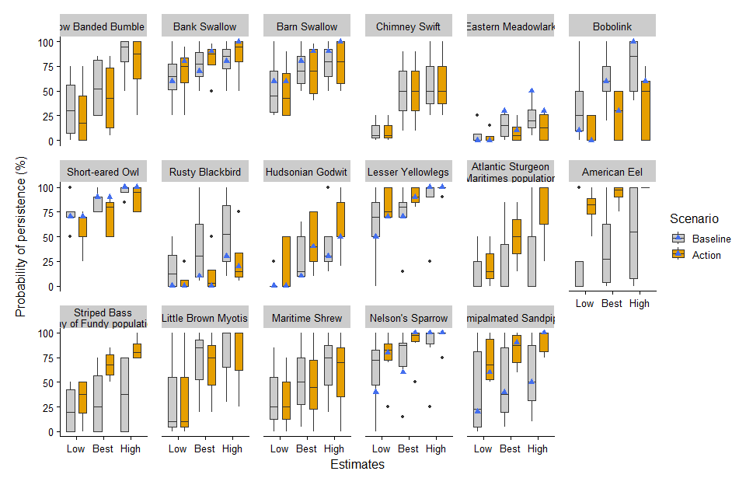

Figure 1. Boxplots summarizing the distribution of the lowest (L), best guess (B), and highest (H) expert estimates of the probability of persistence of species-at-risk under the Baseline scenario and with the Action. The thick horizontal lines indicate the median estimate, while the surrounding box shows the interquartile range. Any outliers are shown as black dots beyond the plot whiskers. Your individual estimates are shown as blue triangles.

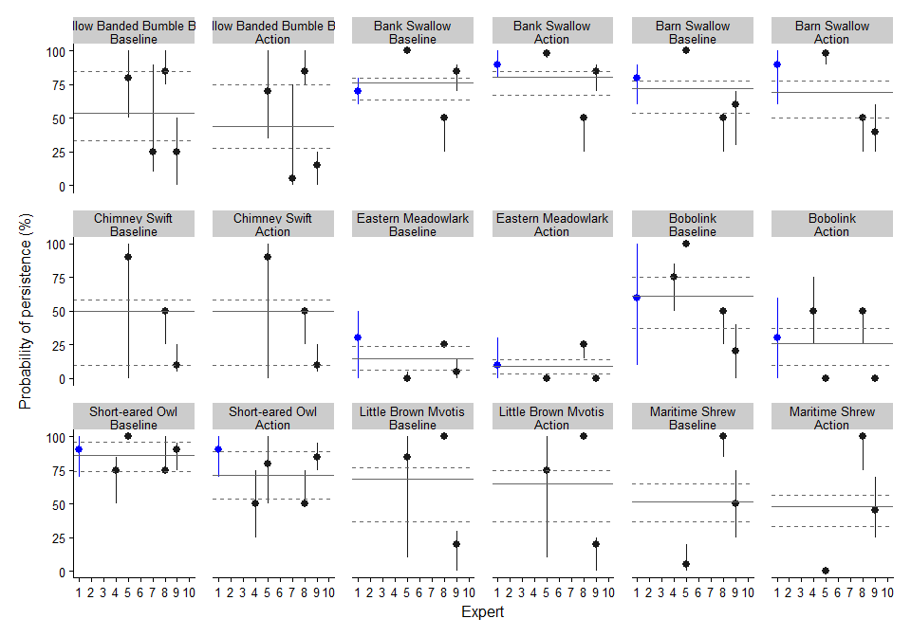

Figure 2. Plots of the probability of persistence of species-at-risk under the Baseline scenario and with the Action. Each point represents the estimates from one expert (points = Best Guess, vertical lines = range from Lowest to Highest estimate). Your individual estimates are plotted in blue. The horizontal lines indicate the mean of the probability of persistence estimates (solid line = Best Guess, dashed lines = Lowest and Highest estimate).