Mackenzie Creek restoration project

Canadian Conservation Exchange Pilot

2024-04-02

## Instructions

An important part of the structured elicitation process is to give each expert the opportunity to review all the expert estimates and then revise their own estimates if desired.

**Please review the following plots summarizing the expert estimates**. Expert names have been converted to codes to maintain confidentiality. Your individual code is: 6.

After reviewing the plots, if you would like to revise your own estimates, you can do so in the accompanying Excel spreadsheet. Please note that revising your estimates is OPTIONAL – you do not have to change your estimates. **If you do not wish to make any changes, please email** [**Kristen.Lalla@ec.gc.ca**](mailto:Kristen.Lalla@ec.gc.ca) **to confirm.**

### Plot descriptions

The box and whisker plots summarize the distribution of the lowest (L), best guess (B), and highest (H) expert estimates of the probability of persistence of species-at-risk under the Counterfactual scenario (grey bars) and with the Action (yellow bars). The thick horizontal lines indicate the median estimate, while the surrounding box shows the interquartile range. Any outliers are shown as black dots beyond the plot whiskers. Your individual estimates are shown as blue triangles.

The point and range plots show each expert’s estimate of the probability of persistence of species-at-risk under the Counterfactual scenario and with the Action. Each point represents the estimates from one expert (points = Best Guess, vertical lines = range from Lowest to Highest estimate). Your individual estimates are plotted in blue. The horizontal lines indicate the mean of the probability of persistence estimates (solid line = Best Guess, dashed lines = Lowest and Highest estimate).

### Expert comments

We have also included additional information or explanation provided by experts about their own estimates in a table following each set of plots.

## Probability of success

The following plots show the initial expert estimates of the probability that the Mackenzie Creek restoration project will be successful (*i.e.*, that the project will successfully achieve its goals).

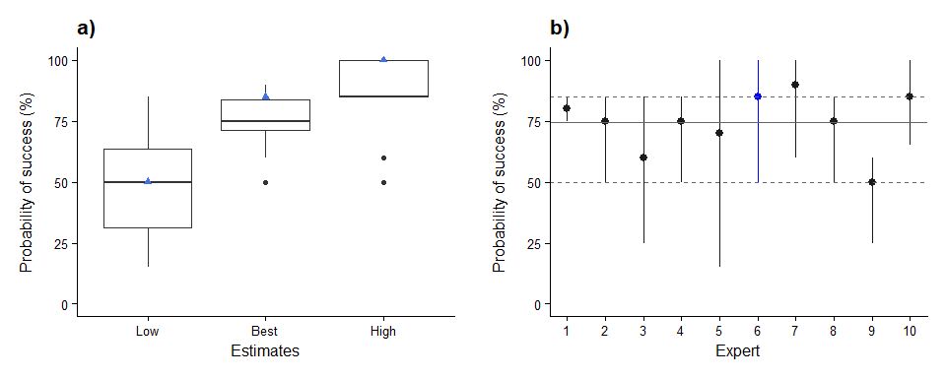

Figure 1 (a) Boxplot summarizing the distribution of the lowest (Low), best guess (Best), and highest (High) expert estimates of the probability of success of the project. (b) Individual expert estimates of the probability of success of the project. Each point and range represents the estimates from one expert. Horizontal lines indicate the mean estimate (solid line = Best Guess, dashed lines = Lowest and Highest estimate). Your individual estimates are plotted in blue.

| **Expert** | **Comments** |
| --- | --- |
| 1 | The description of the project outlined a very feasible reclaim stream crossings. I think the actions taken will help with sedimentation. |
| 2 | The implementation of permanent crossing infrastructure should improve overall habitat quality in those areas. One concern is that OHV users may not use the infrastructure and still cross the stream at undesignated areas. |
| 4 | The "intended outcomes" are fairly easily achieved, assuming illegal OHV activity can be curtailed. And also assuming additional ladscape alterations (forestry, road building) do not add to the problems. However, the "intended outcomes" are further assumed to benefit Bull Trout. That might not be as plausible. Several other factors affect Bull Trout persistence, especially illegal harvest and harm to the other parts of the Mackenzie Creek fishes' range. It is also important to note that no other fish species forms a population in Mackenzie Creek. It is a Bull Trout monoculture. |
| 5 | The baseline goals seem atainable but the human element is complicated. Excluding humans and having 20 years of political support is critical but diffcult to assure. |
| 6 | Assumed that the OHV exclusion fully worked in the highest plausible probability and that ALL restoration activities fully changed the function and grew/stayed in place as intended and rapid recovery then took place in the soil & plant community. In the lowest success, assumed that there were some small incursions of OHVs but that mostly they were still all excluded successfully, but that the restoration itself didn't 'take' as well--might get washed out by floods, or drought conditions result in poor and slow growth of woody plants to colonize and successfully grow along banks and trails and that decompaction wasn't deep enough so soil's water holding capacity and ability to regrow plants was reduced from ideal. The best success assumed that all OHV exclusion was 100% successful and that the restoration actions to decompact, reduce sediment and plant new woody plants were quite successful but not all grew (which is realistic) and also that delays in regrowth to fill in the spaces mean that the 'best' restoration isn't possible if it all doesn't magically grow & sprout to max possible in year 1 (which it inevitably won't). |
| 8 | If offroad vehicle activity is the most important or only manmade disturbance, then I think that directing such vehicles away from the creek and revegetating disturbed areas will probably make the project successful. I'm just wondering how cooperative the vehicle riders will be. |
| 9 | I am assuming 100% success depends on achievement of beneficial changes to all components described as the project's intended outcome. Factors that can influence potential for success in such projects include: the time and resources invested in routine monitoring and maintenance of habitat features and revegetgation areas; timing and duration of monitoring and maintenance during not only an initial period of establishment post-construction but following periods of observations of increased stream discharge, increased watershed disturbance, or increased human use of riparian areas, trails, waterbodies; skill, experience with modifying physical instream structures of those undertaking the project; surrounding area land mangement controls on access and upper watershed conditions. I have previous personal work experience with constructing and monitoring instream and riparian restoration projects addressing salmonid habitat enhancement and revegetation programs (10 years) - this informs my estimates of probability of success. |

## Probability of persistence

The following pages show plots of the initial expert estimates of the probability of persistence over 20 years under the Counterfactual scenario (*i.e.*, if the project did not take place) and with the Action (*i.e.*, if the project is successfully implemented).

### Species-at-risk

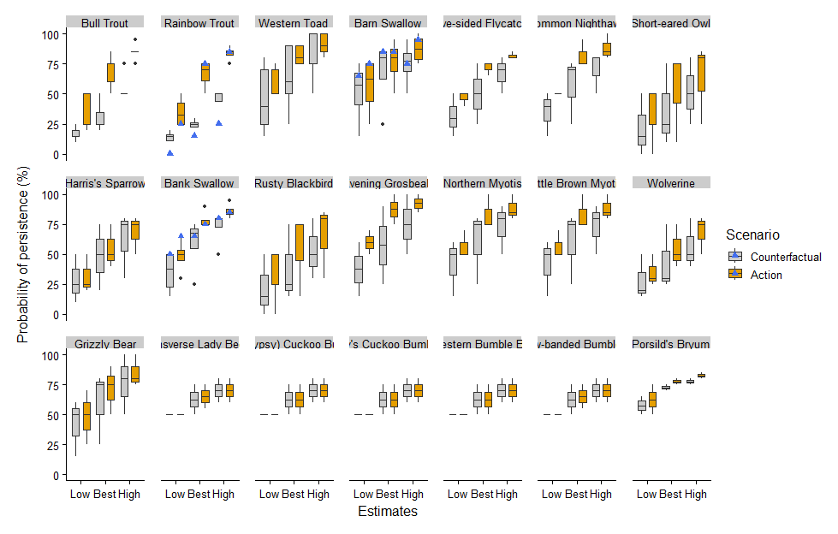

Figure 2. Boxplots summarizing the distribution of the lowest (Low), best guess (Best), and highest (High) expert estimates of the probability of persistence of species-at-risk under the Counterfactual scenario and with the Action. Your individual estimates are shown as blue triangles.

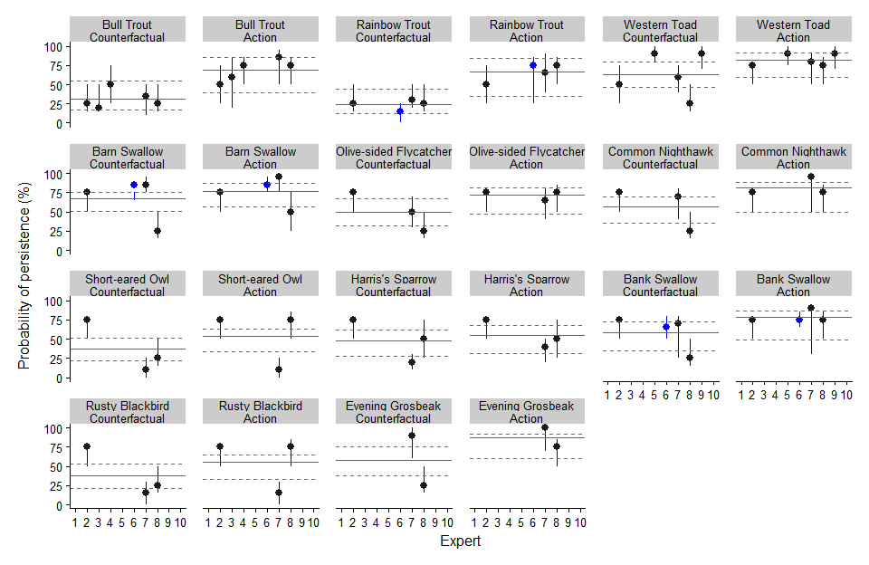

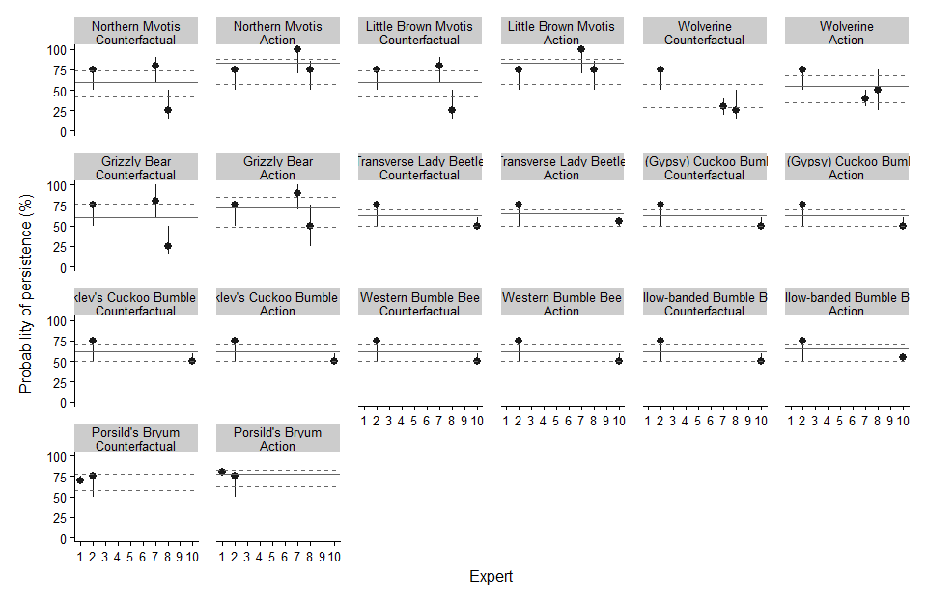

Figure 3. Individual expert estimates of the probability of persistence of species-at-risk under the Counterfactual scenario and with the Action. Each point and range represents the estimates from one expert. Your individual estimates are plotted in blue. Horizontal lines indicate the mean estimate (solid line = Best Guess, dashed lines = Lowest and Highest estimate).

| **Species-at-risk** | **Expert** | **Comments** |
| --- | --- | --- |
| Bull Trout | 1 | I have so little expertise on anything other than plants, I feel quite uncomfortable saying. The actions taken would seem to be beneficial for this species. |
| 2 | This management action should improve stream quality for this species. However, there persistence in the system will likely be impacted by factors outside of this project (e.g., fishing pressure, warming headwaters, etc). |
| 4 | The sediment damage has been ongoing for decades, and the population remains relatively abundant. This suggests the damage is more of a "potential loss in the future" than a current serious loss. It is a issue of probabilities in the future; will a tipping point of too much sediment be reached with, or without the restoration? This project reduces the threat of sediment causing a population loss, but does not ensure the persistence of the Bull Trout. It is a wise and necessary action, AS A PROBABILITY to improve persistence of Bull Trout. |
| 7 | Mackenzie Creek forms the main part of the breeding range of the population. Sedimentation, rutting and other disturbance will be reduced with implementation of the project and will have a positive effect on the species. Issues with upstream sedimentation (outside the project area) and poaching and other stressors during non-breeding areas may still impact viability of this population. |
| 8 | I expect siltation from runoff associated with offroad vehicle trails to degrade spawning and rearing habitat for salmonids and egg-laying habitat for amphibians. Relocating offroad vehicle trails away from creek and revegetating trail crossings should reduce siltation, as long as recreational riders comply with these changes and don't maintain trails. |
| Rainbow Trout | 1 | I have so little expertise on anything other than plants, I feel quite uncomfortable saying. The actions taken would seem to be beneficial for this species. |
| 2 | This management action should improve stream quality for this species. However, there persistence in the system will likely be impacted by factors outside of this project (e.g., fishing pressure, warming headwaters, etc). |
| 4 | There is no Athabasca Rainbow Trout population in Mackenzie Creek. They live in nearby creeks, but not in Mackenzie. |
| 6 | the lowest probability WITH the action is because it might be too late, the negative impacts might be signfiicant enough already that we have passed some threshold that the restoration will not address (since it won't actually be all fixed on day 1, yr 1, it will take years for the changes to be at their maximum, full benefit as the site heals and recovers, which means in the meantime, the restored area isn't actually healthy and isn't contributing the postive things (eg. shade, shelter, filtration, etc) it should, even if it is stopping contributing negatively (eg. sedimentation is stopped)> |
| 7 | Athabasca River Rainbow Trout occur in the creek year-round. Sedimentation, rutting and disturbance will be reduced with implementation of the project and will have a positive effect on the species. |
| 8 | I expect siltation from runoff associated with offroad vehicle trails to degrade spawning and rearing habitat for salmonids and egg-laying habitat for amphibians. Relocating offroad vehicle trails away from creek and revegetating trail crossings should reduce siltation, as long as recreational riders comply with these changes and don't maintain trails. |
| Western Toad | 1 | I have so little expertise on anything other than plants, I feel quite uncomfortable saying. The actions taken would seem to be beneficial for this species. |
| 2 | Upgrading crossing infrastructure could improve habitat quality of the surrounding stream shoreline. If Western Toad are occupying this stream, there could be some improvements. |
| 5 | I would expect this project to have little impact on this species. I have a concern that active management may cause unforeseen impacts such as introducing new pathogens or reducing heterogeneity |
| 6 | do not know enough about their ecology to do any ratings |
| 7 | Western Toad may be able to utilize some habitats where OHV use is currently limited and may persist in the project area in the counterfactual scenario. Sedimentation, rutting and disturbance will be reduced with implementation of the project and will have a positive effect on the species. |
| 8 | I expect siltation from runoff associated with offroad vehicle trails to degrade spawning and rearing habitat for salmonids and egg-laying habitat for amphibians. Relocating offroad vehicle trails away from creek and revegetating trail crossings should reduce siltation, as long as recreational riders comply with these changes and don't maintain trails. |
| 9 | Potential for anticipated reduction in road/OHV trail mortality with project access changes; whether benefit is realized depends on whether SAR use can be confirmed in the project area. Detail provided on project area wetland ecotype is not sufficient for a detailed review to indentify potential pond/openwater habitat types that would support breeding Western Toad and from there, which terrestrial riparian habitat areas used by Western Toad may be improved by the project.   https://www.canada.ca/en/environment-climate-change/services/species-risk-public-registry/management-plans/western-toad-2020.html#toc9  "Data collected during pitfall trapping at six monitoring sites in Alberta from 1997 to 2008 indicated that Western Toads experienced wide fluctuations in relative abundance and adult abundance trends varied by site: two increasing, one decreasing, and three stable (Eaton and Hiltz 2012). Other reports (cited by COSEWIC (2012), that is, Eaves 2004; Schank 2008) have indicated that Western Toad populations are either stable or increasing in parts of Alberta. It should be noted that declines or disappearances could have gone unnoticed in parts of the province with limited survey efforts (Government of Alberta, Sustainable Resource Development 2010). " |
| Barn Swallow | 1 | I have so little expertise on anything other than plants, I feel quite uncomfortable saying. The actions taken would seem to be beneficial for this species. |
| 2 | Upgrading crossing infrastructure will likely have litte impact on the amount of available habtiat for this species. External factors outside of this project are likely the dominant threat to persistence. |
| 6 | Given the forest and cover in the general area remain intact, even with a new/revised location of the OHV trail, I do not think that should affect this species too much. Unfortunately, low numbers elsewhere may be as important at influencing their persistence here, whether or not restoration happens (or is successful). |
| 7 | Barn Swallows are likely uncommon in the study area due to a lack of nesting sites. This species is highly adaptable and more common in disturbed landscapes and may use the creek corridor for foraging if there are breeding sites nearby or during migration. Project implementation may not have much impact on this species. The presence of new bridges for OHV traffic with project implementation may act as nesting sites for Barn Swallows. |
| 8 | Mud-nesting species that nests on vertical surfaces including manmade structures. May benefit from reduced noise levels associated with relocating offroad vehicle activity away from the creek. If bridges are present at trail crossings, removing bridges as part of trail crossing elimination may remove Barn Swallow nesting substrates. |
| 9 | ebird record in Cadomin, unknown avail of antrhopogenic structures for nesting in project area |
| Olive-sided Flycatcher | 1 | I have so little expertise on anything other than plants, I feel quite uncomfortable saying. The actions taken would seem to be beneficial for this species. |
| 2 | Upgrading crossing infrastructure will likely have litte impact on the amount of available habtiat for this species. External factors outside of this project are likely the dominant threat to persistence. |
| 6 | do not know enough about their ecology to do any ratings |
| 7 | Olive-sided Flycatchers typically occupy burned or edge habitats so it's possible this species occurs along the creek. Restoration would potentially reduce noise disturbance and help restore riparian functioning and increase foraging opportunities for the species. |
| 8 | Tree-nesting species that would probably benefit from reduced noise levels (decreased offroad vehicle activity). |
| 9 | ebird records suggest area use by OSFL, habitat suitability may be low - may need detail of specific site characteristics like the presence of snags at clearing edges |
| Common Nighthawk | 1 | I have so little expertise on anything other than plants, I feel quite uncomfortable saying. The actions taken would seem to be beneficial for this species. |
| 2 | Upgrading crossing infrastructure will likely have litte impact on the amount of available habtiat for this species. External factors outside of this project are likely the dominant threat to persistence. |
| 6 | do not know enough about their ecology to do any ratings |
| 7 | Likely that CONI mostly use the creek and riparian areas for foraging during the breeding season but less so for breeding or other activities, which may occur in open areas on the forest floor. |
| 8 | Ground-nester that would probably benefit from reduced risk of nest destruction by offroad vehicles and reduced noise levels. Revegetation of trails near Mackenzie Creek and trail crossings over creek might improve nest cover up to a point, but too much revegetation might reduce nesting habitat. |
| 9 | ebird records suggest area use by CONI, suggest possiblity for use in nesting, if trail or road openings provide disturbed areas of ground/clearings |
| Short-eared Owl | 1 | I have so little expertise on anything other than plants, I feel quite uncomfortable saying. The actions taken would seem to be beneficial for this species. |
| 2 | Upgrading crossing infrastructure will likely have litte impact on the amount of available habtiat for this species. External factors outside of this project are likely the dominant threat to persistence. |
| 6 | do not know enough about their ecology to do any ratings |
| 7 | This species breeds and forages in open habitat and is therefore unlikely to be using the creek corridor currently and project implementation is unlikely to have much impact on the species other than reduced noise disturbance. |
| 8 | Ground-nester that would probably benefit from reduced risk of nest destruction by offroad vehicles and reduced noise levels. Revegetation of trails near Mackenzie Creek and trail crossings over creek might improve nest cover up to a point, but too much revegetation might reduce nesting habitat. |
| 9 | ebird records in region, at some distance from project site; while project is within the species breeding range, typical breeding habitat is described on open landscapes at least 50-100 ha so habitat suitability in the project area likely low. |
| Harris's Sparrow | 1 | I have so little expertise on anything other than plants, I feel quite uncomfortable saying. The actions taken would seem to be beneficial for this species. |
| 2 | Upgrading crossing infrastructure will likely have litte impact on the amount of available habtiat for this species. External factors outside of this project are likely the dominant threat to persistence. |
| 6 | do not know enough about their ecology to do any ratings |
| 7 | This species would only occur in the project area during migration and in low numbers since the core of its migration corridor is further east. This species typically utilizes shrubby or open habitats over its full annual cycle. While implementation of this project may slightly increase persistence of this species in the study area, it will likely not have a large impact. |
| 8 | Unlikely to be nesting in the study area as this is a tundra-breeding species. Only likely to be seen in area during migration. It is unlikely to be present long enough in area to be significantly disturbed by offroad vehicle activity or benefit from the relocation of this activity. |
| 9 | occassional eBird records in regional area, presume for migratory movement since biophysical attributes of breeding habitat |
| Bank Swallow | 1 | I have so little expertise on anything other than plants, I feel quite uncomfortable saying. The actions taken would seem to be beneficial for this species. |
| 2 | Upgrading crossing infrastructure will likely have litte impact on the amount of available habtiat for this species. External factors outside of this project are likely the dominant threat to persistence. |
| 6 | Since bare, eroding banks are beneficial, reducing flattened, compacted OHV crossing areas will have some small or modest impact. Given the forest and cover in the general area remain intact, even with a new/revised location of the OHV trail, I do not think that should affect this species too much. Unfortunately, low numbers elsewhere may be as important at influencing their persistence here, whether or not restoration happens (or is successful). |
| 7 | Bank Swallows are likely found in the study area in low density because they require steep banks for nesting. Likely that BANS would mostly use the creek for foraging during the breeding season and possibly for roosting in riparian vegetation but less so for breeding or other activities. The species may benefit from riparian area restoration through increased foraging opportunities. |
| 8 | Burrow-nesting species that nests in river banks. May benefit from reduced noise levels associated with relocating offroad vehicle activity away from the creek. Reducing runoff at former trail crossings probably won't affect a significant amount of nesting habitat unless these trail crossings are the only available exposed banks for this species. |
| 9 | occassional eBird records in regional area, missing detail on whether streambank conditions/road cutbanks may provide banks of suffient height for use for nests/colonies |
| Rusty Blackbird | 1 | I have so little expertise on anything other than plants, I feel quite uncomfortable saying. The actions taken would seem to be beneficial for this species. |
| 2 | Upgrading crossing infrastructure will likely have litte impact on the amount of available habtiat for this species. External factors outside of this project are likely the dominant threat to persistence. |
| 6 | do not know enough about their ecology to do any ratings |
| 7 | Rusty Blackbird may occur in the study area only in low abundance or may not occur at all since this species is typically associated with treed wetlands during the breeding season. It may occur in the study area in low densities during migration. |
| 8 | Tree-nesting species that would probably benefit from reduced noise levels (decreased offroad vehicle activity). |
| 9 | occassional eBird records in regional area, but missing detail on wetland (marsh,swamp, open water) to evaluate whether biophysical attributes would be present in project area |
| Northern Myotis | 1 | I have so little expertise on anything other than plants, I feel quite uncomfortable saying. The actions taken would seem to be beneficial for this species. |
| 2 | Upgrading crossing infrastructure will likely have litte impact on the amount of available habtiat for this species. External factors outside of this project are likely the dominant threat to persistence. |
| 6 | do not know enough about their ecology to do any ratings |
| 7 | Northern Myotis likely use the creek and adjacent riparian areas for foraging during the breeding season and forests within the project area for breeding and roosting. The species may benefit from riparian area restoration through increased foraging opportunities and higher forage quality, and reduced disturbance. |
| 8 | Reducing offroad vehicle use and noise near the creek should reduce disturbance year-round for roosting and/or hibernating bats using riparian forests. p. 68 in https://multisar.ca/wp-content/uploads/2015/10/Multisar-Bat-BMP-Report-Final.pdf. |
| 9 | Cadomin CH is nearby (hibernaculum), presume potential for use; riparian forested habitats support foraging and roosting but missing detail within forest ecotypes (forest stand age, fragmentation, stand denisty, availablity of snags, tree diameters, heights, decay class, sun exposure...) that would help detail some of the biophysical attributes associated with roosting like larger tree diameters, presence of snags, tree cavities. |
| Little Brown Myotis | 1 | I have so little expertise on anything other than plants, I feel quite uncomfortable saying. The actions taken would seem to be beneficial for this species. |
| 2 | Upgrading crossing infrastructure will likely have litte impact on the amount of available habtiat for this species. External factors outside of this project are likely the dominant threat to persistence. |
| 6 | do not know enough about their ecology to do any ratings |
| 7 | Little Brown Myotis likely use the creek and adjacent riparian areas for foraging during the breeding season and forests within the project area for breeding and roosting. The species may benefit from riparian area restoration through increased foraging opportunities and reduced disturbance. |
| 8 | Reducing offroad vehicle use and noise near the creek should reduce disturbance year-round for roosting and/or hibernating bats using riparian forests. p. 68 in https://multisar.ca/wp-content/uploads/2015/10/Multisar-Bat-BMP-Report-Final.pdf. |
| 9 | Cadomin CH is nearby (hibernaculum), presume potential for use; riparian forested habitats support foraging and roosting but missing detail within forest ecotypes (forest stand age, fragmentation, stand denisty, availablity of snags, tree diameters, heights, decay class, sun exposure...) that would help detail some of the biophysical attributes associated with roosting like larger tree diameters, presence of snags, tree cavities. |
| Wolverine | 1 | I have so little expertise on anything other than plants, I feel quite uncomfortable saying. The actions taken would seem to be beneficial for this species. |
| 2 | Upgrading crossing infrastructure will likely have litte impact on the amount of available habtiat for this species. External factors outside of this project are likely the dominant threat to persistence. |
| 6 | do not know enough about their ecology to do any ratings |
| 7 | Species is sensitive to disturbance and the area has a large human footprint. The restoration project is unlikely to impact the wolverine greatly |
| 8 | Reducing offroad vehicle use and noise near the creek could make it more attractive for wolverines, especially if trails near the creek are revegetated to discourage ATV use. Given the home range size of wolverines, there probably wouldn't be a large change in wolverine numbers, but relocating the trails might increase the probability of wolverines using the creek. https://canadiangeographic.ca/articles/why-wont-wolverines-cross-the-road/. |
| 9 | Possible there may be a reduction to species disturbance and movement in the project area if road/OHV trail access is closed or limited along the creek and riparian area; however, if vehicle use and activity by people is relocated to other areas upslope of Mackenzie Creek, overall this project may not benefit or may have a negative effect to the species depending on new route alignments and specific movement patterns through the project area. Whether any species benefit is realized depends on specific SAR use in the project area - I don't have this detail available. |
| Grizzly Bear | 1 | I have so little expertise on anything other than plants, I feel quite uncomfortable saying. The actions taken would seem to be beneficial for this species. |
| 2 | Upgrading crossing infrastructure will likely have litte impact on the amount of available habtiat for this species. External factors outside of this project are likely the dominant threat to persistence. |
| 6 | do not know enough about their ecology to do any ratings |
| 7 | Grizzly bears will likely use the project area regardless of disturbance since their home ranges are very large however project implementation will likely have a positive impact on this species in the project area. Increased disturbance outside of the project area due to the OHV trail being moved and increasing in linear distance may reduce the persistence of the species in the broader area - note that I did not consider this in my assessment for the species. |
| 8 | Reducing offroad vehicle use and noise near the creek could make it more attractive for grizzly bears as would larger salmonid populations and better salmonid-spawning habitat after relocating trails away from the creek. Given the home range size of grizzlies, there probably wouldn't be a large change in grizzly numbers, but relocating the trails might increase the probability of grizzlies using the creek. |
| 9 | Possible there may be a reduction to species disturbance in the project area if road/OHV trail access is closed or limited along the creek and riparian area; however, if vehicle use and activity by people is relocated to other areas upslope of Mackenzie Creek, overall this project may not benefit or may have a negative effect to the species depending on new route alignments, effects on movement and specific movement patterns through the project area. Whether any species benefit is realized depends on specific SAR use in the project area - I don't have this detail available. |
| Transverse Lady Beetle | 1 | I have so little expertise on anything other than plants, I feel quite uncomfortable saying. The actions taken would seem to be beneficial for this species. |
| 2 | Upgrading crossing infrastructure will likely have litte impact on the amount of available habtiat for this species. External factors outside of this project are likely the dominant threat to persistence. |
| 6 | do not know enough about their ecology to do any ratings |
| 8 | I know nothing about this species or how it might be affected by the lack or presence of offroad vehicles or revegetation of trail crossings |
| 9 | It seems like there is insufficient data to make Canadian population projections showing the probability of persistence. The COSEWIC Status Assessment Report presents the consensus of expert opinion from the COSEWIC Arthropod Species Subcommittee, that within Canada the relative abundance of the Transverse Lady Beetle has been significantly reduced compared to historical levels and extent. The Transverse Lady Beetle has continued to decline or is managing to persist in low numbers across the majority of its range (including AB), while the species appears common and somewhat isolated from the impact of non-native species in BC, YT, NT and likely NU. (COSEWIC 2017) |
| 10 | It is my opinion that the terrestrial impact of the program, successful or not, will not be on a scale grand enough to significantly impact the population size of this species. |
| Ashton (Gypsy) Cuckoo Bumble Bee | 1 | I have so little expertise on anything other than plants, I feel quite uncomfortable saying. The actions taken would seem to be beneficial for this species. |
| 2 | Upgrading crossing infrastructure will likely have litte impact on the amount of available habtiat for this species. External factors outside of this project are likely the dominant threat to persistence. |
| 6 | do not know enough about their ecology to do any ratings |
| 8 | I know nothing about this species or how it might be affected by the lack or presence of offroad vehicles or revegetation of trail crossings |
| 10 | It is my opinion that the terrestrial impact of the program, successful or not, will not be on a scale grand enough to significantly impact the population size of this species. |
| Suckley's Cuckoo Bumble Bee | 1 | I have so little expertise on anything other than plants, I feel quite uncomfortable saying. The actions taken would seem to be beneficial for this species. |
| 2 | Upgrading crossing infrastructure will likely have litte impact on the amount of available habtiat for this species. External factors outside of this project are likely the dominant threat to persistence. |
| 6 | do not know enough about their ecology to do any ratings |
| 8 | I know nothing about this species or how it might be affected by the lack or presence of offroad vehicles or revegetation of trail crossings |
| 10 | It is my opinion that the terrestrial impact of the program, successful or not, will not be on a scale grand enough to significantly impact the population size of this species. |
| Western Bumble Bee | 1 | I have so little expertise on anything other than plants, I feel quite uncomfortable saying. The actions taken would seem to be beneficial for this species. |
| 2 | Upgrading crossing infrastructure will likely have litte impact on the amount of available habtiat for this species. External factors outside of this project are likely the dominant threat to persistence. |
| 6 | do not know enough about their ecology to do any ratings |
| 8 | I know nothing about this species or how it might be affected by the lack or presence of offroad vehicles or revegetation of trail crossings |
| 9 | habitat generalist, found in a wide variety of open habitats, including montane/ lower elev meadows within open coniferous, deciduous, and mixed-wood forests and woodlands; riparian areas; roadsides (COSEWIC 2014; Williams et al. 2014; BC CDC 2021); habitat may be provided by the project area but unknown if the SAR would be found in project area. Maybe some very marginal benefit with project location in foothills so at distance from areas where insecticide use, commercial non-native bee rearing would be presumed to be a greater stressor, but would want to have documentation of SAR invertebrates (bees, lady beetles) at site. |
| 10 | It is my opinion that the terrestrial impact of the program, successful or not, will not be on a scale grand enough to significantly impact the population size of this species. |
| Yellow-banded Bumble Bee | 1 | I have so little expertise on anything other than plants, I feel quite uncomfortable saying. The actions taken would seem to be beneficial for this species. |
| 2 | Upgrading crossing infrastructure will likely have litte impact on the amount of available habtiat for this species. External factors outside of this project are likely the dominant threat to persistence. |
| 6 | do not know enough about their ecology to do any ratings |
| 8 | I know nothing about this species or how it might be affected by the lack or presence of offroad vehicles or revegetation of trail crossings |
| 10 | It is my opinion that the terrestrial impact of the program, successful or not, will not be on a scale grand enough to significantly impact the population size of this species. |
| Porsild's Bryum | 1 | Reading of the COSEWIC status report on Porsild's Bryum indicates that drought is a major threat. I think the actions taken will help maintain the hydrology necessary for Porsild's Bryum persistence. There are not too many subpopulations of Porsild's Bryum within the scope of assessment though so the impact of these actions will still be somewhat modest for this species. |
| 2 | Upgrading crossing infrastructure will likely have litte impact on the amount of available habtiat for this species. External factors outside of this project are likely the dominant threat to persistence. |
| 6 | do not know enough about their ecology to do any ratings |
| 8 | I know nothing about this species or how it might be affected by the lack or presence of offroad vehicles or revegetation of trail crossings |
| 9 | Specific known locations named in the Recovery Strategy appear to be upstream of the area of the project. The following combination of biophysical habitat attributes is required to support a colony of Porsild’s Bryum: Calcareous cliffs or rock outcrops; Continuous or intermittent seepage; Shaded rock face; shade maintained by size and aspect of cliff face, or a continuous tree cover; A microenvironment characterised by lower temperatures and higher relative humidity than adjacent habitat where the species is absent (Recovery Strategy for the Porsild’s Bryum 2017).  Activities likely to result in destruction of critical habitat include alteration to hydrology or water quality/chemistry owing to human landscape use, rock and soil disturbance, deposition of road dust on moss or adjacent vegetation. Effects of these activities can include reduction in relative humidity, reduction in water flow (drought), or increases in site temperature (loss of adjacent canopy, change in shading) and these can alter biophyscial attributes supporting species persistence. |
| Evening Grosbeak | 7 | Species added. Species is a resident in the area - possibly using the forest for nesting and foraging and the riparian area for foraging. Riparian restoration would reduce noise disturbance in the project area and possibly increase foraging opportunities. |
| 8 | Presence of this irruptive species might vary from year to year, depending on food available within forests around Mackenzie Creek. So the treatment might not greatly affect its presence or abundance in the area. But it's a tree-nesting species and a ground forager (https://www.allaboutbirds.org/guide/Evening_Grosbeak/overview) that would probably benefit from reduced noise levels (decreased offroad vehicle activity). |

### Freshwater representative biodiversity (functional groups)

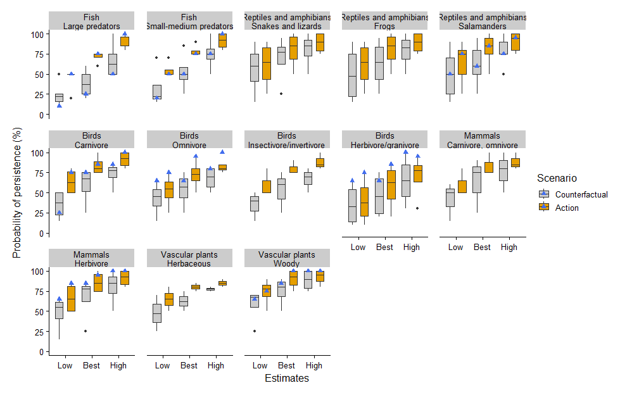

Figure 4. Boxplots summarizing the distribution of the lowest (Low), best guess (Best), and highest (High) expert estimates of the probability of persistence of representative biodiversity (*i.e.*, functional groups) in the freshwater ecotype, under the Counterfactual scenario and with the Action. Your individual estimates are shown as blue triangles.

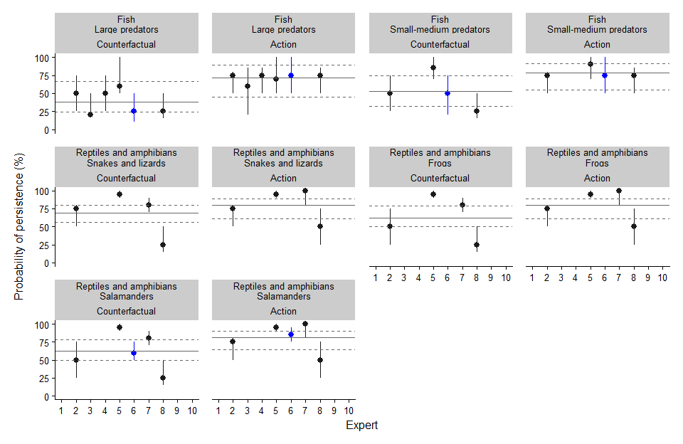

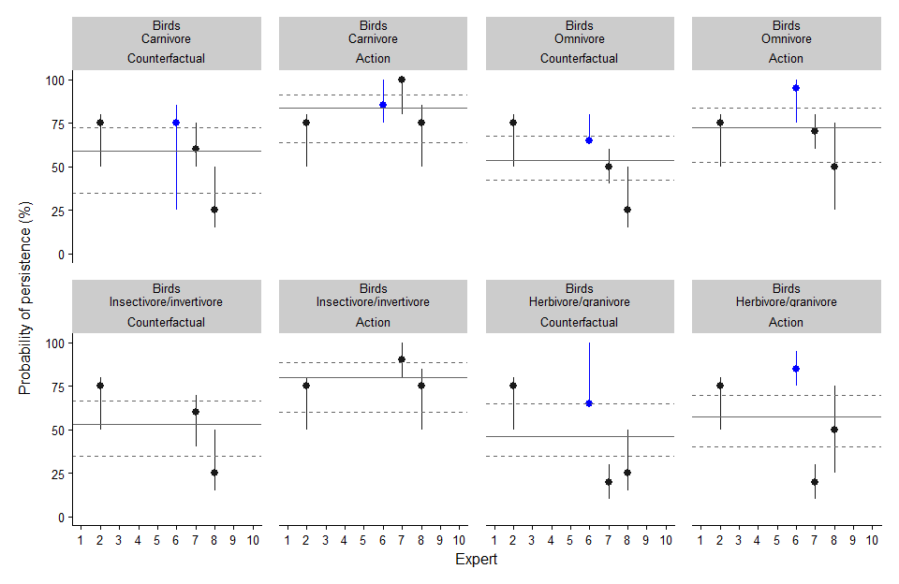

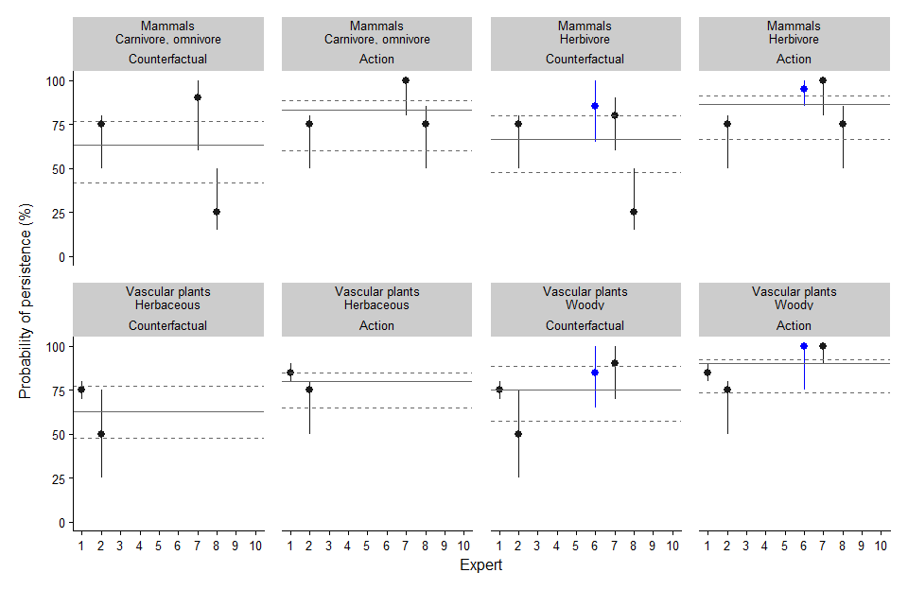

Figure 5. Individual expert estimates of the probability of persistence of representative biodiversity (*i.e.*, functional groups) in the freshwater ecotype, under the Counterfactual scenario and with the Action. Each point and range represents the estimates from one expert. Your individual estimates are plotted in blue. Horizontal lines indicate the mean estimate (solid line = Best Guess, dashed lines = Lowest and Highest estimate).

| **Freshwater Biodiversity** | **Expert** | **Comments** |
| --- | --- | --- |
| Fish Large predators | 2 | Upgrading crossing infrastructure could see improvements to the local and downstream habitat for these species. Is highly dependent on if OHV users use the new infrastructure. |
| 3 | Because of my lack of knowledge of the system as it petains to fish biodiversity, I am only consdiering bull trout and rainbow trout, here. I recognize that there likely are small minnow species in the system, but am not consdering those as predators. Because i think bull trout are the primary species of concern, my scores are identifcal to that of the SAR persistence tab. |
| 4 | Bull Trout are the only large fish predator in the system |
| 5 | Based on the presentation, this seems to be the group most likely to benefit. Still they have persisted this long so I think that they will likely continue. Active management likely improves the overall outlook but as these systems are more complicated than expected, failure or reduction in habitat quality is always a possibility (Such as loss of heterogeneity). I feel as this active management is limited and mostly just excluding people I think it has a higher probability of success than more involved activities.  If refering to pike, I think they are likely fine. |
| 6 | these fish are more tolerant of warmer water than native trout, but still need quality, and in particular, spawning in flooded, clean veg at times, so that influenced my answers; assumed that new impacts in the overall watershed (eg. development, clear cut logging) do not add new problems with hydrology and sedimentation/ nutrient accumulation or flow that alters the channel. |
| 8 | I expect siltation from runoff associated with offroad vehicle trails to degrade spawning and rearing habitat for most fish regardless of trophic level. |
| Fish Small-medium predators | 2 | Upgrading crossing infrastructure could see improvements to the local and downstream habitat for these species. Is highly dependent on if OHV users use the new infrastructure. |
| 4 | There are only reports of occassional captures of other species in this system. It is populated by a monoculture of Bull Trout. |
| 5 | Most of the small fish in this system are fairly resiliant in my opionin and have persisted thus far. I would expect them to to be fine. Still as fish such as chub are pebble nesters there may be some benifit |
| 6 | similar to pike comment, more tolerant than trout and can live in lower quality water (re nutrients & oxygen) |
| 8 | I expect siltation from runoff associated with offroad vehicle trails to degrade spawning and rearing habitat for most fish regardless of trophic level. |
| Reptiles and amphibians Snakes and lizards | 2 | Unsure if there are any lizards or snakes that occupy this area. |
| 5 | I think this will have very little impact on overall reptile populations |
| 6 | do not know enough about their ecology to do any ratings |
| 7 | Project implementation will likely lincrease the persistence of this functional group in the study area due to lowered disturbance. |
| 8 | I expect noise from offroad vehicles would be a disturbance for snakes, and a risk of mortality from snakes being run over by vehicles, but I don't know if significant numbers would be run over by vehicles. |
| Reptiles and amphibians Frogs | 2 | Upgrading crossing infrastructure could see improvements to the local and downstream habitat for these species. Is highly dependent on if OHV users use the new infrastructure. |
| 5 | I think this will have very little impact on overall frog populations |
| 6 | do not know enough about their ecology to do any ratings |
| 7 | Project implementation will likely lincrease the persistence of this functional group in the study area due to reduced disturbance and sedimentation. |
| 8 | I expect siltation from runoff associated with offroad vehicle trails to degrade spawning habitat for amphibians, and a risk of mortality from amphibians being run over by vehicles, but I don't know if significant numbers would be run over by vehicles. |
| Reptiles and amphibians Salamanders | 2 | Upgrading crossing infrastructure could see improvements to the local and downstream habitat for these species. Is highly dependent on if OHV users use the new infrastructure. |
| 5 | I think this will have very little impact on overall salamander populations |
| 6 | assumes that compacted soils, bare soils and drying out of space as well as physically driving over them and altering predation /cover will change enough to be a benefit with the restoration but even without the project, they will persist some spots and recolonize from adjacent forest/ wetlands so some will persist; the stream itself isn't their primary habitat but the terrestrial areas and wetlands will be. |
| 7 | A reduction in OHV disturbance, particularly reduced sedimentation, will likely increase the persistence of these species in the study area. |
| 8 | I expect siltation from runoff associated with offroad vehicle trails to degrade spawning habitat for amphibians, and a risk of mortality from amphibians being run over by vehicles, but I don't know if significant numbers would be run over by vehicles. |
| Birds Carnivore | 2 | Upgrading crossing infrastructure will likely have litte impact on the amount of available habtiat for this functional group. External factors outside of this project are likely the dominant threat to persistence. |
| 6 | Given that they are mobile and move up and down stream, this increases their ability to adjust to habitat changes even if the site doesn't improve as much as it could, but they will rely upon fish still being present--if the site continues to decline, the fish presence will be reduced and influence ability to use the area. |
| 7 | Noise and creek disturbance (i.e. sedimentation) from OHVs lowers the persistence of these species in the project area therefore project implementation would increase the persistence of this functional group. |
| 8 | Mergansers and other aquatic carnivores might benefit from larger fish populations if water conditions are improved, along with elimination of offroad vehicle noise. |
| Birds Omnivore | 2 | Upgrading crossing infrastructure will likely have litte impact on the amount of available habtiat for this functional group. External factors outside of this project are likely the dominant threat to persistence. |
| 6 | improvements in vegetation and reduction in compacted bare soils and improved understory and wetland plant layers will be helpful; they are mobile enough they will also continue to use /move in/out of the stream area regardless if it is restored, likely |
| 7 | This functional group is sensitive to constant disturbance caused by OHV vehicles and vegetation disturbance but likely occur in low abundance in the study area because they occur mostly in slow moving water or wetlands. These species will benefit from educed disturbance with the implementation of the project will likely increase the probablity of persistence of this functional group |
| 8 | I'm not sure if relocating offroad vehicle trails will improve food resources but reduction in noise will probably be beneficial. |
| Birds Insectivore/invertivore | 2 | Upgrading crossing infrastructure will likely have litte impact on the amount of available habtiat for this functional group. External factors outside of this project are likely the dominant threat to persistence. |
| 7 | Project implementation will likely benefit this functional group particularly reduction in OHV disturbance but they can likely persist regardless of project implementation. Note that it's not clear what species are being included in this functional group compared to the wetland functional group. |
| 8 | Dippers might benefit from improved invertebrate populations or fish eggs if water is clearer from less siltation, when offroad vehicle activity is relocated away from the creek. |
| Birds Herbivore/granivore | 2 | Upgrading crossing infrastructure will likely have litte impact on the amount of available habtiat for this functional group. External factors outside of this project are likely the dominant threat to persistence. |
| 6 | improvements in vegetation and reduction in compacted bare soils and improved understory and wetland plant layers will be helpful; they are mobile enough they will also continue to use /move in/out of the stream area regardless if it is restored, likely. They like open often compacted areas with low veg (grass, annuals) so might actually decline in use if the adjacent land is more dense veg and they are fairly tolerant of human activities so likely removing OHV noise/use will have less impact on these spp than other waterfowl |
| 7 | Low likelihood that herbivorous/granivorous species will use Mackenzie Creek to a great extent in the counterfactual situation and with the action since most of these species utilize slow moving or lentic systems for breeding and during migration. |
| 8 | I'm not sure if relocating offroad vehicle trails will improve food resources but reduction in noise will probably be beneficial. |
| Mammals Carnivore, omnivore | 2 | Upgrading crossing infrastructure will likely have litte impact on the amount of available habtiat for this functional group. External factors outside of this project are likely the dominant threat to persistence. |
| 6 | do not know enough about their ecology to do any ratings |
| 7 | These species may be sensitive to over-use of the OHV trail due to disturbance and reduced food availability. Project implementation will likely increase the probability of persistence of these species. |
| 8 | I expect that carnivores and omnivores will be disturbed less after offroad vehicle activity has been relocated. |
| Mammals Herbivore | 2 | Upgrading crossing infrastructure will likely have litte impact on the amount of available habtiat for this functional group. External factors outside of this project are likely the dominant threat to persistence. |
| 6 | removal of human activity will benefit them as well as regrowth of the riparian and littoral veg with restoration success, however given their size and mobility, they will likely be present in the area regardless, just less abundant or spend less time, if the site is more degraded |
| 7 | OHV use likely increases disturbance to these species reducing their use of the creek and associated riparian vegetation. Site reclamation and reduced disturbance will minimize disturbance and increase the potential food availability (riparian vegetation) for these species. |
| 8 | I expect that herbivores will be disturbed less after offroad vehicle activity has been relocated. |
| Vascular plants Herbaceous | 1 | These communities are fairly robust and so can rebound from disturbance to some degree. However, I do believe the actions taken will be beneficial. |
| 2 | Upgrading crossing infrastructure could see improvements to the local and downstream habitat for these species. Is highly dependent on if OHV users use the new infrastructure. |
| 6 | I think that water chemistry and other characteristics are much more relevant than OHV activity/restoration |
| Vascular plants Woody | 1 | These communities are fairly robust and so can rebound from disturbance to some degree. However, I do believe the actions taken will be beneficial. |
| 2 | Upgrading crossing infrastructure could see improvements to the local and downstream habitat for these species. Is highly dependent on if OHV users use the new infrastructure. |
| 6 | will expand (may actually be planted) with restoration--seeded, staked, or just remove compaction and active mechanical damage from OHV trails |
| 7 | OHV use likely increases disturbance to these species reducing their abundance in the creek but not eliminating it . Site reclamation and reduced disturbance from OHVs will minimize disturbance and increase occupancy of these species. |

### Wetland representative biodiversity (functional groups)

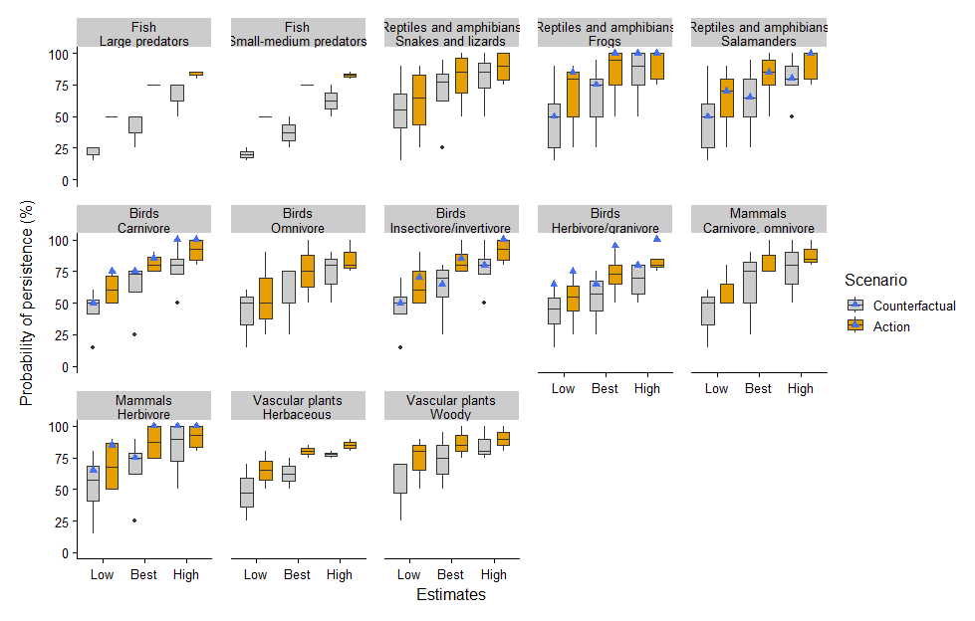

Figure 6. Boxplots summarizing the distribution of the lowest (Low), best guess (Best), and highest (High) expert estimates of the probability of persistence of representative biodiversity (*i.e.*, functional groups) in the wetland ecotype, under the Counterfactual scenario and with the Action. Your individual estimates are shown as blue triangles.

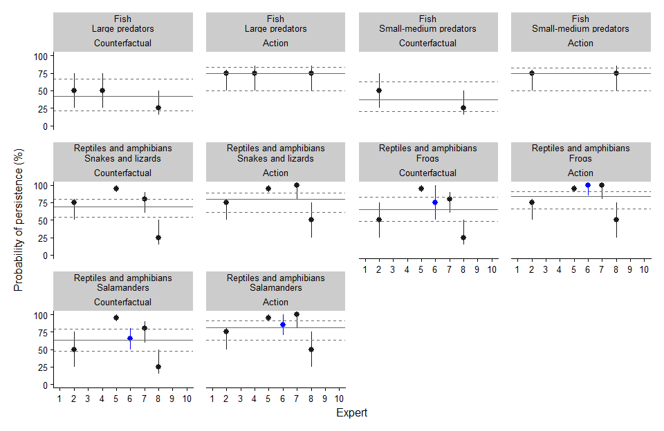

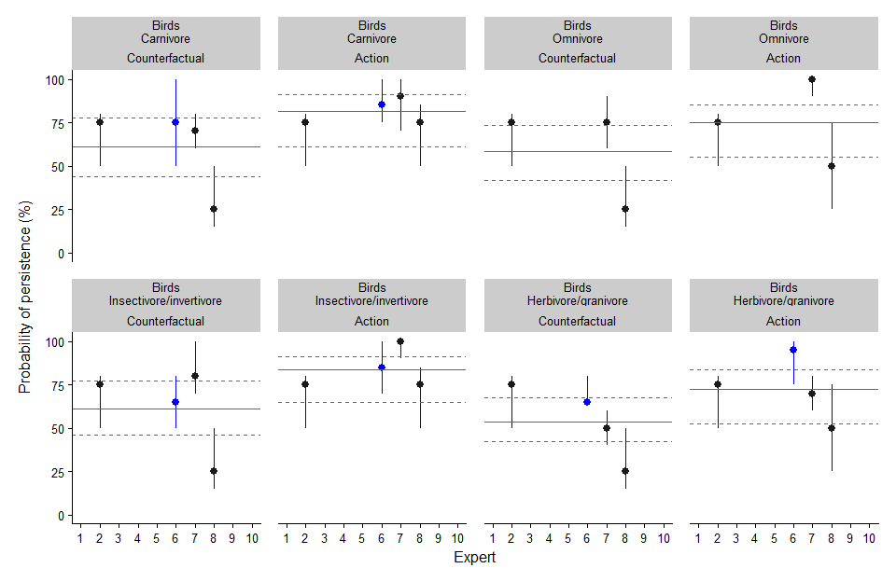

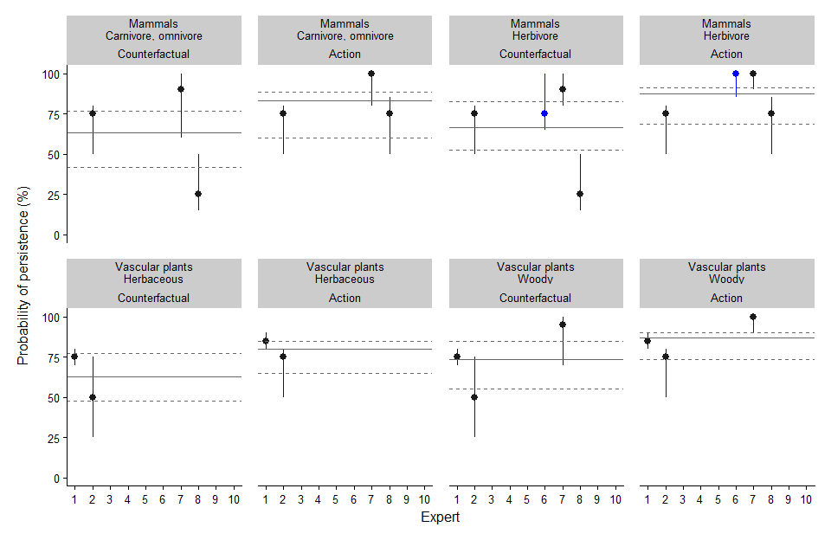

Figure 7. Individual expert estimates of the probability of persistence of representative biodiversity (*i.e.*, functional groups) in the wetland ecotype, under the Counterfactual scenario and with the Action. Each point and range represents the estimates from one expert. Your individual estimates are plotted in blue. Horizontal lines indicate the mean estimate (solid line = Best Guess, dashed lines = Lowest and Highest estimate).

| **Wetland Biodiversity** | **Expert** | **Comments** |
| --- | --- | --- |
| Fish Large predators | 2 | Upgrading crossing infrastructure could see improvements to the local and downstream habitat for these species. Is highly dependent on if OHV users use the new infrastructure. |
| 4 | The Bull Trout live in the mainstem and ephemeral side-channels. Theses side-channels MIGHT be considered wetlands, in which case they have the same effect as the freshwater functional group. |
| 8 | I expect siltation from runoff associated with offroad vehicle trails to degrade spawning and rearing habitat for most fish regardless of trophic level. |
| Fish Small-medium predators | 2 | Upgrading crossing infrastructure could see improvements to the local and downstream habitat for these species. Is highly dependent on if OHV users use the new infrastructure. |
| 4 | same as above |
| 8 | I expect siltation from runoff associated with offroad vehicle trails to degrade spawning and rearing habitat for most fish regardless of trophic level. |
| Reptiles and amphibians Snakes and lizards | 2 | Unsure if there are any lizards or snakes that occupy this area. |
| 5 | I think this will have very little impact on overall reptile populations |
| 7 | A reduction in OHV disturbance will likely increase persistence of these species in the study area. |
| 8 | I expect noise from offroad vehicles would be a disturbance for snakes, and a risk of mortality from snakes being run over by vehicles, but I don't know if significant numbers would be run over by vehicles. |
| Reptiles and amphibians Frogs | 2 | Upgrading crossing infrastructure could see improvements to the local and downstream habitat for these species. Is highly dependent on if OHV users use the new infrastructure. |
| 5 | I think this will have very little impact on overall frog populations |
| 6 | Require the wetland for eggs & tadpoles IF this is the right kind of wetland; since very little of project is wetland (NOT counting riparian), then I've assumed it is the 'right' kind of wetland that a wood frog uses (right permanency, normally fishless, etc). That said, since very little of the project is affecting the wetland, they can /would likely persist because of the overall landscape suitability to come in from nearby areas regardless of the project |
| 7 | A reduction in OHV disturbance, particularly reduced sedimentation and traffic, will likely increase the persistence of these species. |
| 8 | I expect siltation from runoff associated with offroad vehicle trails to degrade spawning habitat for amphibians, and a risk of mortality from amphibians being run over by vehicles, but I don't know if significant numbers would be run over by vehicles. |
| Reptiles and amphibians Salamanders | 2 | Upgrading crossing infrastructure could see improvements to the local and downstream habitat for these species. Is highly dependent on if OHV users use the new infrastructure. |
| 5 | I think this will have very little impact on overall salamander populations |
| 6 | assumes that compacted soils, bare soils and drying out of space as well as physically driving over them and altering predation /cover will change enough to be a benefit with the restoration but even without the project, they will persist some spots and recolonize from adjacent forest/ wetlands so some will persist; the stream itself isn't their primary habitat but the terrestrial areas and wetlands will be and (luckily) since the OHV traffic and trail are generally NOT in the wetland basin, it is more about the riparian & terrestrial impaacts. |
| 7 | A reduction in OHV disturbance, particularly reduced sedimentation and traffic, will likely increase the persistence of these species. |
| 8 | I expect siltation from runoff associated with offroad vehicle trails to degrade spawning habitat for amphibians, and a risk of mortality from amphibians being run over by vehicles, but I don't know if significant numbers would be run over by vehicles. |
| Birds Carnivore | 2 | Upgrading crossing infrastructure will likely have litte impact on the amount of available habtiat for this functional group. External factors outside of this project are likely the dominant threat to persistence. |
| 6 | depends on impacts to small fish/amphibians how impacted they will be; they can fly in from / move to various spots and have very specific/few rookeries, so I mostly considered their foraging for this rating |
| 7 | These species may be sensitive to use of the OHV trail in the project area due to disturbance and reduced food availability. Project implementation will likely increase the probability of persistence of these species. These species likely occur in low abundance in the study area. |
| 8 | Herons and other aquatic carnivores might benefit from larger fish populations if water conditions are improved, along with elimination of offroad vehicle noise. |
| Birds Omnivore | 2 | Upgrading crossing infrastructure will likely have litte impact on the amount of available habtiat for this functional group. External factors outside of this project are likely the dominant threat to persistence. |
| 7 | Species are sensitive to noise and vegetation disturbance caused by OHV vehicles but likely occur in low abundance in the study area because they occur mostly in slow moving water or wetlands. These species will benefit from educed disturbance with the implementation of the project will likely increase the probablity of persistence of this functional group |
| 8 | I'm not sure if relocating offroad vehicle trails will improve food resources but reduction in noise will probably be beneficial. |
| Birds Insectivore/invertivore | 2 | Upgrading crossing infrastructure will likely have litte impact on the amount of available habtiat for this functional group. External factors outside of this project are likely the dominant threat to persistence. |
| 6 | improvements in vegetation and reduction in compacted bare soils and improved understory and wetland plant layers will be helpful as will reducing human noise/disturbance from human activities since they prefer some solitude |
| 7 | Species are sensitive to constant disturbance caused by OHV vehicles and vegetation disturbance. These species will benefit from educed disturbance with the implementation of the project will likely increase the probablity of persistence of this functional group |
| 8 | Invertivores and insectivores might benefit from improved invertebrate populations or fish eggs if water is clearer from less siltation, when offroad vehicle activity is relocated away from the creek. |
| Birds Herbivore/granivore | 2 | Upgrading crossing infrastructure will likely have litte impact on the amount of available habtiat for this functional group. External factors outside of this project are likely the dominant threat to persistence. |
| 6 | improvements in vegetation and reduction in compacted bare soils and improved understory and wetland plant layers will be helpful; these species are somewhat more tolerant to human activity so have left % higher WITHOUT action happening than some other birds. |
| 7 | A reduction in OHV traffic and noise disturbance with project implementation will increase the persistence of these species in the study area. Note that very few bird species are true/obligate granivores during the breeding season including the species provided as examples. |
| 8 | I'm not sure if relocating offroad vehicle trails will improve food resources but reduction in noise will probably be beneficial. |
| Mammals Carnivore, omnivore | 2 | Upgrading crossing infrastructure will likely have litte impact on the amount of available habtiat for this functional group. External factors outside of this project are likely the dominant threat to persistence. |
| 6 | do not know enough about their ecology to do any ratings |
| 7 | These species may be sensitive to over-use of the OHV trail due to disturbance and reduced food availability but will likely persist in the counterfactual scenario. Project implementation will likely increase the probability of persistence of these species. |
| 8 | I expect that carnivores and omnivores will be disturbed less after offroad vehicle activity has been relocated. |
| Mammals Herbivore | 2 | Upgrading crossing infrastructure will likely have litte impact on the amount of available habtiat for this functional group. External factors outside of this project are likely the dominant threat to persistence. |
| 6 | Given some mobility, their persistence is mostly about woody and non-woody plants, which I assumed were somewhat but not severly reduced in the WITHOUT action |
| 7 | Diverse functional group that likely persists with disturbance; however, reduction in OHV traffic in the study area will likely result in a high probability of persistence. |
| 8 | I expect that herbivores will be disturbed less after offroad vehicle activity has been relocated. |
| Vascular plants Herbaceous | 1 | These communities are fairly robust and so can rebound from disturbance to some degree. However, I do believe the actions taken will be beneficial. |
| 2 | Upgrading crossing infrastructure could see improvements to the local and downstream habitat for these species. Is highly dependent on if OHV users use the new infrastructure. |
| Vascular plants Woody | 1 | These communities are fairly robust and so can rebound from disturbance to some degree. However, I do believe the actions taken will be beneficial. |
| 2 | Upgrading crossing infrastructure could see improvements to the local and downstream habitat for these species. Is highly dependent on if OHV users use the new infrastructure. |
| 6 | see freshwater rating |
| 7 | OHV use likely increases disturbance to these species reducing their abundance in the creek but not eliminating it . Site reclamation and reduced disturbance from OHVs will minimize disturbance and increase occupancy of these species. |

### Coniferous forest representative biodiversity (functional groups)

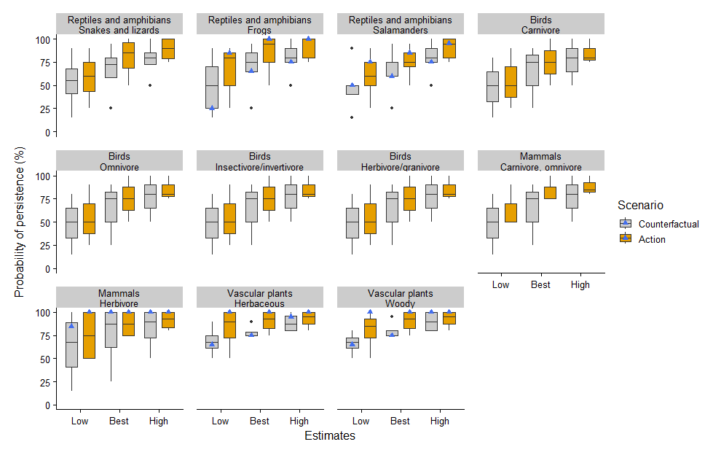

Figure 8. Boxplots summarizing the distribution of the lowest (Low), best guess (Best), and highest (High) expert estimates of the probability of persistence of representative biodiversity (*i.e.*, functional groups) in the coniferous forest ecotype, under the Counterfactual scenario and with the Action. Your individual estimates are shown as blue triangles.

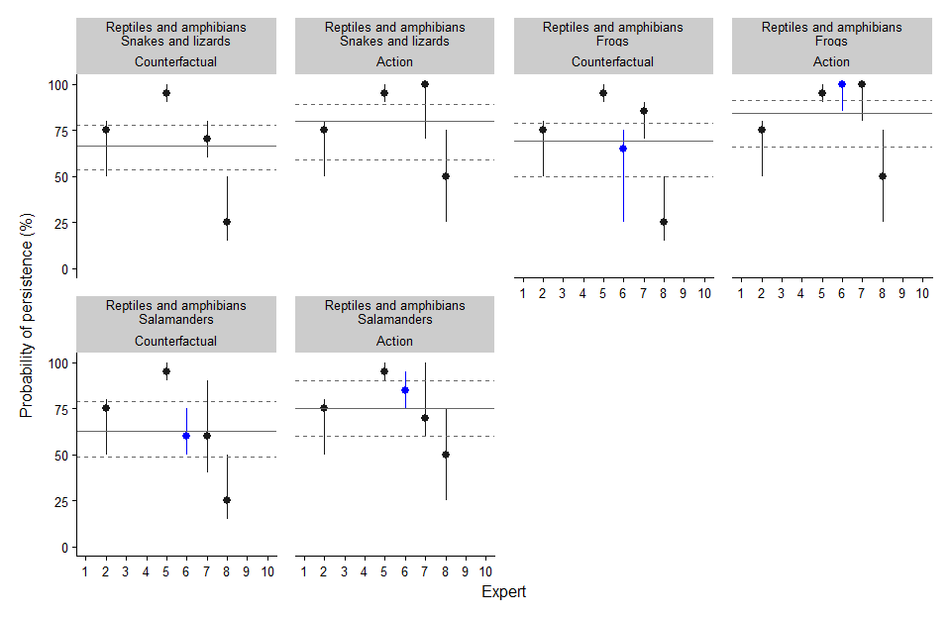

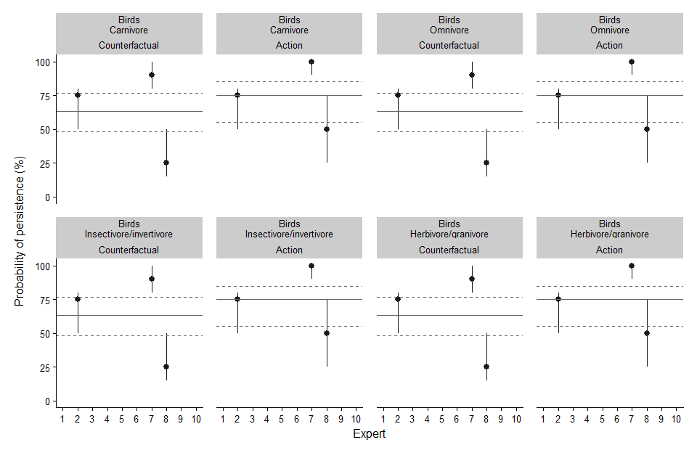

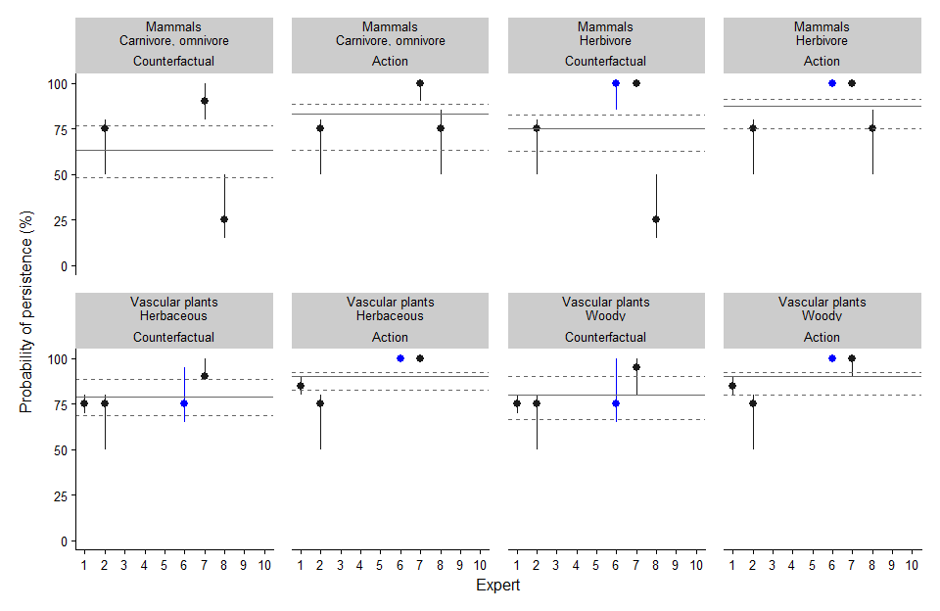

Figure 9. Individual expert estimates of the probability of persistence of representative biodiversity (*i.e.*, functional groups) in the coniferous forest ecotype, under the Counterfactual scenario and with the Action. Each point and range represents the estimates from one expert. Your individual estimates are plotted in blue. Horizontal lines indicate the mean estimate (solid line = Best Guess, dashed lines = Lowest and Highest estimate).

| **Coniferous Forest Biodiversity** | **Expert** | **Comments** |
| --- | --- | --- |
| Reptiles and amphibians Snakes and lizards | 2 | Unsure if there are any lizards or snakes that occupy this area. |
| 5 | I think this will have very little impact on overall reptile populations |
| 6 | do not know enough about their ecology to do any ratings |
| 7 | Reduced disturbance with project implmementation will likely have some positive effect on the persistence of this functional group in the study area. |
| 8 | I expect noise from offroad vehicles would be a disturbance for snakes, and a risk of mortality from snakes being run over by vehicles, but I don't know if significant numbers would be run over by vehicles. |
| Reptiles and amphibians Frogs | 2 | Upgrading crossing infrastructure will likely have litte impact on the amount of available habtiat for this functional group. External factors outside of this project are likely the dominant threat to persistence. |
| 5 | I think this will have very little impact on overall frog populations |
| 6 | Since this isn't their preferred habitat, have adjusted % downward as they will not do as well if it is unhealthy; they can /would likely persist because of the overall landscape suitability to come in from nearby areas regardless of the project |
| 7 | Reduced disturbance with project implmementation will likely have some positive effect on the persistence of this functional group in the study area. |
| 8 | I expect a risk of mortality from amphibians being run over by vehicles, but I don't know if significant numbers would be run over by vehicles. |
| Reptiles and amphibians Salamanders | 2 | Upgrading crossing infrastructure will likely have litte impact on the amount of available habtiat for this functional group. External factors outside of this project are likely the dominant threat to persistence. |
| 5 | I think this will have very little impact on overall salamander populations |
| 6 | assumes that compacted soils, bare soils and drying out of space as well as physically driving over them and altering predation /cover will change enough to be a benefit with the restoration but even without the project, they will persist some spots and recolonize from adjacent forest/ wetlands so some will persist; the stream itself isn't their primary habitat but the terrestrial areas and wetlands will be. |
| 7 | Not many reptiles, amphibians and salamanders occur in coniferous forests but they may disperse through this forest type. However, project implementation will likley have a positive effect on this species including in coniferous forest.. |
| 8 | I expect a risk of mortality from amphibians being run over by vehicles, but I don't know if significant numbers would be run over by vehicles. |
| Birds Carnivore | 2 | Upgrading crossing infrastructure will likely have litte impact on the amount of available habtiat for this functional group. External factors outside of this project are likely the dominant threat to persistence. |
| 6 | do not know enough about their ecology to do any ratings |
| 7 | Reduced disturbance with project implmementation will likely have some positive effect on the persistence of this functional group in the study area. |
| 8 | I'm not sure if relocating offroad vehicle trails will improve food resources but reduction in noise will probably be beneficial. |
| Birds Omnivore | 2 | Upgrading crossing infrastructure will likely have litte impact on the amount of available habtiat for this functional group. External factors outside of this project are likely the dominant threat to persistence. |
| 6 | do not know enough about their ecology to do any ratings |
| 7 | Reduced disturbance with project implmementation will likely have some positive effect on the persistence of this functional group in the study area. |
| 8 | I'm not sure if relocating offroad vehicle trails will improve food resources but reduction in noise will probably be beneficial. |
| Birds Insectivore/invertivore | 2 | Upgrading crossing infrastructure will likely have litte impact on the amount of available habtiat for this functional group. External factors outside of this project are likely the dominant threat to persistence. |
| 6 | do not know enough about their ecology to do any ratings |
| 7 | Bird occupancy can be reduced with noise disturbance therefore implementation of the project would increase the probability of persistence of this functional group in the study area. |
| 8 | I'm not sure if relocating offroad vehicle trails will improve food resources but reduction in noise will probably be beneficial. |
| Birds Herbivore/granivore | 2 | Upgrading crossing infrastructure will likely have litte impact on the amount of available habtiat for this functional group. External factors outside of this project are likely the dominant threat to persistence. |
| 6 | do not know enough about their ecology to do any ratings |
| 7 | Reduced disturbance with the implementation of the project will likely increase the probablity of persistence of this functional group |
| 8 | I'm not sure if relocating offroad vehicle trails will improve food resources but reduction in noise will probably be beneficial. |
| Mammals Carnivore, omnivore | 2 | Upgrading crossing infrastructure will likely have litte impact on the amount of available habtiat for this functional group. External factors outside of this project are likely the dominant threat to persistence. |
| 6 | do not know enough about their ecology to do any ratings |
| 7 | Reduced disturbance with the implementation of the project will likely increase the probablity of persistence of this functional group |
| 8 | I expect that carnivores and omnivores will be disturbed less after offroad vehicle activity has been relocated. |
| Mammals Herbivore | 2 | Upgrading crossing infrastructure will likely have litte impact on the amount of available habtiat for this functional group. External factors outside of this project are likely the dominant threat to persistence. |
| 6 | given the adequate amount of forest, the project likely will have limited impact on these species as they can move around the restoration or non-restored area, either way |
| 7 | These species are generally resilient to disturbance and will likely persist in the study area with the counterfactual scenario with little increase in persistence with project implementation. |
| 8 | I expect that herbivores will be disturbed less after offroad vehicle activity has been relocated. |
| Vascular plants Herbaceous | 1 | These communities are fairly robust and so can rebound from disturbance to some degree. However, I do believe the actions taken will be beneficial. |
| 2 | Upgrading crossing infrastructure will likely have litte impact on the amount of available habtiat for this functional group. External factors outside of this project are likely the dominant threat to persistence. |
| 6 | except for where this plant is destroyed/killed by the OHV use or prevented from growing in highly compacted soils, it is able to persist fairly well at least in part of the project area |
| 7 | Disturbance to these species is likely limited to trails in the study area therefore likely have a high likelihood of persistence in the couterfactual but will likely benefit from project implementation. |
| Vascular plants Woody | 1 | These communities are fairly robust and so can rebound from disturbance to some degree. However, I do believe the actions taken will be beneficial. |
| 2 | Upgrading crossing infrastructure will likely have litte impact on the amount of available habtiat for this functional group. External factors outside of this project are likely the dominant threat to persistence. |
| 6 | except for where this plant is destroyed/killed by the OHV use or prevented from growing in highly compacted soils, it is able to persist fairly well at least in part of the project area--some of these species will be more tolerant (spruce, poplars) than others (eg. birch) |
| 7 | Reduced disturbance with the implementation of the project will likely increase the probablity of persistence of the |

### Mixed Forest representative biodiversity (functional groups)

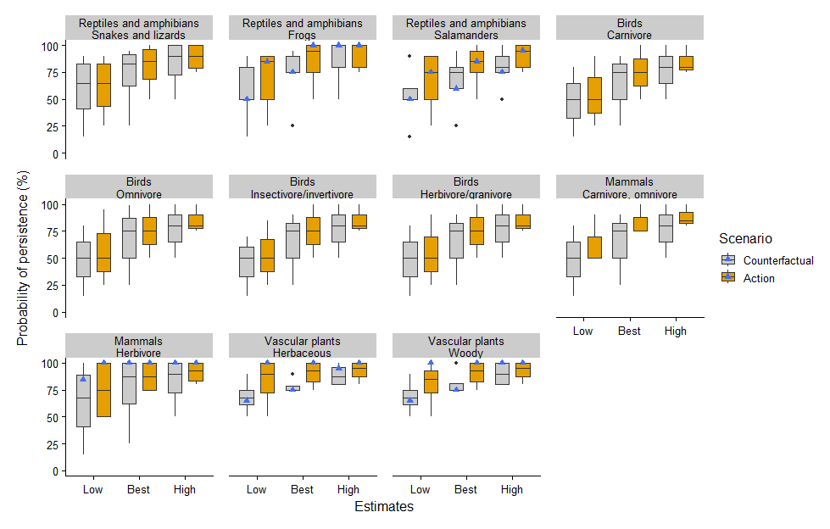

Figure 10. Boxplots summarizing the distribution of the lowest (Low), best guess (Best), and highest (High) expert estimates of the probability of persistence of representative biodiversity (*i.e.*, functional groups) in the mixed forest ecotype, under the Counterfactual scenario and with the Action. Your individual estimates are shown as blue triangles.

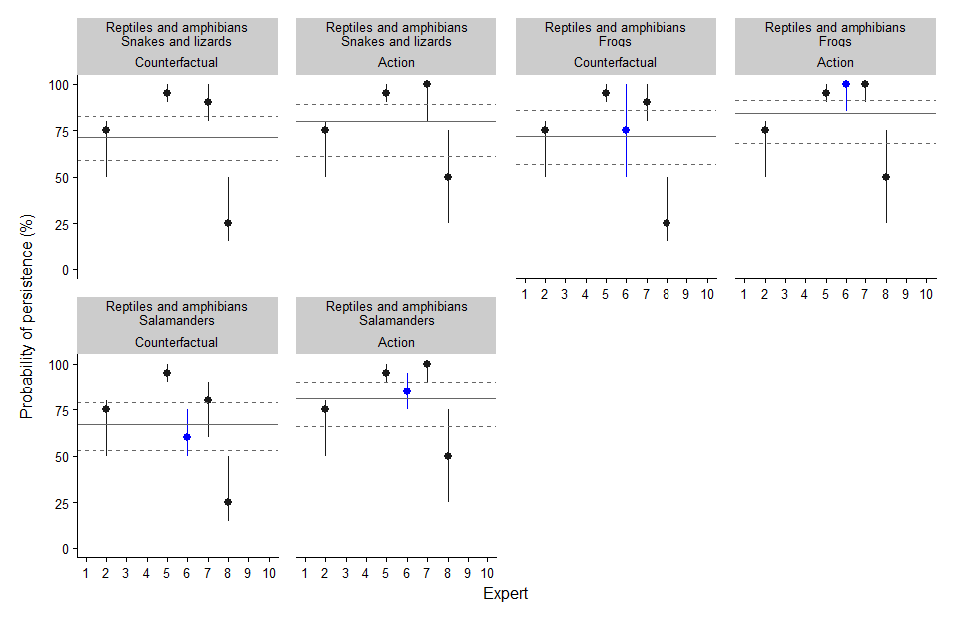

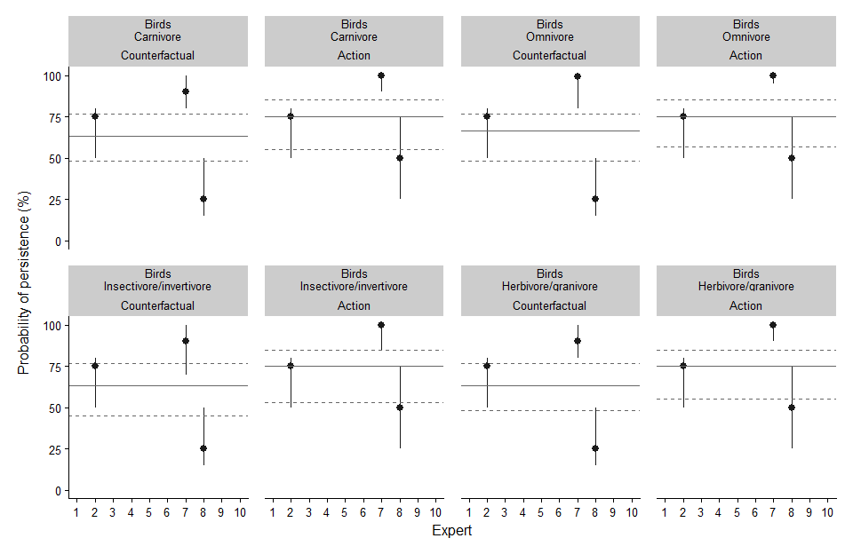

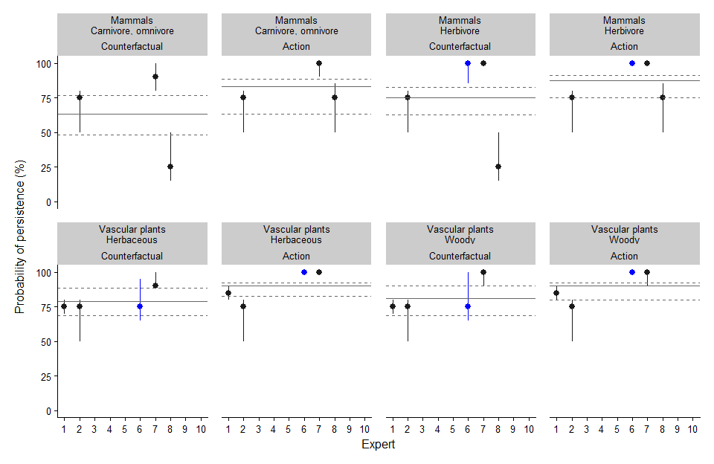

Figure 11. Individual expert estimates of the probability of persistence of representative biodiversity (*i.e.*, functional groups) in the mixed forest ecotype, under the Counterfactual scenario and with the Action. Each point and range represents the estimates from one expert. Your individual estimates are plotted in blue. Horizontal lines indicate the mean estimate (solid line = Best Guess, dashed lines = Lowest and Highest estimate).

| **Mixed Forest Biodiversity** | **Expert** | **Comments** |
| --- | --- | --- |
| Reptiles and amphibians Snakes and lizards | 2 | Unsure if there are any lizards or snakes that occupy this area. |
| 5 | I think this will have very little impact on overall reptile populations |
| 6 | do not know enough about their ecology to do any ratings |
| 7 | Low occurrence of mixed forest in the study area. Reduced disturbance with project implmementation will likely have some positive effect on the persistence of this functional group in the study area. |
| 8 | I expect noise from offroad vehicles would be a disturbance for snakes, and a risk of mortality from snakes being run over by vehicles, but I don't know if significant numbers would be run over by vehicles. |
| Reptiles and amphibians Frogs | 2 | Upgrading crossing infrastructure will likely have litte impact on the amount of available habtiat for this functional group. External factors outside of this project are likely the dominant threat to persistence. |
| 5 | I think this will have very little impact on overall frog populations |
| 6 | Given that they spend a lot of time in upland forest, they can /would likely persist because of the overall landscape suitability to come in from nearby areas regardless of the project |
| 7 | Low occurrence of mixed forest in the study area. Reduced disturbance with project implmementation will likely have some positive effect on the persistence of this functional group in the study area. |
| 8 | I expect a risk of mortality from amphibians being run over by vehicles, but I don't know if significant numbers would be run over by vehicles. |
| Reptiles and amphibians Salamanders | 2 | Upgrading crossing infrastructure will likely have litte impact on the amount of available habtiat for this functional group. External factors outside of this project are likely the dominant threat to persistence. |
| 5 | I think this will have very little impact on overall salamander populations |
| 6 | assumes that compacted soils, bare soils and drying out of space as well as physically driving over them and altering predation /cover will change enough to be a benefit with the restoration but even without the project, they will persist some spots and recolonize from adjacent forest/ wetlands so some will persist; the stream itself isn't their primary habitat but the terrestrial areas and wetlands will be. |
| 7 | Low occurrence of mixed forest in the study area. Reduced disturbance with project implmementation will likely have some positive effect on the persistence of this functional group in the study area. |
| 8 | I expect a risk of mortality from amphibians being run over by vehicles, but I don't know if significant numbers would be run over by vehicles. |
| Birds Carnivore | 2 | Upgrading crossing infrastructure will likely have litte impact on the amount of available habtiat for this functional group. External factors outside of this project are likely the dominant threat to persistence. |
| 6 | do not know enough about their ecology to do any ratings |
| 7 | Low occurrence of mixed forest in the study area. Reduced disturbance with project implmementation will likely have some positive effect on the persistence of this functional group in the study area. |
| 8 | I'm not sure if relocating offroad vehicle trails will improve food resources but reduction in noise will probably be beneficial. |
| Birds Omnivore | 2 | Upgrading crossing infrastructure will likely have litte impact on the amount of available habtiat for this functional group. External factors outside of this project are likely the dominant threat to persistence. |
| 6 | do not know enough about their ecology to do any ratings |
| 7 | Low occurrence of mixed forest in the study area. Reduced disturbance with project implmementation will likely have some positive effect on the persistence of this functional group in the study area. |
| 8 | I'm not sure if relocating offroad vehicle trails will improve food resources but reduction in noise will probably be beneficial. |
| Birds Insectivore/invertivore | 2 | Upgrading crossing infrastructure will likely have litte impact on the amount of available habtiat for this functional group. External factors outside of this project are likely the dominant threat to persistence. |
| 6 | do not know enough about their ecology to do any ratings |
| 7 | Bird occupancy can be reduced with noise disturbance therefore implementation of the project would increase the probability of persistence of this functional group in the study area. |
| 8 | I'm not sure if relocating offroad vehicle trails will improve food resources but reduction in noise will probably be beneficial. |
| Birds Herbivore/granivore | 2 | Upgrading crossing infrastructure will likely have litte impact on the amount of available habtiat for this functional group. External factors outside of this project are likely the dominant threat to persistence. |
| 6 | do not know enough about their ecology to do any ratings |
| 7 | Reduced disturbance with the implementation of the project will likely increase the probablity of persistence of this functional group |
| 8 | I'm not sure if relocating offroad vehicle trails will improve food resources but reduction in noise will probably be beneficial. |
| Mammals Carnivore, omnivore | 2 | Upgrading crossing infrastructure will likely have litte impact on the amount of available habtiat for this functional group. External factors outside of this project are likely the dominant threat to persistence. |
| 6 | do not know enough about their ecology to do any ratings |
| 7 | These species will benefit from educed disturbance with the implementation of the project will likely increase the probablity of persistence of this functional group |
| 8 | I expect that carnivores and omnivores will be disturbed less after offroad vehicle activity has been relocated. |
| Mammals Herbivore | 2 | Upgrading crossing infrastructure will likely have litte impact on the amount of available habtiat for this functional group. External factors outside of this project are likely the dominant threat to persistence. |
| 7 | These species are generally resilient to disturbance and will likely persist in the study area with the counterfactual scenario with little increase in persistence with project implementation. |
| 8 | I expect that herbivores will be disturbed less after offroad vehicle activity has been relocated. |
| Vascular plants Herbaceous | 1 | These communities are fairly robust and so can rebound from disturbance to some degree. However, I do believe the actions taken will be beneficial. |
| 2 | Upgrading crossing infrastructure will likely have litte impact on the amount of available habtiat for this functional group. External factors outside of this project are likely the dominant threat to persistence. |
| 7 | Disturbance to these species is likely limited to trails in the study area therefore likely have a high likelihood of persistence in the couterfactual but will likely benefit from project implementation. |
| Vascular plants Woody | 1 | These communities are fairly robust and so can rebound from disturbance to some degree. However, I do believe the actions taken will be beneficial. |
| 2 | Upgrading crossing infrastructure will likely have litte impact on the amount of available habtiat for this functional group. External factors outside of this project are likely the dominant threat to persistence. |
| 7 | Disturbance to these species is likely limited to trails in the study area therefore likely have a high likelihood of persistence in the couterfactual. |

### Ecotypes

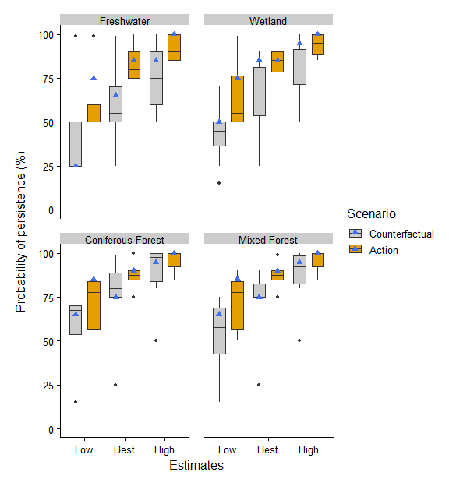

Figure 12. Boxplots summarizing the distribution of the lowest (Low), best guess (Best), and highest (High) expert estimates of the probability of persistence of the different ecotypes under the Counterfactual scenario and with the Action. Your individual estimates are shown as blue triangles.

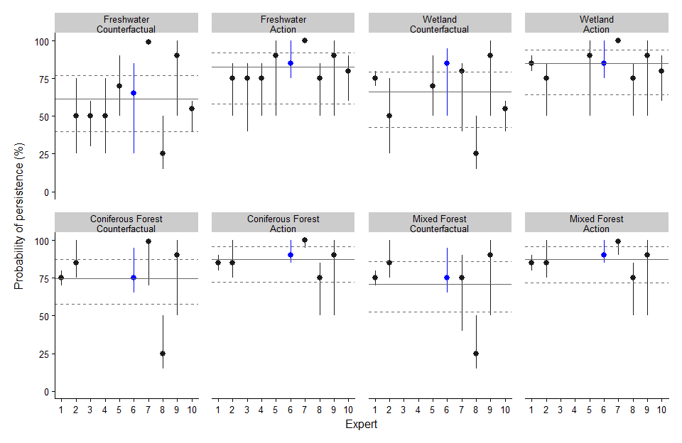

Figure 13. Individual expert estimates of the probability of persistence of the different ecotypes under the Counterfactual scenario and with the Action. Each point and range represents the estimates from one expert. Your individual estimates are plotted in blue. Horizontal lines indicate the mean estimate (solid line = Best Guess, dashed lines = Lowest and Highest estimate).

| **Ecotype** | **Expert** | **Comments** |
| --- | --- | --- |
| Freshwater | 2 | Assuming that OHV users use the new infrasturcture, the new crossings should result in improvements to the local and downstream freshwater habitat. |
| 4 | If the Bull Trout are lost, the functioning of this ecotype is lost. Bulls are the only fish here. |
| 5 | As it is the focus of the project I think the river will benefit most. As with my previous notes I think there are many variables that are not controllable. I think this project is a positive one, and one that I am supportive of but I am cautiously optimistic. |
| 6 | depending on how much damage has been done, it might be too late, or 20 years of recovery, after restoration may not be enough to ensure persistence of sufficiently good condition |
| 7 | Freshwater will continue to persist in the Mackenzie Creek drainage regardless of project implementation. However, the quality of the freshwater will improve with project implementation. |
| 8 | This ecotype is most likely to be negatively affected in the counterfactual scenario and benefit from the proposed action. |
| 9 | Freshwater ecotype - I am uncertain how changes to patterns of seasonal precipitation, snowfall accumulation, watershed storage over the next 20 years might result in changes to upper headwater systems and whether any of these would result in measurable change to the mapped area of freshwater ecotype present in the project area. |
| Wetland | 1 | These communities are fairly robust and so can rebound from disturbance to some degree. However, I do believe the actions taken will be beneficial. |
| 2 | Assuming that OHV users use the new infrasturcture, the new crossings should result in improvements to the local and downstream wetland habitat. |
| 5 | Wetlands should benefit from reduced turbidity. |
| 6 | depending on how much damage has been done, it might be too late, or 20 years of recovery, after restoration may not be enough to ensure persistence of sufficiently good condition |
| 7 | The distribution of wetlands in the project area is mostly along the creek as riparian vegetation. Wetlands will likely continue to persist regardless of project implementation; however, will likely become degraded without mitigation. Wetlands should continue to persist in good health with project implementation. |
| 8 | This ecotype might also be negatively affected in the counterfactual scenario and benefit from the proposed action. |
| 9 | Wetland ecotype - I am uncertain how changes to patterns of seasonal precipitation, snowfall accumulation, watershed storage over the next 20 years might result in changes to upper headwater systems and whether any of these would result in measurable change to the mapped area of wetland (riparian) ecotype present in the project area. |
| Coniferous Forest | 1 | These communities are fairly robust and so can rebound from disturbance to some degree. However, I do believe the actions taken will be beneficial. |
| 2 | I don't suspect updating crossing infrastrucure will have long-term impacts on this ecotype. |
| 5 | It seems unlikely to me that this project will have a decernable impact to these systems at this scale |
| 7 | Impacts of OHV use are likely mainly on existing trails but the counterfactual scenario will continue to degrade existing coniferous forests. Project implementation will result in peristence of coniferous forest in the project area. |
| 8 | Reducing offroad vehicle activity near the creek will probably reduce the probability of manmade fires started by poorly cleaned vehicles, along with the spread of invasive plant seeds carried into forest trails on ATVs. |
| 9 | Coniferous forest - I am uncertain how changes to patterns of seasonal precipitation, snowfall accumulation, fire disturbance may result in measurable effects to mapped area of coniferous forest ecotype. |
| Mixed Forest | 1 | These communities are fairly robust and so can rebound from disturbance to some degree. However, I do believe the actions taken will be beneficial. |
| 2 | I don't suspect updating crossing infrastrucure will have long-term impacts on this ecotype. |
| 5 | It seems unlikely to me that this project will have a decernable impact to these systems at this scale |
| 7 | Limited distribution of mixed forests in the project area. Unmitigated use of the existing trails and the creek bed by OHV traffic will degrade existing forest. Project implementation should ensure persistence of any existing mixed forest. |
| 8 | Reducing offroad vehicle activity near the creek will probably reduce the probability of manmade fires started by poorly cleaned vehicles, along with the spread of invasive plant seeds carried into forest trails on ATVs. |
| 9 | Mixed forest - I am uncertain how changes to patterns of seasonal precipitation, snowfall accumulation, fire disturbance may result in measurable effects to mapped area of mixed forest ecotype. |