Question: Do solar flares correlate to CME events

Test Method:

Evaluate occurrence count of solar flares and CME events over several months and determine if they have a linear relationship.

Result: Plot of the two datasets shows some relationship.

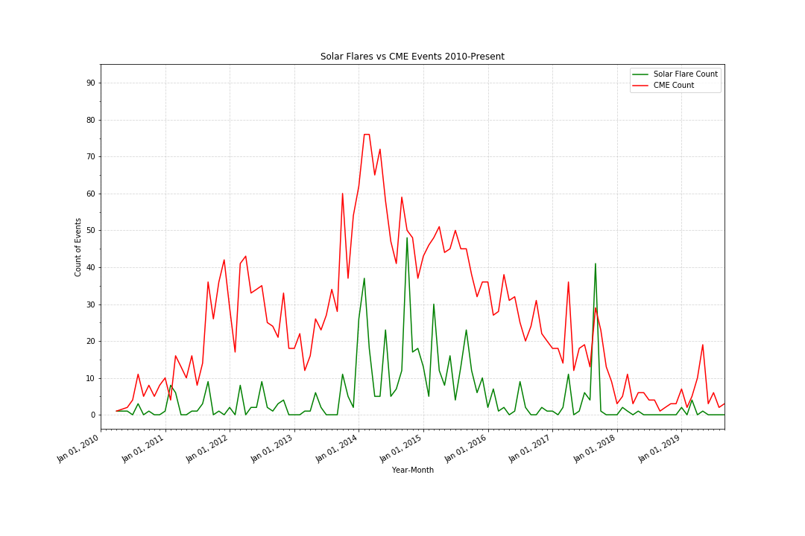

Question: Do solar flares power correlate to CME speed?

Test Method:

Find Flares and CMEs that were linked and compare Flare power to CME ejection speed.

Result:

With an r2 = 0.22 and p-test value of 2.9e-60, we can conclude that there is a relationship but, perhaps we are missing something because of the low correlation coefficient.

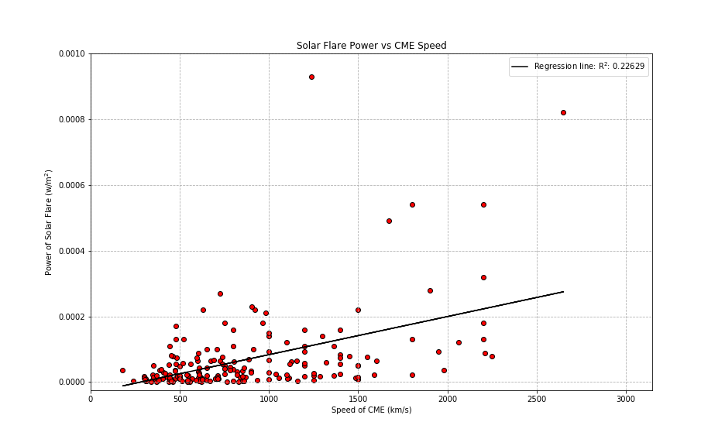

Question: If the sun has a cycle of 11 years, can we determine where we are in this cycle based on the trend of CME events?

Method: Evaluate occurrences of sunspots and CME events looking for correlation between number of occurrences.

Results:

There is a weak relationship between CMEs and sunspots with a R2= 0.60, but virtually no relationship with sunspots and solar flares with an R2=0.16.

