Project Plan

Mapbox New York Map

IS 217

Table of Contents
Introduction
Background
Software Requirements
Work Breakdown………………………………………………………………………...

Project purpose and goals:
Our project started as something simple yet functional we were able to use to use mapbox create an application to show many of point of interest in New York City. The app categorizes all POI in the city and color code the categories for ease of access. Basically what we would like to do is offer the user a way to filter and view search results. We used color code markers to show those results for ease of use. We were able to use Yelp’s API to show the reviews of the markers. This was a pretty difficult since we don’t have a programming background but finally after all the hard work we were able to pull it off. We did a lot of the markers manually and exported them from a CSV file that contains all the data.
- We used Mapbox framework to display the New York map.
- Mapbox API was used to create this application.
- It uses Google maps API.
- It uses yelp API to get the reviews and display them.
- It uses JSON to create the parameters of the makers that are display on the screen.

Background
Khaled and I have little to no programming experience. This is going to be our first full scale project using javascript. We are hoping for the best and know this is going to be a hard project to accomplish. Especially since we using mapbox which we have no clue how to use yet and mapbox itself is pretty extensive and complicated. Like previously stated we were able to incorporate Yelp’s API into this project and this is done to power the reviews. But our research has been incredible helpful and has allow us to complete the project in time.

Hardware and Software Requirements
The project uses the AFS server to run the application since this is a school project speed is not our top priority. GITHUB repository was created and used to post the final version of our project. Also Yelp API tutorial was also used to get a better understanding on how to implement this tool.

Work Breakdown
All of the coding was done by Khaled; he was able to take our idea and bring it to fruition. Khaled put a lot of research into this project and that allowed him to handle the technical side of it. Alex tried working on Yelp’s API but proved too much for him to handle. Alex’s role was to give ideas on what the final project might look like. He also provided all the data for the CSV file and the pictures that show up on the markers. Alex final role in this was to put the application live to show the final result.

Previous Versions:
This is a mockup from previous unreleased version of our application. We focused on the New York area; note how all the markers are the same colors.
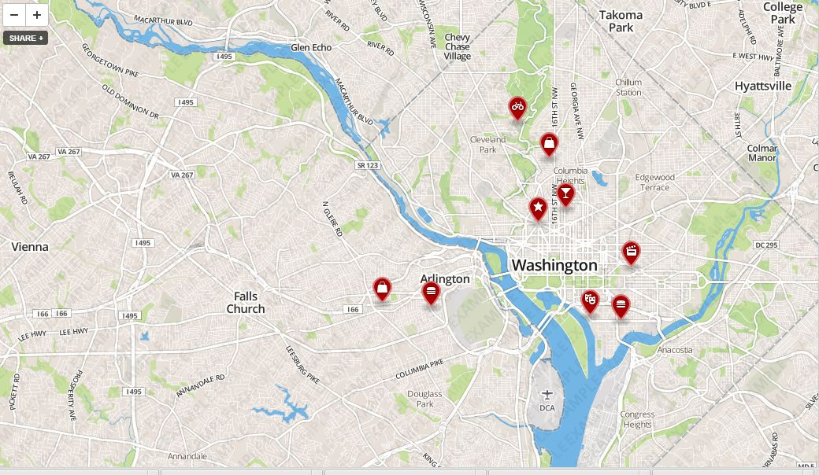

Markers pop ups note how the images aren’t display on this previous version.
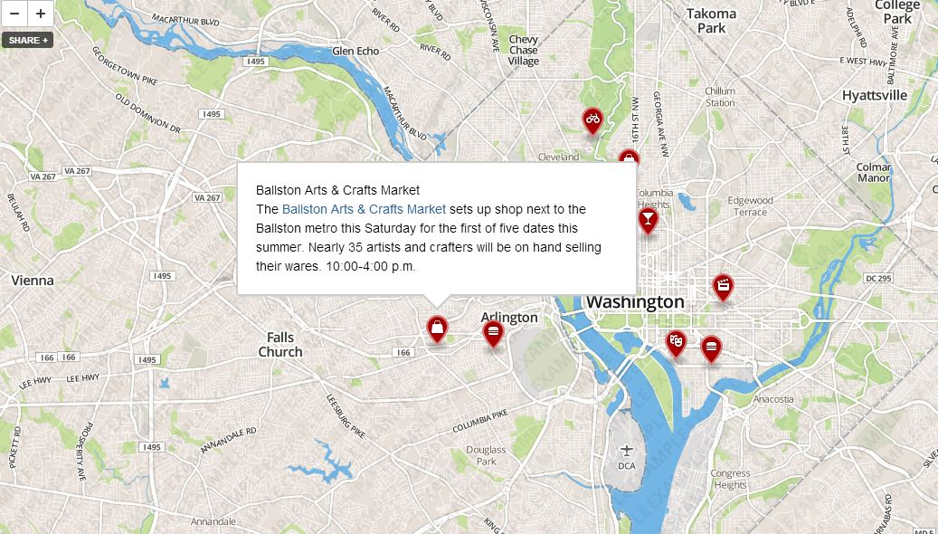
Final Version
This is the final stable version of our application note how all the markers are categorize and color code.
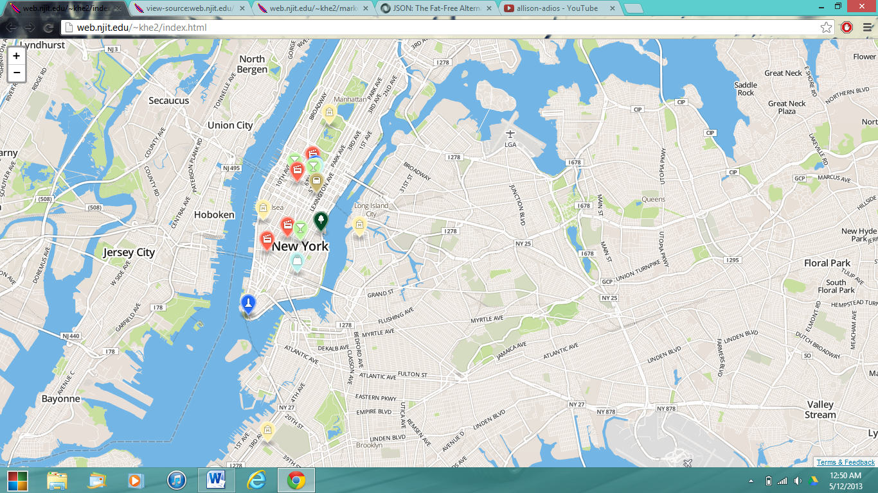
Screenshot of the pop up window
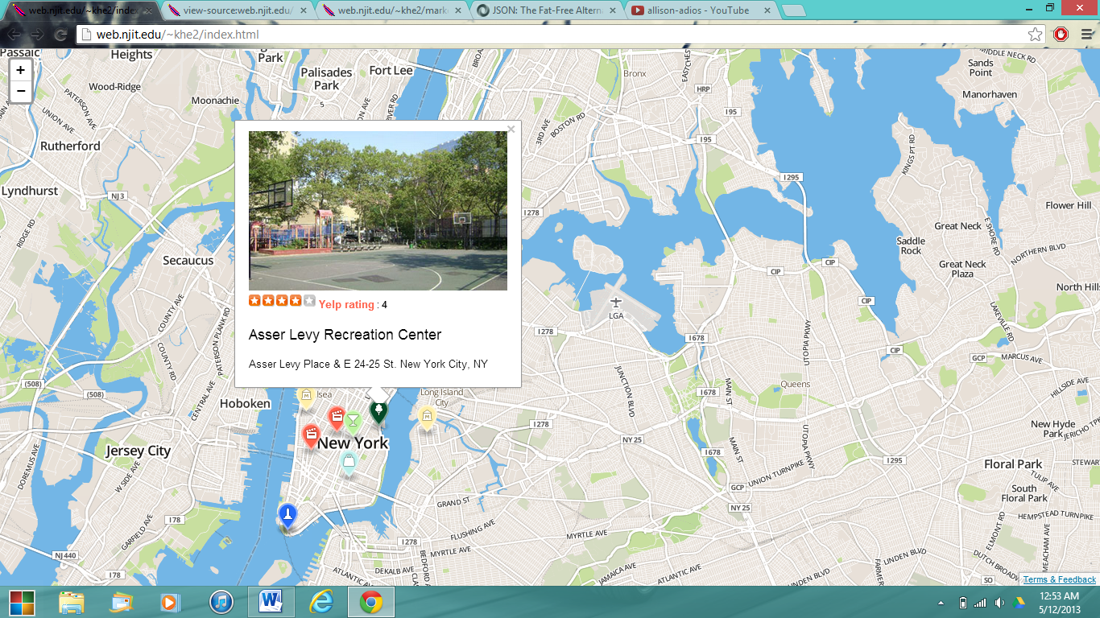
Yelp is used to show the reviews of the POI
Related Links:
http://web.njit.edu/~aed7/ny_map.html
https://github.com/aed7/Project-Mapbox

