Risks and Rewards: College Teams Investing During Volatile Market Conditions
Aedan Bingham & Alexander Smith

Abstract
The quantitative side of investing is well studied, with many recognizable phrases such as herding behavior and fear of missing out bias. Yet, few existing experiments look towards the qualitative side, digging into the why behind investing decisions. This paper puts a dent in that, describing that team-based investing is a process in which sequential and frequently subconscious checkpoints are reached before a buy or sell decision is made. Two factors make this particularly unique, (1) a period of heightened market volatility and (2) the study group consisting of college students. Under these conditions, the conclusions reached point towards teams with consistent investing principles and frequent communication resulting in higher returns.
Keywords: behavioral finance, experimental investing, group investment decision-making, behavioral biases, risk tolerance
JEL classification: G11, G41, D23, D81

- Introduction
In 2024 a study was conducted at Worcester Polytechnic Institute examining the financial competence of undergraduate students. The results were surprising, not only did students on average lack knowledge about the tax system and general savings practices, but there were also significant deficiencies in the area of investing. To give one example, only 11.1% of respondents knew what compound interest rate range would lead to a sum of money doubling in 25 years; on the flip side 48.8% of respondents thought that the interest rate was more than double the actual answer of 1.0281 [3]. This lack of knowledge has been examined at other universities and communities across the United States [4, 14].
With the increase in access to information over the last half-century, one would believe that the importance of investing in building wealth would be better understood. For example, it has been well established that investing over long periods of time in the U.S. market over the last century will bring about strong returns, as over the last 70 years the S&P 500 has averaged a yearly 10.5% (6.6% when adjusted for inflation), with the seasonal correction. For everyday people investing has become one of the most accessible tools in increasing one’s personal and generational wealth. Yet, for all the quantitative studies on a myriad of investor decisions and other factors, little qualitative work has been done. Qualitative, meaning sitting down and talking with the investors and asking them why they choose this over that rather than running regression analyses on their trades. Discussing with investors the why, how, when, and everything in between helps establish a better and more holistic understanding of what makes an investor act. What leads someone not to invest or progressively pushes them over that undefined ledge of action to invest, can be attributed to individual objectives, psychology, and many more unquantifiable factors.
- Literature Review / Background
Over many studies investors have been shown to be prone to many biases. Those such as loss aversion, overconfidence, mental accounting, anchoring, herd behavior, and information contagion are particularly notable [11, 13]. Quite importantly, these biases and heuristics are more likely to be exhibited when under conditions of uncertainty [11]. Barber & Odean [2] find that individual investors who trade most frequently measurably underperform the market, with excessive trading losses of 1-3% relative to the average investor. Specifically, while the market returned 17.9% from 1991 to 1996, households that traded most returned only 11.4% while the average household earned 16.4% [2]. The attention of these investors to news such as global events or business performance reports gives a reason for why trading spikes when it does. Da, Engelberg, & Gao [5] describe that frequently, increased attention via news pulls investors towards certain assets which produces strong short-term results due to overreaction, which increases stock-price pressure and overall reverse and underperform over the course of the year. Frequently, this leads to retail investors overpaying for attention-grabbing stocks and increasing volatility. This observation is especially relevant to this study. Also worth noting is that there exists extreme variation in individual investing behavior. The median investor spends only six minutes on research per trade ticker versus the mean spends half an hour. There are also similarities, such as overly focusing on large market share companies, investing based on recent news into more speculative stocks, or herding due to concentrated analyst reports [9].
Considering individual versus group decisions complicates the picture. Putting investors in a deliberating group doesn’t neutralize individual bias, rather it can lead investors to amplify support around an extreme idea one member is leaning towards [15, 16]. This initial leaning is a large predictor of how a team’s risk preferences will play out, as groups that are risk-adverse will become less risk prone while risk-prone groups will seek greater risk; early work by Stoner [12] and subsequent studies by Wallach, Kogan, and Bem [15, 16] discovered that group deliberation had the ability to produce systematic shifts in risk-taking. By sharing the risk of decision making across several group members, there is a diffusion-of-responsibility that often results in less strenuous analysis than an individual making the decision [15]. No evidence suggests that team deliberation changes individual’s initial risk profiles according to Ambrus, Greiner, & Pathak [1]. Rather through bargaining, compromise, and persuasion, “[…] group investment decisions are driven by individual preferences that are not the same as when people make individual choices in isolation” [10]. By only analyzing the outcomes of decisions, the divergence in individual preferences can be missed. No uniform evidence exists regarding risk and group decisions, however early works such as Nordhoy’s in 1962 find that group investing produces more restrained risk-taking [6].
To briefly summarize, individual investors have been found to be both overconfident and attention-driven [2, 5], while group deliberation reshapes rather than removes that bias which frequently depends on the group’s starting lean or a headstrong individual [10, 15, 16]. The uniqueness of this study relative to these previous findings is the interplay of individual bias, team deliberation, and intense real-world news attention all in an active volatile market window. The combination of qualitative interviews with quantitative account data makes this a rare insight into reasoning behind “the trade”.
- Methodology
The structure of the study was straightforward. There were three teams of investors, a beginner, intermediate, and expert team. Each team was given $500 to invest through Fidelity’s brokerage platform over the course of four months.
Individuals were recruited via promotional advertising at Worcester Polytechnic Institute’s Investing Club. This decision was made as people with baseline investing experience were wanted, as with the shorter time frame of the study there was less time to learn the basics. Too, the other reason to recruit individuals familiar with investing was to better reflect the real world as younger adults and especially college students have less experience and are more prone to high investment risk [7]. From there, applicants were selected via the quality of their application, skill level, and whether there was expressed desire to work with others. Collaboration was key, since investors were grouped into three skill levels based off of years of investing experience and self-reported knowledge (out of 10). Each team started with five members, but some teams lost a member or two due to a clearly defined lack of participation. Generally speaking:
- Beginner team: 3 people, 1-2 years of experience, reported knowledge 4-6
- Intermediate team: 4 people, 2-4 years of experience, reported knowledge 3-7
- Expert team: 4 people, 2-5+ years of experience, reported knowledge 4.5-8
Over the course of the study, which took place from January 2nd to May 2nd, 2026, three recorded “interview” sessions were conducted. The first session was in person during mid-January and was comprised of base questions about what their objectives, methods, and investing philosophies were. The second was conducted via an online survey in mid-March, involving in-depth questions which required the respondent to thoughtfully think through factors which went into their investing decisions. The third session happened in-person at the beginning of May, where questions were posed to help the teams reflect on their decision-making processes and overall experience investing collaboratively with others. Each session involved a parallel core set of questions which aimed at exploring risk tolerance, decision triggers, and team dynamics to measure changes over time.
Due to the nature of the study, various ethical considerations were at play. Proper usage of the brokerage account was of extreme sensitivity, due to the possibility that an investor would attempt to transfer funds from their team’s specified Fidelity account. Risk financial practices were also of concern and banned, such as shorting, margin trading, options, highly leveraged positions, and other such risky investments; such results would have been intriguing if these practices were allowed, yet this study did not have the resources to conduct this. Lastly, taxes had to be paid and reported on the income earned. Each of these considerations were understood and signed by each participant in the Financial Behavior document.
Throughout the study confidentiality was maintained and proper procedures were followed which were outlined and signed upon before the study began.
IRB approval was granted and both the investigator (Aedan Bingham) and supervisor (Alexander Smith, Ph.D.) are certified by the CITI Program in Human Subjects in Social & Behavioral Research as of July 2026.
- Overview
Each participant had a baseline level knowledge of finance and investing, while many had taken economics and/or finance courses in college. Investing philosophies and values differed across the board—some focusing on medium-to-long run semiconductors while others invested based on global news and trends. Nearly all participants noted that they kept track of the news, though with differing effects on their decisions. Teams were assembled by skill level and encouraged to collaborate. While each member had brokerage account access, teams reported only trading once consensus had been reached on a given asset. A few participants left the study, yet no significant conflicts arose within the teams. The major variables tracked focused on risk tolerance, asset allocation, investing philosophy, team dynamics, and market reaction, within a set of bounded parameters to keep the study focused. Specific participant- and team-level statistics can be found in the appendix.
As the reader may be wondering, the timeframe of this study—January 2nd to May 2nd, 2026—was a very volatile period for the market. This was primarily due to the war between Iran and the United States which closed the Strait of Hormuz, a major channel where around 20% of the world’s oil trade passes through. As a result energy prices rose, most significantly brent crude oil prices to over $117 per barrel in April, from $71 in February, which raised concerns of broader market impacts. An indicator of volatility levels, VIX peaked at an intraday high of 31.65 on March 27th, from a pre-war close of 19.86. The first half of the study saw negative returns across the teams, as the S&P 500 troughed at approximately -7.5% in late March (03/30/2026). While the second half saw intense growth to the cumulative tune of approximately +5.4% by May 2nd (note the NASDAQ 100 saw +15.9% growth over the same period). As will be seen, some took this as an opportunity while others shied away. The teams’ reactions to the uniqueness of this period proved to provide rich findings and results.
Market Performance Overlayed with Crude Brent Oil and Volatility Data
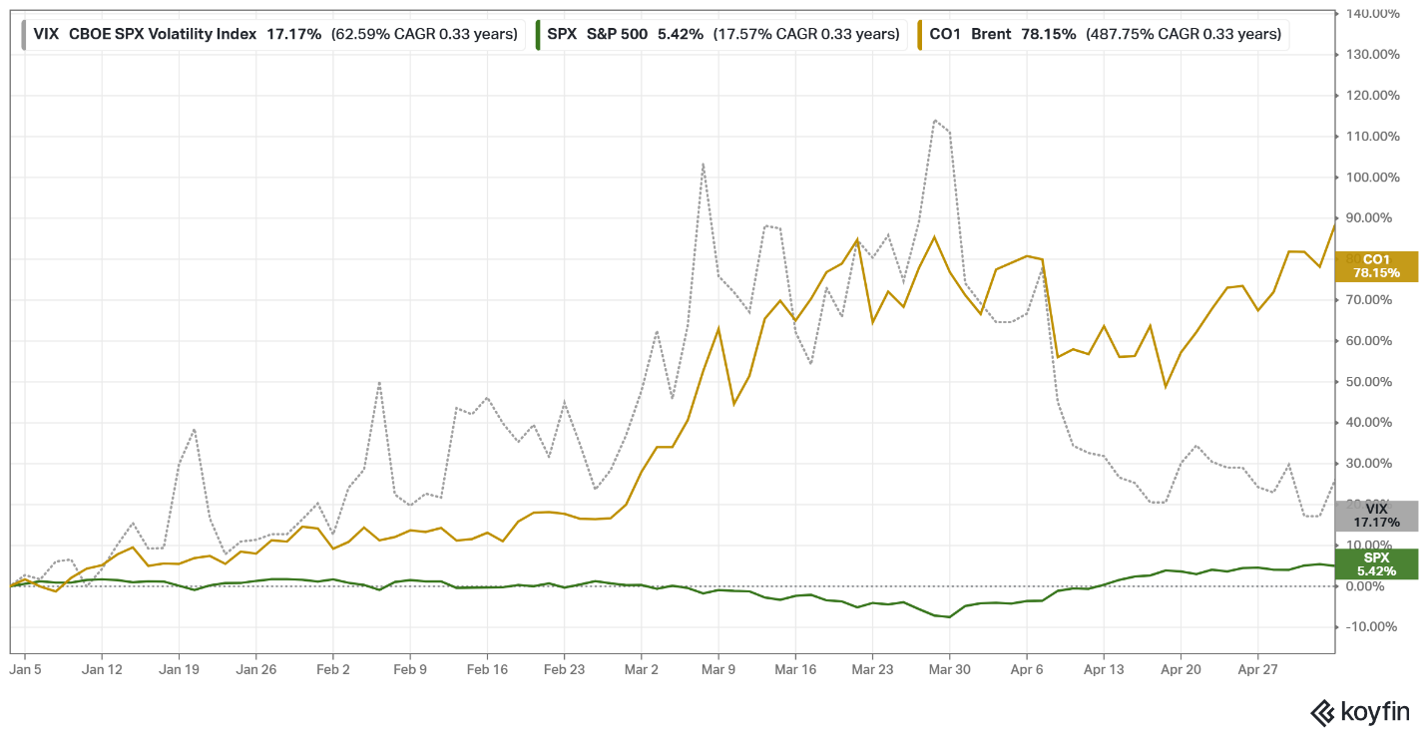
Shown above are the indicators for brent crude oil (CO1), the CBOE Volatility Index (VIX), and the S&P 500 (SPX). Overall, the market rebounded strongly during April. Note that brent crude oil prices see a reporting price variation of $±7.5\%$.
- Findings
With a four-month timeframe, the normal course of action for a financial advisor would be to focus on portfolio stability and suitability. This is frequently achieved through low-volatility and liquid instruments, such as money market or dividend focused stocks. Yet, no team took an approach that resembled the core functions and constraints of a financial advisor. And each team performed quite differently over the short period. Most notably, the intermediate team saw the largest cumulative gain of +43.0%, while the beginner team produced a small positive net change of +8.4% after shifting into defensive assets, and the expert team performed worst ending in the red at -14.5%. During the February and March market downturn, all teams were below their initial investment, but each team invested in the April rebound differently. What the intermediate team did differently was an increase in trade activity which enabled them to capture the April recovery, while the beginner and expert teams moved to safer assets, missing the majority of the rebound. Details for each team can be found in the results section, and detailed trading data in the appendix.
Team-based psychology played a major role in investing behavior. For each team the decision-making process was comprised of two stages. First, each individual would go out and use their own methods to find what they believed to be good investments. Then, they would bring their ideas back to the group and enter the second stage vetting process. Most interestingly, teams exhibited quite different approaches to validating investment ideas during the second stage. The intermediate group focused on rapid and reinforcement-based decisions. As one team member said, “When you bring up a stock and other people start agreeing with you, that is one of the strongest signs.” In contrast, the beginner team relied on cross-checking fundamentals and peer review to gain confidence in an investing decision. The expert team did the same as the beginner, only conducting more formal and rigorous analysis.
Each team and each participant was also asked if they felt their decisions were made with intuition, analysis, or both. The beginner group appeared concerned about the complexity of the market, heavily relying upon financial fundamentals and long-term investments requiring less expertise. A consequence of this was that the team could never pin down generalized investing rules to follow. They were split upon intuition vs analysis. One team member said that if intuition and analysis conflicted they would not invest, another said they only rely upon analysis as it “removes bias,” and the third said their intuition has to agree with their analysis for it to be a sound investment. The intermediate group had two members who believed in pure analysis and data while the other two believed in intuition: “I feel like this is more of a gut feeling than a clear line between not knowing enough and knowing enough.” The expert team had the most interesting responses to this concept. Early on they described themselves relying heavily on the analysis side, wanting “[…] multiple reasons to invest in a stock […].” Yet later in the study the team discussed how intuition is just as important. If it is a large investment or the team is split in their decision, the last step to greenlight a trade was that it had to agree with their intuition, or as one member said, they had to “feel good about it.”
Emotional sensitivity to losses was consistent throughout each team. Participant behavior agreed with literature around loss aversion, as the emotional magnitude of losses is greater than that of gains. During the market drop of February and March, participants reported how losses felt greater than gains which subsequently influenced their behavior. The impact of biases differentiate significantly by team. The expert team was more likely to step back and recognize their own biases, such as loss aversion and identifying how to minimize losses, via planning stop-sell orders. The less experienced teams reported mixed emotional reactions and were not able to identify behavioral biases they held. It must be noted that a major reason for each team taking higher levels of risk early in the study was due to the fact that the experimental funds were not “earned,” and thus there was a reduced perceived personal cost to losing money.
One of the most surprising results from this study was how the intermediate group blew the beginner and expert groups out of the water. The team’s +43.0% four-month cumulative gain can be substantially attributed to three identifiable factors: (1) The team had a collaborative dynamic and frequent communication which led to faster decision execution. (2) As a team, they were willing to take extensive short-term risk and not pull out during the market downturn. (3) Reliance on peer reinforcement coincided with the market’s rapid April rebound. These factors were directly associated with their success. Yet, as with all stock picking, “luck” was a notable factor and if experiments were repeated, vastly different results would unfold.
- Results
In the end, the intermediate team performed the best and the expert team the worst. While not fully explainable, several identifiable factors went into each team’s outcome.
Portfolio performance by team from January 2nd to May 2nd, including the low point of each account near the beginning of April. See the Tracking Trades part of the appendix for specific trades per team.
The most principal of these factors were team’s investing philosophy, collaboration, and ability to adapt to a rapidly changing market environment. Interestingly, the team that performed best defined clear objectives while keeping their investment approach malleable. In the end this team also saw the greatest displacement in collaboration, starting off the study as a dissociated group and ending with a well-oiled communication system. In the end, each team separately described how critical current events are to successful short-to-medium term investing. More importantly, everyone came away having learned other investors’ perspectives from team-based investing.

The beginner team achieved both of its primary goals: developing a better understanding of the market and avoiding a loss on its initial investment. The team began the study with a cautious approach, investing in S&P 500-tracking funds, including FXAIX and VOO. After these investments declined in value during the middle of the study, the team decided to reallocate its portfolio towards large-cap stocks and gold, which they viewed as safer opportunities in a volatile market. Following minimal additional trading, the team closed its account at $541.88, with an 8.38% gain on the initial $500 investment.
The team’s overall approach to investing was centered on steadily building wealth over the long term rather than focusing on short term returns. They favored diversification through ETFs and index funds, while also keeping in mind financial indicators such as earnings, growth, and price-to-earnings ratios when evaluating potential investments. Their investment ideas came from a combination of fundamentals analysis, news, and social media. However, the team did not develop a general market philosophy or specific investment strategy beyond general principles. This was reflected in their adaptive approach over the course of the study, as market conditions led them to adapt from broad index investments to large-cap stocks and gold.
The team generally collaborated throughout the study, sharing investment ideas and discussing alternative approaches before making decisions. They reported few disagreements and said working as a group made them more comfortable with their decisions due to other members’ cross-examination of each other’s reasoning. At the same time, they acknowledged that they did not devote as much time to the account as they would have wished, particularly when market conditions shifted.
At the end of the study the team reported that, if it were to be repeated, they would be more actively involved. Specifically, they would have traded more frequently, monitored the account more closely, and purchased a larger swath of equities. They also noted that the experience increased their attention to the role of news and external events in shaping investment outcomes. Overall, the team considered the experience successful, having improved their understanding of investing and ending up with a higher account value than what they started with.

The intermediate team entered the study with two clear goals in mind: to beat the S&P 500 and learn more about how other people think about investing. In pursuit of these, they adopted a highly thematic and risk-oriented approach, rotating through positions in nuclear energy, defense and space, mega-cap tech, gold, and bitcoin. They actively traded throughout the study, with monthly portfolio overhauls and a willingness to adapt when market conditions quickly changed. Literature says higher household portfolio turnover often equals lower returns [2], yet the intermediate group’s performance stands in the face of this. Although the team began with a relatively cautious mindset, their strategy became more aggressive over time, leading the team to ultimately finish with $714.78, a gain of 42.96% on the initial investment.
The team did not describe a single overarching philosophy beyond taking risk over the short duration of the study. Instead, their approach was shaped by current events, market trends, and a preference for assets that appeared to be timely or undervalued. Team members often emphasized that they did not like buying at “all-time highs,” and their monthly account turnovers reflected that instinct. When the market looked weak they shifted into safter assets and then shifted back into riskier ones when opportunities appeared near the market’s trough. The team’s strategy was less a predefined plan than a series of targeted responses to changing conditions, guided by a self-described “high risk, high reward” outlook.
Over the first few weeks of the study the team’s collaboration was low. Not everyone attended the first meeting, and the group initially lacked a strong shared dynamic or common mission. However, over time the members began meeting more consistently and communicating often via text which helped them become more comfortable working with one another. There were only minor disagreements around investment decisions, such as over penny stocks, and no major conflict developed. By the study’s midpoint the team felt more cohesive and better able to exchange ideas, with multiple members stating they had learned much from one another’s differing perspectives.
One of the clearest patterns that surfaced was the team’s reinforcement bias. When one member proposed a stock, agreement from the rest of the group frequently served as a signal of confidence. As one teammate said: “When you bring up a stock and other people start agreeing with you, that is one of the strongest signs.” That kind of mutual validation, unbeknownst to themselves or not, helped the team feel comfortable buying, especially when a trade already fit the broader market story in mind. Similarly, the group acknowledged that this process could encourage more risk-taking. At the end of the day, the team’s experience showed how quickly group agreement can strengthen conviction, shape trade decisions, and push investors toward a more aggressive stance than they might have taken alone.

The expert team began the study with a relatively optimistic outlook and the goal of growing their account to $600-$700 while also learning from one another’s thinking. Their early portfolio was built around diversified exposure, with precious metals such as GLD and SLV, broad market exposure through SPY, and a smaller position in FANG. Midway through the study, the team shifted towards a more defensive stance, exiting SPY and moving into XLU (utilities sector ETF) and SHY (1–3-year treasury bond ETF). The move, while reducing risk, also meant that the team missed much of the market rally that followed in April and they ended the study at $427.37, well below their initial investment.
The team described its investment philosophy as high-risk and long-duration, with decisions driven by current events, market trends, and company information. Their focus was more on individual opportunities than on broad sector performance, and several team members emphasized the importance of news, social context, and technical signals in identifying potential trades. As one member said, they looked at the “social situation” and “trends over time” before trading. At the same time another member stated their desire to stock pick: “I also plan to research mid-cap companies with strong growth potential—possible “next NVIDIA” or “next Tesla” candidates.” In practice, however, the team’s behavior was more cautious than its stated philosophy suggested. When volatility increased, the team responded defensively rather than treating it as an opportunity for doubling down on aggressive trading.
Communication was one of the team’s biggest weaknesses. Although members generally felt things were going well, they also noted that they did not meet or follow up as often as they should have, in part due to busy schedules and time-zone differences halfway through the study. Quite significantly, when one member with stronger investing experience appeared to take on a more central role, the other teammates took less ownership which resulted in a lack of timely execution. As one teammate said, the group knew they were more emotionally vulnerable to losses and needed to be “more analytical” to mitigate how much emotions affected them, while another noted that working with others helped them gain “more perspectives.” At the same time, the team acknowledged that the slower pace of interaction often made it harder to act quickly on market opportunities.
By the end of the study, team consensus was that the experience reinforced how important news and external conditions are for shorter-term investing. Several members said they would have benefited from more meeting times, quicker communication, and more disciplined use of risk-management tools such as stop-loss orders. The group also recognized that once it shifted into defensive assets, it was difficult to recover from earlier losses. Overall, the team’s results reflected a divergence from its ambitious risk-taking philosophy to more hesitant and reactive execution once the market became volatile.
- Conclusion
Studying investing behavior is not new, yet a qualitatively based approach on college students is. While such information is unquantifiable, when pairing it with investors’ quantitative trade data, participants’ investing process or lack thereof, becomes increasingly visible. This is not to say that one can put a pin on an investor and predict how they will behave. Rather, a qualitatively complimented approach provides much deeper insights into behavior.
There were substantial limitations to the study. Beyond the short four-month time horizon—which itself shifted investor’s focus from value investing towards short-term current events-based trading—it was also limited by a small sample size, constrained account features, and the use of non-personal experimental funds. Further research would benefit from the additional data around risk preferences and the use of a scale for risk-tolerance, such as Grable and Lytton’s [8]. Significant events that affected the market—such as the Iran War, as well as large capex spending in AI infrastructure development in the form of semiconductors and energy—confound the ability to distinctly link the performance of teams to psychology. The other major limitation was participant buy-in. Even though they received significant financial compensation, the investors often had little time to focus on the account, which could be amended by including an application filtering question about time commitments. What did work well were the in-person discussions, an increase in which would benefit future studies.
Overall, the results suggest that team structure, communication, as well as decision-making speed and dynamism directly affect short-term outcomes. Teams that create clear investing principles with malleable methods to implement those principles, who also incorporate frequent communication and responsive decision making, can balance both exposure to market growth and limit downturn risks. In non-finance speak, this means teams that decrease their exposure to volatility, $1.0≥β$, fail to capture the entire upside swings of the market. The intermediate group, who most closely took the aggressive growth-oriented approach, netted +43.0% growth from their initial investment. On the flip side, teams who lack frequent communication, avoid considerable external factors such as current events, or have a domineering team member see poorer short-term performance; these qualities originated in the beginner (+8.5%) and expert teams (-14.5%) who lost or made minimal gains on their initial investment. It must also be noted that no team took the core investing approach that would be expected of a financial advisor, who during a short timeframe would focus on portfolio stability and suitability.
The last element connecting the findings with the results is around how investors weight intuition and analysis when making decisions. A major motivation for this study was to determine the “click factor” behind investing decisions, yet as work on this paper continued it became apparent that for nearly all investors there is no one click moment or reason. Rather, it is a conscious and subconscious deliberation. Teams that had a mix of individuals that preferred intuition and others who preferred analysis saw the most success. This is most likely due to the ability to validate ideas from both (1) the hard analytics side and (2) intuition which only comes with developed experience. The team who changed this process—the expert team began as analytically minded and later switched to relying on intuition—saw the poorest performance. From this study it appears that team-based investing benefits most from the quality of consistency, in both communication and investing principles.
- References & Appendix
[1] Ambrus, Attila, Ben Greiner, and Parag A. Pathak. “How Individual Preferences Get Aggregated in Groups: An Experimental Study.” Journal of Public Economics 129 (2015): 1–13. https://doi.org/10.1016/j.jpubeco.2015.05.008.
[2] Barber, Brad M., and Terrance Odean. “Boys Will Be Boys: Gender, Overconfidence, and Common Stock Investment.” The Quarterly Journal of Economics 116, no. 1 (2001): 261–92. https://faculty.haas.berkeley.edu/odean/papers/gender/BoysWillBeBoys.pdf.
[3] Bingham, Aedan. 2025. “What WPI Students Know about Personal Finance.” Worcester Polytechnic Institute (WPI) - Department of Social Science & Policy Studies. https://papers.ssrn.com/sol3/papers.cfm?abstract_id=5245648.
[4] Chen, Haiyang, and Ronald P. Volpe. “An Analysis of Personal Financial Literacy Among College Students.” Financial Services Review 7, no. 2 (1998): 107–28. https://doi.org/10.1016/S1057-0810(99)80006-7.
[5] Da, Zhi, Joseph Engelberg, and Pengjie Gao. “In Search of Attention.” The Journal of Finance 66, no. 5 (2011): 1461–99. https://academicweb.nd.edu/~zda/Google.pdf.
[6] Eliaz, Kfir, Debraj Ray, and Ronny Razin. “Choice Shifts in Groups: A Decision-Theoretic Basis.” American Economic Review 96, no. 4 (2006): 1321–32. https://doi.org/10.1257/aer.96.4.1321.
[7] FINRA Investor Education Foundation. “New FINRA Foundation Research Examines Shifting Investor Behaviors, Preferences and Attitudes.” FINRA, December 4, 2025. https://www.finra.org/media-center/newsreleases/2025/new-finra-foundation-research-examines-shifting-investor-behaviors.
[8] Kuzniak, Stephen, Abed Rabbani, Wookjae Heo, Jorge Ruiz-Menjivar, and John Grable. “The Grable and Lytton Risk-Tolerance Scale: A 15-Year Retrospective.” Financial Services Review 24, no. 2 (2015): 177–92. https://doi.org/10.61190/fsr.v24i2.3240.
[9] Laarits, Toomas, and Jeffrey Wurgler. 2025. “THE RESEARCH BEHAVIOR OF INDIVIDUAL INVESTORS.” NBER WORKING PAPER SERIES 33625 (March). https://papers.ssrn.com/sol3/papers.cfm?abstract_id=5198972.
[10] Risky Investment Decisions: How Are Individuals Influenced by Their Groups?. W. Kip Viscusi, Owen R. Phillips, and Stephan Kroll. 2011. “Risky Investment Decisions: How Are Individuals Influenced by Their Groups?” Journal of Risk and Uncertainty 43: 81–106. https://doi.org/10.1007/s11166-011-9123-3.
[11] Sharma, Shubham, and Vinod Negi. “Effect of Behavioural Biases on Investors’ Decision Making: A Systematic Literature Review.” Metamorphosis: A Journal of Management Research 24, no. 1 (June 2025): 105–13. https://doi.org/10.1177/09726225251319119.
[12] Stoner, James A. F. A Comparison of Individual and Group Decisions Involving Risk. Cambridge, MA: Massachusetts Institute of Technology, 1961. https://www.researchgate.net/publication/279834356_A_Comparison_of_Individual_and_Group_Decisions_Involving_Risk.
[13] Taheri Hosseinkhani, Nima. “Behavioral Finance and Investor Psychology in Volatile Markets: Insights into Decision-Making, Biases, and Market Dynamics.” Preprint, October 2025. https://doi.org/10.2139/ssrn.5585212.
[14] TIAA Institute and Global Financial Literacy Excellence Center. “TIAA Institute–GFLEC Personal Finance (P-Fin) Index.” TIAA Institute. Accessed August 17, 2026. https://www.tiaa.org/public/institute/focus/personal-finance-index.
[15] Wallach, Michael A., Nathan Kogan, and Daryl J. Bem. “Diffusion of Responsibility and Level of Risk Taking in Groups.” Journal of Abnormal Psychology 68, no. 3 (1964): 263–74. https://doi.org/10.1037/h0042190.
[16] Wallach, Michael A., Nathan Kogan, and Daryl J. Bem. “Group Influence on Individual Risk Taking.” Journal of Abnormal and Social Psychology 65, no. 2 (1962): 75–86. https://doi.org/10.1037/h0044376.
Appendix:
Participant Stats

It must be noted that multiple individuals expressed their desire to work in a group with other students they knew. As a core tenant of this study was to promote collaboration in each team, such individuals were grouped together.

Tracking Trades

Note that this figure has different subtotals compared to the figure presented in the results section. This is due to rounding.
Supplementary Market Context
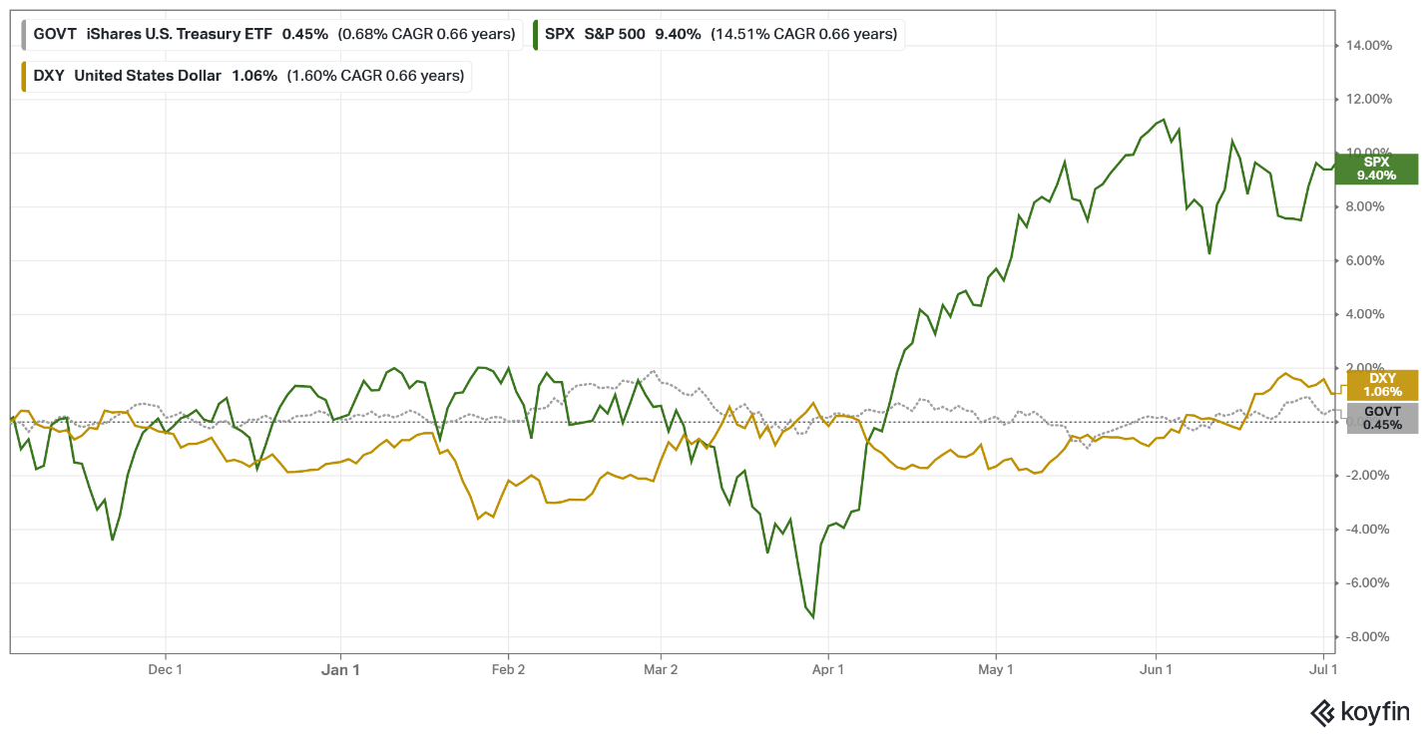This figure illustrates the performance of the S&P 500 relative to the U.S. Dollar and aggregate Treasuries (bills, notes, bonds), providing an extended macro perspective on market performance from November 2nd to July 2nd.
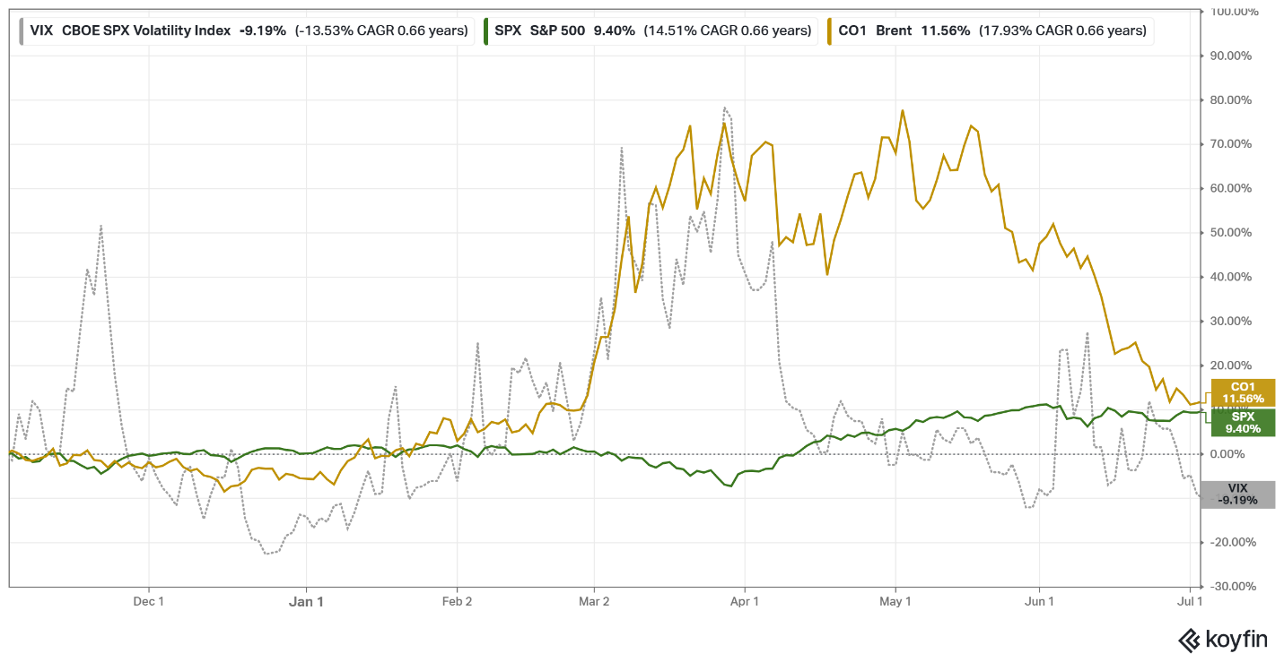Using the same indicators as the figure shown in the overview section—brent crude oil (CO1), the CBOE Volatility Index (VIX), and the S&P 500 (SPX)—though over November to July. This gives greater market context on the conditions before and after the study. From the beginning date of November 2nd, the S&P 500 was up +9.40%.

Table of Events
Date | Event
Jan 2, 2026 | Study period begins (S&P 500 close: 6,858.47)
Feb 28, 2026 | US and Israel launch surprise strikes on Iran ("Operation Epic Fury"), killing Supreme Leader Khamenei, marking the start of the war
Early March 2026 | Iran closes the Strait of Hormuz (~20% of global oil trade)
March 30, 2026 | Market trough: S&P 500 down ~-7.5% cumulative
March 31, 2026 | Rally begins
May 1–2, 2026 | Study period ends / market peak: S&P 500 +5.4%, Nasdaq 100 +15.9% cumulative



Author and 3rd year student at Worcester Polytechnic Institute (WPI).
Advisor and Professor in WPI’s Social Science and Policy Studies Department. 08/26/2026

