*Anjuman-I-Islam’s*

## M. H. SABOO SIDDIK COLLEGE OF ENGINEERING

8, Saboo Siddik Polytechnic Road, Byculla, Mumbai, Maharashtra 400008

**DEPARTMENT OF INFORMATION TECHNOLOGY**

**ITL702 Project for**

**Internet of Everything Lab**

REPORT

**Title of the Project**

# “ FIRE FIGHTING ROBOT ”

**Supervisor**

# PROF. SHRINIDHI GINDI

**REV - 2019 ‘C’ Scheme**



**University of Mumbai Academic Year (2024 -25)**

# CERTIFICATE

This is to certify that the project entitled “**Fire Fighting Robot** ” is a bona fide work of **“Ansari Jaffer (211405) ,Khan Ejaj (211416), Khan Imran (211417), Khan Talha (211419)"** submitted to the University of Mumbai in partial fulfilment of the requirement for the ITL702 Mini Project for Internet of Everything Lab of the 7th Semester in **Department of Information Technology**.

Prof. Shrinidhi Gindi Supervisor

# MINI PROJECT REPORT APPROVAL

This project report entitled “**Fire Fighting Robot**” by **“Ansari Jaffer (211405) ,Khan Ejaj (211416), Khan Imran (211417), Khan Talha (211419)”** is approved for the ITL702 Mini Project for Internet of Everything Lab project of the 7th Semester.

|  |
| --- |
| **Examiner 1 …………….**  **Examiner 2 ………………** |
| Date:  Place: Mumbai |

# DECLARATION

We declare that this written submission represents my ideas in our own words and where others' ideas or words have been included, We have adequately cited and referenced the original sources. We also declare that We have adhered to all principles of academic honesty and integrity and have not misrepresented or fabricated or falsified any idea/data/fact/source in our submission. We understand that any violation of the above will be cause for disciplinary action by the Institute and can also evoke penal action from the sources which have thus not been properly cited or from whom proper permission has not been taken when needed.

|  |  |  |
| --- | --- | --- |
| Name | Roll no. | Sign |
| **Ansari Jaffer** | **211405** | **………….** |
| **Khan Ejaj** | **211416** | **………….** |
| **Khan Imran** | **211417** | **………….** |
| **Khan Talha** | **211419** | **………….** |

Date:

Place: Mumbai

# ABSTRACT

The development of a firefighting robot equipped with advanced Internet of Things (IoT) capabilities. The robot is designed to autonomously navigate hazardous environments, detect and extinguish fires, and transmit real-time data to a cloud-based platform. By leveraging IoT technology, the robot can provide valuable insights into fire conditions, enabling remote monitoring and control. The robot incorporates various sensors, including temperature, smoke, and gas detectors, to assess the severity of the fire and guide its response. Furthermore, the cloud-based platform allows for data analysis, visualization, and the development of predictive models to enhance firefighting efficiency and safety. The project emphasizes enhancing fire response and minimizing risks through automation, instantaneous communication, and the potential for customization and expansion. This project contributes to the field of fire safety by integrating advanced technologies to create a dependable and self-directed system for fire detection, suppression, and real-time communication.

# TABLE OF CONTENT

|  |  |  |  |
| --- | --- | --- | --- |
| **1.** | **Introduction**............................................................................................................... | | 1 |
|  | **1.1** | Literature Survey.............................................................................................. | 3 |
|  | **1.2** | Problem Statement............................................................................................ | 5 |
|  | **1.3** | Objectives…………………………................................................................. | 5 |
|  | **1.4** | H/W and S/W Requirements …..................................................................... | 6 |
|  | **1.5** | Diagrams …………………………………………………………………….. | 7 |
| **2.** | **Methodology and Implementation**................................................................................ | | 9 |
| **3.** | **Result and Discussion ……………………………………………………………….** | | 12 |
| **4.** | **Conclusion ……………………………………………………………………………** | | 14 |
| **5.** | **Future Scope…………………………………………………………………………..** | | 15 |
| **6.** | **References……………………………………………………………………………...** | | 16 |

1. **INTRODUCTION**

The project that is being presented is focused on a firefighting robot. Robots are capable of performing tasks in a more efficient, cost-effective, and accurate manner than humans. It has grown in popularity as technology has advanced, making human work simpler. The firefighting robot is programmed to scan for and extinguish fires in affected areas. The consequences of fire cannot be prevented, and they can occur in both young, newly formed forests and mature natural forests. Fire has a focused impact on plant growth because it destroys undesirable vegetation, allowing other species to emerge. To occupy Gas sensor, tank which consists of water, wireless remote, wireless android device and Wi-Fi powered camera are all important components in the robot’s construction . A wireless robot can conduct successful work, allowing the robot to be operated from a distance . LTDAR is an algorithm developed ultraviolet radiation sensor to reliably find fire using a long wave flame sensor, and created for a mobile intelligent firefighting robot . The act of sprinkling water on a fire is known as firefighting. The robotic vehicle is equipped with water tanks and a pump that is operated by wireless communication . As a result of a fire outbreak (or) fire explosion, we are demanding that we use human resources that are not secure to put out the fire. It is very much possible to replace human work in putting out a fire in a dangerous environment by using higher technology, specifically robotics . This strategy would free firefighters from dangerous tasks, increase their efficiency, and reduce the number of fires. It will discourage human lives from being jeopardized. Forth is, we'll create an Arduino based firefighting robot that will detect the fire and it will begin to pump water on the fire detected area using sprinkler.

In recent years, there has been a growing need for effective fire-fighting solutions, particularly in areas where human intervention may be limited or hazardous. To address this challenge, we have developed an Arduino-based fire-fighting robot equipped with SMS alert capabilities. This innovative robot combines the power of Arduino microcontrollers, sensors, and mobile communication technology to autonomously detect and extinguish fires while alerting authorities or users via SMS.

Key Features:

Arduino Microcontroller: The brain of the robot is powered by Arduino, providing a flexible and programmable platform for controlling its actions and responses.

Fire Detection Sensors: Utilizing flame sensor, the robot can swiftly detect the presence of flames or sudden temperature rises in its vicinity.

Mobile Communication Module: Integrated with a GSM/GPRS module, the robot can send real-time SMS alerts to predefined phone numbers, notifying authorities or users about the fire incident.

Autonomous Navigation: Equipped with motor drivers and sensors like ultrasonic or infrared, the robot can navigate through environments autonomously, ensuring efficient coverage of the area.

Fire Suppression Mechanism: The robot is equipped with a fire extinguishing system, such as a water pump or a fire retardant dispenser, to suppress flames upon detection.

Remote Control Capability: In addition to autonomous operation, the robot can also be remotely controlled by users or emergency responders via wireless communication protocols like Bluetooth or Wi-Fi.

Application Scenarios:

Industrial Facilities: Deployed in factories or warehouses where fire hazards are prevalent, the robot can patrol the premises and respond to fire outbreaks promptly.

Residential Buildings: Installed in homes or apartment complexes, the robot can serve as an additional layer of fire protection, especially in unoccupied areas or during nighttime.

Wildfire Monitoring: In remote or forested areas prone to wildfires, the robot can autonomously traverse the terrain, detect fires, and alert authorities for timely intervention.

With its advanced features and versatile applications, the Arduino-based fire-fighting robot with SMS alert offers a proactive and reliable solution for fire prevention and mitigation in various environments.

# LITERATURE SURVEY

1. Tawfiqur Rakib, M. A. Rashid Sarkar proposed a fire fighting robot model which consists of a base platform made up of ‘Kerosene wood’, LM35 sensor for temperature detection, flame sensors to detect the fire and a water container of 1 litre capacity which is made up of a strong cardboard that makes it water resistant. The robot has two wheels for its movement. [1]
2. Saravanan P. ,Soni Ishawarya proposed a model which uses Atmega2560 micro-controller and in which the robot is divided into three basic units according to their functions which are as locomotive unit, fire detecting unit and extinguishing unit.Each unit performs their task in order to achieve the desired output of extinguishing fire.The locomotive unit is used for the movement of the robot and to avoid the obstacles with the help of four IR and four ultrasonic sensors.The fire detecting unit is used to detect fire using LDR and temperature sensor. The extinguishing unit is used to extinguish the fire using water container and BLDC motor.The robot also have a bluetooth module that is connected with the smartphones in order to navigate it in the proper direction. [2]
3. S. Jakthi Priyanka,R. Sangeetha proposed an android controlled fire fighting robot which uses Arduino UNO R3. The robot consists of gas sensor for fire detection, gear motor and motor drive for the movement of robot, a bluetooth module to connect the robot with the android device and to control the robot with the smartphone as well. Water pump and sprinkler is also used in this. To instruct the Arduino UNO an open source software which is Arduino IDE is required to code and to implement that code in Arduino UNO. [3]
4. Nagesh MS, Deepika T V , Stafford Michahial, Dr M Shivakumar proposed a fire extinguishing robot which employs DTMF (Dual Tone Multi Frequency Tones) technology for the navigation of the robot and uses a flame sensor for fire detection that is capable of sensing flame of the wavelength range 760 to 1100 nm and sensitivity varies from 10cm to 1.5feet. [4]
5. Sushrut Khajuria, Rakesh Johar, Varenyam Sharma, Abhideep Bhatti proposed an arduino based fire fighter robot which consists of RF based remote operation to operate the robot and water pump.The robot is controlled by the user within a range of 7 metres.It also consists of a wireless camera which helps user to move the robot in the required direction.[5]
6. Khaled Sailan, Prof. Dr.-Ing. Klaus-Dieter Kuhnert, Simon Hardt proposed an obstacle avoidance robot named as Amphibious Autonomous Vehicle. In this robot, a fuzzy controller is used to avoid static obstacle in real time.It aims to guide the robot or vehicle along its path avoiding all the obstacle that comes along the path.[6]

**On comparison with all above mentioned literature survey , our project differs with the following details ,**

The fire-fighting robot with SMS alert operates through the following steps:

1. Continuous Monitoring: Fire sensors detect changes in temperature or smoke levels, allowing the robot

to monitor the environment for fires.

1. Fire Detection and Localization: The Arduino Uno processes sensor data to identify the presence and location of fires, determining the robot's target.
2. Navigation and Movement Control: Motor drivers enable precise movement control, allowing the robot to navigate obstacles and reach the fire location.

The fire-fighting robot with SMS alert offers an efficient and proactive solution for fire safety in indoor environments. Its autonomous capabilities, combined with real-time communication through SMS alerts, enhance response time and effectiveness in fire detection and suppression, contributing to overall fire emergency management.

# PROBLEM STATEMENT

A fire fighter's work entails detecting and extinguishing fires. In this rapidly evolving technological age, the world is gradually moving toward automated systems. Firefighters, on the other hand, are often in danger of losing their lives. The majority of the deaths were caused by toxic gases found in the firefighting environment. As a result, in order to resolve these issues, our system was developed.

# OBJECTIVES

1. Develop an autonomous fire-fighting robot for indoor environments.
2. Implement a fire suppression mechanism for efficient extinguishing.
3. Integrate a GSM module for real-time SMS alerts.
4. Enhance fire safety and response efficiency through automation.
5. Utilize Arduino Uno for control and programming flexibility.
6. Allow customization and future expansion.

# HARDWARE AND SOFTWARE REQUIREMENTS

1. Arduino Uno: The Arduino Uno serves as the central control unit for the fire-fighting robot. It provides the necessary processing power and I/O capabilities for controlling the robot's functionalities.
2. Fire Sensors: Fire sensors are essential for detecting the presence of fires. Common types of fire sensors include temperature sensors, smoke detectors, or gas sensors. Choose sensors based on their sensitivity, accuracy, and compatibility with the Arduino Uno.
3. Motor Drivers: Motor drivers are used to control the movement of the robot. They interface between the Arduino Uno and the motors, enabling precise control of the robot's navigation. Select motor drivers that are suitable for the type and specifications of the motors used in the robot.
4. Motors and Wheels: The robot requires motors and wheels for movement. The choice of motors and wheels will depend on factors such as the size of the robot, the weight it needs to carry, and the terrain it will operate on.
5. Water Sprinkler or Extinguishing Mechanism: A water sprinkler or an extinguishing mechanism is needed for fire suppression. The specific mechanism can vary depending on the requirements and the size of the firefighting robot. Ensure that the mechanism is compatible with the Arduino Uno and can be controlled effectively.
6. GSM Module: The GSM module enables the robot to send real-time SMS alerts. Choose a GSM module that is compatible with the Arduino Uno and supports the necessary communication protocols. Consider factors such as network coverage and SIM card requirements.
7. Power Supply: A suitable power supply is essential to provide the necessary voltage and current for the Arduino Uno, motors, sensors, and other components. Select a power supply that can meet the power requirements of the entire system.

**Specifications:**

1. Arduino Uno: Microcontroller board with sufficient I/O pins, compatible with Arduino programming language and IDE.
2. Fire Sensors: High sensitivity to detect fires, capable of reliable and accurate fire detection in indoor environments.
3. GSM Module: GSM module with support for SMS communication, compatible with the Arduino Uno and capable of sending real-time alerts to designated phone numbers.

# DIAGRAMS

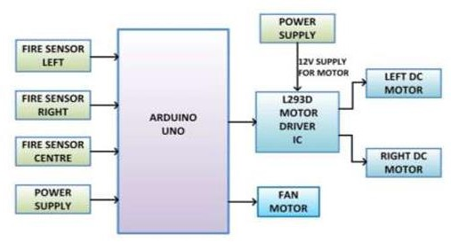

Fig 1.1 Block Diagram of Fire Fighting Robot Using Ardunio

## Cost Estimation :-

For an Arduino-based fire-fighting robot with SMS alert, we need to consider several factors such as the components required, their prices, and any additional expenses like shipping or taxes. Here's a breakdown of the components you might need along with approximate prices:

Arduino Board: ₹500 - ₹1000 Motor Driver: ₹200 - ₹500

DC Motors (with wheels): ₹400 - ₹800 (per motor, depending on quality and torque) Node MCU :- ₹140

Temperature Sensor (for fire detection): ₹100 - ₹300 GSM Module (for SMS alert): ₹500 - ₹1000

Power Supply (Battery, Charger): ₹500 - ₹1500 Wiring, Connectors, and Miscellaneous: ₹300 - ₹500 Total Estimated Cost Range: ₹1500 - ₹2000

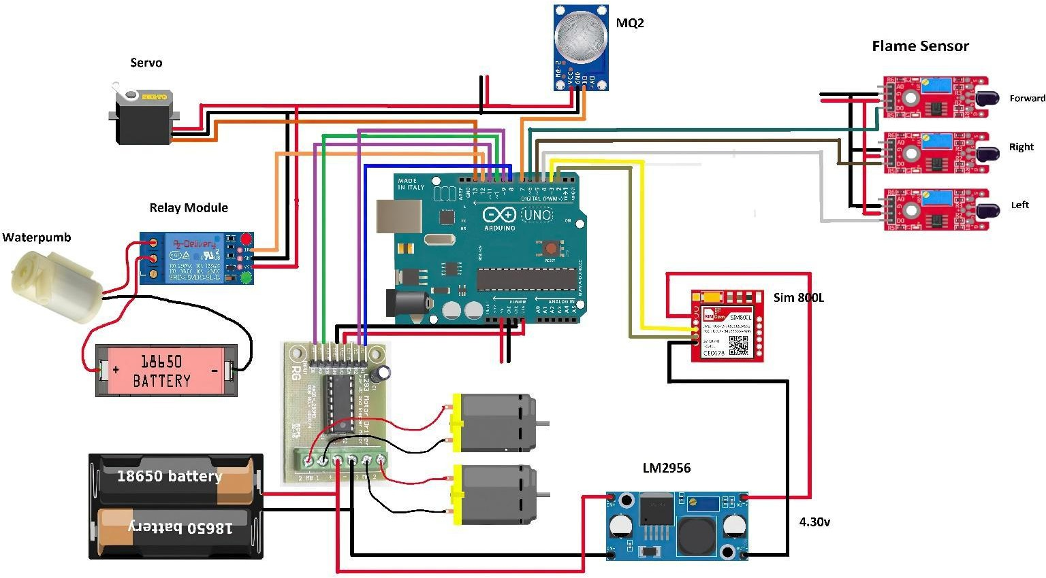

Fig 1.2 Circuit Diagram of Fire Fighting Robot Using Ardunio

# IMPLEMENTATION

## Source Code :-

#include <Servo.h> //include servo.h library #include <SoftwareSerial.h> //include SoftwareSerial.h library

Servo myservo; int pos = 0;

boolean fire = false;

const String PHONE = "+91**********"; //use your number with country code #define rxPin 2

#define txPin 3

SoftwareSerial sim800L(rxPin,txPin); #define Left 4 // left sensor

#define Right 5 // right sensor #define Forward 6 //front sensor #define GAS_SENSOR 7 //Gas sensor #define LM1 8 // left motor

#define LM2 9 // left motor

#define RM1 10 // right motor

#define RM2 11 // right motor

#define pump 12 //water pumb

void setup()

{

Serial.begin(115200); sim800L.begin(9600);

sim800L.println("AT"); delay(1000); sim800L.println("AT+CMGF=1"); delay(1000);

pinMode(Left, INPUT); pinMode(Right, INPUT); pinMode(Forward, INPUT); pinMode(GAS_SENSOR, INPUT); pinMode(LM1, OUTPUT); pinMode(LM2, OUTPUT); pinMode(RM1, OUTPUT); pinMode(RM2, OUTPUT); pinMode(pump, OUTPUT);

myservo.attach(13); myservo.write(90);

while(sim800L.available()){ Serial.println(sim800L.readString());

}

}

void put_off_fire()

{

digitalWrite(LM1, HIGH); digitalWrite(LM2, HIGH); digitalWrite(RM1, HIGH); digitalWrite(RM2, HIGH); digitalWrite(pump,HIGH); delay(500);

for (pos = 50; pos <= 110; pos += 1) { myservo.write(pos);

delay(10);

}

for (pos = 110; pos >= 50; pos -= 1) { myservo.write(pos);

delay(10);

}

digitalWrite(pump,LOW); myservo.write(90); fire=false;

}

void loop()

{

myservo.write(90); //Sweep_Servo();

if (digitalRead(Left) ==1 && digitalRead(Right)==1 && digitalRead(Forward) ==1)

{

delay(500); digitalWrite(LM1, HIGH); digitalWrite(LM2, HIGH); digitalWrite(RM1, HIGH); digitalWrite(RM2, HIGH);

}

else if (digitalRead(Forward) ==0)

{

digitalWrite(LM1, HIGH); digitalWrite(LM2, LOW); digitalWrite(RM1, HIGH); digitalWrite(RM2, LOW); fire = true;

}

else if (digitalRead(Left) ==0)

{

digitalWrite(LM1, HIGH); digitalWrite(LM2, LOW); digitalWrite(RM1, HIGH); digitalWrite(RM2, HIGH);

}

else if (digitalRead(Right) ==0)

{

digitalWrite(LM1, HIGH); digitalWrite(LM2, HIGH); digitalWrite(RM1, HIGH); digitalWrite(RM2, LOW);

}

delay(400);//change this value to change the distance

if(digitalRead(GAS_SENSOR)== 0)

{

Serial.println("Gas is Detected."); send_sms();

}

while (fire == true)

{

put_off_fire(); Serial.println("Fire Detected."); make_call();

}}

void make_call()

{

Serial.println("calling. ");

sim800L.println("ATD"+PHONE+";"); delay(20000); //20 sec delay sim800L.println("ATH"); delay(1000); //1 sec delay

}

void send_sms()

{

Serial.println("sending sms. ");

delay(50); sim800L.print("AT+CMGF=1\r"); delay(1000);

sim800L.print("AT+CMGS=\""+PHONE+"\"\r");

delay(1000); sim800L.print("Gas Detected"); delay(100); sim800L.write(0x1A); delay(5000);

}

# Result and Discussion

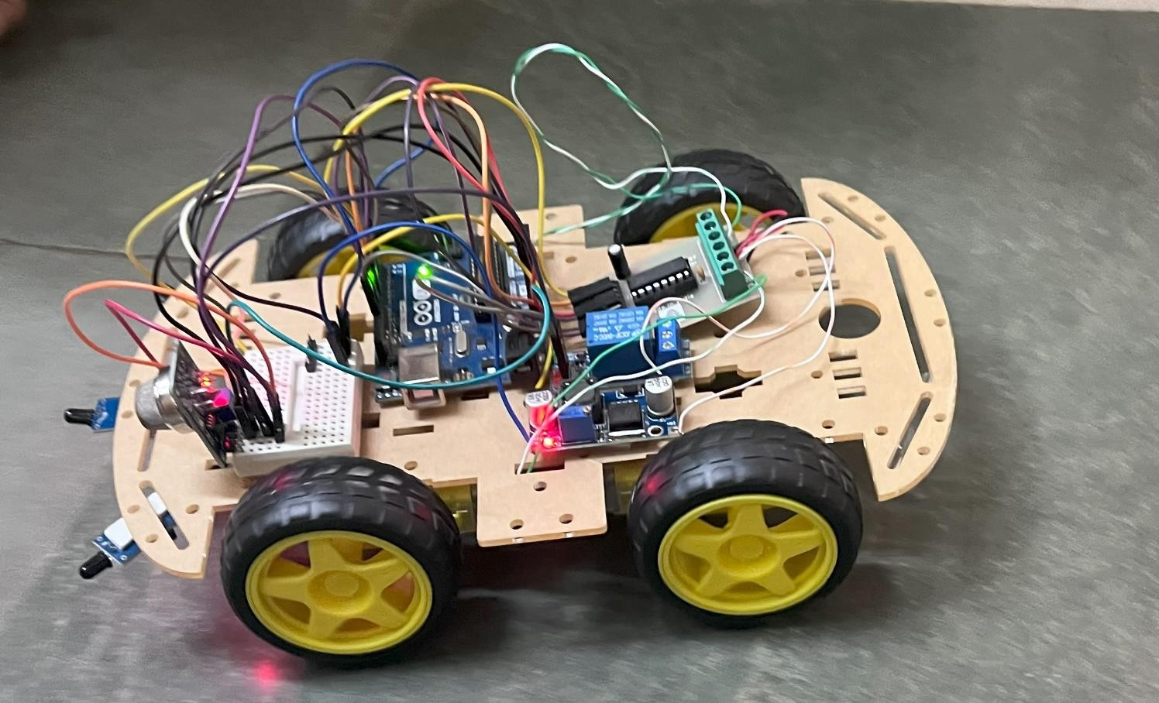

Fig. 3.1 Connections of Model

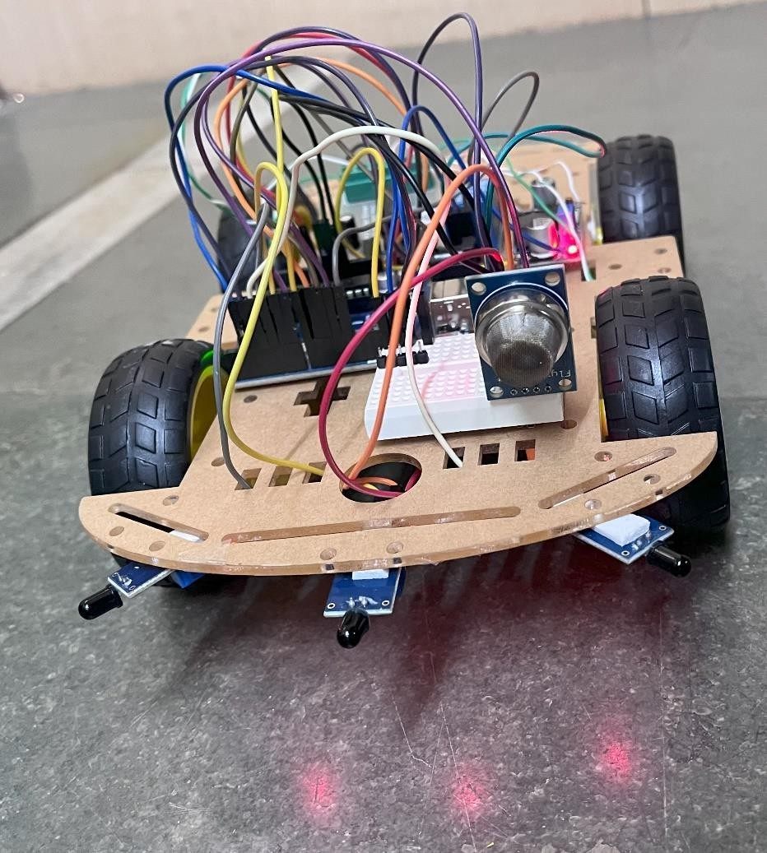

Fig. 3.2 Model is Successfully Operating

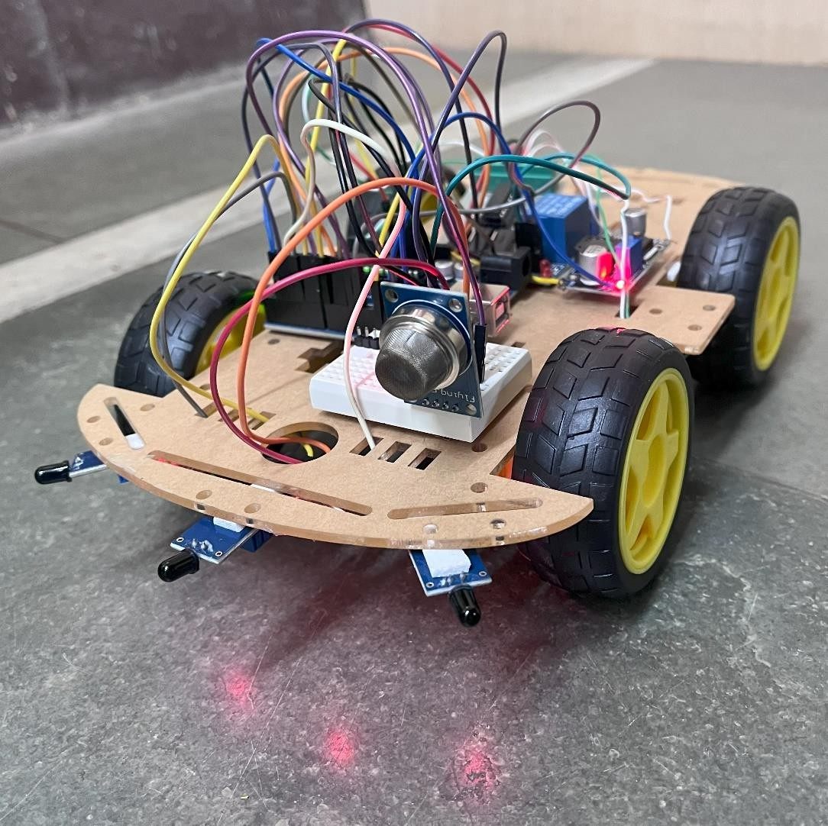

Fig. 3.3 Working Model

# CONCLUSION

**The integration of IoT technology with firefighting robots presents a significant advancement in fire safety and response.** By leveraging cloud-based data storage and analysis, these robots offer enhanced capabilities, including:

* **Real-time data collection:** Sensors on the robot can gather data on temperature, smoke density, gas levels, and other relevant environmental factors, providing critical information for decision-making.
* **Remote monitoring and control:** Operators can monitor the robot's status, view live video feeds, and remotely control its actions from a safe distance.
* **Data analysis and predictive maintenance:** Historical data can be analyzed to identify patterns, predict potential failures, and optimize robot performance.
* **Improved situational awareness:** Cloud-based data can be shared with firefighters and emergency responders, providing a comprehensive understanding of the fire scene.
* **Enhanced safety:** Robots can enter hazardous environments without risking human lives, reducing the number of injuries and fatalities.

**While firefighting robots have the potential to revolutionize fire safety, several challenges remain to be addressed.** These include ensuring reliable communication, addressing cybersecurity concerns, and developing robots that can navigate complex environments effectively. As technology continues to advance, it is expected that firefighting robots will play an increasingly important role in protecting lives and property.

# FUTURE SCOPE

There are several potential future enhancements that could be made to Arduino based fire fighting robots:

Enhanced Sensing Technologies: Integration of advanced sensors like thermal cameras or gas sensors to improve fire detection accuracy in diverse environmental conditions.

* Intelligent Path Planning: Implementation of intelligent path planning algorithms for optimized navigation, obstacle avoidance, and efficient movement in complex indoor environments.
* Wireless Communication: Exploration of wireless communication protocols (e.g., Wi-Fi, Bluetooth) to enhance connectivity, enabling real-time data transmission, remote control, and integration with other smart devices
* Fire Analytics and Prediction: Development of data analytics algorithms to analyze fire incident data, identify patterns, and enable proactive fire prediction and prevention measures.
* Autonomous Recharging and Maintenance: Designing a self-charging and self-maintenance system for the robot, including automatic docking stations for recharging and self-diagnostic capabilities for issue identification and resolution.

By implementing these future enhancements, the fire-fighting robot with SMS alert can further improve its capabilities, response time, and effectiveness in mitigating fire incidents. These advancements contribute to the ongoing development of advanced fire safety systems, ensuring the protection of lives and property

# REFERENCES

1. Tawfiqur Rakib, M. A. Rashid Sarkar, “Design and fabrication of an autonomous firefighting robot with multi sensor fire detection using PID controller”, ICIEV Volumn 23 issue-1 JUNE 2016.
2. ​Saravanan P. ,Soni Ishawarya, “Android controlled intergrated semi-autonomous firefighting robot”, Ineternational journal of innovative science Engg. and Technology 2015.

[3] S. Jakthi Priyanka,R. Sangeetha, “Android controlled firefighting robot”,Ineternational journal of innovative science Engg. and Technology ,Volumn 3, 2017.

### Text Books:

1. ​Interconnecting Smart Objects with IP: The Next Internet, Jean-Philippe Vasseur, Adam Dunkels, Morgan Kuffmann
2. ​Designing the Internet of Things , Adrian McEwen (Author), Hakim Cassimally
3. Internet of Things: Converging Technologies for Smart Environments and Integrated Ecosystems, Dr. Ovidiu Vermesan, Dr. Peter Friess, River Publishers
4. ​Internet of Things (A Hands-on-Approach) , Vijay Madisetti , Arshdeep Bahga

### References:

1. ​6LoWPAN: The Wireless Embedded Internet, Zach Shelby, Carsten Bormann, Wiley
2. ​Building the internet of things with ipv6 and mipv6, The Evolving World of M2M Communications, Daniel Minoli John Wiley & Sons
3. ​Contiki Cooja User Guide.
4. Fundamentals of Sensor Network Programming: Applications and Technology, By S. Sitharama Iyengar, Nandan

Parameshwaran, Vir V. Phoha, N. Balakrishnan, Chuka D. Okoye, Wiley publication.

1. ​Recent research/white papers

### Digital Reference :

1. ​IoT Analytics -Thingshttps://thingspeak.com
2. ​https:/[/www.contiki](http://www.contiki-ng.org/)-[ng.org/](http://www.contiki-ng.org/)