*Using a Compartmentalized Epidemiological Model to Quantify and Predict the Spread of the Coronavirus in Haiti*

By: Ariel Friedman

April 22, 2020

**Introduction**

This paper aims to create an SIER model of the spread of the coronavirus in Haiti. Haiti is a unique case because the first case of COVID-19 was recorded in Haiti on March 21st, 2020, a significant delay from the first case in the United States. I hope to use upcoming data and assumptions that are being gathered by current research from reputable organizations such as the World Health Organization and the Centers for Disease Control. I will compare the spread of COVID-19 in Haiti to a nation with a similar population density and similar hygienic practices, but a greater availability of data.

Haiti is one of the poorest countries in the world. Access to health care and development services are limited. There are four health professionals for every 10,000 people – even less in rural communities. As a result, easily treatable and preventable diseases often lead to death (Project Medishare). Furthermore, non-deadly viruses, such as COVID-19 may be increasingly deadly for those in Haiti, as the population is disproportionately immunosupressed. For instance, currently, 1 in 5 children in Haiti are malnourished, 1 in 10 are acutely malnourished and 1 in 14 will die before reaching the age of 5. Many children in Haiti have one meal per day (“Malnutrition Statistics”).

The effects of chronic and acute malnutrition are life-long. Severe malnutrition suffered in the first two years of life in Haiti has resulted in irreversible physical and mental disabilities and depressed immune systems, likely making children more susceptible to contracting COVID-19 (“Malnutrition Statistics”).

In response to the rapid spread of COVID-19, the president of Haiti has declared a state of emergency and ordered schools, factories, and religious entities to close; established a curfew; and closed the country’s borders. The government announced the new policies after previously suspending air travel from most countries (“COVID-19 in Haiti”).

This project is relevant for two reasons. Firstly, the spread of COVID-19 is undeniably a pandemic that requires a global response. The health of one nation is intrinsically related to the health of the US, and, even greater, the world. Second, Haiti has a history of viral spread, panning from the spread of HIV/AIDs to the Zika Virus to Cholera, making it a likely spot for a widespread, destructive, and deadly pandemic (“Haiti Country Profile”).

**Literature Review**

Due to the recency and urgency of the spread of COVID-19, many authors have utilized some variation of the SIR model in order to model the spread of the disease, differing in their assumptions made to structure the model.

In one instance, authors from Xianmen University, use a SIAR model that accounts for different populations, outside of humans, including bats, hosts, reservoir (the Seafood market) and people (Tianmu). Although this work provided an in depth analysis of the spread of the disease from different sources, it included far too numerous parameters, making it unlikely that this model would allow any policy-maker to make concrete judgements.

Another relevant and strong form of literature came from the Journal of Thoracic Disease, in which the authors provided a similar model to the one that will be used in this paper. The authors used an SIER model to describe the present spread of COVID-19 in China and even provided viable estimates for their parameters, comparing real-life data to the model (Yang). This model is useful because it provides guidelines for parameters to be used, although it was written to explain phenomena in a different country, which likely has different properties of spread.

**Question of Interest**

Can we use models and parameter estimates from China and the US to predict the spread of COVID-19 in Haiti?

**Assumptions:**

1. The population in Haiti is 11.0 million (“Haiti Country Profile”).
2. Person-to-person spread: The virus is thought to spread mainly from person-to-person (CDC).
3. Deaths
   1. Deaths of all groups will not be recorded.
   2. Symptomatic Death % is 3.4%- days from first symptom to death is 14 days on average (WHO).
4. Births
   1. Babies born to mothers with COVID-19 are not expected to be born into the symptomatic population (CDC).
   2. Moreover, for simplification of the model, births will not be taken into account
5. Recovered to infected immunity:
   1. We will assume that the virus that causes COVID-19 will not reinfect people due to short timeline and lack of information (NPR).

**Model Structure**

The populations will be divided into four population groups.

1. Susceptible: The people that are not yet infected with COVID-19 and have never been.
2. Exposed: Individuals have been in contact with the disease and are possibly infectious, but not yet infected themselves.
3. Infected and Symptomatic: The people that are infected with COVID-19 and are displaying symptoms.
4. Recovered: The people that were infected with COVID-19 and are no longer positive for COVID-19.

**Diagram of Model:**

Using the assumptions of the model, and the model structure, this is the diagram I will be using for the spread of COVID-19 in Haiti.

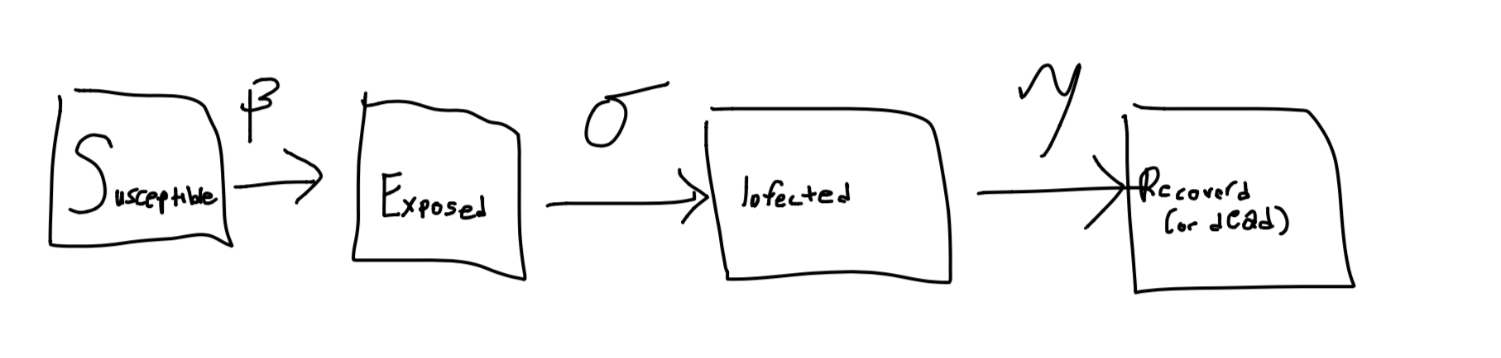

$β$: Rate of transmission from susceptible to exposed ~ estimated number of contacts per day

$σ$: Incubation rate (from being exposed to infected) ~ 1/(average duration of exposed state to infected state)

$γ$: Average recovery rate

Equations

N = S+E+I+R = $S_{0}+I_{0}+E_{0}$

$\frac{dS}{dt}$**= $-β\frac{SI}{N}$**

$\frac{dE}{dt}$**= $β\frac{SI}{N}-σE$**

$\frac{dI}{dt}$**= $σE$- $γ$** I

$\frac{dR}{dt}$**= $γ$** I

**Findings and Graphs**

**Graph 1:**

All three parameter values used by the Journal of Thoracic Disease model.

𝛽, 𝞼, 𝛄= 0.78735, 1/7, 0.154

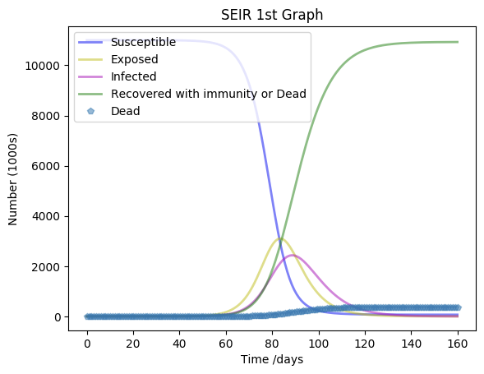

Chart 1:

|  |  |
| --- | --- |
| Max Deaths | 371,576.73 |
| Max Cases | 2,434,673.78 |
| Day of Max Exposed | 83 |
| Day of Max Infected | 88 |
| Day Gap | 5 |

The model predicts that the peak number of infections will occur 83 days in. Furthermore. There is a 5 day gap between maximum # of exposures and max # of infections.

**Graph 2**: Changing beta to be lower, where beta is estimated contacts per day. Ideas for possible range of beta are given by the World Health Organization, which explains how beta is quantified. I wanted to see how the graph looked if there were only 0.5 contacts per day for the infected (WHO).

𝛽, 𝞼, 𝛄 =0.5, 1/7, 0.154

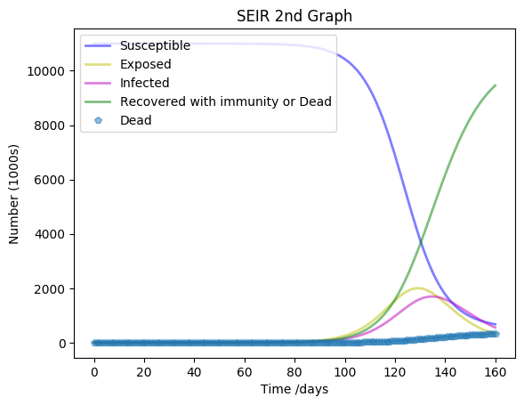

Chart 2:

|  |  |
| --- | --- |
| Max Deaths | 321,489.18 |
| Max Cases | 1,696,066.97 |
| Day of Max Exposed | 128 |
| Day of Max Infected | 134 |
| Day Gap | 6 |

The peak of infections occurs 46 days later than the previous model. A low amount of contacts per day means it will take a really long time for the maximum of the graphs to be realized. Furthermore, fewer deaths occur at the maximum, attributed to fewer contacts per day

**Graph 3:** Changing beta to be higher, where beta is estimated contacts per day. Idea is also generated from WHO.

𝛽, 𝞼, 𝛄 =2, 1/7, 0.154

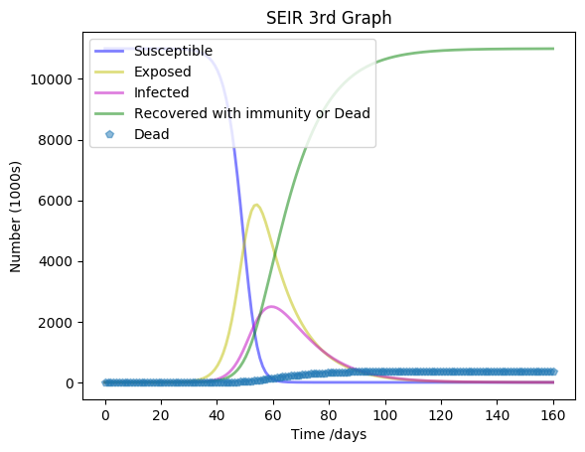

**Chart 3:**

|  |  |
| --- | --- |
| Max Deaths | 373,917.53 |
| Max Cases | 2,497,509.78 |
| Day of Max Exposed | 54 |
| Day of Max Infected | 59 |
| Day Gap | 5 |

An increase in the number of contacts per day leads to an increase in cases and deaths. Furthermore, the peaks will occur sooner.

**Graph 4:** Changing sigma to be lower, where sigma is 1/(average amount of days in the exposed state).

𝛽, 𝞼, 𝛄 = 0.78735, 1/12, 0.154

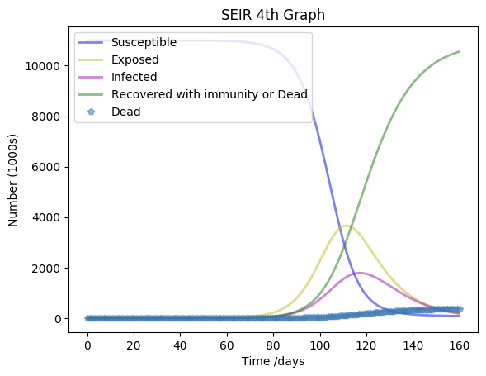

**Chart 4:**

|  |  |
| --- | --- |
| Max Deaths | 358,868.03 |
| Max Cases | 1,787,132.74 |
| Day of Max Exposed | 111 |
| Day of Max Infected | 117 |
| Day Gap | 6 |

Compared to the original graph, the days of the maximums occur much later.

**Graph 5:** Changing sigma to be even lower, where sigma is 1/(average amount of days in the exposed state).

𝛽, 𝞼, 𝛄 = 0.78735, 1/18, 0.154

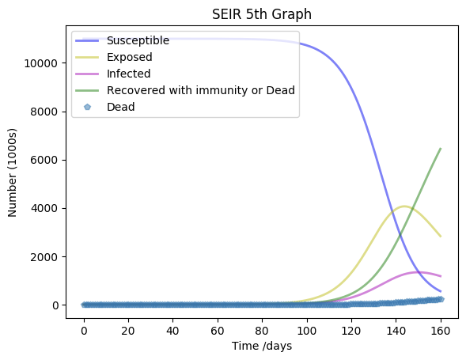

**Chart 5:**

|  |  |
| --- | --- |
| Max Deaths | 218,987.58 |
| Max Cases | 1,337,040.36 |
| Day of Max Exposed | 143 |
| Day of Max Infected | 149 |
| Day Gap | 6 |

By lowering sigma further, there is an even later occurrence of the peaks in the number of infections and exposures. This is the case with the fewest deaths, likely because the amount of days spent in the exposed state is very high, on average.

**Graph 6:** changing gamma to be lower based on confidence interval (Yang).

𝛽, 𝞼, 𝛄 = 0.78735, 1/7,0.0721

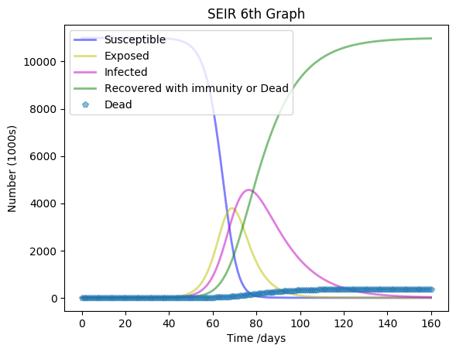

**Chart 6:**

|  |  |
| --- | --- |
| Max Deaths | 373180.87 |
| Max Cases | 4,567,307.821 |
| Day of Max Exposed | 68 |
| Day of Max Infected | 76 |
| Day Gap | 8 |

Decreasing the recovery rate leads to a larger gap in days between maximum exposure and maximum number of infections.

**Graph 7**: changing gamma to be higher, based on confidence interval in the Journal of Thoracic Medicine (Yang).

𝛽, 𝞼, 𝛄 = 0.78735, 1/7, 0.238

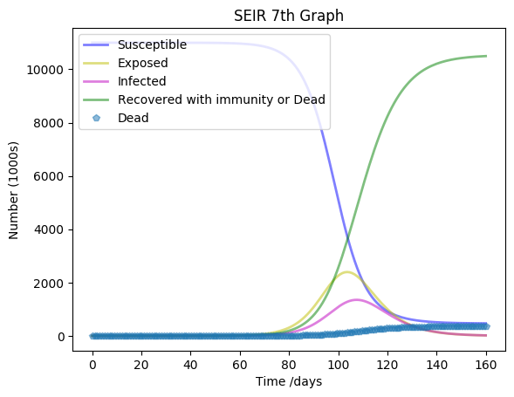

Chart 7:

|  |  |
| --- | --- |
| Max Deaths | 356,915.43 |
| Max Cases | 1,351,589.51 |
| Day of Max Exposed | 103 |
| Day of Max Infected | 107 |
| Day Gap | 4 |

This graph is very similar to the original Graph 1. Nothing Unique has been observed

**Fitting the Graph Section**

For this section, I will use a simpler SIR model, due to the quality of collected data.

**Collected data:**

Deaths = 0,0,0,0,0,0,0,0,0,0,0,0,0,0,0,0,0,0,0,1,1,2,2,2,3,3,3

Infections = 1,2,2,2,6,7,8,8,8,8,8,15,15,15,16,16,17,18,19,24,25,30,31,31,33,40,41

Number of Days = 27

**The Equations:**

S = - $βSI$

I = $βSI -γI$

R = $γ$ I

**The Model**

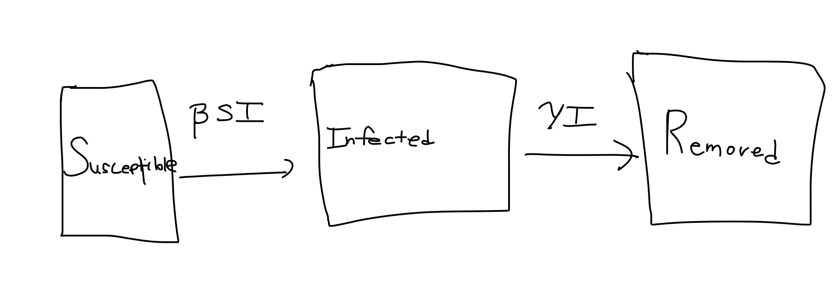

**Findings**

Using simulated annealing, I came up with estimates for the 2 parameters that I used and graphed the results for the population. I anchored with initial guesses that 𝛽, 𝛄 = 0.8499, 1/33 and iterated 10,000 times.

𝛽, 𝛄 = 0.75 (infection rate), 1/16 (recovery rate)

**Graph**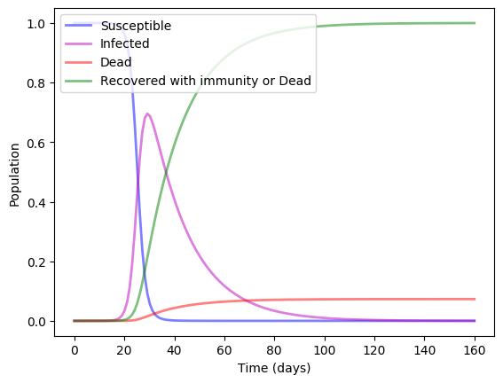

**Chart**

|  |  |
| --- | --- |
| Day of Maximum Infections | 29 |
| Max Deaths | 804,681 |
| Max Cases | 7,650,824 |

These findings may imply that previous estimates have overestimated the number of deaths and underestimated the number of cases, although this number is extremely high, casting doubt on the goodness of fit.

**Conclusion:**

According to the World Health Organization, only 28 percent of Haitians have access to basic sanitation equipment (WHO). The definition of basic sanitation includes Hand hygiene, which is a critical element in disease prevention, including preventing the spread of COVID-19. The cholera outbreak, a disease that can be prevented through careful sanitation and hygiene, was especially distressful in Haiti due to the lack of proper sanitation and hand-washing. Furthermore, medical facilities in Haiti have struggled to provide basic services due to shortages of drugs, oxygen, blood, fuel, and staff (National Geographic).

The findings show that decreasing the average number of contacts per day between susceptible and infected individuals would have a significant effect on reducing the number of infections and deaths. This implies that implementing a social distancing policy, especially for infected persons, would be able to achieve such a goal. Social distancing may also have the effect of delaying the peak number of exposed, deaths, and infections. Thus, it is clear that the numbers of deaths and infections would change favorably if social distancing, basic sanitation practices, and implementation of improved healthcare was done in Haiti.

If there had been more time to evaluate this research area, I would have been able to see the 160-day period realize in real life. This would have allowed me to use a line-of-best-fit method to provide accurate estimates of the parameters for Haiti uniquely.

Furthermore, the estimates of parameters that I used may have been flawed for many reasons. Firstly, current parameters are mostly bases on the US and China, two countries with very different healthcare than Haiti. For instance, Haiti is an island, has an extreme shortage of health infrastructure and sanitation, and has a less healthy overall population. Second, the model may have been more accurate using more parameters, although the country is unlikely to record a complex variety of data due to the weak healthcare system. For instance, understanding the amount of surfaces, meats, food contaminated by COVID-19 may be relevant, but expecting this data to be recorded is unrealistic (NEJM). Another parameter to be called into question is the death rate, which the World Health Organization has conceded varies significantly by age and country (WHO).

**Works Cited**

*Centers for Disease Control and Prevention*, Centers for Disease Control and Prevention, www.cdc.gov/coronavirus/2019-ncov/prepare/pregnancy-breastfeeding.html?CDC_AA_refVal=www.cdc.gov/coronavirus/2019-ncov/specific-groups/pregnancy-faq.html.

“About Us.” *Project Medishare*, projectmedishare.org/about-us/.

Berkeley Jr. “WHO Says Coronavirus Outbreak in China Has Peaked, New Cases in Iran and Italy Are 'Deeply Concerning'.” *CNBC*, CNBC, 24 Feb. 2020, www.cnbc.com/2020/02/24/who-says-coronavirus-outbreak-in-china-has-peaked-new-cases-in-iran-and-italy-are-deeply-concerning.html.

“COVID-19 in Haiti - The Current Response and Challenges - Haiti.” *ReliefWeb*, reliefweb.int/report/haiti/covid-19-haiti-current-response-and-challenges.

Greenfield, Nell. “Do You Get Immunity After Recovering From A Case Of Coronavirus?” *NPR*, NPR, 20 Mar. 2020, www.npr.org/sections/goatsandsoda/2020/03/20/819038431/do-you-get-immunity-after-recovering-from-a-case-of-coronavirus.

“Haiti Country Profile.” *Centers for Disease Control and Prevention*, Centers for Disease Control and Prevention, 27 Aug. 2019, www.cdc.gov/globalhivtb/where-we-work/haiti/haiti.html.

“Home: JMP.” *Home | JMP*, washdata.org/?tx_displaycontroller[type]=country_files.

“How Coronavirus Spreads.” *Centers for Disease Control and Prevention*, Centers for Disease Control and Prevention, 13 Apr. 2020, www.cdc.gov/coronavirus/2019-ncov/prevent-getting-sick/how-covid-spreads.html.

“Malnutrition Statistics.” *Meds &amp; Food for Kids*, 23 Apr. 2015, mfkhaiti.org/malnutrition-stats/.

Sidder, Aaron. “How Cholera Spread So Quickly Through Haiti.” *National Geographic*, 18 Aug. 2016, [www.nationalgeographic.com/news/2016/08/haiti-cholera-crisis-united-nations-admission/#close](http://www.nationalgeographic.com/news/2016/08/haiti-cholera-crisis-united-nations-admission/#close).

Tianmu Chen, Jia Rui, Qiupeng Wang, Zeyu Zhao, Jing-An Cui, Ling Yin bioRxiv 2020.01.19.911669; doi: https://doi.org/10.1101/2020.01.19.911669

Sutton, D., et al. “Aerosol and Surface Stability of SARS-CoV-2 as Compared with SARS-CoV-1: NEJM.” *New England Journal of Medicine*, 13 Apr. 2020, www.nejm.org/doi/full/10.1056/NEJMc2004973.

“WHO Director-General's Opening Remarks at the Media Briefing on COVID-19 - 3 March 2020.” *World Health Organization*, World Health Organization, [www.who.int/dg/speeches/detail/who-director-general-s-opening-remarks-at-the-media-briefing-on-covid-19---3-march-2020](http://www.who.int/dg/speeches/detail/who-director-general-s-opening-remarks-at-the-media-briefing-on-covid-19---3-march-2020).

Yang Z, Zeng Z. Modified SEIR and AI prediction of the epidemics trend of COVID-19 in China under public health interventions. J Thorac Dis 2020;12(3):165-174. doi: 10.21037/jtd.2020.02.64