// A -> B -> C
// B is measured

v1 = vmax1 A / (km1 + A)
v2 = vmax2 B / (km2 + B)

A' = -v1
B' = v1-v2
C' = v2

!!B

A = 1
B = 0
C = 0

vmax1 = 0.1
km1 = 0.8
vmax2 = p *0.02
km2 = 0.3

p = 0
@10 p = go
@40 p = 2*go

tf = 80

script
setting go = 0,1
solve
next
end script

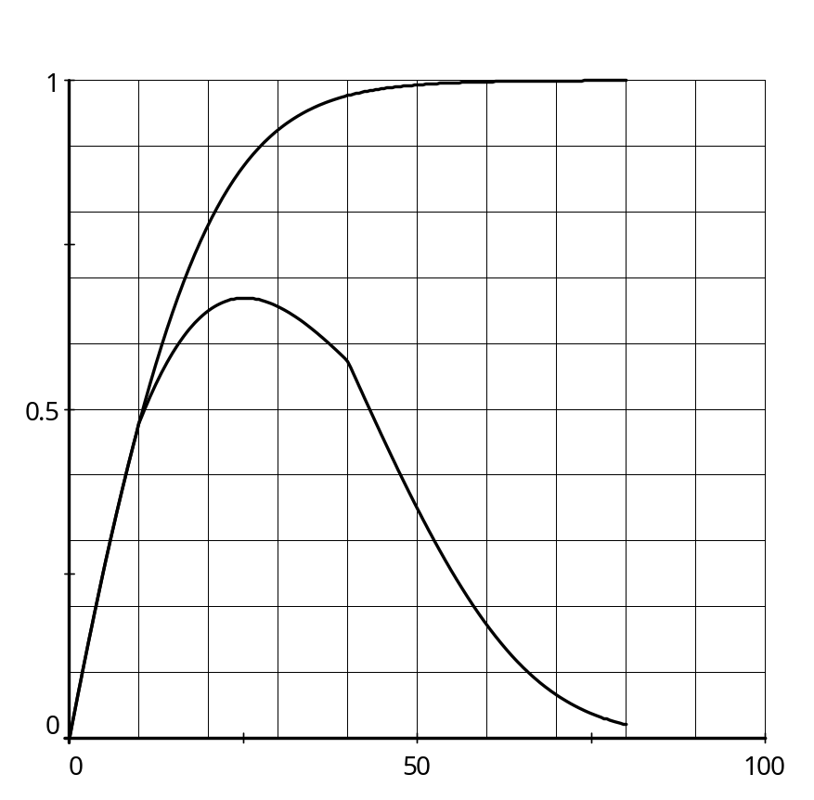
2 V_{max2}
V_{max2}
0

