# Introduction

It’s a Fifa Ultimate Team Ionic App that uses mongodB and node. We use mongodB to store the players with the help of studio 3T. We use node.js to connect mongodB and ionic.

# System Requirements

This App runs on IOS, Android and Windows.

# Technology Used and Why

The technologies used in the app are

**Ionic** “is a complete open-source SDK for hybrid mobile app development. The original version was released in 2013 and built on top of AngularJS and Apache Cordova. The more recent releases, known as Ionic 3 or simply "Ionic", are built on Angular.”

Mongodb: We are using this as our database to store the players.

Node.js : This is what connects our database to ionic.

# Architecture of the Solution

3-tier

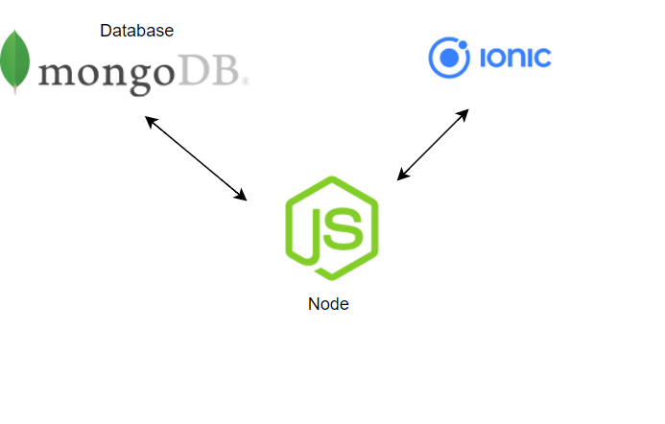

# Design Methodology

We used Agile. “Agile software development describes an approach to software development under which requirements and solutions evolve through the collaborative effort of self-organizing and cross-functional teams and their customer/end user.”

# Features of the Implementation

## Server

We used Node as our server, with express and mongoose.

Ionic sends a request to the server.

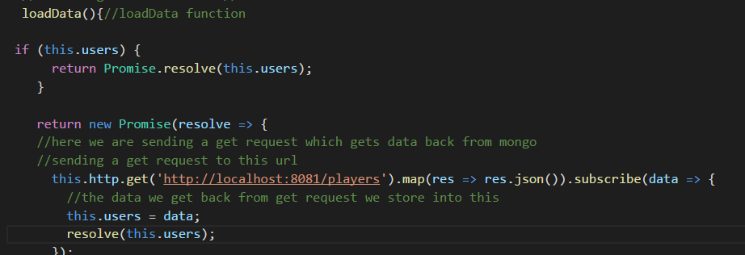

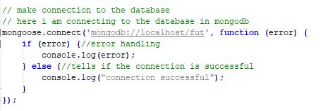

## Database

We use studio3T to import csv file into the database.

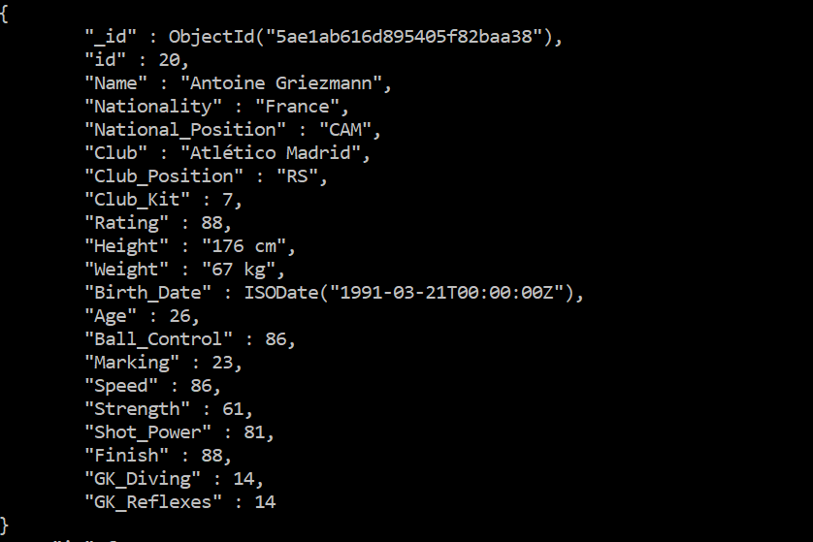

# Limitations

wi-fi connectivity

Another limitation was meeting up for project.

# Recommendations for Future Development

We would like to implement more feature. Such as adding a player and updating players.

# Conclusions

We learned about http requests and how a 3 tier application works. This project has helped us understand more about the 3 Tier architecture. This project helped us understand how important teamwork is and also has increased our knowledge of 3 Tier architecture.