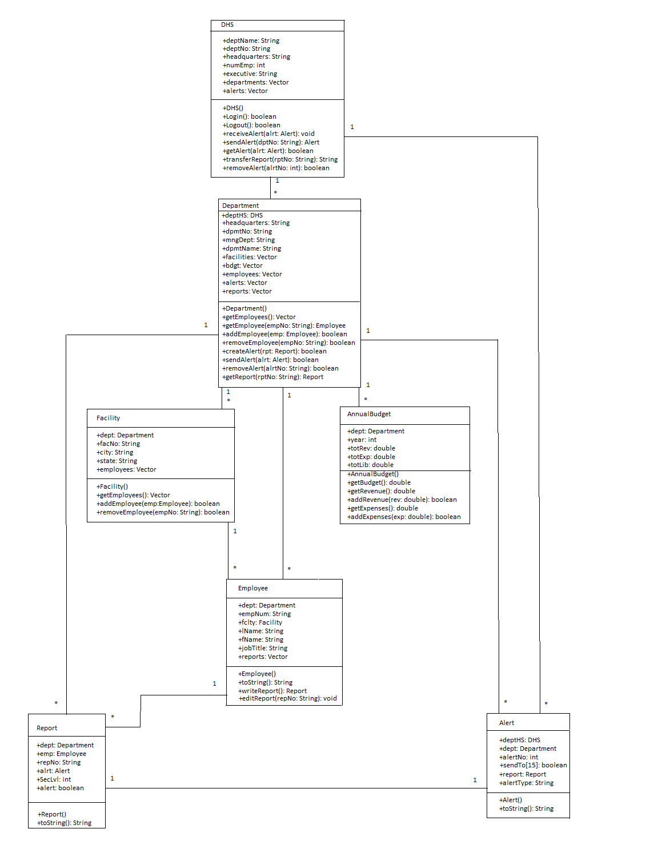
- DHS has many (Vector) Departments and many (Vector) Alerts. Both Department and Alert contain a reference to DHS (deptHS: DHS).
- Through the DHS class, a Department’s Employee may login and logout of the system.
- Department has many (Vector) Facilities, many (Vector) Employees, many (Vector) Reports, many (Vector) Alerts, and many (Vector) AnnualBudgets. Facility, Employee, Report, Alert, and Annual Budget contain a reference to the specific Department (dept: Department).
- A Facility has many (Vector) Employees. Employee has a reference to the Facility where that employee works (fclty: Facility).
- An Employee has many (Vector) Reports it may work on. A Report contains a reference to the Employee who worked on it (emp: Employee).
- A Report contains a reference to the Alert it generated if an Alert was generated (alrt: Alert), and a reference to NULL if no Alert was generated.
- A Report contains a boolean value indicating whether an alert is to be made.
- An Alert contains a reference to the Report that generated it (report: Report).
- To send an Alert to the DHS, the Alert is first created and added to the Department’s Alert Vector. Then the Department adds the alert to the DHS’s Alert vector and informs the DHS that an Alert has been sent (via calling the DHS’s receiveAlert(alrt: Alert) function).
- The call to the DHS’s receiveAlert(alrt: Alert) function is to alert the DHS that a new Alert has been received. It sends the Alert (sendAlert(alrt: Alert)) for each department that the alert is to marked to be sent to, as shown by the Alert’s toSend boolean array.
- When an employee requires more information than is given in the Alert, it queries the DHS, who fetches the Report from the source Department and delivers a copy of it to the requesting Department.
- When the subject of an Alert has been handled or is no longer current, the Alert will be removed from the DHS Alert Vector. This will trigger the removal of the Alert from the Departments who received the Alert. This also sets the Alert reference in the Report that generated the alert to NULL.
- An employee may edit a Report it has previously worked on.

Department Inheritance Model
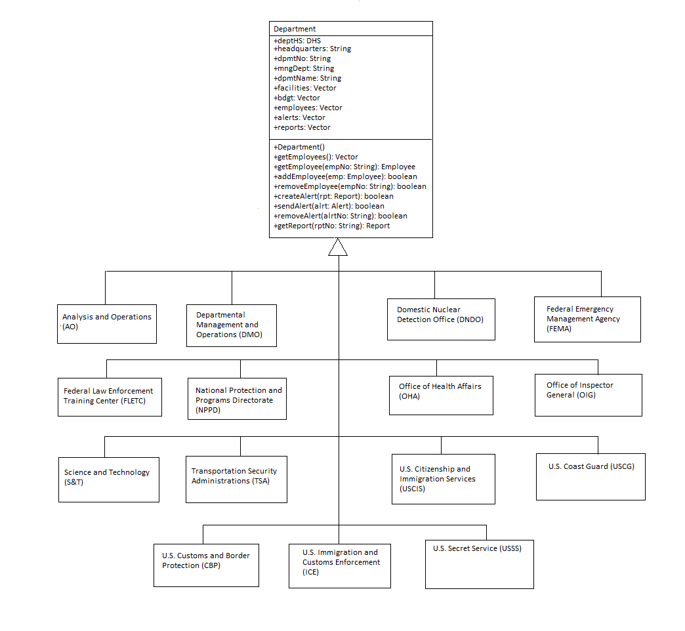

- Our software is based on information sharing. Each department shares the basic steps for information sharing. The difference only lies in what types of reports a department works with, and in this model, only a general report is used for simplicity.

Report Inheritance Model
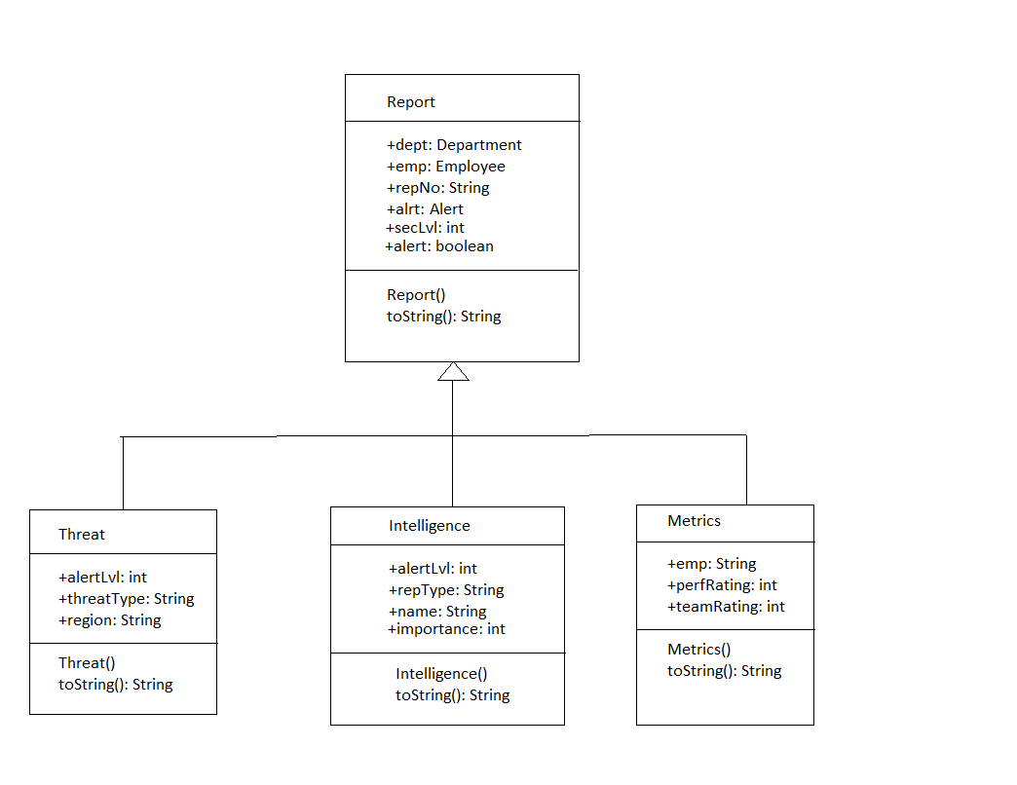

- This is just a small sample of the different types of Reports available in our software.
- The general report contains all the all the basic information shared by all reports and details on how to print the report.
- Each sub-Report adds on fields specific to the Report and details on how to print the added fields.

