**Problem 2: Many Eyes**

**Part A**: Take a look at President Faust’s inauguration speech. Try several types of visualization to look at the data. Which visualization technique can best answer the following questions? Give a brief answer to the following questions and describe how the visualization technique supports answering them in HW_3_ManyEyes.pdf. Include screenshots to support your answers.

1. What does President Faust see in “the future” ?

She sees the continues importance of the role that the university plays in education, the future, accountability of knowledge, and in the word. I have chosen for this visualization the “Tag Cloud” visualization:

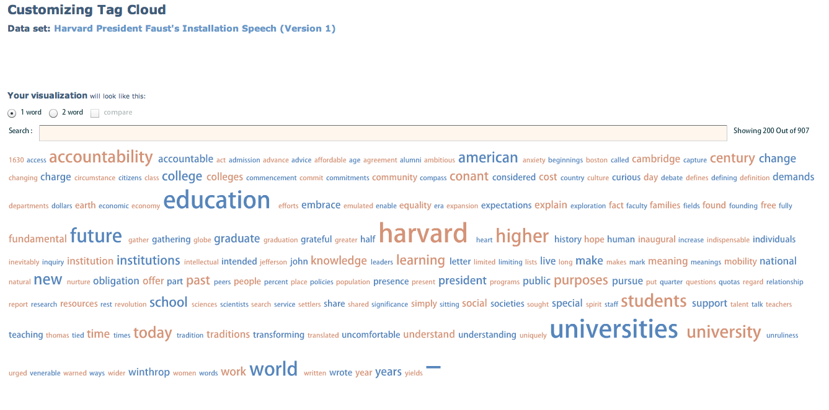

In my opinion this visualization supports the speech with key words such as “Education”, “Harvard” , “Universities”, “future, etc. The visual encoding of these fonts provide with text fonts and sizes that are more predominant visually than smaller words in the background. In addition, the pattern of the text flowing from left to right in vertical lines gives you a sense of key words mentioned above in motion as we go into future ventures.

1. What does Faust see as the responsibility of Harvard? What must “we” do?

President Faust makes an emphasis on the importance and need of synergy, links and relationships between schools, universities and society around the world. For this speech and to answer this question I have chosen the “Phrase Net” visualization. The encoding of this visualization show contours or links between key entities of relevance in her speech. The text fonts and sizes are predominant visually to the importance of the links between the “University”, colleges add societies.

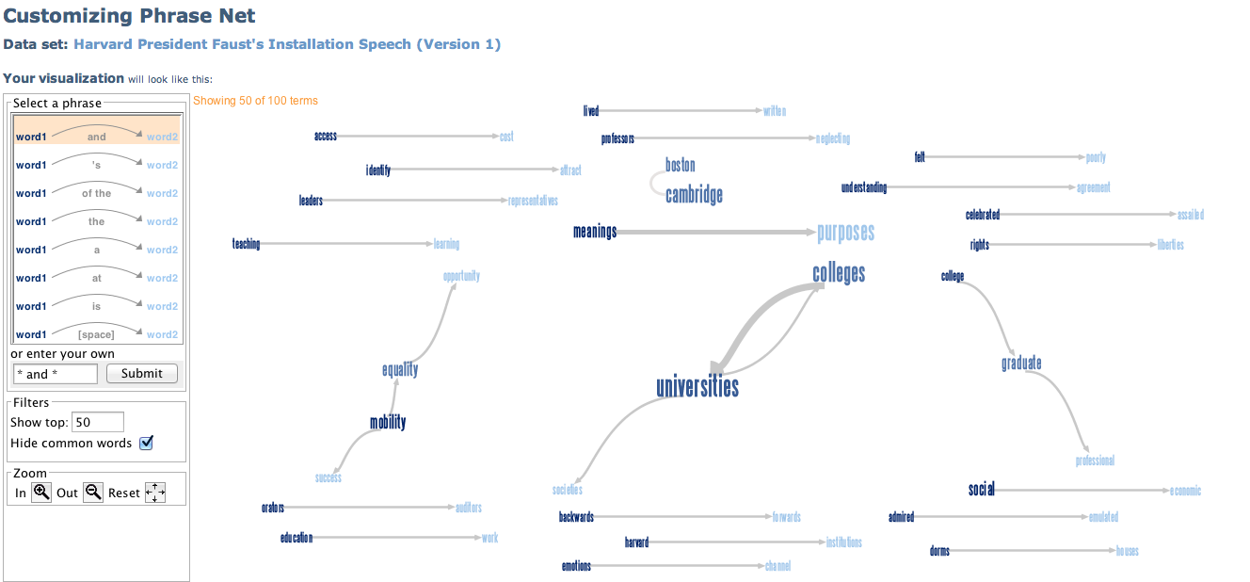

Part B. Take a look at the 2000-10 Apple Production in the United States. Using the visualization methods available in Many Eyes, answer the following questions:

1. Which states produced the most apples? Which state produced the least?

The states that produced the most apples are Washington, Pennsylvania, New York, Michigan and California. The states that produced the least are Arkansas, Delaware, Iowa, Kansas, Kentucky, New Mexico, Rhode Island, South Carolina, Tennessee, Utah and Vermont.

1. Which stat(s) had an increase in apple production? Which state(s) showed a decrease?

The state that seems to have an increase in apple production is New York. States that had a decrease in apple production are California, Virginia, Oregon, West Virginia and Wisconsin.

The following is a screenshot of the visualization chart:

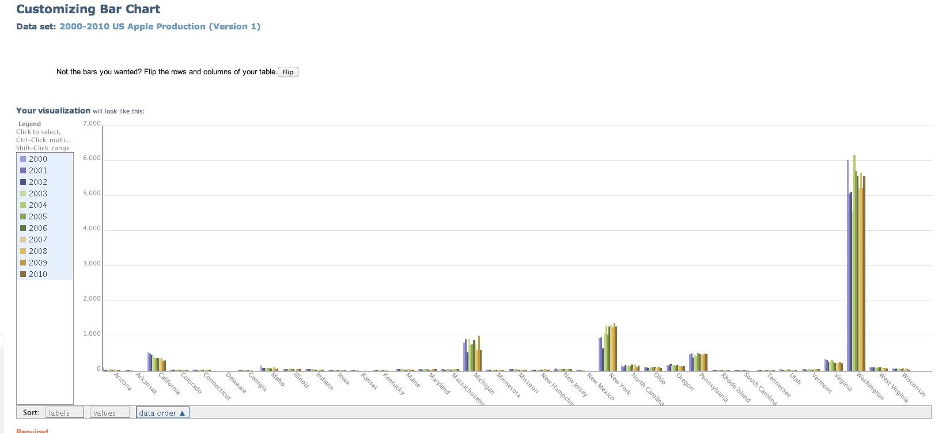

This bar chart supports to answer the questions since the aggregated bar charts by state encode the amount of apple production per year in different high contrast bar colors. You can clearly see different trends of apple production between states.

**Part C:** Take a look at the 2009 Average Monthly Income by Education and 2009 Educational Attainment.xls provided in the supplementary files. You will need to refine and combine the data to answer the following questions. Using the visualization methods available in Many Eyes, answer the following questions in HW_3_ManyEyes. Also explain how the visualization technique supports you in answerring these questions:

1. Convey the relationship between education attainment and income. At what level of education is there a significant benefit to income?

2. Look at the average monthly income by gender and by race. Do you find a significant disparity in income between gender or between race?