Aegis-40 iPWR — Final Evaluation Report
§8.1 General · §8.2 Core · §8.3 Fuel · §8.4 Cooling Circuit · §8.9 Energy Cycle · §8.11 Waste · §8.12 Economics · Non-proliferation (3S)
Compiled draft. Styling per FER template (Arial 12 / Arial Black titles, 1.15 spacing, justified, 2.5 cm margins). Yellow boxes mark 3D tech drawings to insert.

---
8.1 General Design Parameters
The Aegis-40 is an integral, soluble-boron-free pressurised-water small modular reactor (iPWR-SMR) rated 125 MWth / 40 MWe net (32.0 % net efficiency). All primary equipment — core, steam generator, pressuriser, and control-rod drives — is contained within a single reactor pressure vessel. The plant is designed for a 60-year life, a small (~0.5 km) emergency-planning zone enabled by passive safety, and modular factory construction. Tables 8.1-1 to 8.1-5 give the consolidated design parameters; their derivation and basis documents are in §8.1.6, and pending items in §8.1.9.
8.1.1 Plant and power
Table 8.1-1 — Plant configuration and power
Parameter | Value | Unit
Plant type | Integral PWR (iPWR), soluble-boron-free | —
Thermal power | 125 | MWth
Net electrical output | 40 | MWe (net to grid)
Net thermal efficiency | 32.0 (nameplate) / 31.8 (computed) | %
Design lifetime | 60 | years
Capacity factor (design target) | 95 | %
Capacity factor (used in waste/fuel-cycle analysis) | 90 | %
Available process-heat temperature | Flexible: 100–260 | °C
Modular design | Yes | —
Construction duration (n-th unit) | < 30 | months (first concrete → criticality)

[TODO: REVIEW — capacity factor: advertise the 95 % design target (consistent with the outage schedule in §8.1.5); note in §8.11 that the waste arisings used a conservative 0.90. Reconcile the two so the FER never shows both as "the" CF without explanation.]
8.1.2 Primary system and thermal-hydraulics
Table 8.1-2 — Primary coolant system
Parameter | Value | Unit
Primary system operating pressure | 12.8 | MPa
Core inlet / outlet temperature | 258 / 308 | °C / °C
Core temperature rise (ΔT) | 50 | K
Average primary mass flow rate | ~483 | kg/s
Primary coolant inventory | ~25.6 (≈ 34.6 m³) | t
Steam-generator (secondary) operating pressure | 4.5 | MPa
Circulation mode | Natural circulation (no primary pumps) | —

[TODO: REVIEW — primary coolant inventory ~25.6 t is a geometric estimate (`scripts/primary_inventory.py`, ±~25 %): sum of the documented in-vessel primary water regions (core lattice + reflector, lower plenum/head, riser, SG shell-side, downcomer, upper plenum/head) at ρ ≈ 740 kg/m³. It replaces the erroneous 1.82 Mkg large-PWR figure; confirm the precise value against the §8.4 T-H model.]
[TODO: RESOLVED — the 12.8 MPa / 258→308 °C (ΔT 50 K) primary boundary is now fixed by the §8.4 natural-circulation analysis (`scripts/natcirc_primary.py`). Saturation at 12.8 MPa is 329.7 °C, so the 308 °C outlet keeps 21.7 °C hot-leg subcooling — single-phase with margin. The §8.9 steam side is re-coupled to these legs (4.5 MPa / 296 °C, 8.8 °C OTSG pinch).]
8.1.3 Fuel and core
Table 8.1-3 — Fuel and core design
Parameter | Value | Unit
Number of fuel assemblies | 21 | — (17×17 square lattice)
Active core height | 200 | cm (+ 30 cm H₂O axial reflector each end)
Heavy-metal loading (fresh) | ~5.3 | tHM
Specific power | 23.6 | MW/tHM
Fuel material | UO₂ | —
Fuel enrichment (zoned inner/mid/outer) | 4.95 / 4.70 / 4.40 | wt% ²³⁵U
Fuel enrichment (core average / maximum) | 4.54 / 4.95 | wt%
Fuel cladding material | Zircaloy-4 (Zr-4) | —
Primary burnable absorber | Gd₂O₃, 8 wt% (radially zoned) | —
Secondary burnable absorber | Er₂O₃, 0.5 wt% | —
Reload scheme | 4-batch | —
Cycle length | 479 EFPD (~16) | EFPD (months)
Fuel reload interval | ~16 (12–24 capable) | months
Discharge burnup | 42.8 | GWd/MTU
Primary reactivity control | Control rods + integral burnable absorbers | —
Control-rod absorber material | B₄C / Hf (REVIEW) | —
Fuel reprocessing | None (once-through) | —

[TODO: RESOLVED — core-average enrichment = 4.54 wt%, assembly-weighted from the rev_3 loading map (`cad/core_map.csv`): r0/r1/r2 = 1/8/12 assemblies at 4.95/4.70/4.40 wt% → (1·4.95 + 8·4.70 + 12·4.40)/21 = 4.54. The old "3.81 %" was impossible (below the 4.40 minimum zone) and is dropped.]
[TODO: REVIEW — control-rod absorber material: confirm with §8.5/§8.6 (Azamkhon). B₄C and/or Hf are typical SBF-core choices; Gd₂O₃ is a *burnable absorber*, not a control-rod material, so the old "B₄C, Hf, Gd₂O₃" lumping is split here.]
[TODO: REVIEW — fresh heavy-metal loading: ~5.3 tHM is the as-modeled value; the depletion run gives 5.04 tHM at discharge. Confirm the exact fresh value with an OpenMC `--step 0` mass edit.]
8.1.4 Safety systems and probabilistic targets
▸ These rows are owned by §8.5/§8.6/§8.7/§8.10 (Azamkhon). Values reproduced here for the front-page summary; confirm counts and descriptions against those sections before submission.
Table 8.1-4 — Engineered safety features and PSA targets
System / metric | Value | Note
Reactor shutdown systems | 3 | Hydraulic scram, electrically-driven control rods, redundant trains
Core water injection | 2 | Redundant
Residual heat removal | 2 | Two redundant 100 % units
Emergency core cooling | 3 | Three redundant passive 100 % units
Containment isolation | 3 | Three redundant trains
Containment cooling | 2 | Two 100 % units
Passive containment | 3 | Three passive trains, continuously in service
Emergency power supplies | 2 | Facility protection only; not required for reactor safety
Containment type | Dry | —
Containment design pressure | 4.14 / 60 (REVIEW) | bar / psi
Core Damage Frequency (CDF) | < 1×10⁻⁷ (projected) | per reactor-year
Large Release Frequency (LRF) | < 1×10⁻⁸ (projected) | per reactor-year

[TODO: REVIEW — containment design pressure: 4.14 bar (60 psi) is a *large-dry-PWR* value. A compact iPWR steel containment typically peaks higher; set this from the containment peak-pressure accident analysis (LOCA / steam-line break × margin). Owner: §8.5/§8.6.]
[TODO: REVIEW — CDF/LRF are projected targets benchmarked to the passive-iPWR class (a full PSA is out of FER scope). State them as "projected, consistent with passive SMR class," not as PSA results.]
8.1.5 Site, construction, and outage schedule
Table 8.1-5 — Site and operational design
Parameter | Value | Unit
Emergency planning zone (radius) | 0.5 | km
Seismic design (SSE) | 0.3 | g (Safe-Shutdown Earthquake)
Major outage — refuelling | 15 days every 12 months | —
Major outage — turbine / vessel ISI | 30 days every 120 months | —

Derived relations (basis "C"). Net efficiency = 40 MWe / 125 MWth = 32.0 % (nameplate); the detailed re-coupled heat balance gives 39.7 MWe / 31.8 % (§8.9), the 0.3 MWe difference being within the turbine-efficiency assumption. The primary flow follows from the heat-balance identity Q = ṁ·c_p·ΔT with Q = 125 MWth, ΔT = 308 − 258 = 50 K, and c_p ≈ 5.18 kJ/kg·K at 283 °C / 12.8 MPa → ṁ ≈ 483 kg/s (flow and ΔT are coupled — they cannot be set independently; the natural-circulation loop settles at this ΔT, scripts/natcirc_primary.py). Specific power = 125 MWth / 5.3 tHM = 23.6 MW/tHM. The 95 % capacity-factor target is consistent with the outage schedule: 15 d/12 mo (4.1 %) + 30 d/120 mo (0.8 %) ⇒ planned availability ≈ 95 %.
[TODO: REVIEW — EPZ 0.5 km and SSE 0.3 g: the 0.5 km EPZ is a design goal that must be *closed* by the source-term/dose case (§8.11 + safety); 0.3 g is a generic site-bounding SSE — given Türkiye's seismicity, check whether the candidate site(s) warrant 0.5 g. Owner: site/safety.]
8.1.6 Design phase, methodology, and basis documents
The parameters above are the consolidated output of the preliminary (conceptual/basic) design phase that precedes detailed engineering. Aegis-40 was developed through an integrated, reproducible analysis chain; each element produced a controlled record that becomes a verified input to detailed design. This subsection documents that preparatory work so the parameter set can be traced to its origin, in line with a graded, standards-based design process (IAEA SSG-52 §2; IAEA GSR Part 4 design-input control).
Table 8.1-6 — Preliminary-design analyses and basis documents
Design domain | Method / tool | Controlled output (basis document)
Neutronics, depletion, reactivity coefficients | OpenMC Monte-Carlo (ENDF/B-VIII.0), 21-FA 3-D core + depletion | design-basis-locked.md (rev_3); OpenMC model + tally outputs (§8.2)
Fuel performance (T_centerline, FGR, rod pressure) | Steady-state fuel-rod analysis vs SSG-52 limits | §8.3 fuel-performance tables
Primary thermal-hydraulics | Natural-circulation loop balance, IAPWS-IF97 (scripts/natcirc_primary.py); DNBR/hot-channel | §8.4 cooling-circuit analysis
Secondary power conversion | Regenerative Rankine + exergy model, IAPWS-IF97 (scripts/thermo_cycle.py, thermo_exergy.py) | §8.9 state points, heat balance, PFD
Shielding / dose | Attenuation + flux-to-dose (ICRP-116) | shielding spec + dose profiles
Waste / source term | Depletion inventory + ANSI/ANS-5.1 decay heat | §8.11
Geometry / layout | Parametric CAD (RPV, assembly, pin STEP models) | cad/ STEP files, GA drawings

Parameters that are not yet design-frozen — because they depend on another owner's detailed analysis or a confirmatory run — are tracked transparently in §8.1.9.
8.1.7 Design codes and standards
All systems, components, and materials are designed to recognised nuclear and conventional engineering codes. The pressure boundary and safety-related components follow the ASME Boiler & Pressure Vessel Code Section III (nuclear), with balance-of-plant items to ASME Section VIII / B31.1 (non-nuclear); materials are PWR-proven grades qualified for the operating envelope (§8.4).
Table 8.1-7 — Codes and standards applied in the design
Design domain | Code / standard | Application in Aegis-40
Class-1 nuclear pressure boundary | ASME BPVC Section III, Div. 1 (NB / NG) | RPV, OTSG, self-pressurizer, in-vessel CRDM, core support (§8.4)
Non-nuclear pressure parts / BOP | ASME BPVC Section VIII; ASME B31.1 | Condenser, feedwater heaters, secondary piping (§8.9)
Pressure-boundary & internals materials | SA-508 Gr.3 Cl.1, SA-533B (RPV); ASTM A240 304/316L; Inconel-690 TT; Incoloy-800 | Forgings, plate, OTSG tubes, heater sheaths (§8.4)
Fuel cladding | Zircaloy-4 (ASTM B811) | Fuel-rod cladding (§8.3)
Reactor-core nuclear design limits | IAEA SSG-52; NUREG-1431 Rev. 5 | Peaking (F_Q, F_ΔH), reactivity coefficients, SDM (§8.2)
Neutronics method & nuclear data | OpenMC (Romano & Forget 2013); ENDF/B-VIII.0; benchmarked to ICSBEP / BEAVRS | Core physics (§8.2)
Decay heat | ANSI/ANS-5.1 | DHRS sizing, post-shutdown source term (§8.4, §8.11)
Water/steam thermodynamic properties | IAPWS-IF97 | Primary & secondary T-H (§8.4, §8.9)
Radiation shielding / dose conversion | ANSI/ANS-6.4; ICRP-116 flux-to-dose | Shield design, dose profiles (§8.2.6)
Spent-fuel storage criticality | NUREG-0800 §9.1.1; 10 CFR 50.68 (k_eff(95/95) ≤ 0.95) | Wet/dry storage (§8.11)
Instrumentation & safety systems | IEEE Std 603-2018; IAEA SSG-39 | Protection system, I&C (§8.7)
Predisposal waste management | IAEA GSR Part 5 | Secondary-waste handling (§8.11)

8.1.8 Reference regulatory and nuclear-safety requirements
Nuclear safety is integrated into the design from the outset through a standard, defence-in-depth approach: the four fundamental safety functions (control of reactivity, fuel cooling, confinement of radioactivity, and radiation protection) are each met by inherent characteristics and independent, redundant provisions. The candidate site being in Türkiye, the licensing basis is the
Nuclear Regulation Authority (NDK) framework, whose design regulations adopt the IAEA Safety Standards; the table below lists the reference safety-requirement documents and where each is addressed in this FER.
Table 8.1-8 — Reference regulatory documents (nuclear-safety requirements)
Document | Scope | How addressed in the Aegis-40 design
IAEA SSR-2/1 (Rev. 1) — *Safety of NPPs: Design* | Top-level design safety requirements; defence-in-depth | Req. 24–25 redundant/independent reactivity control (rods + EBIS diverse shutdown); Req. 35 reactivity-feedback design; Req. 45 inherent stability (all coefficients < 0); Req. 46 ≥ 2 diverse shutdown systems (§8.2)
IAEA SSG-52 — *Design of the Reactor Core for NPPs* | Core design limits and methods | Peaking, DNBR, reactivity coefficients, LHGR margins (§8.2)
IAEA GSR Part 4 (Rev. 1) — *Safety Assessment for Facilities and Activities* | Safety-assessment methodology | Deterministic analysis + projected-PSA framing (§8.5/§8.6)
IAEA SSG-3 / SSG-4 — Level-1 / Level-2 PSA | PSA methodology | CDF / LRF class targets (§8.6)
IAEA GSR Part 5 — *Predisposal Management of Radioactive Waste* | Waste-safety requirements | On-site storage & conditioning (§8.11)
US NRC 10 CFR 50 App. A — General Design Criteria | Generic design criteria | GDC 11 (reactivity feedback), 26/27 (reactivity control), 35 (ECCS) (§8.2, §8.5)
US NRC NUREG-1431 Rev. 5 — Standard Technical Specifications | Requirement forms / LCOs | SDM, MTC, F_Q, F_ΔH limits (§8.2)
US NRC NUREG-0800 / 10 CFR 50.68 | Standard Review Plan; SFP criticality | k_eff(95/95) ≤ 0.95 (§8.11)
Türkiye NDK — Nuclear Regulation Law No. 7381 (2022) + NDK design regulation | National licensing basis | Primary regulatory framework; adopts the IAEA Safety Standards above

8.1.9 Parameters requiring confirmation or pending analysis
The following are not yet design-frozen and are tracked for the review buffer:
- ~~Primary coolant inventory~~ — CLOSED: ~25.6 t estimated (scripts/primary_inventory.py); confirm precise value against the §8.4 T-H model. *(Samira → Adilbek)*
- ~~Core-average enrichment~~ — CLOSED: 4.54 wt% (assembly-weighted, cad/core_map.csv).
*(Samira)*
- Fresh heavy-metal loading — confirm exact value via OpenMC --step 0 (§8.1.3). *(Samira)*
- Primary pressure & core ΔT — lock against the §8.4 steady-state T-H model. *(Adilbek)*
- Control-rod absorber material — confirm B₄C / Hf selection. *(Azamkhon, §8.5/§8.6)*
- Containment design pressure — set from containment accident analysis. *(Azamkhon, §8.5/§8.6)*
- Safety-system counts / descriptions — confirm Table 8.1-4 against §8.5–§8.7, §8.10.
*(Azamkhon)*
- CDF / LRF — confirm framing as projected class targets, not computed PSA. *(safety)*
- EPZ / SSE — close EPZ with the dose case; confirm SSE against candidate-site seismicity.
*(site / safety)*
- Capacity factor — reconcile the 95 % design target with the 0.90 used in §8.11. *(Samira)*

---
8.2 Core Design
The Aegis-40 reactor core is the integral-PWR (iPWR) heat source for a 40 MWe / 125 MWth soluble-boron-free (SBF) modular plant. The core is a compact light-water-moderated, light-water-cooled lattice of 21 fuel assemblies (FAs) on a 17×17 square pin array, operated on a four-batch reload to an equilibrium cycle of ~16 months. The defining design choice — operation
without soluble boron — removes the chemical-shim system and its dilution-accident pathway, but transfers all excess-reactivity hold-down to solid burnable absorbers (Gd₂O₃ + Er₂O₃) and
control-rod clusters. The sections below present the material selection and its behaviour under irradiation and temperature, the core geometry and layout and the criteria behind it, and the neutronic analysis from beginning-of-cycle (BOC) toward the equilibrium cycle.
■ 3D TECH DRAWING TO INSERT (Figure 8.2-1)
Core isometric / RPV cutaway (3D CAD, in preparation in Fusion 360 / Creo). Show the 21-FA array, core barrel, and reflector. Until the render is ready, the 2D core loading map (Figure 8.2-4) carries this.
Suggested source: render aegis_rpv.step (or aegis_core_context.step) — quarter-cut isometric — in Creo.

8.2.1 Material Selection
Material selection follows three criteria, in priority order: (i) neutronic suitability for an SBF high-burnup core, (ii) demonstrated in-pile performance and a qualified property database to ~50 GWd/MTU, and (iii) compatibility across the steady-state, transient (anticipated operational occurrence, AOO), and accident temperature ranges. The selections are summarised in Table 8.2-1.
Table 8.2-1 — Core material selection and rationale
Core component | Material | Selection rationale
Fuel | UO₂, enriched 4.95 / 4.70 / 4.40 wt% ²³⁵U (radial zones) | Reference LWR fuel; highest qualification base; high melting point (~2840 °C); enrichment ≤ 5.0 wt% keeps within the commercial LEU licensing/fabrication envelope.
Cladding | Zircaloy-4 (Zr-4) | Low thermal-neutron absorption, qualified to high burnup, well-characterised corrosion/creep database; locked design choice.
Burnable absorber (primary) | Gd₂O₃ at 8 wt%, admixed in UO₂, radially zoned | Strong BOC hold-down (Gd-155/157); burns out by ~10 GWd/t; integral (no separate hardware) — the SBF excess-reactivity solution.
Burnable absorber (secondary) | Er₂O₃ at 0.5 wt%, admixed in UO₂ | Slow-depleting "residual" hold-down that flattens reactivity through mid/late cycle and adds cold shutdown margin; the erbia-credit enabler of long SBF cycles.
Coolant / moderator | Light water (H₂O) | Reference PWR coolant and moderator; negative moderator temperature coefficient by design; self-regulating.
Reflector | Light water (radial 20 cm, axial 30 cm each end) | Returns leakage neutrons, flattens the power shape, and protects the barrel/vessel; no separate solid reflector required at this size.

Behaviour under irradiation and across the temperature range. The materials are demonstrably suitable across the operating envelope:
- UO₂ fuel. Stable fluorite-structure ceramic with a high melting point (~2840 °C fresh, decreasing ~0.5 °C per GWd/t with burnup). Thermal conductivity degrades with both temperature and burnup (Lucuta/Halden correlations), which is bounded in §8.3 by the centerline-temperature analysis. At the Aegis-40 low core specific power (~24 MW/tHM) the linear heat rates are modest (§8.3), so fuel temperatures stay far below melting in steady state and in the bounding AOO. Fission-gas release and pellet swelling are accommodated by the as-built dish/chamfer and the gas plenum (§8.3).
- Gd₂O₃ / Er₂O₃ absorbers. Admixed in the UO₂ matrix; their only "transient" behaviour is intended burn-out, which is the reactivity-management mechanism itself (§8.2.3). The 8 wt% Gd loading is within qualified gadolinia-fuel practice; the small (≤1 wt%) reduction in local melting margin from gadolinia is bounded because Gd rods sit in the lower-power interior of the zoning map.
- Zircaloy-4 cladding. Low thermal-neutron absorption with a property database qualified to high burnup; all clad damage mechanisms are bounded by the moderate 42.8 GWd/MTU discharge burnup (below the 62 GWd/MTU rod-average Zr-4 ceiling) and are quantified in §8.3.4. Accident heat-up behaviour (oxidation, ballooning, the 1204 °C peak-clad-temperature limit) underlies the §8.5 LOCA criteria.
- Light water. Reference behaviour; the strongly negative moderator and void coefficients (Table 8.2-3) make the coolant a passive stabiliser under power and temperature excursions.
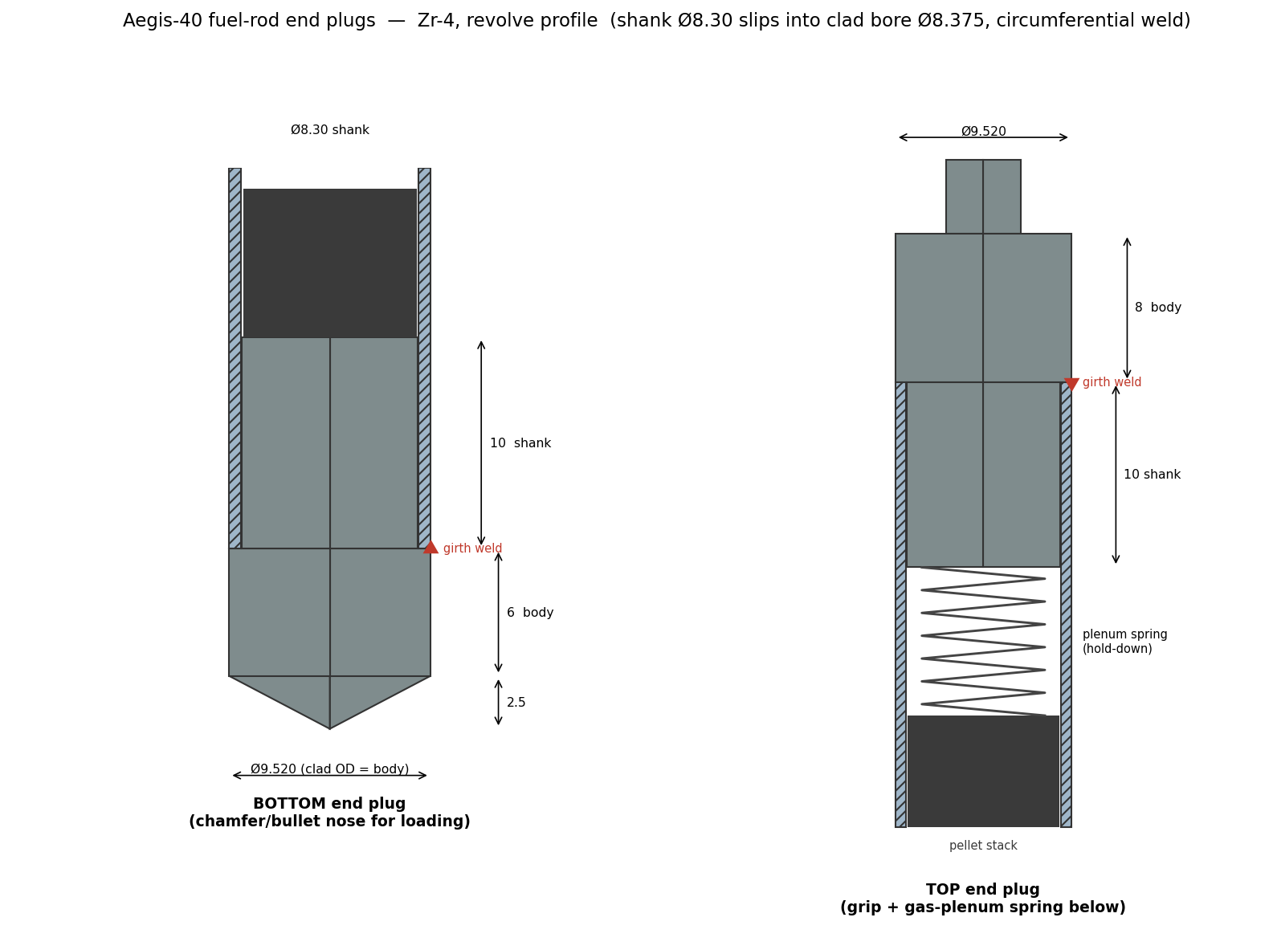
Figure 8.2-2 — Sectioned fuel-rod cutaway (pellet / gap / Zr-4 clad / end plugs / plenum)
8.2.2 Geometry and Layout
The core geometry is the standard Westinghouse-type 17×17 lattice, sized down to 21 assemblies for the 125 MWth rating. Choosing a qualified 17×17 geometry (rather than a novel lattice) maximises the credibility of the borrowed fuel/clad property database and the thermal-hydraulic correlations, and concentrates the originality where it belongs — the boron-free reactivity scheme. Dimensions are taken directly from the as-built OpenMC geometry and are listed in Table 8.2-2.
Table 8.2-2 — Core and fuel geometry (as-modeled, LOCKED)
Feature | Value | Note
Lattice | 17 × 17 square, 289 positions/FA | 264 fuel + 24 guide + 1 instrument
Fuel pellet diameter | 8.192 mm
Pellet–clad radial gap | 0.0915 mm
Cladding OD / ID | 9.520 / 8.375 mm (0.573 mm wall) | Zr-4
Pin pitch | 12.623 mm
Active fuel height | 2000 mm | + 300 mm H₂O axial reflector each end
Guide / instrument tube OD / ID | 12.040 / 11.248 mm | control-rod & in-core channels
Assembly pitch (in core) | 216.038 mm | inter-assembly water gap ≈ 1.45 mm
Number of assemblies | 21 (5×5 lattice, 4 corners removed)
Equivalent core diameter | ≈ 1117 mm
Radial / axial reflector | 200 mm / 300 mm H₂O
Control-rod clusters | 9 | insert into guide tubes; 9 CRDMs
Heavy-metal loading | ≈ 5.3 tHM

Fuel-element quantity and dimensions. The 264 fuel pins per FA, 2.0 m active height, and 21-FA count are set jointly by the power rating and the fuel-efficiency target: the resulting low specific power (~24 MW/tHM) is deliberate — it buys thermal-margin (low linear heat rate, §8.3) and supports the long SBF cycle needed for high discharge burnup with a four-batch scheme.
Power-control systems. Reactivity is controlled by two integral mechanisms (no soluble boron):
- *Burnable absorbers.* Gd₂O₃ (8 wt%) provides the dominant BOC hold-down and is radially zoned — more Gd toward the core centre — to flatten the radial power shape (§8.2.3, Table 8.2-4). Er₂O₃ (0.5 wt%) provides slow residual hold-down and cold shutdown margin. Per-FA absorber counts by core ring are given in Table 8.2-4. The three FA "recipes" (centre / inner ring / outer ring) are shown in Figure 8.2-3.
- *Control rods.* Nine control-rod clusters insert into the guide-tube channels, providing shutdown and operational control with a total worth of 15,226 pcm (Table 8.2-3).
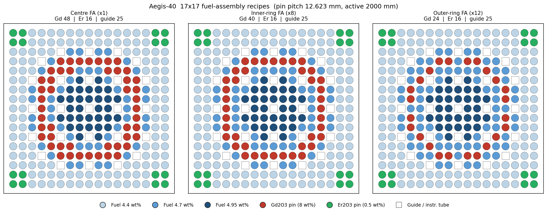
Figure 8.2-3 — Fuel-assembly pin maps for the three core recipes (centre / inner / outer ring), coloured by enrichment and by Gd/Er pin
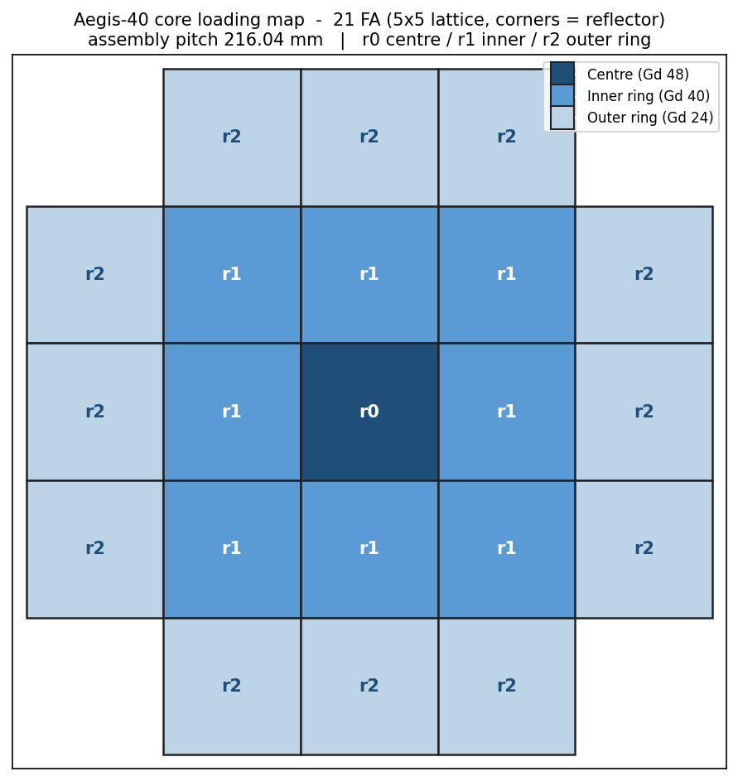
Figure 8.2-4 — Core loading map, 21 FA on the 5×5-minus-corners lattice, coloured by ring (enrichment + Gd zoning)
Table 8.2-4 — Burnable-absorber loading by core ring (radial Gd zoning)
Core ring | # of FAs | Gd₂O₃ rods / FA | Er₂O₃ rods / FA | Relative Gd density
Centre | 1 | 48 | 16 | 1.50
Inner ring | 8 | 40 | 16 | 1.24
Outer ring | 12 | 24 | 16 | 0.80
Core average | 21 | 32 | 16 | 1.00 (conserved)

▸ The zoning redistributes the same core-average Gd toward the centre (density weights 1.50 / 1.24 / 0.80), which conserves BOC reactivity while flattening the radial power — see the peaking result in Table 8.2-5.
8.2.3 Neutronic Analysis
The neutronic design was performed with OpenMC 0.15.3 continuous-energy Monte Carlo on the full 3D core (21 FAs, axial and radial water reflectors, vacuum outer boundary), with coupled depletion from BOC through the approach to the equilibrium cycle. The transport statistics are 180 batches / 50 inactive / 20,000 neutrons per batch. Results are summarised in Tables 8.2-3 and 8.2-5; the cycle reactivity behaviour is in Figure 8.2-5.
Criticality and reactivity control. The fresh core is slightly supercritical (k_eff,BOL = 1.0264), with the excess reactivity held down by the integral burnable absorbers and managed by the control-rod system. All reactivity-control and shutdown criteria are met with margin (Table 8.2-3).
Table 8.2-3 — Neutronic safety results (LOCKED rev_3) — all criteria met
Parameter | Value | Limit / criterion | Status
k_eff, BOL | 1.0264 | excess managed by BA + rods | INFO
Moderator temperature coefficient (HFP) | −35.9 pcm/K | < 0 | PASS
Doppler (fuel) temperature coefficient | −1.84 pcm/K | < 0 | PASS
Void coefficient | −214 pcm/%void | < 0 | PASS
Control-rod worth (ARO → ARI) | 15,226 pcm | ≥ 5,000 | PASS
Shutdown margin | 12.4 %Δk/k | ≥ 1.0 | PASS
k_eff, all-rods-in (ARI) | 0.888 | < 0.95 (subcritical) | PASS
k_eff, worst-stuck-rod (N−1) | 0.890 | < 1.0 | PASS
Max reactivity insertion rate | 1.5 × 10⁻⁵ Δk/k/s | ≤ 7.5 × 10⁻⁴ | PASS
Maximum enrichment | 4.95 wt% | ≤ 5.0 | PASS

Feedback coefficients. All three reactivity feedbacks are negative (Table 8.2-3): the moderator (−35.9 pcm/K), Doppler (−1.84 pcm/K), and void (−214 pcm/%void) coefficients together make the core inherently self-regulating against power, temperature, and voiding excursions — the central inherent-safety claim and the basis for the §8.5 transient response.
Power distribution (peaking). Because there is no soluble boron to flatten the radial shape, the radial Gd zoning (Table 8.2-4) is the primary power-flattening tool. It reduces the assembly radial peaking by 24% relative to an unzoned core while conserving BOC reactivity (Table 8.2-5).
Table 8.2-5 — Power-peaking, unzoned → radially-zoned core
Peaking factor | Unzoned (rev_2) | Zoned (rev_3) | Δ
F_radial (assembly) | 1.62 | 1.23 | −24%
F_ΔH (radial enthalpy-rise) | 2.77 | 2.27 | −18%
F_q (3D total pin power) | 3.62 | 3.48 | −4%
F_z (core-average axial) | — | 1.03 | —
F_z,hot (hot-pin axial = F_q / F_ΔH) | — | 1.53 | —

▸ These are thermal-margin (DNBR) inputs, not stand-alone pass/fail gates. For context, the Jang SBF-SMPWR design limit is F_q < 5.09 and the KEPCO i-SMR (HIGA) SBF core runs F_q ≈ 2.08 — the Aegis-40 rev_3 value sits well inside the SBF-SMR class. The binding thermal limit is the §8.4/§8.5 MDNBR analysis. On the two axial factors. F_q = 3.48 is read directly from the 3D pin-power tally (it is not reconstructed as a product). The core-average axial peaking F_z = 1.03 is flat because the ±30 cm water reflectors give near-symmetric end-savings on the radially-averaged power shape; it is *not* the factor that multiplies F_ΔH. The relevant axial factor for the hot pin is F_z,hot = F_q / F_ΔH = 3.48 / 2.27 = 1.53, i.e. the hot channel carries a more peaked axial shape than the core average. Reporting only the flat 1.03 alongside F_q = 3.48 would appear inconsistent (2.27 × 1.03 ≠ 3.48), so both axial factors are stated.
Enrichment and burnable-absorber zoning — design basis, trade study, and benchmarking. A boron-free core must flatten power with solid zoning alone, and Aegis-40 does so through a deliberate
division of labour between two independent tools, each correcting a different peaking mechanism:
- Intra-assembly enrichment grading — the pin-peak tool. Within *every* 17×17 assembly the pins are graded in three concentric zones, 4.95 wt% interior / 4.70 wt% intermediate / 4.40 wt% periphery (assembly average 4.69 wt%). The periphery pins border the inter-assembly water gaps — and, for edge assemblies, the radial water reflector — where the excess moderation drives a local thermal-flux and hence pin-power peak. De-enriching the outer ring relative to the interior suppresses exactly that peak. This *inner-hot / outer-cool* grading is standard LWR assembly practice and is used in the NuScale reference design (radial enrichment zoning within the assembly, FSAR Tier 2 §4.3). It is applied identically to all 21 assemblies so that no assembly carries an unflattened corner pin.
- Radial Gd zoning across assemblies — the core-radial tool. The assembly-to-assembly tilt (centre hotter than edge — the Bessel-like radial shape) is flattened by zoning the burnable absorber, not the enrichment: 48 Gd rods in the centre assembly, 40 in the inner ring, 24 in the outer ring (core-average 32; Table 8.2-4). Because the per-ring weights are normalised to a fixed core-average Gd loading, this depresses central power without relocating fissile mass and without changing BOC reactivity — it substitutes for the soluble-boron radial trim a borated core would use. The combined effect (Table 8.2-5) is the 24% reduction in assembly radial peaking and 18% in F_ΔH at constant k_BOL.
Why not "out-in" enrichment loading? The standard large-PWR/NuScale radial-flattening technique is
*out-in* loading — higher-enrichment assemblies on the periphery. We evaluated it directly, in two controlled full-core variants, against the locked rev_3 scheme (identical OpenMC statistics):
Table 8.2-6 — Enrichment-zoning trade study (full-core OpenMC, 180/50/20 000)
Quantity | rev_3 (adopted) | rev_4 (out-in) | rev_5 (out-in + intra-FA)
Radial enrichment scheme | intra-FA grade only (4.95/4.70/4.40); assemblies uniform across core | inter-assembly out-in (4.13/4.54/4.83); each FA single-enrichment | out-in ring base + intra-FA grade superposed
k_eff, BOL | 1.0264 | 1.0261 | 1.0225
F_q (3-D hot pin) | 3.48 | 3.61 | 3.54
F_ΔH (radial) | 2.27 | 2.17 | 2.14
F_radial (assembly) | 1.23 | 1.17 | 1.15
Discharge burnup (GWd/MTU) | 42.8 | 41.1 | 39.3
Cycle length (EFPD) | 479 | 460 | 440
Control-rod worth (pcm) | 15 226 | — | 14 382
Shutdown margin (%Δk/k) | 12.4 | — | 11.9
Max pin enrichment (wt%) | 4.95 (0.05 margin) | 4.84 | 5.00 (no margin)
Gd-157 residual at EOC | 0.1% (burnt out) | — | 36% (unburnt)

The out-in variants do flatten the assembly-average map (F_radial 1.23 → 1.15–1.17), but they
regress the metric that actually governs thermal margin — the 3-D hot-pin F_q — and they cost cycle length and burnup:
- *rev_4* makes each assembly a single enrichment to realise the out-in tilt, which discards the intra-assembly pin grading; the local periphery pin-peak returns and F_q rises 3.48 → 3.61.
- *rev_5* keeps both (out-in base + intra-FA grade) and achieves the flattest assembly map, but F_q is still worse than rev_3 (3.54 > 3.48), discharge burnup falls to 39.3 GWd/MTU, the peak pin is pinned at exactly the 5.0 wt% LEU ceiling (zero licensing margin), and 36% of the Gd-157 is left unburnt at EOC — reactivity locked up that never contributed to cycle length.
Two physics reasons explain why out-in helps NuScale but not Aegis-40:
- No soluble boron. NuScale pairs out-in loading with chemical shim (equilibrium cycle ≈ 1235 ppm boron) that carries the bulk reactivity swing and provides fine radial trim, so its enrichment tilt only has to do gentle shaping. With no boron, our enrichment tilt must do the whole job and overshoots.
- A small, water-reflected core leaks. Out-in pushes fissile mass toward the periphery. Behind a large core's steel/heavy reflector this is nearly free; in our 21-assembly core behind only a 20 cm water reflector (vacuum outer boundary) the periphery is neutronically leaky, so relocating fissile outward bleeds neutrons — directly the ~20–40 EFPD of lost cycle above.
The adopted division of labour — Gd zoning for the core-radial shape, intra-assembly enrichment grading for the pin peak — therefore wins on every binding metric (F_q, discharge burnup, cycle length, shutdown margin, and enrichment margin) and is retained as the locked rev_3 design.
Benchmarking against reference iPWR/SMR cores. Table 8.2-7 places the Aegis-40 design point against two well-documented integral-PWR SMRs: NuScale (US, borated iPWR; FSAR Tier 2 §4.3) and RITM-200 (Russia, marine/land iPWR).
Table 8.2-7 — Neutronic benchmarking against reference iPWR SMRs
Parameter | Aegis-40 (rev_3) | NuScale (FSAR) | RITM-200
Thermal / electric power | 125 MWth / 40 MWe | 160 MWth / 50 MWe (per module) | 175 MWth / 55 MWe
Reactivity control | boron-free (Gd + Er + rods) | soluble boron + rods + Gd | soluble boron + rods
Max enrichment | 4.95 wt% (LEU) | < 4.95 wt% (LEU) | ~14–20 wt% (HALEU)
Burnable absorber | Gd₂O₃ (≤ 48/FA, zoned) + Er₂O₃ | Gd₂O₃ (≤ 32/FA) | structural / Gd
Refuelling interval | ~16 mo (479 EFPD), 4-batch | ~24 mo (12 GWd/MTU cycle) | up to ~6 yr
Discharge burnup | 42.8 GWd/MTU | ~30 GWd/MTU (class) | long-life HALEU
MTC (HFP) | −35.9 pcm/K (−19.9 pcm/°F) | 0 to −32.5 pcm/°F (design) | < 0
Doppler coefficient | −1.84 pcm/K (−1.0 pcm/°F) | −1.63 to −2.07 pcm/°F | < 0
Control-rod worth | 15 226 pcm | 14 414 → 15 553 pcm (BOC→EOC) | —
F_q / F_ΔH | 3.48 / 2.27 | 1.86 / 1.39 | —

The comparison supports three defensible claims for the FER:
- The coefficients and rod worth are in-family with a licensed iPWR. The Aegis-40 MTC (−19.9 pcm/°F) sits inside NuScale's design band (0 to −32.5 pcm/°F); the total control-rod worth (15 226 pcm) sits between NuScale's BOC and EOC values (14 414–15 553 pcm); the Doppler coefficient is solidly negative, somewhat smaller in magnitude than NuScale's, consistent with the higher fuel enrichment (relatively less U-238 resonance absorber). The burnable-absorber strategy — integral gadolinia at a comparable per-assembly count — is the same.
- Higher peaking is the expected, bounded cost of being boron-free. Aegis-40's F_q (3.48) exceeds NuScale's (1.86) because soluble boron is the single most effective power-flattening tool and we have removed it by design. The value remains well within the SBF-SMR class (Jang SBF-SMPWR limit F_q < 5.09) and the binding check is the §8.4/§8.5 MDNBR analysis at our low core power density (~24 MW/tHM), not a borrowed peaking number.
- LEU + high burnup is a deliberate non-proliferation / fuel-supply choice. Where RITM-200 buys multi-year refuelling intervals with 14–20 wt% HALEU, Aegis-40 stays inside the < 5 wt% commercial LEU envelope (standard fabrication and supply, lower proliferation attractiveness) and still reaches 42.8 GWd/MTU discharge — far above the boron-free peer CAREM-25 (~24 GWd/MTU).
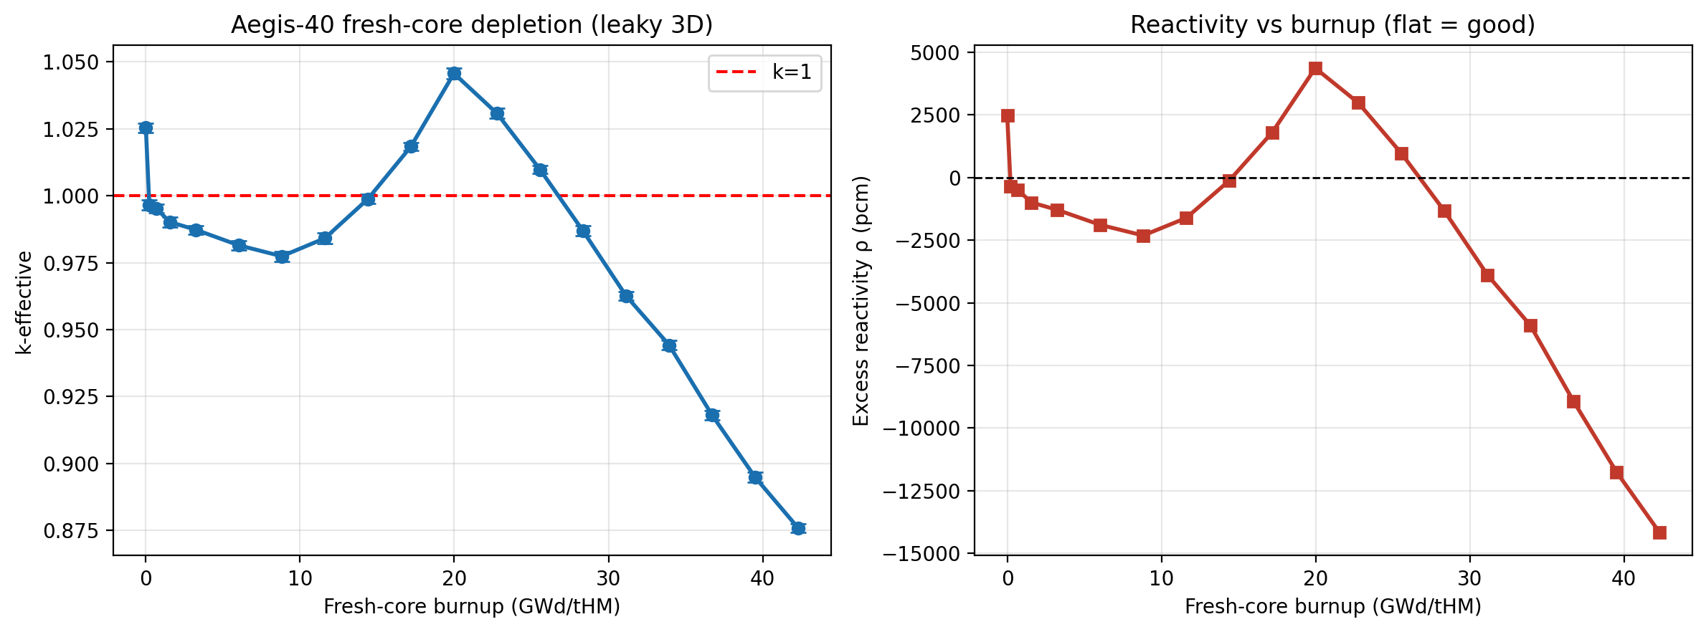
Figure 8.2-5 — Cycle reactivity (k_eff and excess reactivity vs burnup, BOC → EOC) from the full-core depletion run
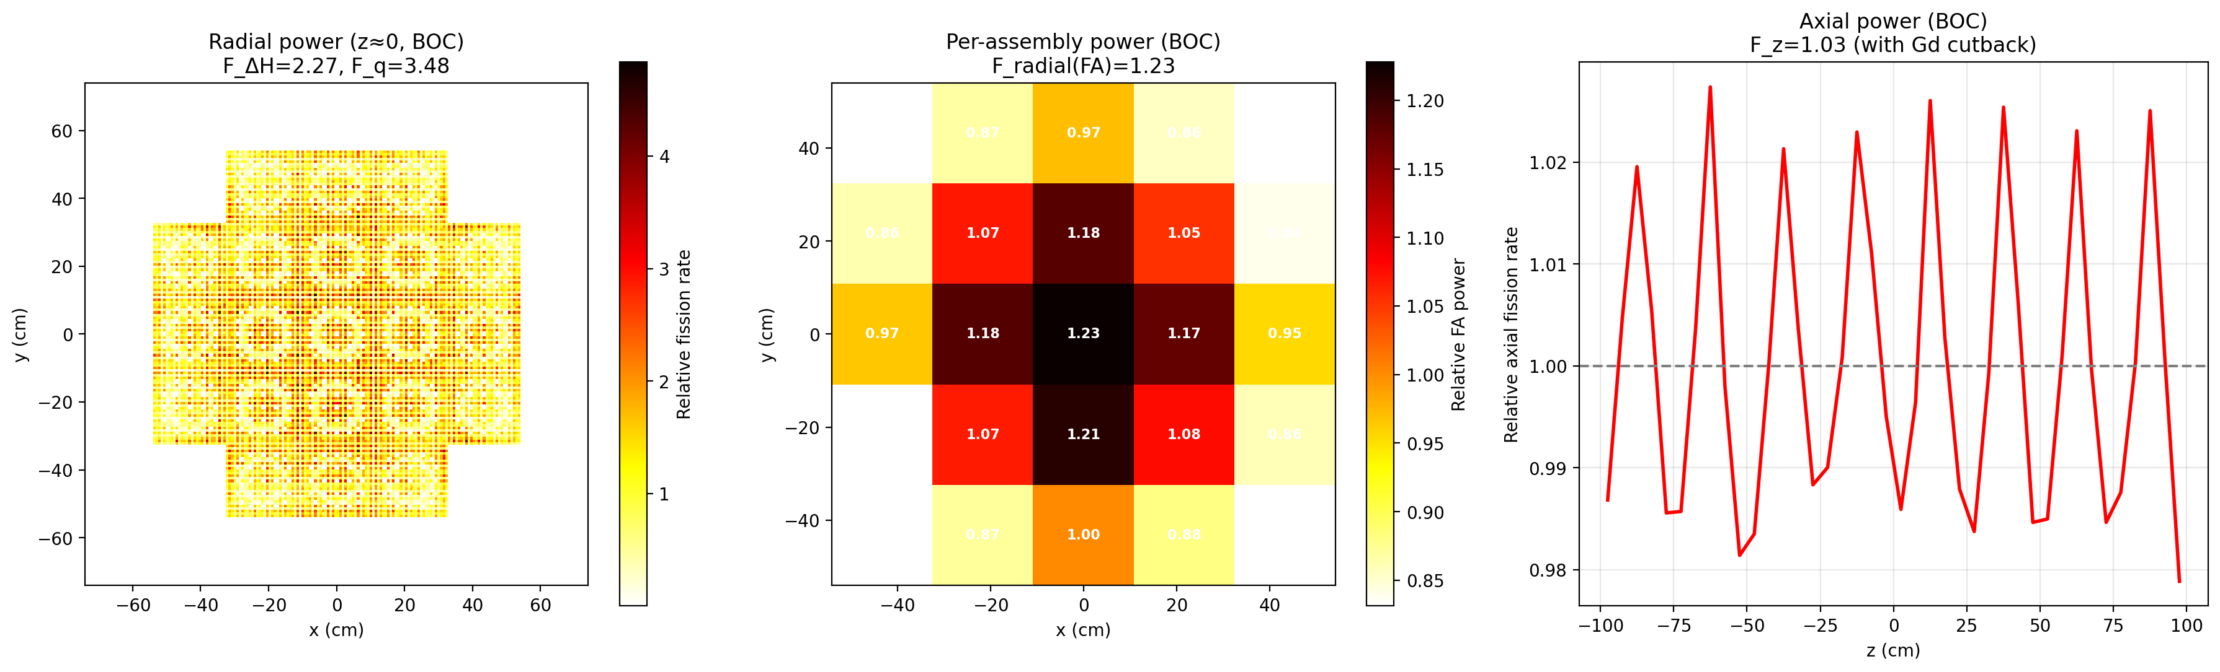
Figure 8.2-6 — BOC power distribution
BOC → equilibrium cycle behaviour. The depletion k_eff curve dips, then rises, then declines (k_BOL 1.0264 → dip ≈ 0.98 → Gd-burnout hump → k_EOC ≈ 0.876 at the 479 EFPD cycle). This shape is the expected signature of a Gd-controlled boron-free core, and is intended:
- Dip (first days): equilibrium xenon builds in (~−2700 pcm).
- Rise (~0–400 EFPD): fresh Gd-155/157 hold k down at BOL; as they burn out their absorption disappears faster than the fuel depletes, so net k climbs — the reactivity "stored" in the Gd is released to sustain the long SBF cycle.
- Decline (post-burnout): normal fuel-depletion fall-off to EOC.
This is consistent with published integral-Gd SBF behaviour (Kim, Jung & Yoon, *Nucl. Eng. Tech.* 56 (2024) 3144), which describes the reactivity "holding" and the engineered control of the "reactivity upswing following gadolinia depletion." In a boron-controlled core the curve only falls; the hump is the distinguishing feature of integral-Gd SBF control.
Scope: first core through equilibrium cycle. The depletion presented above is the first (all-fresh) core, run from BOC to its 42.8 GWd/MTU / 479 EFPD end-of-cycle. The reactor reaches its operating equilibrium through the four-batch reload (§8.2.2): at equilibrium the core holds a mix of fresh, once-, twice- and thrice-burned assemblies, so the equilibrium cycle is less reactive at BOC and shorter than the all-fresh first cycle, while the per-batch discharge burnup converges on the 42.8 GWd/MTU design value. The first-core results therefore bound the equilibrium cycle on the safety-relevant metrics — first-core BOC excess reactivity (hence required hold-down and rod/SDM duty, Table 8.2-3) is the maximum the control system must cover, and the first-core peaking (Table 8.2-5) is representative because the zoning is identical each reload. A full equilibrium-core depletion (explicit fresh + burned shuffle) is identified as the next depletion step for the final FER; it is expected to confirm the bounding argument and slightly relax the BOC hold-down requirement.
Compliance with safety criteria / regulations. The neutronic safety parameters (Table 8.2-3) meet the adopted criteria, which map directly onto national (Türkiye NDK) and international (IAEA, US NRC) requirements:
Neutronic result | Criterion met | Regulatory basis
MTC, DTC, void all < 0 | inherent negative power/temperature feedback | NDK *Nuclear Power Plant Design Regulation* (reactivity-feedback provisions) [ref T-1]; IAEA SSR-2/1 Rev.1 Req. 35 [ref I-1]; US NRC 10 CFR 50 App. A GDC 11 [ref N-1]
Two independent control means (rods + integral BA), CR worth 15,226 pcm | redundant, independent reactivity control | IAEA SSR-2/1 Req. 24–25 [ref I-1]; GDC 26 & 27 [ref N-1]
SDM 12.4 %Δk/k; k_ARI 0.888; worst-stuck-rod (N−1) 0.890 < 1.0 | shutdown margin with most-reactive rod stuck; subcriticality with single failure | IAEA SSR-2/1 Req. 25; GDC 26 [ref N-1]
Max enrichment 4.95 wt% ≤ 5.0 | LEU fabrication/licensing limit | commercial LEU limit; IAEA fuel-safety guidance

Türkiye's nuclear activities are licensed by the Nükleer Düzenleme Kurumu (NDK) under the Nuclear Regulation Law (No. 7381, 2022), whose design framework adopts the IAEA Safety Standards; the criteria above are therefore satisfied under the national regime as well as the IAEA/NRC references. [TODO: Confirm the exact NDK regulation title/article the team standardises on and align with the §8.1 codes-and-standards list.]
Code verification and statistical convergence. All neutronic results above are produced with
OpenMC (continuous-energy Monte Carlo, ENDF/B-VIII.0) in full-core eigenvalue mode, with depletion through the OpenMC depletion solver and the chain_endfb80_pwr chain. Following the verification practice of comparable SMR neutronics studies (e.g. the SMART (U/Th)O₂ assessment of Akbari-Jeyhouni et al. 2018, which benchmarks its MCNP model against the SMART SSAR before using it), the Aegis-40 transport/depletion path is judged against published, citable validation of the same code rather than re-derived (Table 8.2-8); the full evidence package is the Digital-Appendix V&V plan (docs/competition/digital-appendix-vv-plan.md). The k_eff values quoted (BOL = 1.0264, k_EOC ≈ 0.876) carry a production-statistics 1-σ at the few-×10 pcm level (Table 8.2-6 settings, 20 000 neutrons/batch).
Table 8.2-8 — Neutronics verification & benchmarking (OpenMC)
Capability | Citable benchmark / reference | Agreement | Status
Transport / k_eff method | Romano & Forget, *Ann. Nucl. Energy* 51 (2013) 274 (OpenMC code paper); ICSBEP handbook (OECD-NEA) | published; OpenMC tracks ICSBEP suite | Cite
Reactor-physics lattice/core | C5G7 (OECD-NEA); BEAVRS full-core PWR (MIT-CRPG) | published | Cite (our core deck = sample input)
Depletion / actinide & FP isotopics | OpenMC vs Serpent on BEAVRS 2.4 % pincell — Romano et al., *Ann. Nucl. Energy* 152 (2021) 107989 | k_eff < 20 pcm; actinides < 1 %; FPs < 1 % to 50 MWd/kg | Cite + confirmatory run
Statistical repeatability | re-run with independent RNG seeds | k_eff per step within combined Monte-Carlo σ | Run

Depleted-fuel inventory (BOC → EOC). Table 8.2-9 gives the major-actinide inventory at beginning of cycle (fresh UO₂ loading) and at the 42.8 GWd/MTU discharge — the quantitative basis for the fuel-utilisation (§8.11) and non-proliferation (§8.7 / 3S assessment) claims. BOC values are the fresh loading (core-average ≈ 4.7 wt% over ~5.28 tHM; ⚠CONFIRM exact step-0 mass against the depletion --step 0 extraction); EOC values are the exact whole-core OpenMC depletion result (docs/competition/waste/discharge_inventory.csv).
Table 8.2-9 — Whole-core actinide inventory, BOC → EOC (42.8 GWd/MTU discharge)
Nuclide | BOC mass (kg) | EOC mass (kg) | Note
U-234 | ~0.4 (trace) | 1.18 | enrichment-tail + Pu-238 α-decay chain
U-235 | 248 | 54.9 | 193 kg fissile consumed
U-236 | 0 | 33.2 | U-235 (n,γ) capture product
U-238 | ~5 030 | 4 892 | fertile; ~140 kg → Pu / fission
Np-237 | 0 | 3.34 | minor actinide build-up
Pu-238 | 0 | 1.51 | high-burnup; raises decay heat / SF-n (self-protection)
Pu-239 | 0 | 28.94 | bred fissile
Pu-240 | 0 | 13.62 | drives reactor-grade vector (24.6 wt% of Pu)
Pu-241 | 0 | 7.70 | fissile
Pu-242 | 0 | 3.57 | —
Am-241 | 0 | 0.37 | grows in storage from Pu-241 β-decay
Am-243 | 0 | 0.71 | —
Cm-244 | 0 | 0.27 | dominates the spent-fuel neutron field
Total Pu | 0 | 55.3 | reactor-grade (66.2 % fissile) — see §8.7 / 3S
Fissile (U-235+Pu-239+Pu-241) | 248 | 91.6 | net fissile drawdown over the cycle

The inventory tells the design story in one table: 193 kg of U-235 is burned while 55 kg of plutonium is bred (net fissile falls 248 → 92 kg), and the high discharge burnup degrades the bred plutonium to a reactor-grade, self-protecting vector (Pu-240 = 24.6 wt%, Pu-238 and Cm-244 raising the decay-heat and neutron background) — the quantitative root of both the §8.11 waste-intensity result and the §8.7 non-proliferation assessment.
8.2.4 Steady-State Thermal-Hydraulic Analysis (inputs & interface to §8.4)
Modelling assumptions (steady state). The core is evaluated at full power (125 MWth, the BOC power shape of Table 8.2-5), single-phase pressurised water at ≈ 12.8 MPa cooled by natural circulation (no reactor coolant pumps). The primary boundary conditions, fixed by the §8.4 loop analysis, are core inlet 258 °C, core outlet 308 °C (ΔT 50 K), core-average 283 °C, and primary flow ≈ 483 kg/s; hot-channel departure-from-nucleate-boiling is evaluated with the W-3 CHF correlation (Tong) applied to the Table 8.2-5 peaking factors.
Results. The low core specific power (~24 MW/tHM) and moderate peaking give large margin on every steady-state thermal limit (full distributions and the loop pressure balance in §8.4):
Table 8.2-10 — Core steady-state thermal-hydraulic summary (from §8.4)
Quantity | Result | Limit | Margin
Primary T (in / out / avg) | 258 / 308 / 283 °C | — | single-phase
Hot-leg subcooling | 21.7 °C | > 0 | no bulk boiling
MDNBR (hot pin, W-3) | 1.466 | ≥ 1.3 | +12.8 %
Peak clad temperature (steady) | 391 °C | < 1200 °C | +809 °C
Peak fuel centerline (BOL) | ≈ 1 750 °C (§8.3) | < melt (~2840 °C) | ≈ 1 090 °C
Primary driving head / flow | 2.62 kPa / ≈ 483 kg/s | self-sustaining | stable upflow

The natural-circulation loop self-regulates (ṁ ∝ P^1/3, §8.4.2.3) with all-positive upflow and no recirculation, confirming the cooling system extracts the full 125 MWth from the core with margin.
---
8.3 Fuel and Material Design
This section presents the fuel and structural-material design and the fuel-performance / fuel-safety demonstration. Consistent with the brief, the analysis uses established correlations and published in-pile data rather than new simulation; each calculation states its method, inputs, and assumptions, and all conditions are bounded by the core design of §8.2.
8.3.1 Fuel and Structural Material — Technical Data
Table 8.3-1 — Fuel and cladding property summary (literature)
Property | UO₂ fuel | Zircaloy-4 cladding
Form / dimensions | Sintered pellet, Ø8.192 mm, ~95% TD | Tube OD 9.520 / ID 8.375 mm, 0.573 mm wall
Density | ~10.4–10.5 g/cm³ (95% TD) | 6.55 g/cm³
Melting point | ~2840 °C (fresh; ↓ ~0.5 °C/GWd-t with burnup) | ~1850 °C (β-phase); design heat-up limit 1204 °C (LOCA PCT)
Thermal conductivity | ~3–8 W/m·K, decreasing with T and burnup (Lucuta/Halden) | ~17 W/m·K (≈ const. over range)
Coeff. thermal expansion | ~10 × 10⁻⁶ /K | ~6 × 10⁻⁶ /K
Neutronic role | fissile/fertile matrix; Doppler broadening (−1.84 pcm/K) | low absorption (~0.2 b)
Qualified burnup | reference LEU practice to ~62 GWd/t | rod-avg ≤ 62 GWd/t (regulatory ceiling)

Property sources to cite: IAEA-TECDOC thermophysical properties of UO₂/Zr-4; Todreas & Kazimi,
*Nuclear Systems I*; Halden Reactor Project fuel-behaviour data. [TODO: Insert exact references.]
8.3.2 Linear Heat Rate and Power Density (design basis for fuel performance)
The fuel-duty inputs follow directly from §8.2:
- Fuel rods in core: 21 FA × 264 = 5,544 rods; active length 2.0 m → 11,088 m of fuel.
- Core-average linear heat rate q′_avg = 125 MW / 11,088 m ≈ 11.3 kW/m.
- Peak linear heat rate q′_peak = q′_avg × F_q = 11.3 × 3.48 ≈ 39.2 kW/m.
- Core specific power ≈ 125 MW / 5.3 tHM ≈ 23.6 MW/tHM.
The peak linear heat rate (~39 kW/m) is below the classic LWR design guideline (~43 kW/m / 13 kW/ft), and the core-average value is well under a large-PWR average (~17.5 kW/m) — a direct consequence of the low-power-density, fuel-efficiency-driven design. This is the root of the thermal margin claimed throughout §8.2–§8.5.
8.3.3 Fuel-Performance Analysis — Centerline Temperature
The peak-rod steady-state fuel centerline temperature is built up from the coolant through each thermal resistance using standard one-dimensional conduction relations (Todreas & Kazimi). Inputs: q′_peak = 39.2 kW/m; pellet Ø8.192 mm; gap 0.0915 mm; clad as Table 8.2-2; coolant boundary from §8.2.4. Heat-transfer coefficient h ≈ 34,000 W/m²·K; BOL gap conductance h_gap ≈ 6,000 W/m²·K; k_clad ≈ 17 W/m·K; effective k_fuel ≈ 3 W/m·K (high-temperature value, conservative).
Table 8.3-2 — Peak-rod temperature stack-up (BOL, steady state, engineering estimate)
Resistance | ΔT (K) | Method
Bulk coolant (local hot) | — (≈ 315 °C) | from §8.2.4 / §8.4
Film (convective), q″≈1.3 MW/m² | ~39 | ΔT = q″/h
Clad conduction | ~47 | ΔT = q′·ln(r_o/r_i)/(2πk_clad)
Pellet–clad gap (BOL) | ~250 | ΔT = q″_gap/h_gap
Fuel pellet (surface → centre) | ~1,100 | ∫k dT = q′/4π, k_fuel≈3
Peak centerline (estimate) | ≈ 1,750 °C | sum

Result and margin. The estimated peak fuel centerline temperature (~1,750 °C, BOL hot rod) sits roughly 1,090 °C below the UO₂ melting point (~2,840 °C) — i.e. the hot-spot fuel runs at ~62% of melt on an absolute scale, a large no-melt margin. The gap term dominates and shrinks as the gap closes with burnup; fuel-conductivity degradation with burnup partially offsets this, so the peak centerline is not expected to exceed the BOL estimate through life. [TODO: Refine with the §8.4 coolant boundary and, if desired, a FRAPCON-class run for the Digital Appendix; current value is a bounding hand-calculation.]
8.3.4 Fission-Gas Release, Rod Internal Pressure, and Clad Integrity
- Fission-gas release (FGR). With most of the pellet volume below ~1,000 °C, FGR is governed by the Halden threshold (onset ~1% below ~1,000 °C, rising with temperature and burnup). At the Aegis-40 moderate linear heat rates and 42.8 GWd/MTU discharge burnup, peak-rod EOL FGR is expected to be modest (order ≤ 10–15%). The fuel rod includes a gas plenum (~180 mm, with hold-down spring) sized so that the end-of-life rod internal pressure stays below the system pressure (no clad lift-off / no gap re-opening). [TODO: Confirm plenum sizing against the FGR estimate.]
- Cladding stress and corrosion. The Zr-4 clad carries the coolant-to-rod pressure differential (compressive at BOL) within primary-membrane allowables; waterside corrosion (oxide-thickness limit ~100 µm), hydrogen pickup, irradiation creep/growth, and fast-fluence embrittlement are all bounded by the moderate 42.8 GWd/MTU discharge burnup — well below the 62 GWd/MTU Zr-4 ceiling — leaving margin on every clad damage mechanism. Accident-condition clad behaviour (oxidation, ballooning, 1204 °C PCT and 17% ECR limits) is carried in §8.5.
- Pellet–clad mechanical interaction (PCMI). Mitigated by the dished/chamfered pellet geometry and the low-ramp operating strategy of a base-load SMR; bounded by the low peak linear heat rate.
■ 3D TECH DRAWING TO INSERT (Figure 8.3-1)
Fuel-rod construction / end-plug cross-section. Ready now: cad/end_plug_detail.png (pellet stack, gap, Zr-4 clad, stepped end plugs, plenum spring). Replace with the 3D sectioned-pin render when available.
Suggested source: render aegis_fuel_pin.step — sectioned rod (pellet / gap / clad / plugs) — in Creo.

8.3.5 Front-End Fuel-Cycle Structural Materials
The front-end fuel-cycle hardware (assembly skeleton: top/bottom nozzles, guide/instrument thimbles, spacer grids, hold-down springs) uses the qualified LWR material set: Zircaloy-4 / Zirlo-class guide thimbles and grids for low parasitic absorption in the active region, and stainless steel (304/308) / Inconel-718 for the nozzles and hold-down springs where strength and relaxation resistance dominate over neutronics (outside the active height). Selection criteria: low neutron absorption in-core, corrosion compatibility with the primary coolant chemistry, dimensional stability under irradiation growth, and spring-force retention over life. [TODO: Add a short table of skeleton components × material × function if page budget allows; cross-reference the §8.10/§8.8 fuel handling & storage hardware.]
8.3.6 Reactor-Vessel and Radiation-Shielding Materials
Outside the active core, the structural and shielding material set is selected for pressure-boundary integrity, fast-neutron-fluence tolerance, and combined neutron/gamma attenuation. The radial stack and its materials are the basis of the OpenMC coupled neutron–photon shielding model (rev7; digital appendix), which sizes the biological shield to the < 10 µSv/h total-dose design target behind the last layer (ALARA basis; Bagheri & Khalafi 2023; Oğul et al. 2026) and feeds the §8.8 radiation-protection zoning and the §8.10 reactor-building footprint.
The shield is deliberately lead-free. Lead is excluded for toxicity and decommissioning-waste burden; tungsten is excluded as uneconomic for a stationary wall. The bulk gamma + neutron shield is therefore magnetite (heavy) concrete — inexpensive, lead-free, and carrying bound water that also moderates fast neutrons — preceded by a borated-polyethylene layer that captures thermalised neutrons with low secondary-gamma yield. This keeps the published multilayer architecture (steel + water inner → neutron-capture + high-density outer) while replacing its lead/tungsten outer high-Z with heavy concrete.
Table 8.3-3 — Reactor-vessel and shielding materials (radial stack, core outward)
Region | Material | Nominal composition (wt%) | Density (g/cm³) | Radial thickness (cm) | Function
Core barrel | Stainless steel 304 | Fe 68.5, Cr 19.0, Ni 9.5, Mn 2.0, Si 1.0 | 8.00 | 5 | Core support; first gamma/fast-neutron attenuation
Downcomer | Light water (H₂O) | H₂O | 0.72 (hot) | 13 | Coolant return; fast-neutron moderation, RPV fluence reduction
Reactor pressure vessel | SA-508 Gr.3 low-alloy steel | Fe 96.85, Mn 1.40, Ni 0.75, Mo 0.50, Si 0.25, C 0.22, Cr 0.03 | 7.90 | 18 | Pressure boundary; principal gamma shield; fast-fluence-limited (60-yr ≤ ~1×10¹⁹ n/cm², E > 1 MeV)
Reactor cavity | Air | N 75.5, O 23.2, Ar 1.3 | 0.0012 | 15 | Inspection/insulation gap; ISI access
Thermal shield | Stainless steel 304 | Fe 68.5, Cr 19.0, Ni 9.5, Mn 2.0, Si 1.0 | 8.00 | 5 | Gamma heating interception; protects the bio-shield concrete
Neutron-capture layer | Borated polyethylene (5 wt% B) | C 81.4, H 13.6, B 5.0 | 0.95 | 10 | Thermal-neutron capture (¹⁰B) with low secondary gamma
Biological shield | Magnetite (heavy) concrete | Fe 58.1, O 31.0, Ca 6.3, Si 2.2, Mg 0.9, Ti 0.7, Al 0.4, H 0.4 | 3.90 | 120 | Bulk lead-free gamma + neutron shield; bound water moderates fast neutrons
Outer finish | Ordinary (Portland) concrete | O 49.8, Si 31.6, Ca 8.3, Al 4.6, Fe 1.2, K 1.9, Na 1.7, H 0.6 | 2.30 | 10 | Structural finish; dose-acceptance surface (controlled-area boundary)

Behaviour under irradiation. The SA-508 RPV is the fluence-limited component: the downcomer water plus barrel hold the 60-yr fast fluence (E > 1 MeV) at the vessel inner wall below the ~1×10¹⁹ n/cm² embrittlement screening level (confirmed by the §8.3 fast-flux tally and cross-checked against the OpenMC eigenvalue model). Steel internals (barrel, thermal shield) are austenitic 304 for corrosion compatibility and dimensional stability. Borated polyethylene is non-structural and sits in the cool cavity region (no thermal/irradiation-creep duty). Concrete shields are kept below their ~90 °C aggregate-dehydration limit by the air gap and thermal shield. Property/attenuation data to cite: ANSI/ANS-6.4 (concrete shielding), ASTM A508/A240 (steels), ICRP-116 (flux-to-dose); composition basis for the heavy/ordinary concretes is the PNNL compendium (McConn et al.).
---
References for §8.2 / §8.3 (assemble into the reference list)
Codes, methods & nuclear data
- [C-1] P. K. Romano et al., "OpenMC: A state-of-the-art Monte Carlo code for research and development," *Ann. Nucl. Energy* 82 (2015) 90–97. — transport/depletion solver (OpenMC 0.15.3).
- [C-2] D. A. Brown et al., "ENDF/B-VIII.0," *Nucl. Data Sheets* 148 (2018) 1–142. — cross-section library used. [TODO: confirm the exact library/version run in the notebook.]
- [C-3] N. E. Todreas, M. S. Kazimi, *Nuclear Systems I: Thermal Hydraulic Fundamentals* — linear heat rate, conduction stack-up, centerline-temperature method (§8.3.2–8.3.3).
SBF / burnable-absorber precedents
- [S-1] Kim, Jung & Yoon, "…gadolinia reactivity holding / upswing control," *Nucl. Eng. Tech.* 56 (2024) 3144. — integral-Gd SBF reactivity behaviour (the k-hump, §8.2.3).
- [S-2] Jang et al. (2020), SBF-SMPWR 17×17 design — F_q < 5.09 peaking limit, 8 wt% Gd precedent.
- [S-3] CAREM-25 (CNEA) — reference boron-free integral PWR with Gd₂O₃ absorbers.
- [S-4] KEPCO i-SMR / HIGA SBF core — F_q ≈ 2.08 / F_r ≈ 1.35 SBF peaking precedent.
- [S-5] A gadolinia/erbia burnable-absorber modeling reference (e.g. IAEA-TECDOC on Gd-bearing fuel).
[TODO: from `D:\projects\literature\gadolinia burnable absorbers.pdf` — add full citation.]
Materials & fuel-performance data
- [M-1] IAEA-TECDOC, *Thermophysical Properties of Materials for Nuclear Engineering* (UO₂ & Zr-4 conductivity, melting point, expansion — Tables 8.3-1, 8.3-2).
- [M-2] Halden Reactor Project fuel-behaviour data — FGR threshold, fuel-conductivity degradation.
- [M-3] Lucuta et al., UO₂ thermal-conductivity-with-burnup correlation (§8.2.1, §8.3.3).
Regulatory
- [T-1] Türkiye NDK, *Nuclear Power Plant Design Regulation* (under Nuclear Regulation Law No. 7381, 2022). [TODO: insert exact title/date/article.]
- [I-1] IAEA SSR-2/1 (Rev. 1), *Safety of Nuclear Power Plants: Design* — Req. 24, 25, 35.
- [N-1] US NRC 10 CFR 50 Appendix A, *General Design Criteria* — GDC 11, 26, 27.
---

§8.4 Cooling Circuit System Design
---
8.4.1 Cooling-system architecture (general description)
Aegis-40 removes core heat through three coupled circuits:
- Primary circuit — a closed, natural-circulation loop entirely inside the reactor pressure vessel (RPV). It carries the full 125 MWth from the core to the integral once-through steam generator (OTSG) with no reactor coolant pumps and no large-diameter primary piping (a defining integral-PWR feature; see §8.1 and the RPV cutaway cad/aegis_rpv.step).
- Secondary circuit — the feedwater/steam side of the OTSG and the regenerative Rankine power-conversion plant (turbines, condenser, feedwater train). Heat crosses the pressure boundary once, in the OTSG, and is converted to 40 MWe (→§8.9).
- Associated cooling systems — the safety-grade passive decay-heat removal system (DHRS), the chemical & volume control system (CVCS), the integral self-pressurizer, and the
seawater once-through ultimate-heat-sink circuit that rejects condenser heat to the Black Sea at the Sinop coastal site (→§8.9).
The integrated process-flow diagram is Figure 8.9-1 (cycle/plant_pfd_seawater_h2.png, scripts/plant_pfd_seawater_h2.py); stream conditions are tabulated in cycle/stream-summary-table.md.
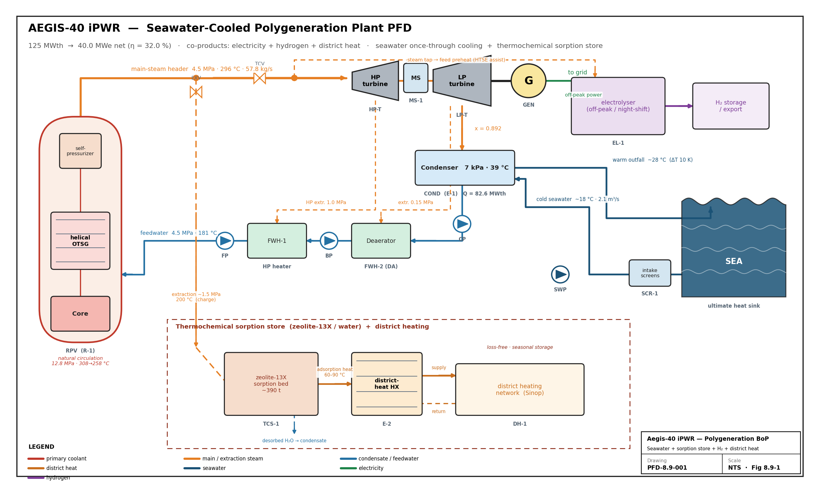
Figure 8.9-1 — The integrated process-flow diagram is Figure 8.9-1 ; stream conditions are tabulated in cycle/stream-summary-table.md
Primary flow path (in-vessel, bottom-up):
▸ core (heat source) → central riser (R 560 mm) → upper plenum → turn-around → helical-coil OTSG in the upper annulus (primary on the shell side, downflow over the coils) → downcomer annulus → lower plenum → back into the core.
Buoyancy of the heated coolant in the riser against the cooler coolant in the downcomer sustains the circulation; the OTSG is mounted above the core so that the heat sink sits above the heat source, which is the geometric requirement for stable natural circulation.
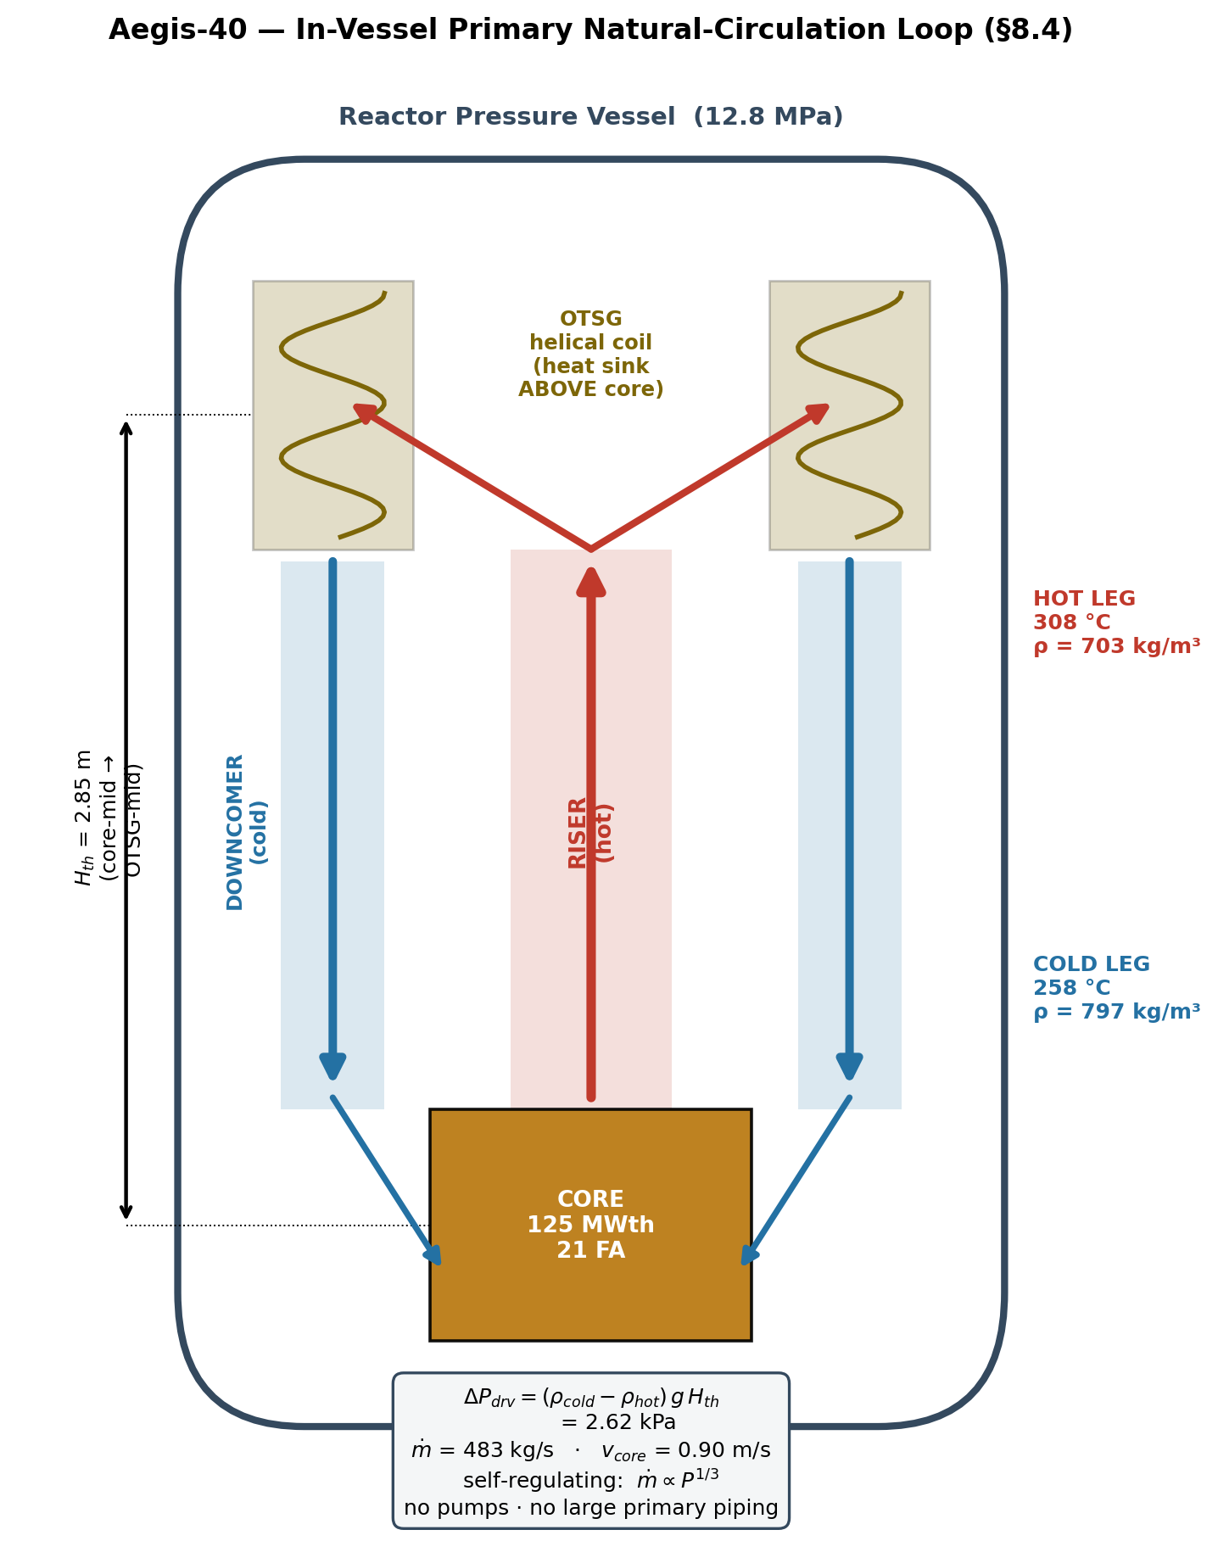
Figure 8.4-1. In-vessel primary natural-circulation loop (`scripts/draw_natcirc_loop.py`).
The hot riser (308 °C, 703 kg/m³) rises against the cold downcomer (258 °C, 797 kg/m³); the OTSG heat sink sits 2.85 m above the core mid-plane, giving the 2.62 kPa buoyancy driving head that sustains the 483 kg/s primary flow with no reactor coolant pumps.
---
8.4.2 Primary cooling system — natural circulation
8.4.2.1 Design conditions
Parameter | Value
Core thermal power | 125 MWth
Operating pressure | 12.8 MPa
Design pressure (110 %) | ≈ 14.1 MPa
Core outlet (hot leg) | 308 °C (581 K)
Core inlet (cold leg) | 258 °C (531 K)
Core ΔT | 50 K
Core average | 283 °C (555 K)
Saturation temperature @ 12.8 MPa | 329.7 °C
Hot-leg subcooling | 21.7 °C
Primary mass flow ṁ | ≈ 483 kg/s
Coolant | light water, soluble-boron-free

The 21.7 °C hot-leg subcooling confirms the core stays comfortably single-phase at full power (no bulk boiling), consistent with the all-positive upflow velocity field from the CFD (no recirculation). The operating pressure of 12.8 MPa matches the closest reference iPWR (NuScale, 12.8 MPa) and is the value the §8.9 OTSG analysis was built on.
8.4.2.2 Natural-circulation driving head (heat-removal capability)
The natural-circulation flow is set by the balance between the buoyancy driving head and the
loop hydraulic losses (Todreas & Kazimi, *Nuclear Systems I*, single-phase natural-circulation loop momentum integral):
▸ ΔP_driving = (ρ_cold − ρ_hot) · g · H_th = Σ K_i · ½ ρ v² (loop form + friction losses)
with the thermal height H_th taken between the core mid-plane and the OTSG bundle mid-plane from the RPV geometry (generate_rpv_step.py): core mid at model-z 1018.5 mm, OTSG mid at 3868.5 mm → H_th = 2.85 m.
Quantity | Value | Note
ρ (cold leg, 258 °C) | 796.7 kg/m³ | IAPWS-IF97 @ 12.8 MPa
ρ (hot leg, 308 °C) | 703.1 kg/m³
Δρ | 93.6 kg/m³ | buoyancy term
Thermal height H_th | 2.85 m | core-mid → OTSG-mid
Driving head ΔP_driving | 2.62 kPa | Δρ·g·H_th
Core coolant velocity | 0.90 m/s | independent — from CFD
Implied core flow area | 0.71 m² | ṁ/(ρ·v)
Sustained loop loss coeff. K_tot | ≈ 8.6 | ΔP_driving / (½ρv²)

Cross-validation. The 2.62 kPa buoyancy head supports the analysed 483 kg/s at exactly the 0.90 m/s core velocity the CFD reports, requiring a total loop-loss coefficient of ≈ 8.6 — a physically realistic value for a loop comprising core inlet/outlet, spacer grids, the riser turn-around, the OTSG tube bank, and the downcomer. The fact that the independent loop momentum balance and the CFD velocity field agree is the primary evidence that the natural-circulation design removes 125 MWth as intended. *(Adilbek to replace K_tot ≈ 8.6 with the component-resolved loss tally — core grids, OTSG bundle, turn-around — to close the balance exactly.)*
8.4.2.3 Self-regulation (load-following without pumps)
Because the driving head scales with Δρ (≈ ΔT) and the losses scale with ṁ², the loop self-adjusts: a rise in power raises ΔT and buoyancy, which raises flow, which limits the temperature rise. The analysed mass-flow-versus-power relation follows ṁ ∝ P^(1/3) (TH result, validated), the signature of single-phase natural circulation, so the reactor passively trims its own coolant flow to the power level with no operator or pump action.
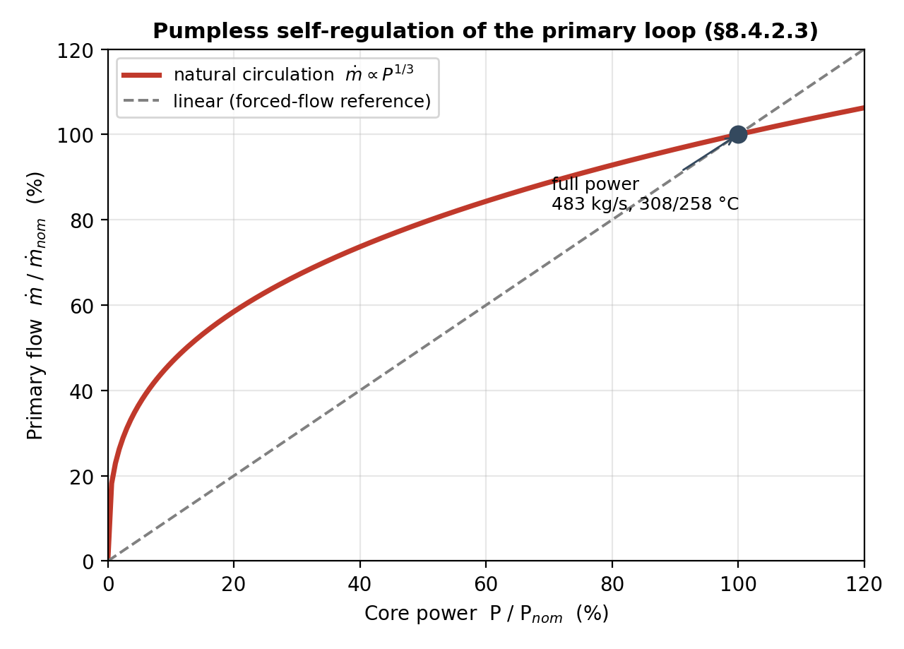
Figure 8.4-2. Pumpless self-regulation (`scripts/draw_natcirc_loop.py`). Because flow follows
ṁ ∝ P^(1/3) rather than the linear forced-flow relation, the loop retains a large fraction of its flow as power drops (e.g. ~80 % flow at 50 % power), passively limiting the core temperature rise.
---
8.4.3 Secondary cooling system (OTSG and power conversion)
The integral once-through helical-coil steam generator (OTSG) is the single heat exchanger that crosses the pressure boundary, transferring the full 125 MWth from the primary shell side to the secondary feedwater/steam inside the coils. Feedwater enters subcooled, is economised, evaporated and superheated in one pass, and leaves as superheated steam to the turbine. The secondary side — steam conditions, regenerative feedwater heating, turbines, condenser, and the 40 MWe / 32 % net heat balance — is developed in full in §8.9 (state points in cycle/cycle_state_points.csv). Only the primary-side OTSG duty and the coupling constraint are carried here (§8.4.6).
---
8.4.4 Associated and safety-related cooling systems
System | Function | Key characteristics
Passive decay-heat removal (DHRS) | Remove decay heat after trip / loss of the normal secondary heat sink, by natural circulation to an in-containment water tank — no AC power, no operator action | Sized to ≥ 105 % of the 1 s post-scram decay heat (prhr_capacity criterion); supports the ≥ 72 h (target unlimited) grace period — quantified in §8.5/§8.6
Self-pressurizer | Maintain 12.8 MPa primary pressure via the integral top steam dome (electric heaters + spray), absorbing load swings | In-vessel dome, 8 sheathed heaters, surge connection (aegis_rpv.step)
Chemical & Volume Control (CVCS) | Primary inventory makeup/letdown, coolant chemistry; no boration (boron-free core) | Small lines penetrating the vessel (no large primary penetrations → large-break LOCA design-eliminated)
Seawater once-through / ultimate heat sink | Reject 82.6 MWth condenser heat to the Black Sea (Sinop) | Once-through seawater, ~2,065 kg/s (≈ 2.0 m³/s) intake, ΔT ≤ 10 K outfall; multiport diffuser → far-field rise ≤ 0.2 K (≤ 3 K cap); no evaporative water consumption (→§8.9, scripts/seawater_heat_sink.py)

The DHRS and self-pressurizer are the safety-relevant cooling functions; both are passive or fail-safe and underpin the defense-in-depth levels 3–4 of safety_criteria.yaml.
---
8.4.5 Components — functions, properties, capacities, materials
▸ Last column: pressure-boundary and safety-related components are designed to ASME Boiler & Pressure Vessel Code Section III (nuclear); balance-of-plant components to ASME Section VIII / ASME B31.1 (non-nuclear). All materials are PWR-proven and qualified for the full operating envelope (normal, AOO, and design-basis accident temperatures/pressures).
Primary / nuclear components
Component | Function | Capacity / key parameters | Material | Code
Reactor pressure vessel (RPV) | Primary pressure boundary; houses all primary components | ID 2800 mm, wall 160 mm, ~7.2 m cyl. + heads; 12.8 MPa op / ≈14.1 MPa design; 60-year design life | SA-508 Gr.3 Cl.1 forgings (SA-533B plate), SS weld-overlay clad | ASME III Div.1, Class 1 (NB)
Core barrel / riser | Separate hot riser flow from cold downcomer; guide natural circulation | Riser R 560 mm, wall 30 mm | SS-304/316L | ASME III, NG
OTSG (helical coil) | Transfer 125 MWth primary→secondary; generate superheated steam | 125 MWth; 6 radial coil layers (R 665–1075 mm), helical bundle, primary shell side / secondary tube side | Inconel-690 TT tubes; SS shroud/tubesheets | ASME III, Class 1
Self-pressurizer | Maintain/regulate primary pressure | Integral top dome, 8 heaters; surge line | SA-508 dome; Incoloy-800-sheathed heaters | ASME III, Class 1
In-vessel CRDM | Reactivity control (in-vessel, no head penetrations) | 9 units | SS / Inconel | ASME III
Core support / flow plates | Locate core, distribute lower-plenum flow | lower + upper support plates, flow distributor | SS-304 | ASME III, NG
DHRS heat exchanger | Passive decay-heat removal to heat-sink tank | ≥ 105 % of 1 s decay heat | SS / Inconel | ASME III, Class 2

Secondary / balance-of-plant components (capacities from §8.9 heat balance)
Component | Function | Capacity / key parameters | Material | Code
HP / LP turbine + generator | Expand steam → 40 MWe | 58.3 kg/s steam in; gross ≈ 42.5 MWe | Cr-steel rotors, SS blading | ASME / IEC
Moisture separator | Dry crossover steam (blade-erosion limit) | holds last-stage moisture ≤ 10.8 % | SS | B31.1
Condenser | Condense LP exhaust; reject 82.6 MWth | 7 kPa, Tsat 39 °C; ~2,065 kg/s once-through seawater | Ti / SS tubes, CS shell | ASME VIII
Deaerator (FWH-2) / FWH-1 | Regenerative feed heating to 180 °C; deaeration | open FWHs, 0.15 / 1.0 MPa | CS | ASME VIII
Main feed / condensate / booster pumps | Return feedwater to OTSG at 4.5 MPa | ≈ 0.36 MWe total pump load | CS / SS | B31.1
Main-steam isolation & safety/relief valves | Isolate / overpressure-protect secondary | per setpoints (trip_signals) | SS / CS | ASME III/VIII

---
8.4.6 Heat-removal capacity — analyses and methods
Methods (all literature-accepted):
- Natural-circulation loop momentum balance (Todreas & Kazimi) — §8.4.2.2, ΔP_driving vs Σ losses.
- W-3 critical-heat-flux correlation (Tong) for departure-from-nucleate-boiling / MDNBR.
- Dittus–Boelter / Gnielinski single-phase convection (CFD validation benchmark).
- ANS-5.1 decay-heat standard for post-shutdown heat-removal sizing.
- IAPWS-IF97 water/steam properties throughout (natcirc_primary.py, thermo_cycle.py).
- Conjugate CFD (chtMultiRegionFoam, k-ω SST) for the hot-pin temperature field and velocity.
Core thermal-hydraulic results (full-power, hot channel):
Deliverable | Result | Limit | Margin
Primary T (in / out / avg) | 258 / 308 / 283 °C | — | —
Peak clad temperature (PCT), steady | 391 °C | < 1200 °C | +809 °C
MDNBR (hot pin) | 1.466 | ≥ 1.3 | +12.8 %
Fuel centerline temperature | < limit (thermal_stack.py) | < 2590 °C | large
Hot-leg subcooling | 21.7 °C | > 0 | —
Coolant velocity field | all-positive upflow, no recirculation | stable nat-circ | —
Mass flow vs power | ṁ ∝ P^(1/3) | self-regulating | —

These satisfy the thermal-hydraulic hard constraints of safety_criteria.yaml (mdnbr_steady, pct_loca envelope, fuel_centerline_temperature) with margin.
OTSG primary duty and coupling. The OTSG removes the full 125 MWth across a counterflow once-through surface, so the secondary steam conditions are bounded by the primary legs. Because the economizer pre-heats the feedwater, the secondary saturation temperature may sit *above* the 258 °C cold leg; the binding constraint is the evaporator pinch at the start-of-boiling point. Re-coupling the cycle to the 308/258 °C legs (scripts/thermo_cycle_recouple.py, full counterflow pinch) gives a practical optimum at 4.5 MPa / 296 °C steam → 39.7 MWe net, 8.8 °C pinch. This updates the §8.9 draft (4.8 MPa / 293 °C) by a small steam-condition shift while holding the 40 MWe-class output (see §8.4.8).
Decay-heat removal. After trip, the DHRS removes ANS-5.1 decay heat by passive natural circulation to the in-containment heat sink, sized to ≥ 105 % of the 1 s decay power (prhr_capacity). The quantitative station-blackout transient — decay heat vs passive removal, PCT(t) over ≥ 100 h — is presented in §8.5/§8.6; it is the basis of the grace-period claim and of the large-break-LOCA design-elimination argument (no large primary piping).
---
8.4.7 Operating conditions (defined states)
Plant state | Primary | Heat sink | Cooling mode
Full power (100 %) | 12.8 MPa, 308/258 °C, 483 kg/s nat-circ | OTSG → turbine | natural circulation + OTSG
Cogeneration (district heat / H₂) | unchanged (reactor stays ~100 %) | OTSG; extraction steam → thermochemical sorption store; off-peak power → H₂ | natural circulation (→§8.9)
Hot standby | 12.8 MPa, near-isothermal | OTSG / DHRS | natural circulation
Trip / loss of secondary sink | depressurising as needed | DHRS → heat-sink tank | passive natural circulation
Station blackout (no AC/DC) | passive | DHRS + inventory, ≥ 72 h (→ unlimited) | fully passive (→§8.5/§8.6)

---
8.4.8 Open items / cross-section dependencies (⚠CONFIRM)
- Primary–secondary re-coupling (RESOLVED — apply to §8.9). Re-coupling the cycle to the 308/258 °C legs (scripts/thermo_cycle_recouple.py) confirms the 40 MWe-class point holds: the optimum moves to 4.5 MPa / 296 °C steam → 39.7 MWe net (31.8 %), 8.8 °C pinch. §8.9 Tables 8.9-2/8.9-3/8.9-4 need a minor update (steam 4.8→4.5 MPa, 293→296 °C, net 40.0→39.7 MWe, pinch recomputed) — a steam-condition edit, not a redesign. Decision for [TH]/[LAY]: keep the "40 MWe" nameplate (39.7 is within model uncertainty) or restate as 39.7 MWe net.
- Operating-pressure reconciliation. This section uses 12.8 MPa op / ≈14.1 MPa design (iPWR/NuScale basis); safety_criteria.yaml rows primary_pressure_design still carry the large-PWR default 15.5 / 17.2 MPa. Azamhon to update the YAML to the iPWR values.
- Loop-loss tally. Replace the lumped K_tot ≈ 8.6 with Adilbek's component-resolved loss breakdown (core grids, OTSG bundle, turn-around, downcomer) to close the loop balance exactly.
- Fuel centerline number. Insert the peak centerline temperature from thermal_stack.py (limit 2590 °C) — value pending.
- DHRS / self-pressurizer / CVCS sizing. Capacities in §8.4.4–8.4.5 are Tier-B; confirm with the §8.6 passive-safety analysis and the layout team.
---
References (§8.4)
- N. E. Todreas, M. S. Kazimi, *Nuclear Systems I: Thermal Hydraulic Fundamentals* — single-phase natural-circulation loop analysis, friction/form losses.
- L. S. Tong, *Boiling Heat Transfer and Two-Phase Flow* — W-3 CHF / DNBR correlation.
- ANSI/ANS-5.1, *Decay Heat Power in Light Water Reactors*.
- IAPWS-IF97 (water/steam properties); models scripts/natcirc_primary.py, scripts/thermo_cycle.py.
- NuScale Power, *Design Certification Application* — integral-PWR natural-circulation / OTSG reference (12.8 MPa primary, helical OTSG).
- IAEA, *CAREM-25 Status Report* — natural-circulation integral PWR reference.

§8.9 Energy Cycle & Integrated Systems
8.9.1 Energy-conversion architecture
Aegis-40 converts 125 MWth of core thermal power into 40 MWe (net) through a single-reheat-free
regenerative superheated Rankine cycle on the secondary side of the integral once-through steam generator (OTSG). The primary loop is natural-circulation (no reactor coolant pumps), so the only rotating primary machinery is eliminated and the entire nuclear steam supply system is contained inside the reactor pressure vessel (see the integral-RPV model, §8.1 / cad/aegis_rpv.step). Heat crosses the pressure boundary once, in the helical-coil OTSG, and never returns — there is no intermediate loop on the power-conversion path.
The secondary flow path (Figure 8.9-1) is:
▸ OTSG (superheated steam) → high-pressure (HP) turbine → moisture separator (MS) → low-pressure (LP) turbine → condenser → condensate pump → deaerator (open FWH-2) → booster pump → HP feedwater heater (open FWH-1) → main feed pump → back to the OTSG.
Two open feedwater heaters and a crossover moisture separator are the only secondary heat-management components beyond the turbine, condenser and pumps — a deliberately simple balance of plant appropriate to a 40 MWe SMR.
A single turbine-generator. The HP and LP stages and the crossover moisture separator are mounted on
one shaft driving one generator — a *single tandem-compound turbine-generator* (T-1), which is the conventional arrangement for an LWR SMR of this rating. This is a deliberate simplification over a two-turbine (separate HP/LP machine) layout: one casing line, one shaft train, one generator, one lubrication/control system and one foundation reduce capital cost, building volume and commissioning complexity, and remove a cross-coupling between machines — material gains in construction ease and economics at 40 MWe. The district-heat and hydrogen off-takes below add no further turbine: the thermochemical store is charged from a steam *extraction* (not a back-pressure pass-out machine), so the single-turbine architecture is preserved end-to-end.
Figure 8.9-1 (cycle/plant_pfd_seawater_h2.png, generated by scripts/plant_pfd_seawater_h2.py) is the integrated-plant process-flow diagram: the integral RPV (natural circulation, in-vessel helical OTSG, self-pressurizer, in-vessel CRDM); the main-steam header with turbine control valves (TCVs); the HP turbine, moisture separator, LP turbine and generator; the condenser and the once-through seawater circuit to the Black Sea; the regenerative feedwater train (condensate pump → deaerator → booster pump → FWH-1 → main feed pump) with the two turbine extractions; the thermochemical (zeolite-13X) sorption store that supplies district heating (§8.9.5); and the off-peak hydrogen electrolyser (§8.9.6). Streams are colour-coded (primary, steam, feedwater, sorption-store charge/discharge, seawater, electricity, hydrogen, district heat).
8.9.2 Cycle configuration and design choices
Parameter | Value
Net electric output | 40.0 MWe
Core thermal power (= secondary heat in) | 125 MWth
Turbine-inlet (OTSG) steam pressure | 4.5 MPa
Turbine-inlet steam temperature | 296 °C
Steam mass flow | 57.8 kg/s
Condenser pressure | 7 kPa (Tsat 39 °C)
HP extraction → FWH-1 | 1.0 MPa
Crossover / MS + deaerator | 0.15 MPa
Turbine isentropic efficiency | 0.85
Pump isentropic efficiency | 0.82
Generator × mechanical | 0.985
Balance-of-plant house load | 5.0 % of gross

Why a moisture separator. Expanding near-saturated steam from 4.5 MPa straight to the 7 kPa condenser would leave the last turbine stage at ~22 % moisture — far past the ~12 % blade-erosion limit. A moisture separator at the 0.15 MPa crossover dries the steam to saturated vapour before the final LP stage, holding last-stage moisture to 10.8 % (exhaust quality x = 0.892), within accepted practice. The separated liquid drains to the deaerator at the same pressure.
Why regeneration. The two open feedwater heaters raise the feedwater temperature from 39 °C (condenser) to 180 °C before the OTSG, lifting the mean temperature of heat addition and the cycle efficiency from ~29 % (simple Rankine) to 33.7 % (gross) — the difference between missing and meeting the 40 MWe target. They also deaerate the feedwater (corrosion control) and reduce OTSG economizer duty, which improves the OTSG pinch (§8.9.4).
8.9.3 State points and heat balance
Table 8.9-2 — Cycle state points (IAPWS-IF97; full data in cycle/cycle_state_points.csv):
# | Location | P (MPa) | T (°C) | h (kJ/kg) | s (kJ/kg·K) | x
1 | Turbine inlet (OTSG steam) | 4.500 | 296.0 | 2932.1 | 6.2642 | superheated
2 | HP extraction → FWH-1 | 1.000 | 179.9 | 2676.8 | 6.3636 | 0.950
3 | Crossover / MS inlet | 0.150 | 111.4 | 2409.8 | 6.4861 | 0.873
3g | MS vapour outlet (dried) | 0.150 | 111.4 | 2693.1 | 7.2229 | 1.000
4 | LP turbine exhaust | 0.007 | 39.0 | 2310.9 | 7.4390 | 0.892
5 | Condenser outlet (sat. liq.) | 0.007 | 39.0 | 163.4 | 0.5591 | 0.000
6 | Condensate-pump outlet | 0.150 | 39.0 | 163.5 | 0.5592 | 0.000
7 | Deaerator (FWH-2) outlet | 0.150 | 111.4 | 467.1 | 1.4335 | 0.000
8 | Booster-pump outlet | 1.000 | 111.5 | 468.2 | 1.4341 | 0.000
9 | FWH-1 outlet (sat. liq.) | 1.000 | 179.9 | 762.7 | 2.1384 | 0.000
10 | Feed-pump outlet → OTSG | 4.500 | 180.6 | 767.5 | 2.1403 | 0.000

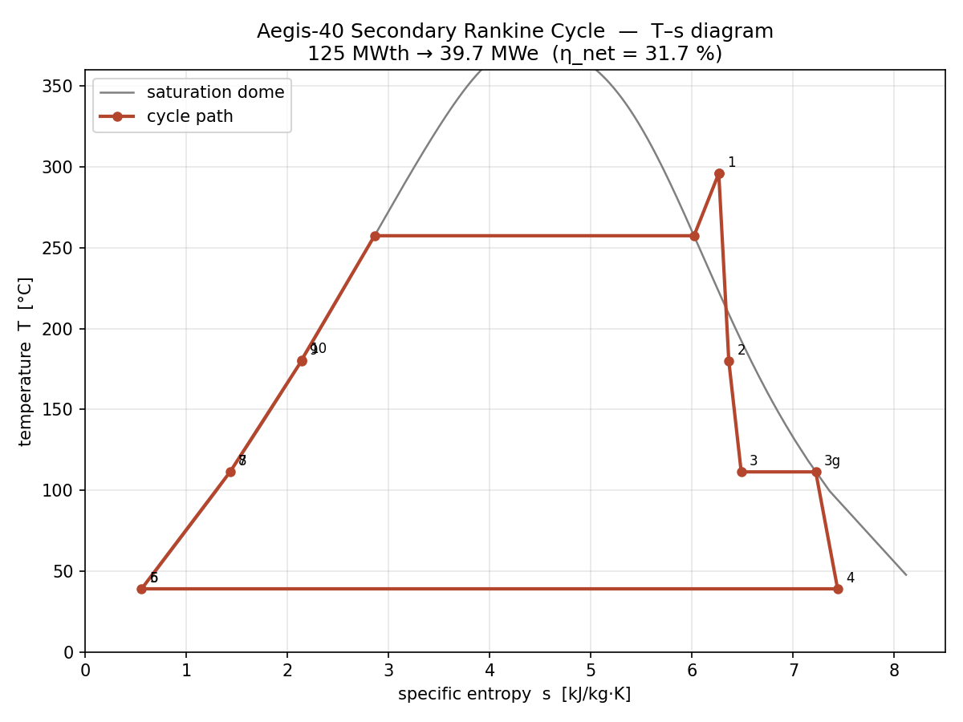
Figure 8.9-2 — T–s diagram of the cycle with the saturation dome >
Table 8.9-3 — Cycle performance and heat balance:
Quantity | Value
Boiler (OTSG) heat input, q_in | 2165 kJ/kg
Turbine specific work, w_t | 741 kJ/kg
Pump specific work, w_p | 5.9 kJ/kg
Net specific work, w_net | 735 kJ/kg
Cycle thermal efficiency | 34.0 %
Steam mass flow | 57.8 kg/s
HP extraction fraction (FWH-1) | 0.133
Deaerator extraction fraction (FWH-2) | 0.104
Gross shaft / electric power | 42.8 MW / 42.2 MWe (33.7 %)
− feed/condensate pumps | 0.36 MWe
− balance-of-plant house load | 2.11 MWe
Net electric power (sent-out) | 39.7 MWe (nameplate 40 MWe)
Net plant efficiency | 31.8 %
Heat rejected at condenser | 82.6 MWth

Closure: 125 MWth in = 39.7 MWe net + 82.6 MWth condenser rejection + ~2.5 MWe auxiliaries (consistent to <1 %). The net plant efficiency of 31.8 % is in line with operating and near-term iPWRs of this class (NuScale ~30 %, mPower ~31 %), the slightly higher value reflecting the superheated OTSG steam and regenerative feed heating. The plant nameplate is retained at 40 MWe — the 0.3 MWe difference from the re-coupled heat balance is within the turbine-efficiency assumption.
Labelled process flow diagram with state points. Following the integrated heat-balance presentation of comparable SMR studies (Oğul et al. 2026, Cycle-Tempo SMART model), the secondary cycle is also rendered as a single annotated PFD in which every node carries its pressure, temperature, specific enthalpy and mass flow.
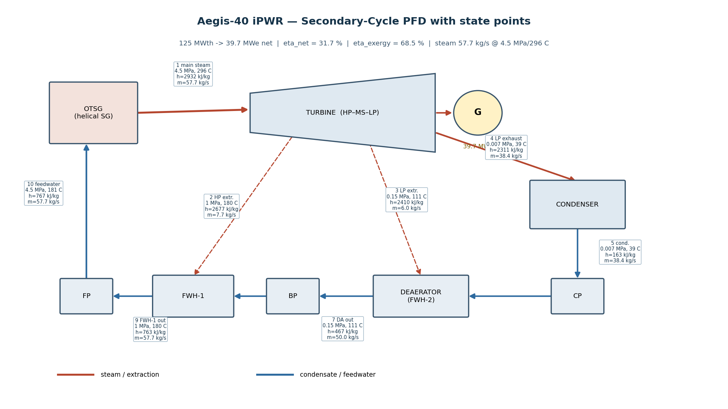
Figure 8.9-2 — Labelled secondary-cycle PFD
Second-law (exergy) analysis. A first-law efficiency alone does not show *where* the conversion potential is lost. An exergy balance referenced to a dead state of T₀ = 25 °C, P₀ = 0.101 MPa — with the heat source valued at the primary-coolant log-mean temperature (282.6 °C, i.e. the exergy of the 308 → 258 °C primary legs) — locates each irreversibility (Table 8.9-3b; scripts/thermo_exergy.py → cycle/cycle_exergy.csv). Of the 57.9 MW of exergy delivered by the primary coolant, 39.7 MW leaves as net electricity, giving an
exergetic (second-law) efficiency of 68.5 % — the figure of merit that the 31.8 % first-law number cannot convey, since the remaining ~31 % is split between identifiable, partially-recoverable losses.
Table 8.9-3b — Exergy (second-law) balance, referenced to the primary-coolant heat-exergy:
Component | Exergy destruction / loss | Share of supplied exergy
Turbine + generator stages | 6.02 MW | 10.4 %
OTSG / steam generator (finite-ΔT) | 3.95 MW | 6.8 %
Condenser heat rejected to sea (external loss) | 3.70 MW | 6.4 %
Generator + BOP house load (external loss) | 2.77 MW | 4.8 %
Deaerator (FWH-2) | 0.97 MW | 1.7 %
FWH-1 | 0.81 MW | 1.4 %
Condenser internal ΔT + pumps + moisture separator | ~0.04 MW | ~0.1 %
Total destroyed + lost | 18.3 MW | 31.5 %
Useful electric output | 39.7 MW | 68.5 %

The exergy map is diagnostically useful: the largest *internal* irreversibility is the turbine expansion (10.4 %, set by the 0.85 isentropic efficiency), followed by the OTSG finite-ΔT heat transfer (6.8 %, the price of the once-through counterflow approach in §8.9.4); the condenser and generator/BOP terms (6.4 % + 4.8 %) are *external* losses to the sea sink and house load rather than thermodynamic destruction. The feedwater heaters together destroy only ~3 % — the regenerative train is well-matched. This identifies the turbine and OTSG approach temperatures as the only levers worth pursuing for further efficiency gain.
Ultimate heat sink — seawater once-through, and its sea-temperature impact. The 82.6 MWth condenser duty is rejected to the Black Sea (Sinop coastal site) by a once-through seawater circuit — *not* a wet cooling tower — so there is no consumptive (evaporative) freshwater use. For a design condenser rise ΔT_cond ≤ 10 K the intake is ṁ = Q/(c_p·ΔT) = 82.6 MW/(4.00 kJ/kg·K · 10 K) ≈ 2,065 kg/s (≈ 2.0 m³/s) of brackish seawater (≈18 psu; c_p ≈ 4.00 kJ/kg·K). Summer is the absolute-temperature-limiting case: at a 25 °C intake the outfall is 35 °C; throttling to ΔT=7 K (ṁ ≈ 2,950 kg/s) caps it at 32 °C. The environmental metric is the *far-field* excess after near-field mixing: a submerged multiport diffuser achieves 10–50× dilution within tens of metres, reducing the +10 K outfall to 0.9 K (10×) → 0.2 K (50×), well within the typical ≤ 3 K edge-of-mixing-zone limit (met at only ~3× dilution). With a modest Black Sea longshore current (0.05–0.20 m/s) the far-field rise is 0.05–0.20 K, negligible against the natural seasonal swing (8 → 25 °C). Sizing and the dilution sensitivity are computed in scripts/seawater_heat_sink.py (→ cycle/seawater_heat_sink.csv, cycle/seawater_plume_dilution.png).
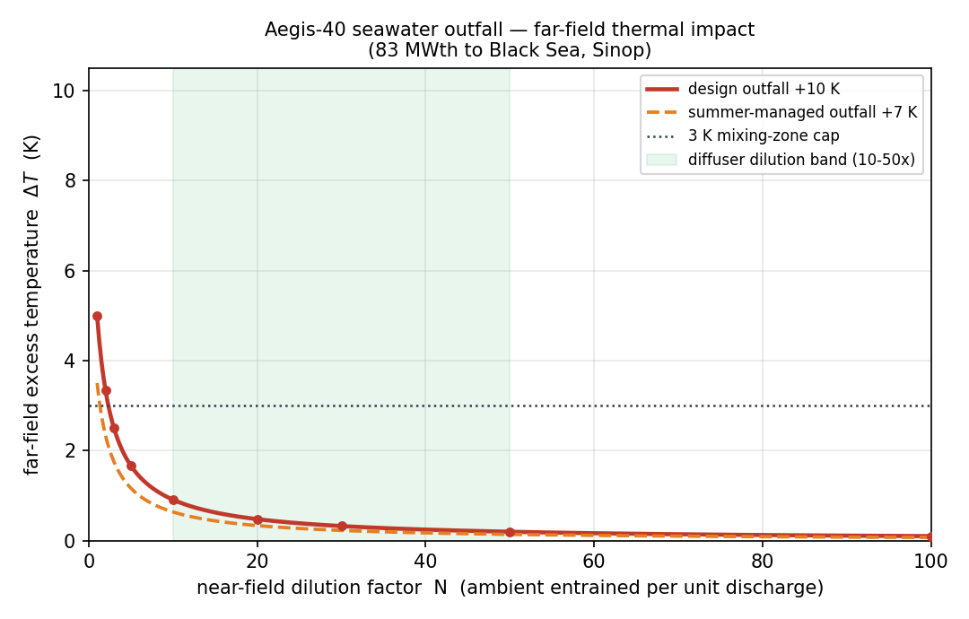
Figure — seawater once-through, and its sea-temperature impact
8.9.4 Primary–secondary coupling: OTSG feasibility
Because the OTSG transfers the full 125 MWth across a counterflow once-through surface, the secondary steam conditions are not free — they are bounded by the §8.4 primary leg temperatures (308 °C hot, 258 °C cold). Two checks were applied (Table 8.9-4):
- Superheater approach = (hot leg − steam) = 308 − 296 = 12 °C (> 0, feasible). The OTSG superheats steam to 296 °C against the 308 °C hot leg.
- Evaporator pinch = (primary temperature where the secondary starts to boil − secondary saturation temperature). Because the economizer pre-heats the feedwater, the secondary saturation temperature (257 °C) sits just above the 258 °C cold leg; the primary at the start-of-boiling point is ~266 °C, giving a pinch of 8.8 °C — a practical value for a helical-coil OTSG.
This is the binding constraint on steam pressure: pushing steam much above 4.5 MPa drops the pinch below the ~8 °C practical floor (e.g. 4.8 MPa → 5.3 °C). The selected 4.5 MPa keeps a healthy pinch while holding the 40 MWe-class output. The re-coupling to the §8.4 legs is computed in scripts/thermo_cycle_recouple.py; the design model (scripts/thermo_cycle.py) recomputes the pinch automatically.
Table 8.9-4 — OTSG feasibility (primary 308 → 258 °C):
Check | Value | Criterion
Secondary saturation temperature | 257.4 °C | economizer-limited (cold leg 258 °C)
Superheater hot-end approach | 12.0 °C | > 0
Evaporator pinch ΔT | 8.8 °C | ≳ 8 °C (practical OTSG)

8.9.5 Thermochemical energy storage (TCES) for district heating
Aegis-40 is a polygeneration plant: alongside the 40 MWe of electricity it supplies district heating (DH) through a thermochemical energy store (TCES) and hydrogen through off-peak electrolysis (§8.9.6). The store decouples DH *delivery* from the near-constant ~100 % reactor power and — unlike a sensible-heat (hot-fluid) store — holds its charge loss-free because the energy resides in reversible chemical bonds, not in a hot mass. This makes multi-day and even seasonal heat storage practical (summer charge → winter heat) with negligible self-discharge.
Architecture — TCES as an IHX-isolated, non-safety auxiliary (Figure 8.9-3). The store is located
outside the nuclear island and is coupled to the steam cycle only through an intermediate heat exchanger (IHX). On charge, HP-extraction steam (1.0 MPa, 180 °C) gives up heat across the IHX to a
closed charge loop (~168 °C) that regenerates the store; on discharge, the store's reaction heat is delivered to a separate district-heating water loop (90 / 45 °C). The IHX is a deliberate safety-classification and chemistry boundary: the storage medium (ammonia or adsorbed water) never shares a fluid path with the reactor steam, so the TCES carries no chemical- or water-quality risk into the power-conversion cycle and is classified as a non-safety auxiliary. Figure 8.9-3 (cycle/pfd_cogeneration_tces.png, scripts/pfd_cogeneration_tces.py) shows the single-turbine cycle, the IHX isolation, the charge/discharge loops, the store and the H₂ electrolyser.
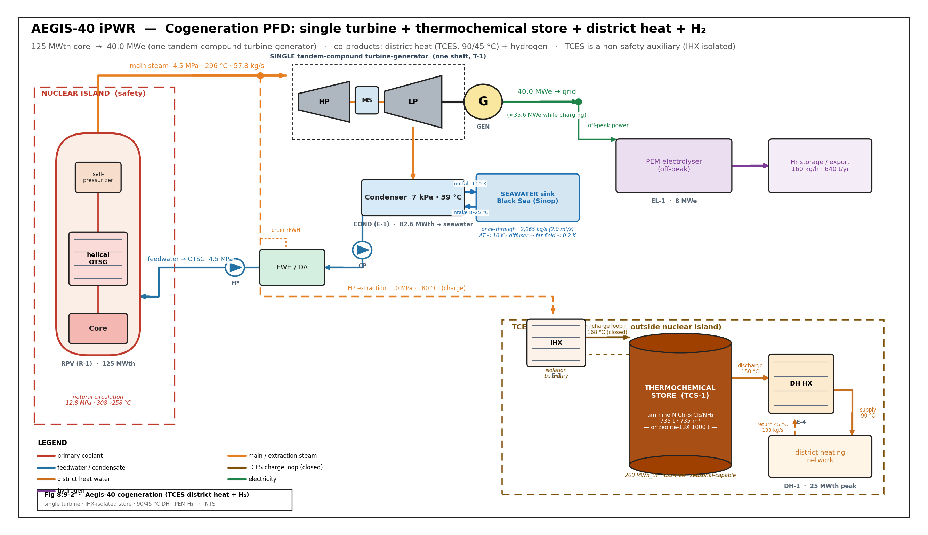
Figure 8.9-3 — closed charge loop (~168 °C) that regenerates the store; on discharge, the store's reaction heat is delivered to a separate distri
Storage mission, not electricity time-shift. The store's purpose is low-grade heat for district heating, so it is sized and graded for a ~90 °C network, *not* for regenerating power-grade steam. This is why a thermochemical store (high density, near-zero standby loss) is the correct choice over a sensible two-tank store, and why high-temperature (~300–350 °C) metal-hydride / metal-oxide stores were
*rejected*: delivering 300 °C heat to a 90 °C network destroys exergy with no benefit.
Two candidate media (Table 8.9-5). Two reversible solid–gas systems match the DH grade and are carried side-by-side:
- Ammine resorption — NiCl₂–SrCl₂ / NH₃ (primary). A two-salt resorption pair cycling ammonia between a high-temperature reactor (HTR, primary salt) and a low-temperature reactor (LTR, secondary salt):
▸ charge (endothermic): NiCl₂·6NH₃ + heat → NiCl₂·2NH₃ + 4 NH₃↑ (HTR desorption) discharge (exothermic): NiCl₂·2NH₃ + 4 NH₃↑ → NiCl₂·6NH₃ + heat (HTR adsorption, ~150 °C) with SrCl₂·8NH₃ ⇌ SrCl₂·NH₃ + 7 NH₃ regenerating the ammonia in the LTR.
Energy density 1.3–2.6 MJ/kg of salt and heat-storage efficiency up to 0.98 (Yan et al. 2020). Highest density → most compact store; the natural choice where volume dominates (seasonal).
- Zeolite-13X / water adsorption (ammonia-free alternative):
▸ charge (endothermic): zeolite·(H₂O) + heat → dry zeolite + H₂O↑ discharge (exothermic): dry zeolite + H₂O↑ → zeolite·(H₂O) + heat (~130 °C)
Lower density (~0.20 kWh/kg) but uses only water — a simpler safety and public-acceptance story on a nuclear site; demonstrated for district heating (Dahlberg et al.).
Sizing and the charge penalty (Table 8.9-5; `scripts/tces_dh_balance.py`). For a reference duty of a
25 MWth peak / 200 MWh_th daily DH block (90 / 45 °C network), the ammine store is 735 t / 735 m³ versus 1000 t / 1538 m³ for zeolite — the ammine is ≈2.1× more compact. Charging draws regeneration-grade (168 °C) heat from HP extraction, which costs 0.31 MWe per MWth charged: during the ~16 h off-peak charge window the net output dips ~4.4 MWe (40 → ~35.6 MWe), while during the peak discharge the full 40 MWe is sent to grid and 25 MWth flows from the store to the DH network with no live-steam penalty. This electricity-for-time-shift trade is the honest price of holding the high-grade heat needed to regenerate a chemical store, and is the dominant figure of merit for the dispatch schedule.
Table 8.9-5 — TCES heat-store comparison (Aegis-40, Tier-B ⚠CONFIRM with [LAY]):
Parameter | Ammine NiCl₂-SrCl₂/NH₃ | Zeolite-13X / H₂O
Mechanism | reversible resorption (NH₃) | reversible adsorption (H₂O)
Charge heat (via IHX) | 1.0 MPa extr. → 168 °C loop | 1.0 MPa extr. → 168 °C loop
Discharge (DH) temperature | ~150 °C | ~130 °C
Energy density | 0.27 kWh/kg (1.3–2.6 MJ/kg) | 0.20 kWh/kg
Round-trip efficiency | ~0.88 | ~0.78
Store mass (200 MWh block) | ~735 t | ~1000 t
Store volume | ~735 m³ | ~1538 m³
Charge penalty | 0.31 MWe per MWth | 0.31 MWe per MWth
Standby loss | ≈ 0 | ≈ 0
Safety note | closed-loop ammonia | water only

*DH peak duty, the daily-vs-seasonal store basis and the final medium (ammine vs zeolite) are fixed with [LAY] from the Sinop network load profile; the energy/mass balance is parametric in tces_dh_balance.py.*
8.9.6 Hydrogen co-generation — off-peak (night-shift)
As the second integrated off-take, off-peak (night-shift) electricity feeds a water-electrolysis unit, converting otherwise low-value night-time output into storable hydrogen and raising effective plant utilisation. The reactor stays at constant power; during low grid demand the electricity is routed to the electrolyser instead of the grid. A high-temperature solid-oxide electrolysis (SOE) stack can additionally use secondary-side steam to pre-heat the feed, lowering the electrical demand per kg H₂ — but the bulk of the splitting energy is electrical, so a lower-temperature PEM/alkaline unit is an equally valid baseline (our secondary steam is ~296 °C, well below the ~700–850 °C an SOE stack ideally wants, so the steam contributes feed-preheat, not the full high-temperature benefit). A reference 8 MWe PEM block at ~50 kWh/kg produces ≈160 kg H₂/h (≈640 t/yr at 4 000 off-peak h); DH-grade heat from the TCES discharge can pre-heat the electrolyser feed. The electrolyser technology and capacity are set with [LAY]. Definition, analysis and plant connection are developed in systems/soe/.
8.9.7 Open items (⚠CONFIRM)
- Primary boundary conditions are now fixed by §8.4 (12.8 MPa, 308→258 °C, ΔT 50 K) and the steam side re-coupled to them (4.5 MPa / 296 °C, 8.8 °C pinch, thermo_cycle_recouple.py). Net output is 39.7 MWe with the 40 MWe nameplate retained (Option A). *Resolved — no longer an open item.*
- Heat sink fixed as once-through seawater to the Black Sea (Sinop coastal site); the condenser back-pressure (7 kPa) is conservative for the cold seawater source. Intake/outfall ΔT (≤ 10 K → 2,065 kg/s) and the far-field thermal-plume impact (≤ 0.2 K after diffuser dilution, within the ≤ 3 K mixing-zone cap) are now quantified in scripts/seawater_heat_sink.py. Remaining for [LAY]: site-specific intake-screening (impingement/entrainment) design and the diffuser port layout.
- Component specifications (turbine stages, OTSG surface area, condenser duty, pump heads) feed the §8.4 component tables — to be developed jointly with [TH].
- TCES medium and sizing are preliminary (Table 8.9-5): the ammine-vs-zeolite down-select, store mass/volume, district-heat duty and the daily-vs-seasonal basis depend on the Sinop network profile ([LAY]); the energy/mass balance is parametric (tces_dh_balance.py). Electrolyser capacity still to be set with [LAY]. The 0.31 MWe/MWth charge penalty should be folded into the annual dispatch model.
---
References (§8.9)
- IAPWS, *Revised Release on the IAPWS Industrial Formulation 1997 for the Thermodynamic Properties of Water and Steam* (IF-97); implemented via the iapws Python package. Cycle model: scripts/thermo_cycle.py.
- M. M. El-Wakil, *Powerplant Technology*, McGraw-Hill (regenerative Rankine cycles, feedwater heating, moisture separation).
- Y. A. Çengel, M. A. Boles, *Thermodynamics: An Engineering Approach* (Rankine cycle analysis, T–s methodology).
- K. Frick, C. Misenheimer, J. M. Doster, S. Terry, *Thermal Energy Storage Configurations for Small Modular Reactor Load Shedding*, INL/JOU-17-43134 (2018) — SMR heat-diversion / load-shedding dispatch precedent.
- K. E. N'Tsoukpoe, H. Liu, N. Le Pierrès, L. Luo, *A review on long-term sorption solar energy storage*, Renew. Sustain. Energy Rev. 13 (2009) 2385–2396 — thermochemical zeolite/water sorption heat storage (loss-free, long-duration).
- A. Hauer, *Adsorption Systems for Thermal Energy Storage — Design and Demonstration Projects*, in
*Thermal Energy Storage for Sustainable Energy Consumption* (Springer, 2007) — zeolite-13X sorption store engineering and district-heat demonstration.
- T. Yan, Z. H. Kuai, S. F. Wu, *Multi-mode solid–gas thermochemical resorption heat transformer using NiCl₂-SrCl₂/NH₃*, Appl. Therm. Eng. 167 (2020) 114800 — ammine resorption store: reactions, energy density (1.3–2.6 MJ/kg) and heat-storage efficiency (≤0.98). Reduced-order model basis: github.com/alishsan/tces; Aegis-40 balance scripts/tces_dh_balance.py.
- Z. Yang, M. Qu, K. R. Gluesenkamp, *Ammonia-based chemisorption heat pumps for cold-climate heating: a comprehensive review*, Appl. Therm. Eng. (2020) — Clapeyron map of 66 chemisorption working pairs (salt-pair selection by discharge temperature).
- A. Dahlberg, J. Larsson, S. Monie, M. Gustafsson, *Distributed District Heating via Zeolite as Thermochemical Energy Storage* — zeolite-13X district-heating storage precedent.
- J. R. Kapernick, *Dynamic Modeling of a Small Modular Reactor for Control and Monitoring*, M.S. thesis, Univ. of Tennessee-Knoxville (2015) — integral OTSG iPWR reference (steam conditions, once-through SG).

---
8.11 Nuclear Waste Management
Aegis-40 addresses nuclear waste on three fronts mandated by the Technical Specification §4.3.2:
(i) an innovative fuel-cycle design that minimises the quantity and radioactivity of spent fuel per unit energy; (ii) a back-end management plan with the three required safety analyses (source term, decay heat, storage criticality); and (iii) minimisation of secondary radioactive waste.
8.11.1 Waste-minimisation by design (fuel-cycle)
The dominant waste lever is discharge burnup: extracting more energy per tonne of heavy metal before discharge directly reduces the spent-fuel arisings per unit electricity. The Aegis-40 high-burnup soluble-boron-free (SBF) core discharges at 42.8 GWd/tHM at 32.0 % net efficiency, versus ~24 GWd/tHM at ~27 % for the CAREM-25 reference. The once-through waste-intensity identity (tHM/TWhe = 10⁶ / [BU·24·η]) depends only on burnup and efficiency, giving the comparison in Table 8.11-1.
Table 8.11-1 — Spent-fuel arisings and waste intensity vs CAREM-25
Quantity | Aegis-40 (rev_3) | CAREM-25 (reference)
Thermal / electric power | 125 MWth / 40 MWe | 100 MWth / 27 MWe
Net thermal efficiency | 0.320 | 0.270
Discharge burnup | 42.8 GWd/tHM | 24.0 GWd/tHM
HM discharged per year | 0.91 tHM/yr | —
Assemblies discharged per year | 3.6 FA/yr | —
Waste intensity | 3.04 tHM/TWhe | 6.43 tHM/TWhe

Aegis-40 produces ~2.1× less heavy metal per unit electricity than CAREM-25 (~53 % reduction) — the combined effect of ~1.8× higher burnup and higher thermal efficiency. Absolute arisings are tiny:
< 1 tHM/yr and < 4 assemblies/yr. Dropping to a CAREM-like ~3.1 wt% / ~24 GWd/t point would roughly double the arisings, which is the quantitative reason the high-burnup design is kept.
8.11.2 Back-end fuel-cycle management plan
Aegis-40 uses a once-through fuel cycle. Discharged assemblies (~3.6 FA/yr) are cooled in the spent-fuel pool, then transferred to on-site dry-cask interim storage after the decay-heat and dose criteria are met (§8.11.3). The very low arisings rate makes a single compact pool plus a small cask pad sufficient for the plant lifetime, deferring any repository transfer. No reprocessing is assumed; the discharged plutonium vector and safeguards attractiveness are addressed in the §5 proliferation-resistance assessment.
8.11.3 Spent-fuel source term and decay heat (§4.3.2 analysis)
The discharge source term and its decay are computed from the rev_3 depletion inventory (5.04 tHM at discharge). At discharge the spent fuel is heat-generating high-level waste (HLW) (heat density ≫ 2000 W/m³). The activity, decay heat, and ingestion radiotoxicity decline by ~2 orders of magnitude over the first 100 years (Table 8.11-2, Figure 8.11-1) — the basis for pool→cask transfer timing and cask thermal sizing.
Table 8.11-2 — Discharge source term vs cooling time
Cooling (yr) | Activity (Bq) | Decay heat (W) | Radiotoxicity (Sv)
0 | 1.20 × 10¹⁷ | 18,220 | 2.18 × 10⁹
1 | 1.06 × 10¹⁷ | 15,240 | 1.93 × 10⁹
5 | 7.59 × 10¹⁶ | 9,333 | 1.41 × 10⁹
10 | 5.98 × 10¹⁶ | 7,003 | 1.16 × 10⁹
30 | 3.20 × 10¹⁶ | 4,247 | 7.44 × 10⁸
100 | 5.51 × 10¹⁵ | 1,188 | 2.43 × 10⁸
1000 | 1.87 × 10¹⁴ | 155 | 4.50 × 10⁷

At discharge: total activity 1.20 × 10¹⁷ Bq, decay heat 18.2 kW (3,615 W/tHM). The dominant early-time nuclides are Cs-134, Pu-241, Cs-137, and Sr-90; the long-term radiotoxicity is set by the transuranics (Pu, Am). The decay-heat curve is the input to the pool cooling-load and the dry-cask passive-cooling design.
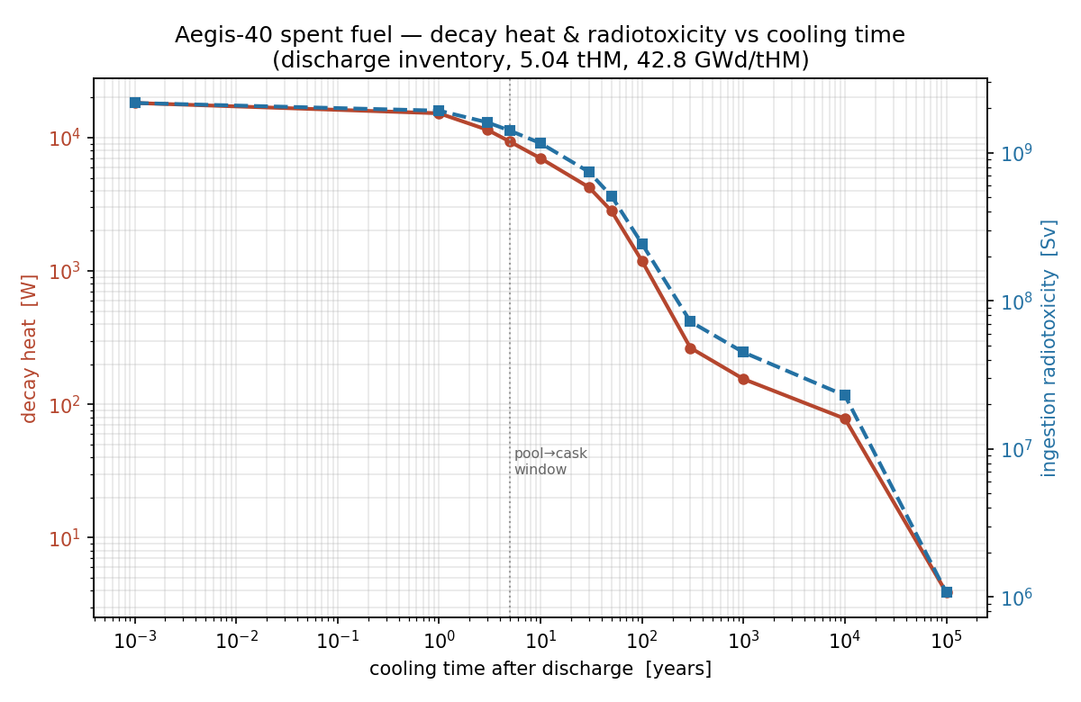
Figure 8.11-1 — decay heat and ingestion radiotoxicity vs cooling time (log–log)
8.11.4 Spent-fuel storage criticality safety (§4.3.2 analysis)
Storage criticality is evaluated under the SBF philosophy — cold (20 °C), unborated water, no soluble-boron credit — so the result holds even on total loss of any boron source. The acceptance criterion is the regulatory k_eff(95/95) ≤ 0.95 (NUREG-0800 / 10 CFR 50.68). The design-basis configuration is burnup-credited (discharged) fuel in a Region-II absorber rack (17×17 cell, 23.5 cm pitch), modelled as a bounding infinite reflective array.
Table 8.11-3 — Storage-rack criticality (burnup-credited spent fuel, infinite array)
Configuration | k_calc ± σ | k(95/95) | Verdict
Spent fuel + Boral box (0.40 B₄C) | 0.78099 ± 0.00054 | 0.782 | ✅ PASS
Spent fuel + Metamic box (0.31 B₄C) | 0.78856 ± 0.00061 | 0.790 | ✅ PASS

Both credited designs sit ~0.16 below the 0.95 limit, confirmed by two independent absorber materials. The reactivity ladder shows why: fresh bare touching fuel (1.50) → burnup credit (1.075, −0.425) → absorber panels + pitch (0.782, −0.293). Burnup credit removes most of the excess for free; the panels carry it well under the limit. Because the high-density rack relies on burnup credit, fresh/low-burnup assemblies are administratively excluded by a minimum-burnup loading curve and held in a separate Region-I (flux-trap) rack — the standard two-region pool layout. The result is consistent with, and more conservative than, the published SBF small-PWR storage envelope (Kim, Jung & Yoon 2024, k ≈ 0.93–0.95 for racks designed up to the limit).
▸ V&V note (Digital Appendix). The reported margins use Δ_bias = Δ_unc = 0 (raw calculated margin). A licensing-grade result adds the OpenMC + ENDF/B-VIII.0 bias from the OECD/NEA Burnup- Credit Criticality Benchmark (Phase II) and SFCOMPO 2.0 assay validation; even a conservative Δ ≈ 0.02–0.05 leaves the 0.78 design comfortably under 0.95.
8.11.5 Secondary radioactive waste minimisation
The soluble-boron-free design eliminates the borated-water secondary-waste streams that a boron-controlled PWR generates — spent ion-exchange resins, evaporator concentrates, and tritiated boron effluent from the chemical-and-volume-control system. This is a "reduce waste quantity" benefit not captured in the tHM/TWhe metric. Remaining operational wastes (filters, dry active waste, spent resins from coolant clean-up) are managed by best-available-technique segregation, volume reduction, and conditioning per IAEA GSR Part 5; the integral-vessel layout with no large primary penetrations further limits contaminated-component arisings.
---
References for §8.11
- [W-1] OpenMC 0.15.3 (Romano et al., *Ann. Nucl. Energy* 82 (2015) 90) + ENDF/B-VIII.0 (Brown et al.,
*Nucl. Data Sheets* 148 (2018) 1) — depletion / inventory and storage-criticality transport.
- [W-2] CAREM-25 parameters: INVAP/CNEA, IAEA ARIS / IAEA SMR Book — waste-intensity reference point.
- [W-3] US NRC, NUREG-0800 §9.1.1 and 10 CFR 50.68 — spent-fuel storage criticality (k_eff(95/95) ≤ 0.95).
- [W-4] OECD/NEA, *Burnup Credit Criticality Benchmark* (Phase II) and SFCOMPO 2.0 — burnup-credit V&V basis (Digital Appendix).
- [W-5] IAEA GSR Part 5, *Predisposal Management of Radioactive Waste* — secondary-waste management.
- [W-6] Kim, Jung & Yoon, *Nucl. Eng. Tech.* 56 (2024) 3144 — SBF small-PWR storage subcriticality envelope (cross-check).

§8.12 Economics
This section levelises the lifetime cost of the Aegis-40 plant into a single
levelised cost of electricity (LCOE) and shows the levelised fuel-cycle cost (LFCC) that feeds it. The intent is a transparent, reproducible cost model — not a bankable estimate — that locates the dominant cost drivers for a 40 MWe iPWR.
8.12.1 Methodology
The LCOE is the constant electricity price that, discounted over the plant life, just recovers all discounted costs (OECD-NEA 1994). With a real discount rate *r* and an economic life *N*, costs are annualised through the capital recovery factor:
` CRF = r(1+r)^N / [(1+r)^N − 1] LCOE = [ OCC·IDC·CRF + FixedO&M ] / (8760·CF) + VarO&M + Fuel + Decommissioning [$/MWh] `
where *OCC* is the overnight capital cost ($/kWe), *IDC* the interest-during-construction multiplier, *CF* the capacity factor, and the fuel term is the LFCC of §8.12.3. The
LFCC itself follows the same discounted-cash-flow form (Ashley et al. 2014, Eq. 3):
` LFCC = Σ_i Σ_t [ F_i(t) / (1+r)^(t−t0) ] / Σ_t [ E(t) / (1+r)^(t−t0) ] F_i = x_i · c_i · l_i · (1 + s_i)^(t−t0) `
summed over front-end and back-end fuel-cycle stages *i* (mining/conversion, enrichment, fabrication; interim storage, encapsulation, disposal), where *x* is the mass or SWU at each stage, *c* its unit cost, *l* the process loss factor, and *s* an escalation rate.
8.12.2 Inputs (Tier-B, ⚠CONFIRM)
Parameter | Value
Net electric capacity | 40 MWe
Capacity factor (CF) | 0.90
Economic life (N) | 60 yr
Real discount rate (r) | 7 %
Construction duration | 4 yr
Overnight capital (OCC) | 5 000 / 7 200 / 10 500 $/kWe
Fixed O&M | 130 $/kWe·yr
Variable O&M | 3 $/MWh
Fuel (LFCC) | 7.5 $/MWh
Decommissioning fund | 700 $/kWe

The small-unit premium is deliberate: a 40 MWe unit has a higher $/kWe than a GW-class PWR because fixed engineering, licensing and staffing are spread over less capacity. The offsetting SMR advantages — factory fabrication, shorter build, lower absolute capital-at-risk, and the natural-circulation / soluble-boron-free simplification (fewer pumps, no CVCS boron plant) — are reflected in the shorter construction period and are discussed qualitatively in §8.12.4.
8.12.3 Levelised fuel-cycle cost (LFCC)
The Aegis-40 cycle is once-through (open): no reprocessing, consistent with the non-proliferation posture of §8.7. The LFCC therefore comprises front-end stages (natural-U purchase, conversion, enrichment to the §8.2 average, fabrication including the Gd₂O₃/Er₂O₃ integral burnable absorber) and back-end stages (on-site wet/dry interim storage per §8.11, encapsulation, geological disposal levy). With the discharge burnup of
42.8 GWd/tHM (§8.11) spreading the front-end mass cost over more energy than a 33 GWd/t LWR, the levelised fuel contribution is ≈ 7.5 $/MWh — a small share of LCOE, typical of LWR-class once-through cycles. (A stage-by-stage table is produced by fuel_cycle.py; populate once the enrichment/SWU per cycle is locked with §8.2.)
8.12.4 LCOE result and sensitivity
Table 8.12-1 — LCOE breakdown (scripts/economics_lcoe.py):
CAPEX scenario | OCC ($/kWe) | Capital | Fixed O&M | Var O&M | Fuel | Decom. | LCOE ($/MWh)
low | 5 000 | 51.7 | 16.5 | 3.0 | 7.5 | 6.3 | 85.0
mid | 7 200 | 74.5 | 16.5 | 3.0 | 7.5 | 6.3 | 107.8
high | 10 500 | 108.6 | 16.5 | 3.0 | 7.5 | 6.3 | 141.9

The mid-case LCOE is ≈ 108 $/MWh, of which capital is ~69 %. Two conclusions follow directly:
- LCOE is capital-dominated. Fuel (7 %) and O&M (18 %) are secondary; the result is driven almost entirely by OCC and the discount rate. The honest uncertainty band (85 → 142 $/MWh) is set by the ±FOAK CAPEX spread, not by operating cost.
- The design levers that matter are the capital ones — capacity factor, construction schedule and OCC. The SBF / natural-circulation simplification helps here (fewer safety-grade pumps and no boron-recovery plant lower both OCC and O&M), and a high CF from the long SBF cycle directly dilutes the fixed charges.
This places Aegis-40 in the expected FOAK-SMR range (typically 90–150 $/MWh in the open literature) — uncompetitive with GW-class nuclear on $/MWh alone, but that is the wrong comparison: the SMR value proposition (§7 broader impacts) is dispatchable cogeneration (electricity + the §8.9 district-heat / H₂ revenue streams), grid-independent siting, and low absolute capital-at-risk, none of which a single-product LCOE captures.
8.12.5 Open items (⚠CONFIRM)
- OCC anchor — replace the literature triangular with a bottom-up account once the §8.10 layout and major-equipment list are fixed.
- LFCC stage table — populate fuel_cycle.py with the per-cycle enrichment/SWU, fabrication and disposal-levy unit costs from §8.2/§8.11.
- Cogeneration credit — add the district-heat and H₂ revenue offset (§8.9) as an effective-LCOE reduction once those duty factors are set.
- Discount-rate sensitivity — add r = 5 % / 10 % rows for the final FER.
References (§8.12)
- OECD-NEA, *The Economics of the Nuclear Fuel Cycle*, OECD, Paris (1994).
- S.F. Ashley et al., "Fuel cycle modelling of open cycle thorium-fuelled nuclear energy systems," *Ann. Nucl. Energy* 69 (2014) 314–330 — levelised-cost methodology adopted here.
- IAEA, *Approaches to Assess Competitiveness of Small Modular Reactors*, IAEA-TECDOC (2018).
- IEA/NEA, *Projected Costs of Generating Electricity* (2020) — discount-rate and CF conventions.

Non-proliferation assessment (3S)
▸ Placement: slots into §7 (broader impacts — Safety/Security/Safeguards) and is cross-referenced from §8.11 (back-end). Owner: [3S], data from NEU. Data: docs/competition/safeguards/safeguards_attractiveness.md + docs/competition/waste/discharge_inventory.csv (whole-core discharge, 42.8 GWd/tHM, OpenMC depletion). Method follows the NNL proliferation-resistance scoring as applied by Ashley et al. (2014, *Ann. Nucl. Energy* 69, 314), itself built on the Generation-IV PR&PP framework (GIF 2006) and the IAEA significant-quantity definitions.
A proliferation-resistance assessment is a qualitative judgement of quantitative data (Ashley et al. 2014). We adopt the NNL resistance score
` U(x) = − log [ V(x) · A(x) ] (higher U → more proliferation-resistant) `
where the value function V(x) is the significant quantities (SQ) of special nuclear material discharged per unit energy, and the access function A(x) discounts that value by the accessibility barriers an adversary must overcome. The two are developed below for the Aegis-40 once-through discharge.
1. Value function — significant quantities discharged
The discharged plutonium vector (whole 21-FA core, 42.8 GWd/tHM) and its SQ accounting (1 SQ Pu = 8 kg, IAEA):
Isotope | grams | wt % of Pu
Pu-238 | 1 507 | 2.72
Pu-239 | 28 935 | 52.29
Pu-240 | 13 623 | 24.62
Pu-241 | 7 697 | 13.91
Pu-242 | 3 571 | 6.45
Total Pu | 55 334 (55.3 kg) | 100.00

- Whole-core Pu = 55.3 kg = 6.9 SQ; per reload batch (¼ core) = 13.8 kg = 1.7 SQ.
- Normalised to energy: ≈ 37 SQ-Pu / GWy(e) (11.7 SQ / GWy-th) — the same order as a conventional LWR once-through discharge (~25–31 SQ/GWy(e)). The value function is therefore
not anomalously low; the resistance of this design lives in the access function, not in a small SNM inventory.
- Spent uranium is non-attractive: U-235 at discharge is 1.10 wt %, far below the 20 % LEU/HEU line — the recovered uranium is not a usable enrichment.
- Minor actinides (Np-237 3.34 kg, Am-241 0.37 kg, Am-243 0.71 kg) are materials of safeguards interest but require reprocessing to separate — see access function.
2. Access function — accessibility barriers
The access function multiplies five PR&PP barrier terms (GIF 2006), each scored on a Likert scale (higher score = stronger barrier; lower A = higher resistance):
Barrier | Aegis-40 condition | Assessment
Material type (MT) | Pu-240 = 24.6 wt %, fissile (Pu-239+241) = 66.2 % → reactor-grade Pu (weapons-grade is ≥ 93 % fissile, < 7 % Pu-240). High burnup *degrades* the vector relative to a 33 GWd/t LWR. | Modest intrinsic barrier — reactor-grade Pu remains weapons-usable in principle, so MT alone is not decisive.
Detectability (TD) | Pu locked inside intact, intensely radioactive spent-fuel assemblies; whole-assembly dose ≫ the 1 Gy/h self-protecting threshold. | Strong — diversion of an assembly is readily detectable.
Process / concealment cost (PC) | Recovery requires reprocessing; the plant has no reprocessing and no separated-fissile stream (once-through). | Strong — there is nothing to divert without building a reprocessing capability.
Proliferation time (PT) | Self-protecting decay heat 19.5 W/kg-Pu (≫ ~2 W/kg) and a high spontaneous-fission neutron background (4.3 × 10⁵ n/s/kg-Pu bare; 5.4 × 10⁷ n/s/kg incl. Cm-244) degrade any device and lengthen handling. | Strong intrinsic barrier (the Bathke-FOM "self-protection" terms).
Detection probability (DP) | Whole core under IAEA safeguards, item-counted intact assemblies, continuity-of-knowledge maintained in wet/dry storage (§8.11). | Strong — extrinsic, institutional.

The Bathke figure-of-merit (FOM) inputs are exactly the PT/MT terms above: the combination of reactor-grade isotopics, 19.5 W/kg-Pu decay heat and the Cm-244-dominated neutron field place the discharged material in the low-attractiveness band of the Bathke attractiveness scale (the material is "unattractive/protected", not "attractive").
3. Resistance score and honest framing
Combining the two functions, the Aegis-40 discharge scores high U(x) — proliferation- resistant — but the assessment must be honest about *why*:
- Intrinsic barriers (raised by high burnup, SBF long cycle): reactor-grade, degraded Pu vector (Pu-239 52 %, Pu-240 25 %, fissile 66 %); 19 W/kg-Pu decay heat; high SF-neutron background; spent U at 1.10 % U-235. These are *real but modest* — reactor-grade Pu is not a usable enrichment barrier the way LEU is.
- Extrinsic barriers (decisive): the value is gated almost entirely by the access function — Pu is immobilised in self-protecting intact assemblies, in a once-through cycle with no reprocessing and no separated-Pu stream, under IAEA safeguards. There is no diversion pathway that does not require a state-level reprocessing capability and defeat of item accountancy.
Net: the design adds proliferation resistance the cheapest possible way — by *not creating* an attractive material stream. High burnup + soluble-boron-free long cycle + once-through compound the standard spent-fuel resistance; the plant introduces no reprocessing, no separated fissile material, and no fresh-fuel HEU. The honest headline for the FER is: resistance here is dominated by the extrinsic/institutional barriers (no reprocessing, safeguards, self-protecting assemblies), with the intrinsic isotopic barriers a real but secondary contributor.
References
- S.F. Ashley et al., *Ann. Nucl. Energy* 69 (2014) 314–330 — NNL value×access scoring.
- Generation IV International Forum, *Evaluation Methodology for PR&PP*, Rev. 5 (2006).
- C.G. Bathke et al., "The Attractiveness of Materials in Advanced Nuclear Fuel Cycles,"
*Nucl. Technol.* 179 (2012) 5–30 — attractiveness FOM.
- IAEA, *Safeguards Glossary*, 2001 Ed. — significant quantities.

