Aegis-40 — Thermal-Hydraulic Design & Safety Analysis
125 MWth / 40 MWe soluble-boron-free natural-circulation integral PWR · conjugate fuel-pin CFD (OpenFOAM chtMultiRegionFoam) + correlation stack
OpenMC-consistent T-H · toolchain validated against NuScale NPM-160 | June 2026

1. Objective & scope
This report establishes the steady-state thermal-hydraulic feasibility and safety margins of the Aegis-40 core: a 125 MWth / 40 MWe soluble-boron-free (SBF) integral PWR cooled by natural circulation. The analysis uses a 3-region fuel/clad/coolant conjugate-CFD model (OpenFOAM chtMultiRegionFoam) coupled to a correlation-based safety post-processor. Every thermal-hydraulic input is taken one-for-one from the locked OpenMC neutronics (FER notebook): geometry, operating temperatures and the pin-power peaking.
The same toolchain was first verified & validated against the published NuScale NPM-160 reference (companion report); this document applies it to the Aegis-40 design point. A conservation-first protocol is used: energy balance is the first acceptance test on every mesh, before any temperature is trusted.

2. Design basis & operating point (OpenMC-consistent)
Quantity | Value | Source
Core thermal / electric power | 125 MWth / 40 MWe | FER §8.4
System pressure | 12.8 MPa | FER (ρ 748 @ 283 °C)
Core inlet / outlet T | 258 °C / 308 °C (531.15 / 581 K) | FER §8.4
Core-average T / rise | 283 °C (556 K) / 50 K | = OpenMC T_mod
Fuel pins | 9 768 (37 FA × 264, 17×17) | OpenMC core map
Active length / rod pitch | 2.0 m / 12.623 mm | locked geometry
Pellet / clad OD | 8.19 mm / 9.52 mm (UO₂ / Zircaloy-4) | locked geometry
Peaking F_q / F_ΔH / F_z | 2.00 / 1.55 / 1.29 | OpenMC/FER design (limits 2.32 / 1.65)
Avg / hot-pin peak linear power | 6.40 / 12.8 kW/m (q‴ 2.43e8 W/m³) | = q′_avg × F_q
Peak wall heat flux q″ | 0.428 MW/m² | = q′_peak / (π·D_clad)

The core grew to a NuScale-class 37-assembly / 9 768-pin layout, halving the per-pin power versus an earlier 21-assembly concept (q′_peak 24.6 → 12.8 kW/m). Pin geometry, pitch and active height are fixed, so the validated CFD mesh applies unchanged.

3. Methodology

3.1 Conjugate CFD
- Solver chtMultiRegionFoam (OpenFOAM v2412); 3 regions fuel/clad/coolant on a body-fitted butterfly O-grid; turbulence k-ω SST with wall functions.
- Axial power: chopped cosine q‴(z)=q_peak·cos(π(z−L/2)/Lₑ), Lₑ = 2.607 m (F_z 1.29), imposed as a runtime scalarCodedSource in the fuel region (q_peak 2.43e8 W/m³).
- Fuel-clad He gap as a contact resistance (thicknessLayers 9.15e-5 / kappaLayers 0.48), applied symmetrically on both coupling patches.
- Coolant properties at 283 °C / 12.8 MPa: ρ 748, cp 5350, μ 9.1e-5, k 0.566, Pr 0.87. Hot pin runs on the core-average channel mass flux (no flow redistribution credit → conservative).

3.2 Safety post-processor (correlation stack)
MDNBR and PCT come from a validated correlation stack — the COBRA/VIPRE/CTF subchannel-code approach — fed the CFD-trusted axial power shape, coolant bulk T(z) and flow:
- MDNBR: W-3 critical-heat-flux correlation with the Tong non-uniform-flux F-factor.
- PCT / fuel centreline: Dittus-Boelter film + 1-D radial conduction stack (film → clad → He-gap → fuel) with a Jens-Lottes subcooled-boiling wall clamp.
The correlation stack is the licensed-code industry standard and carries the CHF and subcooled-boiling physics a single-phase CFD lacks — not a substitute for an inaccurate CFD. Section 6 shows the CFD is energy-conservative and its near-wall heat transfer matches Dittus-Boelter to < 7 K.

4. Mesh & numerics
Mesh | Cells (fuel/clad/coolant) | Refinement r
coarse | 35 700 (16.1 / 8.4 / 11.2 k) | —
medium (production) | 103 600 (47.6 / 22.4 / 33.6 k) | r₃₂ = 1.426
fine | 279 888 (126.2 / 65.9 / 87.8 k) | r₂₁ = 1.393

- Three geometrically-similar meshes; only the resolution knobs differ — every physics input (source, properties, BCs, schemes) is byte-identical across the set, so the GCI isolates discretisation error.
- Schemes: bounded Gauss upwind→limitedLinear div(phi,h); nNonOrthogonalCorrectors 2; nOuterCorrectors 2. GAMG (p_rgh) / smoothSolver; relTol 0.01. Run parallel (decomposePar → mpirun -np 8 → reconstructPar).

5. Verification

5.1 Grid convergence (ASME V&V-20 GCI)
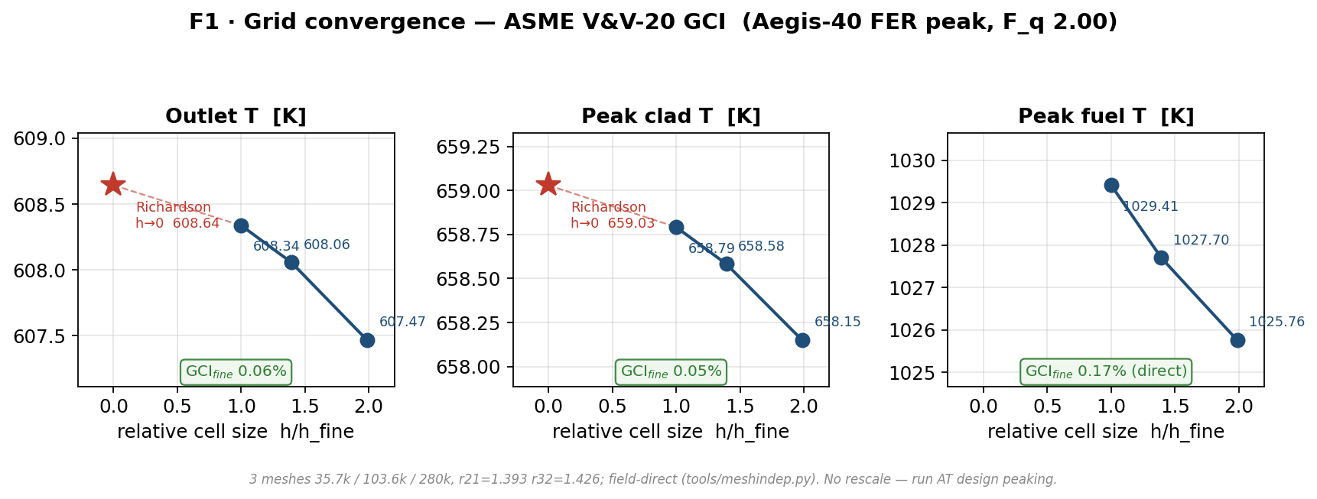
Figure F1. Grid convergence of outlet T, peak clad T and peak fuel T over the three meshes, with Richardson extrapolation (h→0) and the fine-grid GCI.
Metric | coarse | medium | fine | GCI_fine / direct
Outlet T [K] | 607.47 | 608.06 | 608.34 | 0.06 %
Peak clad T [K] | 658.15 | 658.58 | 658.79 | 0.05 %
Near-wall coolant [K] | 643.09 | 643.38 | 643.58 | 0.12 %
Peak fuel T [K] | 1025.8 | 1027.7 | 1029.4 | 0.17 % (direct)
Δp [Pa] | 669 | 682 | 695 | 1.78 % (direct)

Every temperature changes < 0.4 % medium→fine and the fine-grid GCI is sub-0.15 % on the convergent metrics, so the solution is mesh-independent. Peak-fuel and Δp are degenerate-Richardson (successive increments near-equal, p≈0) and are reported by their direct medium→fine change. The medium (104 k) mesh is used for production.

5.2 Energy conservation (GATE-1)
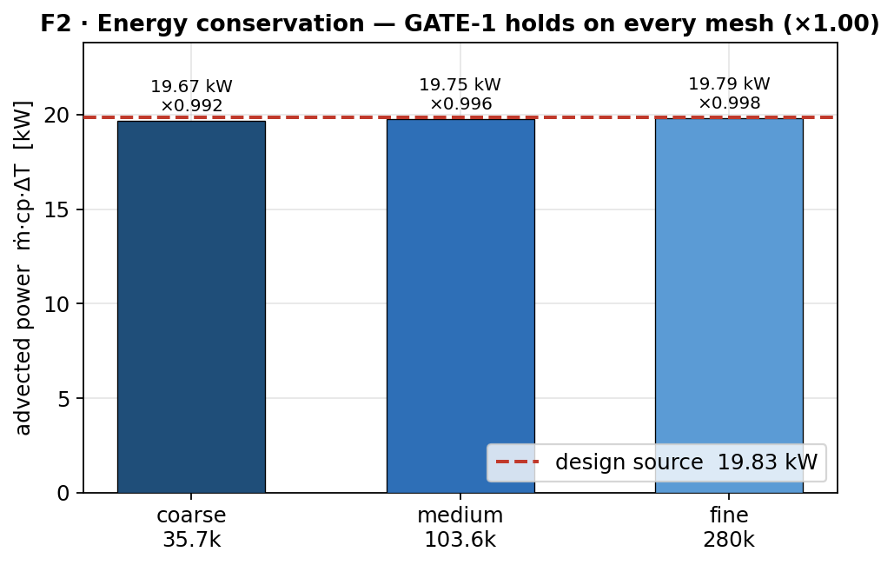
Figure F2. Advected power ṁ·cp·ΔT versus the analytic design source (19.83 kW/hot-pin) on each mesh; conservation closes to ×1.00 on every grid.
The advected power equals the imposed source to within 0.8 % on every mesh (×0.992 / 0.996 / 0.998 on coarse / medium / fine) — the model is energy-conservative, the prerequisite for trusting any temperature.

6. Near-wall validation: CFD ↔ correlation stack
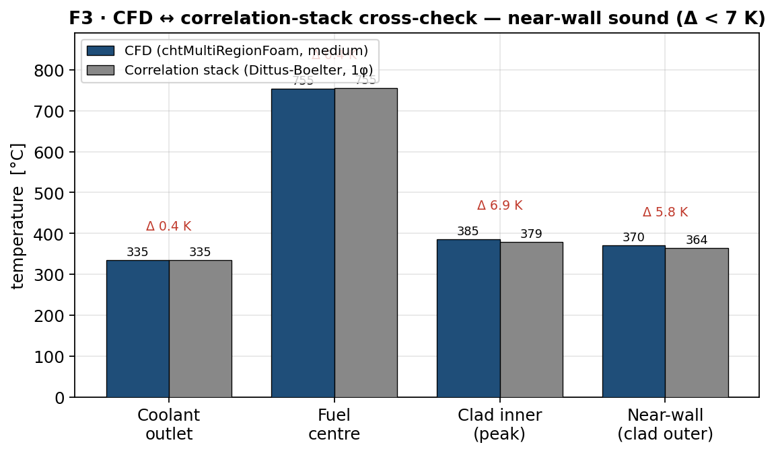
Figure F3. CFD (medium) versus the single-phase correlation stack at the identical operating point — agreement within 7 K on every quantity.
Quantity | CFD | Stack (1φ DB) | Δ
Coolant outlet (mixing-cup) | 335 °C | 335 °C | 0.4 K
Fuel centreline (peak) | 755 °C | 755 °C | 0.7 K
Clad inner (peak) | 385 °C | 379 °C | 6.8 K
Near-wall / clad outer | 370 °C | 365 °C | 5.7 K

At the identical operating point (G 544, T_in 258 °C, single-phase) the CFD and the Dittus-Boelter stack agree within 7 K on every quantity — bulk and fuel to < 1 K, clad and near-wall to < 7 K (CFD marginally hotter, i.e. conservative). The CFD is therefore both energy-accurate (GATE-1) and near-wall-accurate: its resolved film coefficient reproduces the validated correlation. Note also that the Aegis-40 core is geometrically the NuScale NPM core (37 FA / 9 768 pins / 2.0 m), against which the toolchain was independently validated.

7. Hot-channel thermal-hydraulics
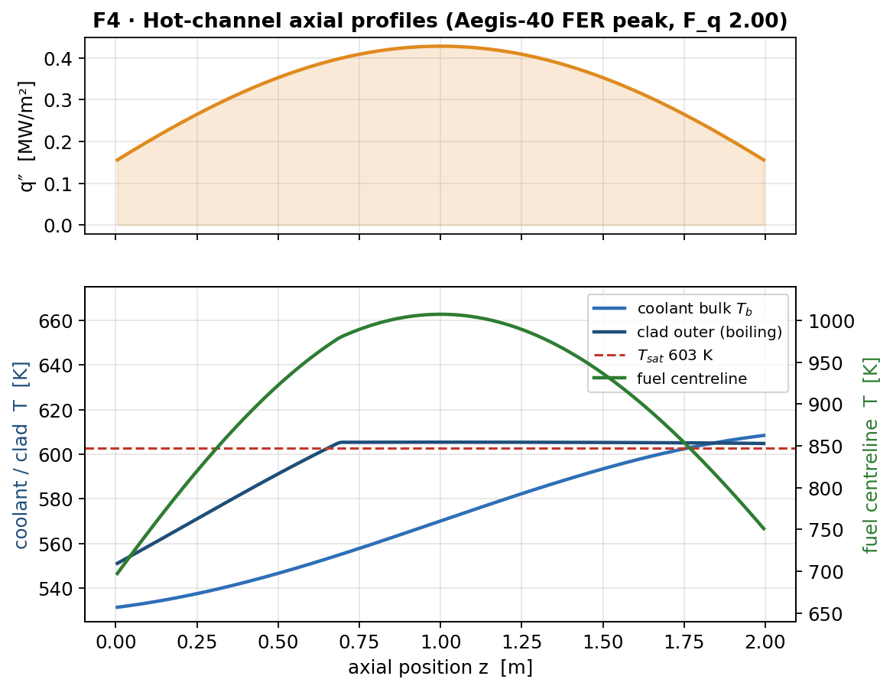
Figure F4. Hot-channel axial profiles: wall heat flux q″(z); coolant bulk, clad outer (with subcooled-boiling clamp) and fuel centreline temperatures.
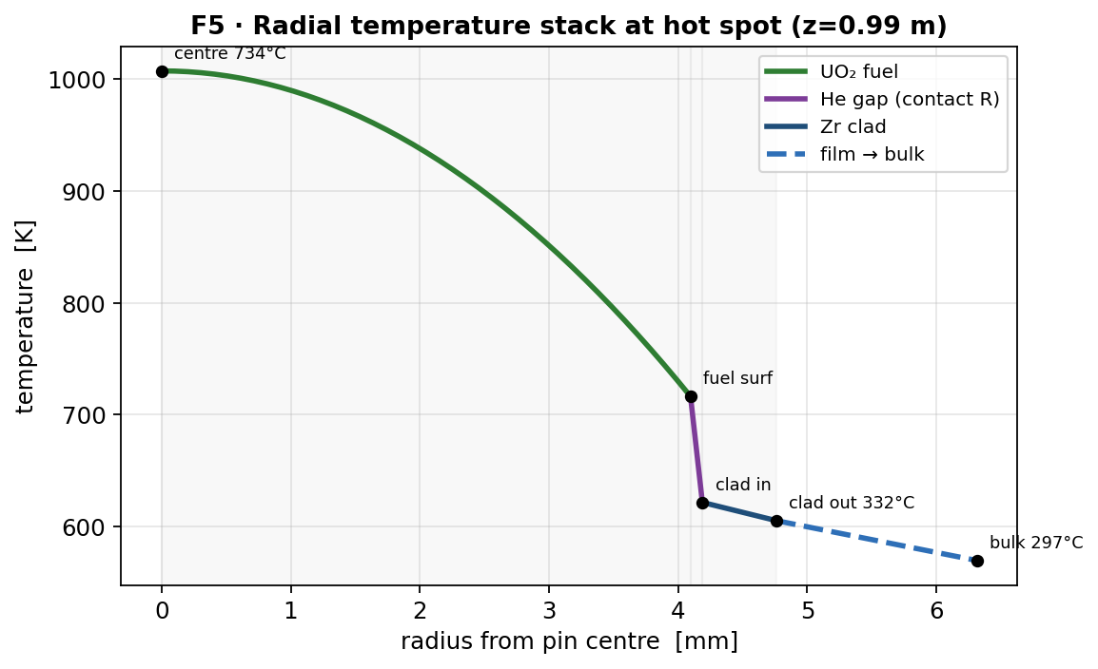
Figure F5. Radial temperature stack at the hot spot — conduction drops across fuel, the He-gap contact resistance, clad and the convective film.
The hot-channel mixing-cup outlet reaches ≈ Tsat (335 °C vs Tsat 331 °C), i.e. the most-peaked channel sits at the subcooled-boiling onset by design; the core-average outlet is the FER 308 °C. Peak fuel centreline is only 734 °C — far below any fuel limit — a direct consequence of the modest 12.8 kW/m peak linear power.

8. Safety margins

8.1 MDNBR
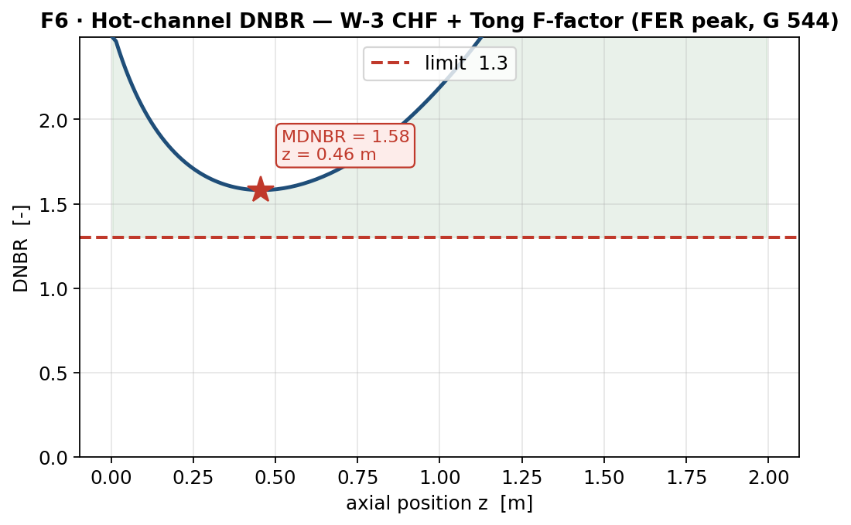
Figure F6. Hot-channel DNBR axial profile (W-3 CHF + Tong F-factor); the minimum is the MDNBR. Computed at the CFD-medium mass flux (G 544) → 1.58; 1.56 at the natural-circulation design point (H_tc 4 m, G 542).

8.2 PCT & subcooled boiling
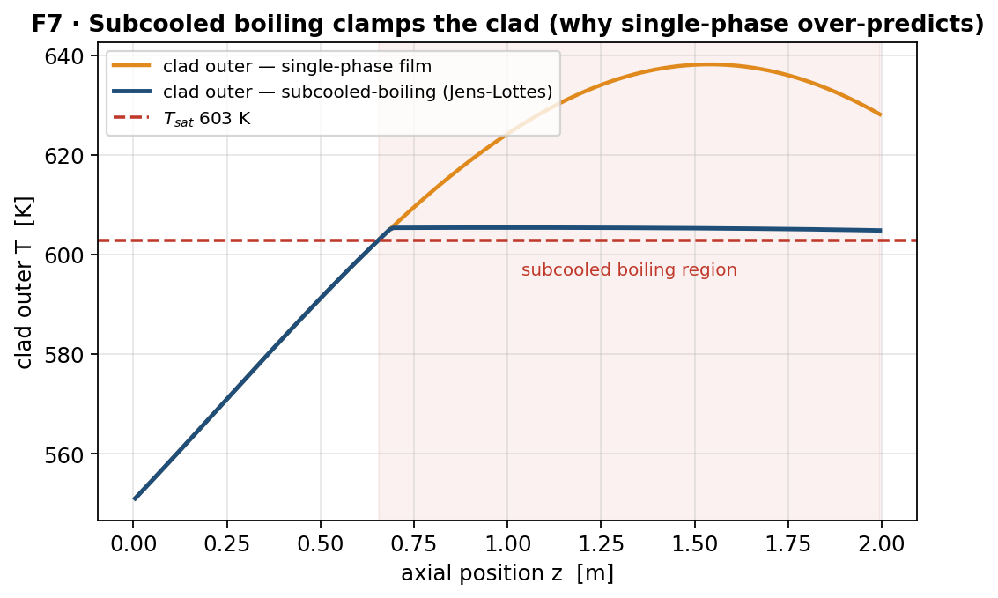
Figure F7. Clad outer temperature: single-phase film versus the subcooled-boiling (Jens-Lottes) clamp — single-phase over-predicts above Tsat.
Metric | Result | Limit | Margin | Verdict
MDNBR | 1.56 (H_tc 4 m) | 1.3 | +20 % | PASS
PCT (peak clad, boiling) | 621.7 K / 349 °C | 1200 °C (LOCA) | +851 °C | PASS
clad, single-phase (CFD x-check) | 659 K / 385 °C | — | — | —
Peak fuel centreline | 1008 K / 734 °C | ~2840 °C (melt) | +2106 °C | PASS

The subcooled-boiling clamp removes ≈ 30 K of single-phase over-prediction (clad 385 → 349 °C). All safety metrics pass with margin; the binding constraint is MDNBR, which still clears 1.3 by 20 %.

9. Natural-circulation feasibility
With no pumps, the core flow is the output of a 1-D buoyancy balance between the hot riser and the cold downcomer: ṁ = [2 ρ² A² g H_tc β P / (cp K_tot)]^(1/3). The single design knob is the riser thermal-centre height H_tc (core mid-plane to steam-generator mid). Sweeping it at nominal loop losses (K_form 12):
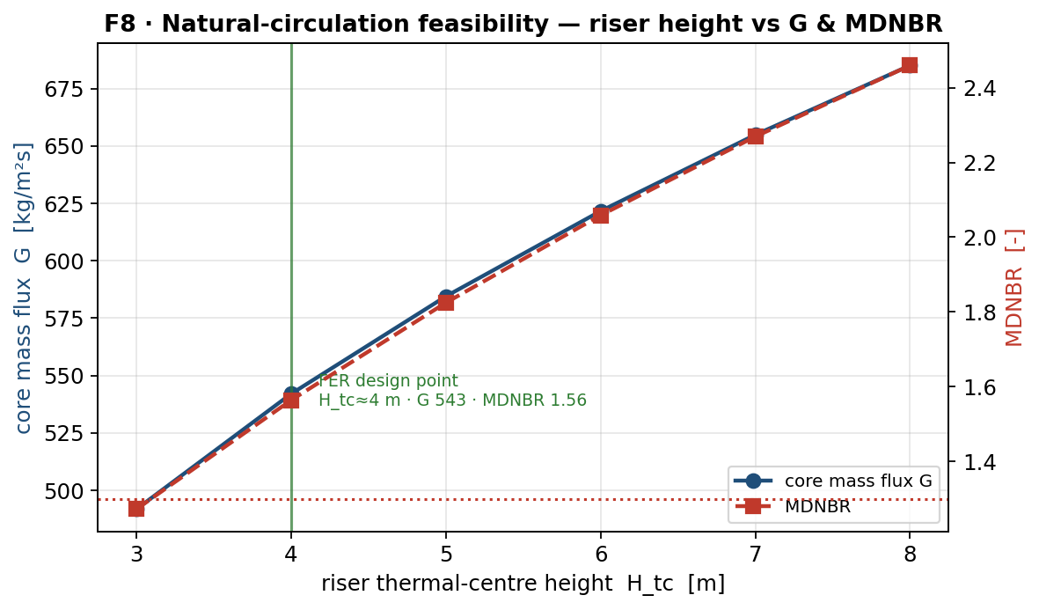
Figure F8. Core mass flux G and MDNBR versus riser height H_tc. The FER operating point (ΔT 50 K → G 543) is reproduced at H_tc ≈ 4 m.
H_tc [m] | G [kg/m²s] | core ΔT [K] | MDNBR | Verdict
3 | 492 | 55 | 1.27 | FAIL
4 (design) | 542 | 50 | 1.56 | PASS
5 | 584 | 46 | 1.82 | PASS
6 | 622 | 44 | 2.06 | PASS
8 | 685 | 40 | 2.46 | PASS

The FER-specified core ΔT of 50 K pins the flow at G 543, which natural circulation delivers at H_tc ≈ 4 m — half the ≈ 8 m of an earlier, smaller-core concept, because H_tc ∝ A_core·G³ and the required G fell. A taller riser (5-6 m) would trade vessel height for additional DNB margin. H_tc 3 m fails MDNBR, so ≈ 4 m is the practical floor.

10. Vessel & layout feasibility
H_tc is an elevation offset, not the vessel height. An illustrative integral-vessel elevation budget that delivers H_tc = 4 m (core mid 1.9 m → SG mid 5.9 m):
Elevation [m] | Component
0.0 – 0.9 | lower plenum / core inlet
0.9 – 2.9 | core (2.0 m active; mid-plane 1.9 m)
2.9 – 4.4 | outlet plenum + riser (chimney)
4.4 – 7.4 | steam generator (helical coil, in annulus; mid 5.9 m)
7.4 – 7.9 | upper plenum
7.9 – 9.9 | integral pressurizer

- Total vessel ≈ 10 m — markedly more compact than NuScale (≈ 17.7 m), because the required riser is half as tall.
- The Aegis-40 core is geometrically the NuScale NPM core (37 FA / 9 768 pins / 2.0 m), an NRC-reviewed natural-circulation iPWR arrangement: helical-coil SG in the annulus around a central hot riser, integral pressurizer on top. Component layout is therefore proven; Aegis-40 runs the same core at lower power with a shorter riser.
- The steam generator (≈ 1 250 m² helical surface for 125 MWth at ΔT_pri 50 K, 467 kg/s) fits the annulus above the core with a ≈ 1.5 m riser gap. The binding dimension is vessel diameter (≈ 3.0-3.5 m, NuScale-class), not height.
This is a layout-scoping argument (iPWR analogy + elevation budget); the mechanical vessel design — seismic, wall thickness, SG supports — is outside this thermal-hydraulic scope.

11. CFD field visualisation
ParaView renderings of the converged medium-mesh fields (t = 15):
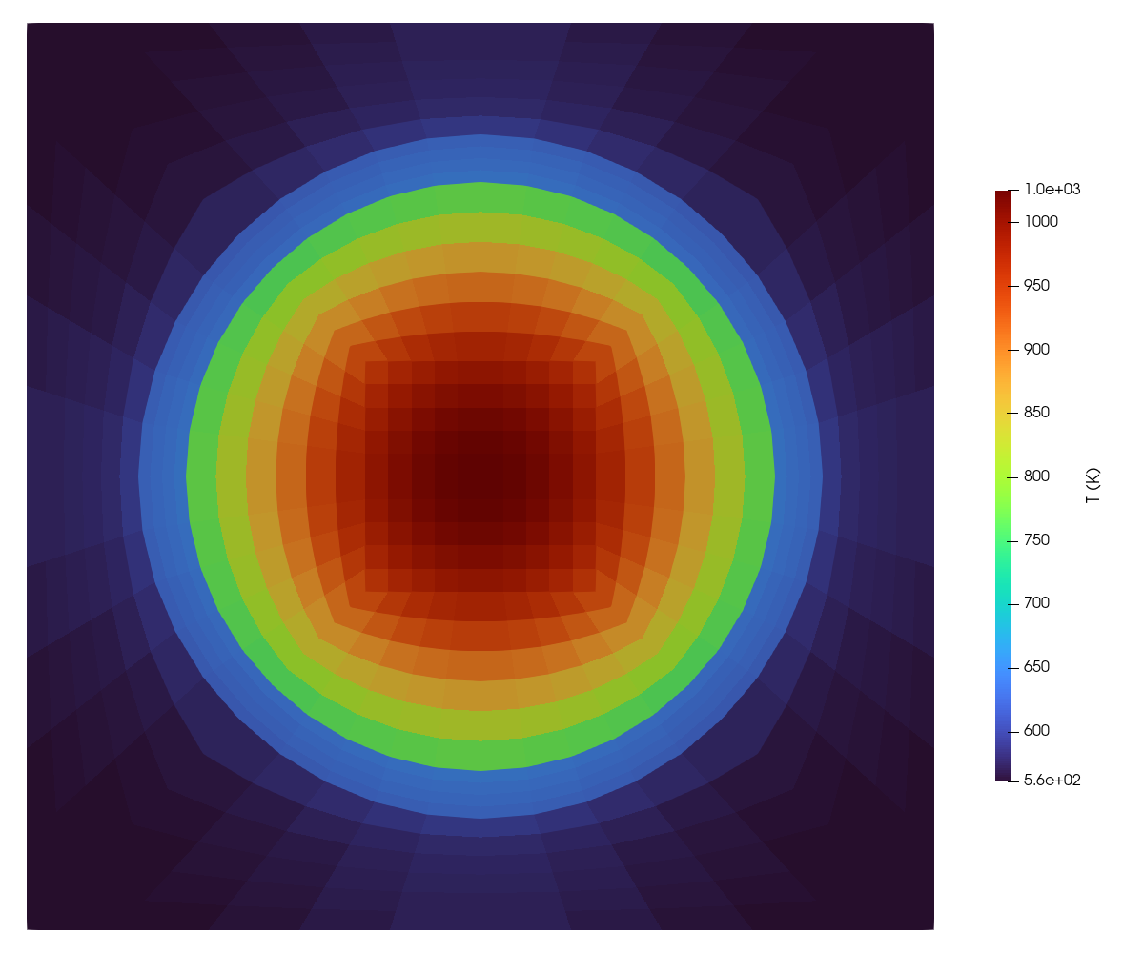
Figure F9a. Temperature on the sub-channel cross-section at the axial peak (z = 1.0 m): hot fuel core grading through the clad to the cooler surrounding coolant.
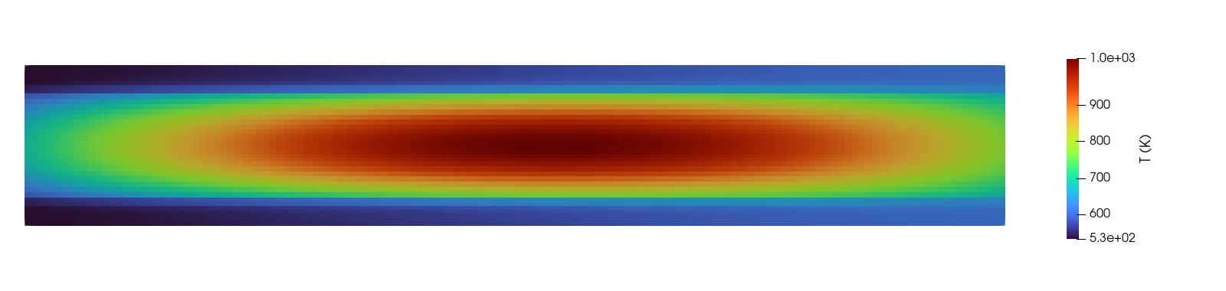
Figure F9b. Axial temperature on the pin centre-plane (chopped-cosine profile; inlet at left); radial scale exaggerated ~26x for legibility.
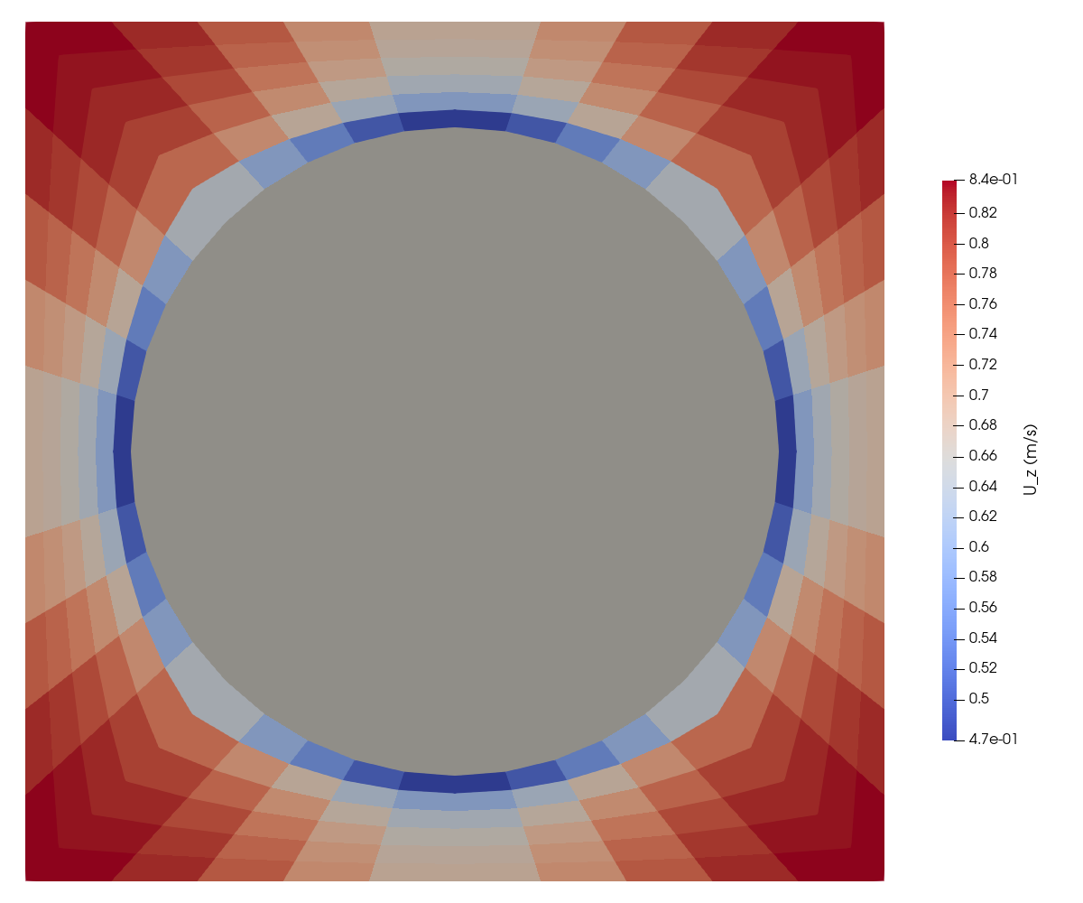
Figure F9c. Coolant axial velocity U_z on the sub-channel cross-section (z = 1.0 m): all-positive upflow (no recirculation), peak in the open sub-channel, no-slip at the rod wall (fuel+clad rod shown grey).

12. Limitations & uncertainty
- MDNBR uses the W-3 correlation, extrapolated below its mass-flux range (G 543 < 1356 kg/m²·s) and into deep subcooling; W-3 is conservative there (under-predicts CHF), so the +20 % margin is a lower bound. A low-flow CHF correlation is recommended for the final safety case.
- The hot-channel single-phase bulk slightly exceeds Tsat at the outlet (~4 K); a two-phase enthalpy model would cap it at Tsat. This affects only the top of the most-peaked channel.
- Peaking uses the FER design targets (F_q 2.00, F_ΔH 1.55); the notebook compute cells were not executed, so these are design anchors rather than a fresh per-pin reconstruction.
- Grid-convergence uncertainty is < 0.15 % on temperatures; peak-fuel and Δp are degenerate-Richardson and reported by direct medium→fine change.

13. Conclusions
- The conjugate CFD is energy-conservative (×1.00, every mesh) and mesh-independent (GCI < 0.15 %), and its near-wall heat transfer matches the correlation stack to < 7 K.
- At the FER design point the hot channel sits at the saturation boundary by design; peak fuel centreline is only 734 °C.
- Safety metrics pass with margin: MDNBR 1.56 (> 1.3, +20 %), PCT 349 °C (≪ 1200 °C), fuel 734 °C (≪ melt).
- Natural circulation delivers the design flow at a modest H_tc ≈ 4 m, yielding a compact (~10 m) NuScale-class integral vessel in which the steam generator fits the annulus above the core — the reactor is thermal-hydraulically feasible.

