8.8. Auxiliary Systems Design

Scope and classification basis
Following SSG-62 §2.2–2.4, an auxiliary system does not itself perform a primary plant function but must be available so that other systems (including the main systems) can perform theirs; a supporting system is an auxiliary system used to serve a safety function [SSG-62]. The Aegis-40 auxiliary and supporting systems are classified by safety class in accordance with their importance to safety per SSG-30 [SSG-62 §3.4, §3.52].
A defining consequence of the Aegis-40 passive safety architecture is invoked directly from SSG-62 §3.6 and §4.1: for plants whose safety functions rely on buoyancy, gravity or stored energy and contain fewer active components, the need for safety-classified supporting systems can be significantly smaller. Accordingly, no auxiliary system in this section is required to prevent core damage; the natural-circulation primary loop and passive decay-heat removal (§8.4, §8.6) discharge the fundamental safety functions without auxiliary support. The auxiliary systems preserve normal operation, provide defence-in-depth (DiD) backup, and limit dose in line with ALARA.
The systems governed by other guides are addressed in their proper FER sections and only summarised here for completeness: fire protection (SSR-2/1 Req. 74; NS-G-1.7 / SSG-64) — §8.8.11 and §8.6; radiation-protection design (Req. 81; NS-G-1.13) — §8.8.12; fuel handling and storage (Req. 80; SSG-63) — §8.8.10; radioactive-waste and effluent processing (Req. 78, 79) — FER §8.11; decay-heat removal and the steam/feedwater systems (Req. 70 part, 77; SSG-56) — §8.4/§8.6. The auxiliary-systems interconnection overview is Figure 8.8-1.
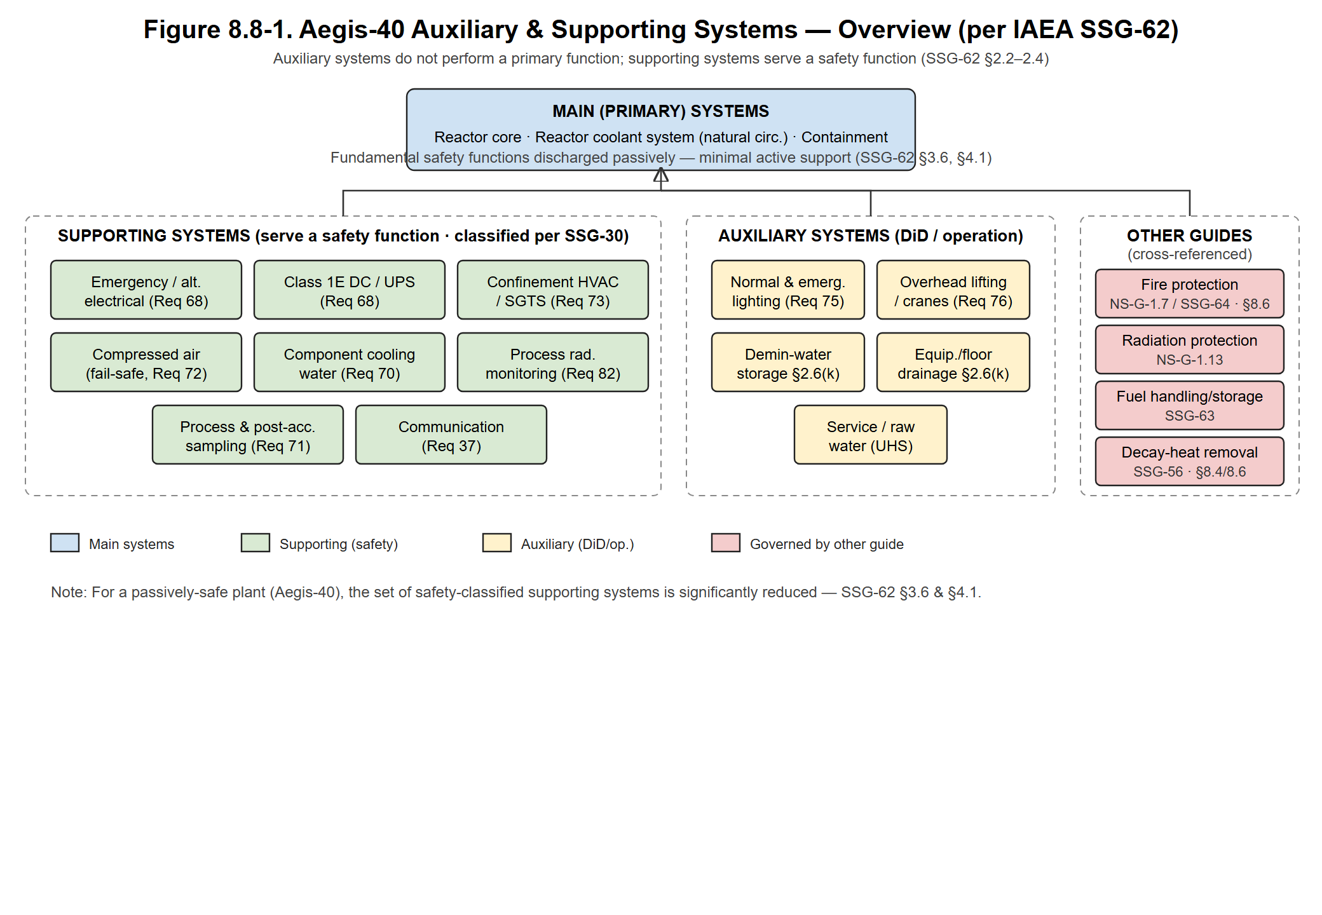
Figure 8.8-1. Aegis-40 auxiliary and supporting systems — overview (per IAEA SSG-62).

8.8.1. Air Conditioning and Ventilation (HVAC) and Fission-Product Release Control — SSG-62 §4.108–4.170 (Req. 73)
Purpose. Maintain temperature, humidity, cleanliness and the directional pressure cascade of plant areas so air always flows from lower to higher potential contamination, controlling airborne fission-product migration in normal operation and design-basis accidents (DBA) [SSG-62 §4.108–4.170; NS-G-1.13].
Subsystems / operating principle.
• Controlled-area (reactor building) HVAC — once-through (non-recirculating); building held at negative pressure (target −250 Pa); exhaust through pre-filter → HEPA ≥99.97 % @0.3 µm → impregnated charcoal iodine adsorber (≥99 % elemental I) → HEPA, released via the monitored stack.
• Fuel-handling-area ventilation — independent train, auto-realigned to recirculation/filtration on a high-radiation signal (§8.8.5).
• Standby Gas Treatment System (SGTS) — redundant 2×100 % filtration train; on containment-isolation/high-radiation it holds secondary confinement at negative pressure and filters leakage before elevated release. As the EPZ is at the plant boundary (§8.1), SGTS is a DiD provision, not a credited core-protection system.
• Main-Control-Room habitability HVAC — isolates and pressurises the MCR (target +120 Pa), filters intake through HEPA + charcoal, keeping operator dose within DBA limits [GDC 19], supporting the limited-staffing Digital-Twin concept (§8.7).
Safety function & SSG-62 compliance. HVAC dampers serving a confinement function fail to the safe (closed) position on loss of power/air (§8.8.2). Redundant divisions are independent and protected against internal/external hazards per SSG-62 §3.15–3.28. Performance: filter efficiencies above; the system maintains the pressure cascade on single active failure.
Layout & maintenance. Air-handling units, fans and filter trains in dedicated rooms; below-grade placement shortens ducts and adds shielding. Bag-in/bag-out filter change-out; differential-pressure monitoring schedules replacement; in-place DOP/halide efficiency testing [RG 1.52]. See Figure 8.8-2.
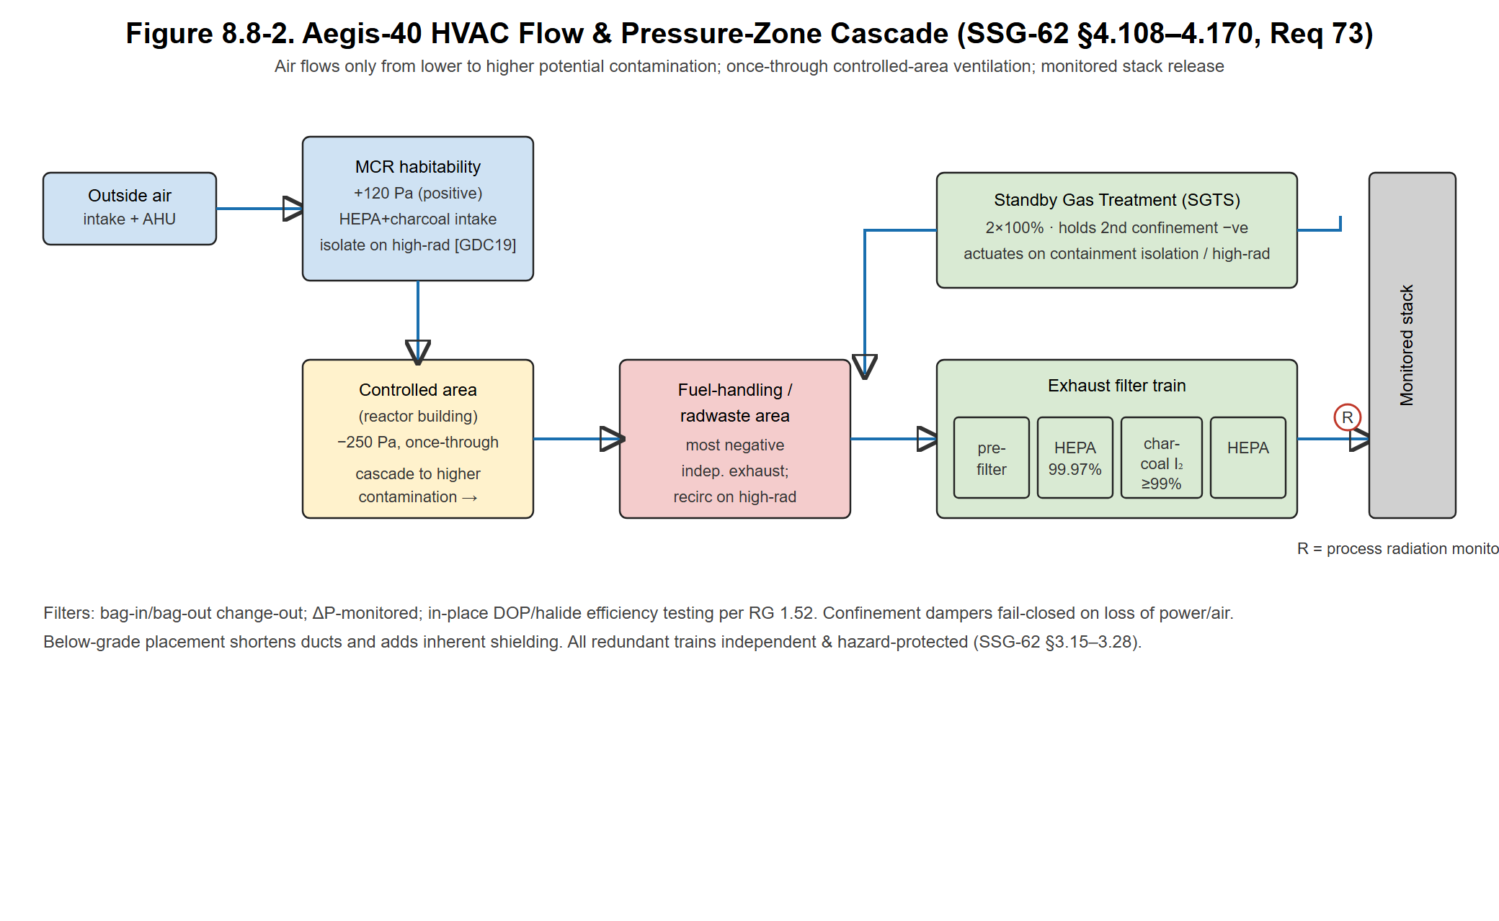
Figure 8.8-2. HVAC flow and pressure-zone cascade.

8.8.2. Compressed-Air Systems — SSG-62 §4.94–4.107 (Req. 72)
Purpose. Supply clean, dry, oil-free air to pneumatic instruments and valve actuators, plus service and breathing air [SSG-62 §4.94].
Subsystems.
• Instrument Air (IA) — oil-free compressors, after-coolers, twin desiccant dryers; pressure dewpoint ≤ −40 °C (target), filtration to ISO 8573-1 Class 2; air receiver provides ride-through on compressor swap.
• Service Air (SA) — isolated from IA so SA demand cannot degrade IA quality [SSG-62 §4.95–4.99].
• Breathing Air — grade-D for maintenance in contaminated areas.
Safety function (fail-safe). All air-operated valves with a protective function fail to the safe position on loss of instrument air or power (containment-isolation valves fail closed; passive-DHR valves fail open), so loss of compressed air initiates rather than defeats the safe-state transition (§8.6) [SSG-62 §4.103–4.107]. Loss of the IA system shall not cause a postulated initiating event [SSG-62 §3.13].
Maintenance. Lead/lag/standby compressor rotation, automatic dryer regeneration, periodic dewpoint and oil-carryover monitoring. See Figure 8.8-3.
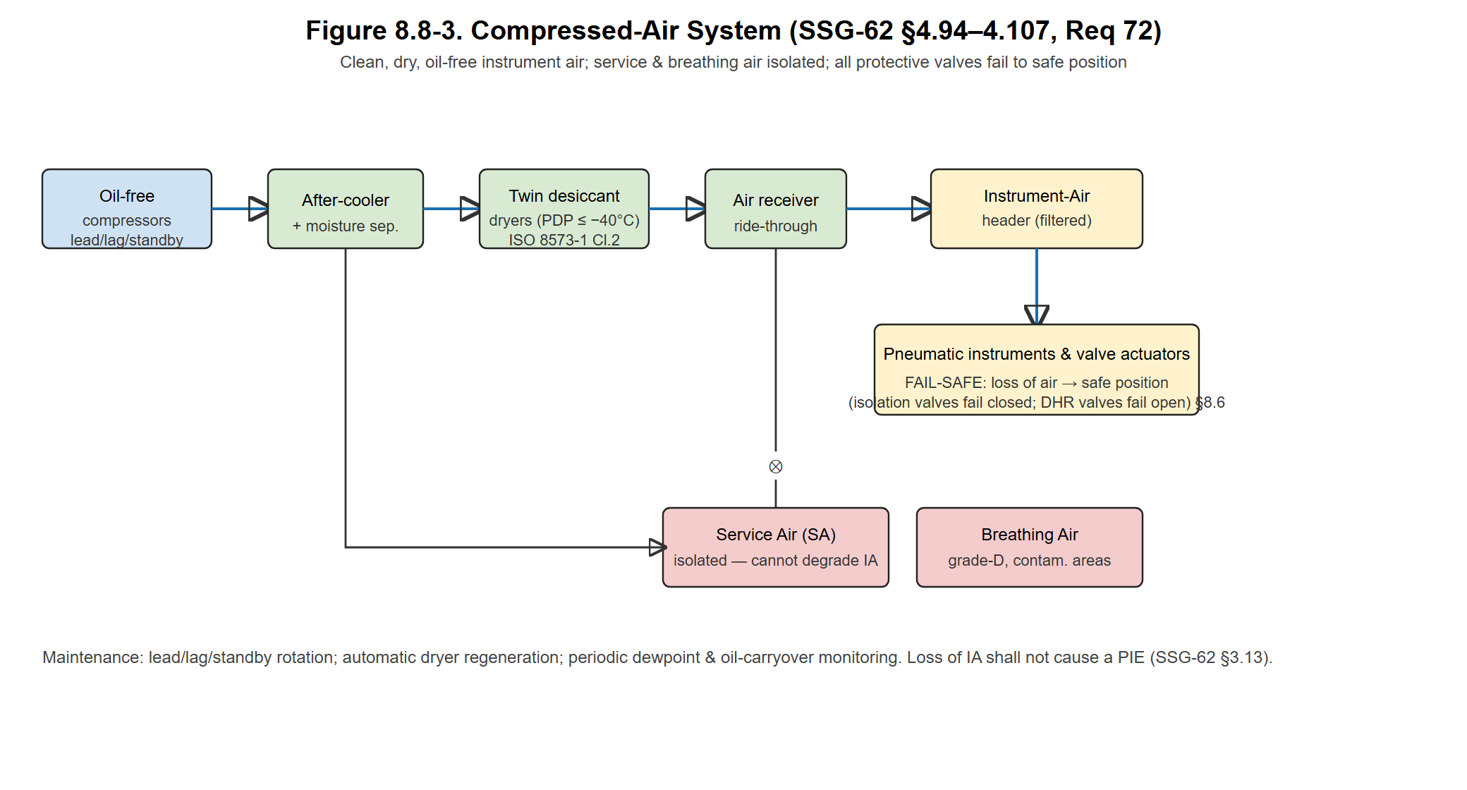
Figure 8.8-3. Compressed-air system (instrument / service / breathing).

8.8.3. Electrical Power — Supporting Systems for Emergency and Alternate Supply — SSG-62 §4.233–4.267 (Req. 68); SSG-34
Purpose. Provide reliable power to plant loads and, in particular, the supporting power needed by systems important to safety. The overall electrical-power architecture follows SSG-34; this section concentrates on the supporting systems for the emergency and alternate power sources that are the subject of SSG-62 (Req. 68) [SSG-62 §4.233].
Off-site (preferred) power. Two physically and electrically independent off-site supplies connect to the Sinop grid via separate lines and switchyard bays; either independently feeds all auxiliaries [GDC 17; IEEE Std 308; SSG-34].
On-site distribution. Turbine-generator → main step-up transformer; auxiliaries from a unit auxiliary transformer with fast transfer to a reserve transformer on loss of the unit source. Distribution is segregated into Class 1E (safety) and non-1E trains with physical separation and electrical isolation [IEEE Std 384].
Emergency / alternate AC. Two independent standby AC sources (target ≥ 2×100 % of protected loads) serve plant protection and orderly shutdown. Consistent with SSG-62 §3.6, their unavailability does not challenge core safety — this is the basis for the negligible station-blackout (SBO) contribution to core-damage frequency. The supporting systems for these sources (fuel-oil supply, starting air, jacket-cooling, lubrication, room ventilation) are designed with the autonomy, availability and robustness commensurate with the served function and "with adequate margin" [SSG-62 §3.5, §4.233–4.267].
DC and uninterruptible power.
• Class 1E DC — redundant, independent battery banks (target ≥ 72 h coping without recharge) feed the protection system, safety instrumentation and DC isolation valves needed for passive safety, riding through extended SBO consistent with the >100 h passive-cooling target (§8.5).
• UPS — battery-backed inverters supply clean AC to I&C, the DCS and the Digital-Twin process computer (§8.7); the safety-side UPS is isolated from the non-safety side across the one-way data diode / air-gap.
Independence & maintenance. Redundant divisions in separate fire areas (§8.8.11) with no shared raceways; common-cause vulnerabilities between redundant supporting trains identified and removed as far as practicable [SSG-62 §3.38, §4.233–4.267]. Battery rooms ventilated and H₂-monitored; periodic battery capacity discharge and relay-protection testing. Single-line diagram: Figure 8.8-4.
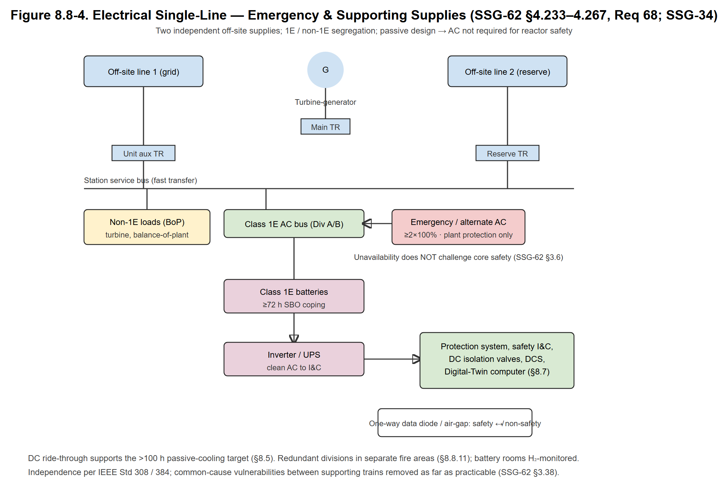
Figure 8.8-4. Electrical single-line — emergency and supporting supplies.

8.8.4. Process and Post-Accident Sampling System — SSG-62 §4.45–4.72 (Req. 71)
Purpose. Take representative samples of process fluids during normal operation and under accident conditions to monitor coolant chemistry, activity and core/containment status while limiting operator dose [SSG-62 §4.45–4.72].
Design features.
• Sample points on the reactor-coolant system, containment atmosphere/sump, and effluent paths; remote/shielded sampling stations with flushing to prevent cross-contamination.
• Post-accident sampling capability sized for high-activity samples (e.g., dissolved H₂, boron — minimal here owing to the SBF core, fission-product activity, containment hydrogen) with shielded handling and dose control.
• Sample lines penetrating containment have qualified automatic isolation [SSR-2/1 Req. 56].
Safety function. Supports accident management and the Digital-Twin state estimate (§8.7) by providing chemistry/activity data. Performance: representativeness, response time and dose-per-sample targets defined per SSG-62 §4.45–4.72.
Maintenance. Periodic calibration of in-line analysers; line flushing and integrity checks. See Figure 8.8-5.
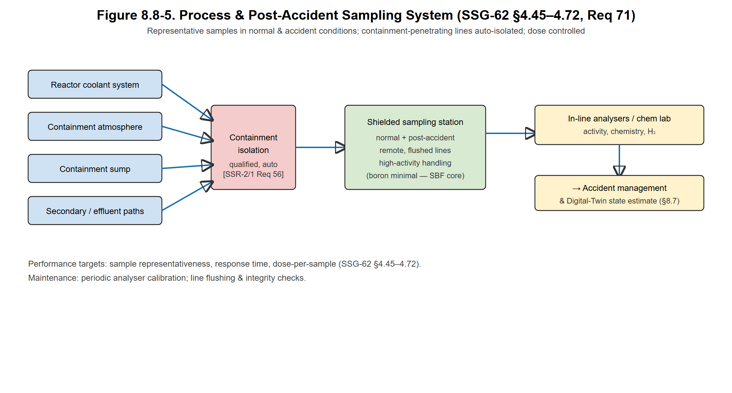
Figure 8.8-5. Process and post-accident sampling system.

8.8.5. Process Radiation Monitoring System — SSG-62 §4.73–4.93 (Req. 82)
Purpose. Continuously monitor radioactivity in plant process streams and effluent paths to detect abnormal conditions, initiate protective actions, and record releases [SSG-62 §4.73–4.93]. (This is distinct from radiation-protection design / area & personnel monitoring, which is §8.8.12 under NS-G-1.13.)
Channels.
• Reactor-coolant and steam/secondary activity (fuel-failure and primary-to-secondary leak detection).
• Containment-atmosphere, ventilation-exhaust and gaseous stack-discharge monitors.
• Liquid-effluent discharge monitors.
• Component-cooling-water and other intermediate loops (in-leakage detection, §8.8.9).
Safety function. High readings provide initiating signals to HVAC realignment / SGTS (§8.8.1), MCR habitability isolation (§8.8.2/8.8.3) and effluent-discharge isolation, linking process monitoring to the ESF actuation logic (§8.6–8.7). Monitors are safety-classified per their function [SSG-62 §4.73–4.93; SSG-30].
Maintenance. Periodic source-check/calibration; redundancy so a single monitor outage does not blind a credited function. See Figure 8.8-6.
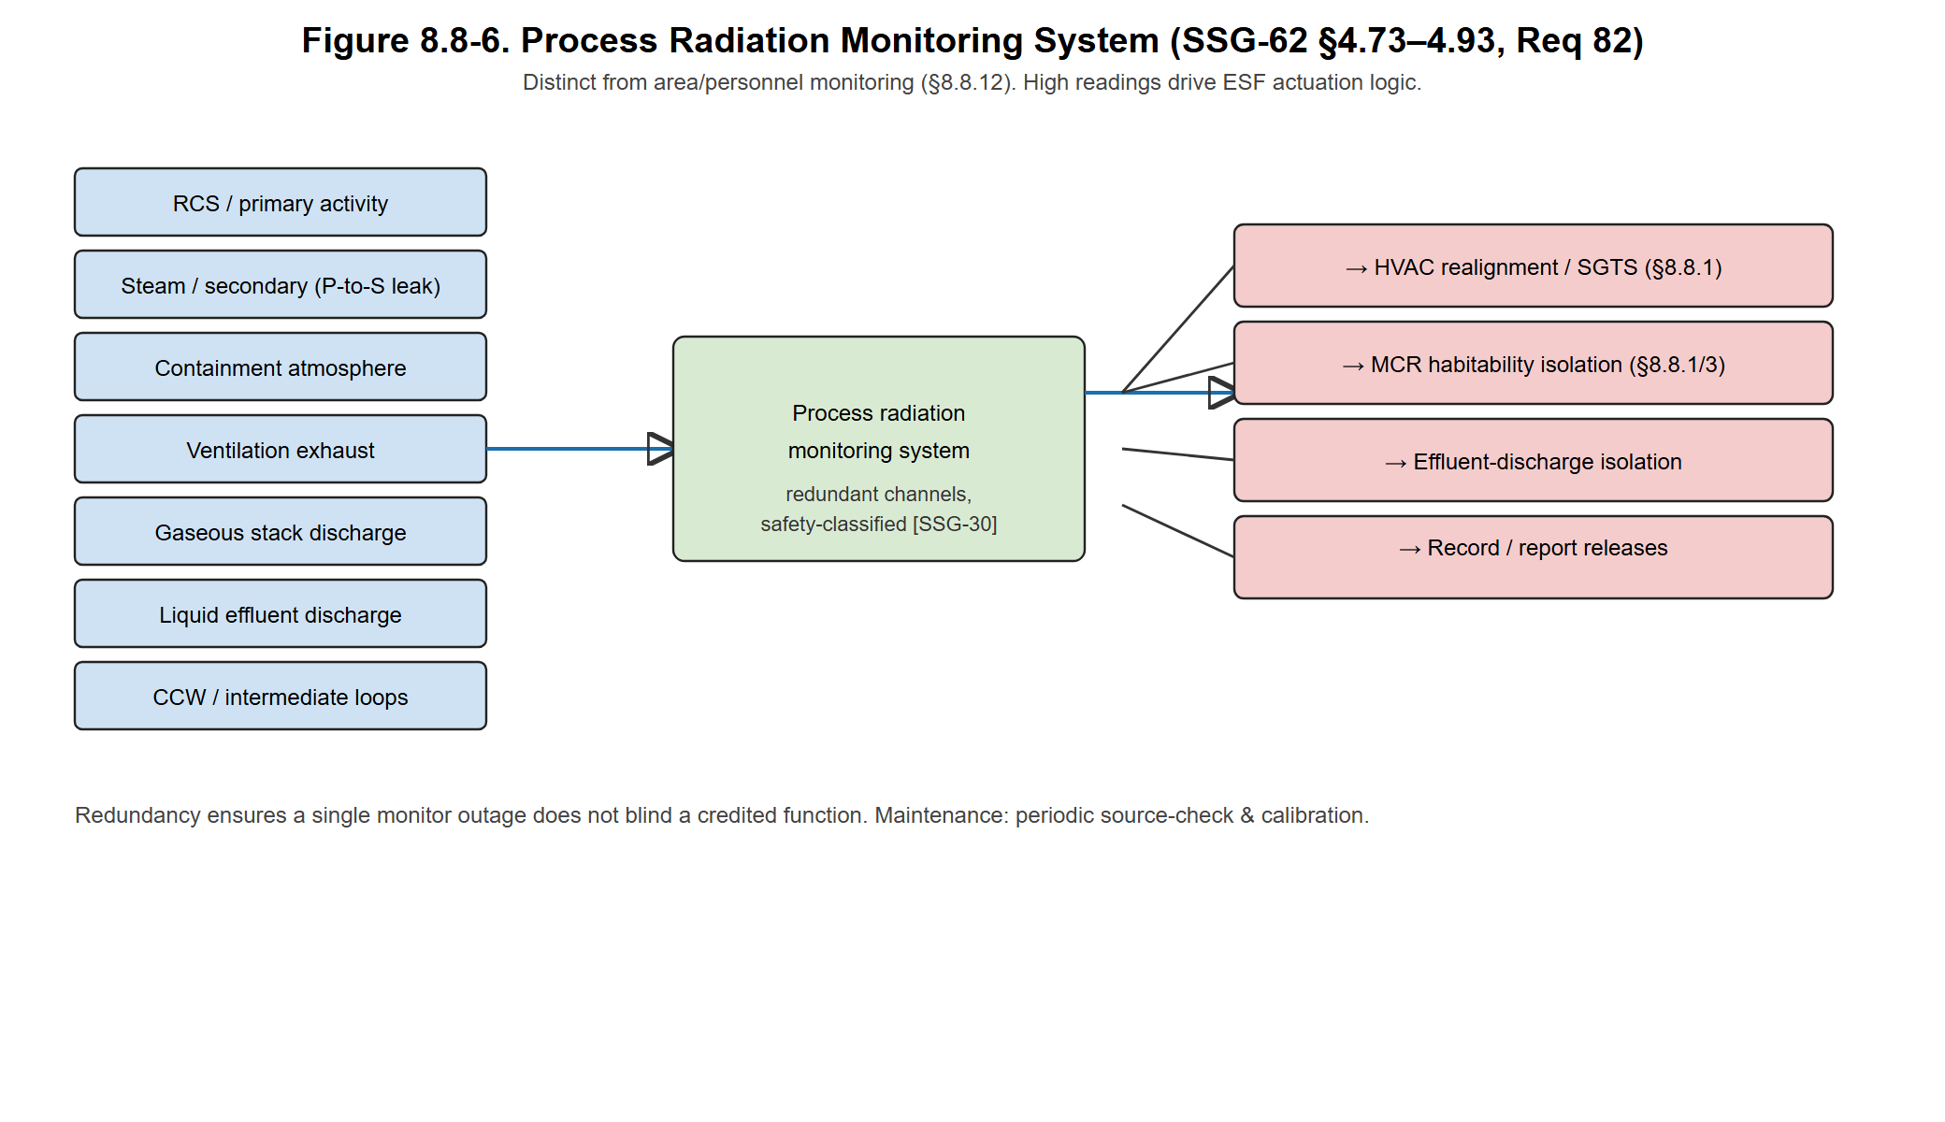
Figure 8.8-6. Process radiation monitoring system.

8.8.6. Communication Systems — SSG-62 §4.5–4.24 (Req. 37)
Purpose. Provide reliable internal and external communication for normal operation, anticipated operational occurrences and accident conditions, including communication with off-site emergency organisations [SSG-62 §4.5–4.24].
Design features.
• Diverse means (hard-wired intercom/page-party, telephone, wireless, sound-powered phones) so no single failure or single hazard defeats all communication [SSG-62 §4.6, diversity & independence].
• MCR, supplementary control point, on-site emergency centre and key local stations covered; communication functions credited for accident management are powered from emergency/UPS supplies (§8.8.3).
• Qualified against the noise, fire, seismic and radiation environments of the locations served [SSG-62 §3.58–3.65].
Safety function. Supports operator actions and emergency response; not required for the passive safety functions but credited in the DiD/accident-management strategy. See Figure 8.8-7.
Maintenance. Periodic functional tests of each medium and of MCR-to-emergency-centre links.
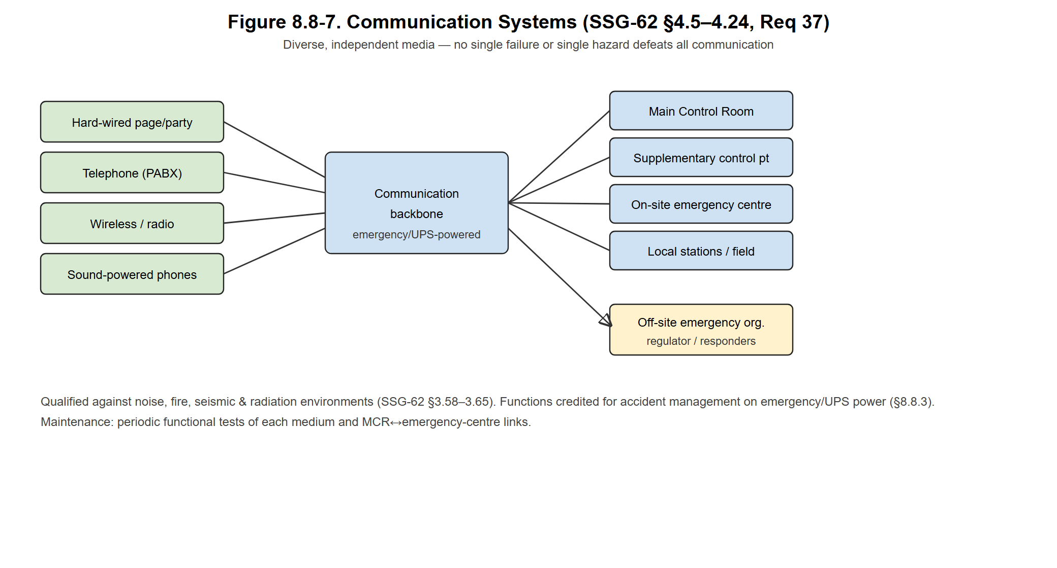
Figure 8.8-7. Communication systems architecture.

8.8.7. Normal and Emergency Lighting — SSG-62 §4.171–4.179 (Req. 75)
Purpose. Provide adequate lighting for safe operation and, on loss of normal power, emergency lighting for operator action, safe egress and access to equipment important to safety [SSG-62 §4.171–4.179].
Design features.
• Normal lighting from the standard AC distribution; emergency lighting in the MCR, supplementary control point, escape routes, and locations of manual safety actions, fed from emergency AC and/or self-contained battery units (target ≥ 90 min autonomy).
• Illumination levels and durations matched to the credited operator actions; below-grade areas given particular attention.
Safety function. Enables credited manual actions and evacuation during loss of off-site power / SBO. See Figure 8.8-8.
Maintenance. Periodic battery-unit duration tests and lamp checks.
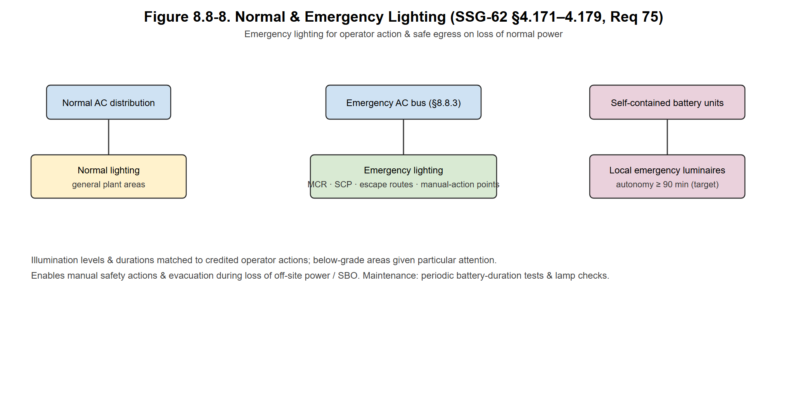
Figure 8.8-8. Normal and emergency lighting.

8.8.8. Overhead Lifting and Handling Equipment — SSG-62 §4.180–4.198 (Req. 76)
Purpose. Move heavy loads (RPV head and internals, casks, large components) safely, preventing loads from impacting equipment or fuel important to safety [SSG-62 §4.180–4.198].
Design features.
• Main lifting equipment (e.g., reactor-building/polar or gantry crane) designed to single-failure-proof standards where a load drop could affect safety, with over-speed, over-load and restricted-zone interlocks [SSG-62 §4.196].
• Safe load paths that avoid carrying heavy loads over irradiated fuel or safety equipment.
• Cranes exposed to contamination given smooth/strippable coatings for decontamination [SSG-62 §4.197]; design life and provisions consistent with the preliminary decommissioning plan [SSG-62 §4.198].
Safety function. Prevents heavy-load-drop initiating events. Pre-service maximum-expected-load testing and periodic in-service inspection/testing of safety interlocks [SSG-62 §4.196]. See Figure 8.8-9.
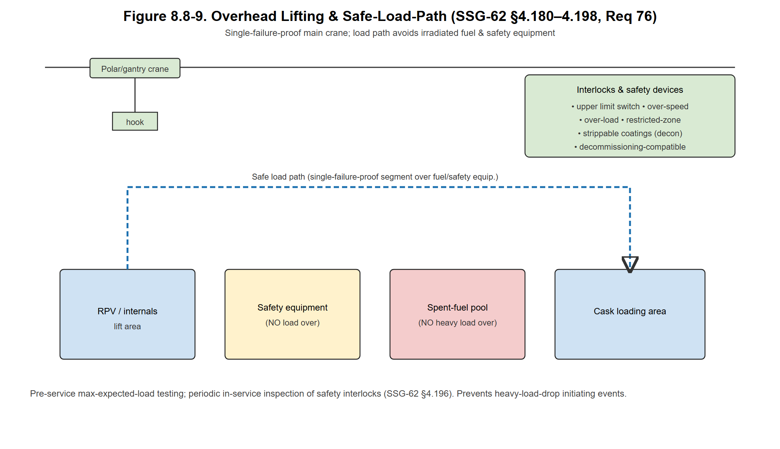
Figure 8.8-9. Overhead lifting and safe-load-path.

8.8.9. Auxiliary Cooling, Demineralised-Water and Drainage Systems — SSG-62 §4.25–4.44 (Req. 70 part) & §2.6(k)
Component Cooling Water System (CCWS). Closed demineralised-water loop removing heat from auxiliary loads (spent-fuel-pool coolers, sampling coolers, non-safety pump coolers) and rejecting it to the raw-water / ultimate-heat-sink interface (Black Sea seawater). As a closed intermediate loop it is a monitored barrier between potentially radioactive sources and the environment; CCWS radiation monitoring (§8.8.5) detects in-leakage. Redundant 2×100 % pumps/heat-exchangers for credited loads (target) [SSG-62 §4.25–4.44].
Raw-Water / Service-Water System. Transfers CCWS heat to the ultimate heat sink; designed against external hazards and biofouling for the coastal site [SSG-62 §3.19–3.28].
Demineralised-water storage and supply and equipment / floor-drainage systems are provided as auxiliary systems per SSG-62 §2.6(k): the demin-water reserve supports makeup and chemistry; drainage collects, segregates and routes potentially radioactive leakage to the liquid-radwaste system (FER §8.11), kept separate from non-radioactive drains [SSG-62 §4.225].
Reactor-coolant makeup and purification (reduced CVCS). The soluble-boron-free core eliminates the boron-control and boron-recovery functions of a conventional CVCS — a stated Aegis-40 originality (PER §5.1). A reduced makeup-and-purification subsystem still: maintains primary inventory and pressuriser level; purifies coolant via ion-exchange demineralisers (corrosion- and fission-product removal, source-term/dose reduction); and controls chemistry (Li-OH pH, H₂ for O₂ suppression) within PWR water-chemistry guidelines. Eliminating soluble-boron handling simplifies the auxiliary building, cuts liquid radwaste, and supports safeguards-by-design (PER §3.3). See Figure 8.8-10.
Maintenance. Resin change-out under HP control; CCWS leak monitoring; chemistry sampling and trending.
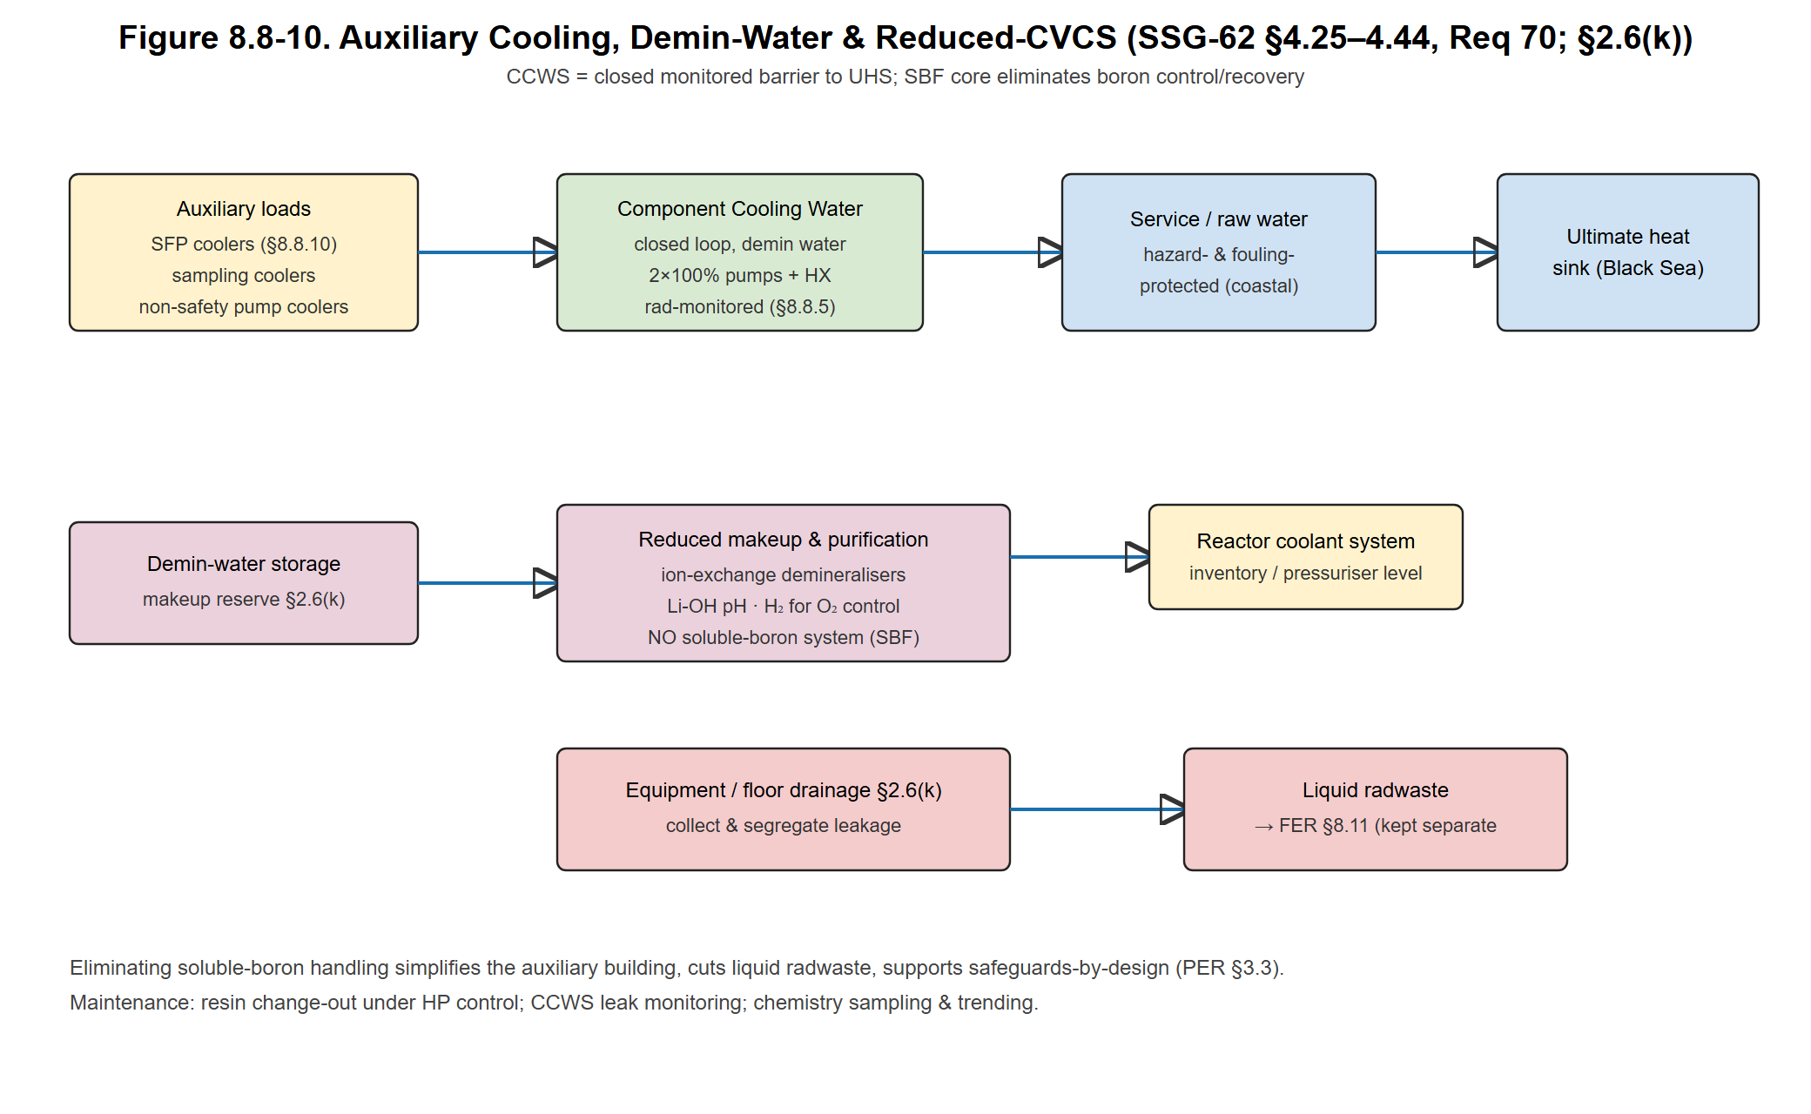
Figure 8.8-10. Auxiliary cooling, demineralised-water and reduced-CVCS.

8.8.10. Fuel Handling and Storage Systems — SSR-2/1 Req. 80; SSG-63
Purpose. Receive, store, load and unload fuel safely, maintaining sub-criticality, cooling, shielding and confinement. The Aegis-40 runs an 18-month, 4-batch cycle on a 21-assembly core, so a refuelling outage replaces ≈ 5–6 of the 21 assemblies (target).
New fuel. Fresh 17×17 assemblies stored dry in criticality-safe racks with k_eff ≤ 0.95 under optimum-moderation flooding [ANSI/ANS-8.1]; because the core is SBF, criticality safety relies on fixed geometry and absorber rack materials, not dissolved boron.
Refuelling. Below-grade refuelling cavity; integral RPV head/internals removed; refuelling machine and underwater transfer to the spent-fuel pool; load/travel interlocks; double-verification of assembly identity/position for safeguards (§3S).
Spent-Fuel Pool & SFP Cooling/Cleanup (SFPCCS). Absorber racks (k_eff ≤ 0.95) in a stainless-lined pool sized for the cycle history plus one full-core offload (target); cooling via redundant 2×100 % HX trains to CCWS (§8.8.9), bulk ≤ 50 °C; passive gravity makeup from an elevated tank for a long boil-off grace period; cleanup by ion-exchange/filters [SSG-63; IAEA SSG-15].
Maintenance. Pool level/temperature instrumentation, liner leak-chase, periodic crane/machine load testing. See Figure 8.8-11.
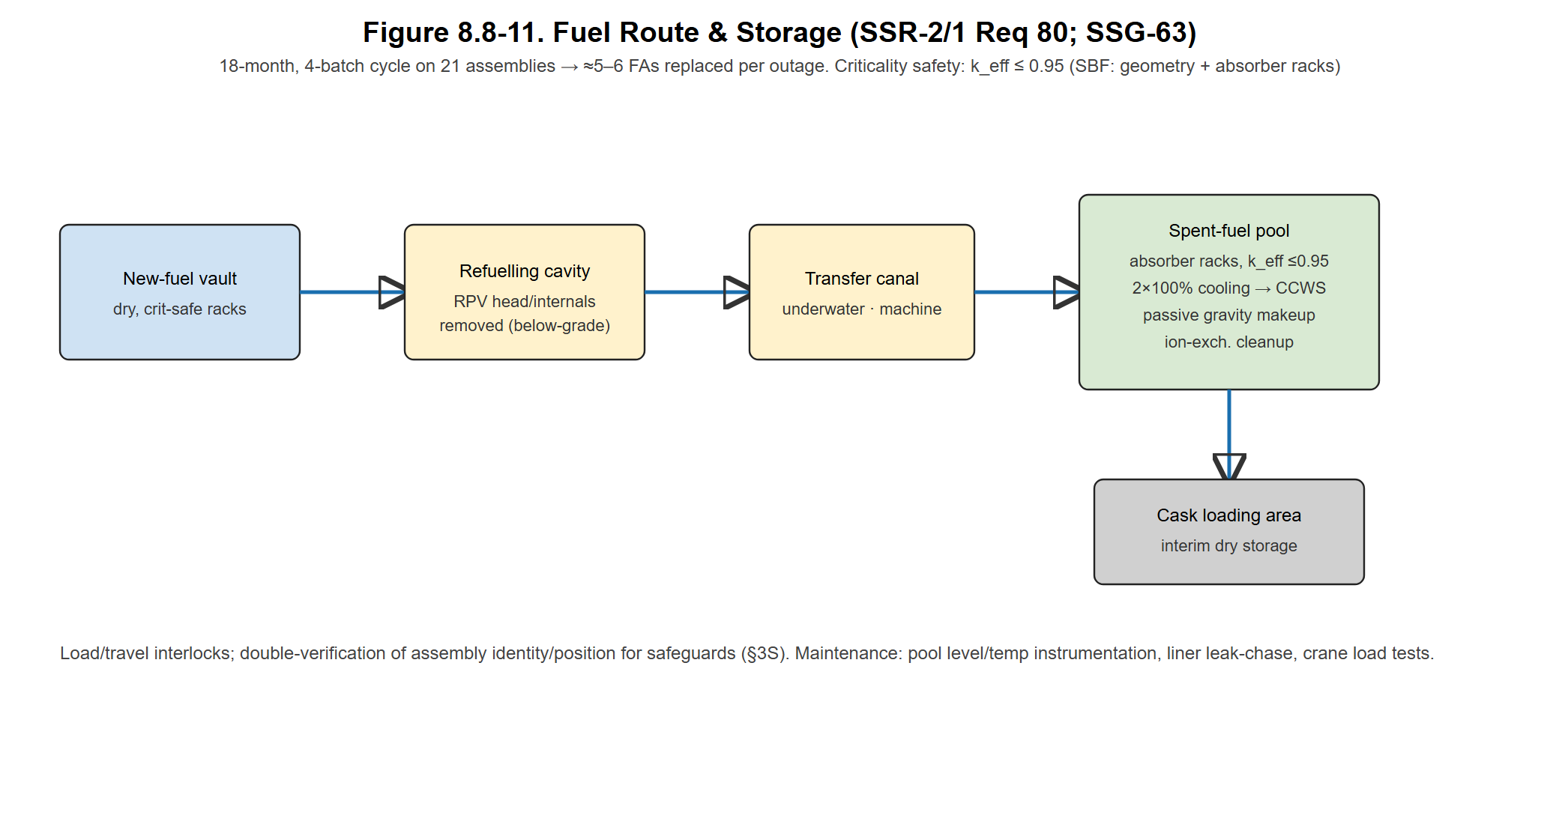
Figure 8.8-11. Fuel route and storage.

8.8.11. Fire Protection System — SSR-2/1 Req. 74; NS-G-1.7 / SSG-64
Purpose. Protect against fire by the DiD strategy prevent–detect–suppress–confine, while ensuring a safe-shutdown path remains available despite any single fire [NS-G-1.7 / SSG-64; NFPA 805].
Design features.
• Fire-area separation — redundant safety divisions in separate fire areas bounded by 3-hour-rated barriers with rated penetration seals and dampers; the division-independent passive safety functions strongly limit a fire's ability to defeat safe shutdown.
• Detection — addressable smoke/heat and (oil/turbine areas) flame detection to the fire panel and MCR.
• Suppression — wet-pipe sprinklers generally; pre-action/deluge in high-hazard areas (lube-oil, transformers); clean-agent (inert-gas) total flooding in electrical/I&C and computer rooms to protect the DCS/Digital-Twin (no Halon).
• Fire-water — redundant fire pumps (one diesel, one electric) ensure suppression during loss of off-site power.
Maintenance. Scheduled detector/pump testing, sprinkler inspection, barrier-penetration surveillance. See Figure 8.8-12.
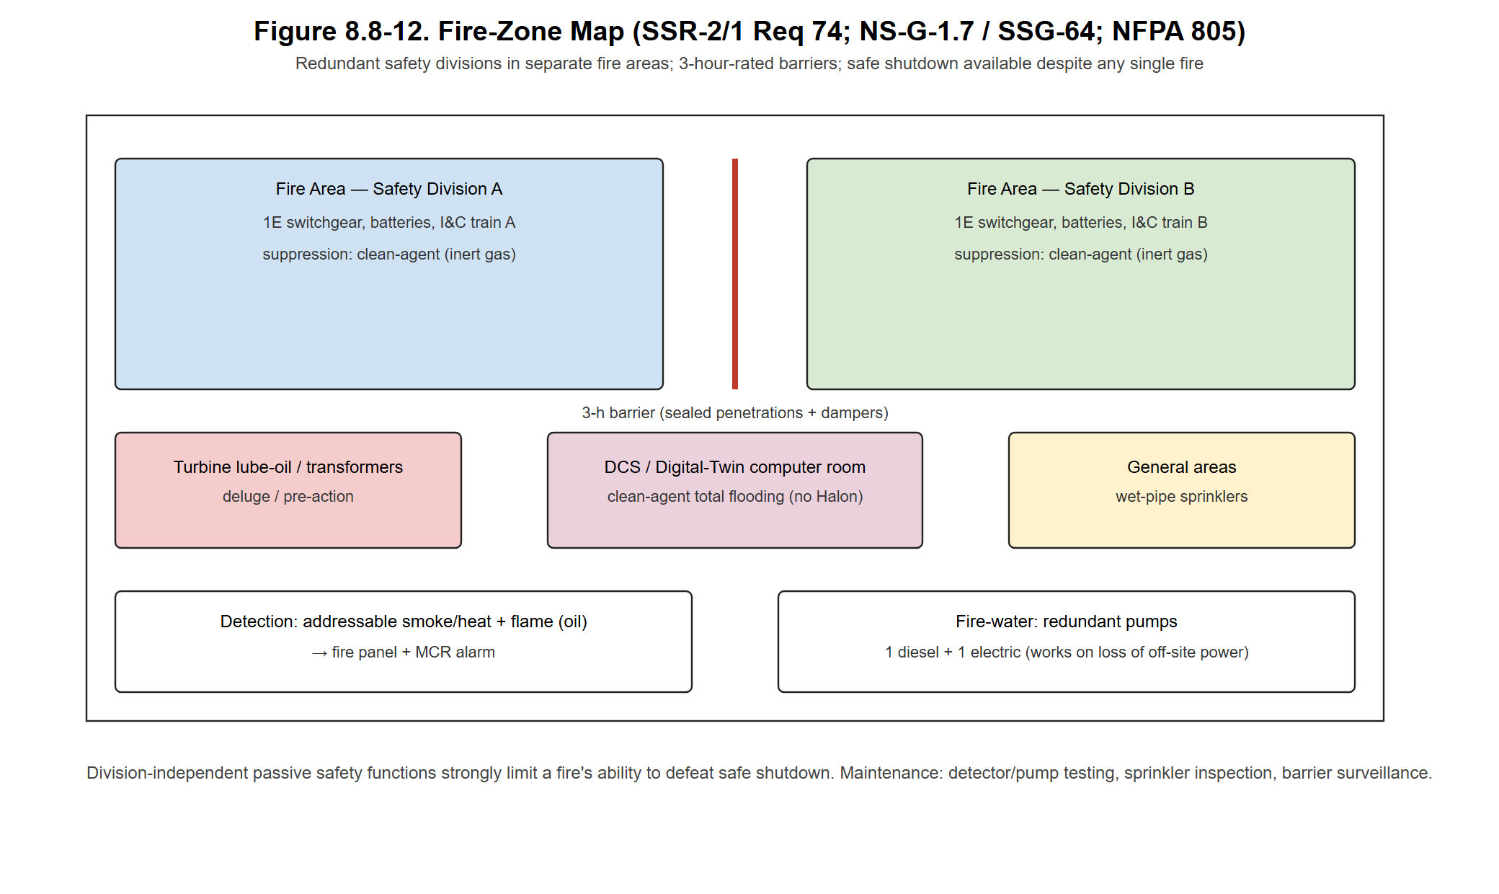
Figure 8.8-12. Fire-zone map.

8.8.12. Radiation Protection Provisions in Auxiliary Systems — SSR-2/1 Req. 81; NS-G-1.13
Purpose. Keep occupational and public exposure ALARA [NS-G-1.13; ICRP 103; IAEA GSR Part 3]. (Process-stream activity monitoring is the separate system in §8.8.5.)
Engineered means.
• Shielding — concrete/steel biological shields plus inherent shielding of the below-grade cavity.
• Area Radiation Monitoring System (ARMS) — fixed gamma/neutron monitors with MCR alarms in accessible areas.
• Continuous Air Monitors (CAMs) — particulate/iodine/noble-gas channels, interlocked to HVAC (§8.8.1).
• Access control & dosimetry — HP control point, electronic + passive dosimetry, contamination monitors, decontamination facility.
Interface. Radiation signals drive HVAC isolation, SGTS and MCR habitability actions (§8.8.1–8.8.3). Effluent and radioactive-waste handling is covered in FER §8.11. See Figure 8.8-13 (radiation-monitoring layout).
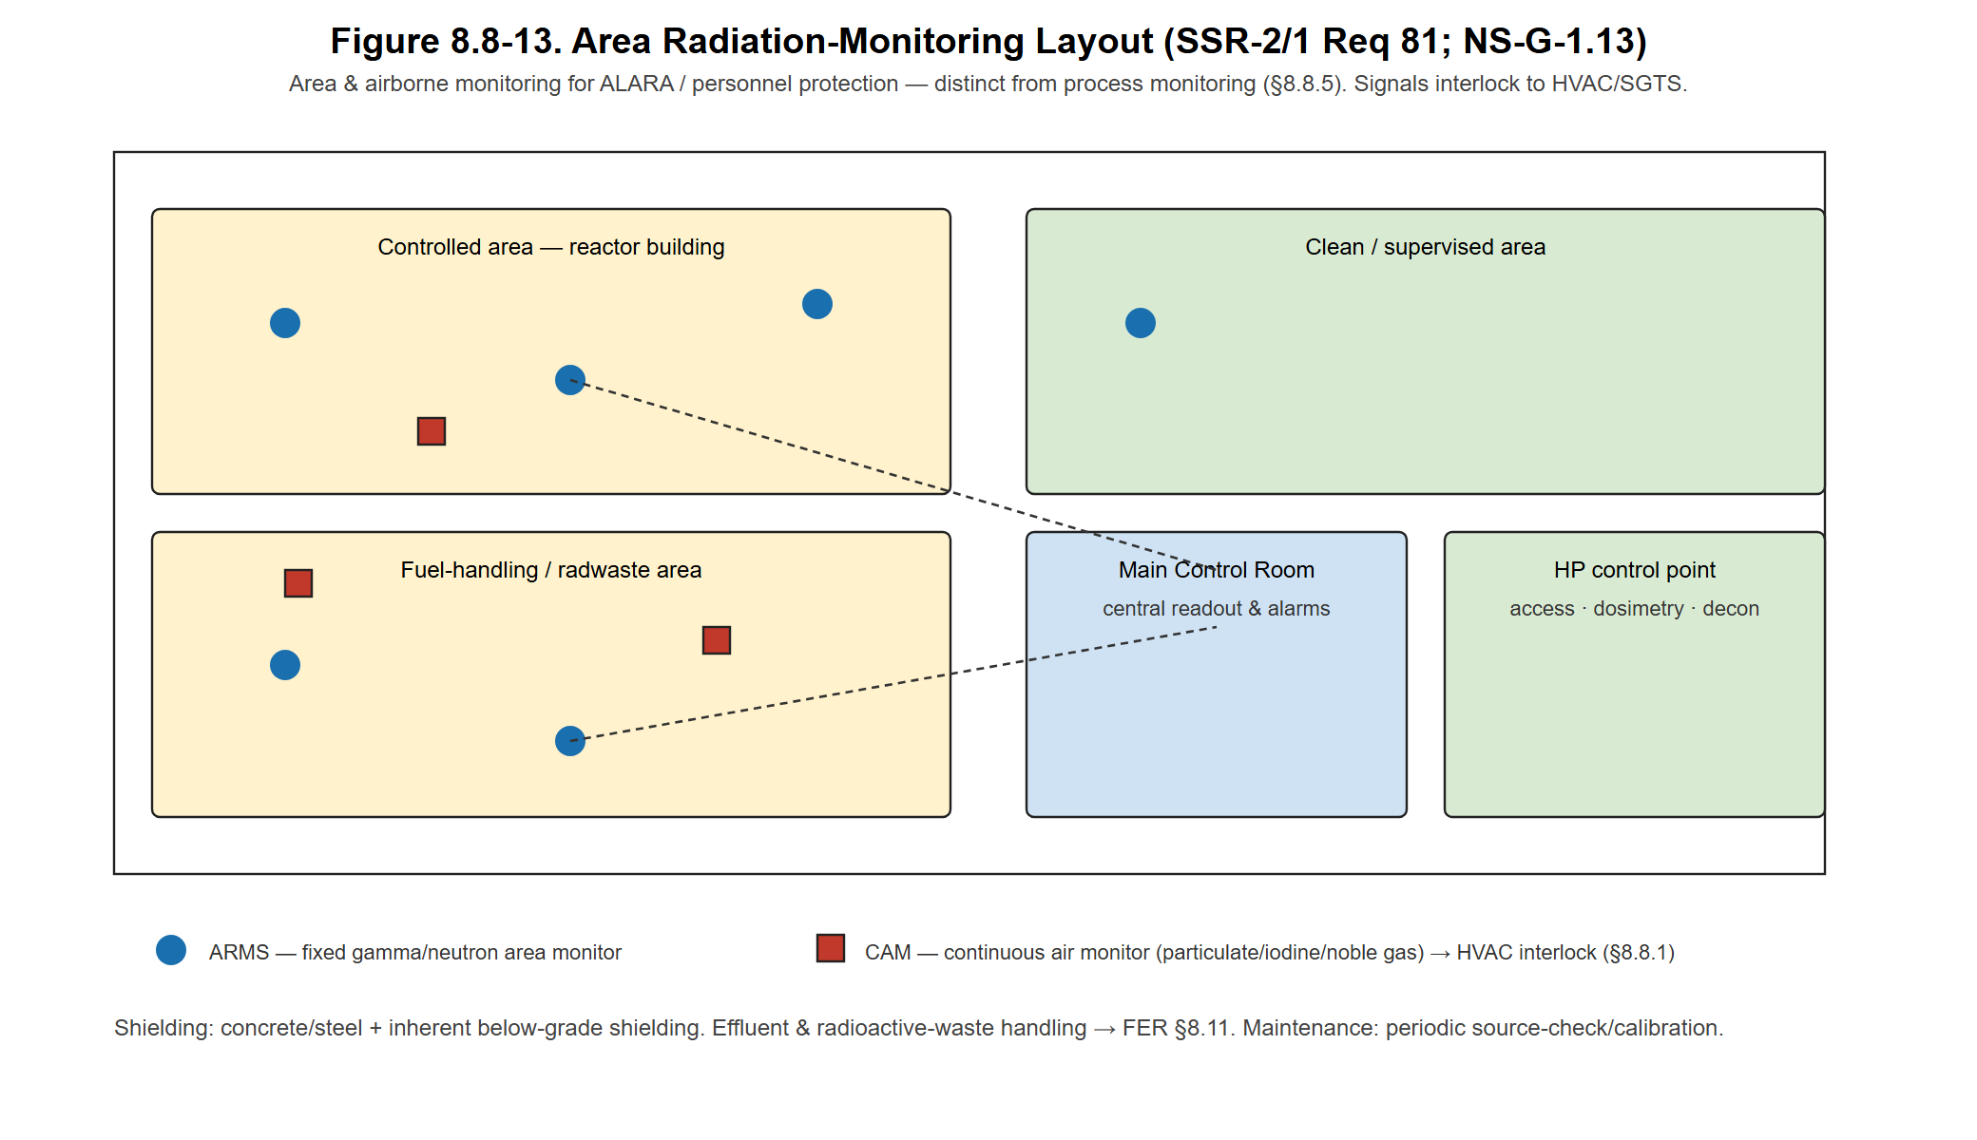
Figure 8.8-13. Area radiation-monitoring layout.

References cited in §8.8
• IAEA, Design of Auxiliary and Supporting Systems for Nuclear Power Plants, SSG-62, Vienna (2020/Russian ed.).
• IAEA, Safety of Nuclear Power Plants: Design, SSR-2/1 (Rev. 1) — Requirements 37, 68, 70–82.
• IAEA, Design of Electrical Power Systems for Nuclear Power Plants, SSG-34.
• IAEA, Design of the Reactor Coolant System and Associated Systems …, SSG-56.
• IAEA, Design of Fuel Handling and Storage Systems for Nuclear Power Plants, SSG-63.
• IAEA, Protection against Internal Fires and Explosions in the Design of NPPs, NS-G-1.7 (current: SSG-64).
• IAEA, Radiation Protection Aspects of Design for Nuclear Power Plants, NS-G-1.13.
• IAEA, Storage of Spent Nuclear Fuel, SSG-15 (Rev. 1).
• IAEA, Safety Classification of Structures, Systems and Components in NPPs, SSG-30.
• IAEA, GSR Part 3; ICRP Publication 103.
• U.S. NRC 10 CFR 50 App. A (GDC 17, 19); RG 1.52.
• IEEE Std 308, Std 384; ANSI/ANS-8.1; NFPA 805; ISO 8573-1.

8.9. Energy Cycle and Integrated Systems
Technical information regarding the energy cycle of the modular reactor, including electricity generation and non-electrical applications, should be presented in this section.
  - The energy conversion system design and flow diagrams for electricity generation from the modular reactor should be provided.
  - Definitions and detailed analyses of the systems planned to be integrated with the modular reactor for non-electrical applications—such as hydrogen production, seawater desalination, district heating, and process heat facilities for industries—together with their connections to the plant, should be presented.

8.10. Plant Layout Design

8.10.1. Overall Layout Description
The Aegis-40 is a 125 MWth / ~40 MWe (net) integral Pressurized Water Reactor (iPWR) for coastal deployment at the Sinop site on the Turkish Black Sea coast, identified as the optimal Turkish NPP location by multi-criteria analysis [Kurt, 2014]. The general arrangement is developed to satisfy four governing objectives simultaneously: inherent nuclear safety, construction efficiency and modularity, economic competitiveness, and reliable long-term operation and maintenance over the 60-year design life.
The defining spatial characteristic is the complete integration of the primary pressure boundary. The Reactor Pressure Vessel (RPV) — dimensionally referenced to the NuScale VOYGR Design Certification Application (NRC Docket No. 52-048) — houses the core, two helical-coil once-through steam generators (OTSGs), and the integral pressurizer within a single pressure boundary. Primary circulation is driven entirely by natural convection, with no reactor coolant pumps. This integral, pump-free architecture removes all large-bore primary piping, eliminates the large-break loss-of-coolant accident (LB-LOCA) as a design-basis event, and substantially reduces the Reactor Building footprint.
Following IAEA plant-grouping practice, the site is organised into a Nuclear Island (NI) containing all Seismic Category I / Class 1E structures, and a combined Energy / Conventional Island (E-CI) of Seismic Category II structures housing power conversion and the non-electrical applications. The overall site arrangement is shown in Figure 8.10-1.
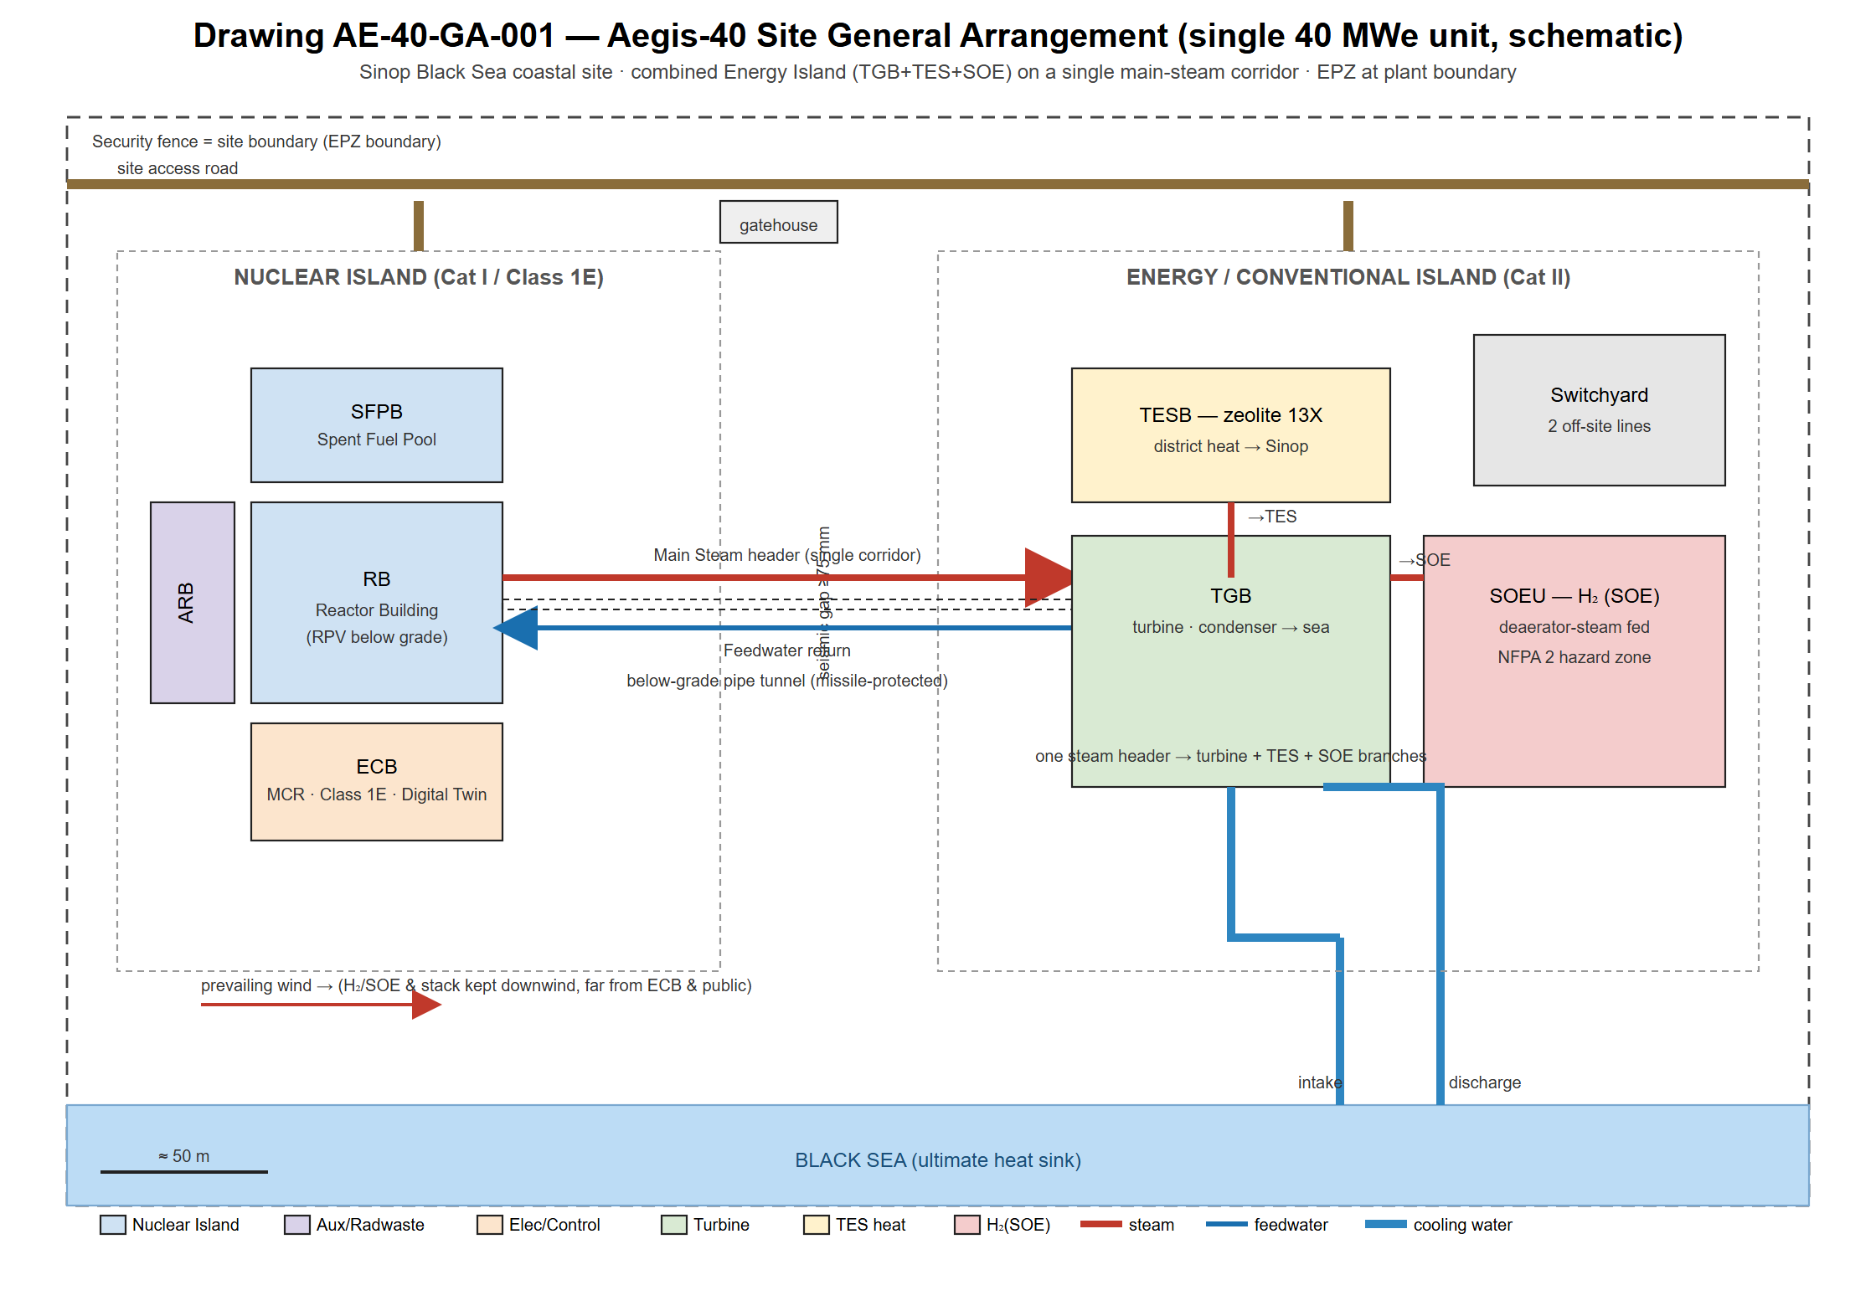
Figure 8.10-1. Aegis-40 site general arrangement (single 40 MWe unit).

8.10.2. Site Zoning and the Combined Energy Island
A key layout decision for the Aegis-40 is that the three secondary-side consumers — the steam turbine, the Thermochemical Energy Storage (TES) district-heating module, and the Solid Oxide Electrolysis (SOE) hydrogen unit — are all co-located within a single Energy Island and fed from one main-steam corridor leaving the Reactor Building. Because all three loads draw from the secondary side (the turbine from the main steam header, the TES from a pass-out / extraction branch at ~280 °C / 15 bar during peak hours, and the SOE from the deaerator-inlet steam during off-peak hours), a single below-grade steam corridor with short branch take-offs serves the entire island. This minimises high-energy piping length, the number of Reactor-Building penetrations, and the overall footprint, while simplifying isolation and in-service inspection. The steam-distribution arrangement is shown in Figure 8.10-2.
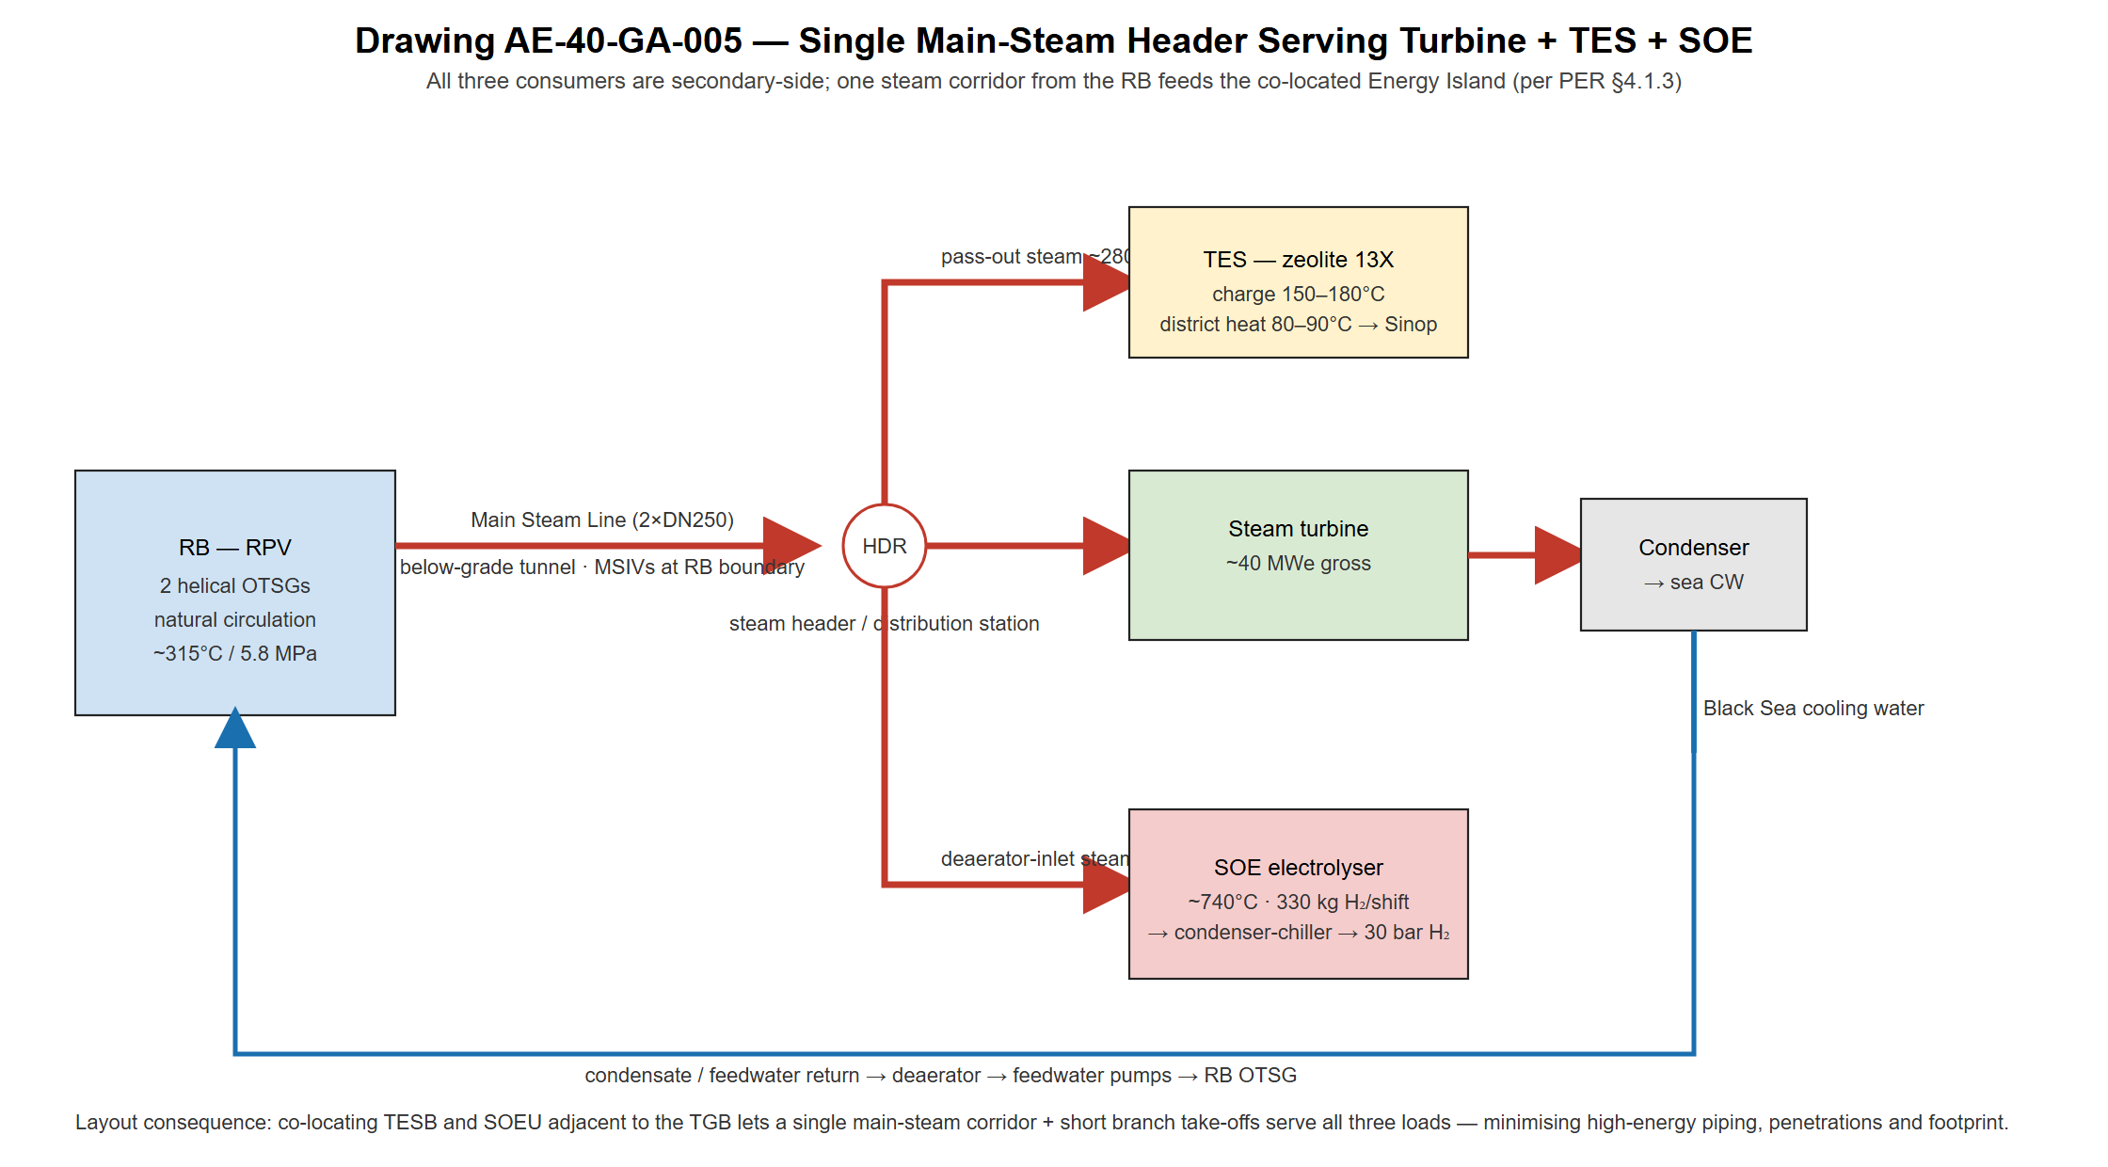
Figure 8.10-2. Single main-steam header serving turbine, TES and SOE.
The Turbine Generator Building (TGB) is oriented with its condenser end toward the sea to shorten the circulating-water route to the Black Sea ultimate heat sink. The TES Building (TESB) is placed on the landward side of the TGB, closest to the Sinop district-heating tie-in, and the SOE hydrogen unit (SOEU) is located at the downwind end of the island as a detached, NFPA-2-compliant hydrogen hazard zone, kept clear of the control room and the public boundary. A seismic gap of not less than 75 mm separates all Category I structures from the Category II Energy Island to prevent structural interaction during the Safe Shutdown Earthquake (SSE = 0.3 g).

8.10.3. Principal Buildings and Structures
Table 8.10-1 summarises the main buildings, their functions, safety classifications and key construction parameters. The Nuclear Island grade-level arrangement is shown in Figure 8.10-3.
Table 8.10-1. Aegis-40 principal buildings, safety classification and construction notes.
• Reactor Building (RB) — houses RPV, natural-circulation primary loop, containment vessel, passive DHRS HX and IRWST. Seismic Cat. I / Class 1E. Reinforced concrete; 1.2 m shielding walls; post-tensioned dome; below-grade RPV pool.
• Spent Fuel Pool Building (SFPB) — interim spent-fuel storage, transfer canal, fuel-handling machine. Seismic Cat. I. RC; shared shielding wall with RB; borated-water pool.
• Auxiliary / Radwaste Building (ARB) — reduced CVCS (SBF core), liquid radwaste, decontamination, chemistry. Seismic Cat. I/II. RC (Cat. I zones) + steel (Cat. II).
• Electrical & Control Building (ECB) — main control room, supplementary control point, Digital-Twin process computer, Class 1E switchgear, emergency power. Seismic Cat. I / Class 1E. Hardened RC; tornado-missile protected; air-gapped from external networks.
• Turbine Generator Building (TGB) — steam turbine, condenser, feedwater heaters, deaerator, generator. Seismic Cat. II. Structural steel; seismic gap ≥75 mm from NI; ≥20 m turbine-missile separation.
• TES / District-Heating Building (TESB) — zeolite 13X sorption modules (~390 t), heat exchangers, district-heating interface. Seismic Cat. II. Steel; adjacent to TGB secondary loop.
• SOE Hydrogen Unit (SOEU) — solid-oxide cells (5 MWe), H₂ condenser-chiller, compression to 30 bar. Seismic Cat. II. Detached pad; H₂ hazard separation per NFPA 2.
The Reactor Building is the dominant NI structure: a cylindrical RC shell with a post-tensioned hemispherical dome enclosing the containment vessel and the below-grade RPV pool. The pump-free integral primary loop requires no primary-pump penetrations through containment, reducing the number of penetrations and simplifying in-service inspection.
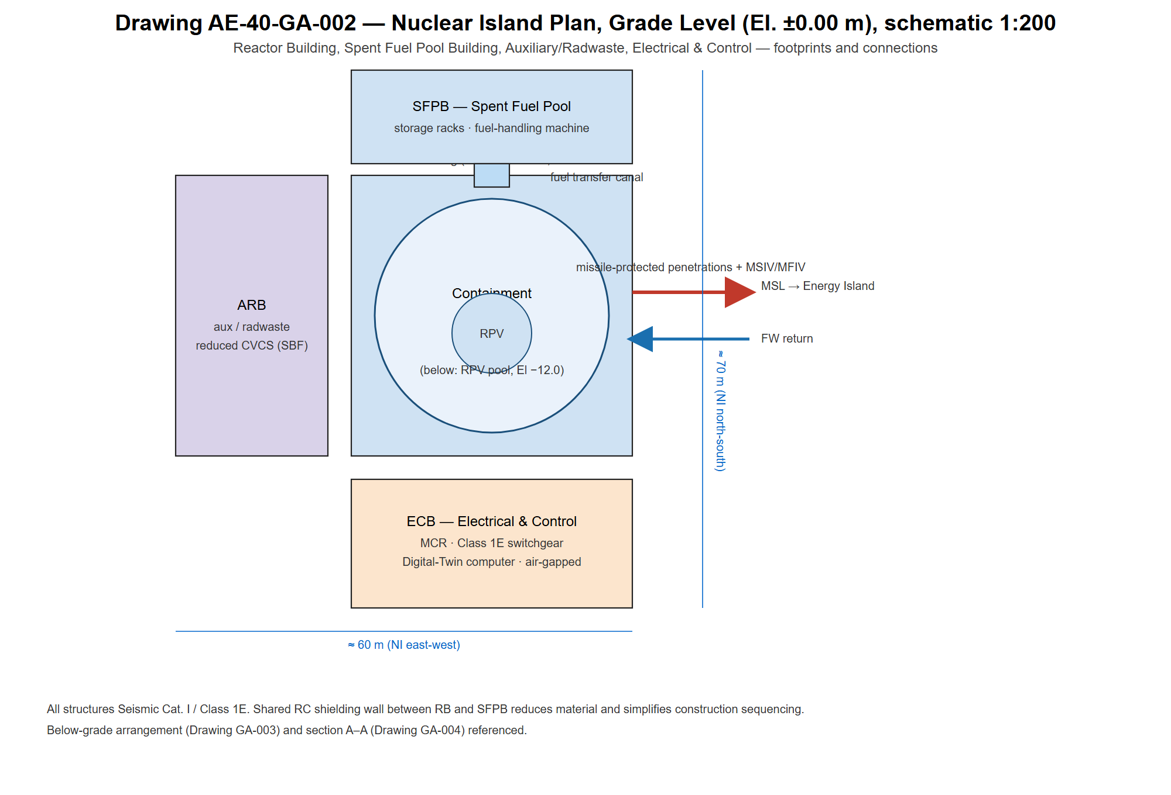
Figure 8.10-3. Nuclear Island plan, grade level (El. plus/minus 0.00).

8.10.4. Below-Grade Arrangement and Passive-Safety Layout
The entire RPV is positioned below grade within a steel-lined borated-water pool, consistent with the NuScale and CAREM-25 reference configurations. The below-grade plan at the RPV-pool level (El. −12.0 m) is shown in Figure 8.10-4 and the north–south cross-section in Figure 8.10-5. This placement simultaneously: lowers the centre of gravity of the heaviest components, improving seismic performance under the 0.3 g SSE; enables fully gravity-driven passive safety functions (DHRS and ECCS) with no pumps or active valves; provides the pool as the ultimate heat sink for a >100 h passive-cooling grace period (§8.5) and as biological shielding; reduces the exposed security perimeter; and gives inherent protection against external hazards including aircraft impact — supporting the plant-boundary Emergency Planning Zone.
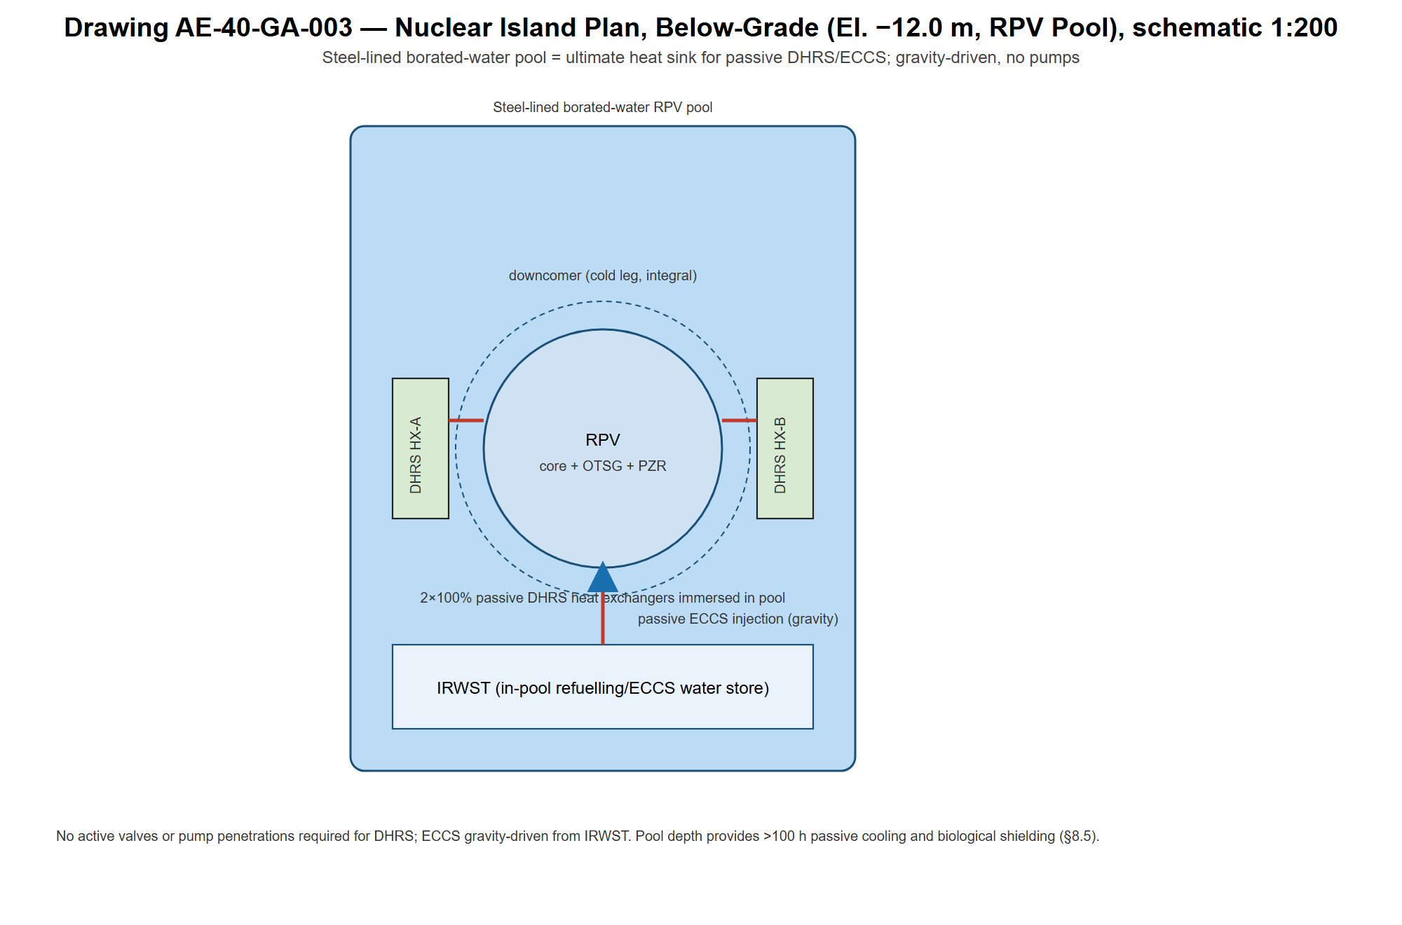
Figure 8.10-4. Nuclear Island below-grade plan (RPV pool, El. -12.0).
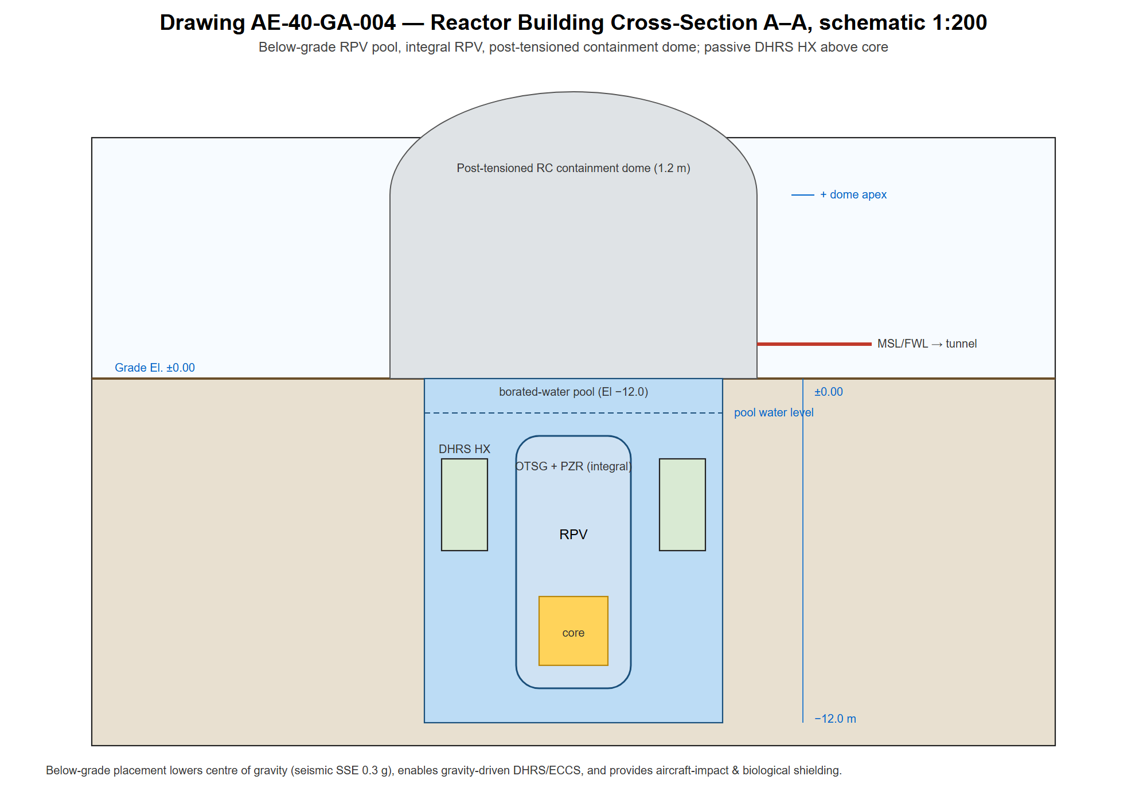
Figure 8.10-5. Reactor Building cross-section A-A.

8.10.5. Two- and Three-Dimensional Layout Plans
The general arrangement is documented in the following reference drawings, submitted as Digital Appendices:
• AE-40-GA-001 — Site General Arrangement Plan (1:500): boundary, road access, Sinop seawater intake/discharge, building spacing, EPZ boundary.
• AE-40-GA-002 — Nuclear Island Plan, Grade Level (El. ±0.00), 1:200.
• AE-40-GA-003 — Nuclear Island Plan, Below-Grade (El. −12.0 / RPV pool), 1:200.
• AE-40-GA-004 — Reactor Building Cross-Section A–A, 1:200.
• AE-40-GA-005 — Main-Steam Distribution to Turbine + TES + SOE.
• AE-40-GA-006 — Full-Site 3D Isometric, generated from the CAD model.
The 3D CAD model (FreeCAD / Fusion 360) is the Single Source of Truth (SSOT) for spatial coordination and contains all structures, equipment and piping of nominal diameter ≥50 mm, maintained under version control (Git/GitHub). Structural information feeding the specification basis includes RC wall/slab thicknesses and rebar schedules (from seismic demand per ASCE 4-16 / 43-19), structural-steel member and connection details for Category II buildings, inter-building connection structures (below-grade pipe tunnel, cable tunnel, personnel corridors), and system weight distributions used as structural-analysis inputs. The site 3D massing is shown in Figure 8.10-6.
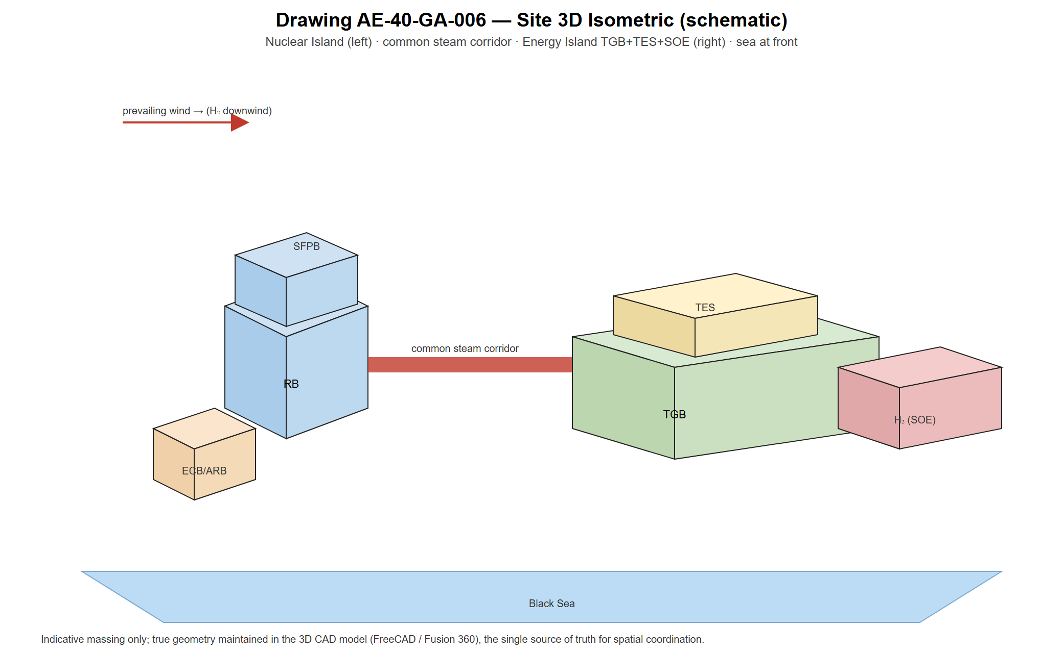
Figure 8.10-6. Site 3D isometric (schematic).

8.10.6. Critical Piping Arrangement
Critical piping comprises large-diameter / high-energy lines whose dimensions, thermal expansion or seismic response govern building penetrations, equipment placement and structure sizing. Table 8.10-2 lists the Aegis-40 critical piping, including the TES and SOE steam branches unique to this multi-application configuration.
Table 8.10-2. Aegis-40 critical piping — routing, design parameters and layout drivers.
• Main Steam Line (MSL) — 2 × DN250, ~315 °C / 5.8 MPa, RB → Energy Island (below-grade tunnel). ASME III Cl. 2; MSIVs inside RB within 1.5 m of penetration; whip restraints ≤3 m; redundant trains ≥3 m apart; common corridor serves turbine + TES + SOE branch take-offs.
• Main Feedwater Line (FWL) — 2 × DN200, ~220 °C / 6.5 MPa, Energy Island → RB (co-routed with MSL). ASME III Cl. 2; MFIVs at RB boundary; thermal sleeve at RPV nozzle; RC dividing wall from MSL in the tunnel.
• TES charging branch — pass-out / extraction steam ~280 °C / 1.5 MPa, header → TESB. Isolation valves at TESB inlet; short run within the Energy Island.
• SOE steam branch — deaerator-inlet steam, header → SOEU (off-peak). Isolation + flow control; H₂-side separated per NFPA 2.
• Decay Heat Removal (DHRS) — 2 × DN100, 343 °C / 15.5 MPa, intra-RB (RPV ↔ DHRS HX in pool). ASME III Cl. 1; fully passive; no active valves; no containment penetration required.
• Passive ECCS injection — 2 × DN80, 15.5 MPa design, intra-RB (IRWST → RPV). ASME III Cl. 1; gravity-driven; no pump penetrations.
• Pressurizer surge line — eliminated by the integral design (internal to RPV upper head).
Main steam and feedwater lines exit the RB through dedicated, missile-protected, double-walled penetrations with annular leak-off monitoring and are routed in a below-grade tunnel to the Energy Island; postulated pipe-whip zones have been confirmed not to impact safety-related SSCs.

8.10.7. Scalability and Multi-Unit Roadmap
While the reference design is a single 40 MWe unit, the arrangement is laid out to support the staged multi-unit deployment envisaged in the PER (5–10 units toward Turkey's SMR targets). Additional units replicate the NI module and share common infrastructure (intake/discharge, switchyard, access, and the Energy Island services), enabling phased construction and economies of scale on the same site, consistent with the NuScale multi-module precedent.

