**Acentric Factor:**

<https://www.crktech.com/wp-content/uploads/modvdw-pt4.pdf>

Edmister, W.C., “Applied Hydrocarbon Thermo., Petrol. Refiner”, Vol. 37 No. 4 (April, 1958).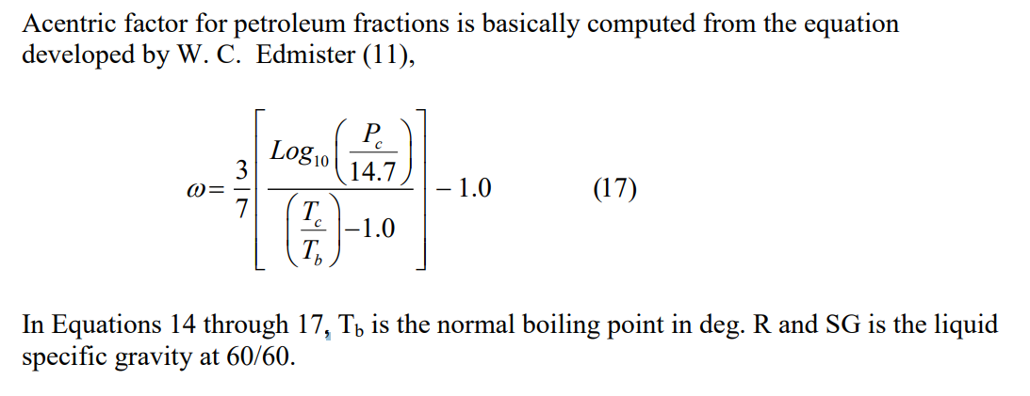

Kesler, M.G. and Lee, B.I., “Hydrocarbon Processing”, Vol. 55, No. 3, (March 1976) Page 153.

From Wikipedia:

<file:///C:/Users/EricKim/Documents/AP42/AP42-Emissions-py/Use%20of%20Critical%20Point%20in%20Equation%20of%20State%20Modeling%20for%20Reservoir%20Fluids.pdf>

Pederson (2004)

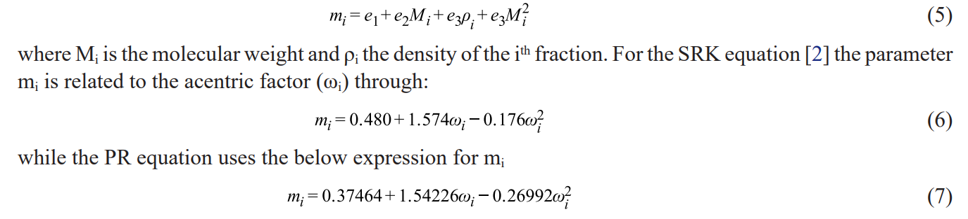

**Tc and Pc:**

<https://www.crktech.com/wp-content/uploads/modvdw-pt4.pdf>

Lee-Kesler (1975)

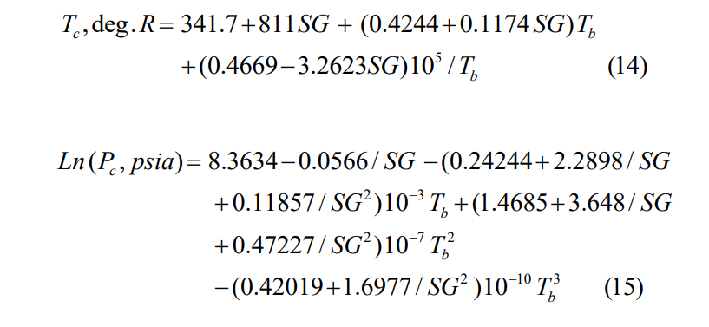

<file:///C:/Users/EricKim/Documents/AP42/AP42-Emissions-py/Use%20of%20Critical%20Point%20in%20Equation%20of%20State%20Modeling%20for%20Reservoir%20Fluids.pdf>

Pederson (2004)



Riazi, “prediction of thermophysical properties of petroleum fractions” (1985) (API technical data book 4D3.1)

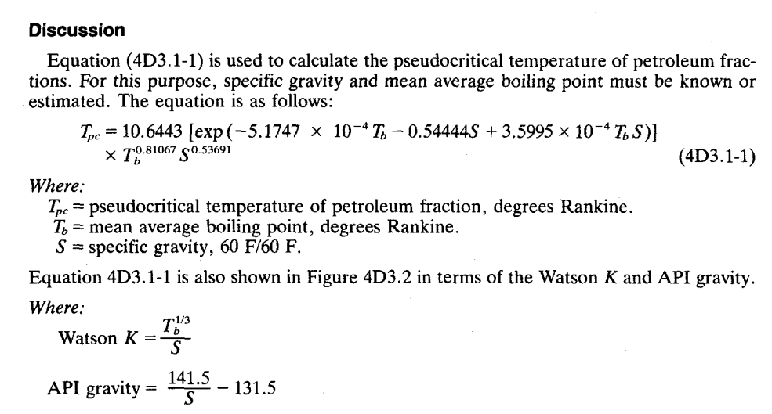

**Boiling Point**

Riazi (2005) Tb is in unit of K

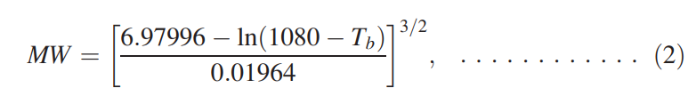

Riazi (1986)

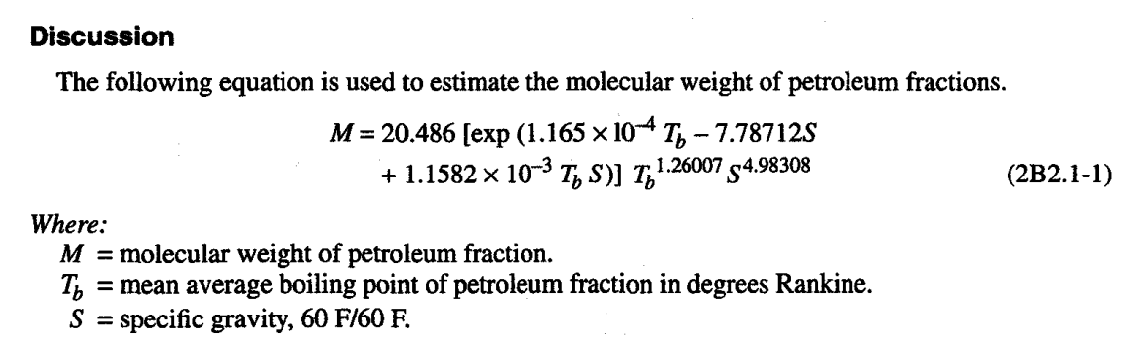

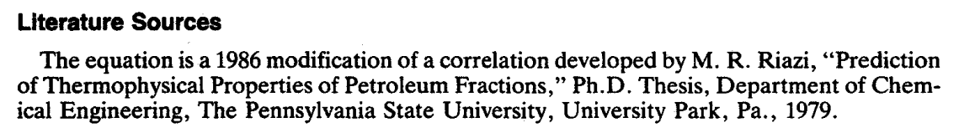

**Binary Interaction Parameters**

Properties of Gases and Liquids 5th ed. Pg 172

