AM AI SAFE
AI System Maturity Assessment Report
for
vCISO.One

Assessment Date: 2026-01-08
Assessment ID: N/A
Framework Version: 1.0.0

Table of Contents
- Executive Summary
- Assessment Context
- Assessment Results
- Key Findings & Risk Themes
- Recommendations
5.1 High Priority Recommendations
5.2 Medium Priority Recommendations
5.3 Low Priority Recommendations
- Evidence & Assurance Coverage
- Scope, Assumptions & Limitations

1. Executive Summary
1. Purpose of the Assessment
The objective of this assessment was to evaluate the maturity of the AI system "Another AI System" at vCISO.One, focusing on various domains critical to AI governance. The domains assessed include Data Integrity, Reliability, Accountability, Transparency, Security, Privacy, Fairness, Explainability, Safety, Sustainability, and Inclusivity.
2. Assessment Context
The system is currently in the development lifecycle stage. Specific aspects regarding business criticality, hosting model, data sensitivity, and oversight arrangements were not provided, limiting the ability to assess risk thoroughly. However, the developmental stage indicates that the system is in its early phases where foundational governance practices can be established.
3. Overall Maturity Outcome
The overall AI maturity score is 71.9%, placing the system in the Developing maturity tier. This tier typically signifies that while some governance practices are in place, significant work is needed to strengthen overall maturity and effectiveness.
4. Domain-Level Performance Overview
The strongest-performing domains are Data Integrity and Reliability, both scoring 84%. The lowest-performing domains include Inclusivity at 56%, Sustainability at 66%, and Safety at 69%. Notably, the low scores in these domains reflect a concentration of multiple low-scoring questions, suggesting a need for focused improvement efforts in these areas.
5. Key Insights
- The overall maturity position is Developing, indicating a mix of established practices and areas requiring enhancement.
- The strongest domain areas are Data Integrity and Reliability, scoring 84%.
- Primary risk or gap concentration is evident in Inclusivity, Sustainability, and Safety, with these domains performing below 70%.
- A total of 8 high-priority actions have been identified, signaling urgent areas needing attention.
- The maturity distribution reveals a larger number of questions categorized as Basic, indicating foundational governance practices may still be underdeveloped.
6. Forward-Looking Summary
Addressing the identified priority actions offers a pathway to enhance the governance and maturity of the AI system over time. By focusing on areas with lower scores, particularly Inclusivity, Sustainability, and Safety, vCISO.One can build a more robust framework that supports responsible and effective AI deployment, aligning practices with the organization's long-term strategic goals.

2. Assessment Context
This assessment evaluates the AI maturity of a specific AI system operated by vCISO.One, using the AM AI SAFE framework. The assessment context below provides important background for interpreting the results.
AI System Context
- System lifecycle stage: development
- Business / operational criticality:
- System ownership model:
- Deployment / hosting model:
- Highest data sensitivity handled:
- Governance and oversight model:
The context above has been considered when interpreting maturity outcomes, risk concentrations, and prioritised recommendations.

3. Assessment Results
3.1 Overall AI Maturity Outcome
vCISO.One achieved an overall AI maturity score of 71.9%, placing the system within the Developing maturity tier.
This tier reflects the extent to which AI governance, risk management, and operational practices are established, consistently applied, and supported across the assessed domains.

3.2 Domain-Level Results Overview
- The table below summarises performance across the assessed AI maturity domains.
Domain | Score (%) | Maturity Tier | Low-Scoring Questions
Inclusivity | 56.2 | Good | 4
Sustainability | 65.6 | Good | 4
Fairness | 68.8 | Good | 3
Explainability | 68.8 | Good | 3
Safety | 68.8 | Good | 3
Transparency | 71.9 | Good | 3
Security | 71.9 | Good | 2
Privacy | 71.9 | Good | 3
Accountability | 78.1 | Advanced | 2
Data Integrity | 84.4 | Advanced | 2
Reliability | 84.4 | Advanced | 1

3.3 AI Maturity Heatmap
The heatmap below provides a detailed visual representation of performance across all assessed questions.
- Rows represent AI maturity domains
- Columns represent individual assessment questions
- Colours indicate relative maturity levels, from lowest to highest
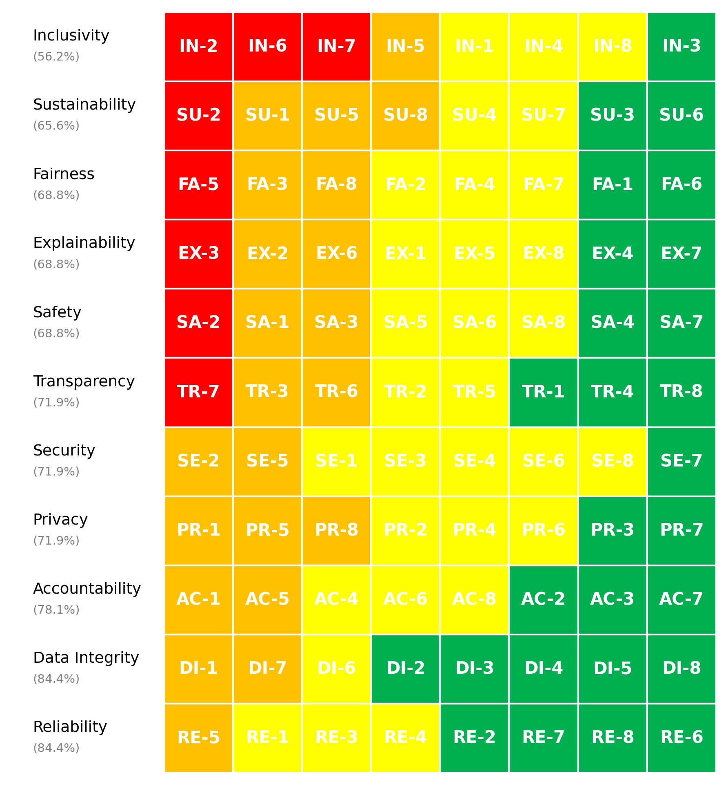
Figure 1. vCISO.One AI System Maturity Heatmap

3.4 Maturity Distribution
The distribution of maturity levels across all assessed questions is summarised below.
- Non-Ideal: 8 questions
- Basic: 22 questions
- Good: 31 questions
- Advanced: 27 questions
This distribution highlights how maturity is currently spread across foundational, developing, and more advanced practices.

4. Key Findings & Risk Themes
Finding 1: Overall Maturity Distribution Indicates Developmental Challenges
Observation: The maturity distribution indicates a predominance of Basic (score 2) and Good (score 3) responses, with a total of 53 questions (out of 88) falling in these categories, highlighting substantial developmental constraints.
Evidence: Out of 88 questions, 8 scored Non-Ideal, 22 scored Basic, 31 scored Good, and only 27 scored Advanced. The overall score of 71.9% places the system in the Developing tier, indicating that while some aspects are functioning adequately, many areas require significant improvement.
Risk Implication: This maturity distribution suggests operational risks due to insufficiently mature processes and methodologies. If unaddressed, the current level of maturity could lead to governance issues and hinder the system's ability to evolve in alignment with strategic objectives.
Finding 2: Disparity Between Strong and Weak Domain Performance
Observation: There is a notable disparity between high-performing domains such as Data Integrity and Reliability, both scoring 84%, contrasted with lower-performing domains, particularly Inclusivity, which scored 56%.
Evidence: The gap between the highest and lowest domain scores is 28 percentage points. The top scores in Data Integrity and Reliability reflect a solid foundation, whereas Inclusivity, alongside other lower-scoring domains like Safety and Sustainability (69% and 66%, respectively), indicates significant deficiencies.
Risk Implication: The pronounced differences in performance across domains raise concerns regarding balance and comprehensive oversight within AI governance frameworks. Lower scores in key areas like Inclusivity reflect potential vulnerabilities in stakeholder engagement and equitable technology deployment, posing risks to the system's long-term acceptance and effectiveness.
Finding 3: High Concentration of High-Priority Actions in Weak Domains
Observation: The assessment indicates that the majority of high-priority actions are concentrated in domains that currently exhibit weaker performance, particularly in Inclusivity, Safety, and Sustainability.
Evidence: Among the 8 high-priority actions identified, several are directed toward improving Inclusivity (IN-2, IN-6, IN-7), Sustainability (SU-2), and Explainability (EX-3). The low scores in these areas underscore a critical need for focused improvements.
Risk Implication: The concentration of high-priority actions in these weaker domains suggests a reactive approach to risk management rather than a proactive one. If the corresponding actions are not effectively executed, the risks associated with these vulnerabilities could persist or exacerbate, leading to cascading effects on the system's overall performance and stakeholder trust.
Finding 4: Lifecycle Stage Impacts Maturity and Criticality
Observation: The system is currently in the development stage, which correlates with lower maturity scores, particularly in critical domains related to safety and inclusivity.
Evidence: As the system is still being developed, the overall score is 71.9%, indicating challenges in readiness and operational maturity. Areas critical to AI deployment, such as Safety (69%) and Inclusivity (56%), exhibit notable weaknesses that underscore this developmental stage.
Risk Implication: Being in the development lifecycle stage creates inherent risks in operational readiness, especially for a system that may be business-critical once deployed. The observed deficiencies in key domains could lead to compromised safety and inclusivity at launch, potentially impacting user safety, satisfaction, and compliance with stakeholder expectations.

5. Recommendations
Based on the assessment results, the following recommendations are prioritised to support progressive improvement in AI governance, risk management, and operational maturity.

5.1 High Priority Recommendations
High Priority recommendations address critical gaps identified through low-scoring questions and represent areas requiring urgent attention to mitigate risk.
Summary
- Number of High Priority actions: 8
- Dominant risk themes: Harm Prevention Risk, Cybersecurity Access Risk, Accessibility Equity Risk, Bias Discrimination Risk, Disclosure Communication Risk
Domain | Question ID | Recommendation | Timeframe | Effort | Risk Theme
Inclusivity | IN-2 | Convene customer focus groups with representation across socioeconomic backgrounds, including underbanked populations, to guide financial AI development. | 0-90 days | High | Accessibility Equity Risk
Inclusivity | IN-6 | Develop financial inclusion features for underbanked populations, with alternative qualification methods and simplified application processes. | 0-90 days | High | Accessibility Equity Risk
Inclusivity | IN-7 | Create region-specific financial service interfaces with localized terminology, cultural considerations, and relevant financial product options. | 0-90 days | High | Accessibility Equity Risk
Sustainability | SU-2 | Implement algorithmic efficiency programs for trading and risk models, using quantization and pruning techniques with regular optimization cycles. | 0-90 days | High | Environmental Long-term Risk
Explainability | EX-3 | Create multi-format decision explanations with visual risk scores for customers, factor-weighted charts for advisors, and regulatory-compliant documentation for auditors. | 0-90 days | High | Decision Interpretability Risk
Fairness | FA-5 | Conduct real-world simulations using anonymized customer datasets from diverse backgrounds to identify bias before full deployment. | 0-90 days | High | Bias Discrimination Risk
Safety | SA-2 | Create financial harm prevention protocols with automated detection of unusual decisions, requiring human review for outlier cases. | 0-90 days | High | Harm Prevention Risk
Transparency | TR-7 | Create transparent customer communications clearly indicating when interactions are with AI systems versus human representatives, with opt-out paths. | 0-90 days | High | Disclosure Communication Risk

5.2 Medium Priority Recommendations
Medium Priority recommendations address gaps associated with foundational or partially established practices and should be implemented over the medium term.
Domain | Question ID | Recommendation | Timeframe | Effort | Risk Theme
Inclusivity | IN-5 | Form diverse customer advisory panels including traditionally underbanked populations to provide ongoing input throughout development and testing. | 3-6 months | Medium | Accessibility Equity Risk
Sustainability | SU-1 | Establish comprehensive energy monitoring for trading and risk assessment AI, calculating precise carbon costs per transaction with quarterly board reports. | 3-6 months | Medium | Environmental Long-term Risk
Sustainability | SU-5 | Implement balanced performance frameworks for financial models, establishing acceptable accuracy thresholds while optimizing for computational efficiency. | 3-6 months | Medium | Environmental Long-term Risk
Sustainability | SU-8 | Implement continuous energy monitoring for financial AI systems, integrating findings into ESG reporting with transparent efficiency metrics. | 3-6 months | Medium | Environmental Long-term Risk
Explainability | EX-2 | Implement customer comprehension testing with diverse financial literacy levels, iteratively improving explanation formats until verified understanding is achieved. | 3-6 months | Medium | Decision Interpretability Risk
Explainability | EX-6 | Create interactive decision explanation interfaces showing key factors affecting financial outcomes, with what-if scenarios for customer exploration. | 3-6 months | Medium | Decision Interpretability Risk
Fairness | FA-3 | Deploy automated fairness monitoring that compares approval rates, interest offerings, and claim processing across customer segments. | 3-6 months | Medium | Bias Discrimination Risk
Fairness | FA-8 | Establish fairness requirements in model specifications, with bias assessments required at each development milestone before proceeding. | 3-6 months | Medium | Bias Discrimination Risk
Safety | SA-1 | Implement financial harm assessments documenting potential negative impacts on customers, with mandatory remediation strategies for all identified risks. | 3-6 months | Medium | Harm Prevention Risk
Safety | SA-3 | Implement transaction safety monitoring detecting unusual decision patterns, with automated holds and expert review for outlier cases. | 3-6 months | Medium | Harm Prevention Risk
Privacy | PR-1 | Implement financial privacy compliance frameworks addressing all applicable regulations, with dedicated privacy officers and quarterly compliance reviews. | 3-6 months | Medium | Data Protection Privacy Risk
Privacy | PR-5 | Create comprehensive data protection combining tokenization, data masking, perturbation techniques, and aggregate analytics with statistical controls. | 3-6 months | Medium | Data Protection Privacy Risk
Privacy | PR-8 | Create comprehensive cross-border compliance with customer jurisdiction tracking, automated transfer controls, and regular compliance verification. | 3-6 months | Medium | Data Protection Privacy Risk
Security | SE-2 | Implement financial transaction defenses against adversarial attacks, with pattern recognition, anomaly detection, and multi-factor verification for unusual activities. | 3-6 months | Medium | Cybersecurity Access Risk
Security | SE-5 | Create financial model integrity frameworks with cryptographic validation, automated comparison testing, and segregated duties for model deployments. | 3-6 months | Medium | Cybersecurity Access Risk
Transparency | TR-3 | Create regulatory access frameworks providing transparent documentation, model validation results, and decision audit trails for compliance reviews. | 3-6 months | Medium | Disclosure Communication Risk
Transparency | TR-6 | Create transparent documentation of financial model data sources, including third-party data, validation methodologies, and algorithm selection with regulatory compliance. | 3-6 months | Medium | Disclosure Communication Risk
Accountability | AC-1 | Create comprehensive accountability frameworks with designated roles, documented response procedures, and regular testing for financial decision systems. | 3-6 months | Medium | Governance Oversight Risk
Accountability | AC-5 | Implement comprehensive responsibility matrices documenting specific ownership across risk, compliance, business and technology for AI governance. | 3-6 months | Medium | Governance Oversight Risk
Data Integrity | DI-1 | Create comprehensive data quality pipelines with automated profiling, completeness verification, consistency checks, and regular accuracy audits. | 3-6 months | Medium | Data Quality Lineage Risk
Data Integrity | DI-7 | Create comprehensive third-party evaluation with source due diligence, data sample validation, quality monitoring, and contractual quality requirements. | 3-6 months | Medium | Data Quality Lineage Risk
Reliability | RE-5 | Create comprehensive financial failure analysis identifying decision vulnerabilities, data dependencies, and market condition impacts with mitigation strategies. | 3-6 months | Medium | System Performance Risk

5.3 Low Priority Recommendations
Low Priority recommendations focus on long-term maturity uplift and alignment with leading practices.
Domain | Question ID | Recommendation | Timeframe | Effort | Risk Theme
Inclusivity | IN-1 | Design financial tools with voice-enabled navigation, screen reader compatibility, and offline functionality for customers without consistent internet access. | 6-12 months | Low | Accessibility Equity Risk
Inclusivity | IN-4 | Implement accessibility-first design principles with regular WCAG compliance audits and testing with users who have various disabilities. | 6-12 months | Low | Accessibility Equity Risk
Inclusivity | IN-8 | Analyze service utilization and approval rates across customer segments, implementing targeted solutions when disparities exceed defined thresholds. | 6-12 months | Low | Accessibility Equity Risk
Sustainability | SU-4 | Calculate transaction-level carbon costs for AI-driven financial services, including emissions data in ESG reporting with specific reduction commitments. | 6-12 months | Low | Environmental Long-term Risk
Sustainability | SU-7 | Implement balanced performance frameworks for financial models, establishing acceptable accuracy thresholds while optimizing for computational efficiency. | 6-12 months | Low | Environmental Long-term Risk
Explainability | EX-1 | Create explainability matrices for financial decisions, scaling detail and transparency based on transaction value and potential customer impact. | 6-12 months | Low | Decision Interpretability Risk
Explainability | EX-5 | Create model selection frameworks prioritizing interpretability for credit decisions, with transparent documentation of performance-explainability trade-offs. | 6-12 months | Low | Decision Interpretability Risk
Explainability | EX-8 | Create plain-language decision explanations for customers, detailed factor analysis for financial advisors, and regulatory documentation for auditors. | 6-12 months | Low | Decision Interpretability Risk
Fairness | FA-2 | Establish demographic benchmarking against regional population data, with mandatory data enrichment when representation gaps exceed 5%. | 6-12 months | Low | Bias Discrimination Risk
Fairness | FA-4 | Implement comprehensive fairness metrics including demographic parity, equal opportunity, and disparate impact analysis for all financial decisions. | 6-12 months | Low | Bias Discrimination Risk
Fairness | FA-7 | Implement targeted fairness metrics for underbanked populations, with specific model adjustments to address historical financial exclusion. | 6-12 months | Low | Bias Discrimination Risk
Safety | SA-5 | Create financial system failsafes with immediate transaction suspension capabilities and clear protocols for emergency system deactivation. | 6-12 months | Low | Harm Prevention Risk
Safety | SA-6 | Implement financial risk analysis identifying potential customer harm scenarios, with documented mitigation strategies and compensating controls. | 6-12 months | Low | Harm Prevention Risk
Safety | SA-8 | Implement financial stress testing including unusual transaction patterns, market volatility scenarios, and potential exploitation attempts. | 6-12 months | Low | Harm Prevention Risk
Privacy | PR-2 | Create comprehensive data protection using tokenization, data masking, perturbation techniques, and aggregate analytics with statistical controls. | 6-12 months | Low | Data Protection Privacy Risk
Privacy | PR-4 | Create comprehensive purpose limitation systems with transaction-linked controls, automated enforcement, and regular compliance verification. | 6-12 months | Low | Data Protection Privacy Risk
Privacy | PR-6 | Create comprehensive privacy monitoring combining access auditing, data transfer tracking, and automated anomaly detection with immediate alerts. | 6-12 months | Low | Data Protection Privacy Risk
Security | SE-1 | Create financial-grade model protection with encryption at rest and in transit, multi-factor authentication, and comprehensive audit trails for compliance. | 6-12 months | Low | Cybersecurity Access Risk
Security | SE-3 | Implement comprehensive security audit program with quarterly penetration testing, regulatory compliance assessment, and simulated adversarial attacks. | 6-12 months | Low | Cybersecurity Access Risk
Security | SE-4 | Create comprehensive model security across development, staging and production, with segregated environments and multi-factor authentication for deployments. | 6-12 months | Low | Cybersecurity Access Risk
Security | SE-6 | Create transaction defense systems with input validation, pattern recognition, and multi-factor verification for unusual financial activities. | 6-12 months | Low | Cybersecurity Access Risk
Security | SE-8 | Implement comprehensive security testing program with quarterly vulnerability assessments, regulatory testing, and simulated adversarial attacks. | 6-12 months | Low | Cybersecurity Access Risk
Transparency | TR-2 | Create detailed model documentation repositories tracking data lineage, preprocessing steps, algorithm selection, and regulatory compliance documentation. | 6-12 months | Low | Disclosure Communication Risk
Transparency | TR-5 | Identify and document any black-box elements in financial systems, implementing rigorous explanation tools and validation processes for regulatory compliance. | 6-12 months | Low | Disclosure Communication Risk
Accountability | AC-4 | Create comprehensive dispute resolution for AI financial decisions with clear appeal procedures, human review requirements, and remediation options. | 6-12 months | Low | Governance Oversight Risk
Accountability | AC-6 | Implement comprehensive lifecycle management with designated roles for model development, validation, deployment, monitoring and retirement. | 6-12 months | Low | Governance Oversight Risk
Accountability | AC-8 | Create comprehensive dispute resolution including human review options, clear appeal procedures, and multiple resolution paths for automated decisions. | 6-12 months | Low | Governance Oversight Risk
Data Integrity | DI-6 | Create comprehensive preprocessing workflows with standardized cleansing, consistent normalization, and documented transformation rules for financial data. | 6-12 months | Low | Data Quality Lineage Risk
Reliability | RE-1 | Implement comprehensive financial reliability testing including market volatility scenarios, unusual customer profiles, and edge cases with strict performance thresholds. | 6-12 months | Low | System Performance Risk
Reliability | RE-3 | Create comprehensive financial monitoring with automated drift detection, performance tracking, and scheduled validation against current market conditions. | 6-12 months | Low | System Performance Risk
Reliability | RE-4 | Create comprehensive financial reliability metrics including decision consistency, accuracy rates, availability, and response time with regulatory reporting. | 6-12 months | Low | System Performance Risk

6. Evidence Assurance Coverage
This section summarises the level of supporting evidence provided during the assessment.
- Total evidence artefacts submitted: 0
- Artefacts linked to high-priority risks: 0
- Overall evidence coverage: 0.0%
- Identified evidence gaps: 8
Key Evidence Gaps Identified
- Inclusivity – IN-2: High priority action without linked evidence
- Inclusivity – IN-6: High priority action without linked evidence
- Inclusivity – IN-7: High priority action without linked evidence
- Sustainability – SU-2: High priority action without linked evidence
- Explainability – EX-3: High priority action without linked evidence
Evidence coverage supports confidence in the assessment results and highlights areas where additional assurance artefacts would strengthen governance and audit readiness.

7. Scope, Assumptions Limitations
This assessment is based on information provided at the time of assessment, including self-reported responses and submitted evidence artefacts.
Key limitations include:
- The assessment does not constitute legal, regulatory, or compliance advice
- Results reflect current practices and may change as controls mature or operating conditions evolve
- Evidence sufficiency has been assessed at a high level and does not replace formal audit or assurance activities
Future reassessments are recommended to track maturity progression over time and validate the effectiveness of implemented improvements.

Report generated on: 2026-01-08T01:46:06
Assessment source reference: N/A

