

AM AI SAFE
AI Awareness & Foundations Assessment
for
Small Org

2026-01-19

Automated Version

Table of Contents
1. Executive Snapshot 3
2. Organisation & Context Profile 3
3. Foundational Controls & Readiness Signals 5
4. Awareness Assessment Results 6
5. Tailored Learning & Next-Step Recommendations 7
6. Your Pathway Through the AM AI SAFE Framework 8
7. Appendix A – Detailed Responses 10

- Executive Snapshot
This section provides a high-level snapshot of Small Org’s current AI awareness and foundational readiness. It is designed for senior leaders and decision-makers who want a clear understanding of where the organisation sits today, what this indicates in practical terms, and how prepared the organisation is to engage with AI-related discussions and decisions. The narrative below is derived directly from your assessment results and highlights the overall awareness level without delving into technical or compliance detail.
Results Summary
Your organisation demonstrates Emerging AI awareness with an overall score of 64.0%, which is above the Retail / Hospitality sector AI awareness average of 41%. Your organisation is showing early signs of AI awareness, with isolated pockets of understanding and increasing curiosity. While some staff recognise potential use cases, overall knowledge remains inconsistent. Focus on foundational education, awareness sessions, and building shared language around AI to prepare for the next stage of capability development.
Executive Interpretation
Small Org currently operates at an emerging tier of AI awareness, as evidenced by a score of 64.0%. This indicates that while the organization has made foundational strides in understanding and engaging with AI technologies, there remains significant work to be done to fully leverage these advancements. At this stage, the focus is on building a solid foundation for AI integration that aligns with industry standards and evolving customer expectations.
The organization displays strong capabilities in data and digital readiness, which positions it well for future growth in AI applications. However, it faces challenges in areas critical to fostering a comprehensive AI strategy, particularly in leadership alignment, broad awareness among staff, and the development of essential skills. This assessment specifically reflects the current level of awareness and foundational understanding of AI within the organization, underscoring the importance of enhancing these elements to advance further in its AI maturity journey.
Key Takeaways
- Current position: Emerging
- What’s working: Governance & Trust Foundations (70%), Data & Digital Readiness (90%)
- Primary gap: People & Skills (45%)
- Recommended focus (next 90 days): Enhance understanding of AI applications across the organization.
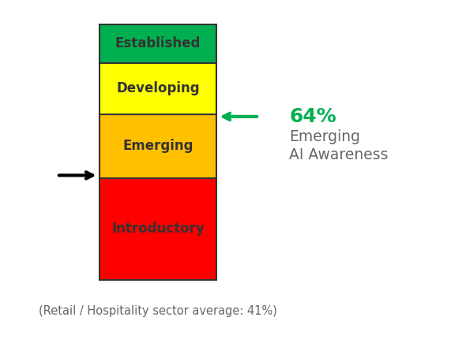
Figure 1. Overall AI awareness level. Black arrow shows Retail / Hospitality sector average; Green/Red arrows shows Small Org is Above/Below sector average.

- Organisation & Context Profile
AI awareness does not exist in isolation. This section places your assessment results in the context of Small Org’s operating environment, leadership posture, and digital maturity. By translating your onboarding inputs into a concise narrative, this section helps explain why certain results may have emerged and ensures that subsequent insights are grounded in your organisation’s reality rather than generic assumptions.
Organisation Snapshot
- Sector: Retail / Hospitality
- Organisation size: 250–999
- Primary business unit assessed: Factory operations

Starting Point with AI
- AI familiarity: Basic awareness
- Digital transformation stage: Developing
- Leadership interest in AI: Occasionally
- Comfort with technology change: Moderate

Contextual Interpretation
The organization operates within the retail and hospitality sector, indicating a landscape where customer experience and operational efficiency are pivotal. With a basic awareness of AI, there is a foundational understanding of its potential, which suggests an opportunity for deeper exploration and learning about how AI could enhance business practices. The current stage of digital transformation is developing, pointing to ongoing efforts to modernize processes and technologies.
Leadership interest in AI is described as occasional, which indicates a varying level of engagement with the potential applications of AI. This suggests that there may be opportunities for increased dialogue and education around AI initiatives to foster a more consistent interest among decision-makers. Additionally, a moderate comfort level with technology change implies that while there may be some apprehensions, there is also a readiness to adapt and explore new technological solutions as the organization continues its journey toward digital advancement.

Sector Context (Indicative Only)
The radar chart below illustrates how the organisation’s domain scores compare with Retail / Hospitality sector averages, offering a high-level reference point to identify relative strengths, potential gaps, and areas that may warrant further attention.
These benchmarks are provided for contextual guidance only and should not be interpreted as definitive measures of compliance, performance, or risk, as sector maturity can vary significantly based on organisational size, operating context, regulatory exposure, and AI adoption maturity.
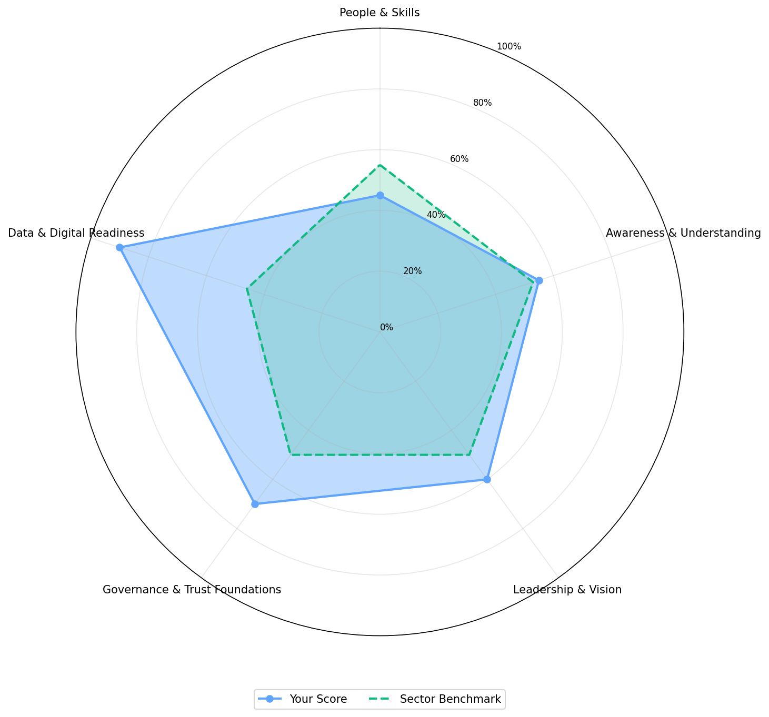
Figure 2. Small Org AI awareness domain scores compared with Retail / Hospitality sector averages.

- Foundational Controls & Readiness Signals
Effective AI awareness is supported by basic organisational foundations such as governance clarity, data responsibility, and digital readiness. This section summarises the foundational signals identified through your responses and explains how they influence the organisation’s ability to engage with AI safely and confidently. The commentary focuses on readiness for learning and early exploration, rather than formal controls or enforcement.
Existing Governance Foundations
Based on your responses, the following foundations are currently in place:
Data governance practices
Privacy policy / processes
Values or ethics charter
Interpretation
At this stage, the identified governance foundations such as a privacy policy, data governance practices, and a values or ethics charter matter significantly as they establish a framework for safe learning and experimentation. They provide guidance on responsible data usage and ethical behaviour, fostering an environment where team members can explore innovative ideas with a clear understanding of key principles. This foundation enhances awareness, enabling Small Org to navigate potential challenges thoughtfully, while promoting a culture that values informed decision-making and proactive engagement with emerging technologies.
Digital & Data Readiness Signals
- Digital / automation activity: Some automation or analytics pilots
- Data & digital skill confidence: Moderate
- Openness to AI learning: Moderate
The organization's reported readiness signals suggest a thoughtful approach to AI awareness activities. With some experience in automation and analytics, along with moderate confidence in digital skills, it's essential to frame awareness initiatives in a way that builds on existing knowledge while fostering a comfortable learning environment. Given the moderate openness to AI learning, a gradual and supportive pace in introducing concepts will help cultivate engagement and understanding, ensuring that employees feel empowered rather than overwhelmed.
- Awareness Assessment Results
This section summarises how Small Org responded across the key awareness domains assessed as part of the AI Awareness & Foundations Assessment. Rather than examining individual questions in detail, the focus here is on overall patterns and balance across domains, highlighting where awareness is relatively consistent and where additional support may be beneficial. The insights presented are intended to inform understanding, not to assign risk or performance ratings.
Domain-Level Overview
Domain | Maturity Level | Score
People & Skills | Developing | 45%
Awareness & Understanding | Developing | 55%
Leadership & Vision | Developing | 60%
Governance & Trust Foundations | Established | 70%
Data & Digital Readiness | Leading | 90%

Key Patterns Observed
The assessment results illustrate a nuanced landscape of awareness, characterized by a balance that suggests a generally consistent understanding across the various domains. The distribution of awareness appears relatively even, indicating that individuals have similarly engaged with the different aspects of the assessment. This uniformity may point to a well-rounded grasp of the subject matter, as opposed to significant disparities that would suggest strengths in some areas but weaknesses in others. Such a balanced awareness can facilitate a comprehensive approach to learning and application, fostering a holistic perspective rather than a fragmented one. Overall, the findings reflect a collective understanding that is both broad and integrated, although specific nuances within this balance remain undetailed.
- Tailored Learning & Next-Step Recommendations
This section translates your assessment results into targeted learning and awareness activities that are appropriate for your current stage of AI maturity. Rather than focusing on technical implementation, the emphasis here is on building shared understanding, confidence, and responsible decision-making across leadership and key teams. The recommendations below are intentionally practical and proportionate, helping Small Org develop AI awareness in a way that supports informed conversations and safe future choices.
Primary Motivation
You indicated your main reason for taking this assessment was to Educate staff / leadership.
Based on this selection:
- Targeted awareness materials aligned to your policies and sector obligations will deliver the most value.
Preferred Learning Formats
Based on your organisation’s preferred learning formats, the recommended options for further learning for your staff are:
- Provide micro-learning modules and FAQs that staff can access on demand.
- Run a 60–90 minute interactive AI awareness workshop for leadership and key functions.
- Offer a concise AI awareness guide and curated reading list aligned with your policies.
Prioritised Awareness Actions (Curated & Explained)
Awareness assessments often identify more potential improvement actions than can be realistically addressed at once. This section presents a deliberately curated set of awareness-stage actions that are most relevant to your current results. The aim is to support focus, momentum, and confidence-building, rather than overwhelm. The actions shown below reflect learning-oriented steps that help translate awareness into practical understanding and shared expectations.
High Priority Actions (Top 5)

Question ID | Domain | Recommended action
AU-01 | Awareness & Understanding | Run an introductory AI awareness session for staff and leaders explaining what AI is, how it works, and where it is already being used in customer-facing retail and hospitality environments.
AU-05 | Awareness & Understanding | Facilitate a discussion about how AI may change day-to-day tasks in customer-facing retail and hospitality environments, emphasising that it is there to support, not replace, people.
GT-01 | Governance & Trust Foundations | Send a reminder about privacy and data-handling expectations, including examples of what information from customer-facing retail and hospitality environments must never be entered into AI tools.
LV-04 | Leadership & Vision | Set aside regular time for leaders to review examples of how similar organisations in customer-facing retail and hospitality environments are using AI safely and effectively.
PS-04 | People & Skills | Share a curated set of beginner-friendly AI learning resources tailored to common roles and tasks in customer-facing retail and hospitality environments.
Medium Priority Actions (Top 5)

Question ID | Domain | Recommended action
AU-02 | Awareness & Understanding | Hold a short workshop with key teams to identify where AI could help reduce manual work, improve decision-making, or strengthen outcomes in customer-facing retail and hospitality environments.
GT-03 | Governance & Trust Foundations | Share a brief internal update explaining which AI tools or pilots are being explored, why they were chosen, and how they support work in customer-facing retail and hospitality environments.
LV-01 | Leadership & Vision | Include AI as a regular topic in leadership or governance meetings to explore how it could support strategic goals in customer-facing retail and hospitality environments.
LV-05 | Leadership & Vision | Create a simple evaluation checklist for AI tools that covers privacy, security, accuracy, usability, and risk considerations relevant to customer-facing retail and hospitality environments.
PS-02 | People & Skills | Encourage staff to try a safe, low-risk AI-assisted tool—such as summarising text or generating simple drafts—and share what helped their work in customer-facing retail and hospitality environments.
Low Priority Actions (Top 5)

Question ID | Domain | Recommended action
AU-03 | Awareness & Understanding | Create a simple myth-vs-fact guide that clarifies what AI can and cannot do in customer-facing retail and hospitality environments, avoiding hype and fear.
DR-01 | Data & Digital Readiness | Document your main data sources—such as records, logs, transactions, or case information—so staff clearly understand what information exists in customer-facing retail and hospitality environments.
DR-05 | Data & Digital Readiness | Ask IT or system owners to confirm whether your current systems can support basic AI-assisted tools—such as summarisation or reporting—without creating undue risk in customer-facing retail and hospitality environments.
GT-04 | Governance & Trust Foundations | Introduce a basic AI risk-check process that teams must complete before trialling new tools, prompting them to consider accuracy, privacy, fairness, and operational impact in customer-facing retail and hospitality environments.
LV-02 | Leadership & Vision | Approve one small, low-risk AI pilot so the organisation can gain hands-on experience and learn from a controlled experiment.
Action Narrative
At the emerging awareness stage, our focus is on nurturing understanding and fostering a culture of learning. The actions selected reflect a careful consideration of what will provide momentum without overwhelming our current capacities. Each action is designed to facilitate clear communication and reinforce foundational knowledge that supports safe progress. This approach allows us to adapt and build on our experiences as we move forward. Importantly, while we are currently prioritizing these actions, there are numerous additional opportunities beyond what is presented here, ensuring that we can expand our efforts as we grow in awareness and capability.
- Your Pathway Through the AM AI SAFE Framework
AI awareness is the starting point of a broader, progressive journey. This section shows how your current results fit within the wider AM AI SAFE framework and outlines the logical next stages as organisational understanding and confidence grow. Progression is not mandatory or time-bound; instead, it is designed to align with your readiness, priorities, and appetite for deeper AI assessment and governance.
Based on your results and openness:
[✓] AI Awareness Foundations Assessment (this report)
If you would like help translating this report into a simple action plan, internal briefing, or awareness campaign, this can be facilitated using the AM AI SAFE supporting tools and materials.
- Appendix A – Detailed Responses
This appendix provides a detailed view of the individual responses submitted during the assessment. It is included for transparency, internal review, and future comparison purposes. While not required for understanding the overall results, this information can be useful when tracking changes over time or preparing for more detailed AI readiness or maturity assessments.

AU-01 – How familiar are staff and leaders with what artificial intelligence (AI) actually is?
- Your response: Most people have little or no understanding of AI or what it can do.
- Domain: Awareness & Understanding
- Maturity level: Introductory
- Score: 1/4

AU-02 – How well does the organisation understand the potential benefits of AI for its work?
- Your response: Some awareness of AI potential, but not connected to business goals.
- Domain: Awareness & Understanding
- Maturity level: Emerging
- Score: 2/4

AU-03 – How confident is the organisation in separating AI myths from realistic capabilities?
- Your response: Staff generally understand AI’s practical uses and limitations.
- Domain: Awareness & Understanding
- Maturity level: Developing
- Score: 3/4

AU-04 – How open are leaders and staff to learning about AI and its implications?
- Your response: AI learning is part of ongoing professional development and curiosity is celebrated.
- Domain: Awareness & Understanding
- Maturity level: Established
- Score: 4/4

AU-05 – How clearly can staff and leaders explain how AI might impact their roles or services in the future?
- Your response: No discussion of AI’s impact on roles or services.
- Domain: Awareness & Understanding
- Maturity level: Introductory
- Score: 1/4

LV-01 – How actively do leaders discuss or explore AI within the organisation’s strategic direction?
- Your response: AI occasionally mentioned but without direction or intent.
- Domain: Leadership & Vision
- Maturity level: Emerging
- Score: 2/4

LV-02 – How supportive are leaders of experimenting with small, low-risk digital or AI projects?
- Your response: Leaders encourage small-scale, safe experimentation to explore AI potential.
- Domain: Leadership & Vision
- Maturity level: Developing
- Score: 3/4

LV-03 – How well does the organisation connect AI exploration to its mission or community outcomes?
- Your response: AI principles directly tied to measurable outcomes that improve community or business value.
- Domain: Leadership & Vision
- Maturity level: Established
- Score: 4/4

LV-04 – How willing is the organisation to invest time or resources in learning about AI responsibly?
- Your response: No time or resources allocated to AI learning.
- Domain: Leadership & Vision
- Maturity level: Introductory
- Score: 1/4

LV-05 – How confident are leaders in making informed decisions about adopting AI tools or vendors?
- Your response: Some awareness, but decisions largely rely on vendor advice.
- Domain: Leadership & Vision
- Maturity level: Emerging
- Score: 2/4

DR-01 – How well does the organisation understand what data it has and where it’s stored?
- Your response: Data inventories or registers exist for major systems.
- Domain: Data & Digital Readiness
- Maturity level: Developing
- Score: 3/4

DR-02 – How reliable and accurate does the organisation consider its data to be?
- Your response: Consistent data-quality practices applied organisation-wide.
- Domain: Data & Digital Readiness
- Maturity level: Established
- Score: 4/4

DR-03 – How easily can staff access the data they need to make decisions?
- Your response: Data accessibility and sharing supported by clear governance and secure platforms.
- Domain: Data & Digital Readiness
- Maturity level: Established
- Score: 4/4

DR-04 – How secure and protected is organisational data from unauthorised access or misuse?
- Your response: Security is proactive, reviewed regularly, and aligned with best-practice standards.
- Domain: Data & Digital Readiness
- Maturity level: Established
- Score: 4/4

DR-05 – How ready is the organisation’s technology infrastructure to support data analytics or AI exploration?
- Your response: Systems modern, stable, and support data-driven projects.
- Domain: Data & Digital Readiness
- Maturity level: Developing
- Score: 3/4

PS-01 – How comfortable are staff using data or digital tools in their daily work?
- Your response: Staff generally confident using digital tools and basic data analysis.
- Domain: People & Skills
- Maturity level: Developing
- Score: 3/4

PS-02 – How willing are staff to experiment with new tools or ways of working?
- Your response: Some openness, but limited support for experimentation.
- Domain: People & Skills
- Maturity level: Emerging
- Score: 2/4

PS-03 – How confident are managers in supporting their teams through technology change?
- Your response: Some managers lead small-scale initiatives but support varies.
- Domain: People & Skills
- Maturity level: Emerging
- Score: 2/4

PS-04 – How effectively does the organisation encourage staff to learn new skills related to technology or data?
- Your response: No structured training or learning opportunities available.
- Domain: People & Skills
- Maturity level: Introductory
- Score: 1/4

PS-05 – How confident are staff that AI or automation will support, not replace, their work?
- Your response: Staff fear AI will replace roles or reduce job security.
- Domain: People & Skills
- Maturity level: Introductory
- Score: 1/4

GT-01 – How aware is the organisation of privacy and data-protection responsibilities?
- Your response: Staff have limited awareness of privacy obligations.
- Domain: Governance & Trust Foundations
- Maturity level: Introductory
- Score: 1/4

GT-02 – How does the organisation ensure technology and data are used responsibly and ethically?
- Your response: Responsible-use principles documented and actively promoted.
- Domain: Governance & Trust Foundations
- Maturity level: Established
- Score: 4/4

GT-03 – How open is the organisation to being transparent about how it uses data or emerging technologies?
- Your response: Some information shared reactively or when required.
- Domain: Governance & Trust Foundations
- Maturity level: Emerging
- Score: 2/4

GT-04 – How prepared is the organisation to identify and manage risks associated with new digital tools or AI?
- Your response: Basic risk assessments performed before adopting new technologies.
- Domain: Governance & Trust Foundations
- Maturity level: Developing
- Score: 3/4

GT-05 – How confident is the organisation in its ability to adopt AI responsibly in the future?
- Your response: Confident and intentional about pursuing AI responsibly and strategically.
- Domain: Governance & Trust Foundations
- Maturity level: Established
- Score: 4/4

