AM AI SAFE
AI Framework Assessment
for
{{org.name}}

{{assessment.date}}

Automated Version

Table of Contents
1. Executive Summary 3
2. Assessment Results 3
Figure 1. ACME AI Maturity Heatmap 4
3. Recommendations 4
3.1. High Priority Recommendations 4
Table 1. High Priority Recommendations 5
3.2. Medium Priority Recommendations 5
Table 2. Medium Priority Recommendations 5
3.3. Low Priority Recommendations 5
Table 3. Low Priority Recommendations 6

- Executive Summary
The objective of this assessment was to evaluate {{org.name}}’s AI maturity across critical domains to identify strengths, weaknesses, and opportunities for improvement in their use and governance of artificial intelligence.
Using the AM AI SAFE framework, the assessment covered 11 key domains:
- Fairness
- Transparency
- Explainability
- Accountability
- Data Integrity
- Reliability
- Security
- Privacy
- Safety
- Inclusivity
- Sustainability
These domains encompass 88 targeted questions designed to provide a comprehensive view of {{org.name}}’s AI capabilities and risks.
- Assessment Results
The results indicate that {{org.name}} has achieved an overall AI maturity score of {{overall.score}}%, placing the organization within the {{overall.tier}} AI Maturity category.
The heatmap below provides a visual representation of {{org.name}}’s performance across the 11 domains and the corresponding 88 assessment questions. Each cell in the heatmap represents the score for a specific question, with colours indicating the level of performance:
- Red: Lowest scoring questions, indicating significant gaps that require immediate attention.
- Orange: Below-average performance, highlighting areas for improvement.
- Yellow: Moderate performance, reflecting foundational practices with room for growth.
- Green: High performance, demonstrating strong alignment with best practices.
The heatmap is organized as follows:
- Rows represent the 11 domains of the AM AI SAFE Framework.
- Columns represent the 8 questions associated with each domain, scored on a scale from 0 (lowest) to 3 (highest).
- After all answers have been collected, scores are calculated and heatmap arranged with domains sorted by total score in descending order, and individual answer scores arranged from left to right, with lowest scores to the left.
- This provides an intuitive view of your organization’s overall AI maturity status from both a domain and individual control perspective and allows for prioritisation of recommendations.
{{assets.heatmapUrl}}
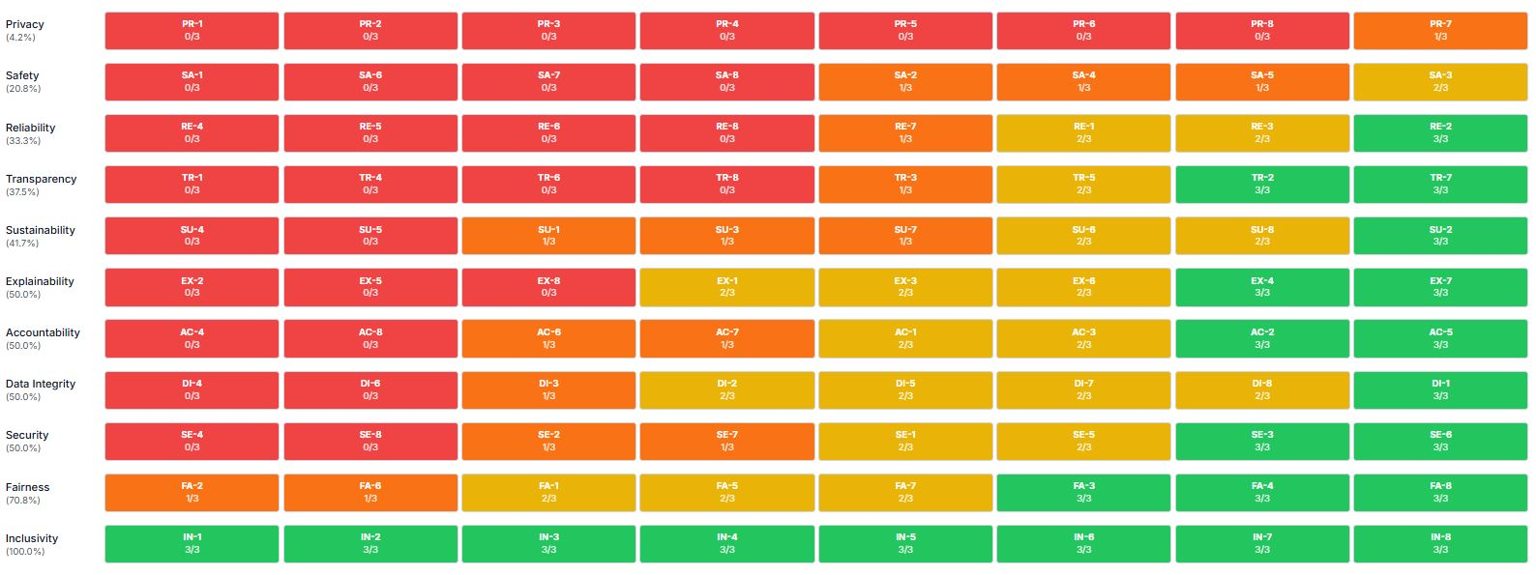
Figure 1. {{org.name}} AI Maturity Heatmap
- Recommendations
Based on the findings of the AI Maturity Assessment, the following key recommendations are proposed to help {{org.name}} enhance its AI governance and achieve a higher level of AI maturity:
  - High Priority Recommendations
These High Priority actions recommended for {{org.name}} are in response to the lowest ‘Non-Ideal’ scoring questions from the AI Maturity Assessment. These represent critical gaps that require urgent attention to mitigate risks and align {{org.name}}’s AI practices with best-in-class standards. Addressing these actions will strengthen foundational aspects of AI governance and build momentum for broader improvements.
Domain | Question ID | Recommendation
{% for action in actions.dynamic %}{{domain}} | {{question_id}} | {{text}}{{/actions.dynamic}}
Table 1. High Priority Recommendations
  - Medium Priority Recommendations
These Medium Priority recommendations focus on addressing gaps identified in the set of ‘Basic’ scoring questions from the AI Maturity Assessment. These initiatives build on the immediate actions by targeting areas that require moderate effort and investment but are crucial for enhancing {{org.name}}’s AI maturity within the next 6–12 months.
Domain | Question ID | Recommendation
{% for action in actions.dynamic %}{{domain}} | {{question_id}} | {{text}}{{/actions.dynamic}}
Table 2. Medium Priority Recommendations
  - Low Priority Recommendations
These Low Priority recommendations focus on addressing gaps identified as ‘Good’ scoring questions from the AI Maturity Assessment. These initiatives are designed to drive sustained improvement and align {{org.name}}’s AI practices with industry-leading standards over the next 1–3 years. The long-term strategy emphasizes strategic investments, cultural shifts, and innovative approaches to AI governance.
Domain | Question ID | Recommendation
{% for action in actions.dynamic %}{{domain}} | {{question_id}} | {{text}}{{/actions.dynamic}}
Table 3. Low Priority Recommendations

