

AM AI SAFE
AI Awareness & Foundations Assessment
for
vCISO.One

2026-01-10

Automated Version

Table of Contents
1. Executive Summary 3
2. Assessment Results 3
Figure 1. vCISO.One AI Maturity Heatmap 4
3. Recommendations 4
3.1. High Priority Recommendations 4
Table 1. High Priority Recommendations 4
3.2. Medium Priority Recommendations 4
Table 2. Medium Priority Recommendations 5
3.3. Low Priority Recommendations 5
Table 3. Low Priority Recommendations 5

- Executive Snapshot
This report provides a concise view of vCISO.One’s current level of AI awareness and foundational readiness.
It is based on responses to the AM AI SAFE – AI Awareness & Foundations Assessment, designed specifically for organisations that are:
- Early in their AI journey,
- Wanting to understand key concepts, risks, and responsibilities, and
- Looking for safe, practical next steps without a full technical audit.
Overall, vCISO.One is currently assessed at:
Overall Awareness & Foundations Level: Developing (61.0%)
This indicates encouraging progress. vCISO.One is starting to think actively about AI, with some early practices in place. The next step is to formalise simple guidelines and build targeted awareness across leadership and key teams.

A visual summary of your results is shown below:

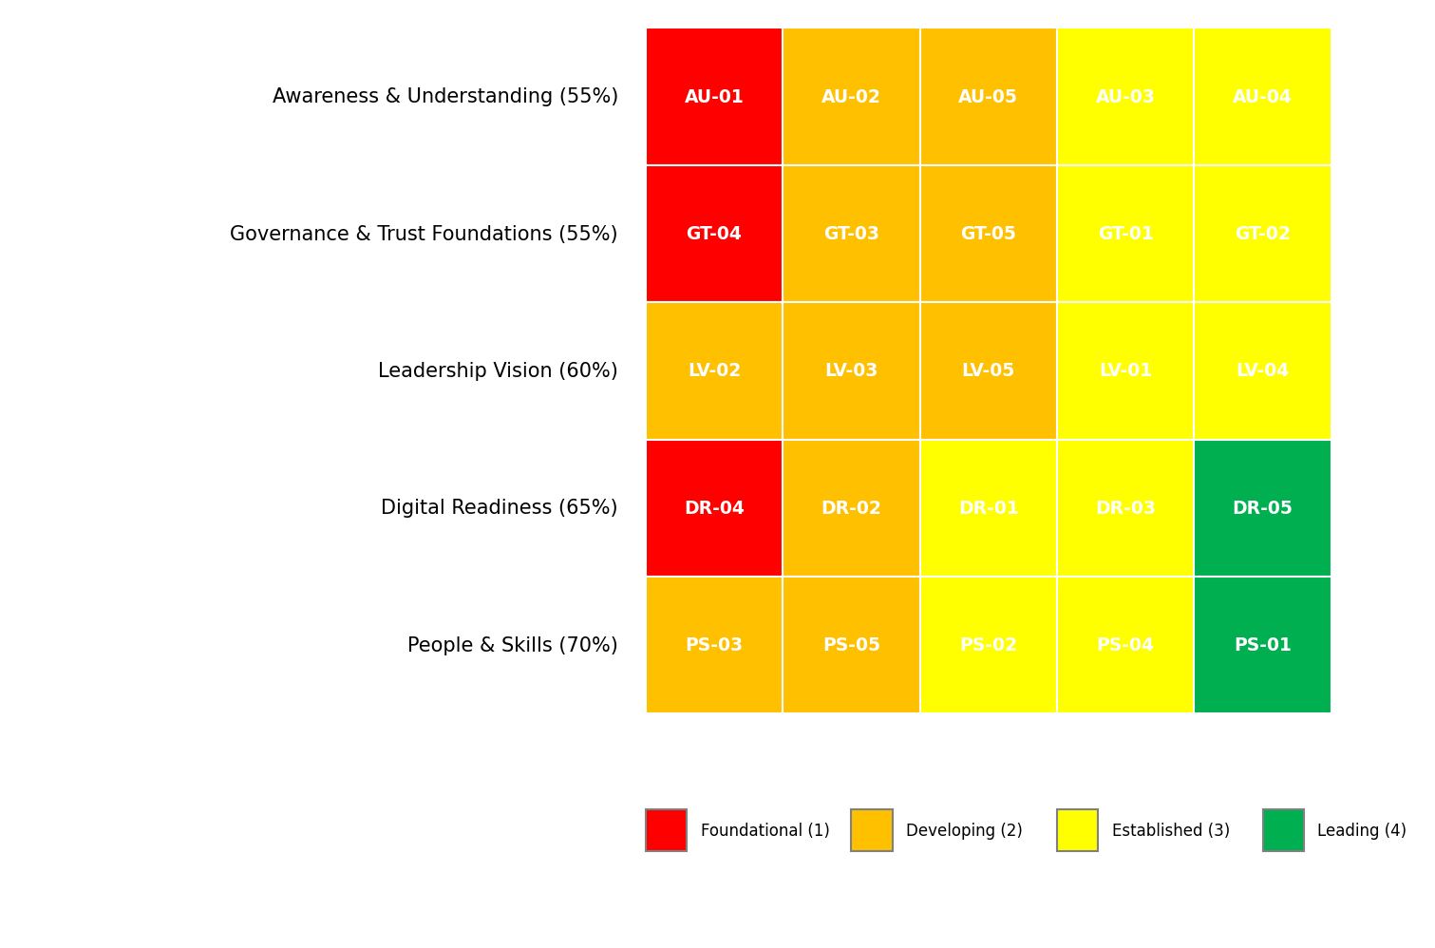

(The chart above illustrates vCISO.One’s relative strengths and gaps across key awareness domains such as leadership understanding, risk awareness, responsible data use, and staff capability.)

- Organisation & Context Profile
This section translates your onboarding inputs into a short narrative so that the findings are grounded in your reality.
Organisation Snapshot
vCISO.One operates within the Education sector and has an approximate size of 250–999 staff.
This assessment was primarily completed for the Dept Q business unit.
Starting Point with AI
Your organisation reported:
- AI Familiarity: Basic awareness
- Digital Transformation Stage: Developing
- Leadership Interest in AI: Regularly
- Comfort with Technology Change: Moderate
This suggests that many stakeholders are still forming an understanding of what AI is, where it fits, and what it means for their roles. The recommendations in this report prioritise clarity, confidence, and safe experimentation.

Leadership engagement with AI is a strength. This creates a solid platform to embed simple “guardrails” and lead by example in responsible AI use.
With moderate comfort, AI awareness activities should mix reassurance (risk-managed, compliant) with practical benefits relevant to daily work.

- Foundational Controls & Readiness Signals
Existing Governance Foundations
Based on your responses, the following foundations are currently in place:
- ICT / Cybersecurity policies

These existing foundations provide a valuable platform. By lightly extending them (e.g., adding AI-specific clauses to privacy, data use, and ethics documents), vCISO.One can quickly establish credible AI guardrails without starting from scratch.
Digital & Automation Activity
You indicated: Some automation or analytics pilots

With active digital or automation initiatives underway, vCISO.One is well-positioned to explore targeted AI use-cases, provided foundational responsibilities (governance, privacy, risk) are understood.
Data Skills & Openness
- Data & Digital Skill Confidence: Moderate
- Openness to Future AI Learning/Pilots: Moderate
There is a workable base. With focused awareness material, staff can quickly adapt to AI-enabled tools while following appropriate safeguards.

There is openness to carefully framed initiatives, especially when linked to productivity, service quality, or risk reduction.

- Awareness Assessment Results
This section summarises how vCISO.One responded to key awareness and foundation questions.
Overall Level: Developing (61.0%)

(Visual: A simple segmented bar or donut chart showing Foundational → Developing → Established with 61.0% highlighted.)

Domain-Level Insights

- **Awareness Understanding:** 34.4% – Basic

- **Governance Trust Foundations:** 34.4% – Basic

- **Leadership Vision:** 37.5% – Basic

- **Digital Readiness:** 40.6% – Basic

- **People Skills:** 43.8% – Basic

Key Gaps Risks

- Awareness Understanding (34%)

- Governance Trust Foundations (34%)

- Leadership Vision (38%)

- Digital Readiness (41%)

- People Skills (44%)

- Tailored Learning Next-Step Recommendations
This section is fully driven by your metadata and results to feel bespoke.
Primary Motivation
You indicated your main reason for taking this assessment was:
Educate staff / leadership

Targeted awareness materials aligned to your policies and sector obligations will deliver the most value.

Preferred Learning Formats
Based on your preferences:
- Provide micro-learning modules and FAQs that staff can access on demand.
- Run a 60–90 minute interactive AI awareness workshop for leadership and key functions.

Priority Actions (Awareness-Stage Only)
These are intentionally light-weight, practical and aligned with your current level.

- **High:** Implement comprehensive awareness understanding improvements to achieve best practices in this area.

- **High:** Implement comprehensive governance trust foundations improvements to achieve best practices in this area.

- **High:** Implement comprehensive digital readiness improvements to achieve best practices in this area.

- **Medium:** Implement comprehensive awareness understanding improvements to achieve best practices in this area.

- **Medium:** Implement comprehensive awareness understanding improvements to achieve best practices in this area.

- **Medium:** Implement comprehensive governance trust foundations improvements to achieve best practices in this area.

- **Medium:** Implement comprehensive governance trust foundations improvements to achieve best practices in this area.

- **Medium:** Implement comprehensive leadership vision improvements to achieve best practices in this area.

- **Medium:** Implement comprehensive leadership vision improvements to achieve best practices in this area.

- **Medium:** Implement comprehensive leadership vision improvements to achieve best practices in this area.

- **Medium:** Implement comprehensive digital readiness improvements to achieve best practices in this area.

- **Medium:** Implement comprehensive people skills improvements to achieve best practices in this area.

- **Medium:** Implement comprehensive people skills improvements to achieve best practices in this area.

- **Low:** Implement comprehensive awareness understanding improvements to achieve best practices in this area.

- **Low:** Implement comprehensive awareness understanding improvements to achieve best practices in this area.

- **Low:** Implement comprehensive governance trust foundations improvements to achieve best practices in this area.

- **Low:** Implement comprehensive governance trust foundations improvements to achieve best practices in this area.

- **Low:** Implement comprehensive leadership vision improvements to achieve best practices in this area.

- **Low:** Implement comprehensive leadership vision improvements to achieve best practices in this area.

- **Low:** Implement comprehensive digital readiness improvements to achieve best practices in this area.

- **Low:** Implement comprehensive digital readiness improvements to achieve best practices in this area.

- **Low:** Implement comprehensive people skills improvements to achieve best practices in this area.

- **Low:** Implement comprehensive people skills improvements to achieve best practices in this area.

(Example backend generation rules:
- HIGH: any domain 40% → 1–2 simple actions (e.g., “Publish one-page AI do/don’t guide”)
- MEDIUM: domains 40–65%
- LOW: domains 66%+ → optional enhancements)
- Your Pathway Through the AM AI SAFE Framework
Based on your results and openness:
[✓] AI Awareness Foundations Assessment (this report)

[→] **Recommended Next Step:** AI Readiness / Discovery Assessment
This will help sadsada identify concrete, low-risk AI use-cases and required safeguards.

If you would like support translating this report into a simple action plan, internal briefing, or awareness campaign, this can be facilitated using the AM AI SAFE supporting tools and materials.

- Appendix A – Detailed Responses (Optional)

