

AM AI SAFE
AI Awareness & Foundations Assessment
for
Test Organization

2025-01-20

Automated Version

Table of Contents
1. Executive Snapshot 3
2. Organisation & Context Profile 3
3. Foundational Controls & Readiness Signals 5
4. Awareness Assessment Results 6
5. Tailored Learning & Next-Step Recommendations 7
6. Your Pathway Through the AM AI SAFE Framework 8
7. Appendix A – Detailed Responses 10

- Executive Snapshot
This section provides a high-level snapshot of Test Organization’s current AI awareness and foundational readiness. It is designed for senior leaders and decision-makers who want a clear understanding of where the organisation sits today, what this indicates in practical terms, and how prepared the organisation is to engage with AI-related discussions and decisions. The narrative below is derived directly from your assessment results and highlights the overall awareness level without delving into technical or compliance detail.
Results Summary
Your organisation demonstrates Developing AI awareness with an overall score of 65.0%, which is above the Technology sector AI awareness average of 60%. AI awareness is growing consistently across the organisation. Many individuals understand core concepts and can identify relevant opportunities, though some knowledge gaps remain. Strengthening leadership engagement, deepening practical understanding, and establishing light governance foundations will support your transition into readiness assessment.
Executive Interpretation

Key Takeaways
- Current position: Developing
- What’s working: Awareness Understanding (75%)
- Primary gap: No critical gaps identified
- Recommended focus (next 90 days): Build structured awareness programs and refine governance frameworks
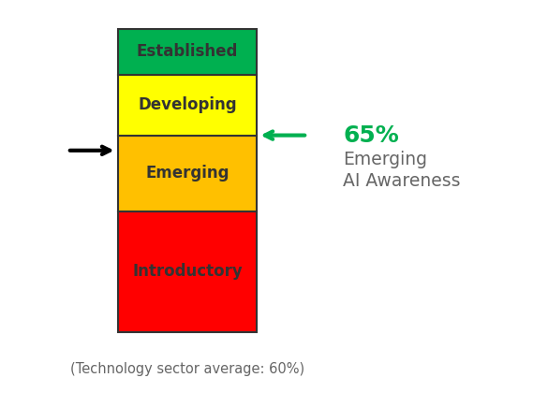
Figure 1. Overall AI awareness level. Black arrow shows Technology sector average; Green/Red arrows shows Test Organization is Above/Below sector average.

- Organisation Context Profile
AI awareness does not exist in isolation. This section places your assessment results in the context of Test Organization’s operating environment, leadership posture, and digital maturity. By translating your onboarding inputs into a concise narrative, this section helps explain why certain results may have emerged and ensures that subsequent insights are grounded in your organisation’s reality rather than generic assumptions.
Organisation Snapshot
- Sector: Technology
- Organisation size: 51-200
- Primary business unit assessed: IT

Starting Point with AI
- AI familiarity: Somewhat familiar
- Digital transformation stage: Developing
- Leadership interest in AI: High
- Comfort with technology change: Comfortable

Contextual Interpretation

Sector Context (Indicative Only)
The radar chart below illustrates how the organisation’s domain scores compare with Technology sector averages, offering a high-level reference point to identify relative strengths, potential gaps, and areas that may warrant further attention.
These benchmarks are provided for contextual guidance only and should not be interpreted as definitive measures of compliance, performance, or risk, as sector maturity can vary significantly based on organisational size, operating context, regulatory exposure, and AI adoption maturity.
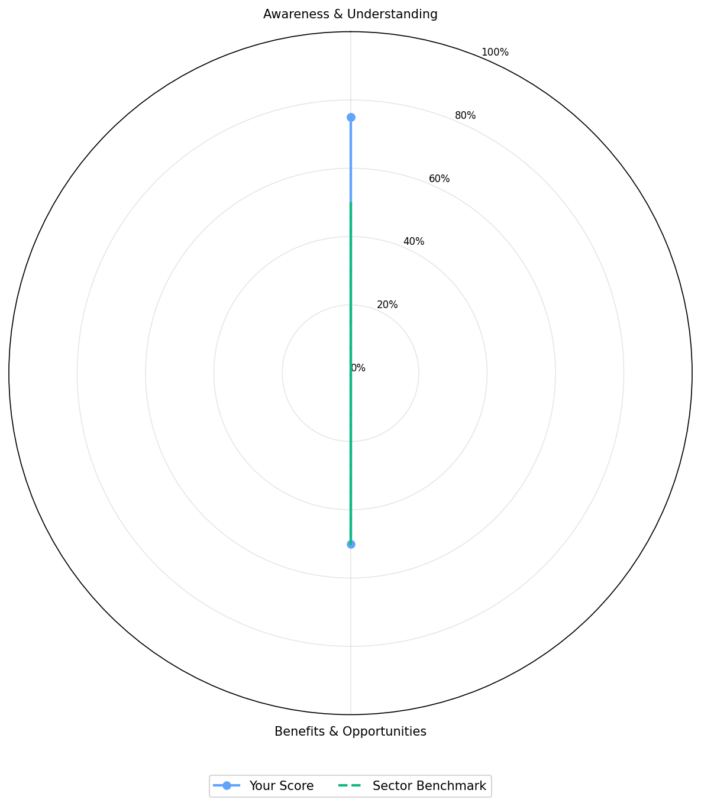
Figure 2. Test Organization AI awareness domain scores compared with Technology sector averages.

- Foundational Controls Readiness Signals
Effective AI awareness is supported by basic organisational foundations such as governance clarity, data responsibility, and digital readiness. This section summarises the foundational signals identified through your responses and explains how they influence the organisation’s ability to engage with AI safely and confidently. The commentary focuses on readiness for learning and early exploration, rather than formal controls or enforcement.
Existing Governance Foundations
Based on your responses, the following foundations are currently in place:
Interpretation

Digital Data Readiness Signals
- Digital / automation activity: Multiple initiatives
- Data digital skill confidence: Moderate
- Openness to AI learning: High

- Awareness Assessment Results
This section summarises how Test Organization responded across the key awareness domains assessed as part of the AI Awareness Foundations Assessment. Rather than examining individual questions in detail, the focus here is on overall patterns and balance across domains, highlighting where awareness is relatively consistent and where additional support may be beneficial. The insights presented are intended to inform understanding, not to assign risk or performance ratings.
Domain-Level Overview
Domain | Maturity Level | Score
Awareness Understanding | Established | 75%
Benefits Opportunities | Developing | 50%

Key Patterns Observed

- Tailored Learning Next-Step Recommendations
This section translates your assessment results into targeted learning and awareness activities that are appropriate for your current stage of AI maturity. Rather than focusing on technical implementation, the emphasis here is on building shared understanding, confidence, and responsible decision-making across leadership and key teams. The recommendations below are intentionally practical and proportionate, helping Test Organization develop AI awareness in a way that supports informed conversations and safe future choices.
Primary Motivation
You indicated your main reason for taking this assessment was to .
Based on this selection:
Preferred Learning Formats
Based on your organisation’s preferred learning formats, the recommended options for further learning for your staff are:
- No format was specified; we recommend a blended approach: short explainers + one live session.
Prioritised Awareness Actions (Curated Explained)
Awareness assessments often identify more potential improvement actions than can be realistically addressed at once. This section presents a deliberately curated set of awareness-stage actions that are most relevant to your current results. The aim is to support focus, momentum, and confidence-building, rather than overwhelm. The actions shown below reflect learning-oriented steps that help translate awareness into practical understanding and shared expectations.
High Priority Actions (Top 5)

Question ID | Domain | Recommended action
AU-1 | Awareness & Understanding | Industry-specific action
Medium Priority Actions (Top 5)

No Medium priority sector-specific actions identified.

Question ID | Domain | Recommended action
Low Priority Actions (Top 5)

No Low priority sector-specific actions identified.

Question ID | Domain | Recommended action
Action Narrative

- Your Pathway Through the AM AI SAFE Framework
AI awareness is the starting point of a broader, progressive journey. This section shows how your current results fit within the wider AM AI SAFE framework and outlines the logical next stages as organisational understanding and confidence grow. Progression is not mandatory or time-bound; instead, it is designed to align with your readiness, priorities, and appetite for deeper AI assessment and governance.
Based on your results and openness:
[✓] AI Awareness Foundations Assessment (this report)
[✓] Recommended Next Step: AI Readiness Assessment
This will help Test Organization identify concrete, low-risk AI use-cases and required safeguards.
If you would like help translating this report into a simple action plan, internal briefing, or awareness campaign, this can be facilitated using the AM AI SAFE supporting tools and materials.
- Appendix A – Detailed Responses
This appendix provides a detailed view of the individual responses submitted during the assessment. It is included for transparency, internal review, and future comparison purposes. While not required for understanding the overall results, this information can be useful when tracking changes over time or preparing for more detailed AI readiness or maturity assessments.

AU-1 – Test question 1
- Your response: Some awareness
- Domain: Awareness Understanding
- Maturity level: Developing
- Score: 3/4

BO-1 – Test question 2
- Your response: Limited awareness
- Domain: Benefits Opportunities
- Maturity level: Emerging
- Score: 2/4

