AM AI SAFE
AI System Maturity Assessment Report
for
vCISO.One

Assessment Date: 2026-01-09
Assessment ID: N/A
Framework Version: 1.0.0

Table of Contents
- Executive Summary
- Assessment Context
- Assessment Results
- Key Findings & Risk Themes
- Recommendations
5.1 High Priority Recommendations
5.2 Medium Priority Recommendations
5.3 Low Priority Recommendations
- Evidence & Assurance Coverage
- Scope, Assumptions & Limitations

1. Executive Summary
Heading 2: Purpose of the Assessment
The objective of this assessment was to evaluate the maturity of the AI system, specifically the Chatbot Test, across various domains relevant to its operation. The assessment encompasses domains such as Data Integrity, Privacy, Sustainability, Safety, Reliability, Security, Fairness, Explainability, Inclusivity, Transparency, and Accountability.
Heading 2: Assessment Context
The Chatbot Test is currently in the production lifecycle stage, which signifies that it is actively utilized within a live environment. Details regarding its business criticality, hosting model, data sensitivity, and oversight arrangements were not provided, thus limiting the context for external risk evaluation.
Heading 2: Overall Maturity Outcome
The overall AI maturity score for the Chatbot Test is 79.0%, placing it within the Established tier. This tier indicates that the system demonstrates a significant level of maturity, establishing solid processes and controls that support its effective operation, though opportunities for improvement remain.
Heading 2: Domain-Level Performance Overview
The strongest-performing domains include Data Integrity, scoring 94%, followed by Privacy and Sustainability, both at 88%. In contrast, the lowest-performing domains are Accountability at 62%, Transparency at 72%, and Inclusivity, Explainability, and Fairness, all at 75%. Notably, Accountability has a higher concentration of low-scoring questions, indicating a potential area for focus and improvement.
Heading 2: Key Insights
- The overall maturity position is defined as Established, indicating effective processes are in place with room for enhancement.
- Data Integrity, Privacy, and Sustainability are identified as the strongest domain areas.
- Primary risk or gap concentration is evident in Accountability, Transparency, and Inclusivity, where lower scores suggest vulnerabilities.
- A total of three high-priority actions have been identified, requiring immediate attention to bolster maturity.
- Notable maturity distribution patterns reflect a larger volume of questions scoring in the Good and Advanced ranges, indicating a solid foundation in most areas despite identified weaknesses.
Heading 2: Forward-Looking Summary
Addressing the identified priority actions will contribute to strengthening AI governance and enhancing the overall maturity of the Chatbot Test over time. By targeting the specific gaps outlined, the organization can foster a more robust framework that supports sustained success and resilience in its AI initiatives.

2. Assessment Context
This assessment evaluates the AI maturity of a specific AI system operated by vCISO.One, using the AM AI SAFE framework. The assessment context below provides important background for interpreting the results.
AI System Context
- System lifecycle stage: production
- Business / operational criticality:
- System ownership model:
- Deployment / hosting model:
- Highest data sensitivity handled:
- Governance and oversight model:
The context above has been considered when interpreting maturity outcomes, risk concentrations, and prioritised recommendations.

3. Assessment Results
3.1 Overall AI Maturity Outcome
vCISO.One achieved an overall AI maturity score of 79.0%, placing the system within the Established maturity tier.
This tier reflects the extent to which AI governance, risk management, and operational practices are established, consistently applied, and supported across the assessed domains.

3.2 Domain-Level Results Overview
- The table below summarises performance across the assessed AI maturity domains.
Domain | Score (%) | Maturity Tier | Low-Scoring Questions
Accountability | 62.5 | Good | 4
Transparency | 71.9 | Good | 2
Fairness | 75.0 | Advanced | 2
Explainability | 75.0 | Advanced | 2
Inclusivity | 75.0 | Advanced | 0
Reliability | 78.1 | Advanced | 3
Security | 78.1 | Advanced | 0
Safety | 84.4 | Advanced | 0
Privacy | 87.5 | Advanced | 0
Sustainability | 87.5 | Advanced | 0
Data Integrity | 93.8 | Advanced | 1

3.3 AI Maturity Heatmap
The heatmap below provides a detailed visual representation of performance across all assessed questions.
- Rows represent AI maturity domains
- Columns represent individual assessment questions
- Colours indicate relative maturity levels, from lowest to highest
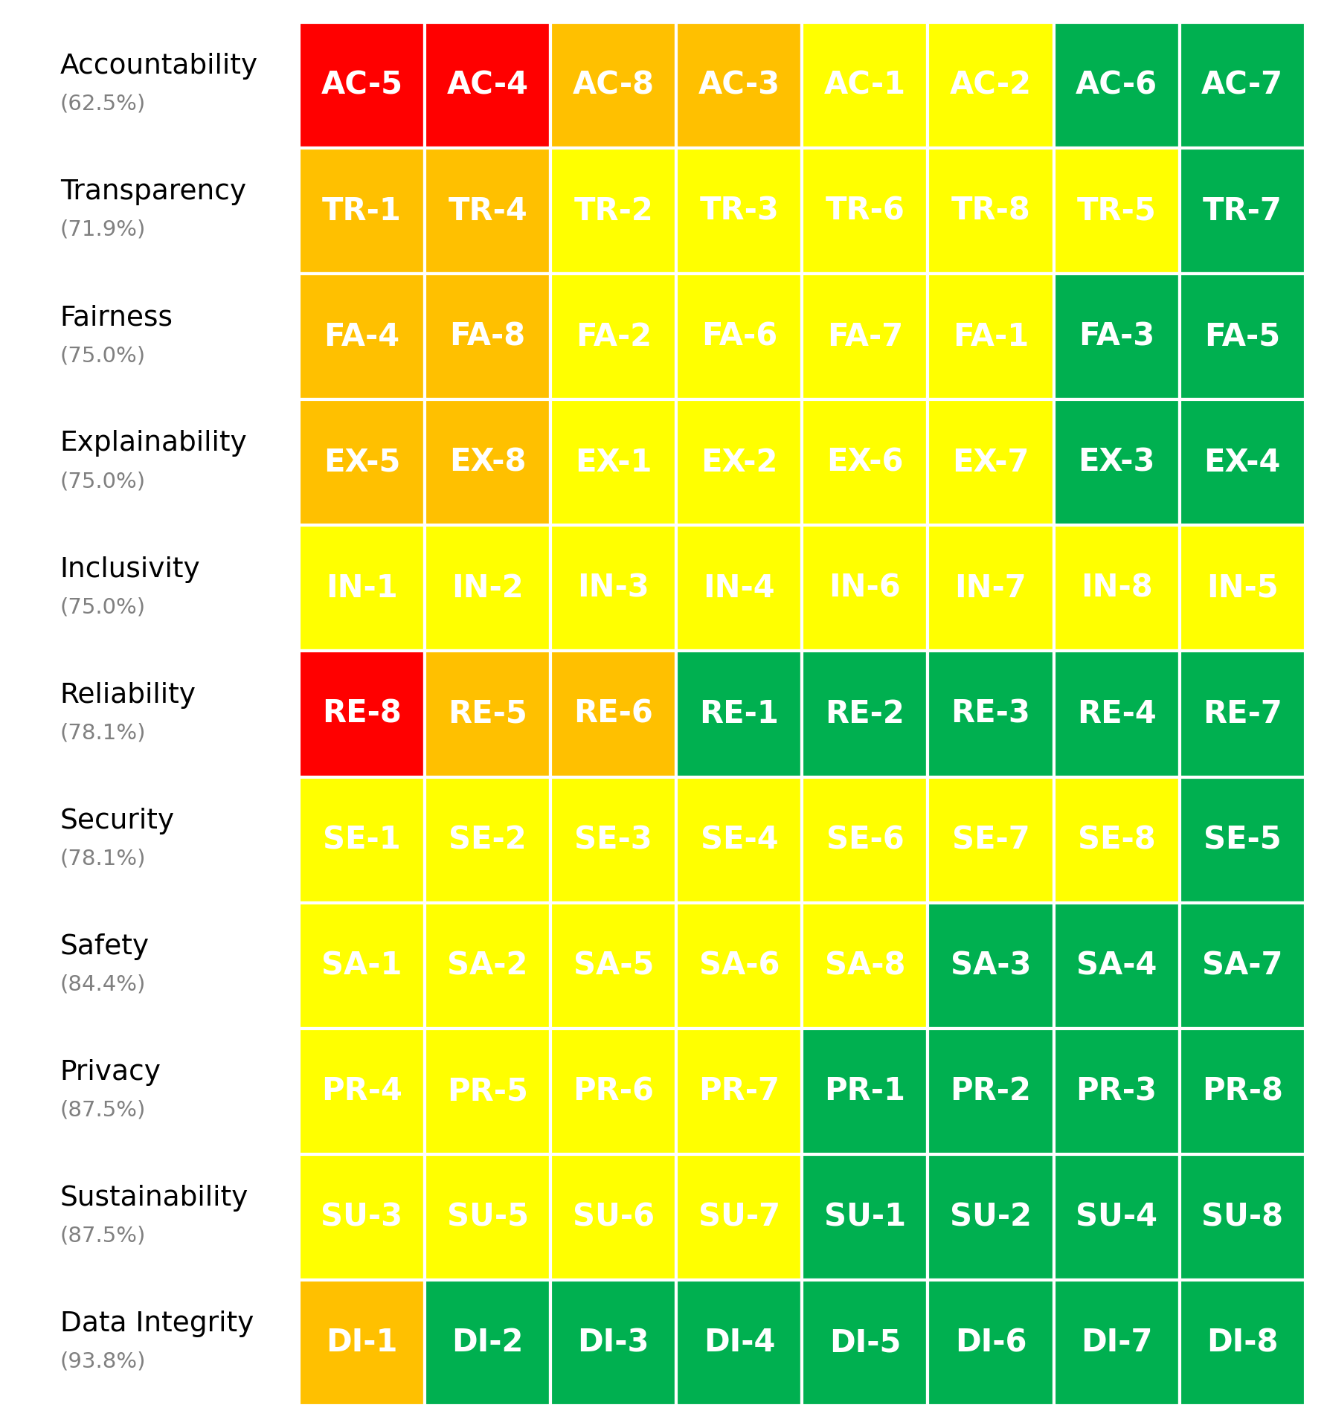
Figure 1. vCISO.One AI System Maturity Heatmap

3.4 Maturity Distribution
The distribution of maturity levels across all assessed questions is summarised below.
- Non-Ideal: 3 questions
- Basic: 11 questions
- Good: 43 questions
- Advanced: 31 questions
This distribution highlights how maturity is currently spread across foundational, developing, and more advanced practices.

4. Key Findings & Risk Themes
Heading 2: Finding - Overall Maturity Distribution
Observation: The assessment results demonstrate a skewed maturity distribution, with a significant concentration of scores at the "Good" (3) level, comprising 43 questions, and prominent representation of higher scores. However, there are also 3 questions categorized as "Non-Ideal" (score 1) and 11 as "Basic" (score 2), indicating a potential risk in critical areas.
Evidence: The scores reflect a distribution where 31 questions scored "Advanced" (4), while lower performance is highlighted by the presence of 11 basic and 3 non-ideal scores. This suggests that while the AI system shows overall maturity, certain elements are lagging significantly.
Risk Implication: The existence of non-ideal and basic level scores may indicate gaps in the underlying AI governance framework, leading to operational vulnerabilities if not adequately addressed. Failure to improve these areas could compromise the overall effectiveness and sustainability of the AI system.
Heading 2: Finding - Comparison of Strong vs. Weak Domains
Observation: The domain-level performance reveals significant contrast between high-scoring areas and those with lower scores. Data Integrity and Privacy stand out as top performers, while Accountability and Transparency exhibit concerning low scores.
Evidence: Data Integrity scored the highest at 94%, while Accountability received the lowest at 62%. The gaps in the Accountability (62%), Transparency (72%), and Inclusivity (75%) domains, associated with higher priority actions, indicate areas requiring urgent focus.
Risk Implication: The disparity between strong and weak domains may undermine effective AI governance and operational integrity. If the weaknesses in Accountability and Transparency are not rectified, the system may face challenges related to trust, compliance, and ethical use.
Heading 2: Finding - Concentration of High-Priority Actions
Observation: A notable concentration of high-priority actions has been identified, particularly within the Accountability and Reliability domains, which show significant need for improvement based on assessment results.
Evidence: Among the three high-priority actions, two are associated with Accountability concerns, while one pertains to Reliability. This points to a critical need for systematic processes related to complaints and role accountability to enhance governance practices.
Risk Implication: The concentration of high-priority actions in these areas highlights an acute operational risk that, if unmitigated, could lead to governance failures. Effective addressing of these issues is essential to establish a robust framework for accountability and reliability in AI operations.
Heading 2: Finding - Implications of System Lifecycle Stage
Observation: The system is currently in the production lifecycle stage, indicating that operational maturity is crucial for impact and sustainability as it directly interacts with real-world environments.
Evidence: The overall maturity score of 79% reflects an established system, yet the identified weaknesses in Accountability, Transparency, and Inclusivity are particularly pertinent given the business-critical nature of the system.
Risk Implication: Operating at a high maturity level while possessing vulnerabilities in critical domains suggests that if these issues are not remedied, the AI system may be exposed to heightened operational risks, potentially affecting business outcomes and stakeholder trust in the deployed solution.
Heading 2: Finding - Gaps in Accountability and Inclusivity
Observation: Accountability ranks as the lowest domain with a score of 62%, closely followed by Inclusivity at 75%, indicating significant vulnerabilities that may affect the system’s social compliance and stakeholder engagement.
Evidence: The presence of four low-scoring questions in the Accountability domain and two in Inclusivity suggests a critical need for improved practices. Additionally, these low scores coincide with the identification of high-priority actions related to these domains, emphasizing underlying issues.
Risk Implication: The observed gaps in Accountability and Inclusivity can have far-reaching implications for ethical AI deployment, including negative impacts on stakeholder relationships and regulatory compliance. Addressing these gaps is vital to ensure that the AI system adheres to social norms and expectations.

5. Recommendations
Based on the assessment results, the following recommendations are prioritised to support progressive improvement in AI governance, risk management, and operational maturity.

5.1 High Priority Recommendations
High Priority recommendations address critical gaps identified through low-scoring questions and represent areas requiring urgent attention to mitigate risk.
Summary
- Number of High Priority actions: 3
- Dominant risk themes: Accessibility Equity Risk, Harm Prevention Risk, Cybersecurity Access Risk, Bias Discrimination Risk, Decision Interpretability Risk
Domain | Question ID | Recommendation | Timeframe | Effort | Risk Theme
Accountability | AC-4 | A structured process is in place for addressing complaints, including a clear escalation path and manual review options. | 0-90 days | High | Governance Oversight Risk
Accountability | AC-5 | Roles and responsibilities are clearly defined, documented, and regularly reviewed to ensure alignment across teams. | 0-90 days | High | Governance Oversight Risk
Reliability | RE-8 | Perform regular testing and retraining based on a defined schedule and monitored performance thresholds. | 0-90 days | High | System Performance Risk

5.2 Medium Priority Recommendations
Medium Priority recommendations address gaps associated with foundational or partially established practices and should be implemented over the medium term.
Domain | Question ID | Recommendation | Timeframe | Effort | Risk Theme
Accountability | AC-3 | Formal escalation policies are documented, with clear paths for resolving critical issues efficiently. | 3-6 months | Medium | Governance Oversight Risk
Accountability | AC-8 | Established mechanisms, such as appeals processes or review boards, are in place to address disputes and ensure resolution. | 3-6 months | Medium | Governance Oversight Risk
Transparency | TR-1 | Detailed user guides and technical documentation, including functionality and limitations, are provided to all relevant stakeholders. | 3-6 months | Medium | Disclosure Communication Risk
Transparency | TR-4 | Information is shared through structured processes, including regular presentations, training sessions, and detailed documentation. | 3-6 months | Medium | Disclosure Communication Risk
Explainability | EX-5 | Explicitly balance complexity and explainability, simplifying models or using interpretable methods where appropriate. | 3-6 months | Medium | Decision Interpretability Risk
Explainability | EX-8 | Explanations are customized for each group (e.g., simplified for end-users, detailed for regulators, and actionable for internal teams). | 3-6 months | Medium | Decision Interpretability Risk
Fairness | FA-4 | Use fairness metrics such as demographic parity or equal opportunity and conduct regular evaluations against these benchmarks. | 3-6 months | Medium | Bias Discrimination Risk
Fairness | FA-8 | Fairness considerations are embedded throughout the design and development process. | 3-6 months | Medium | Bias Discrimination Risk
Reliability | RE-5 | Conduct systematic analyses to identify and document all potential failure points, with mitigation plans in place. | 3-6 months | Medium | System Performance Risk
Reliability | RE-6 | Test extensively with synthetic data, adversarial inputs, and real-world edge cases to ensure consistent performance. | 3-6 months | Medium | System Performance Risk
Data Integrity | DI-1 | Use automated tools and manual reviews to regularly validate data for accuracy, completeness, and quality. | 3-6 months | Medium | Data Quality Lineage Risk

5.3 Low Priority Recommendations
Low Priority recommendations focus on long-term maturity uplift and alignment with leading practices.
Domain | Question ID | Recommendation | Timeframe | Effort | Risk Theme
Accountability | AC-1 | Clear accountability protocols are established, with designated teams responsible for identifying, resolving, and documenting failures. | 6-12 months | Low | Governance Oversight Risk
Accountability | AC-2 | A dedicated AI oversight board or committee is in place to regularly review and monitor system outcomes. | 6-12 months | Low | Governance Oversight Risk
Transparency | TR-2 | Comprehensive documentation of data sources, preprocessing steps, algorithms, and processes is maintained and regularly updated. | 6-12 months | Low | Disclosure Communication Risk
Transparency | TR-3 | Provide transparency reports, detailed system documentation, or interactive dashboards for external review. | 6-12 months | Low | Disclosure Communication Risk
Transparency | TR-5 | No, the system is fully explainable with no black-box components. | 6-12 months | Low | Disclosure Communication Risk
Transparency | TR-6 | Fully disclose data sources and algorithmic details, including limitations and provenance, to stakeholders. | 6-12 months | Low | Disclosure Communication Risk
Transparency | TR-8 | Publish regular, comprehensive transparency reports detailing system functionality, performance, and compliance. | 6-12 months | Low | Disclosure Communication Risk
Explainability | EX-1 | Explainability requirements are determined based on the criticality of the AI system, potential impacts, and stakeholder needs, with clear criteria established. | 6-12 months | Low | Decision Interpretability Risk
Explainability | EX-2 | Conduct user testing with diverse, non-technical participants and iterate based on their feedback to ensure clarity. | 6-12 months | Low | Decision Interpretability Risk
Explainability | EX-6 | Provide user-friendly interfaces that present clear reasoning and key factors influencing decisions. | 6-12 months | Low | Decision Interpretability Risk
Explainability | EX-7 | Use advanced tools like SHAP, LIME, or similar techniques to systematically explain model outputs. | 6-12 months | Low | Decision Interpretability Risk
Fairness | FA-1 | Regularly audit datasets for imbalances or biases and use tools like Fairlearn to detect and mitigate issues. | 6-12 months | Low | Bias Discrimination Risk
Fairness | FA-2 | Conduct demographic analysis and source additional data to address gaps in representation. | 6-12 months | Low | Bias Discrimination Risk
Fairness | FA-6 | Use frameworks like Fairlearn, Aequitas, or IBM AI Fairness 360 to identify and mitigate biases systematically. | 6-12 months | Low | Bias Discrimination Risk
Fairness | FA-7 | Introduce fairness weights or adjustments during model training and evaluate outputs specifically for underserved groups. | 6-12 months | Low | Bias Discrimination Risk
Inclusivity | IN-1 | Design the system with accessibility features such as screen readers, multilingual support, and offline functionality to serve all user groups, including those with disabilities and underserved populations. | 6-12 months | Low | Accessibility Equity Risk
Inclusivity | IN-2 | Actively engage stakeholders from diverse backgrounds and incorporate their input throughout the design and development process. | 6-12 months | Low | Accessibility Equity Risk
Inclusivity | IN-3 | Conduct regular, comprehensive audits for exclusionary outcomes and take corrective actions when needed. | 6-12 months | Low | Accessibility Equity Risk
Inclusivity | IN-4 | Integrate accessibility standards (e.g., WCAG) and test the system with users with disabilities to ensure compliance and usability. | 6-12 months | Low | Accessibility Equity Risk
Inclusivity | IN-5 | Actively involve stakeholders from diverse backgrounds at every stage, from design to testing. | 6-12 months | Low | Accessibility Equity Risk
Inclusivity | IN-6 | Design the system with features and strategies specifically tailored to meet the needs of underrepresented communities (e.g., offline functionality, low-resource language support). | 6-12 months | Low | Accessibility Equity Risk
Inclusivity | IN-7 | Design the system with full localization, including support for multiple languages, cultural nuances, and region-specific needs. | 6-12 months | Low | Accessibility Equity Risk
Inclusivity | IN-8 | Use regular evaluations, including data analysis, user feedback, and testing, to identify and mitigate exclusionary impacts. | 6-12 months | Low | Accessibility Equity Risk
Security | SE-1 | Use encryption, access controls, secure APIs, and tamper-proof logging to protect models and data. | 6-12 months | Low | Cybersecurity Access Risk
Security | SE-2 | Conduct adversarial training, implement input validation checks, and monitor for adversarial patterns. | 6-12 months | Low | Cybersecurity Access Risk
Security | SE-3 | Conduct regular security audits and penetration testing to identify and address vulnerabilities in the AI system. | 6-12 months | Low | Cybersecurity Access Risk
Security | SE-4 | Use secure environments for training, encrypt model artifacts during deployment, and monitor runtime operations for threats. | 6-12 months | Low | Cybersecurity Access Risk
Security | SE-6 | Use adversarial training, anomaly detection systems, and input validation mechanisms to mitigate risks. | 6-12 months | Low | Cybersecurity Access Risk
Security | SE-7 | Use encryption, tokenization, and secure storage for all sensitive data in AI pipelines. | 6-12 months | Low | Cybersecurity Access Risk
Security | SE-8 | Perform regular vulnerability assessments and penetration tests tailored to AI-specific risks. | 6-12 months | Low | Cybersecurity Access Risk
Safety | SA-1 | Conduct comprehensive safety impact assessments during development and deployment, with updates as the system evolves. | 6-12 months | Low | Harm Prevention Risk
Safety | SA-2 | Implement proactive risk identification, monitoring, and mitigation strategies, including safety constraints in design. | 6-12 months | Low | Harm Prevention Risk
Safety | SA-5 | Establish and regularly test automated emergency shutdown protocols to address unsafe behavior. | 6-12 months | Low | Harm Prevention Risk
Safety | SA-6 | Conduct systematic risk assessments, identify mitigation strategies, and document all steps taken to reduce harm. | 6-12 months | Low | Harm Prevention Risk
Safety | SA-8 | Conduct extensive safety testing in realistic and high-risk scenarios, incorporating user feedback and system improvements. | 6-12 months | Low | Harm Prevention Risk
Privacy | PR-4 | Use purpose-limitation tags, access controls, and audits to ensure data is only used for its intended purpose. | 6-12 months | Low | Data Protection Privacy Risk
Privacy | PR-5 | Use state-of-the-art anonymization and pseudonymization techniques, validated through regular testing. | 6-12 months | Low | Data Protection Privacy Risk
Privacy | PR-6 | Implement continuous monitoring systems and automated alerts to detect and prevent privacy violations. | 6-12 months | Low | Data Protection Privacy Risk
Privacy | PR-7 | Conduct privacy impact assessments (PIAs) during both development and deployment, with regular reviews. | 6-12 months | Low | Data Protection Privacy Risk
Sustainability | SU-3 | Use cloud platforms or on-premises infrastructure that relies entirely on renewable energy sources. | 6-12 months | Low | Environmental Long-term Risk
Sustainability | SU-5 | Continuously optimize algorithms to reduce computational costs, balancing performance and sustainability. | 6-12 months | Low | Environmental Long-term Risk
Sustainability | SU-6 | Select hardware or cloud platforms designed for energy efficiency (e.g., TPUs, green-certified data centers). | 6-12 months | Low | Environmental Long-term Risk
Sustainability | SU-7 | Clearly define and implement a balance between sustainability and performance, incorporating trade-offs into the design process. | 6-12 months | Low | Environmental Long-term Risk

6. Evidence Assurance Coverage
This section summarises the level of supporting evidence provided during the assessment.
- Total evidence artefacts submitted: 0
- Artefacts linked to high-priority risks: 0
- Overall evidence coverage: 0.0%
- Identified evidence gaps: 3
Key Evidence Gaps Identified
- Accountability – AC-4: High priority action without linked evidence
- Accountability – AC-5: High priority action without linked evidence
- Reliability – RE-8: High priority action without linked evidence
Evidence coverage supports confidence in the assessment results and highlights areas where additional assurance artefacts would strengthen governance and audit readiness.

7. Scope, Assumptions Limitations
This assessment is based on information provided at the time of assessment, including self-reported responses and submitted evidence artefacts.
Key limitations include:
- The assessment does not constitute legal, regulatory, or compliance advice
- Results reflect current practices and may change as controls mature or operating conditions evolve
- Evidence sufficiency has been assessed at a high level and does not replace formal audit or assurance activities
Future reassessments are recommended to track maturity progression over time and validate the effectiveness of implemented improvements.

Report generated on: 2026-01-09T21:37:09
Assessment source reference: N/A

