AM AI SAFE
AI System Maturity Assessment Report
for
vCISO.One

Assessment Date: 2026-01-07
Assessment ID: N/A
Framework Version: 1.0.0

Table of Contents
- Executive Summary
- Assessment Context
- Assessment Results
- Key Findings & Risk Themes
- Recommendations
5.1 High Priority Recommendations
5.2 Medium Priority Recommendations
5.3 Low Priority Recommendations
- Evidence & Assurance Coverage
- Scope, Assumptions & Limitations

1. Executive Summary
1. Purpose of the Assessment
The objective of this assessment was to evaluate the maturity of the AI system, "Another AI System," across various domains related to AI governance, including data integrity, reliability, accountability, transparency, security, privacy, fairness, explainability, safety, sustainability, and inclusivity.
2. Assessment Context
"Another AI System" is currently in the development stage, with an undefined business criticality, hosting model, data sensitivity, and oversight arrangements. This context implies a need for ongoing attention to the governance of the system as it progresses through its lifecycle.
3. Overall Maturity Outcome
The overall AI maturity score for the system is 71.9%, placing it in the Developing tier. This tier typically indicates that foundational practices are being established but that further development and refinement are needed to enhance maturity across various domains.
4. Domain-Level Performance Overview
The strongest-performing domains are Data Integrity and Reliability, both scoring 84%, indicating robust practices in these areas. The lowest-performing domains are Inclusivity at 56% and Sustainability at 66%, highlighting significant gaps. Additionally, Safety, Fairness, and Explainability all registered scores of 69%. The concentration of low-scoring questions in these areas may be likely contributors to the lower overall maturity tier.
5. Key Insights
- The overall maturity position is Developing, highlighting the need for focused enhancements.
- The strongest domain areas are Data Integrity and Reliability, both demonstrating strong governance practices.
- Concentration of low scores in Safety, Sustainability, and Inclusivity indicates primary risks or gaps that require attention.
- A total of 8 high-priority actions have been identified, emphasizing critical areas for immediate improvement.
- The maturity distribution shows substantial engagement with Good and Advanced categories but reveals some challenges with the Basic and Non-Ideal categories that may require strategic attention.
6. Forward-Looking Summary
Addressing the identified priority actions has the potential to bolster AI governance and enhance overall maturity. By focusing on the lowest-performing domains and leveraging the strengths in Data Integrity and Reliability, the organization can build a more comprehensive framework for the responsible and effective deployment of AI capabilities moving forward.

2. Assessment Context
This assessment evaluates the AI maturity of a specific AI system operated by vCISO.One, using the AM AI SAFE framework. The assessment context below provides important background for interpreting the results.
AI System Context
- System lifecycle stage: development
- Business / operational criticality:
- System ownership model:
- Deployment / hosting model:
- Highest data sensitivity handled:
- Governance and oversight model:
The context above has been considered when interpreting maturity outcomes, risk concentrations, and prioritised recommendations.

3. Assessment Results
3.1 Overall AI Maturity Outcome
vCISO.One achieved an overall AI maturity score of 71.9%, placing the system within the Developing maturity tier.
This tier reflects the extent to which AI governance, risk management, and operational practices are established, consistently applied, and supported across the assessed domains.

3.2 Domain-Level Results Overview
- The table below summarises performance across the assessed AI maturity domains.
Domain | Score (%) | Maturity Tier | Low-Scoring Questions
Inclusivity | 56.2 | Good | 4
Sustainability | 65.6 | Good | 4
Fairness | 68.8 | Good | 3
Explainability | 68.8 | Good | 3
Safety | 68.8 | Good | 3
Transparency | 71.9 | Good | 3
Security | 71.9 | Good | 2
Privacy | 71.9 | Good | 3
Accountability | 78.1 | Advanced | 2
Data Integrity | 84.4 | Advanced | 2
Reliability | 84.4 | Advanced | 1

3.3 AI Maturity Heatmap
The heatmap below provides a detailed visual representation of performance across all assessed questions.
- Rows represent AI maturity domains
- Columns represent individual assessment questions
- Colours indicate relative maturity levels, from lowest to highest
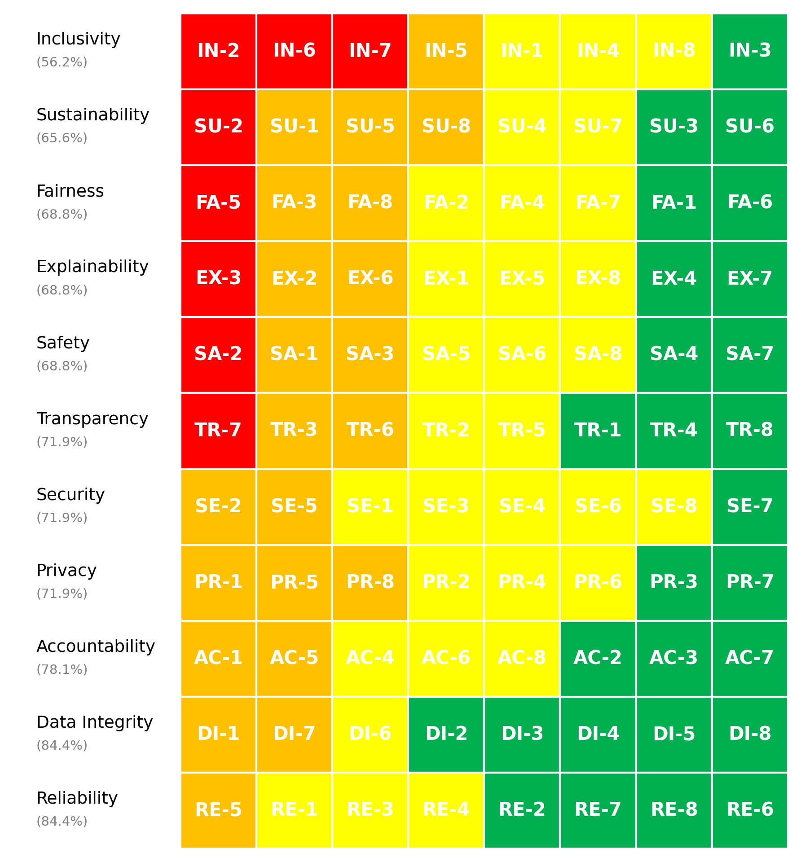
Figure 1. vCISO.One AI System Maturity Heatmap

3.4 Maturity Distribution
The distribution of maturity levels across all assessed questions is summarised below.
- Non-Ideal: 8 questions
- Basic: 22 questions
- Good: 31 questions
- Advanced: 27 questions
This distribution highlights how maturity is currently spread across foundational, developing, and more advanced practices.

4. Key Findings & Risk Themes
Finding 1: Overall Maturity Distribution Indicates Developmental Challenges
Observation: The overall maturity score of 71.9% places the AI system in the Developing tier, suggesting that while progress has been made, there remains significant room for improvement across various domains.
Evidence: The maturity distribution shows that there are 8 questions scoring in the Non-Ideal (1) category, 22 in Basic (2), 31 in Good (3), and 27 in Advanced (4). This distribution indicates that a significant number of foundational aspects are still at a basic level.
Risk Implication: The prevalence of low scores across foundational categories could lead to operational vulnerabilities, impacting the effectiveness and reliability of the AI system's governance and performance in real-world applications.
Finding 2: Strengths in Data Integrity and Reliability Contrast with Safety and Inclusivity Gaps
Observation: The system demonstrates strong scores in Data Integrity and Reliability both at 84%, while Safety (69%) and Inclusivity (56%) are notably weaker, indicating a disparity in proficiency across different domains.
Evidence: The two top-scoring domains (Data Integrity and Reliability) highlight robust management and operational practices, whereas the lowest-scoring domains, Safety and Inclusivity, reveal significant concerns, particularly with Inclusivity scoring well below 60%.
Risk Implication: The contrast between strong domains and those lacking may lead to risks associated with unchecked operational assumptions, potential biases, and inadequate user engagement, ultimately diminishing system efficacy and stakeholder trust.
Finding 3: High Concentration of Priority Actions in Inclusivity and Sustainability
Observation: A noticeable concentration of high-priority actions, specifically around Inclusivity and Sustainability, suggests critical weaknesses that require immediate attention.
Evidence: Out of 8 high-priority actions identified, 5 directly address Inclusivity (e.g., engaging diverse stakeholders and localization efforts) and 1 relates to Sustainability (e.g., optimizing algorithms for efficiency), reflecting the need for targeted improvements in these areas.
Risk Implication: If these high-priority actions are not pursued, it may result in inadequate representation of user needs and missed opportunities for sustainable practices, which could ultimately harm the system's acceptance and viability.
Finding 4: Developmental Lifecycle Impacts Maturity and Risk Profile
Observation: The system is currently in the development stage, which is reflected in the maturity scores and the associated risks.
Evidence: The status as a developing system is consistent with a lower overall maturity score, paired with a relatively high number of low-scoring responses, particularly in critical areas like Inclusivity and Safety.
Risk Implication: Being in a developmental phase presents both opportunities and risks. Unless strategic governance measures are implemented during this stage, the system may encounter significant challenges as it transitions to operational status, particularly concerning user trust and regulatory compliance.

5. Recommendations
Based on the assessment results, the following recommendations are prioritised to support progressive improvement in AI governance, risk management, and operational maturity.

5.1 High Priority Recommendations
High Priority recommendations address critical gaps identified through low-scoring questions and represent areas requiring urgent attention to mitigate risk.
Summary
- Number of High Priority actions: 8
- Dominant risk themes: Explainability, Safety, Sustainability, Fairness, Inclusivity
Domain | Question ID | Recommendation | Timeframe | Effort | Risk Theme
Inclusivity | IN-2 | Actively engage stakeholders from diverse backgrounds and incorporate their input throughout the design and development process.
Inclusivity | IN-6 | Design the system with features and strategies specifically tailored to meet the needs of underrepresented communities (e.g., offline functionality, low-resource language support).
Inclusivity | IN-7 | Design the system with full localization, including support for multiple languages, cultural nuances, and region-specific needs.
Sustainability | SU-2 | Actively optimize algorithms for efficiency using advanced techniques like pruning, quantization, or model distillation.
Explainability | EX-3 | Provide multiple explanation formats (e.g., graphs for analysts, text summaries for end-users) tailored to the needs of diverse audiences.
Fairness | FA-5 | Conduct comprehensive testing with real-world data and scenarios before deployment.
Safety | SA-2 | Implement proactive risk identification, monitoring, and mitigation strategies, including safety constraints in design.
Transparency | TR-7 | Users are clearly notified through explicit messages or labels (e.g., “This is an AI system”).

5.2 Medium Priority Recommendations
Medium Priority recommendations address gaps associated with foundational or partially established practices and should be implemented over the medium term.
Domain | Question ID | Recommendation | Timeframe | Effort | Risk Theme
Inclusivity | IN-5 | Actively involve stakeholders from diverse backgrounds at every stage, from design to testing.
Sustainability | SU-1 | Regularly measure and report the environmental impact of AI training and deployment, including energy usage and carbon emissions.
Sustainability | SU-5 | Continuously optimize algorithms to reduce computational costs, balancing performance and sustainability.
Sustainability | SU-8 | Implement ongoing tracking of environmental metrics such as energy use and carbon emissions, with regular reporting.
Explainability | EX-2 | Conduct user testing with diverse, non-technical participants and iterate based on their feedback to ensure clarity.
Explainability | EX-6 | Provide user-friendly interfaces that present clear reasoning and key factors influencing decisions.
Fairness | FA-3 | Conduct detailed quantitative analysis and qualitative testing with diverse focus groups to identify disparities.
Fairness | FA-8 | Fairness considerations are embedded throughout the design and development process.
Safety | SA-1 | Conduct comprehensive safety impact assessments during development and deployment, with updates as the system evolves.
Safety | SA-3 | Use automated real-time monitoring tools with alert systems to detect and respond to unsafe behavior.
Privacy | PR-1 | Conduct regular audits and implement privacy-by-design principles to ensure compliance with all applicable laws.
Privacy | PR-5 | Use state-of-the-art anonymization and pseudonymization techniques, validated through regular testing.
Privacy | PR-8 | Implement region-specific compliance measures, including data localization and cross-border transfer agreements.
Security | SE-2 | Conduct adversarial training, implement input validation checks, and monitor for adversarial patterns.
Security | SE-5 | Implement version control, checksum validations, and strict access controls to prevent unauthorized changes.
Transparency | TR-3 | Provide transparency reports, detailed system documentation, or interactive dashboards for external review.
Transparency | TR-6 | Fully disclose data sources and algorithmic details, including limitations and provenance, to stakeholders.
Accountability | AC-1 | Clear accountability protocols are established, with designated teams responsible for identifying, resolving, and documenting failures.
Accountability | AC-5 | Roles and responsibilities are clearly defined, documented, and regularly reviewed to ensure alignment across teams.
Data Integrity | DI-1 | Use automated tools and manual reviews to regularly validate data for accuracy, completeness, and quality.
Data Integrity | DI-7 | Conduct thorough evaluations of third-party data sources, including audits and performance testing.
Reliability | RE-5 | Conduct systematic analyses to identify and document all potential failure points, with mitigation plans in place.

5.3 Low Priority Recommendations
Low Priority recommendations focus on long-term maturity uplift and alignment with leading practices.
Domain | Question ID | Recommendation | Timeframe | Effort | Risk Theme
Inclusivity | IN-1 | Design the system with accessibility features such as screen readers, multilingual support, and offline functionality to serve all user groups, including those with disabilities and underserved populations.
Inclusivity | IN-4 | Integrate accessibility standards (e.g., WCAG) and test the system with users with disabilities to ensure compliance and usability.
Inclusivity | IN-8 | Use regular evaluations, including data analysis, user feedback, and testing, to identify and mitigate exclusionary impacts.
Sustainability | SU-4 | Quantify and track the carbon footprint of all training and deployment processes, with goals for reduction.
Sustainability | SU-7 | Clearly define and implement a balance between sustainability and performance, incorporating trade-offs into the design process.
Explainability | EX-1 | Explainability requirements are determined based on the criticality of the AI system, potential impacts, and stakeholder needs, with clear criteria established.
Explainability | EX-5 | Explicitly balance complexity and explainability, simplifying models or using interpretable methods where appropriate.
Explainability | EX-8 | Explanations are customized for each group (e.g., simplified for end-users, detailed for regulators, and actionable for internal teams).
Fairness | FA-2 | Conduct demographic analysis and source additional data to address gaps in representation.
Fairness | FA-4 | Use fairness metrics such as demographic parity or equal opportunity and conduct regular evaluations against these benchmarks.
Fairness | FA-7 | Introduce fairness weights or adjustments during model training and evaluate outputs specifically for underserved groups.
Safety | SA-5 | Establish and regularly test automated emergency shutdown protocols to address unsafe behavior.
Safety | SA-6 | Conduct systematic risk assessments, identify mitigation strategies, and document all steps taken to reduce harm.
Safety | SA-8 | Conduct extensive safety testing in realistic and high-risk scenarios, incorporating user feedback and system improvements.
Privacy | PR-2 | Use advanced techniques such as anonymization, pseudonymization, and encryption throughout the data lifecycle.
Privacy | PR-4 | Use purpose-limitation tags, access controls, and audits to ensure data is only used for its intended purpose.
Privacy | PR-6 | Implement continuous monitoring systems and automated alerts to detect and prevent privacy violations.
Security | SE-1 | Use encryption, access controls, secure APIs, and tamper-proof logging to protect models and data.
Security | SE-3 | Conduct regular security audits and penetration testing to identify and address vulnerabilities in the AI system.
Security | SE-4 | Use secure environments for training, encrypt model artifacts during deployment, and monitor runtime operations for threats.
Security | SE-6 | Use adversarial training, anomaly detection systems, and input validation mechanisms to mitigate risks.
Security | SE-8 | Perform regular vulnerability assessments and penetration tests tailored to AI-specific risks.
Transparency | TR-2 | Comprehensive documentation of data sources, preprocessing steps, algorithms, and processes is maintained and regularly updated.
Transparency | TR-5 | No, the system is fully explainable with no black-box components.
Accountability | AC-4 | A structured process is in place for addressing complaints, including a clear escalation path and manual review options.
Accountability | AC-6 | Dedicated teams or individuals are assigned to monitor and manage the AI system at all stages of its lifecycle.
Accountability | AC-8 | Established mechanisms, such as appeals processes or review boards, are in place to address disputes and ensure resolution.
Data Integrity | DI-6 | Use automated tools and established workflows to clean, normalize, and preprocess data consistently.
Reliability | RE-1 | Conduct comprehensive testing across diverse scenarios, including edge cases, stress conditions, and varied data inputs.
Reliability | RE-3 | Implement continuous monitoring systems with alerts for issues like model drift, degradation, or anomalies.
Reliability | RE-4 | Define and regularly track clear, measurable success metrics that align with business goals and stakeholder expectations.

6. Evidence & Assurance Coverage
This section summarises the level of supporting evidence provided during the assessment.
- Total evidence artefacts submitted: 0
- Artefacts linked to high-priority risks: 0
- Overall evidence coverage: 0.0%
- Identified evidence gaps: 8
Key Evidence Gaps Identified
- Inclusivity – IN-2: High priority action without linked evidence
- Inclusivity – IN-6: High priority action without linked evidence
- Inclusivity – IN-7: High priority action without linked evidence
- Sustainability – SU-2: High priority action without linked evidence
- Explainability – EX-3: High priority action without linked evidence
Evidence coverage supports confidence in the assessment results and highlights areas where additional assurance artefacts would strengthen governance and audit readiness.

7. Scope, Assumptions & Limitations
This assessment is based on information provided at the time of assessment, including self-reported responses and submitted evidence artefacts.
Key limitations include:
- The assessment does not constitute legal, regulatory, or compliance advice
- Results reflect current practices and may change as controls mature or operating conditions evolve
- Evidence sufficiency has been assessed at a high level and does not replace formal audit or assurance activities
Future reassessments are recommended to track maturity progression over time and validate the effectiveness of implemented improvements.

Report generated on: 2026-01-07T23:22:02
Assessment source reference: N/A

