AM AI SAFE
AI System Maturity Assessment Report
for
vCISO.One

Assessment Date: 2026-01-09
Assessment ID: N/A
Framework Version: 1.0.0

Table of Contents
- Executive Summary
- Assessment Context
- Assessment Results
- Key Findings & Risk Themes
- Recommendations
5.1 High Priority Recommendations
5.2 Medium Priority Recommendations
5.3 Low Priority Recommendations
- Evidence & Assurance Coverage
- Scope, Assumptions & Limitations

1. Executive Summary
Heading 2: Purpose of the Assessment
The objective of this assessment was to evaluate the AI system maturity of vCISO.One’s Chatbot Test. The evaluation covered multiple domains including Data Integrity, Privacy, Sustainability, Safety, Reliability, Security, Fairness, Explainability, Inclusivity, Transparency, and Accountability.
Heading 2: Assessment Context
The Chatbot Test is in the production lifecycle stage, indicating active deployment. Further details about business criticality, hosting model, data sensitivity, and oversight arrangements were not provided, limiting the context within which the system operates.
Heading 2: Overall Maturity Outcome
The overall AI maturity score for the Chatbot Test is 79.0%, positioning it within the Established tier. This tier suggests that the system demonstrates a considerable level of maturity and has implemented important practices in AI governance.
Heading 2: Domain-Level Performance Overview
The strongest-performing domains identified are Data Integrity (94%), Privacy (88%), and Sustainability (88%). In contrast, the domains with the lowest performance are Accountability (62%), Transparency (72%), and Inclusivity (75%). A notable concentration of low-scoring questions was observed in the Accountability domain. This may indicate potential challenges in governance structures and processes related to responsible AI use.
Heading 2: Key Insights
- The overall maturity position reflects a solid level of AI governance.
- Data Integrity, Privacy, and Sustainability are the strongest domain areas.
- The primary concentration of gaps exists within Accountability, as demonstrated by the number of low-scoring questions.
- A total of three high-priority actions have been identified for immediate attention.
- There is a noticeable distribution pattern with several questions falling within the Basic maturity level, indicating room for improvement across multiple domains.
Heading 2: Forward-Looking Summary
Addressing the identified priority actions is essential to enhancing AI governance and fostering maturity over time. Implementing targeted improvements in accountability, transparency, and inclusivity will provide a stronger framework for the responsible deployment of AI capabilities within the organization.

2. Assessment Context
This assessment evaluates the AI maturity of a specific AI system operated by vCISO.One, using the AM AI SAFE framework. The assessment context below provides important background for interpreting the results.
AI System Context
- System lifecycle stage: production
- Business / operational criticality:
- System ownership model:
- Deployment / hosting model:
- Highest data sensitivity handled:
- Governance and oversight model:
The context above has been considered when interpreting maturity outcomes, risk concentrations, and prioritised recommendations.

3. Assessment Results
3.1 Overall AI Maturity Outcome
vCISO.One achieved an overall AI maturity score of 79.0%, placing the system within the Established maturity tier.
This tier reflects the extent to which AI governance, risk management, and operational practices are established, consistently applied, and supported across the assessed domains.

3.2 Domain-Level Results Overview
- The table below summarises performance across the assessed AI maturity domains.
Domain | Score (%) | Maturity Tier | Low-Scoring Questions
Accountability | 62.5 | Good | 4
Transparency | 71.9 | Good | 2
Fairness | 75.0 | Advanced | 2
Explainability | 75.0 | Advanced | 2
Inclusivity | 75.0 | Advanced | 0
Reliability | 78.1 | Advanced | 3
Security | 78.1 | Advanced | 0
Safety | 84.4 | Advanced | 0
Privacy | 87.5 | Advanced | 0
Sustainability | 87.5 | Advanced | 0
Data Integrity | 93.8 | Advanced | 1

3.3 AI Maturity Heatmap
The heatmap below provides a detailed visual representation of performance across all assessed questions.
- Rows represent AI maturity domains
- Columns represent individual assessment questions
- Colours indicate relative maturity levels, from lowest to highest
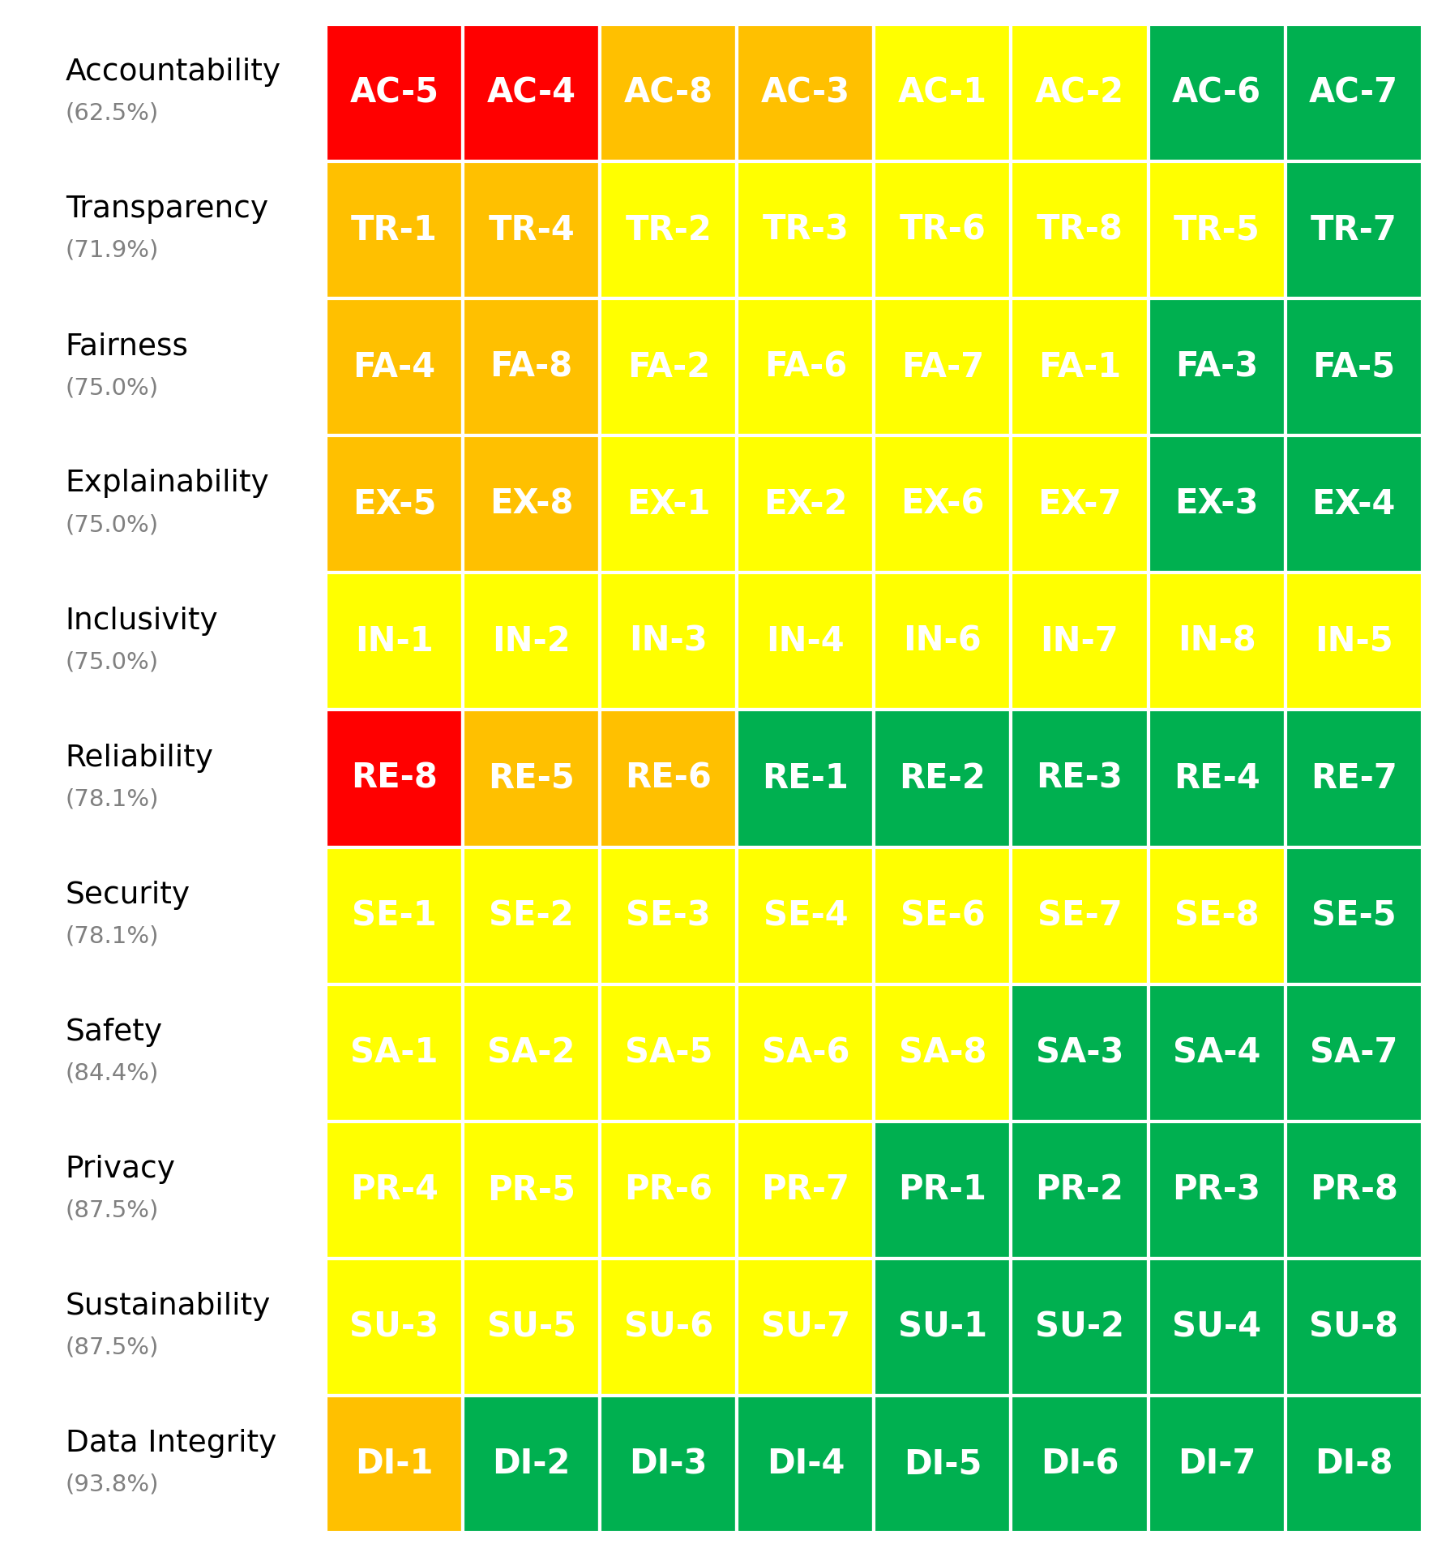
Figure 1. vCISO.One AI System Maturity Heatmap

3.4 Maturity Distribution
The distribution of maturity levels across all assessed questions is summarised below.
- Non-Ideal: 3 questions
- Basic: 11 questions
- Good: 43 questions
- Advanced: 31 questions
This distribution highlights how maturity is currently spread across foundational, developing, and more advanced practices.

4. Key Findings & Risk Themes
Heading 2: Finding - Overall Maturity Distribution Indicates Room for Improvement
Observation: The assessment results indicate a distribution where 3 questions scored as Non-Ideal, 11 as Basic, 43 as Good, and 31 as Advanced. The presence of a significant number of questions scoring below the Advanced level suggests areas needing attention to elevate overall performance.
Evidence: The total of 14 questions scoring in the Non-Ideal and Basic categories represents a notable portion of the assessment, highlighting potential weaknesses across various domains that could affect the maturity of the AI system.
Risk Implication: If the issues represented by the lower-scoring questions remain unaddressed, the organization's AI governance may be compromised, leading to increased operational risks and potentially impacting the system's overall effectiveness and sustainability.
Heading 2: Finding - Strong Performance in Data Integrity Contrasts with Low Accountability Scores
Observation: The domain-level analysis reveals a high performance in Data Integrity at 94%, while Accountability scores are significantly lower at 62%. This stark contrast underscores a disparity in the maturity of these key domains.
Evidence: The assessment shows that while Data Integrity and both Privacy and Sustainability demonstrate high scores (all above 88%), Accountability ranks lowest among all domains with 4 low-scoring questions, indicating considerable concern regarding governance frameworks.
Risk Implication: The disconnect between strong data integrity and weak accountability may compromise trust in the AI system, leading to gaps in governance compliance. Insufficient accountability measures could result in unaddressed issues, undermining overall operational effectiveness.
Heading 2: Finding - High Concentration of Priority Actions Reflects Critical Areas for Improvement
Observation: The assessment identifies a significant concentration of high-priority actions, with 3 actions categorized as high priority reflecting urgent needs across specific domains.
Evidence: The high-priority action items are predominantly linked to the Accountability domain, alongside key aspects of Reliability. The emphasis on these areas indicates urgent vulnerabilities that could benefit from immediate attention to enhance overall AI performance.
Risk Implication: Ignoring the high-priority areas may lead to unresolved issues, ultimately jeopardizing the AI system's operational reliability and governance frameworks. Failure to implement necessary actions could exacerbate existing weaknesses and result in non-compliance with internal standards.
Heading 2: Finding - System Lifecycle Stage Poses Critical Considerations for Maturity
Observation: The system is currently in the production stage and designated as business critical, which amplifies the need for robust maturity across all domains, particularly in areas showing lower performance.
Evidence: With a runtime at the production stage, the system's overall maturity score of 79% indicates that while the AI system is deemed established, specific low-scoring areas such as Accountability (62%) and Transparency (72%) warrant immediate remedial measures to align with operational demands.
Risk Implication: As the system operates in a critical business environment, the existing gaps in Accountability and Transparency could pose significant risks. These weaknesses may lead to operational inefficiencies, reduced stakeholder trust, and potentially create scenarios that could result in adverse outcomes during deployment.
Heading 2: Finding - Gaps in Inclusivity Highlight Areas for Ethical Considerations
Observation: The domain performance shows Inclusivity scoring at 75%, identifying it as one of the top gaps along with Transparency and Accountability.
Evidence: This score is the second lowest among all domains, indicating that despite overall strong performance in areas like Data Integrity and Privacy, ethical aspects of AI deployment are lagging, particularly concerning inclusivity.
Risk Implication: The gap in Inclusivity may lead to biased outcomes and reduced equitable access to the AI system’s benefits. This could pose reputational risks and implications for user acceptance and engagement, particularly if the system's outputs inadvertently favor specific demographics over others.

5. Recommendations
Based on the assessment results, the following recommendations are prioritised to support progressive improvement in AI governance, risk management, and operational maturity.

5.1 High Priority Recommendations
High Priority recommendations address critical gaps identified through low-scoring questions and represent areas requiring urgent attention to mitigate risk.
Summary
- Number of High Priority actions: 53
- Dominant risk themes: Harm Prevention Risk, Governance Oversight Risk, Disclosure Communication Risk, Environmental Long-term Risk, System Performance Risk
Domain | Question ID | Recommendation | Timeframe | Effort | Risk Theme
Accountability | AC-5 | Roles and responsibilities are clearly defined, documented, and regularly reviewed to ensure alignment across teams. | 0-30 days | Medium | Governance Oversight Risk
Accountability | AC-4 | A structured process is in place for addressing complaints, including a clear escalation path and manual review options. | 0-30 days | Medium | Governance Oversight Risk
Transparency | TR-1 | Detailed user guides and technical documentation, including functionality and limitations, are provided to all relevant stakeholders. | 0-30 days | Low | Disclosure Communication Risk
Accountability | AC-8 | Established mechanisms, such as appeals processes or review boards, are in place to address disputes and ensure resolution. | 0-30 days | Medium | Governance Oversight Risk
Accountability | AC-3 | Formal escalation policies are documented, with clear paths for resolving critical issues efficiently. | 0-30 days | Medium | Governance Oversight Risk
Fairness | FA-8 | Fairness considerations are embedded throughout the design and development process. | 0-30 days | Medium | Bias Discrimination Risk
Explainability | EX-8 | Explanations are customized for each group (e.g., simplified for end-users, detailed for regulators, and actionable for internal teams). | 0-30 days | Medium | Decision Interpretability Risk
Reliability | RE-5 | Conduct systematic analyses to identify and document all potential failure points, with mitigation plans in place. | 0-30 days | Medium | System Performance Risk
Transparency | TR-6 | Fully disclose data sources and algorithmic details, including limitations and provenance, to stakeholders. | 0-30 days | Low | Disclosure Communication Risk
Sustainability | SU-3 | Use cloud platforms or on-premises infrastructure that relies entirely on renewable energy sources. | 0-30 days | Medium | Environmental Long-term Risk
Transparency | TR-2 | Comprehensive documentation of data sources, preprocessing steps, algorithms, and processes is maintained and regularly updated. | 0-30 days | Medium | Disclosure Communication Risk
Transparency | TR-8 | Publish regular, comprehensive transparency reports detailing system functionality, performance, and compliance. | 0-30 days | Medium | Disclosure Communication Risk
Explainability | EX-1 | Explainability requirements are determined based on the criticality of the AI system, potential impacts, and stakeholder needs, with clear criteria established. | 0-30 days | Medium | Decision Interpretability Risk
Accountability | AC-1 | Clear accountability protocols are established, with designated teams responsible for identifying, resolving, and documenting failures. | 0-30 days | Medium | Governance Oversight Risk
Explainability | EX-6 | Provide user-friendly interfaces that present clear reasoning and key factors influencing decisions. | 0-30 days | Medium | Decision Interpretability Risk
Inclusivity | IN-5 | Actively involve stakeholders from diverse backgrounds at every stage, from design to testing. | 0-30 days | Medium | Accessibility Equity Risk
Fairness | FA-2 | Conduct demographic analysis and source additional data to address gaps in representation. | 0-30 days | Medium | Bias Discrimination Risk
Reliability | RE-8 | Perform regular testing and retraining based on a defined schedule and monitored performance thresholds. | 3-6 months | Medium | System Performance Risk
Explainability | EX-5 | Explicitly balance complexity and explainability, simplifying models or using interpretable methods where appropriate. | 3-6 months | Medium | Decision Interpretability Risk
Data Integrity | DI-1 | Use automated tools and manual reviews to regularly validate data for accuracy, completeness, and quality. | 3-6 months | Medium | Data Quality Lineage Risk
Fairness | FA-4 | Use fairness metrics such as demographic parity or equal opportunity and conduct regular evaluations against these benchmarks. | 3-6 months | Medium | Bias Discrimination Risk
Reliability | RE-6 | Test extensively with synthetic data, adversarial inputs, and real-world edge cases to ensure consistent performance. | 3-6 months | High | System Performance Risk
Security | SE-1 | Use encryption, access controls, secure APIs, and tamper-proof logging to protect models and data. | 3-6 months | Medium | Cybersecurity Access Risk
Inclusivity | IN-2 | Actively engage stakeholders from diverse backgrounds and incorporate their input throughout the design and development process. | 3-6 months | Medium | Accessibility Equity Risk
Security | SE-4 | Use secure environments for training, encrypt model artifacts during deployment, and monitor runtime operations for threats. | 3-6 months | Medium | Cybersecurity Access Risk
Fairness | FA-7 | Introduce fairness weights or adjustments during model training and evaluate outputs specifically for underserved groups. | 3-6 months | Medium | Bias Discrimination Risk
Security | SE-8 | Perform regular vulnerability assessments and penetration tests tailored to AI-specific risks. | 3-6 months | Medium | Cybersecurity Access Risk
Transparency | TR-3 | Provide transparency reports, detailed system documentation, or interactive dashboards for external review. | 3-6 months | Medium | Disclosure Communication Risk
Inclusivity | IN-8 | Use regular evaluations, including data analysis, user feedback, and testing, to identify and mitigate exclusionary impacts. | 3-6 months | Medium | Accessibility Equity Risk
Fairness | FA-6 | Use frameworks like Fairlearn, Aequitas, or IBM AI Fairness 360 to identify and mitigate biases systematically. | 3-6 months | Medium | Bias Discrimination Risk
Privacy | PR-5 | Use state-of-the-art anonymization and pseudonymization techniques, validated through regular testing. | 3-6 months | Medium | Data Protection Privacy Risk
Inclusivity | IN-4 | Integrate accessibility standards (e.g., WCAG) and test the system with users with disabilities to ensure compliance and usability. | 3-6 months | Medium | Accessibility Equity Risk
Security | SE-3 | Conduct regular security audits and penetration testing to identify and address vulnerabilities in the AI system. | 3-6 months | Medium | Cybersecurity Access Risk
Privacy | PR-4 | Use purpose-limitation tags, access controls, and audits to ensure data is only used for its intended purpose. | 3-6 months | Medium | Data Protection Privacy Risk
Accountability | AC-2 | A dedicated AI oversight board or committee is in place to regularly review and monitor system outcomes. | 3-6 months | Medium | Governance Oversight Risk
Explainability | EX-7 | Use advanced tools like SHAP, LIME, or similar techniques to systematically explain model outputs. | 3-6 months | Medium | Decision Interpretability Risk
Security | SE-6 | Use adversarial training, anomaly detection systems, and input validation mechanisms to mitigate risks. | 3-6 months | Medium | Cybersecurity Access Risk
Privacy | PR-7 | Conduct privacy impact assessments (PIAs) during both development and deployment, with regular reviews. | 3-6 months | Medium | Data Protection Privacy Risk
Explainability | EX-2 | Conduct user testing with diverse, non-technical participants and iterate based on their feedback to ensure clarity. | 3-6 months | Medium | Decision Interpretability Risk
Fairness | FA-1 | Regularly audit datasets for imbalances or biases and use tools like Fairlearn to detect and mitigate issues. | 3-6 months | Medium | Bias Discrimination Risk
Safety | SA-5 | Establish and regularly test automated emergency shutdown protocols to address unsafe behavior. | 3-6 months | High | Harm Prevention Risk
Inclusivity | IN-7 | Design the system with full localization, including support for multiple languages, cultural nuances, and region-specific needs. | 3-6 months | High | Accessibility Equity Risk
Inclusivity | IN-6 | Design the system with features and strategies specifically tailored to meet the needs of underrepresented communities (e.g., offline functionality, low-resource language support). | 3-6 months | High | Accessibility Equity Risk
Transparency | TR-5 | No, the system is fully explainable with no black-box components. | 3-6 months | High | Disclosure Communication Risk
Inclusivity | IN-3 | Conduct regular, comprehensive audits for exclusionary outcomes and take corrective actions when needed. | 3-6 months | High | Accessibility Equity Risk
Safety | SA-6 | Conduct systematic risk assessments, identify mitigation strategies, and document all steps taken to reduce harm. | 3-6 months | High | Harm Prevention Risk
Security | SE-7 | Use encryption, tokenization, and secure storage for all sensitive data in AI pipelines. | 3-6 months | High | Cybersecurity Access Risk
Inclusivity | IN-1 | Design the system with accessibility features such as screen readers, multilingual support, and offline functionality to serve all user groups, including those with disabilities and underserved populations. | 3-6 months | High | Accessibility Equity Risk
Safety | SA-2 | Implement proactive risk identification, monitoring, and mitigation strategies, including safety constraints in design. | 3-6 months | High | Harm Prevention Risk
Safety | SA-1 | Conduct comprehensive safety impact assessments during development and deployment, with updates as the system evolves. | 3-6 months | High | Harm Prevention Risk
Safety | SA-8 | Conduct extensive safety testing in realistic and high-risk scenarios, incorporating user feedback and system improvements. | 3-6 months | High | Harm Prevention Risk
Privacy | PR-6 | Implement continuous monitoring systems and automated alerts to detect and prevent privacy violations. | 3-6 months | High | Data Protection Privacy Risk
Security | SE-2 | Conduct adversarial training, implement input validation checks, and monitor for adversarial patterns. | 3-6 months | High | Cybersecurity Access Risk

5.2 Medium Priority Recommendations
Medium Priority recommendations address gaps associated with foundational or partially established practices and should be implemented over the medium term.
Domain | Question ID | Recommendation | Timeframe | Effort | Risk Theme
Transparency | TR-4 | Information is shared through structured processes, including regular presentations, training sessions, and detailed documentation. | 1-3 months | Medium | Disclosure Communication Risk
Sustainability | SU-6 | Select hardware or cloud platforms designed for energy efficiency (e.g., TPUs, green-certified data centers). | 1-3 months | Medium | Environmental Long-term Risk
Sustainability | SU-7 | Clearly define and implement a balance between sustainability and performance, incorporating trade-offs into the design process. | 1-3 months | Medium | Environmental Long-term Risk

5.3 Low Priority Recommendations
Low Priority recommendations focus on long-term maturity uplift and alignment with leading practices.
Domain | Question ID | Recommendation | Timeframe | Effort | Risk Theme
Sustainability | SU-5 | Continuously optimize algorithms to reduce computational costs, balancing performance and sustainability. | 6-12 months | Medium | Environmental Long-term Risk

6. Evidence Assurance Coverage
This section summarises the level of supporting evidence provided during the assessment.
- Total evidence artefacts submitted: 0
- Artefacts linked to high-priority risks: 0
- Overall evidence coverage: 0.0%
- Identified evidence gaps: 3
Key Evidence Gaps Identified
- Accountability – AC-4: High priority action without linked evidence
- Accountability – AC-5: High priority action without linked evidence
- Reliability – RE-8: High priority action without linked evidence
Evidence coverage supports confidence in the assessment results and highlights areas where additional assurance artefacts would strengthen governance and audit readiness.

7. Scope, Assumptions Limitations
This assessment is based on information provided at the time of assessment, including self-reported responses and submitted evidence artefacts.
Key limitations include:
- The assessment does not constitute legal, regulatory, or compliance advice
- Results reflect current practices and may change as controls mature or operating conditions evolve
- Evidence sufficiency has been assessed at a high level and does not replace formal audit or assurance activities
Future reassessments are recommended to track maturity progression over time and validate the effectiveness of implemented improvements.

Report generated on: 2026-01-09T21:53:55
Assessment source reference: N/A

