AM AI SAFE
AI System Maturity Assessment Report
for
vCISO.One

Assessment Date: 2026-01-08
Assessment ID: N/A
Framework Version: 1.0.0

Table of Contents
- Executive Summary
- Assessment Context
- Assessment Results
- Key Findings & Risk Themes
- Recommendations
5.1 High Priority Recommendations
5.2 Medium Priority Recommendations
5.3 Low Priority Recommendations
- Evidence & Assurance Coverage
- Scope, Assumptions & Limitations

1. Executive Summary
1. Purpose of the Assessment
The purpose of this assessment is to evaluate the maturity of the Another AI System employed by vCISO.One, within the Finance and Insurance industry. The assessment encompasses various domains of AI governance, including data integrity, reliability, accountability, transparency, security, privacy, fairness, explainability, safety, sustainability, and inclusivity.
2. Assessment Context
The Another AI System is currently in the development lifecycle stage. The business criticality, hosting model, data sensitivity, and oversight arrangements associated with this system were not specified.
3. Overall Maturity Outcome
The overall AI maturity score is 71.9%, placing the organization in the Developing maturity tier. This tier generally indicates that the organization is progressing in its AI governance practices but still has significant areas for improvement to achieve enhanced maturity and effectiveness.
4. Domain-Level Performance Overview
The strongest-performing domains are Data Integrity and Reliability, both scoring 84%. In contrast, the lowest-performing domains are Inclusivity at 56%, followed by Sustainability at 66% and Safety at 69%. Patterns indicate a concentration of low-scoring questions particularly in the domains of safety, sustainability, inclusivity, fairness, and explainability, which may likely contribute to the overall maturing state of the organization.
5. Key Insights
- The overall maturity position is classified as Developing, reflecting ongoing improvements and recognitions of enhancements needed.
- The Data Integrity and Reliability domains are the strongest, demonstrating reliable practices in these areas.
- There is a primary concentration of risks or gaps in the Safety, Sustainability, and Inclusivity domains, indicating critical areas for development.
- A total of eight high-priority actions have been identified, indicating urgent needs for improvement.
- The maturity distribution shows a significant number of questions rated at Basic and Non-Ideal levels, suggesting that foundational elements require attention as many domains still exhibit low-scoring questions.
6. Forward-Looking Summary
By addressing the identified priority actions, vCISO.One can enhance AI governance and promote maturing processes across the assessed domains. Continued focus on improvements, particularly in the areas of safety, sustainability, and inclusivity, will foster a more robust AI system that aligns with organizational objectives and industry standards over time.

2. Assessment Context
This assessment evaluates the AI maturity of a specific AI system operated by vCISO.One, using the AM AI SAFE framework. The assessment context below provides important background for interpreting the results.
AI System Context
- System lifecycle stage: development
- Business / operational criticality:
- System ownership model:
- Deployment / hosting model:
- Highest data sensitivity handled:
- Governance and oversight model:
The context above has been considered when interpreting maturity outcomes, risk concentrations, and prioritised recommendations.

3. Assessment Results
3.1 Overall AI Maturity Outcome
vCISO.One achieved an overall AI maturity score of 71.9%, placing the system within the Developing maturity tier.
This tier reflects the extent to which AI governance, risk management, and operational practices are established, consistently applied, and supported across the assessed domains.

3.2 Domain-Level Results Overview
- The table below summarises performance across the assessed AI maturity domains.
Domain | Score (%) | Maturity Tier | Low-Scoring Questions
Inclusivity | 56.2 | Good | 4
Sustainability | 65.6 | Good | 4
Fairness | 68.8 | Good | 3
Explainability | 68.8 | Good | 3
Safety | 68.8 | Good | 3
Transparency | 71.9 | Good | 3
Security | 71.9 | Good | 2
Privacy | 71.9 | Good | 3
Accountability | 78.1 | Advanced | 2
Data Integrity | 84.4 | Advanced | 2
Reliability | 84.4 | Advanced | 1

3.3 AI Maturity Heatmap
The heatmap below provides a detailed visual representation of performance across all assessed questions.
- Rows represent AI maturity domains
- Columns represent individual assessment questions
- Colours indicate relative maturity levels, from lowest to highest
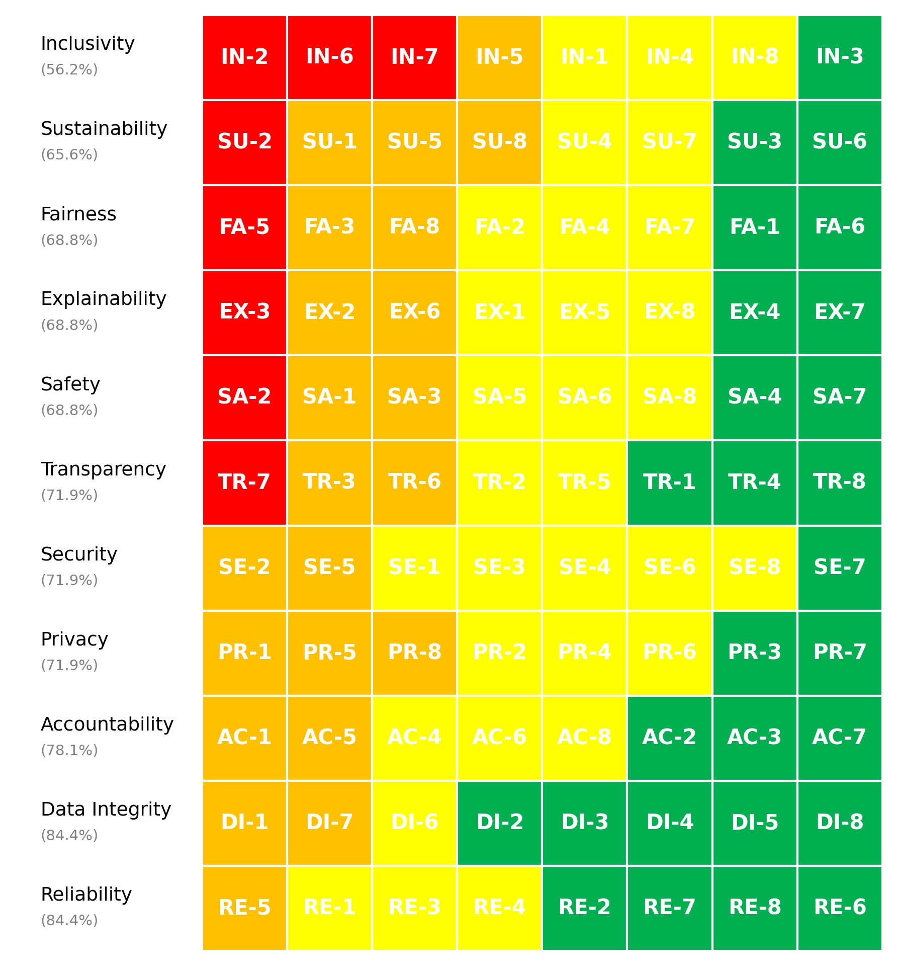
Figure 1. vCISO.One AI System Maturity Heatmap

3.4 Maturity Distribution
The distribution of maturity levels across all assessed questions is summarised below.
- Non-Ideal: 8 questions
- Basic: 22 questions
- Good: 31 questions
- Advanced: 27 questions
This distribution highlights how maturity is currently spread across foundational, developing, and more advanced practices.

4. Key Findings & Risk Themes
Finding 1: Overall Maturity Indicates Developing State
Observation: The overall maturity score of 71.9% categorizes the AI system as being in the Developing tier, indicating a level of maturity that requires attention to various factors contributing to effectiveness and governance.
Evidence: The maturity distribution reveals that out of 88 total questions, 8 are Non-Ideal, 22 are Basic, 31 are Good, and 27 are Advanced. This distribution shows a significant concentration of lower scoring responses, particularly in the Non-Ideal and Basic ranges.
Risk Implication: Remaining in the Developing tier may expose the system to governance risks and operational inefficiencies. Insufficient maturity could hinder the ability to meet stakeholder expectations and affect decision-making based on AI outputs.
Finding 2: Strong Performance in Data Integrity and Reliability
Observation: The assessment reveals that Data Integrity and Reliability each achieved a high score of 84%, representing the strongest domains within the maturity framework.
Evidence: Data Integrity and Reliability have notably low concentrations of low-scoring questions, with only 2 and 1 low-scoring items respectively. These domains exhibit a healthier distribution of scores compared to others.
Risk Implication: The strengths in Data Integrity and Reliability suggest a robust foundation on which to build further improvements. However, if the focus remains limited to these areas without addressing weaker domains, the overall system reliability and efficacy may still be compromised by unaddressed vulnerabilities.
Finding 3: Significant Gaps in Safety, Sustainability, and Inclusivity
Observation: The lowest scores are found in Safety (69%), Sustainability (66%), and Inclusivity (56%), highlighting critical vulnerabilities that require urgent attention.
Evidence: The concentration of low scores in Inclusivity, with 4 questions rated low, suggests systemic weaknesses that can significantly impact user engagement and system adoption. Sustainability also shows a need for focus due to a similarly low score and cluster of low-performing questions.
Risk Implication: Failure to elevate performance in Safety, Sustainability, and Inclusivity may present operational risks and could lead to failures in user trust and acceptance. Addressing these gaps is crucial for ensuring long-term viability and ethical compliance.
Finding 4: Concentration of High-Priority Actions Reflects Critical Improvement Areas
Observation: The assessment identifies 8 high-priority actions that correlate with the most significant gaps in performance, particularly related to Inclusivity and Sustainability.
Evidence: High-priority actions predominantly target areas such as Inclusivity and Sustainability, which have the lowest maturity scores. This reflects an acknowledgment of the need for immediate improvement, particularly with actions including stakeholder engagement and algorithm optimization.
Risk Implication: Concentration on these high-priority actions indicates a recognition of the most pressing weaknesses within the AI system. However, if not actively pursued, the identified risks may lead to operational failures and reputational damage, compromising the system’s overall effectiveness and stakeholder trust.
Finding 5: Lifecycle Stage Impacts Maturity Assessment
Observation: The AI system is currently in the development stage, which influences its maturity assessment outcomes and highlights inherent opportunities and challenges.
Evidence: The overall score of 71.9% reflects the development stage where foundational elements are being established, yet this stage also coincides with the clustering of questions scoring lower in essential areas such as Inclusivity and Sustainability.
Risk Implication: While being in the development stage presents opportunities for adjustments and enhancements, stagnation or insufficient focus on improving identified gaps may result in systemic risks that could hinder the implementation of the AI system into broader operational contexts. This could lead to challenges in scaling and effectiveness once deployed.

5. Recommendations
Based on the assessment results, the following recommendations are prioritised to support progressive improvement in AI governance, risk management, and operational maturity.

5.1 High Priority Recommendations
High Priority recommendations address critical gaps identified through low-scoring questions and represent areas requiring urgent attention to mitigate risk.
Summary
- Number of High Priority actions: 8
- Dominant risk themes: Environmental Long-term Risk, Accessibility Equity Risk, Bias Discrimination Risk, Data Quality Lineage Risk, Cybersecurity Access Risk
Domain | Question ID | Recommendation | Timeframe | Effort | Risk Theme
Inclusivity | IN-2 | Actively engage stakeholders from diverse backgrounds and incorporate their input throughout the design and development process.
Inclusivity | IN-6 | Design the system with features and strategies specifically tailored to meet the needs of underrepresented communities (e.g., offline functionality, low-resource language support).
Inclusivity | IN-7 | Design the system with full localization, including support for multiple languages, cultural nuances, and region-specific needs.
Sustainability | SU-2 | Actively optimize algorithms for efficiency using advanced techniques like pruning, quantization, or model distillation.
Explainability | EX-3 | Provide multiple explanation formats (e.g., graphs for analysts, text summaries for end-users) tailored to the needs of diverse audiences.
Fairness | FA-5 | Conduct comprehensive testing with real-world data and scenarios before deployment.
Safety | SA-2 | Implement proactive risk identification, monitoring, and mitigation strategies, including safety constraints in design.
Transparency | TR-7 | Users are clearly notified through explicit messages or labels (e.g., “This is an AI system”).

5.2 Medium Priority Recommendations
Medium Priority recommendations address gaps associated with foundational or partially established practices and should be implemented over the medium term.
Domain | Question ID | Recommendation | Timeframe | Effort | Risk Theme
Inclusivity | IN-5 | Actively involve stakeholders from diverse backgrounds at every stage, from design to testing.
Sustainability | SU-1 | Regularly measure and report the environmental impact of AI training and deployment, including energy usage and carbon emissions.
Sustainability | SU-5 | Continuously optimize algorithms to reduce computational costs, balancing performance and sustainability.
Sustainability | SU-8 | Implement ongoing tracking of environmental metrics such as energy use and carbon emissions, with regular reporting.
Explainability | EX-2 | Conduct user testing with diverse, non-technical participants and iterate based on their feedback to ensure clarity.
Explainability | EX-6 | Provide user-friendly interfaces that present clear reasoning and key factors influencing decisions.
Fairness | FA-3 | Conduct detailed quantitative analysis and qualitative testing with diverse focus groups to identify disparities.
Fairness | FA-8 | Fairness considerations are embedded throughout the design and development process.
Safety | SA-1 | Conduct comprehensive safety impact assessments during development and deployment, with updates as the system evolves.
Safety | SA-3 | Use automated real-time monitoring tools with alert systems to detect and respond to unsafe behavior.
Privacy | PR-1 | Conduct regular audits and implement privacy-by-design principles to ensure compliance with all applicable laws.
Privacy | PR-5 | Use state-of-the-art anonymization and pseudonymization techniques, validated through regular testing.
Privacy | PR-8 | Implement region-specific compliance measures, including data localization and cross-border transfer agreements.
Security | SE-2 | Conduct adversarial training, implement input validation checks, and monitor for adversarial patterns.
Security | SE-5 | Implement version control, checksum validations, and strict access controls to prevent unauthorized changes.
Transparency | TR-3 | Provide transparency reports, detailed system documentation, or interactive dashboards for external review.
Transparency | TR-6 | Fully disclose data sources and algorithmic details, including limitations and provenance, to stakeholders.
Accountability | AC-1 | Clear accountability protocols are established, with designated teams responsible for identifying, resolving, and documenting failures.
Accountability | AC-5 | Roles and responsibilities are clearly defined, documented, and regularly reviewed to ensure alignment across teams.
Data Integrity | DI-1 | Use automated tools and manual reviews to regularly validate data for accuracy, completeness, and quality.
Data Integrity | DI-7 | Conduct thorough evaluations of third-party data sources, including audits and performance testing.
Reliability | RE-5 | Conduct systematic analyses to identify and document all potential failure points, with mitigation plans in place.

5.3 Low Priority Recommendations
Low Priority recommendations focus on long-term maturity uplift and alignment with leading practices.
Domain | Question ID | Recommendation | Timeframe | Effort | Risk Theme
Inclusivity | IN-1 | Design the system with accessibility features such as screen readers, multilingual support, and offline functionality to serve all user groups, including those with disabilities and underserved populations.
Inclusivity | IN-4 | Integrate accessibility standards (e.g., WCAG) and test the system with users with disabilities to ensure compliance and usability.
Inclusivity | IN-8 | Use regular evaluations, including data analysis, user feedback, and testing, to identify and mitigate exclusionary impacts.
Sustainability | SU-4 | Quantify and track the carbon footprint of all training and deployment processes, with goals for reduction.
Sustainability | SU-7 | Clearly define and implement a balance between sustainability and performance, incorporating trade-offs into the design process.
Explainability | EX-1 | Explainability requirements are determined based on the criticality of the AI system, potential impacts, and stakeholder needs, with clear criteria established.
Explainability | EX-5 | Explicitly balance complexity and explainability, simplifying models or using interpretable methods where appropriate.
Explainability | EX-8 | Explanations are customized for each group (e.g., simplified for end-users, detailed for regulators, and actionable for internal teams).
Fairness | FA-2 | Conduct demographic analysis and source additional data to address gaps in representation.
Fairness | FA-4 | Use fairness metrics such as demographic parity or equal opportunity and conduct regular evaluations against these benchmarks.
Fairness | FA-7 | Introduce fairness weights or adjustments during model training and evaluate outputs specifically for underserved groups.
Safety | SA-5 | Establish and regularly test automated emergency shutdown protocols to address unsafe behavior.
Safety | SA-6 | Conduct systematic risk assessments, identify mitigation strategies, and document all steps taken to reduce harm.
Safety | SA-8 | Conduct extensive safety testing in realistic and high-risk scenarios, incorporating user feedback and system improvements.
Privacy | PR-2 | Use advanced techniques such as anonymization, pseudonymization, and encryption throughout the data lifecycle.
Privacy | PR-4 | Use purpose-limitation tags, access controls, and audits to ensure data is only used for its intended purpose.
Privacy | PR-6 | Implement continuous monitoring systems and automated alerts to detect and prevent privacy violations.
Security | SE-1 | Use encryption, access controls, secure APIs, and tamper-proof logging to protect models and data.
Security | SE-3 | Conduct regular security audits and penetration testing to identify and address vulnerabilities in the AI system.
Security | SE-4 | Use secure environments for training, encrypt model artifacts during deployment, and monitor runtime operations for threats.
Security | SE-6 | Use adversarial training, anomaly detection systems, and input validation mechanisms to mitigate risks.
Security | SE-8 | Perform regular vulnerability assessments and penetration tests tailored to AI-specific risks.
Transparency | TR-2 | Comprehensive documentation of data sources, preprocessing steps, algorithms, and processes is maintained and regularly updated.
Transparency | TR-5 | No, the system is fully explainable with no black-box components.
Accountability | AC-4 | A structured process is in place for addressing complaints, including a clear escalation path and manual review options.
Accountability | AC-6 | Dedicated teams or individuals are assigned to monitor and manage the AI system at all stages of its lifecycle.
Accountability | AC-8 | Established mechanisms, such as appeals processes or review boards, are in place to address disputes and ensure resolution.
Data Integrity | DI-6 | Use automated tools and established workflows to clean, normalize, and preprocess data consistently.
Reliability | RE-1 | Conduct comprehensive testing across diverse scenarios, including edge cases, stress conditions, and varied data inputs.
Reliability | RE-3 | Implement continuous monitoring systems with alerts for issues like model drift, degradation, or anomalies.
Reliability | RE-4 | Define and regularly track clear, measurable success metrics that align with business goals and stakeholder expectations.

6. Evidence Assurance Coverage
This section summarises the level of supporting evidence provided during the assessment.
- Total evidence artefacts submitted: 0
- Artefacts linked to high-priority risks: 0
- Overall evidence coverage: 0.0%
- Identified evidence gaps: 8
Key Evidence Gaps Identified
- Inclusivity – IN-2: High priority action without linked evidence
- Inclusivity – IN-6: High priority action without linked evidence
- Inclusivity – IN-7: High priority action without linked evidence
- Sustainability – SU-2: High priority action without linked evidence
- Explainability – EX-3: High priority action without linked evidence
Evidence coverage supports confidence in the assessment results and highlights areas where additional assurance artefacts would strengthen governance and audit readiness.

7. Scope, Assumptions Limitations
This assessment is based on information provided at the time of assessment, including self-reported responses and submitted evidence artefacts.
Key limitations include:
- The assessment does not constitute legal, regulatory, or compliance advice
- Results reflect current practices and may change as controls mature or operating conditions evolve
- Evidence sufficiency has been assessed at a high level and does not replace formal audit or assurance activities
Future reassessments are recommended to track maturity progression over time and validate the effectiveness of implemented improvements.

Report generated on: 2026-01-08T01:35:46
Assessment source reference: N/A

