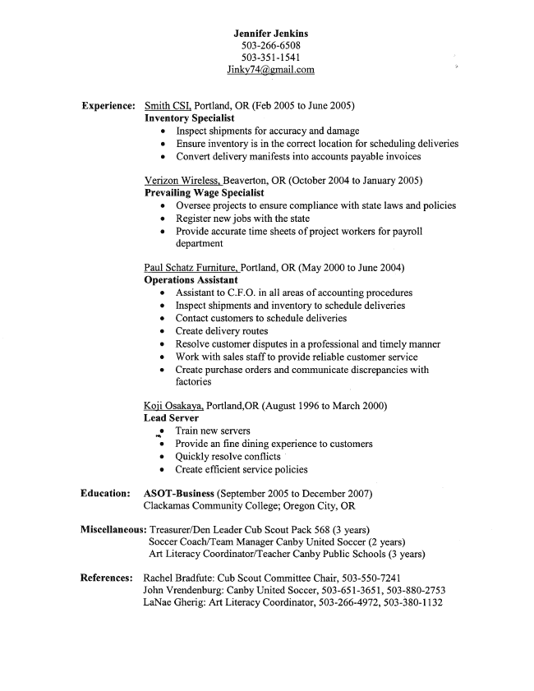
Jennifer Jenkins 503-266-6508
503-351-1541
Experience: Smith CSI, Portland, OR (Feb 2005 to June 2005)
Inventory Specialist
0 Inspect shipments for accuracy and damage I Ensure inventory is in the correct location for scheduling deliveries 0 Convert delivery manifests into accounts payable invoices
Verizon Wireless, Beaverton, OR (October 2004 to January 2005) Prevailing Wage Specialist
0 Oversee projects to ensure compliance with state laws and policies 0 Register new jobs with the state 0 Provide accurate time sheets of project workers for payroll
department
Paul Schatz Furniture, Portland, OR (May 2000 to June 2004) Operations Assistant
0 Assistant to C.F.O. in all areas of accounting procedures 0 Inspect shipments and inventory to schedule deliveries
Contact customers to schedule deliveries Create delivery routes 0 Resolve customer disputes in a professional and timely manner 0 Work with sales staff to provide reliable customer service Q Create purchase orders and communicate discrepancies with
factories
Koji Osakaya, Portland,OR (August 1996 to March 2000) Lead Server
V: Train new servers
0 Provide an ﬁne dining experience to customers 0 Quickly resolve conﬂicts ' 0 Create efﬁcient service policies
Education: ASOT-Business (September 2005 to December 2007)
Clackamas Community College; Oregon City, OR
Miscellaneous: Treasurer/Den Leader Cub Scout Pack 568 (3 years)
Soccer Coach/Team Manager Canby United Soccer (2 years) Art Literacy Coordinator/Teacher Canby Public Schools (3 years)
References: Rachel Bradfute: Cub Scout Committee Chair, 503-550-7241
John Vrendenburg: Canby United Soccer, 503-651-3651, 503-880-2753 LaNae Gherig: Art Literacy Coordinator, 503-266-4972, 503-380-1132

