LAUREN HUFF

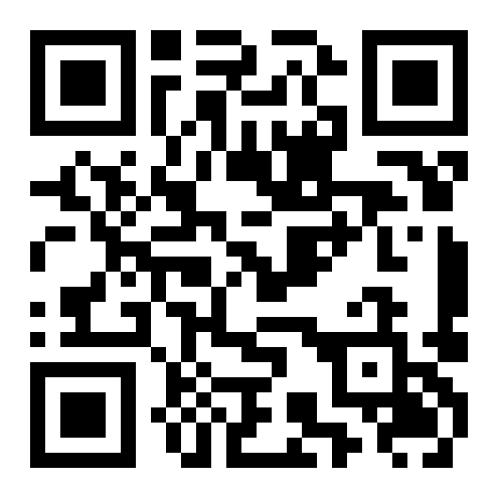
SUMMARY
As a recent graduate of The Evergreen State College, I hold a well-rounded liberal arts degree with an emphasis in political economics and history. Both enthusiastic and hardworking, I have a deep passion for working with people, research and professional & academic writing. I have in depth experience working with diverse groups of children and adults, working effectively in teams, and with creative problem solving.
I’m interested in an entry-level position where I can contribute my skills and experiences, and also grow as an aspiring young professional.

EDUCATION
The Evergreen State College 2009-2012
Bachelor of Arts (B.A.), History and Economics
The Vancouver School of Arts and Academics 2004-2008
High School Diploma

EXPERIENCE
Grace Institute (Grace Art Camp) 06 / 2011 - 08 / 2012
Printmaking Studio Counselor/Assistant
My duties as a printmaking studio counselor/assistant included teaching children ages 4-12 (in groups of 12) the art and practice of printmaking. More specifically, this position consisted of instructing children in various printmaking techniques and artistic principles, aiding children in completing printmaking projects, and studio prep/clean up.

A Brilliant Nanny 03 / 2012 - 06 / 2012
Nanny
As a nanny, I provided care for a variety of children and their families. My various duties included: providing a safe and fun environment, healthy nutrition and meal planning, structuring the children’s days through activity planning, instructing various arts and crafts projects, tutoring, teaching pre-kindergarten skills, instructing children in basic behavioral and social rules, and providing positive emotional support.

Portland Public Schools (The Metropolitan Learning Center) 04 / 2011 - 06 / 2011
Library Intern/Volunteer
As a library intern, I participated in a variety of duties as I intensively learned about the functions of libraries and librarians. Among some of my duties were: working at the front desk, checking books in and out, prepping and cataloging new library books, helping students locate library materials, prepping for and helping students complete workshop assignments, reorganizing the entire fiction section, creating themed displays, and facilitating inter-library loan trades.

Vancouver Public Schools (Lincoln Elementary) 04 / 2011 - 06 / 2011
Library Intern/Volunteer
In this position I worked as a library intern, participating in a variety of library related duties and functions. Among them: working at the front desk, checking books in and out, entering new books into the database, helping students locate library materials, aiding in instructing workshops, creating themed displays, book repair, mass library and equipment catalogization, the creation of Accelerated Reader quizzes, and reading students books aloud.

SKILLS
Mac and PC O/S | Library Catalog & Database | Computer & Library Research
Professional/Academic Writing | Help Desk/Front Desk | Inventorying & Data Entry
Mailroom/Office Tools | Public Speaking | Creative Problem Solving
Professional Communication | Independent Self-Starter | Intuitive Electronic Troubleshooting

VOLUNTEER WORK
Clark County Truancy Project 06/2012-Present
Volunteer Board Member
Vancouver Public Schools (Salmon Creek Elementary) 04/2011-06/2012
Library Volunteer

