data_request_20220419

Arielle Herman

4/19/2022

demo_plus <- c(demographics, "boost_bi", "mntl_hlth_bi", "mntl_hlth_state_bi")  
names(demo_plus) <- demo_plus  
  
issues <- c("stress", "food", "wtr", "hc")  
resources <- c("fam", "gov", "fb", "np")  
variables <- lapply(issues, function(issue) paste("lr", issue, resources, sep = "_")) %>% unlist  
names(variables) <- variables  
  
lapply(variables, function(variable) {  
 splitted <- stringr::str_split(variable, "_") %>% unlist  
 issue <- splitted[2]  
 resource <- splitted[3]  
 make_plots(  
 wrangled, demo_plus, variable,  
 title = glue::glue("Percent Respondents who would reach out to\n{resource} regarding {issue}"),  
 min = 6)  
})

## $lr_stress_fam  
## $lr_stress_fam$borough

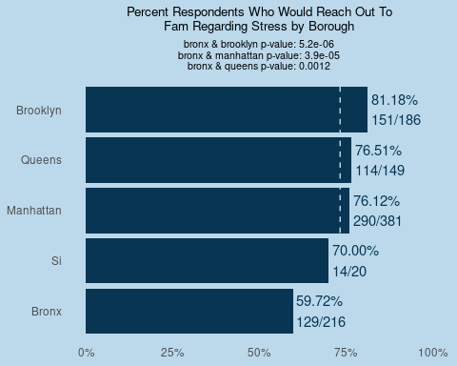

##   
## $lr_stress_fam$decade

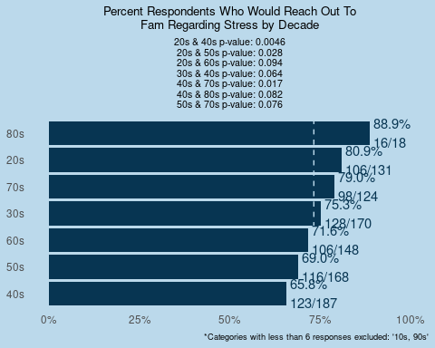

##   
## $lr_stress_fam$gen

## Warning: Removed 1 rows containing missing values (geom_text).

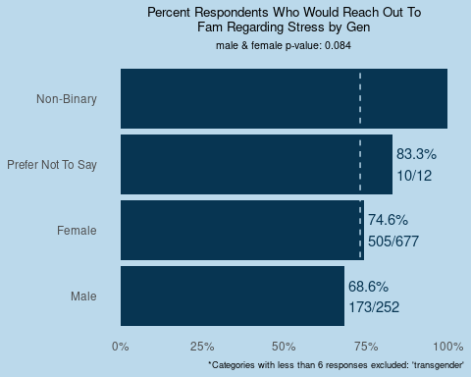

##   
## $lr_stress_fam$race_census

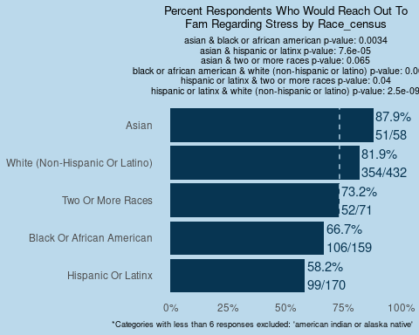

##   
## $lr_stress_fam$not_eng

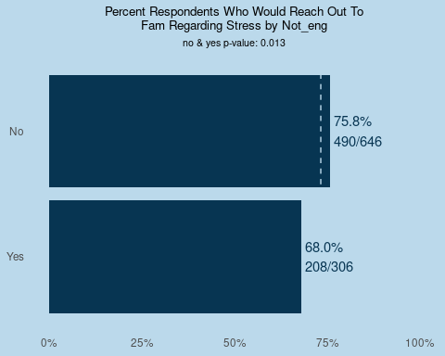

##   
## $lr_stress_fam$mar  
## NULL  
##   
## $lr_stress_fam$sch_level_cat

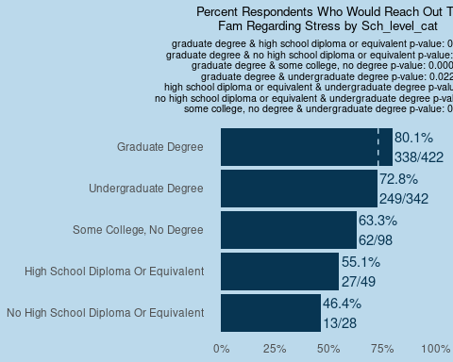

##   
## $lr_stress_fam$hh_ch_0_17_bi

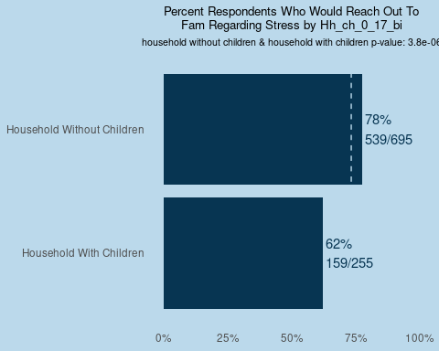

##   
## $lr_stress_fam$hh_65_bi  
## NULL  
##   
## $lr_stress_fam$inc_dist

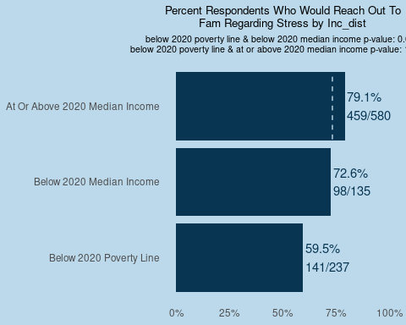

##   
## $lr_stress_fam$emp_status_before

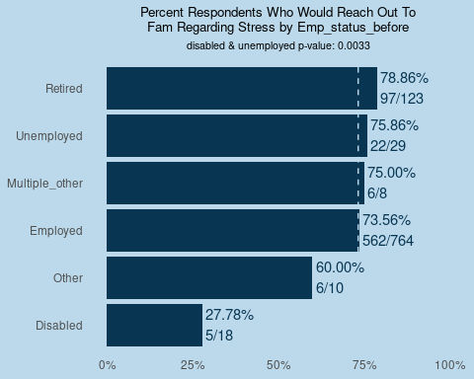

##   
## $lr_stress_fam$emp_status_after

## Warning: Removed 1 rows containing missing values (geom_text).

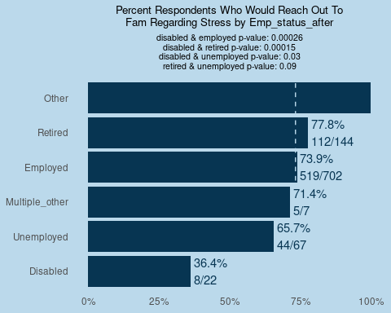

##   
## $lr_stress_fam$res_cat

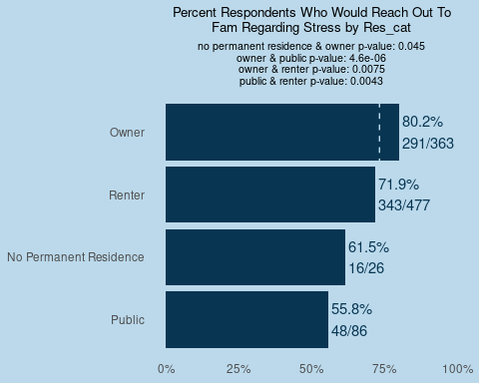

##   
## $lr_stress_fam$boost_bi  
## NULL  
##   
## $lr_stress_fam$mntl_hlth_bi

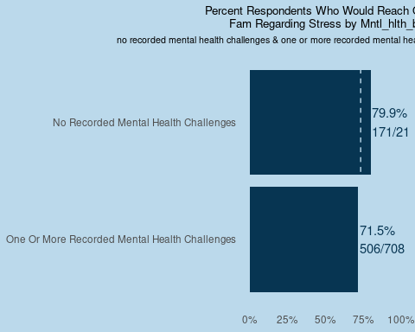

##   
## $lr_stress_fam$mntl_hlth_state_bi  
## NULL  
##   
##   
## $lr_stress_gov  
## $lr_stress_gov$borough

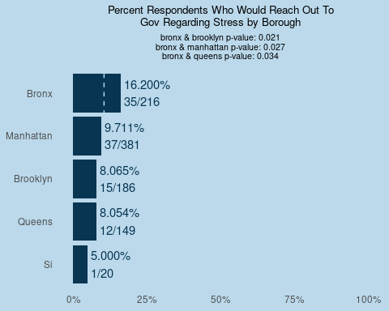

##   
## $lr_stress_gov$decade

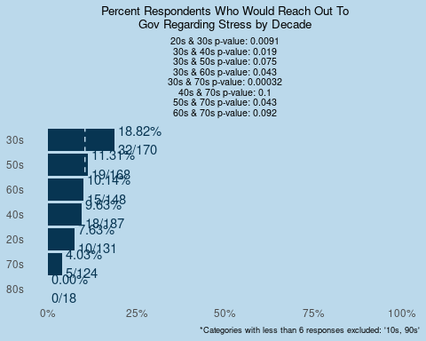

##   
## $lr_stress_gov$gen  
## NULL  
##   
## $lr_stress_gov$race_census

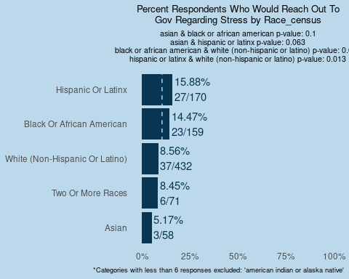

##   
## $lr_stress_gov$not_eng

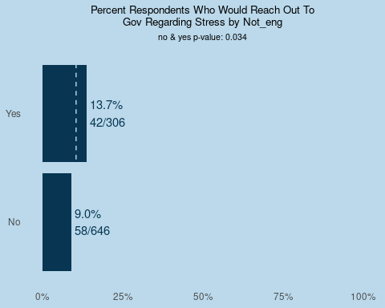

##   
## $lr_stress_gov$mar

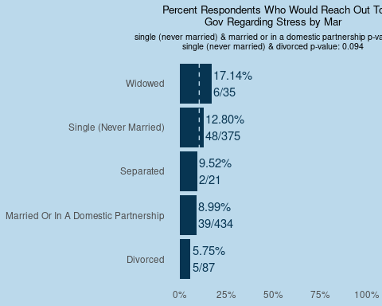

##   
## $lr_stress_gov$sch_level_cat  
## NULL  
##   
## $lr_stress_gov$hh_ch_0_17_bi  
## NULL  
##   
## $lr_stress_gov$hh_65_bi  
## NULL  
##   
## $lr_stress_gov$inc_dist

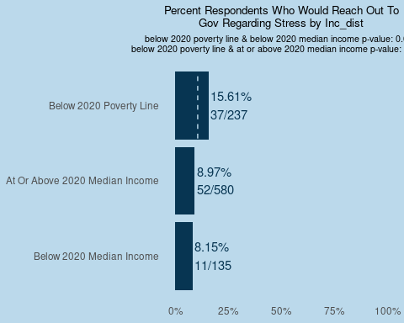

##   
## $lr_stress_gov$emp_status_before  
## NULL  
##   
## $lr_stress_gov$emp_status_after

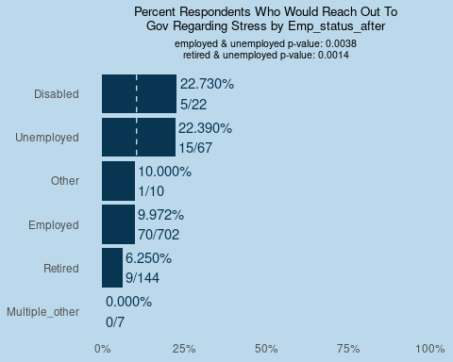

##   
## $lr_stress_gov$res_cat

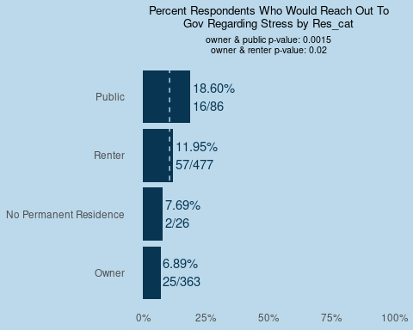

##   
## $lr_stress_gov$boost_bi  
## NULL  
##   
## $lr_stress_gov$mntl_hlth_bi

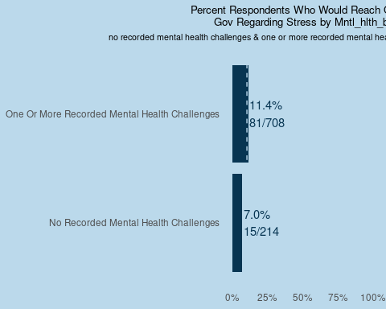

##   
## $lr_stress_gov$mntl_hlth_state_bi

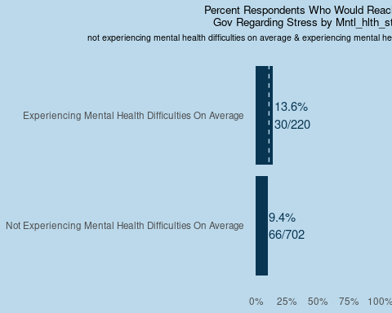

##   
##   
## $lr_stress_fb  
## $lr_stress_fb$borough

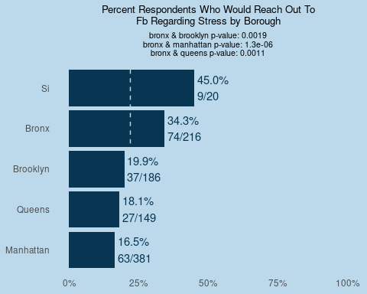

##   
## $lr_stress_fb$decade

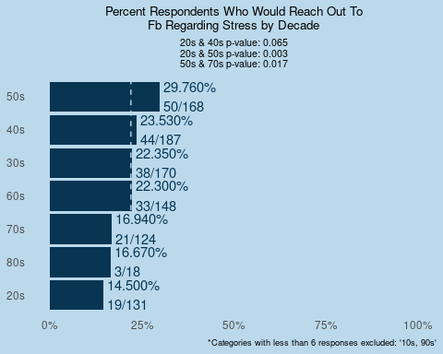

##   
## $lr_stress_fb$gen  
## NULL  
##   
## $lr_stress_fb$race_census

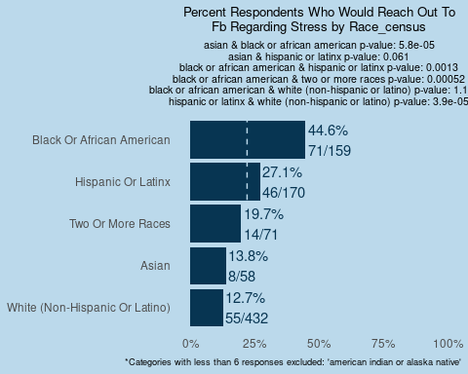

##   
## $lr_stress_fb$not_eng

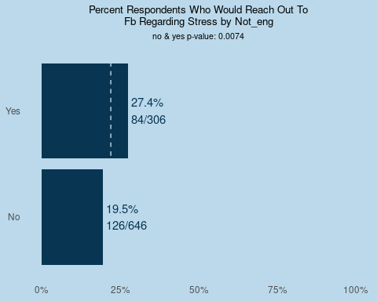

##   
## $lr_stress_fb$mar

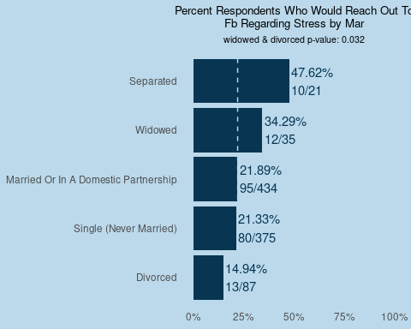

##   
## $lr_stress_fb$sch_level_cat

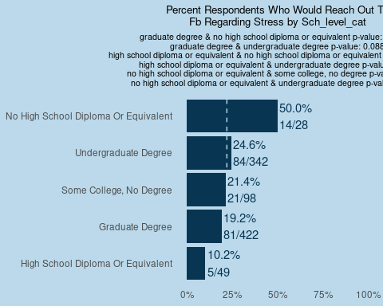

##   
## $lr_stress_fb$hh_ch_0_17_bi

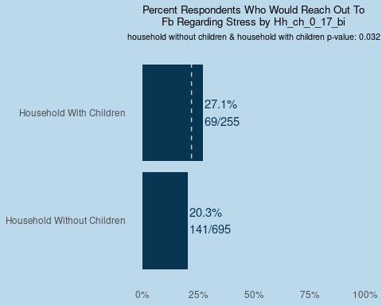

##   
## $lr_stress_fb$hh_65_bi  
## NULL  
##   
## $lr_stress_fb$inc_dist

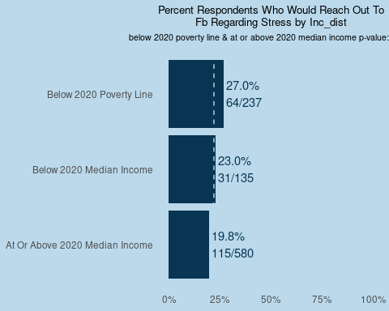

##   
## $lr_stress_fb$emp_status_before  
## NULL  
##   
## $lr_stress_fb$emp_status_after  
## NULL  
##   
## $lr_stress_fb$res_cat

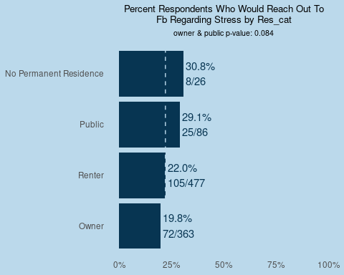

##   
## $lr_stress_fb$boost_bi

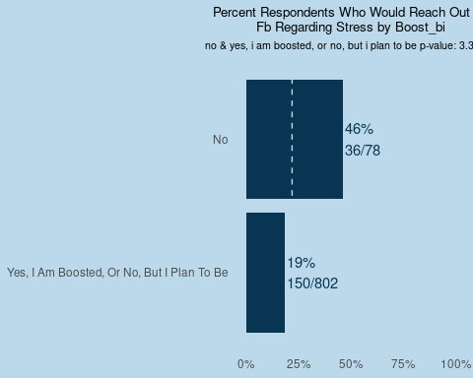

##   
## $lr_stress_fb$mntl_hlth_bi  
## NULL  
##   
## $lr_stress_fb$mntl_hlth_state_bi  
## NULL  
##   
##   
## $lr_stress_np  
## $lr_stress_np$borough

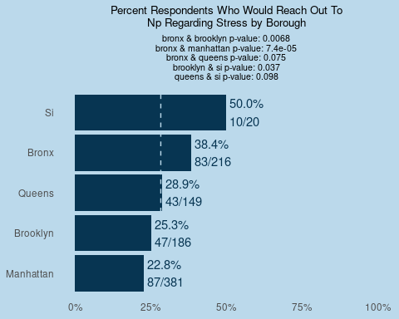

##   
## $lr_stress_np$decade

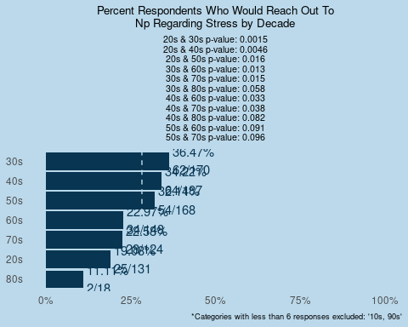

##   
## $lr_stress_np$gen  
## NULL  
##   
## $lr_stress_np$race_census

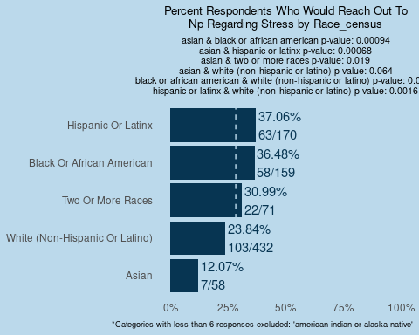

##   
## $lr_stress_np$not_eng  
## NULL  
##   
## $lr_stress_np$mar

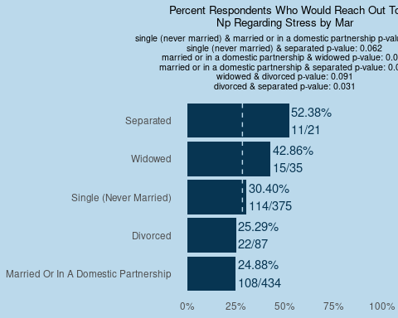

##   
## $lr_stress_np$sch_level_cat  
## NULL  
##   
## $lr_stress_np$hh_ch_0_17_bi  
## NULL  
##   
## $lr_stress_np$hh_65_bi  
## NULL  
##   
## $lr_stress_np$inc_dist

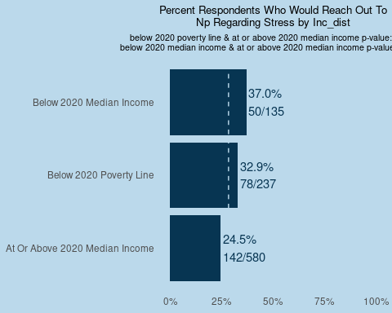

##   
## $lr_stress_np$emp_status_before  
## NULL  
##   
## $lr_stress_np$emp_status_after  
## NULL  
##   
## $lr_stress_np$res_cat

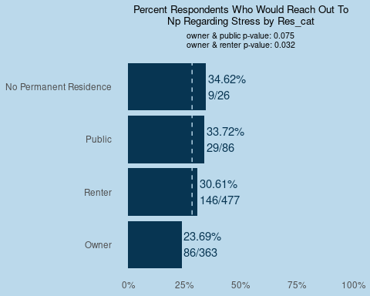

##   
## $lr_stress_np$boost_bi  
## NULL  
##   
## $lr_stress_np$mntl_hlth_bi

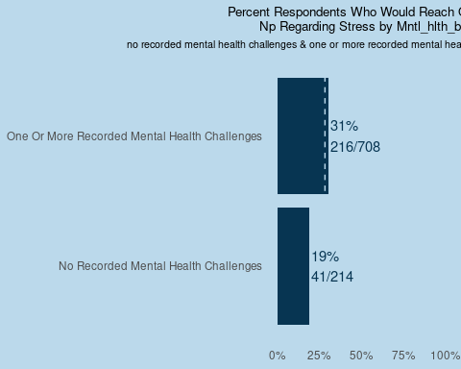

##   
## $lr_stress_np$mntl_hlth_state_bi

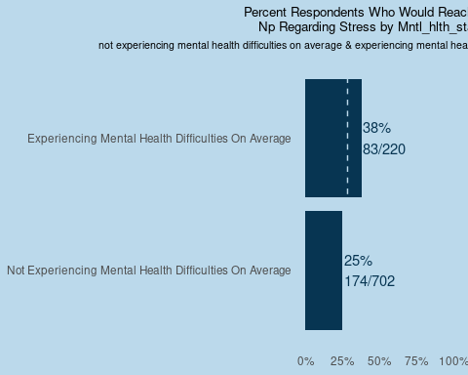

##   
##   
## $lr_food_fam  
## $lr_food_fam$borough

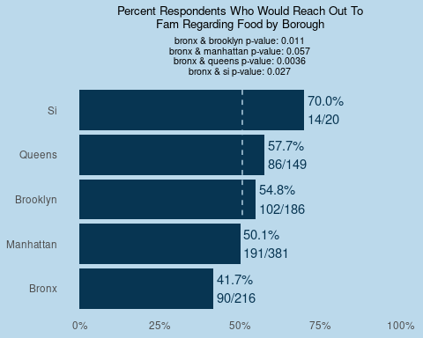

##   
## $lr_food_fam$decade

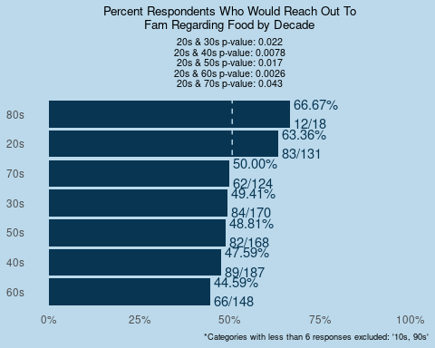

##   
## $lr_food_fam$gen  
## NULL  
##   
## $lr_food_fam$race_census

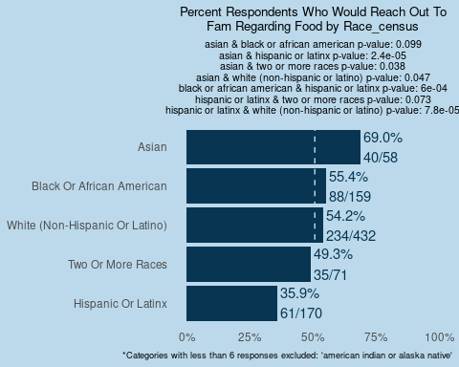

##   
## $lr_food_fam$not_eng  
## NULL  
##   
## $lr_food_fam$mar

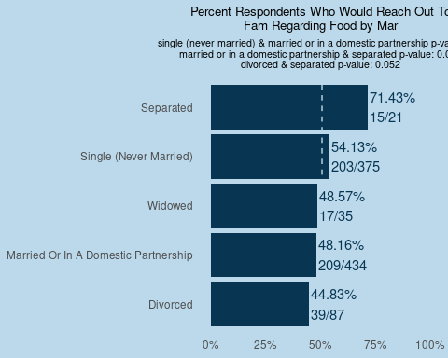

##   
## $lr_food_fam$sch_level_cat

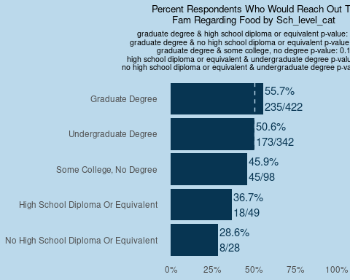

##   
## $lr_food_fam$hh_ch_0_17_bi

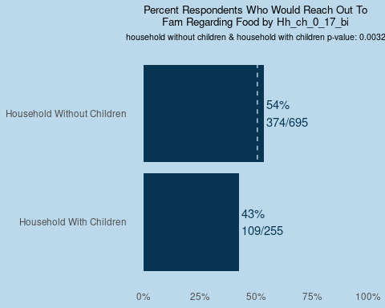

##   
## $lr_food_fam$hh_65_bi  
## NULL  
##   
## $lr_food_fam$inc_dist

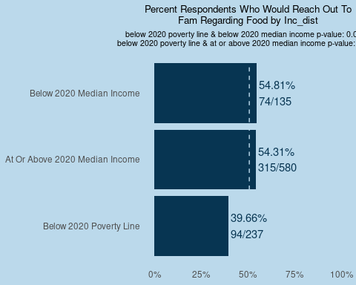

##   
## $lr_food_fam$emp_status_before

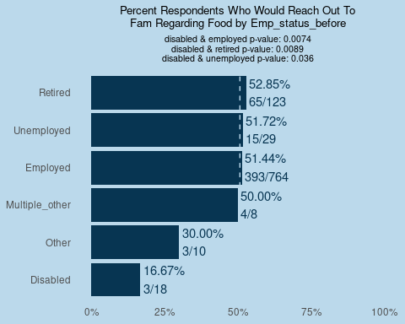

##   
## $lr_food_fam$emp_status_after

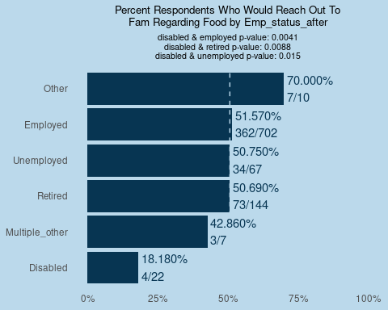

##   
## $lr_food_fam$res_cat

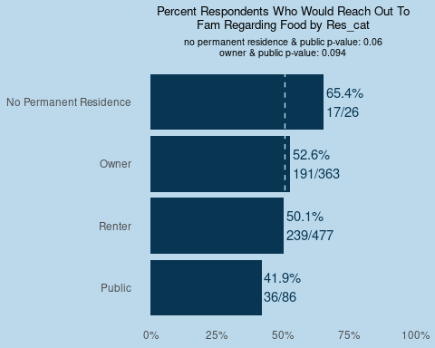

##   
## $lr_food_fam$boost_bi  
## NULL  
##   
## $lr_food_fam$mntl_hlth_bi

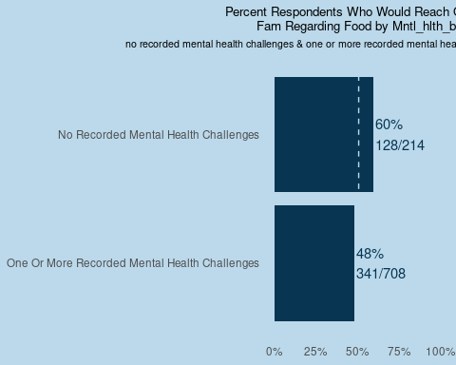

##   
## $lr_food_fam$mntl_hlth_state_bi  
## NULL  
##   
##   
## $lr_food_gov  
## $lr_food_gov$borough  
## NULL  
##   
## $lr_food_gov$decade

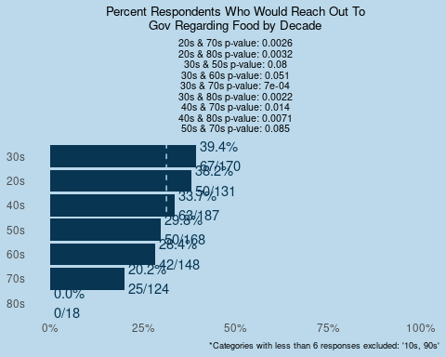

##   
## $lr_food_gov$gen  
## NULL  
##   
## $lr_food_gov$race_census  
## NULL  
##   
## $lr_food_gov$not_eng  
## NULL  
##   
## $lr_food_gov$mar

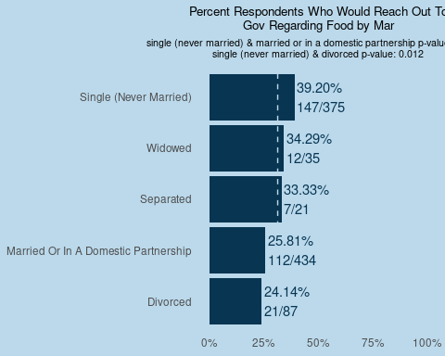

##   
## $lr_food_gov$sch_level_cat

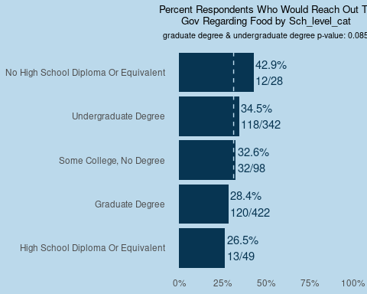

##   
## $lr_food_gov$hh_ch_0_17_bi  
## NULL  
##   
## $lr_food_gov$hh_65_bi

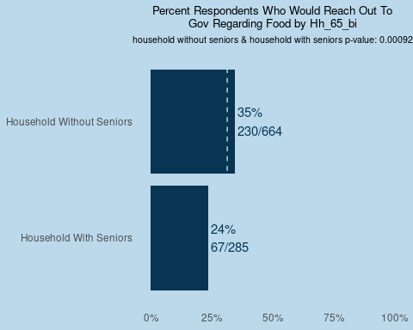

##   
## $lr_food_gov$inc_dist

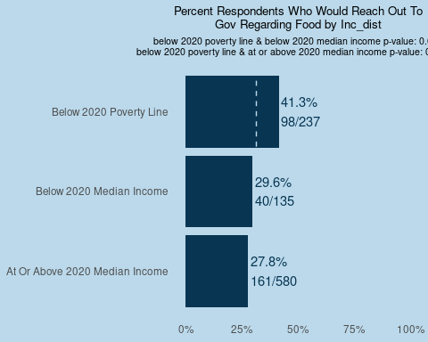

##   
## $lr_food_gov$emp_status_before

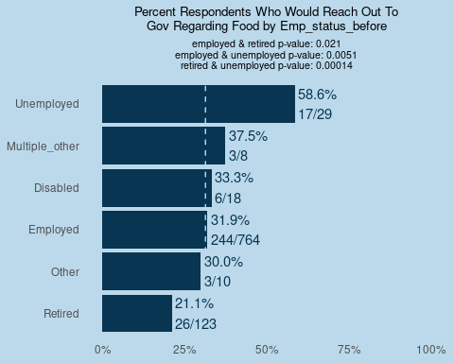

##   
## $lr_food_gov$emp_status_after

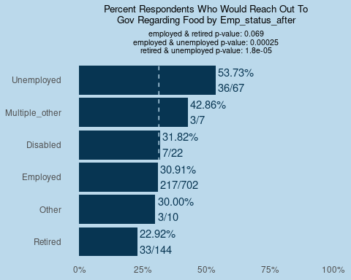

##   
## $lr_food_gov$res_cat

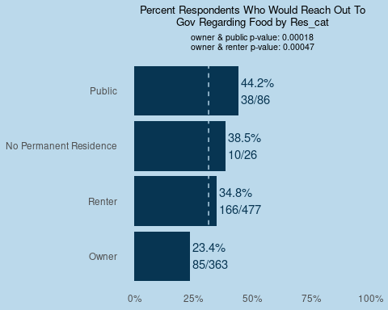

##   
## $lr_food_gov$boost_bi

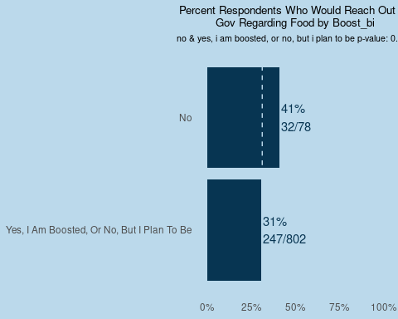

##   
## $lr_food_gov$mntl_hlth_bi  
## NULL  
##   
## $lr_food_gov$mntl_hlth_state_bi  
## NULL  
##   
##   
## $lr_food_fb  
## $lr_food_fb$borough

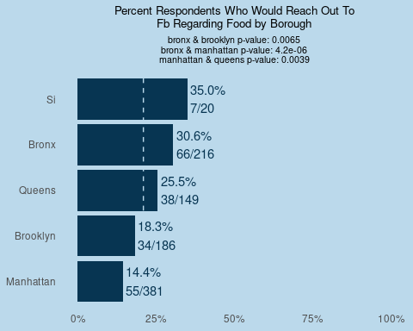

##   
## $lr_food_fb$decade

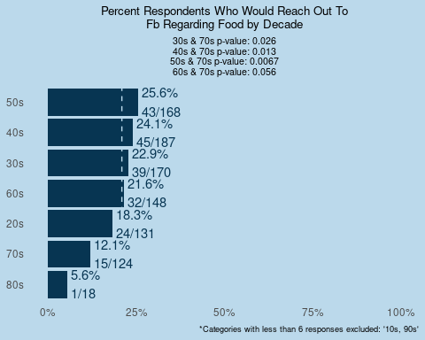

##   
## $lr_food_fb$gen  
## NULL  
##   
## $lr_food_fb$race_census

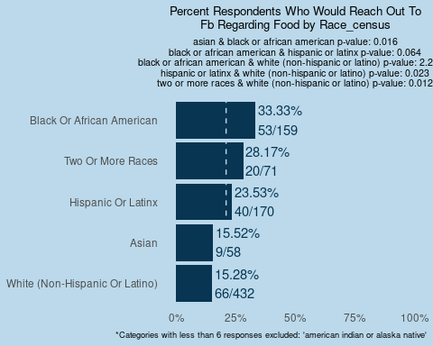

##   
## $lr_food_fb$not_eng

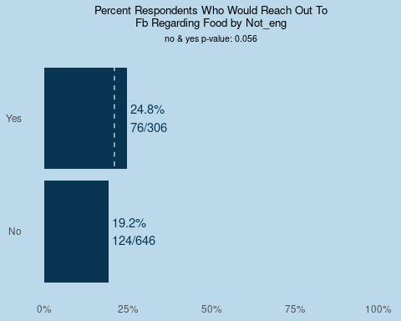

##   
## $lr_food_fb$mar  
## NULL  
##   
## $lr_food_fb$sch_level_cat

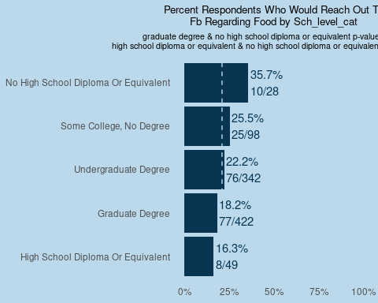

##   
## $lr_food_fb$hh_ch_0_17_bi

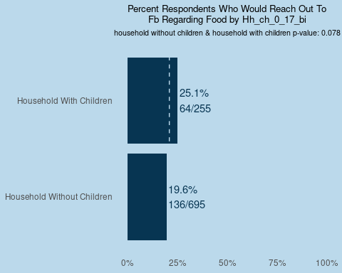

##   
## $lr_food_fb$hh_65_bi

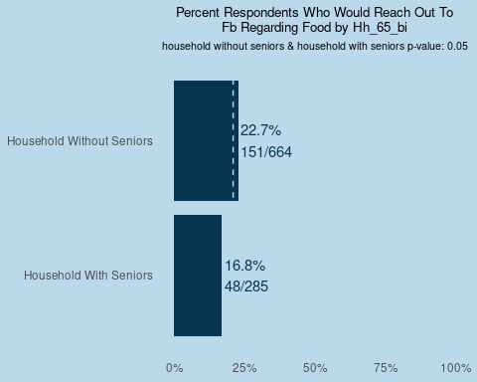

##   
## $lr_food_fb$inc_dist  
## NULL  
##   
## $lr_food_fb$emp_status_before

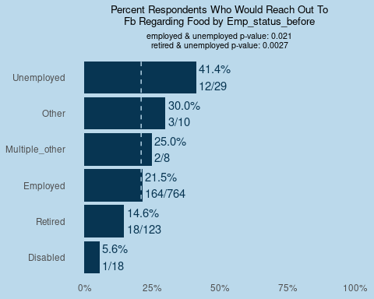

##   
## $lr_food_fb$emp_status_after

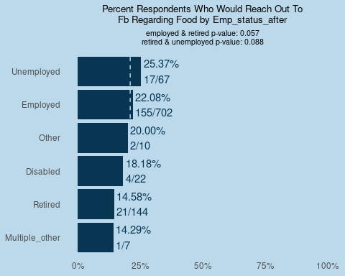

##   
## $lr_food_fb$res_cat  
## NULL  
##   
## $lr_food_fb$boost_bi

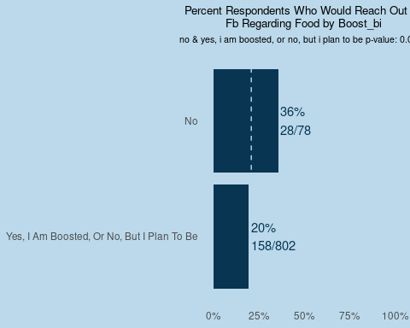

##   
## $lr_food_fb$mntl_hlth_bi  
## NULL  
##   
## $lr_food_fb$mntl_hlth_state_bi  
## NULL  
##   
##   
## $lr_food_np  
## $lr_food_np$borough

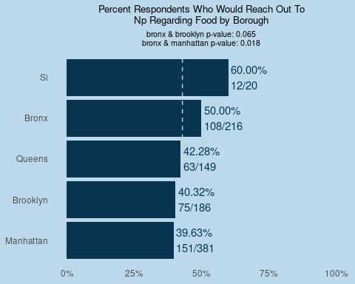

##   
## $lr_food_np$decade

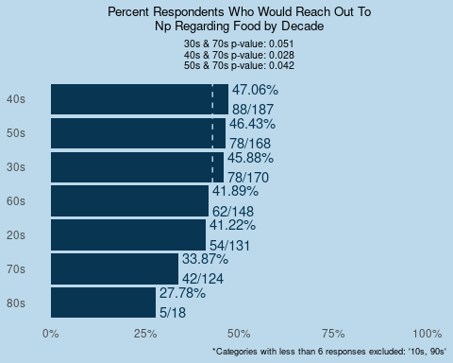

##   
## $lr_food_np$gen

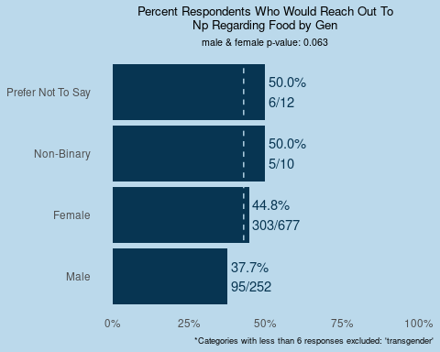

##   
## $lr_food_np$race_census

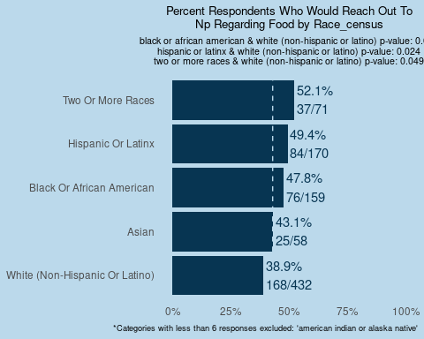

##   
## $lr_food_np$not_eng  
## NULL  
##   
## $lr_food_np$mar

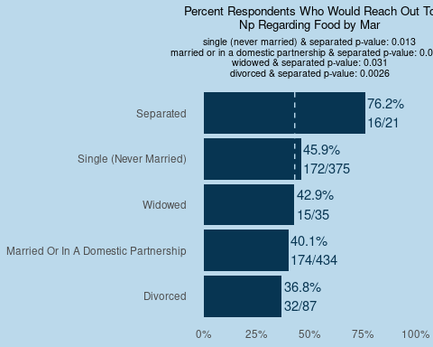

##   
## $lr_food_np$sch_level_cat  
## NULL  
##   
## $lr_food_np$hh_ch_0_17_bi  
## NULL  
##   
## $lr_food_np$hh_65_bi  
## NULL  
##   
## $lr_food_np$inc_dist

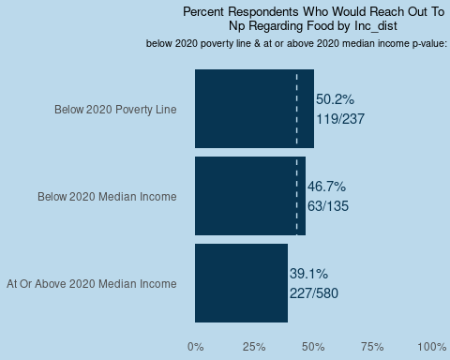

##   
## $lr_food_np$emp_status_before  
## NULL  
##   
## $lr_food_np$emp_status_after  
## NULL  
##   
## $lr_food_np$res_cat

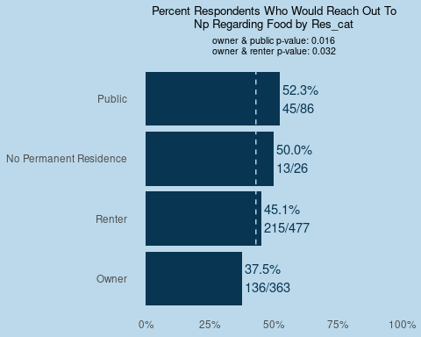

##   
## $lr_food_np$boost_bi  
## NULL  
##   
## $lr_food_np$mntl_hlth_bi  
## NULL  
##   
## $lr_food_np$mntl_hlth_state_bi  
## NULL  
##   
##   
## $lr_wtr_fam  
## $lr_wtr_fam$borough

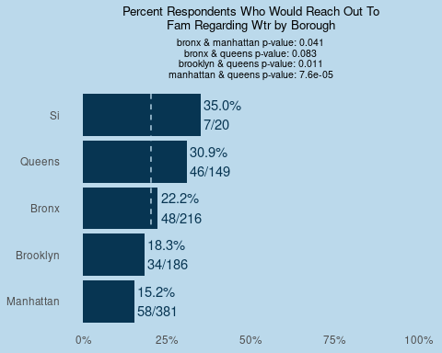

##   
## $lr_wtr_fam$decade

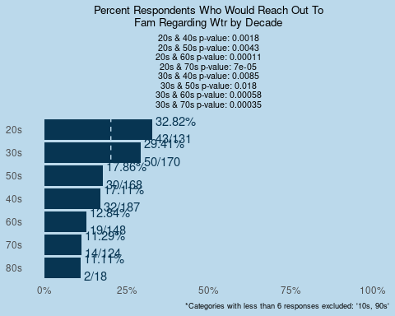

##   
## $lr_wtr_fam$gen  
## NULL  
##   
## $lr_wtr_fam$race_census

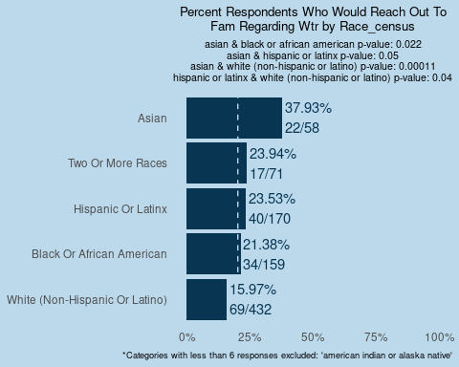

##   
## $lr_wtr_fam$not_eng

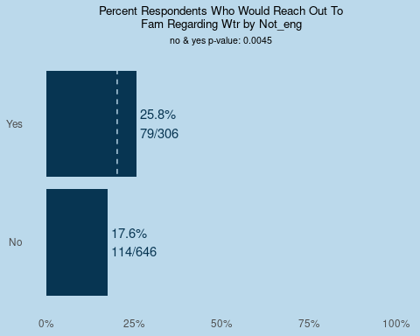

##   
## $lr_wtr_fam$mar

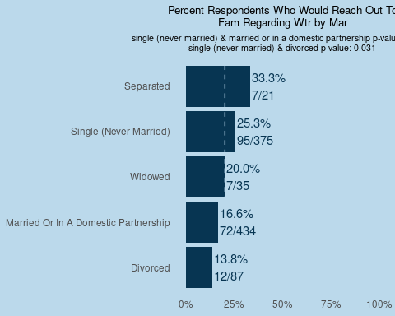

##   
## $lr_wtr_fam$sch_level_cat  
## NULL  
##   
## $lr_wtr_fam$hh_ch_0_17_bi  
## NULL  
##   
## $lr_wtr_fam$hh_65_bi

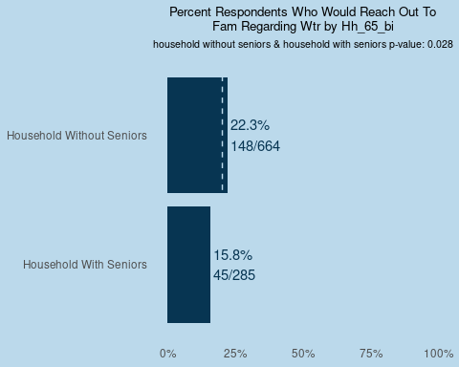

##   
## $lr_wtr_fam$inc_dist  
## NULL  
##   
## $lr_wtr_fam$emp_status_before

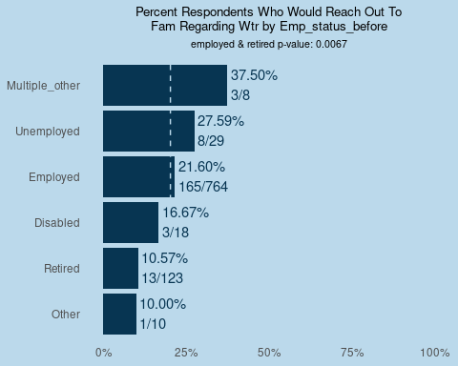

##   
## $lr_wtr_fam$emp_status_after

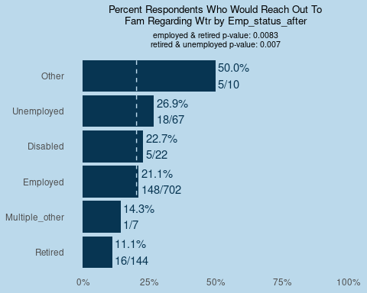

##   
## $lr_wtr_fam$res_cat

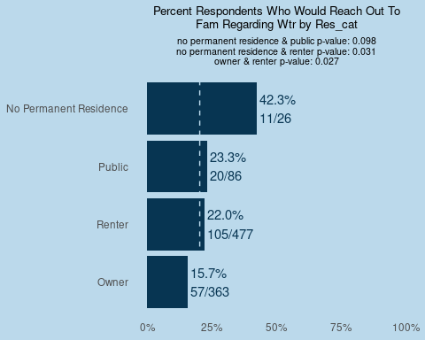

##   
## $lr_wtr_fam$boost_bi

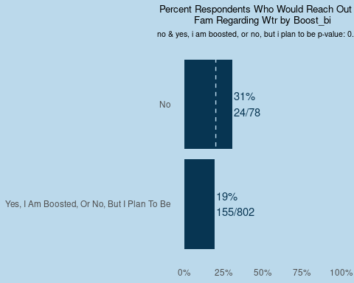

##   
## $lr_wtr_fam$mntl_hlth_bi  
## NULL  
##   
## $lr_wtr_fam$mntl_hlth_state_bi  
## NULL  
##   
##   
## $lr_wtr_gov  
## $lr_wtr_gov$borough

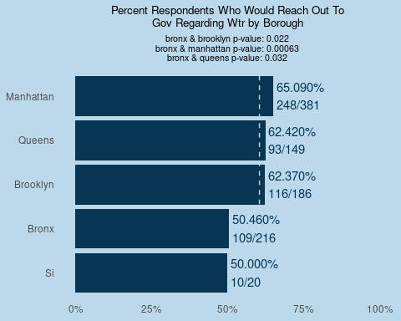

##   
## $lr_wtr_gov$decade

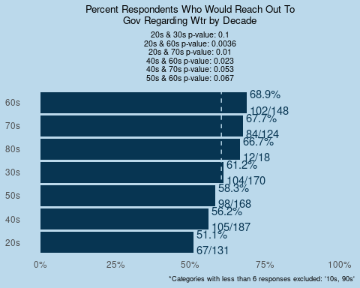

##   
## $lr_wtr_gov$gen  
## NULL  
##   
## $lr_wtr_gov$race_census

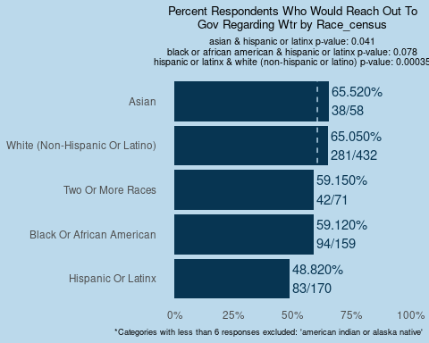

##   
## $lr_wtr_gov$not_eng  
## NULL  
##   
## $lr_wtr_gov$mar  
## NULL  
##   
## $lr_wtr_gov$sch_level_cat

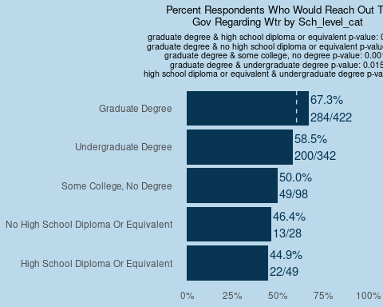

##   
## $lr_wtr_gov$hh_ch_0_17_bi

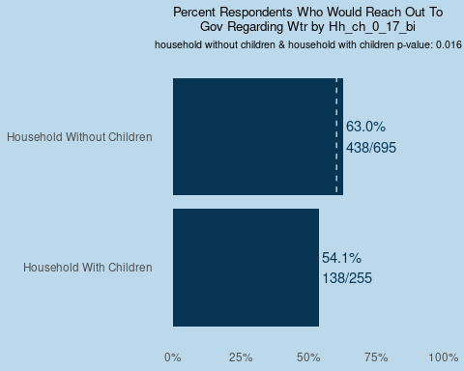

##   
## $lr_wtr_gov$hh_65_bi

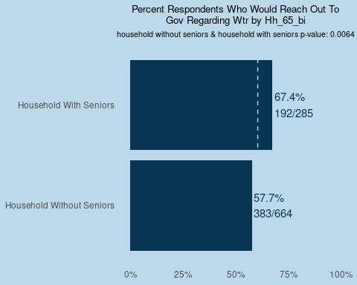

##   
## $lr_wtr_gov$inc_dist

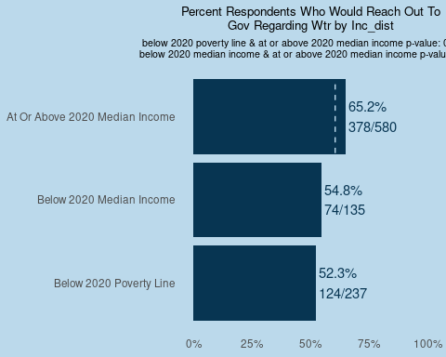

##   
## $lr_wtr_gov$emp_status_before

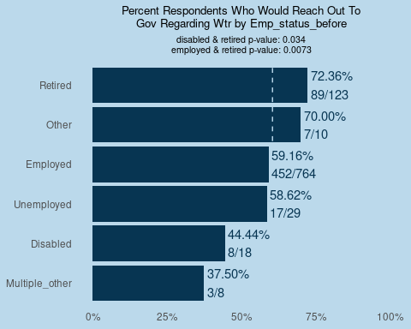

##   
## $lr_wtr_gov$emp_status_after

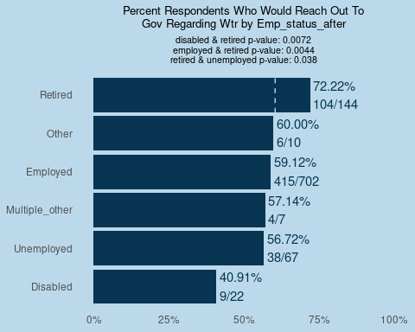

##   
## $lr_wtr_gov$res_cat

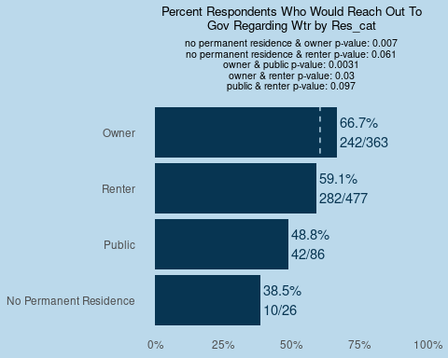

##   
## $lr_wtr_gov$boost_bi  
## NULL  
##   
## $lr_wtr_gov$mntl_hlth_bi

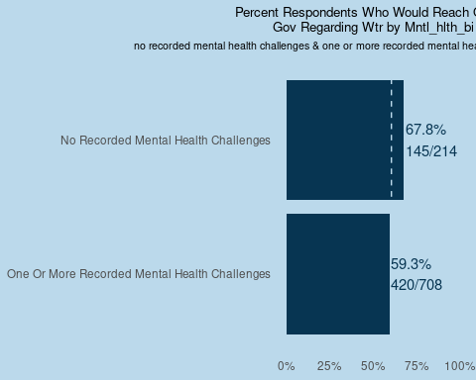

##   
## $lr_wtr_gov$mntl_hlth_state_bi  
## NULL  
##   
##   
## $lr_wtr_fb  
## $lr_wtr_fb$borough

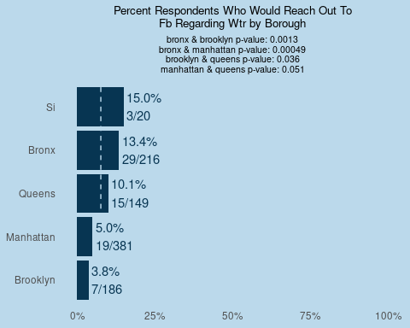

##   
## $lr_wtr_fb$decade

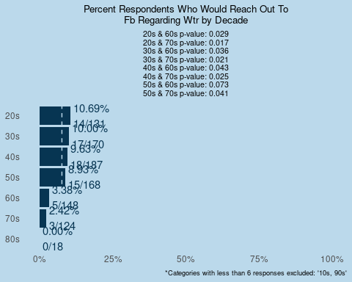

##   
## $lr_wtr_fb$gen  
## NULL  
##   
## $lr_wtr_fb$race_census

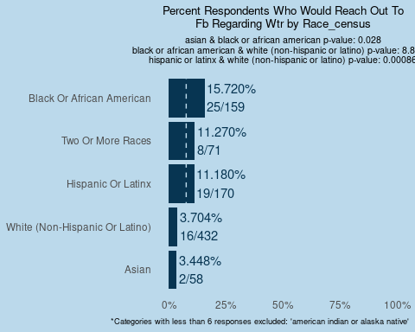

##   
## $lr_wtr_fb$not_eng

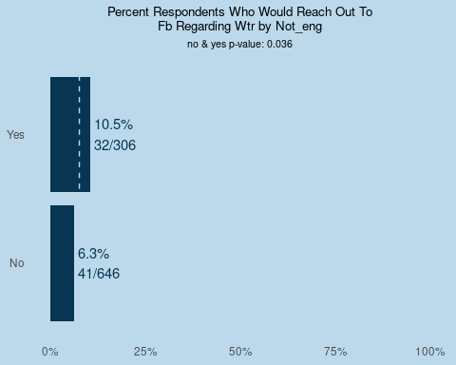

##   
## $lr_wtr_fb$mar

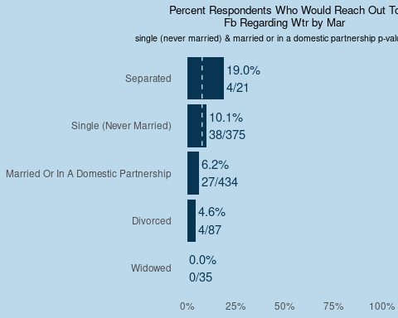

##   
## $lr_wtr_fb$sch_level_cat

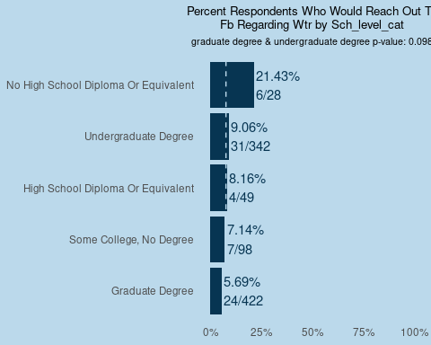

##   
## $lr_wtr_fb$hh_ch_0_17_bi

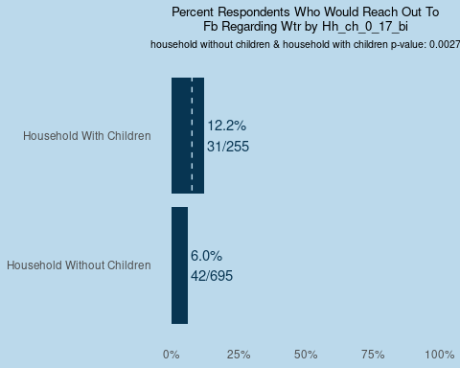

##   
## $lr_wtr_fb$hh_65_bi

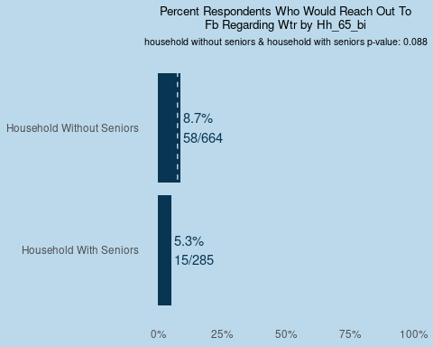

##   
## $lr_wtr_fb$inc_dist

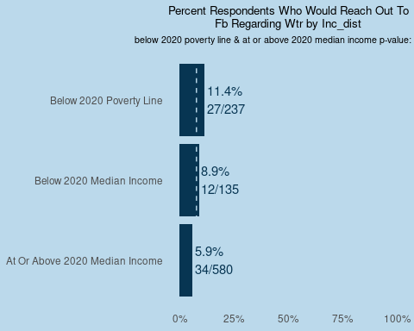

##   
## $lr_wtr_fb$emp_status_before

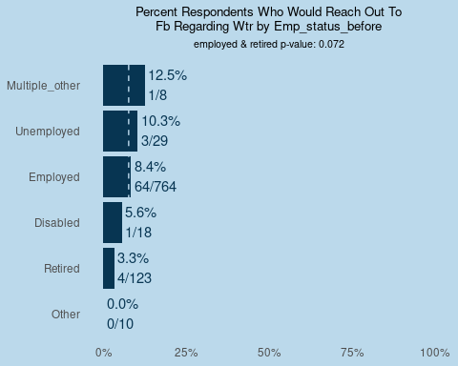

##   
## $lr_wtr_fb$emp_status_after  
## NULL  
##   
## $lr_wtr_fb$res_cat

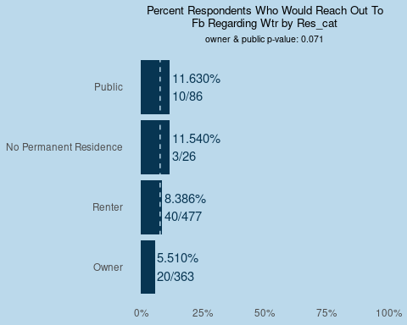

##   
## $lr_wtr_fb$boost_bi

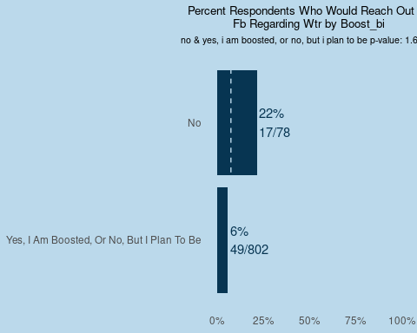

##   
## $lr_wtr_fb$mntl_hlth_bi

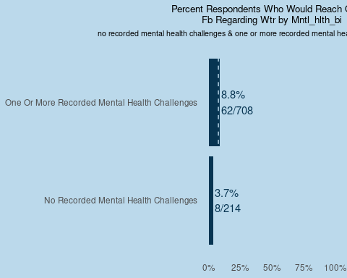

##   
## $lr_wtr_fb$mntl_hlth_state_bi  
## NULL  
##   
##   
## $lr_wtr_np  
## $lr_wtr_np$borough

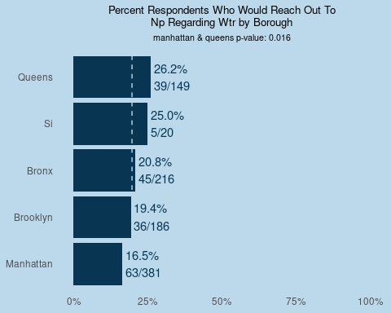

##   
## $lr_wtr_np$decade

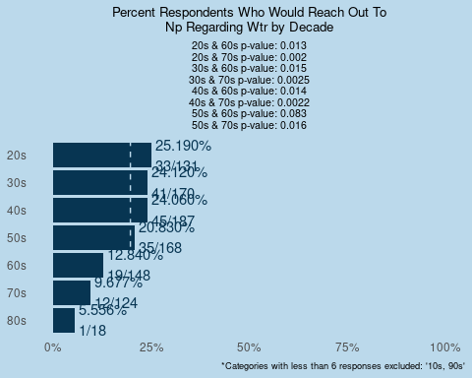

##   
## $lr_wtr_np$gen  
## NULL  
##   
## $lr_wtr_np$race_census

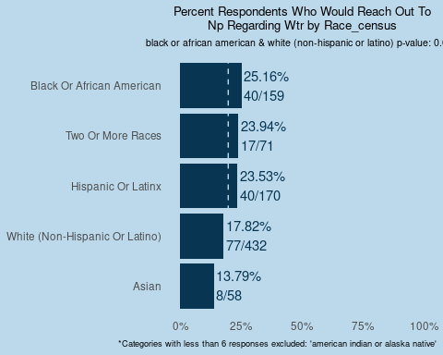

##   
## $lr_wtr_np$not_eng  
## NULL  
##   
## $lr_wtr_np$mar  
## NULL  
##   
## $lr_wtr_np$sch_level_cat

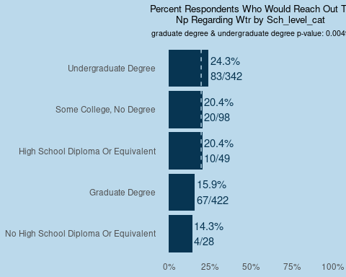

##   
## $lr_wtr_np$hh_ch_0_17_bi  
## NULL  
##   
## $lr_wtr_np$hh_65_bi

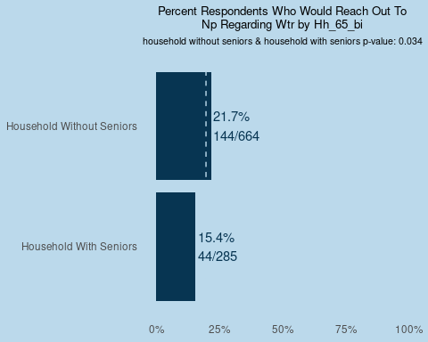

##   
## $lr_wtr_np$inc_dist  
## NULL  
##   
## $lr_wtr_np$emp_status_before

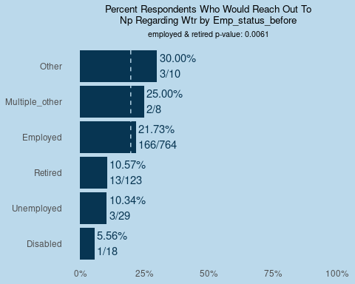

##   
## $lr_wtr_np$emp_status_after

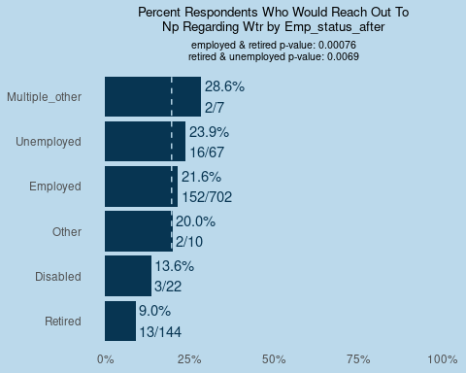

##   
## $lr_wtr_np$res_cat

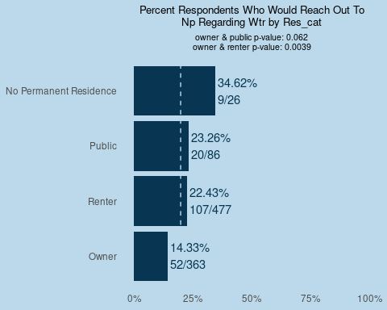

##   
## $lr_wtr_np$boost_bi

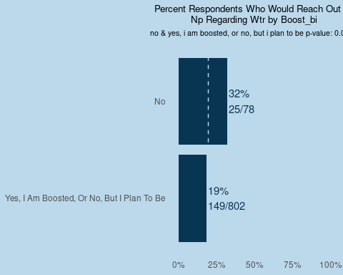

##   
## $lr_wtr_np$mntl_hlth_bi  
## NULL  
##   
## $lr_wtr_np$mntl_hlth_state_bi  
## NULL  
##   
##   
## $lr_hc_fam  
## $lr_hc_fam$borough

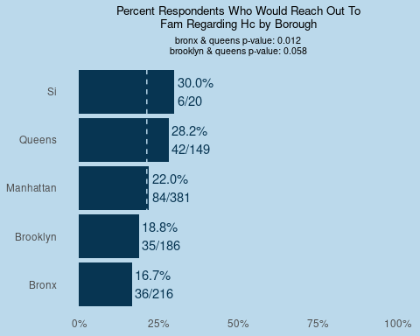

##   
## $lr_hc_fam$decade

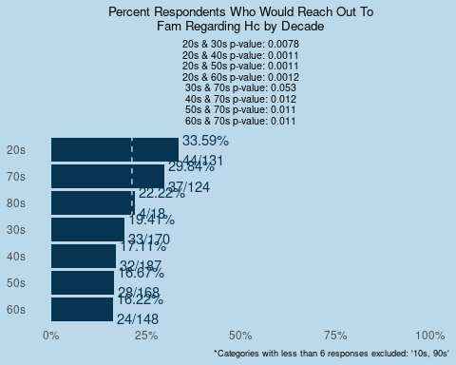

##   
## $lr_hc_fam$gen

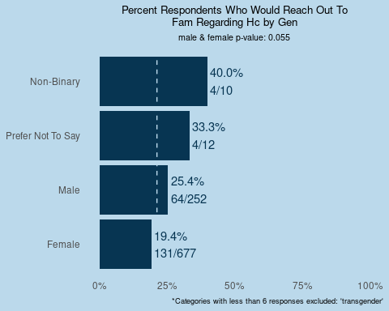

##   
## $lr_hc_fam$race_census

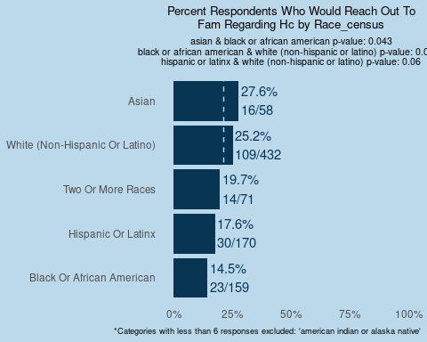

##   
## $lr_hc_fam$not_eng  
## NULL  
##   
## $lr_hc_fam$mar  
## NULL  
##   
## $lr_hc_fam$sch_level_cat  
## NULL  
##   
## $lr_hc_fam$hh_ch_0_17_bi

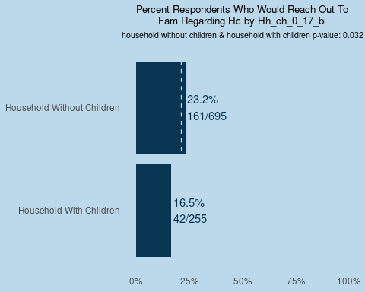

##   
## $lr_hc_fam$hh_65_bi  
## NULL  
##   
## $lr_hc_fam$inc_dist  
## NULL  
##   
## $lr_hc_fam$emp_status_before  
## NULL  
##   
## $lr_hc_fam$emp_status_after  
## NULL  
##   
## $lr_hc_fam$res_cat  
## NULL  
##   
## $lr_hc_fam$boost_bi  
## NULL  
##   
## $lr_hc_fam$mntl_hlth_bi

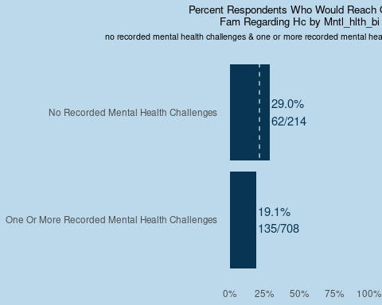

##   
## $lr_hc_fam$mntl_hlth_state_bi  
## NULL  
##   
##   
## $lr_hc_gov  
## $lr_hc_gov$borough

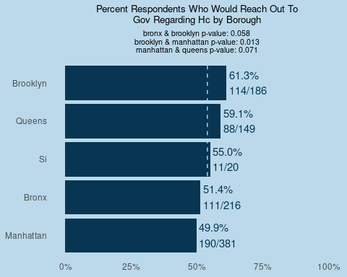

##   
## $lr_hc_gov$decade

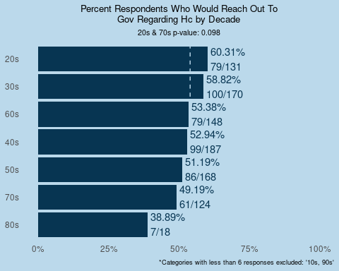

##   
## $lr_hc_gov$gen  
## NULL  
##   
## $lr_hc_gov$race_census  
## NULL  
##   
## $lr_hc_gov$not_eng  
## NULL  
##   
## $lr_hc_gov$mar

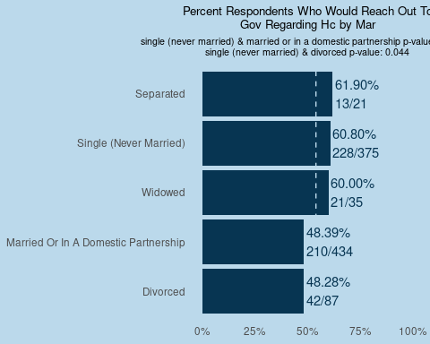

##   
## $lr_hc_gov$sch_level_cat  
## NULL  
##   
## $lr_hc_gov$hh_ch_0_17_bi  
## NULL  
##   
## $lr_hc_gov$hh_65_bi  
## NULL  
##   
## $lr_hc_gov$inc_dist  
## NULL  
##   
## $lr_hc_gov$emp_status_before  
## NULL  
##   
## $lr_hc_gov$emp_status_after

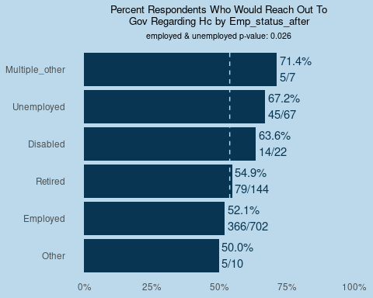

##   
## $lr_hc_gov$res_cat

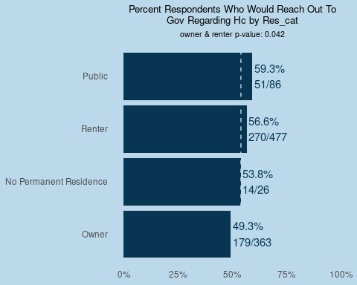

##   
## $lr_hc_gov$boost_bi  
## NULL  
##   
## $lr_hc_gov$mntl_hlth_bi  
## NULL  
##   
## $lr_hc_gov$mntl_hlth_state_bi  
## NULL  
##   
##   
## $lr_hc_fb  
## $lr_hc_fb$borough  
## NULL  
##   
## $lr_hc_fb$decade  
## NULL  
##   
## $lr_hc_fb$gen  
## NULL  
##   
## $lr_hc_fb$race_census  
## NULL  
##   
## $lr_hc_fb$not_eng  
## NULL  
##   
## $lr_hc_fb$mar  
## NULL  
##   
## $lr_hc_fb$sch_level_cat  
## NULL  
##   
## $lr_hc_fb$hh_ch_0_17_bi  
## NULL  
##   
## $lr_hc_fb$hh_65_bi  
## NULL  
##   
## $lr_hc_fb$inc_dist  
## NULL  
##   
## $lr_hc_fb$emp_status_before  
## NULL  
##   
## $lr_hc_fb$emp_status_after  
## NULL  
##   
## $lr_hc_fb$res_cat  
## NULL  
##   
## $lr_hc_fb$boost_bi  
## NULL  
##   
## $lr_hc_fb$mntl_hlth_bi  
## NULL  
##   
## $lr_hc_fb$mntl_hlth_state_bi  
## NULL  
##   
##   
## $lr_hc_np  
## $lr_hc_np$borough

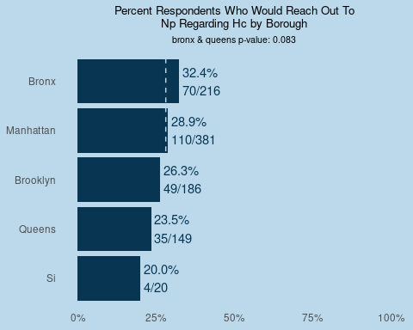

##   
## $lr_hc_np$decade

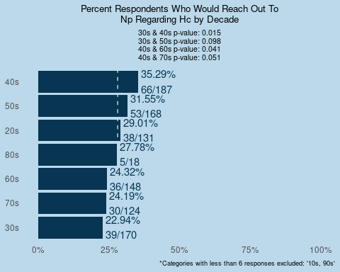

##   
## $lr_hc_np$gen  
## NULL  
##   
## $lr_hc_np$race_census  
## NULL  
##   
## $lr_hc_np$not_eng  
## NULL  
##   
## $lr_hc_np$mar

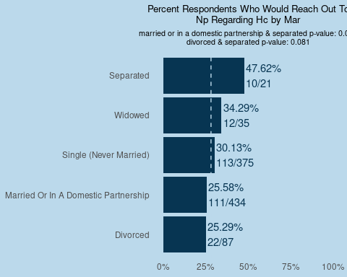

##   
## $lr_hc_np$sch_level_cat

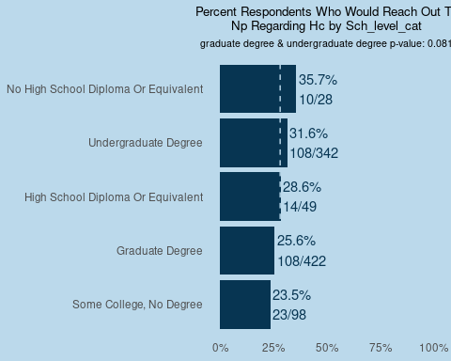

##   
## $lr_hc_np$hh_ch_0_17_bi  
## NULL  
##   
## $lr_hc_np$hh_65_bi  
## NULL  
##   
## $lr_hc_np$inc_dist

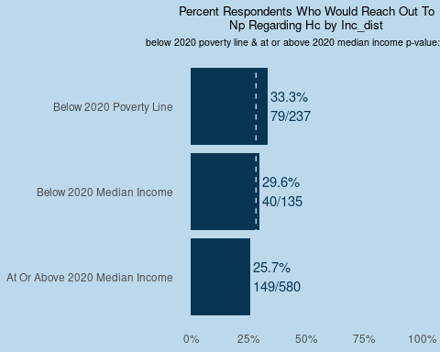

##   
## $lr_hc_np$emp_status_before  
## NULL  
##   
## $lr_hc_np$emp_status_after  
## NULL  
##   
## $lr_hc_np$res_cat

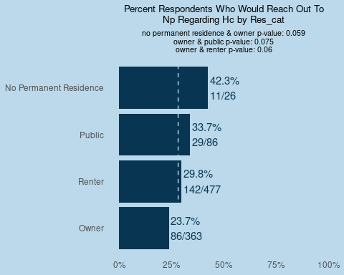

##   
## $lr_hc_np$boost_bi  
## NULL  
##   
## $lr_hc_np$mntl_hlth_bi  
## NULL  
##   
## $lr_hc_np$mntl_hlth_state_bi  
## NULL