**To:** <<CLIENT NAME>>

**From:** <<GREENBRIER>>

**Re:** Competitor Media Analysis

**Date:** <<DATE>>

This competitor analysis provides a comprehensive review of earned media coverage from <<ANALYZED DATE RANGE>> focusing on <<WHAT ARE YOU LOOKING TO GAIN FROM THIS REPORT>>. We selected the <<NUMBER OF COMPETITORS>> based on <<WHY DID YOU INCLUDE THESE COMPETITORS>>.

<<EXECUTIVE SUMMARY>>

# Competitors Analyzed

* *<<Competitor 1>>*
* *<<Competitor 2>>*
* *<<Competitor 3>>*
* *…*

## Metrics

* **Mentions**: A numeric quantification of the mentions of each entity noted above across digital, print and broadcast media during the defined period. Note: This includes all general news outlets and trade publications, but does not include news aggregators, wire services, or market research reports.
* **Mentions Spikes:** Instances of high-volume coverage on a certain date, often related to one story or press release being syndicated across multiple outlets.
* **Sentiment:** Identification of positive, negative or neutral coverage which can be used to identify whether a journalist may provide favorable or problematic coverage of future news.
  + Sentiment is determined by natural language processing algorithms that assign tonality to a mention by analyzing keywords or phrases used within the article.
* **Share of Voice:** Indicates the percentage of total conversation about a brand compared to the conversation about its competitors, emphasizes brand awareness.
* **Social Echo:** Helps understand the virality of news coverage; computed by adding the number of posts, shares, retweets, interactions across social media.
* **Reach:** Estimated potential viewership of a specific article based on the number of monthly unique visitors to the outlet.

## Key Findings

* <<Key Finding 1>>
* <<Key Finding 2>>
* <<Key Finding 3>>
* …

# 

**Most Engaged Articles: VC Firms**

<<OUTLET>>, <<AUTHOR>> : <<ARTICLE HEADLINE HYPERLINKED WITH URL TO ARTICLE>>

* Mentions: COMPETITORS INCLUDED IN ARTICLE ALONGSIDE CLIENT
* <<REACH VALUE>>, <<SOCIAL ECHO>>, <<NUMBER OF SYNDICATIONS>>

# COMPETITIVE ANALYSIS

## Mention Volume By Company

<<INSERT GRAPH IMAGE OF MENTIONS BY VOLUME>>

*Volume of Mentions in Earned Media Coverage for Competing Firms: Blogs, News and Broadcast Mentions (ANALYZED DATE RANGE)*

## Share of Voice by Mentions

<<INSERT GRAPH IMAGE OF SHARE OF VOICE BY MENTION>>

## 

*Share of Voice in Earned Media Coverage for Competing Firms: Blogs, News and Broadcast Mentions (ANALYZED DATE RANGE)*

## Sentiment

<<INSERT GRAPH IMAGE OF SENTIMENT>>

*Sentiment for Competing Firms in Relation to US-China Relations: Blogs, News and Broadcast Mentions (ANALYZED DATE RANGE)*

## Top Keywords for HSG

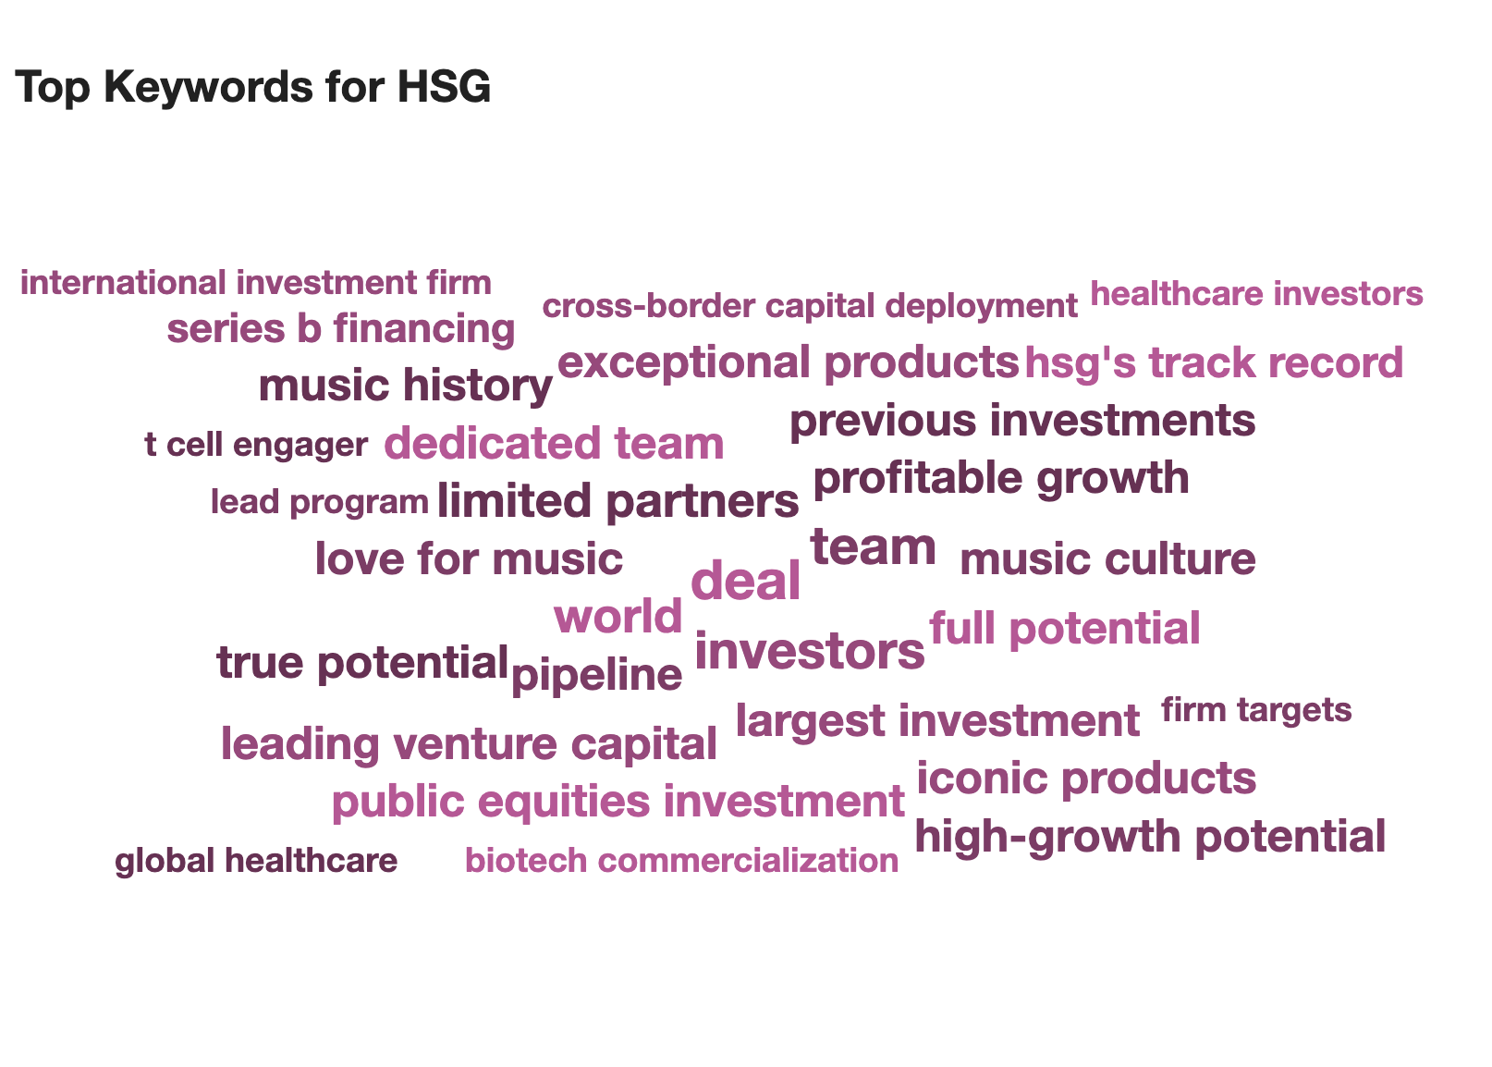

## Appendix

**Comparison At-a-Glance**

|  |  |  |  |  |
| --- | --- | --- | --- | --- |
| **Competitor** | **Total Mentions** | **Positive Mentions** | **Neutral Mentions** | **Negative Mentions** |
| <<COMPETITOR 1>> | CORRESPONDING VALUE FROM GRAPH | CORRESPONDING VALUE FROM GRAPH | CORRESPONDING VALUE FROM GRAPH | CORRESPONDING VALUE FROM GRAPH |
| <<COMPETITOR 2>> | CORRESPONDING VALUE FROM GRAPH | CORRESPONDING VALUE FROM GRAPH | CORRESPONDING VALUE FROM GRAPH | CORRESPONDING VALUE FROM GRAPH |
| <<COMPETITOR 3>> | CORRESPONDING VALUE FROM GRAPH | CORRESPONDING VALUE FROM GRAPH | CORRESPONDING VALUE FROM GRAPH | CORRESPONDING VALUE FROM GRAPH |