AE-251 LAB-5

# Mataria Pence Jagatkumar

# 170382 | [pencem@iitk.ac.in](mailto:pencem@iitk.ac.in)

5th February 2019

**Experiment-1: Strain Gauge**

**OBJECTIVE**

To measure strain using a strain-gauge.

**INTRODUCTION**

A strain gauge takes advantage of the physical property of electrical conductance and its dependence on the conductor's geometry. When an electrical conductor is stretched within the limits of its elasticity such that it does not break or permanently deform, it will become narrower and longer, which increases its electrical resistance end-to-end. Conversely, when a conductor is compressed such that it does not buckle, it will broaden and shorten, which decreases its electrical resistance end-to-end. From the measured electrical resistance of the strain gauge, the amount of induced stress may be inferred.

**APPARATUS**

* Strain-Gauge
* Weights
* Beam

**PRINCIPLE**

Whenever load is applied, the strain is defined as the ratio of change in length to original length. Strain Gauge sensors are of two types: wire type & metal foil type.

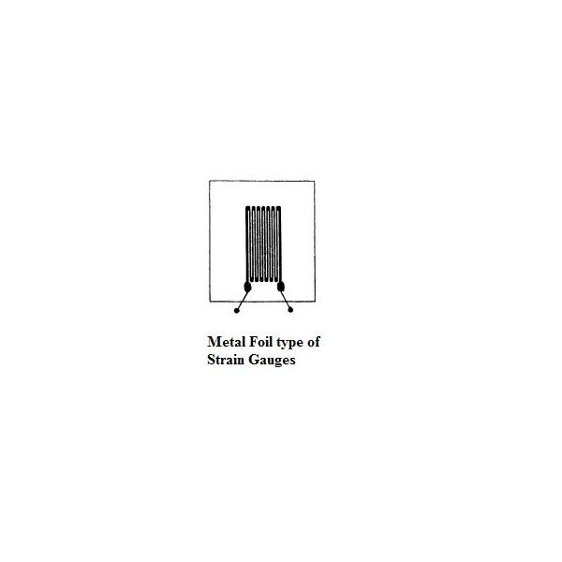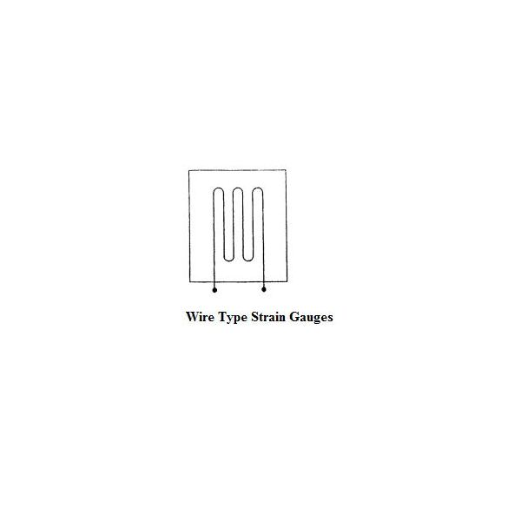

*\*image source:* Book: Measurement and Instrumentation Principles by Alan S. Morris. Figure 13.5

**PROCEDURE**

* Setup the sensors on a cantilever beam, one in middle and other near the support.
* Take Zero Reading of strain-gauge with zero load.
* Increase weights by 200gm. up to 800 gm. and take readings.
* Also take readings while unloading the weights.

**OBSERVATION**

|  |  |  |  |  |
| --- | --- | --- | --- | --- |
| **Load (gm)** | **Strain**  **(Loading)** | **Strain**  **(Unloading)** | **Average** | **Strain**  **(with zero error removed)** |
| 0 | -17 | -10 | -13.5 | 0 |
| 200 | 84 | 93 | 88.5 | 102 |
| 400 | 180 | 192 | 186 | 200 |
| 600 | 273 | 280 | 276.5 | 290 |
| 800 | 364 | 364 | 364 | 378 |

Slope= 0.472

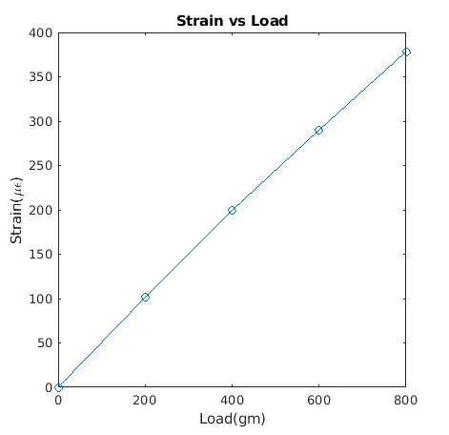

**CONCLUSION**

We understood the working of strain-gauge and how to measure strain using the strain-gauge sensor. The obtained plot is nearly linear with slope of 0.472. We also admired the accuracy of the strain-gauge sensor.

**Experiment-2: Load Cell**

**OBJECTIVE**

To measure the weight using Load cell.

**INTRODUCTION**

Load cells are widely used to measure load or weights. They are usually found in the weighing machines. They generally consists of spring element made of steel or aluminum on which strain gauge is placed, so that they are sturdy yet slightly elastic and hence can be deformed. They are mainly of following types:

* Single point load cells: a load cell is located under a platform that is loaded with a weight from above
* Bending beam load cells: several load cells are positioned under a steel structure and are loaded with a weight from above
* Compressive force load cells: several high-capacity load cells are positioned under a steel structure that is loaded with a weight from above
* Tensile load cells: a weight is suspended from one or more load cells

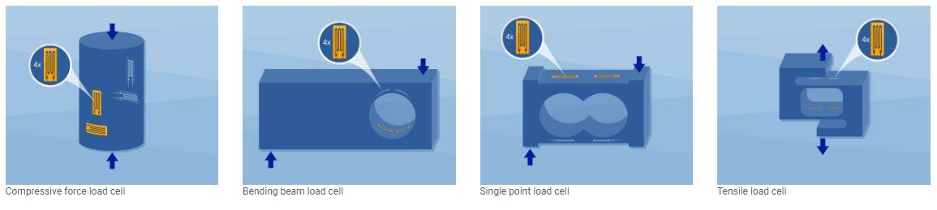

**CONCLUSION**

We learned about the working of load cell and measured load using S type load cell.

*\*image source: https://www.hbm.com/en/6768/what-is-a-load-cell-and-how-does-a-load-cell-work/*

**Experiment-3: Controlling Stepper motor using RT-FPGA**

**OBJECTIVE**

To control stepper motor using FPGA and motor module.

**INTRODUCTION**

*Stepper Motor*

A stepper motor or step motor or stepping motor is a brushless DC electric motor that divides a full rotation into a number of equal steps. The motor's position can then be commanded to move and hold at one of these steps without any position sensor for feedback (an open-loop controller), as long as the motor is carefully sized to the application in respect to torque and speed.

*RT-FPGA (Real Time-Field Programmable Gate Array)*

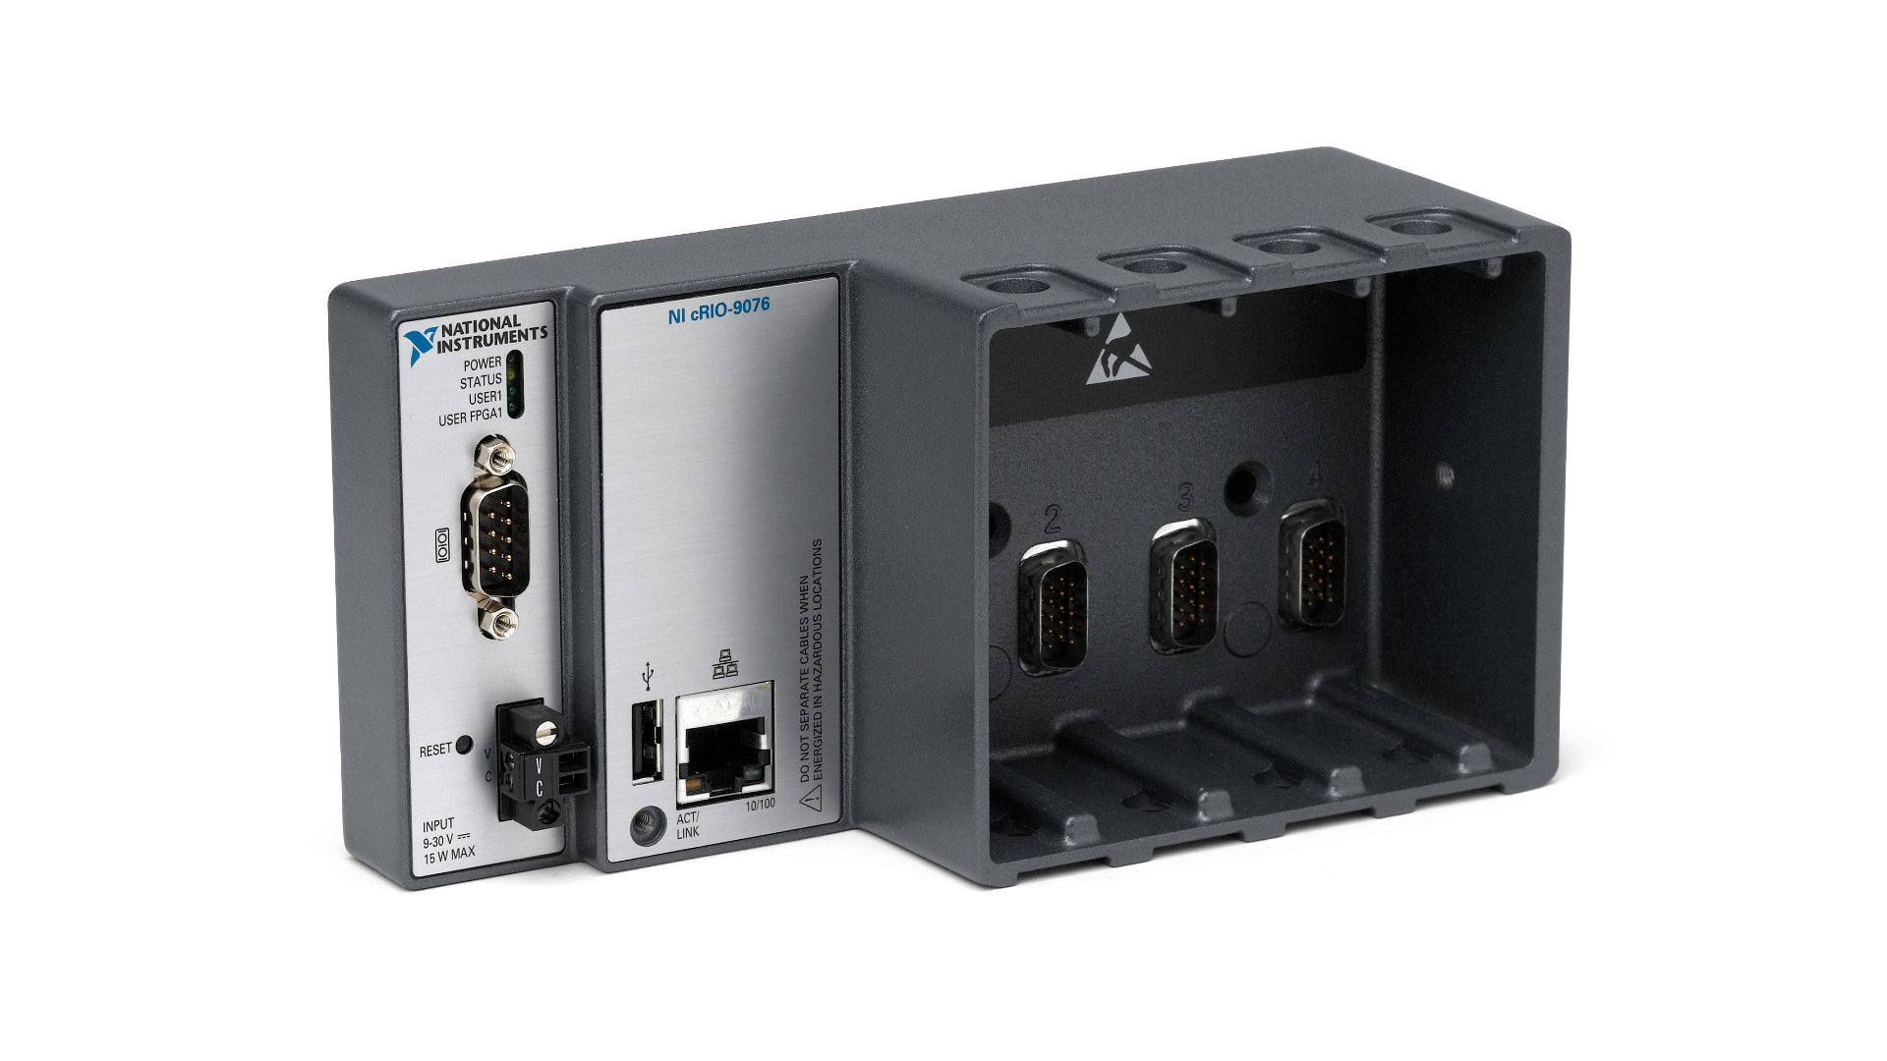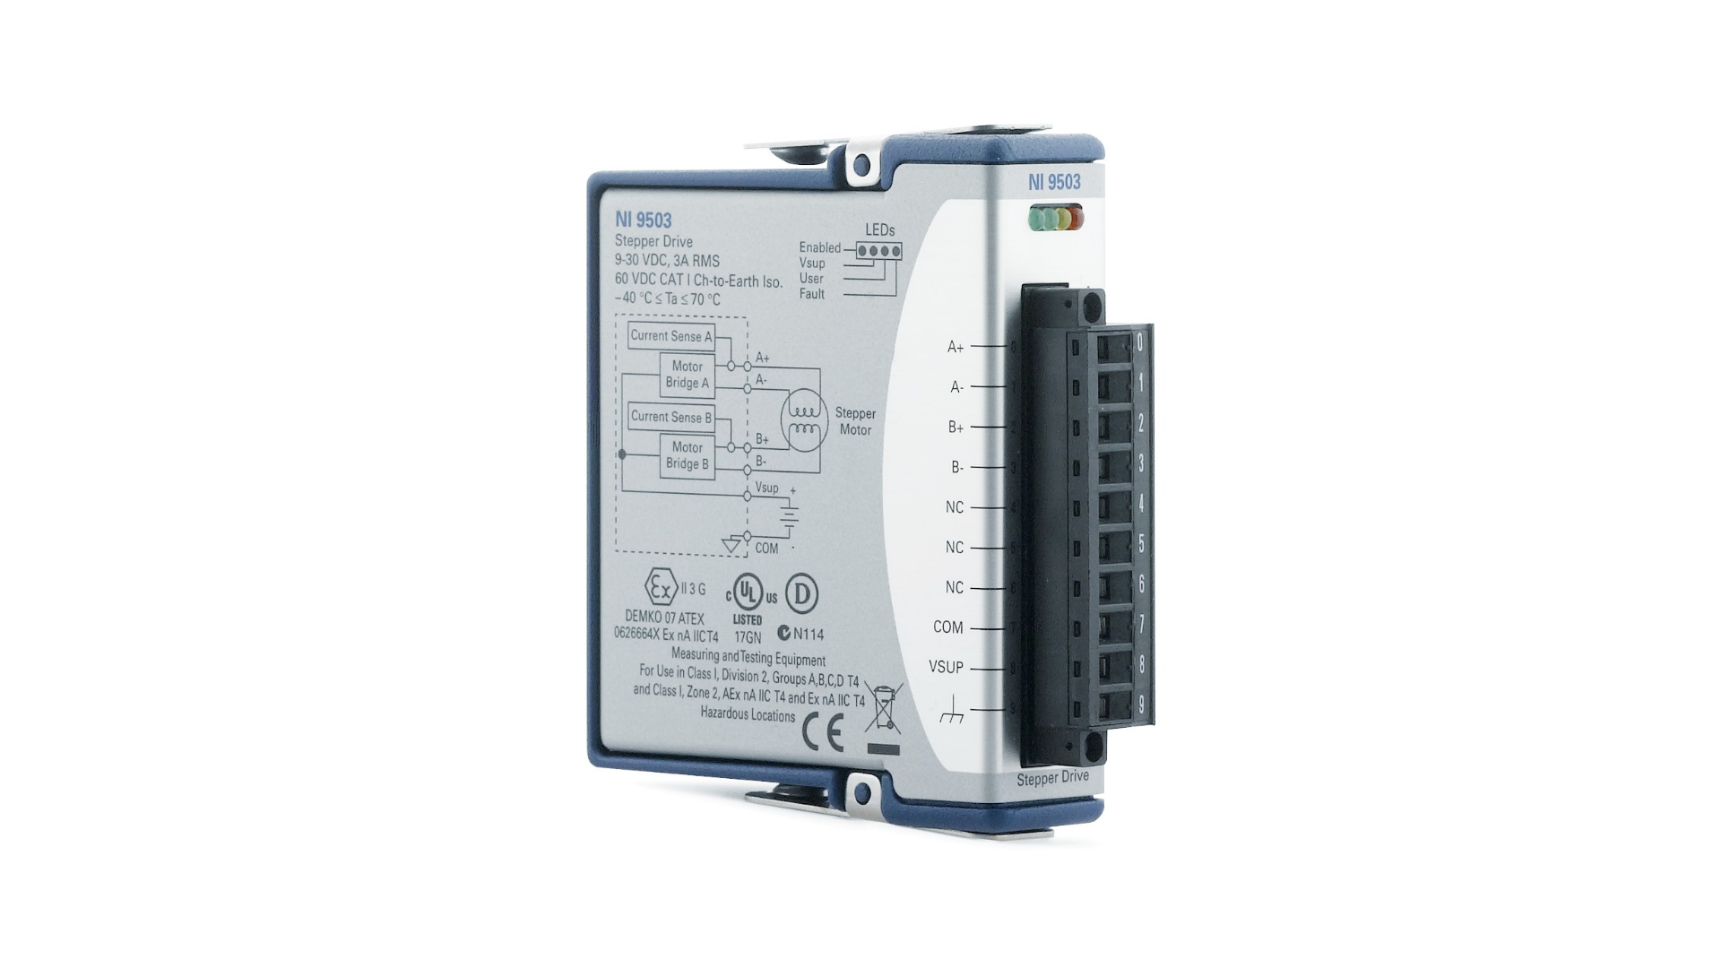FPGAs contain an array of programmable logic blocks, and a hierarchy of reconfigurable interconnects that allow the blocks to be "wired together", like many logic gates that can be inter-wired in different configurations. Logic blocks can be configured to perform complex combinational functions, or merely simple logic gates like AND and XOR. In most FPGAs, logic blocks also include memory elements, which may be simple flip-flops or more complete blocks of memory.[1] Many FPGAs can be reprogrammed to implement different logic functions,[2] allowing flexible reconfigurable computing as performed in computer software.

VI Program to control

Stepper motor using

FPGA

FPGA

Board

Stepper Motor

Module

Computer

CRIO-9076

Chassis

NI 950I

Stepper Motor