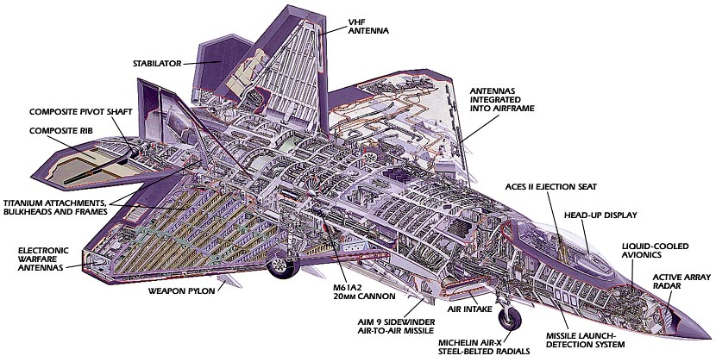

F22-HORNET

**WINGS**

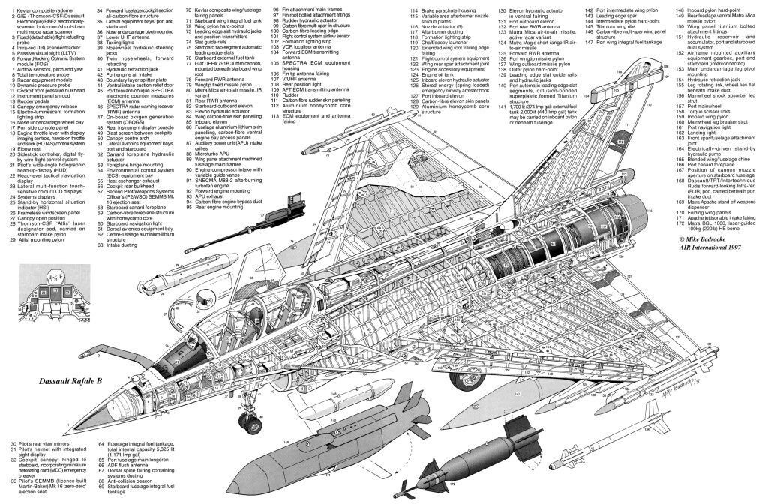

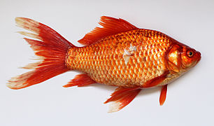

FISH

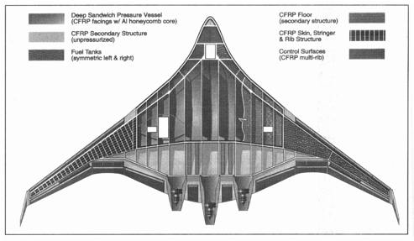

BLENDED WING UAV

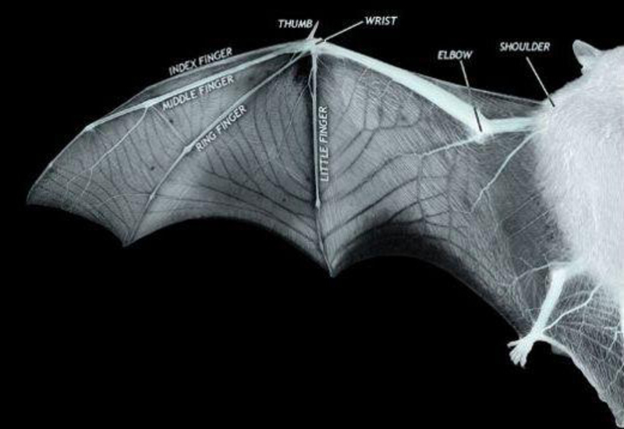

BAT – MODIFIED HAND

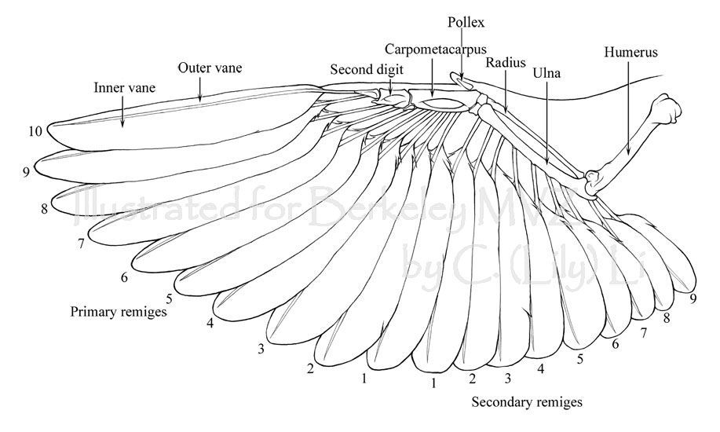

BIRD WING

**Assignment # 1**: Observe and compare the structural feature of the different wing profiles. Answer the following:

1. Explain through a TECHNICAL essay, why the delta wing structure is the way it is, i.e. number, position and dimensions of spars and ribs.
2. Why would evolution lead to such a design of bat wings, or bird wings.
3. The blended wing UAV design seems to be a bit different. Can you think out why?

* Each part should be on separate set of pages. It can be typed, if you so wish…
* Due date: 13/8/19