# Mataria Pence Jagatkumar

# 170382

### Assignment -1

Question -1

**Explain through a TECHNICAL essay, why the delta wing structure is the way it is, i.e. number, position and dimensions of spars and ribs**

* Delta wing structure have a large root chord, and thus it provides a lightweight structure (a prime necessity for design of airframe) by combining a thick wing spar to a low relative wing thickness, this relatively thin wings are required for a supersonic regime aircraft to keep its *wave drag* as low as possible.
* Also a larger root chord ensures large volumes with low thickness, thus increasing the fuel storage capacities.
* The leading edge sweep helps in generating *vortex lift* , and lowers the vortex drag.
* This features makes it pitch stable and thus eliminating the tail requirement.
* To Preserve the shape, Ribs are also aligned in the fashion of increasing sweep.
* 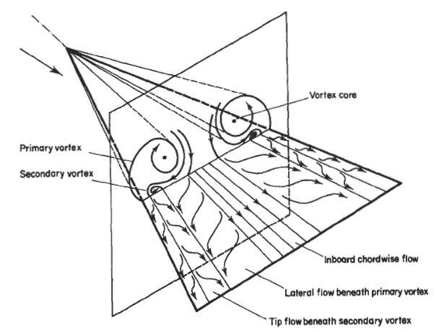To provide torsional rigidity the spars are kept perpendicular to the leading edge.
* This structure also helps in providing rigidity against the vortices generated.

Source: Aviation Stackexchange

* The number depends on load of the aircraft and the speed regimes.
* Different structures of delta have different arrangements as per geometric design, eg. Canard Delta.

Question -2

**Why would evolution lead to such a design of bat wings, or bird wings.**

* The Birds/bats wings are evolved to provide thrust as well as lift, the stitching of feathers gives the required airfoil shape for lift. The bones and joints help to change the angle of attack. The first digit alula can be raised to provide gap and thus decrease the turbulence effects. The Primary feathers are important for flapping flight, which is required for thrust generation during downstroke, and on the upstroke they are rotated to lower down the air resistance. The secondary feathers maintain the airfoil shape and thus have primary function of generating the lift. Apart from these there are various other organs with functions of changing the span, aspect ratio and planform during the flights. These creatures have hollow bones and the respiratory system has also evolved and adapted to provide flight. Certain kinds of birds have hovering capabilities and few long-range birds have evolved with longer wings for gliding.
* Bats have a stretchable wing structure which can bend and curve to provide various stages of flights, this has proved to be more efficient in generating lift. The vortex pattern in the bat wing also provides a positive contribution in lift, something similar to flying wing aircrafts. This membrane wing allows bats to fully control the 3D shape of the wing and thus also allowing them to have a flip landing.

Question -3

**The blended wing UAV design seems to be a bit different. Can you think out why?**

* The Blended wing aircrafts have no distinct boundary/line between joining of fuselage and wing. The wing and body are smoothly blended together.
* The main advantage is to reduce wetted area and thus minimizing skin drag and drag due to wing-aircraft junction. The wing root increase and thus lesser spar-weight and length of the wing.
* It produces lower noise as compared to conventional aircrafts.
* It generally provides more wing loading and fuel efficiencies.
* However they are difficult to manufacture and the overall drag doesn’t significantly reduce and thus are used for a very specific purposes.