AE351 Experiments in Aerospace Engineering



Experiment-P1

Study and calibration of

Pressure sensor and Flow meter

(1-2-2020)

By:

Mataria Pence Jagatkumar

170382 | B9

**OBJECTIVE**

To study different types of pressure sensor and flow meter, and to:

1. Calibrate the Differential Pressure sensor.

2. Characterize the different flow meters (Orifice, Nozzle, and Venturi).

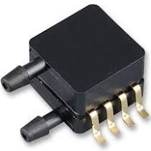**INTRODUCTION & THEORY**

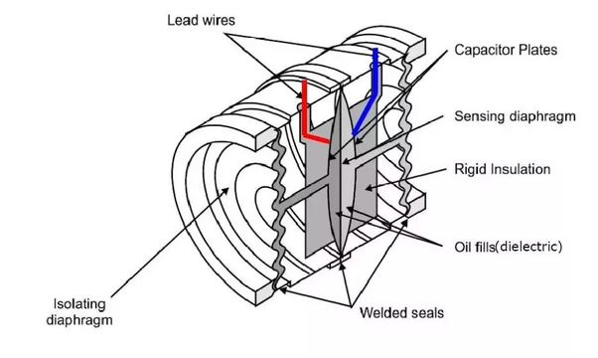

* Pressure is a vital parameter in fluid mechanics. It is defined as the force per unit area. Based on the pressure difference it is generally classified into three types:
  + Absolute Pressure: The actual Pressure exerted at any point in space.
  + Gauge Pressure: The pressure relative to the atmospheric pressure at a given altitude and temperature.
  + Differential Pressure: The difference in pressure between two points.
* Various instruments used to measure linear, nonlinear, mass or volumetric flow rate/pressure of a liquid or a gas. Differential pressure flowmeters use Bernoulli’s equation to measure the flow of fluid in a pipe. Bernoulli’s equation states that the pressure drop across the constriction is proportional to the square of the flow rate. The pressure difference is measured with the change in height of fluid column across a constriction such as orifice, venturi or a nozzle.
* The Differential Pressure sensors are used for more accurate and robust measurement of the pressure. They work by measuring the difference in pressure across a diaphragm using a strain gauge thin-film resistor network or differential capacitance sensors. One side of the diaphragm is connected to the "low pressure port" and the other side of the diaphragm to the "high pressure port". The diaphragm flexes and is sensed as an electrical signal that is proportional to the difference in the two pressures.
* Thus, to measure accurate pressure differences, the calibration of these sensors is required in order to provide the correct factor to relate the voltage change registered to the pressure value.
* The Pitot tube works on the same principle, connected to static pressure port and total pressure port; The difference is measured by the differential pressure sensor and accurate velocity head is obtained.
* Formulas Used:

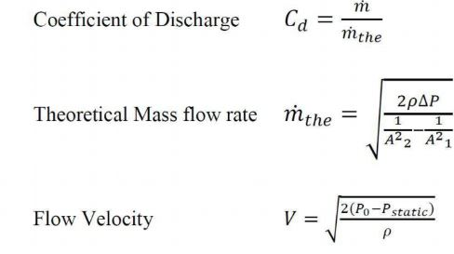

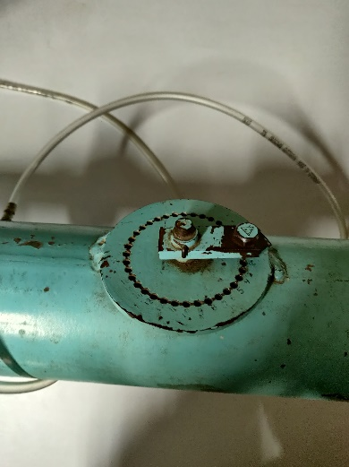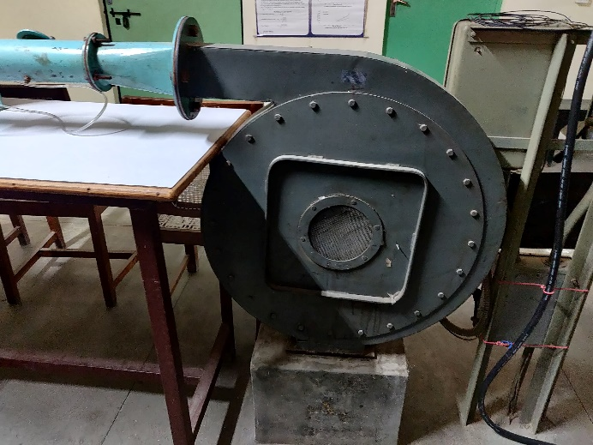**EQUIPMENT USED**

* Experimental Setup: The open-circuit low speed wind tunnel consists of a centrifugal blower driven by an electric motor. The blower draws in air from the atmosphere and discharges through the pipe. The butterfly valve located downstream of the blower is used to control the mass flow rate. The flow meters are fixed downstream of the valve in the order as shown in the figure. The velocity profile is determined at the exit, which is used for calculating the mass flow rate. A valve is attached as shown to control the flow rate
* 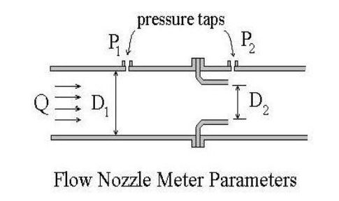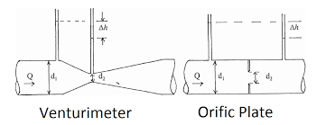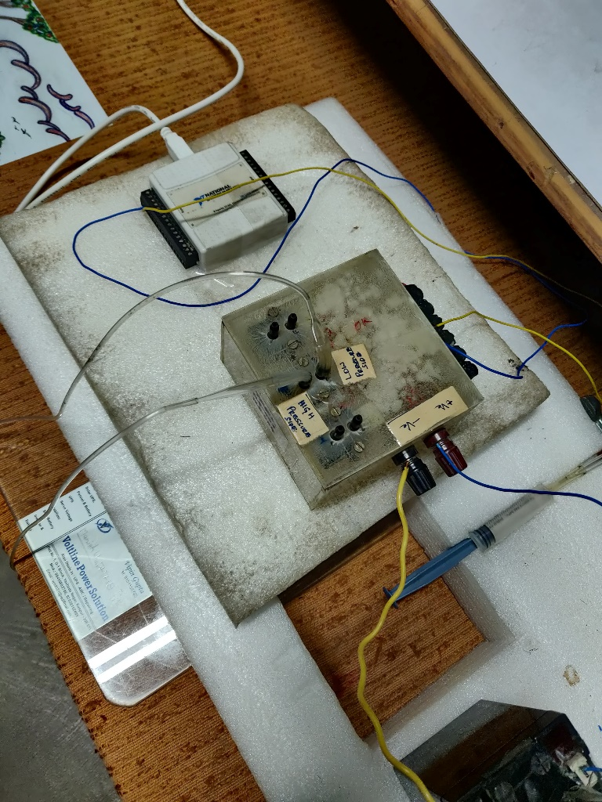Differential Pressure Sensor: An electronic differential pressure sensor is used to determine the pressure drop across flow-meters. An electronic differential pressure sends an electronic signal (DC voltage) based on the pressure difference between the two ports connected to it. For the present experiment one sensor of 0 to 7.25 psi range, three sensors of 0 to 14.5 psi range is used. The data is read through a Data Acquisition Board (DAB) into a VI.
* Venturi Meter: The entrance to a venturi meter is a converging cone with a 15° to 20° angle. It converges down to the throat, which is the point of minimum cross-sectional area, maximum velocity, and minimum pressure in the meter. The exit portion of the meter is a diverging cone with an angle of 5° to 7°, which completes the transition back to full pipe diameter. The diagram on the top shows a typical venturi meter configuration with the parameters, D1,D2,P1 and P2 identified. Because of the smooth gradual transition down to the throat diameter and back to the full pipe diameter, the friction loss in a venturi meter is quite small. This leads to the value of a venturi meter discharge coefficient, C, being nearly one. Typical discharge coefficient values for a venturi meter range from 0.95 to as high as 0.995.
* Orifice Plate: The orifice meter is the simplest of the three types of differential flow meters being considered here. It is just a circular orifice plate with a hole in the middle, usually held in place between pipe flanges, as shown in the figure at the bottom. Because of the abrupt constriction at the orifice plate in an orifice meter, it has more frictional head loss than a venturi meter and a lower value for its discharge coefficient, Cd.
* 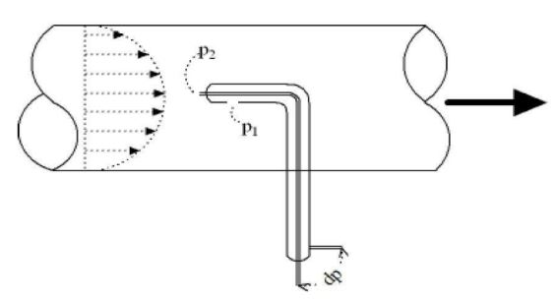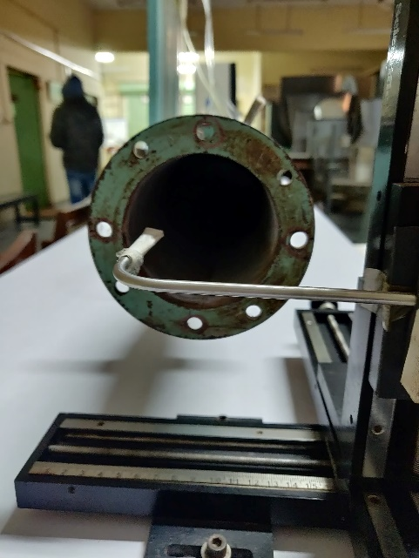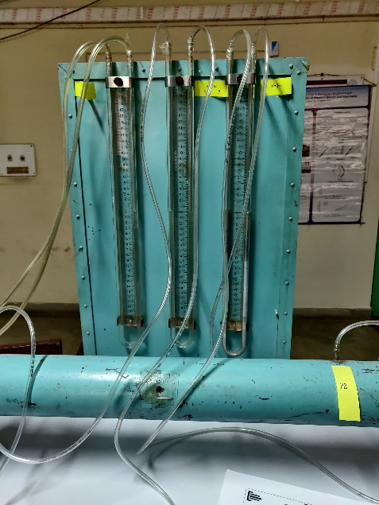Nozzle meter: A nozzle flow meter consists of a short nozzle, usually held in place between two pipe flanges as shown in the diagram at the left. It is simpler and less expensive than a venturi meter, but not as simple as an orifice meter. The frictional loss in a nozzle flow meter is much less than in an orifice meter, but higher than in a venture meter. A typical nozzle flow discharge coefficient value is between 0.93 and 0.98.
* Manometers: Manometers with water and Mercury column for visualizing height difference due to differential pressure.
* Pitot Tube: Pitot tubes can be used to indicate fluid flow velocities by measuring the difference between the static and the dynamic pressures in fluids. A pitot tube can be used to measure fluid flow velocity by converting the kinetic energy in a fluid flow to potential energy.

**PROCEDURE & MEASUREMENTS**

1. Familiarize with the basic principles of Data Acquisition.
2. Note down the ambient temperature and pressure.
3. Calibration of Pressure sensor:

a) Connect the high pressure port of pressure sensor to the calibrator via T-joint and leave the other port of the pressure sensor open to the atmosphere.

b) Obtain the output voltage from the sensor at different pressures applied using the hand pump.

c) Using the acquired data, find the best fit curve (One degree in single variable), which defines the calibration equation for the sensor.

1. Calibration of Flow meter:

a) Connect the pressure taps of flow meters to the pressure sensors using rubber tubes.

b) Switch on the tunnel and set the mass flow rate using the butterfly valve.

c) After steady state is reached, obtain the pressure data from the sensors.

d) Traverse the pitot probe vertically, to determine the velocity profile across the cross-section of the pipe. Use this profile to determine the mass flow rate of air in the pipe.

e) Repeat the above two steps for different flow rates.

**RESULTS & DISCUSSION**

* Flow Meter (Diameter)
  + Orifice: 50 mm (Outer: 78 mm)
  + Nozzle: 48 mm (Outer: 78 mm)
  + Venturi:
    - Outer: 82.61 mm
    - Throat: 43.4 mm
* Readings for Pressure sensor calibration

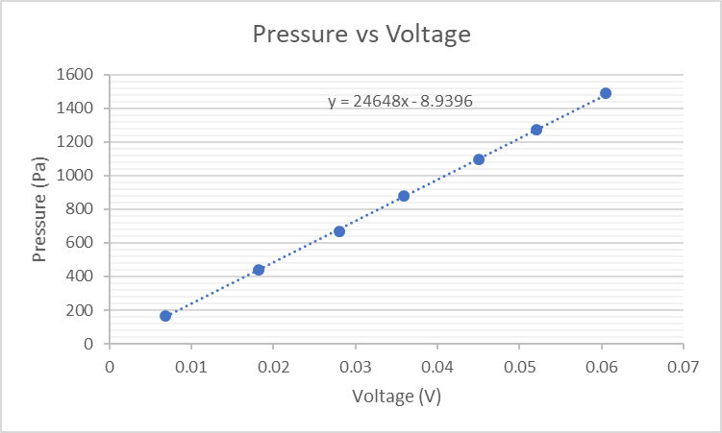

Calibration Equation: **P = 24648(V) – 8.9396**

* Flow Meter
  + Manometer Readings
  + Experimental Mass Flow Rate (with Formula)
  + 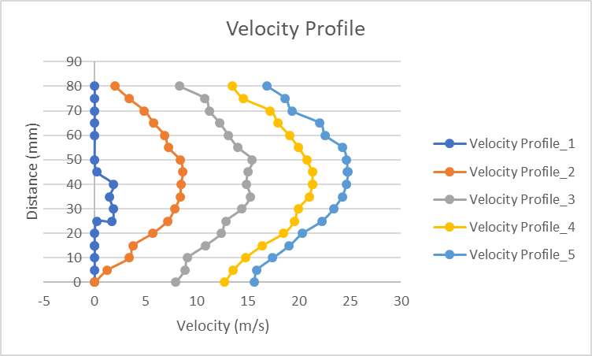Velocity Profile / Theoretical Mass Flow Rate (with velocity at exit)
  + Theoretical Mass Flow Rate
  + Coefficient of Discharge (Cd)

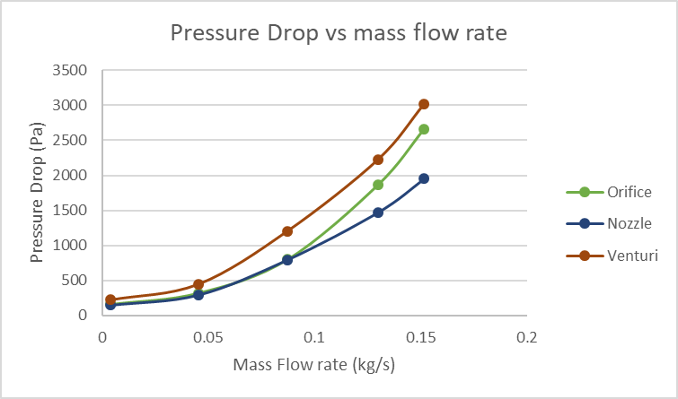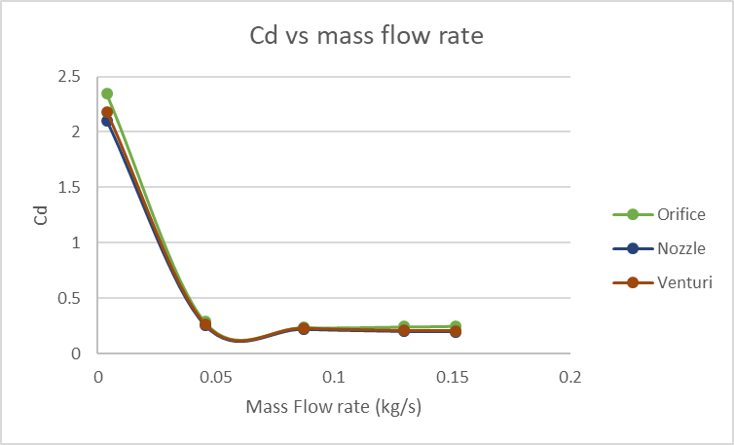

**RESULT ANALYSIS**

* Error
* Sources of Error
  + Inconsistencies of pressure sensor over the years
  + Non Uniform flow rate
  + Viscosity of fluid inside manometer
  + Leakage of air through connecting Pipes
* Precautions
  + Ensure Proper readings while noting manometer data
  + Correct the zero errors if any
  + Gently handle the pitot tube
  + Regularly maintain all the instruments

**CONCLUSION**

The experiment was successfully carried out and the values found resembles the true values to acceptable extent.

**DISCUSSION**

1. **Explain the difference between Absolute, Gauge and Differential Pressure.**
   1. **Absolute Pressure** a perfect vacuum as its reference. This type of pressurereference is the gauge pressure of the media plus the pressure of the atmosphere. As locations change, especially when dealing with elevation changes, the reference point can change because of atmospheric pressure differences. Using an absolute pressure sensor eliminates the reference to a varying atmospheric pressure and relying on a specific pressure range for reference.
   2. **Differential Pressure ​**can be a little more complex than gauge or absolute, butis simply measuring the difference between two medias. Although most gauge pressures are technically a differential pressure sensor—measuring the difference between the media and atmospheric pressure—a true differential pressure sensor is used to identify the difference between the two separate physical areas. For example, differential pressure is used to check the pressure drop—or loss—from one side of an object to the other.
   3. **Gauge Pressure ​**uses a reference to the atmosphere around the sensor. Becausethe sensing element has a deflection due to a pressure change, a reference point is needed to know exactly what pressure is being measured. Pressure sensors that use gauge pressure—typically seen in PSIG, BARG, and kPaG —have some type of vent. This vent can be built in to the sensor or even through a tube in the electrical connection. The vent is positioned to use atmospheric pressure as a reference point for the sensor to measure the media. One common reason for using gauge pressure is to ensure that with any location throughout the world, the sensor will always reference the location in which it is installed.
2. **Explain difference between Piezoresistive strain, Capacitive, Electromagnetic, Piezoelectric, Optical, pressure sensing technology.**
   1. ***Piezoresistive strain gauge:*** Uses the piezoresistive effect of bonded or formedstrain gauges to detect strain due to applied pressure, resistance increasing as pressure deforms the material. Common technology types are Silicon (Monocrystalline), Polysilicon Thin Film, Bonded Metal Foil, Thick Film, and Sputtered Thin Film. Generally, the strain gauges are connected to form a Wheatstone bridge circuit to maximize the output of the sensor and to reduce sensitivity to errors. This is the most commonly employed sensing technology for general purpose pressure measurement.
   2. ***Capacitive:*** Uses a diaphragm and pressure cavity to create a variable​[capacitor](https://en.wikipedia.org/wiki/Capacitor)​todetect strain due to applied pressure, capacitance decreasing as pressure deforms the diaphragm. Common technologies use metal, ceramic, and silicon diaphragms.
   3. ***Electromagnetic:*** Measures the displacement of a diaphragm by means of changesin ​[inductance](https://en.wikipedia.org/wiki/Inductance)​(reluctance), ​[LVDT](https://en.wikipedia.org/wiki/LVDT)​, ​[Hall Effect](https://en.wikipedia.org/wiki/Hall_Effect)​, or by ​[eddy current](https://en.wikipedia.org/wiki/Eddy_current)​principle.
   4. ***Piezoelectric:*** Uses the[​piezoelectric](https://en.wikipedia.org/wiki/Piezoelectric)​effect in certain materials such as quartz tomeasure the strain upon the sensing mechanism due to pressure. This technology is commonly employed for the measurement of highly dynamic pressures.
   5. ***Optical:*** Techniques include the use of the physical change of an optical fiber to

detect strain due to applied pressure. A common example of this type utilizes ​[Fiber](https://en.wikipedia.org/wiki/Fiber_Bragg_Grating) [Bragg Gratings](https://en.wikipedia.org/wiki/Fiber_Bragg_Grating)​. This technology is employed in challenging applications where the measurement may be highly remote, under high temperature, or may benefit from technologies inherently immune to electromagnetic interference. Another analogous technique utilizes an elastic film constructed in layers that can change reflected wavelengths according to the applied pressure (strain).

1. **Coefficient of Discharge**

Coefficient of discharge is stated as the ratio between the actual flow discharge and theoretical flow discharge. It is also referred to as the ratio of mass flow rate at nozzle's discharge edge to the standard nozzle which enlarges an exact working fluid maintained at the similar initial conditions and pressures.

It has no dimensions and depends directly on the rate of flow and velocity of working fluid. It is symbolized by Cd and its value is different for each fluid depending on the kind of measurement of flow. In nozzle flow measurement, the efficiency of Cd is higher when compared to the flow measurement at the orifice. The discharge coefficient is raised by increasing the overall pressure ratio and reducing the convergence semi angle. This parameter is useful for determining the irrecoverable losses associated with a certain piece of equipment in a fluid system, or the "resistance" that piece of equipment imposes upon the flow.