AE351 Experiments in Aerospace Engineering



Experiment-P2

Experimental investigations on

premixed LPG-air flame

(7-2-2020)

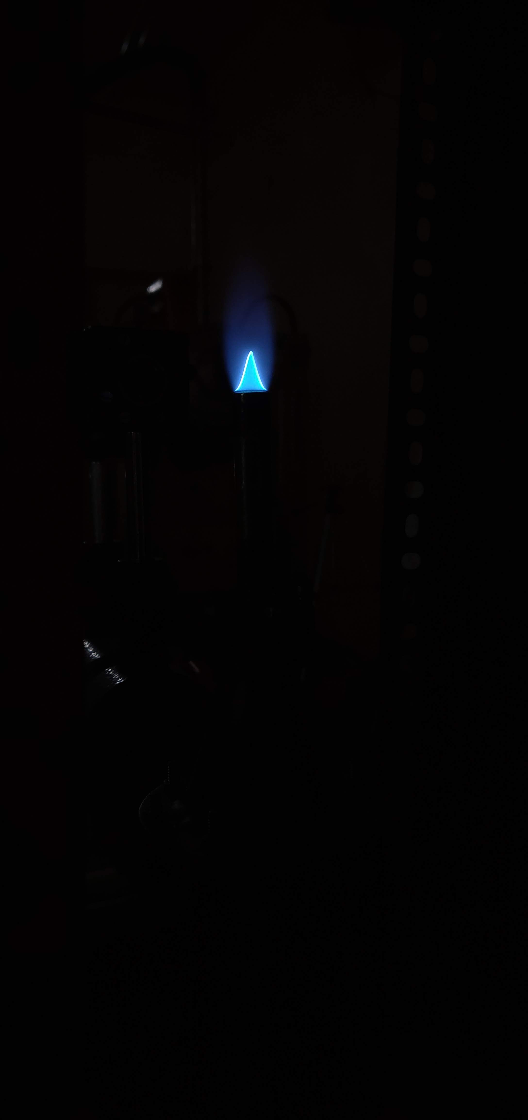

By:

Mataria Pence Jagatkumar

170382 | B9

**OBJECTIVE**

1) To determine 2-D temperature parallel to the flame front.

2) Spectroscopic analysis using Avast spectrometer.

3) Qualitative analysis using Shadow graphic techniques.

**INTRODUCTION & THEORY**

* Flame is the result of an exothermic reaction and is associated with emission of heat and light. They are of two types: Premixed (oxidizer+fuel eg. stove flame) and Diffusion (where oxidizer merges with fuel by molecular diffusion eg. Candle).
* One of the objectives is to study the temperature pattern of the flame; for this purpose, we need a device by which we can measure the temperature of the flame. This is done with the help of a thermocouple. Fine gage S-Type thermocouples are made of Pt-10%Rh/Pt, which are used when fast, accurate temperatures are required (response time of 0.08 sec); however due to high cost we will use slightly higher thickness thermocouple with response time of 50 sec. They work on the principle of emf being generated by the free electron movement in two different metals across the junctions (seebeck effect). The thermocouple emf to temperature relation is found after the calibration process for which, a Nagman’s Temperature calibrator, is used which is of Model 1200HN is a semi-portable, multi hole, dry block type, high Temperature Calibrator which can generate temperature up to 1200K (However due to time constraints a self DAC integrated thermocouple was used which directly provides the temperature value).
* Rotameters are used to control the volumetric flow rate of the air as well as LPG into the burner. By changing these and their pressures, the flame can be tweaked. They contain an object called float by which the flow rate is measured after balance of momentum forces, gravity forces and buoyancy forces.
* The flames have different emission spectra based on the molecules being decomposed (refer appendix). The wavelength of the flame spectrum can be visualized by a spectrometer. Higher scope count (>59000) wavelengths are the most dominating in the emission spectrum.
* The shadowgraph image of the flame is generated using low intensity Diode-pumped-Solid-State LASER which is operating with 220V AC at 50Hz, which can generate a beam of 100mw. This image is analyzed further to calculate the burning velocity.
* Formulas Used:
  + For Adiabatic Flame Temperature:
  + 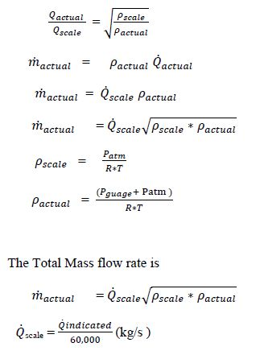For Rotameter Calculations:
  + 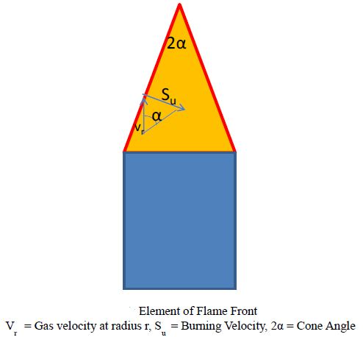Burning Velocity calculations:

Let Area of the burner mouth = A0 (Dia = 10mm)

The average flow velocity in the burner mouth = V0

The total Volume flow of gas = A0 *V0

Let total Area of the flame front, Af moving with Velocity V0

A0 *V0 = Af * Su

To Measure the surface of the Flame Front AB

* Divide it into number of sections of equal height. From Flame Photographs. The surface area of the section AF = π s (r1 + r2)

Where s is distance of AF

* If α is the half cone angle, s = h/cosα
* The area AFGC = ½ s ((r1 + r2)
* The AFBGC = Σ ½ sn (rn + rn+1)

Multiplying by 2π, flame area is calculated.

**EQUIPMENT USED**

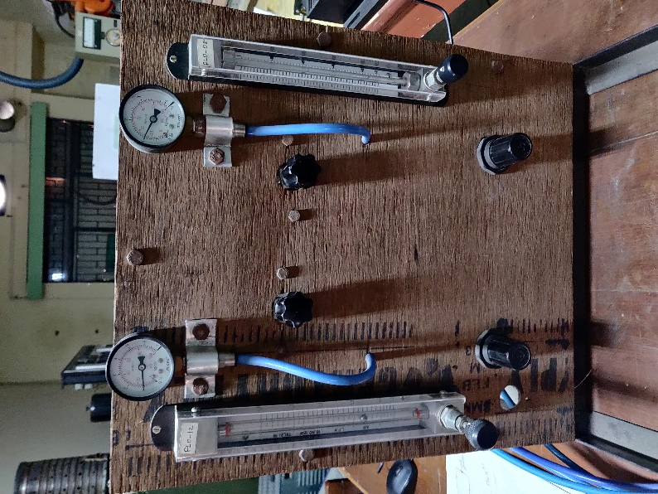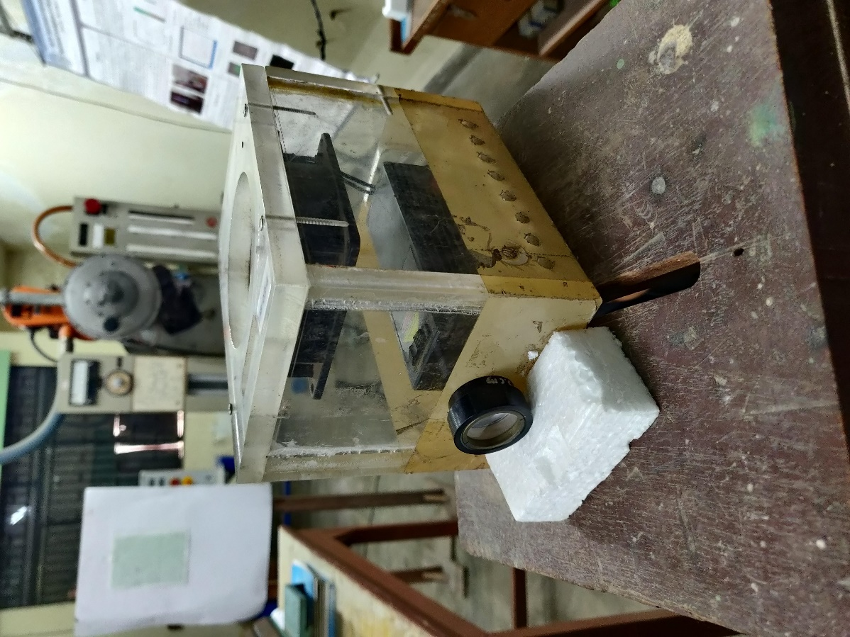

* S-Type Thermocouple
* Burner
* Rotameters
* Pressure valves
* Lenses and mirrors with bench
* Spectrometer
* Laser Diode

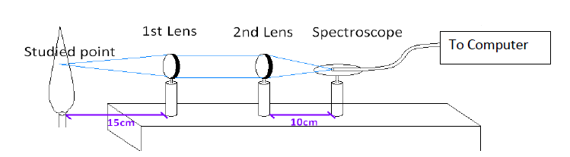**PROCEDURE & MEASUREMENTS**

1. Before starting the experiment, familiarize yourself with various components of test set as well as the instruments used for experimentation.
2. Familiarize with the basic principles of how the data is acquired using and reduced to the required values.
3. Note down the ambient temperature and pressure.
4. When the compressor and the LPG-cylinder is turned on note down the gauge pressures from the control line.
5. To understand the nature of flame, the equivalence ratio was varied right from the Fuel rich premixed flame to stoichiometric AFR to Fuel lean Premixed Flame.
6. At a unique equivalence ratio (ф=1.029), input a grid format, and move the traverse 2-Dimension along with the coordinates as given in the grid, measuring the temperature on those points.
7. Take shadow graphic images using digital camera at the equivalence ratio (ф=1.029)
8. At a point 3cm above the Burner Rim, fix the thermocouple and vary the equivalence ratio.
9. At the same point, using a stroboscope get the intensity of radicals with the change in varying equivalence ratio.

**RESULTS & DISCUSSION**

* 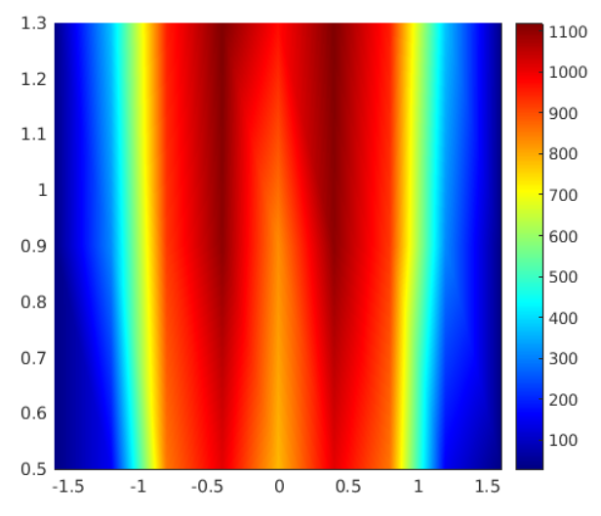2-D Temperature plot

|  |  |  |  |  |  |  |  |  |  |
| --- | --- | --- | --- | --- | --- | --- | --- | --- | --- |
|  | **-1.6** | **-1.2** | **-0.8** | **-0.4** | **0** | **0.4** | **0.8** | **1.2** | **1.6** |
| **0.5** | 30 | 150 | 855 | 1010 | 784 | 1010 | 855 | 150 | 30 |
| **0.9** | 30.4 | 310 | 922.1 | 1102 | 831.5 | 1102 | 922.1 | 310 | 30.4 |
| **1.3** | 35 | 372.5 | 950.4 | 1119.5 | 972 | 1119.5 | 950.4 | 372.5 | 35 |

* Variation of Temperature with Equivalence ratio

(Data at 30 mm above the burner rim)

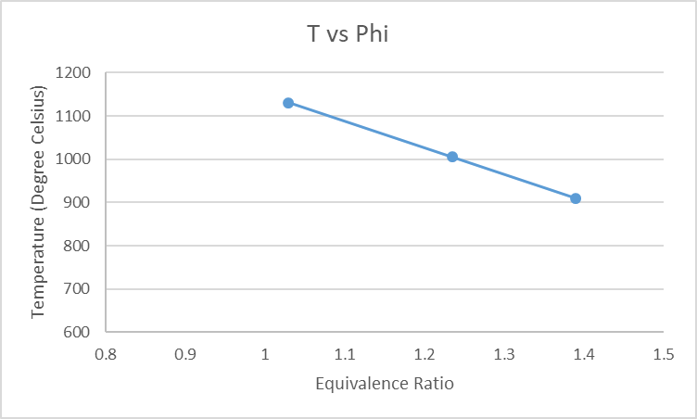

* + Calculations
    - Atmospheric Pressure (P​0​) = 101325 Pa
    - Gauge Pressure (measured from manometer)

of Air = 1 Kg/cm​2,

* + - Total Pressure of Air (P​1​) = (1 x 98066.5) + 101325

= 199391.5 Pa

* + - Gauge Pressure of LPG = 1 Kg/cm​2
    - Total Pressure of LPG (P​2​) = (1 x 98066.5) + 101325

= 199391.5 Pa

* Qindicated​ of Air = 5.5

Qscale​ of Air (Q1​) = Qindicated​​/60000 = 9.16x10-5​ Kg/s

R​air​ = 287 JKg​-1 ​K​-1​ and T = 298 K

Scaled density of Air = P​0 ​/ (R​air​ x T) = 1.18473 Kg/m​3

Actual density of Air = P​1 ​/ (R​air​ x T) = 2.33135 Kg/m​3

* Qindicated​​ of LPG = 0.2

Qscale​ of LPG (Q​2) = Qindicated​​/60000 = 3.33 x 10​-6​ Kg/s

R​LPG​ = 157.7 JKg​-1 ​K​-1​ and T = 298 K

Scaled density of LPG = P​o ​/ (R​LPG​ x T) = 2.15609 Kg/m​3

Actual density of LPG = P​2 ​/ (R​LPG​ x T) = 4.24285 Kg/m​3

* Mass of Air (*ṁ1*) = Q̇1​(ρscale*ρactual)0.5 = 1.52344 x 10​-4​ Kg/s
* Mass of LPG (*ṁ2*) = Q̇2​(ρscale*ρactual)0.5 = 1.00819 x 10​-5​ Kg/s
* Stoichiometric Ratio = 0.0643
* Equivalence Ratio (φ) = (*ṁ2*/ *ṁ1*)/stoichiometric ratio= 1.02921
* Spectrometer analysis

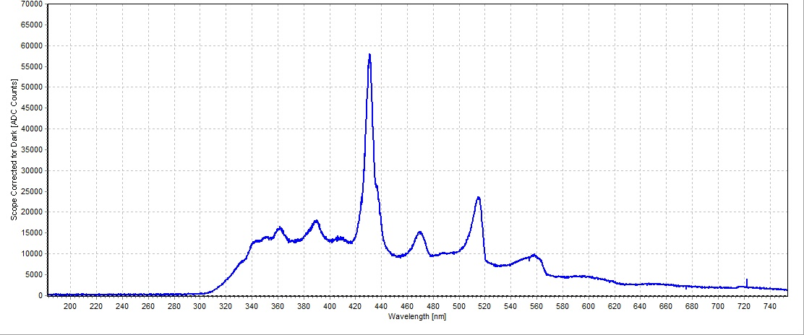

The major component of the emission spectra consists of wavelength

ranging from 420 mm to 440 mm. This corresponds to CH radicals. (Appendix)

* 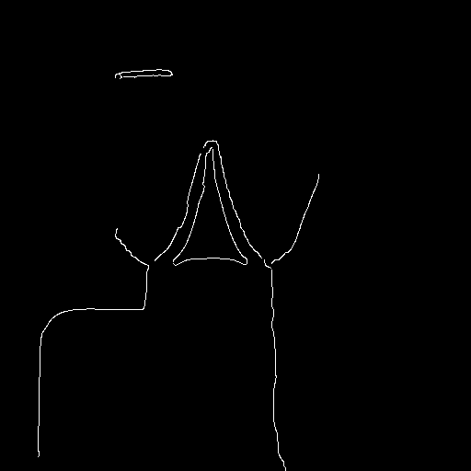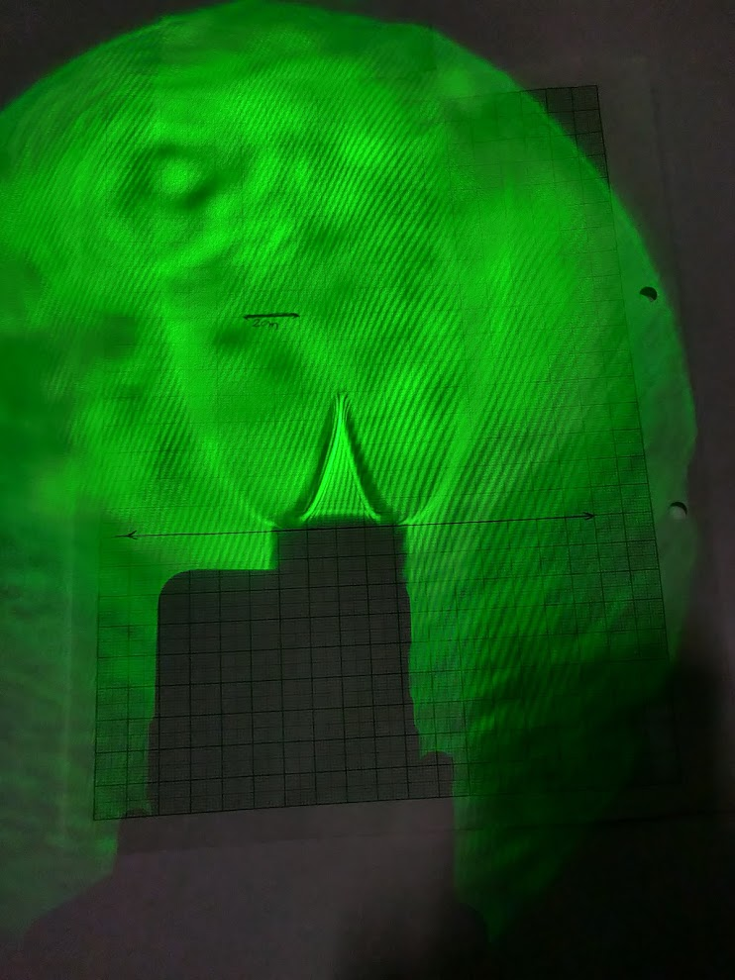Shadowgraph analysis
  + Calculations
    - Diameter (d)=10mm; l=10mm; h=19.66mm
    - Slant Height (L)= 22.05mm
    - Lateral Area (AF)= 2π(l/2)(L) = 692.94 mm2
    - Area of burner opening (A0) = πd2/4 = 78.54 mm2
    - V0= Q1/A0 = 1.1875 m/s
    - SU= Q1/AF = 0.1346 m/s

**RESULT ANALYSIS**

* Sources of Error
  + Lack of proper focus and presence of ambient light/air
  + Heating/Cooling of Thermocouple and high response time
  + Disturbance in airflow
  + Leakage of air through connecting Pipes
* Precautions
  + Turn on the compressor, and then the LPG cylinder. LPG cylinder knob should be completely turned on to avoid pressure losses in the feed line.
  + To avoid spilling of gas (LPG), ignite the burner and then set the required flow rate in the rotameters.
  + While turning on the LASER, make sure that the fan is turned on, then turn on the key and then switch on the LASER. Turn off the laser similarly.
  + While moving the traverse, don’t touch the thermocouple, as it the most delicate part of the experimental setup.
  + Turn off the LPG cylinder first, and then the compressor.

**CONCLUSION**

The experiment was successfully carried out and analyzed.

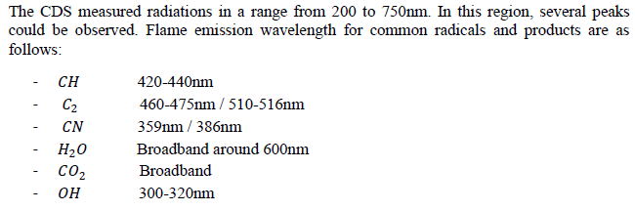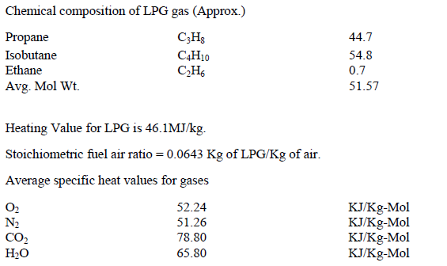**APPENDIX**