AE351 Experiments in Aerospace Engineering



Experiment-S1

Uniaxial Tensile Testing

(10-1-2020)

By:

Mataria Pence Jagatkumar

170382 | B9

**OBJECTIVE**

The objective of this experiment is to perform uniaxial tension test on a dog-bone shaped tensile specimen and analyzing the material parameters by plotting stress-strain curves.

**INTRODUCTION & THEORY**

In a tensile test, the material is subject to tension loads (along uniaxial direction) until failure. Properties like Young’s modulus, Yield stresses, maximum stress, maximum elongation, failure stress/strain can be obtained.

Various kinds of tests according to specimen are possible using relevant UTM. In a dog-bone specimen test (used because of uniaxial symmetry) 1-D/2-D UTM is used.

The Stress & Strain are governed by the following equations:

Engg. Stress = Load/ initial Area;

Engg. Strain = Change in Length/ initial length;

The true stress/strain quantities are subject to incremental changes in geometric properties and thus can be measured at a specific point in time. However, for the tensile experiment, true stress is always greater or equal to engineering stress.

**EQUIPMENT USED**

The following equipment are used along with their descriptions:

* 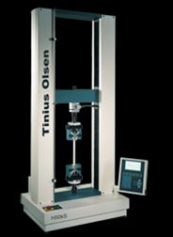Universal Testing Machine

The experiment requires a UTM for generating uniaxial tensile loads. In our case the Tinus Olsen 10kN UTM with crosshead gear displacement capabilities was used. It provides load using lead screw/gear mechanisms. The cross heads are mounted with Load Cells to measure the stresses.

* Dog-Bone Specimen

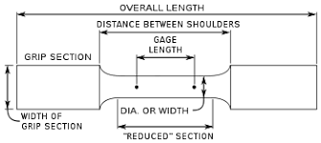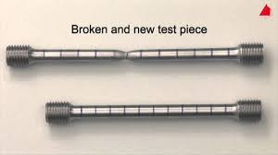Made from the aluminum alloy, the dog bone specimen provides cylindrical uniaxial symmetry and stress in other direction are negligible.

* Extensometer

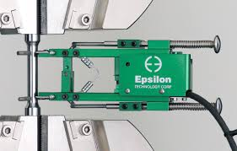It measures the change in length of the specimen with a precision of 10-6 m. It uses piezoelectric sensors and principle of wheat stone for converting voltage fluctuations to readings.

* Horizon Software

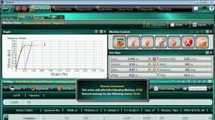The software to plot the readings provided by the Tinus Olsen is known as Horizon. It allows user to tweak various parameters and plot relevant plots with predefined presets.

* Vernier Caliper

It is used to accurately measure the gauge length and diameter of the specimen.

**PROCEDURE & MEASUREMENTS**

1. Switch on the 10 kN Tinius Olsen universal testing machine (UTM). With the help of lab instructor understand the method of conducting tensile test and learn salient features of the software-in-use.
2. Hold the dog-bone shaped test specimen at the UTM grips and carefully mount 25 mm extensometer in between the gage length region of the specimen.
3. Load the specimen in displacement control mode at the speed suggested by the lab instructor.
4. Remove the extensometer at pre-decided (specified) load/strain value.
5. Continue loading the specimen until failure is observed.
6. Record the load vs. cross head displacement data and the load vs. strain gage data (RAW DATA).
7. Plot the stress vs. strain curve as discussed in the class.
8. Carefully observe the failed specimen and perform failure analysis. Analyze and discuss the material behavior from the stress-strain plot. Determine all material characteristics (including elastic modulus, yield stress, failure stress, elastic and plastic zones/limits and various strains).
9. Compare the experimental value of elastic modulus with the published data for the specimen-in-consideration. Calculate the percent differences between the measured and published values.

* 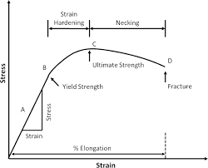Analyzing Stress Strain Curve
  + *Young’s Modulus*: The slope of Linear region
  + *Elastic Limit*: The maximum stress up to which the material will reform again as load is removed.
  + *Yield Point*: The Point on the curve beyond which material executes plastic behavior
  + *Ultimate Strength*: The maximum stress, the material can withstand.
  + *Fracture*: The point at which material breaks.
* 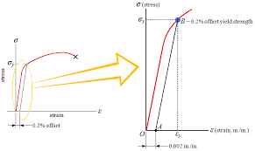Yield Point Calculation

The Yield point is calculated at 0.2% strain. The intersection point of the line with slope equal to young’s modulus starting from 0.2% strain and intersecting the curve, is the yield point.

**RESULTS & DISCUSSION**

Two experiments were covered by the group, following are the results and conclusions on the same.

* Initial Observations
  + Experiment-1
    - Gauge Length: 20mm
    - Diameter: 6.18mm
    - Area: 29.98 mm2
  + Experiment-2
    - Gauge Length: 20mm
    - Diameter: 6.14mm
    - Area: 29.59 mm2
* Plots (Experiment-1)
  + 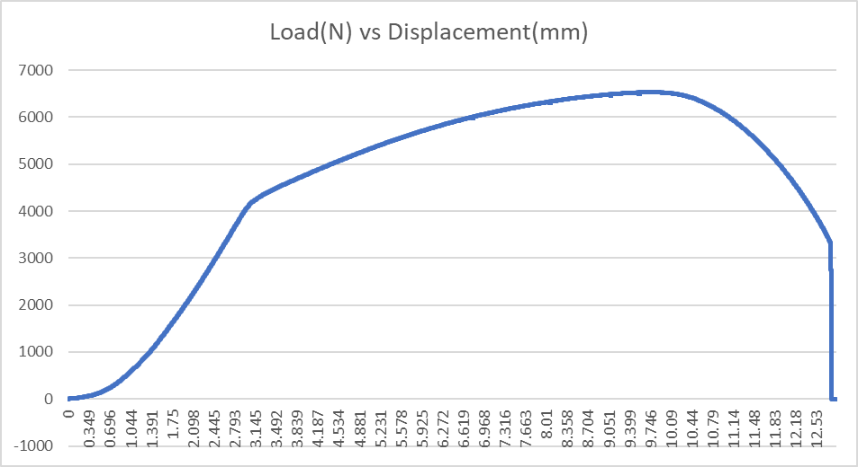Load(N) vs Displacement(mm)
  + 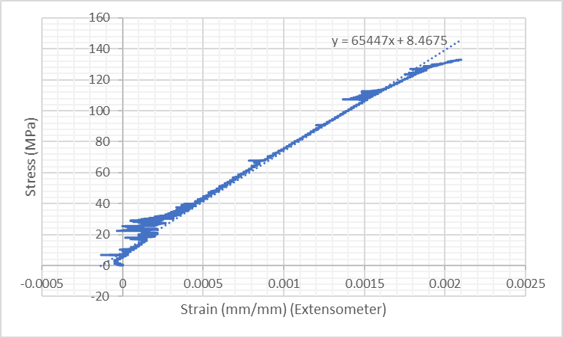Stress (MPa) vs Strain (mm/mm) (extensometer)
  + 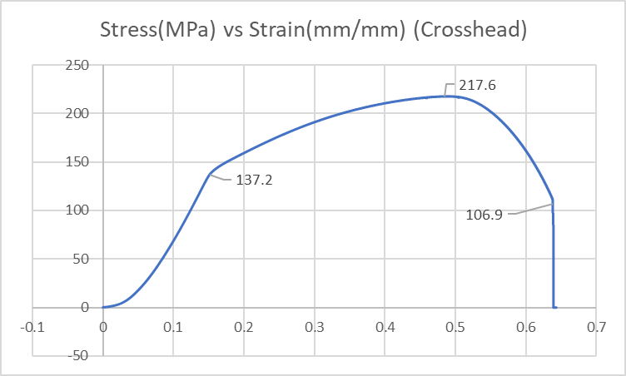Stress (MPa) vs Strain (mm/mm) (Crosshead)
* Calculations (Experiment-1)
  + *Young’s Modulus (E)*: Stress/Strain = slope of graph2 = 65447 MPa = **65.447** **GPa**
  + *Yield Stress*: 137.2 MPa
  + *Ultimate Stress*: 217.6 MPa
  + *Fracture Stress*: 106.9 MPa

Error (wrt standard Aluminum AA6063 magnesium Alloy or its tempers):

* Youngs Modulus: (68.3-65.447)*100/68.3= 4.17%
* Yield Stress: (160-137.2)*100/160= 14.25%
* Ultimate Stress: (217.6-190)*100/190= 14.52%
* Fracture Stress: (106.9-96.5)*100/96.5= 10.77%
* Plots (Experiment-2)
  + 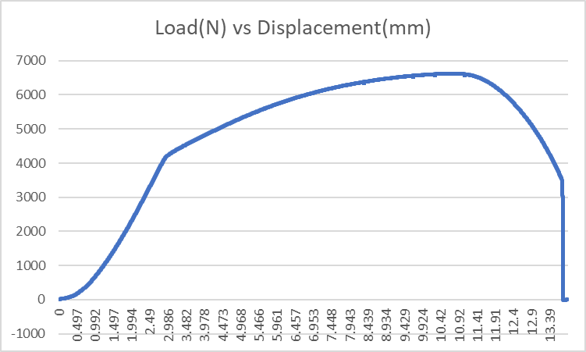Load(N) vs Displacement(mm)
  + 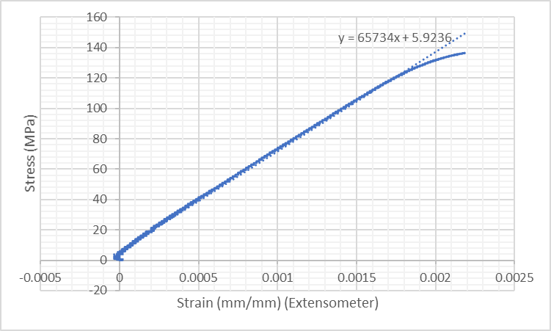Stress (MPa) vs Strain (mm/mm) (extensometer)
  + 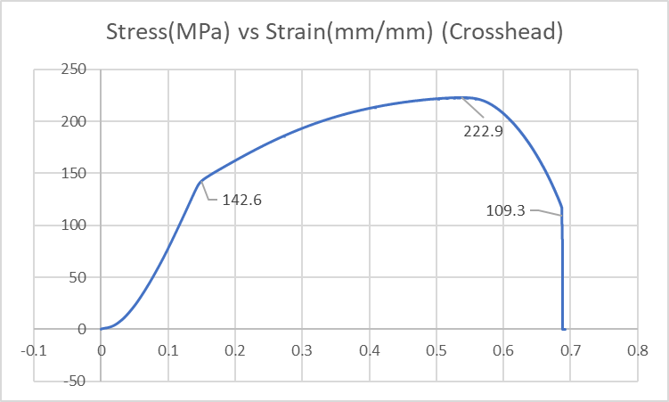Stress (MPa) vs Strain (mm/mm) (Crosshead)
* Calculations (Experiment-2)
  + *Young’s Modulus (E)*: Stress/Strain = slope of graph2 = 65734 MPa = **65.734** **GPa**
  + *Yield Stress*: 142.6 MPa
  + *Ultimate Stress*: 222.9 MPa
  + *Fracture Stress*: 109.3 MPa

Error (wrt standard Aluminum AA6063 magnesium Alloy or its tempers):

* Youngs Modulus: (68.3-65.734)*100/68.3= 3.75%
* Yield Stress: (160-142.6)*100/160= 10.87%
* Ultimate Stress: (222.9-190)*100/190= 17.31%
* Fracture Stress: (109.3-96.5)*100/96.5= 13.26%
* Failure Stress Analysis

The Breakage after Failure stress results into the Slip Plane formation (cone formation). This is evident from the fact that aluminum is a ductile metal and shear stresses leads to failure. From Mohr’s circle the maximum shear stress occurs at 2*Phi=90 Degree. Thus Phi=45 Degree slip plane formation is seen.

**RESULT ANALYSIS**

* Sources of Error
  + The Grips of UTM shows Slippage.
  + Temperature and room conditions may lead to difference in results.
  + Extensometer Handling and zeroing is also a potential source of error.
  + During the experiment the UTM head might show expansion thus resulting in difference with the extensometer values.
  + The specimen might not be perfectly vertical.
* Precautions
  + Extensometer should be removed properly at proper time.
  + Machine maintenance should be done timely to maintain threading and grips.
  + Proper room conditions should be maintained.
  + The specimen should be free from impurities.

**CONCLUSION**

The experiment was successfully carried out and the values found resembles the true values to a certain extent.