AE351 Experiments in Aerospace Engineering



Experiment-S2

Torsion Testing

(17-1-2020)

By:

Mataria Pence Jagatkumar

170382 | B9

**OBJECTIVE**

The objective of this experiment is to perform a torsion (shear) test on a shaft with a circular cross section and

measure the shear modulus of a material using two different methods (T-θ & τXY-γXY).

**INTRODUCTION & THEORY**

In solid mechanics, Torsion is the twisting effect found on any material on application of torque (torsional loads) along the longitudinal axis.

For uniform cross-section, following equation holds true:

𝑇/J = 𝜏/𝑅 = 𝐺𝜃/𝐿

𝑇: External Torque (N·m)

J: Polar Moment of Inertia (in case of a cylinder: ) (m4)

𝜏: Maximum shear stress (N/m2)

𝑅: Radius of the shaft (m)

𝐺: Shear modulus (N/m2)

𝜃: Angle of twist

𝐿: Length of the shaft (m)

* Torque

The Torque is given by: 𝑇 = P·d

Where P is the external load and d is the torque arm.

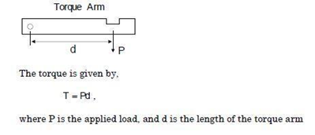

* Angle of Twist

The angle of twist is measured by: tan 𝜃 = h/s

Where h is the dial gauge reading and s is the distance

between dial gauge and shaft center.

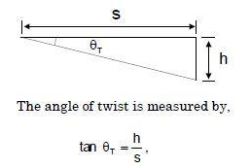

* Shear Strain

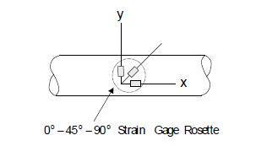The strain rosette provides strain data along the 0-45-90 degrees. These readings can be related as follows:

ε0= εx

ε45= (εx+ εy+γxy)/2

ε90= εy

γxy=2 ε45- ε0- ε90

Thus, Shear strain can be obtained from strain gauge readings.

**EQUIPMENT USED**

The following equipment are used for the experiment:

* Test Cylindrical Shaft Aluminum (6063)
* Dial Gauge
* Bearings and test fixtures
* Strain rosette with strain indicator
* Weights
* Vernier Calipers and Measuring scale

**PROCEDURE & MEASUREMENTS**

1. Apply loads to the torque arm. The load range and the load increment will be given by your lab instructor.
2. At each load, record the three strain gage readings, and the vertical deflection of the torque arm.
3. Determine the torque, shear strain, and the angle of twist for each applied load. Tabulate all measurements and calculations.
4. Use the measured data to generate plots of Shear Stress vs. Shear Strain (τXY-γXY), and Torque vs. Angle of Twist (T-θ).
5. Using linear regression fit the data (Draw a best possible straight-line fit passing through all the data). Calculate shear modulus using the slope of the straight line fit.
6. Compare experimentally measured G to the published value for your specimen material.
7. Calculate the percent differences between the measured and published values.
8. Identify sources of errors in your measurements.

* 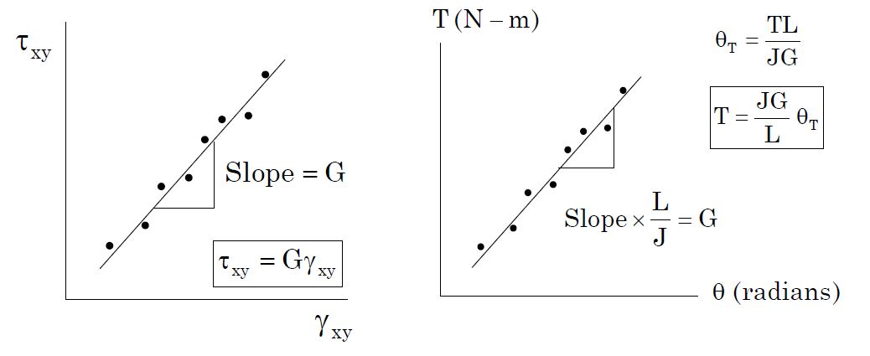Analyzing the graph

**RESULTS & DISCUSSION**

* Initial Observations
  + Length (L) = 700mm
  + Distance b/w shaft center and dial gauge(s)=130mm
  + Torque arm (d) = 344mm
  + Radius (R) = 9.95mm
* Data

|  |  |  |  |  |  |  |  |  |  |
| --- | --- | --- | --- | --- | --- | --- | --- | --- | --- |
| Sno. | Load (N) | ᗴ0 (x10-6 m/m) | ᗴ45 (x10-6 m/m) | ᗴ90 (x10-6 m/m) | h (mm) | θ | T  (Nm) | γXY (x10-6 m/m) | τXY(x106 Pa) |
| 1. | 5 | 0 | 19.9 | 0.004 | 0.38 | 0.167° | 1.72 | 39.80 | 1.112 |
| 2. | 10 | 0 | 39.9 | -0.0015 | 0.80 | 0.352° | 3.44 | 79.80 | 2.224 |
| 3. | 15 | 1 | 60.2 | -0.0015 | 1.22 | 0.538° | 5.16 | 119.40 | 3.336 |
| 4. | 20 | 1 | 79.9 | -0.004 | 1.65 | 0.727° | 6.88 | 158.80 | 4.448 |
| 5. | 25 | -1 | 97.2 | -0.001 | 2.04 | 0.899° | 8.60 | 195.40 | 5.560 |

Sample Calculation (Load = 5 N):

* θ = arctan(h/s) = arctan(0.38/130)= 0.167°
* T = P·d = 5*0.344 = 1.72 Nm
* γxy=2 ε45- ε0- ε90

= (2*19.9 – 0 – 0.004) *10-6 = 39.80 * 10-6 m/m

* τXY = T*R/J = 2*T*R/ = 1.112 * 106 N/m2
* Plots
  + Shear Stress vs Shear Strain (Method-1)

G = Slope = **28.490 GPa**

* + Torque vs Angle of Twist (Method-2)

G = Slope*L/J = **24.384 GPa**

* Error (wrt standard Aluminum AA6063 Alloy):

Standard G = **25.8 GPa**

* + Method-1
    - *Measured G = 28.490 GPa*
    - *Error = 100*(28.490-25.8)/25.8 =* ***10.42%***
  + Method-2
    - *Measured G = 24.384 GPa*
    - *Error = 100*(25.8-24.384)/25.8 =* ***5.48%***

**RESULT ANALYSIS**

* Sources of Error
  + Unstable Strain indicator readings.
  + Incorrect placing of weights (sway of pans or not placing both weights simultaneously).
  + Bearing friction and slippage with shaft.
  + Strain gauge alignment error.
  + Incorrect zeroing and environmental pressure difference.
* Precautions
  + Keep the pans steady while placing weights.
  + Zero the Strain indicator after every load change.
  + Wait for few minutes before recording the readings.
  + Regularly maintain and oil the bearings.

**CONCLUSION**

The experiment was successfully carried out and the values found resembles the true values to acceptable extent.