AE351 Experiments in Aerospace Engineering



Experiment-S3

Beam Deflection and Strains

(24-1-2020)

By:

Mataria Pence Jagatkumar

170382 | B9

**OBJECTIVE**

The objective of this experiment is to experimentally measure the strain and deflection in a beam subjected to transverse loading. Determine the strain and the deflection variation along the beam using Euler-Bernoulli beam theory and compare the results with experimental measurements.

**INTRODUCTION & THEORY**

The experiment consists of a simply supported Beam of rectangular cross section subjected to a concentrated load. The load is applied by hanging dead weight at the specified location of the beam. A total of 15 strain gauges are present.

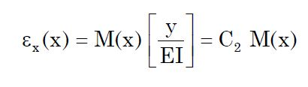The strain gauge locations from the neutral axis (y) are constant. Therefore, from Euler-Bernoulli beam theory the theoretical strain distribution on the top of the beam can be given by,

where C2 = y/EI is a constant that can be calculated.

I = b*d3/12

M = Px/2 (for x<L/2)

M = P(L-x)/2 (for x>L/2)

**EQUIPMENT USED**

* A beam of rectangular cross section with carefully mounted (15) strain gages on its top
* Strain indicator (with Wheatstone bridge circuits) to record strain gauge data
* Weights
* Vernier Calipers and Measuring scale
* Deflection dial gages to measure beam deflection

**PROCEDURE & MEASUREMENTS**

1. Mount the beam with simply supported boundary conditions. Measure beam dimensions and the location of strain gages with respect to the supports. Apply a concentrated load as specified by your lab instructor. Record all dial gage readings and the strain values using strain indicator equipment and tabulate your data.
2. Theoretically calculate strains at each of the strain gage locations using Euler-Bernoulli beam theory and compare your results with experimentally measured strain values. Generate graphs that show both your experimental measurements (as data points) and theoretical predictions (as solid lines/curves). Calculate the percent errors and discuss possible reasons for the discrepancies.
3. Repeat with two concentrated loads

**RESULTS & DISCUSSION**

* Initial Observations
  + Length (L) = 884mm
  + Breadth (B) = 25 mm
  + Height (H) = 11 mm
  + E (for Al) = 69 GPa
* Dial Gauge Readings

|  |  |  |  |  |  |  |
| --- | --- | --- | --- | --- | --- | --- |
| **S No.** | **Position (mm)** | **Zero Load reading (mm)** | | **Displacement with Load (mm)** | | |
| **Start** | **End** | **500 gm** | **1000 gm** | **500+500 gm** |
| 1. | 111 | 0 | -0.01 | -0.11 | -0.23 | -0.20 |
| 2. | 280 | 0 | 0 | -0.26 | -0.53 | -0.43 |
| 3. | 420 | 0 | 0.01 | -0.32 | -0.64 | -0.49 |
| 4. | 614 | 0 | 0.01 | -0.27 | -0.53 | -0.42 |
| 5. | 782 | 0 | 0.03 | -0.11 | -0.23 | -0.14 |

* Case-1 500 gm

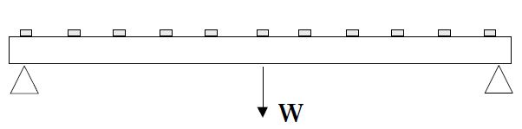

|  |  |  |  |  |  |
| --- | --- | --- | --- | --- | --- |
| Strain Gauge | x (mm) | M (N-m) | εx (x10-6)  (Pred.) | εx (x10-6) (Meas.) | Percent Error |
| 1. | 872 | 0.03 | -0.86265 | -1.3094869 | 34.12305 |
| 2. | 812 | 0.18 | -5.1759 | -4.8884014 | -5.88124 |
| 3. | 753 | 0.3275 | -9.417263 | -9.6958458 | 2.873224 |
| 4. | 692 | 0.48 | -13.8024 | -14.214137 | 2.896675 |
| 5. | 632 | 0.63 | -18.11565 | -18.372875 | 1.400029 |
| 6. | 573 | 0.7775 | -22.35701 | -22.980898 | 2.714801 |
| 7. | 513 | 0.9275 | -26.67026 | -27.497627 | 3.008858 |
| 8. | 482 | 1.005 | -28.89878 | -30.670298 | 5.776022 |
| 9. | 390 | 0.975 | -28.03613 | -27.641815 | -1.4265 |
| 10. | 331 | 0.8275 | -23.79476 | -22.100744 | -7.66498 |
| 11. | 272 | 0.68 | -19.5534 | -17.769705 | -10.0378 |
| 12. | 242 | 0.605 | -17.39678 | -13.203961 | -31.7542 |
| 13. | 146 | 0.365 | -10.49558 | -9.0798631 | -15.5918 |
| 14. | 88 | 0.22 | -6.3261 | -4.7633161 | -32.8087 |
| 15. | 26 | 0.065 | -1.869075 | -0.96432237 | -93.8226 |

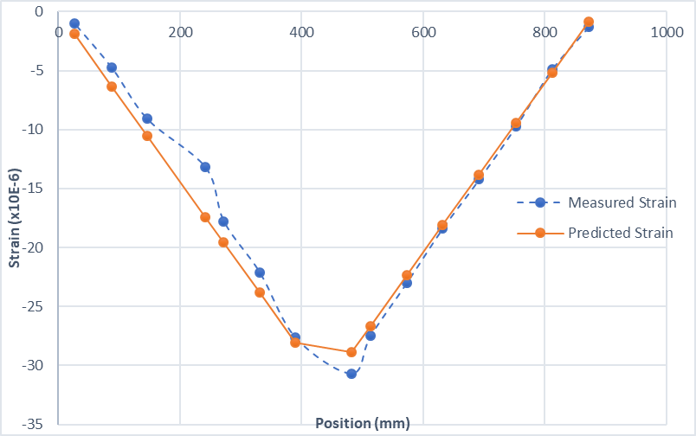

* + Sample Calculations
    - X<L/2 (x = 26mm)

M = W/2*0.026=0.065

ε(predicted)=M*(y)/(E*I)=0.065*(-0.011/2)/191.268)

= -1.869 X 10-6

* + - X>L/2 (x = 482mm)

M = W/2*(0.884-0.482)=1.005

ε(predicted)=M*(y)/(E*I)=1.005*(-0.011/2)/191.268)

= -28.898 X 10-6

* Case-2 1000 gm



|  |  |  |  |  |  |
| --- | --- | --- | --- | --- | --- |
| Strain Gauge | x (mm) | M (N-m) | εx (x10-6)  (Pred.) | εx (x10-6) (Meas.) | Percent Error |
| 1. | 872 | 0.06 | -1.7253 | -3.44343716 | 49.89599287 |
| 2. | 812 | 0.36 | -10.3518 | -10.9954917 | 5.854142021 |
| 3. | 753 | 0.655 | -18.834525 | -20.0768507 | 6.187851464 |
| 4. | 692 | 0.96 | -27.6048 | -29.14206874 | 5.275084462 |
| 5. | 632 | 1.26 | -36.2313 | -37.46577236 | 3.294933701 |
| 6. | 573 | 1.555 | -44.714025 | -46.46747772 | 3.773505269 |
| 7. | 513 | 1.855 | -53.340525 | -55.21085132 | 3.387606377 |
| 8. | 482 | 2.01 | -57.79755 | -61.85382666 | 6.557842706 |
| 9. | 390 | 1.95 | -56.07225 | -55.82124902 | -0.449651315 |
| 10. | 331 | 1.655 | -47.589525 | -45.51083682 | -4.567457611 |
| 11. | 272 | 1.36 | -39.1068 | -36.99172902 | -5.717686186 |
| 12. | 242 | 1.21 | -34.79355 | -27.78036036 | -25.24513559 |
| 13. | 146 | 0.73 | -20.99115 | -19.6020457 | -7.086527199 |
| 14. | 88 | 0.44 | -12.6522 | -10.64294862 | -18.87870976 |
| 15. | 26 | 0.13 | -3.73815 | -2.6659378 | -40.21895034 |

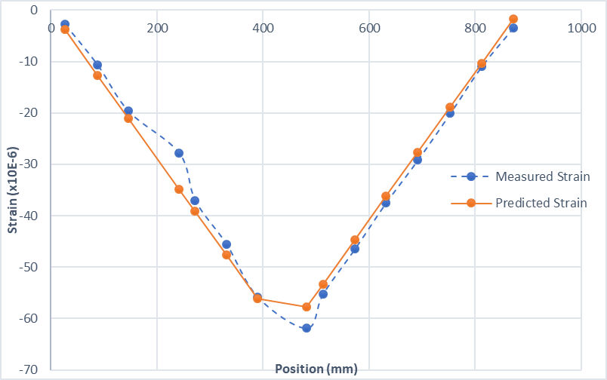

* + Sample Calculations
    - X<L/2 (x = 26mm)

M = W/2*0.026=0.13

ε(predicted)=M*(y)/(E*I)=0.13*(-0.011/2)/191.268)

= -3.738 X 10-6

* + - X>L/2 (x = 482mm)

M = W/2*(0.884-0.482)=2.01

ε(predicted)=M*(y)/(E*I)=1.005*(-0.011/2)/191.268)

= -57.797 X 10-6

* Case-3 500 gm + 500 gm a=290mm

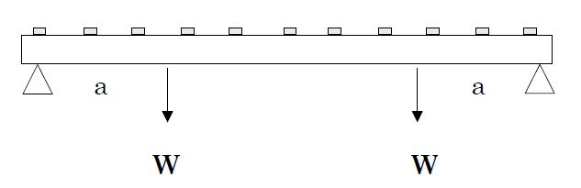

|  |  |  |  |  |  |
| --- | --- | --- | --- | --- | --- |
| Strain Gauge | x (mm) | M (N-m) | εx (x10-6)  (Pred.) | εx (x10-6) (Meas.) | Percent Error |
| 1. | 872 | 0.06 | -1.7253 | -4.35097932 | 60.34685819 |
| 2. | 812 | 0.36 | -10.3518 | -11.48783648 | 9.889037696 |
| 3. | 753 | 0.655 | -18.834525 | -20.35476258 | 7.468707012 |
| 4. | 692 | 0.96 | -27.6048 | -29.30300968 | 5.79534218 |
| 5. | 632 | 1.26 | -36.2313 | -37.5343252 | 3.471556217 |
| 6. | 573 | 1.45 | -41.69475 | -40.36341588 | -3.298368314 |
| 7. | 513 | 1.45 | -41.69475 | -40.73980948 | -2.343998492 |
| 8. | 482 | 1.45 | -41.69475 | -41.37510112 | -0.772563381 |
| 9. | 390 | 1.45 | -41.69475 | -43.84090476 | 4.895324975 |
| 10. | 331 | 1.45 | -41.69475 | -43.30771124 | 3.724420418 |
| 11. | 272 | 1.36 | -39.1068 | -36.69450694 | -6.573989573 |
| 12. | 242 | 1.21 | -34.79355 | -28.00558636 | -24.23789151 |
| 13. | 146 | 0.73 | -20.99115 | -19.78131762 | -6.116035358 |
| 14. | 88 | 0.44 | -12.6522 | -10.89564328 | -16.12164307 |
| 15. | 26 | 0.13 | -3.73815 | -3.18123208 | -17.50635936 |

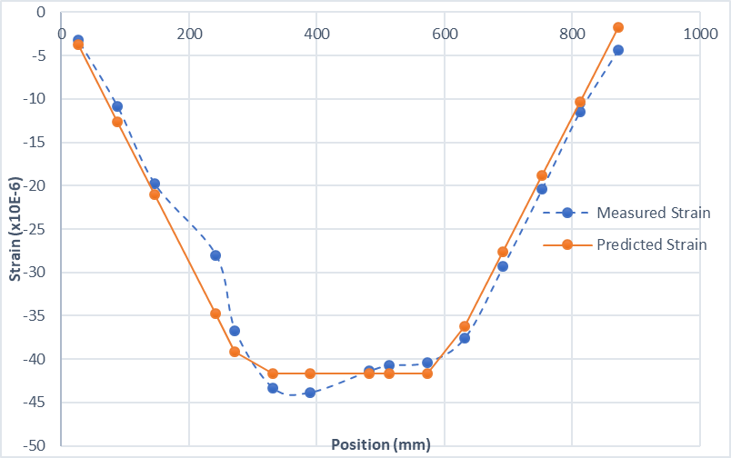

* + Sample Calculations
    - X< a (x = 26mm)

M = W*0.026=0.13

ε(predicted)=M*(y)/(E*I)=0.13*(-0.011/2)/191.268)

= -3.738 X 10-6

* + - a< X <(L-a) (x = 331mm)

M = W*a= 5*0.290 = 1.45

ε(predicted)=M*(y)/(E*I)=1.45*(-0.011/2)/191.268)

= -41.694 X 10-6

* + - X>(L-a) (x = 632mm)

M = W*(L-0.632) = 1.26

ε(predicted)=M*(y)/(E*I)=1.26*(-0.011/2)/191.268)

= -36.231 X 10-6

**RESULT ANALYSIS**

* Sources of Error
  + Unstable Strain indicator readings.
  + Incorrect placing of weights (sway of pans or not placing both weights simultaneously).
  + Slippage of Beam.
  + Strain gauge alignment error.
  + Incorrect zeroing and environmental pressure difference.
  + Dial Gauge spring jamming error.
* Precautions
  + Keep the pans steady while placing weights.
  + Precisely measure the distance between dial gauges and strain gauges.
  + Take multiple readings of strain gauge and use the average.
  + Do not move or touch the beam.

**CONCLUSION**

The experiment was successfully carried out and the values found resembles the true values to acceptable extent.