AE351 Experiments in Aerospace Engineering



Experiment-S4

Principal axes of a given cross-section in a thin walled beam

(31-1-2020)

By:

Mataria Pence Jagatkumar

170382 | B9

**OBJECTIVE**

To determine the principal axes and the orientation of principal planes of an L section beam and to compare with theoretical values.

**INTRODUCTION & THEORY**

Principal axes are the orthogonal axes at the geometric centroid of the given geometry. The Moment of Inertia (MoI), is maximum/minimum about these axes. Also, the deflection is along the direction of load only, when loads are applied along these axes. The below figure represents the experimental setup on the L section beam. Y-Z is the defined coordinate system as shown and Y’-Z’ are Principal axes.

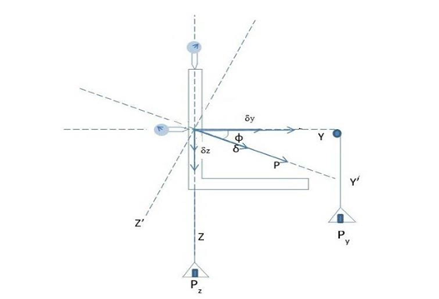

* Equations used
  + 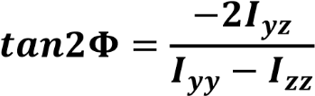Theoretical orientation of the principal axes:
  + Experimentally, the orientation is obtained when the following condition is met:

**EQUIPMENT USED**

* A L section beam with supports
* Dial Gauges
* Vernier Calipers
* Pans and Pulleys
* Weights

**PROCEDURE & MEASUREMENTS**

* Measure the thickness of the web and flange of the L section. Also measure the length of the flange and the height of the web to determine the values of Izz, Iyy, Iyz.
* Adjust the dial gauges to remove any zero error while supporting the pans with your hands to have the no load initial setup.
* Fix the y-direction load Py, and for some random z-direction load Pz, note the beam deflections δy and δz
* Increase the loads in each of the pan and calculate the ratio of loads and the ratio of deflections produced. They should be almost equal i.e., the difference between these two ratios should be very small.
* Repeat the steps above for different values of Py and Pz.

**RESULTS & DISCUSSION**

* Initial Observations

24.8 mm

3.09 mm

25.17 mm

3.18 mm

* Dial Gauge Readings
* Moment of Inertial Calculation (Iyy, Izz and Iyz)

z

24.8 mm

y

Section 1

3.09 mm



25.17 mm

Section 2

3.18 mm

Ycg = (Y1*A1 + Y2*A2)/ (A1+ A2) = 7.231 mm

Zcg = (Z1*A1 + Z2*A2)/ (A1+ A2) = -7.562 mm

d1=3.09 mm; d2=3.18 mm; L1=24.8 mm; L2=25.17 mm

* Iyy = {[d13*(L1) /12] + (Z1-Zcg)2*A1} +

{[d2*(L2-d1) 3 /12] + (Z2-Zcg)2*A2}

= 8716.931 mm^4

* Izz = {[d1*(L1)3/12] + [(Y1-Ycg)2*A1]} +

{[d23 (L2-d1) /12] + [(Y2-Ycg)2*A2]}

= 8268.583 mm^4

* Iyz = {(Z1-Zcg)*(Y1-Ycg)*A1} +

{(Z2-Zcg)*(Y2-Ycg)*A2}

= 4984.833 mm^4



= -22.2364

Φ = -43.712 (degree)

* Plot to verify the experiment with Theoretical value

The intersection point gives the value of Py/Pz or δy/δz which gives experimental φ.

Since the intersection point is (1,1);

Φ = 45 degrees (as expected)

**RESULT ANALYSIS**

* Sources of Error
  + Incorrect placing of weights (sway of pans or not placing both weights simultaneously).
  + Slippage of dial gauge on Beam.
  + Incorrect zeroing and environmental pressure difference.
  + Dial Gauge spring jamming error.
* Precautions
  + Keep the pans steady while placing weights.
  + Take multiple readings of Vernier caliper and use the average.
  + Properly zero the dial gauge.
  + Do not move or touch the beam.

**CONCLUSION**

The experiment was successfully carried out and the values found resembles the true values to an acceptable extent.