MATARIA PENCE  
170382 | [pencem@iitk.ac.in](mailto:pencem@iitk.ac.in)  
Assignment-1 AE441

Q.1. -------

CODE

<https://colab.research.google.com/drive/1UGZJgr5V4ZsJZC7XJBMX9sWSzcATWqKS?usp=sharing>

(a.) Constant G and D=0  
 hb = 134279.48 m  
 ub = 3950.71 m/s  
 θb = 0.2053 radian

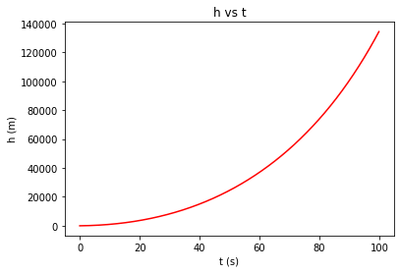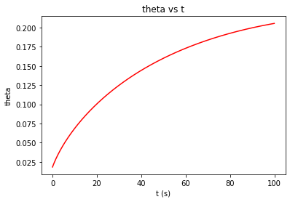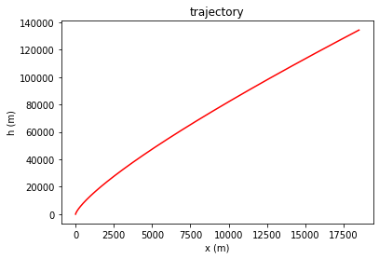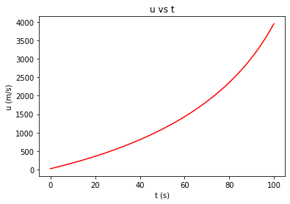

(b.) Variable G and D=0

hb = 134540.79 m  
 ub = 3961.83 m/s  
 θb = 0.2039 radian

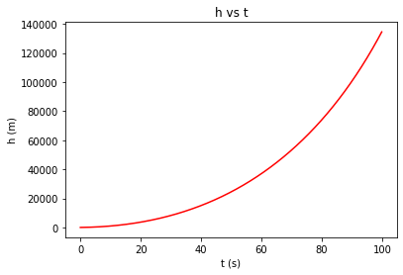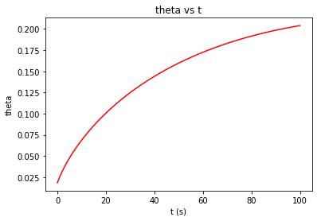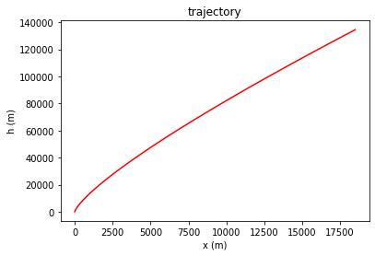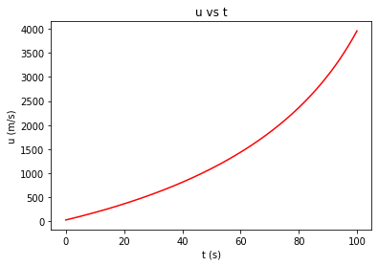

(c.) Constant G and variable D

hb = 132805.51 m  
 ub = 3928.64 m/s  
 θb = 0.2080 radian

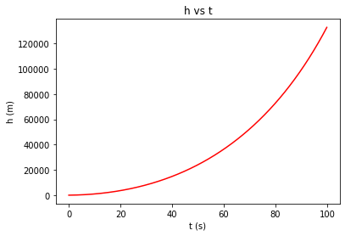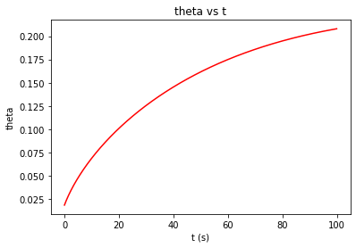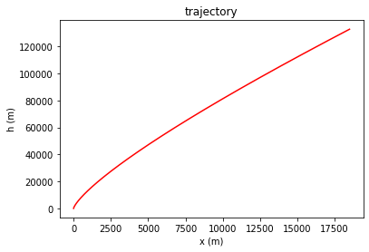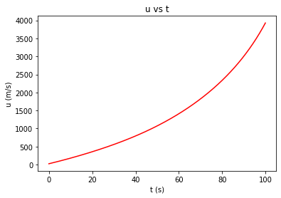

(d.) Variable G and D

hb = 133062.80 m  
 ub = 3939.60 m/s  
 θb = 0.2065 radian

