MATARIA PENCE  
170382 | [pencem@iitk.ac.in](mailto:pencem@iitk.ac.in)  
Assignment-2 AE441

Q.1. -------

CODE

<https://colab.research.google.com/drive/1FsEn9t5fh9rbSFsc-HFafXzGRKbyvrsL?usp=sharing>

Fuel: CH4 (equation in code)

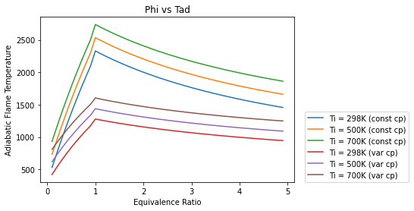Plot

Error

Error at T=298K is 1051.3403706858553 K

Error at T=500K is 1096.465910050159 K

Error at T=700K is 1134.249870129978 K

Observation

* As initial temperature increase, the plot shifts upwards and more Tad is achieved
* For variable cp(real) the Tad achieved is lower than the one assumed @1200K, though this is dependent on fuel as well as the constant cp temp.
* For very low and very high values of phi, the variable cp and constant cp plots tend to cross.