AIRCRAFT DESIGN-I (AE461A)

Final Report

# Group Members Shubham (170685)

Dumpeti Sanjay (170261)

Millennium Giri (170388) Divyanshu Barot(170205) Bharat Swami (170207)

Mission Requirements

1. Weight less than 1500kg
2. Four passengers (75kg each), each can have maximum 10 kg bag / luggage
3. Minimum steady-straight-level-flight speed should be in between 30 to 40 m/s.
4. Design cruise speed should be in between 50 to 70 m/s.
5. Sizing of the aircraft must be iterative process.
6. Feasible to fly from mean sea level – to 10, 000 feet.
7. Rate of climb at mean sea level: 4 to 8 m/s
8. Able to fly at minimum drag condition as well as minimum power condition.
9. Low speed Aircraft.
10. Minimum 4hr endurance.
11. Minimum 1000 km range (round trip).
12. Neutral position of control surfaces at design cruise speed.
13. Landing distance: 400 to 600 metres.
14. Take-off distance: 300 to 500 metres.
15. Service sealing: 7 km.

Weight Estimation

The Gross Weight (W0) of an aircraft is given by -





*where,*

Wp = Payload Weight

We = Empty Weight of the Aircraft Wf = Weight of the Fuel Required

Wc = Weight of the crew (with baggage)

𝑊𝑒 = Empty Weight Fraction

𝑊𝑜

𝑊𝑓= Fuel Fraction

𝑊𝑜

For given W0 < 1500kg Passengers = 4\*(75kg + 10kg) Wp = 340kg

Crew = 1 pilot (75kg + 10kg) Wc = 85kg

We/Wo

From the graph given in the book, for an aircraft with weight less than 1500kg We/W0 is approximately 0.5

We/W0 = 0.5

Wf/Wo

R = 1000kg (Round trip)

Considering the journey as –

Aircraft will go 1000km, will land at reached destination, will replenish the fuel and then again come back to the point from where it embarked its journey by travelling 1000km. Thus, if we calculate Wf/W0 for initial to final destination, it will also be same for reverse journey.

Hence, for low-speed turboprop aircraft taking efficiency (np) = 0.8:

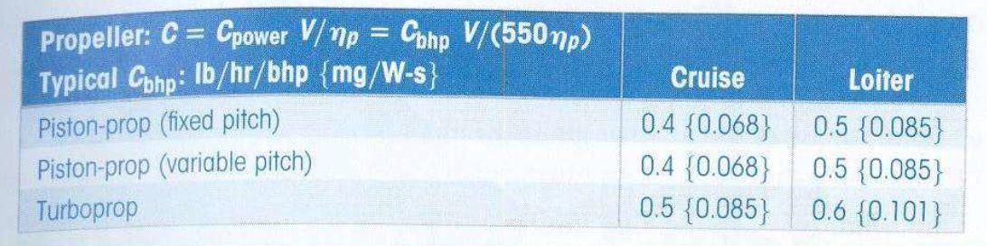

The fuel weight depends on the mission profile and the fuel required as reserve

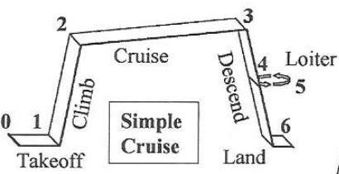

Figure showing mission profile

From historical data:

|  |  |
| --- | --- |
| **Mission Segment** | **(Wi/Wi-1)** |
| Warmup and Take-off | 0.970 |
| Climb | 0.985 |
| Landing | 0.995 |

Clearly, we can conclude than W1/W0 = 0.970

W2/W1 = 0.985

W6/W5 = 0.995

W3/W2

Given Cbhp = 0.5 and

Range (R) = 1000km = 3280840 feet Using the formula for range



Assuming (L/D)max = 14 We get –

W3/W2 = 0.95.

W4/W3

Given: Cbhp = 0.6 and Endurance (E) = 4hours = 14400 sec Vcruise = 50m/sec (Assumed)

Using formula E = (

𝜂𝑝𝑟

)\*(𝐿

# )ln(

𝑊5)

𝑐∗ 𝑉𝑐𝑟𝑢𝑖𝑠𝑒 𝐷 𝑊3

Here,

𝐿= 0.866(𝐿)

max

We get W5/W3 = 0.96

Now,

𝐷 𝐷

𝑊6 𝑊1 𝑊2 𝑊3 𝑊5 𝑊6

= ( ) ( ) ( ) ( ) ( )

Hence, W6/W0 = 0.86 Using

𝑊𝑜

𝑊𝑜 𝑊1 𝑊2 𝑊3 𝑊5

Wf/W0 = 0.15

Wf/W0 = 1.06(1- 𝑊6)

𝑊

Wo

Wo = (Wc + Wp)/[1 – (Wf + We)/W0] Wo= 1214kg (<1500kg)

Fuel weight = Wf = (Wf/W0)\*W0 = 181.1kg

Now taking on more crew member in flight of weight (75kg + 10kg) as co-pilot Wcrew = 170kg

Gives, Wo = 1457kg (<1500kg)

Wf = 218.55kg

Earlier, we have taken Range as 1000km for one side journey and 1000km for reverse journey. Now we will take overall range as 2000km and will calculate the total weight.

For, R = 2000km, (W3/W2)new = 0.9 (from formula of range). Only W3/W2 will change, rest weight ratios will remain the same.

(W6/Wo)new = 0.82

(Wf/Wo)new = 0.19

Calculating weight for 1 pilot we get,

(W0)new = 1370kg (using same formula as before) This is still less than 1500kg

(Wf)new = 260.3kg

Calculating wight for 1 pilot + 1 co-pilot we get

(W0)new = 1645kg ; (Wf)new = 312.55kg

This is more than 1500kg, which means it violates our mission requirement. Hence, in this case we will proceed without co-pilot.

W/S

Assuming, Vstall = 35m/sec (from mission requirement) and at 45 degrees flap deflection CLmax = 2.34

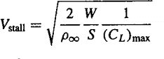At sea level, Vstall is given by the formula:

From here we get, W/S = 179.15kg/m2

Flight path radius (R)

Using landing distance, L = 500m

(here Vf = 1.23\* Vstall) R = 94.55m

Flare Height (hf)



(here assuming θ = 3 degrees) hf = 0.129m

Sa

Approaching distance to clear 15m

Sa = 283.744m

𝑆𝑎 =

15 − ℎ𝑓

𝑡𝑎𝑛(𝜃)

Flare distance (Sf)

Flare distance:

Sf = R\*Sin(θ)

Sf = 4.948m

Ground roll (Sg)

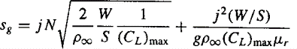

For commercial planes, j = 1.15 Assuming N = 3 and μ = 0.04 Also,

Sg = 211.308m

Sg = L – Sa – Sf

After putting Sg and all the known and given quantities in the above equation, we will get a quadratic equation in √W/S.

W/S = 103.62kg/m2

W/S

Considering level flight at 10000ft altitude with Vcruise = 70m/sec (from mission requirement).

Also, ρ (density) = 0.9093 at 10000ft.

Considering flat bottom airfoil with Cmac = -0.05 and Cd0 = 0.02

We can get CL = (Cd0/k)^0.5 = 0.597

We know k = 1/(𝜋\*e\*AR); AR = 8, e = 0.7

Hence, using formula

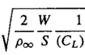

Vcruise =

W/S = 135.71kg/m2

Now, taking the Case where range is 2000kms with one pilot only, our MTOW was

W0 = 1370kg

We get S = 14.47 m2

b (Wing length) = 10.76m (given AR = 8)

c (chord length) = b/AR = 1.345m (Considering rectangular wing)

Hence, the design of rectangular wing is given as below and the shaded portion inside the wing is fuel tank.

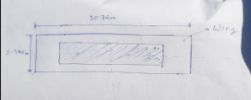

Maximum thickness of wing is 12 percent at 34.9 percent of chord length for NACA63412.

Hence, Maximum thickness = 0.1614m at 0.469m from the leading edge of the wing.

Power Calculation

At the cruise

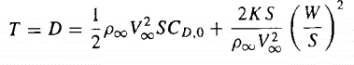

P=DV

Due to fuel consumption weight of the airplane will decrease

𝑊2

𝑊𝑜

𝑊1 ∗ 𝑊2

=

𝑊𝑜 ∗ 𝑊1

W2=1301.5kg

𝑊2

𝑊𝑜

= 0.95

WMC= 𝑊2 ∗ (1 + 𝑊3

)

WMC=1275.64kg

2 𝑊2

S= 𝑊 =14.47m2

𝑊⁄𝑆

At sea level ρ=1.225

At cruise speed V=50 m/s P=48007.49 Nm/s

Preq=64.37hp

For given rate of climb

P=0.265V3 +744124.64

𝑉

𝑃𝑎𝑣 − 𝑃𝑟𝑒𝑞

= 𝑟𝑜𝑐

𝑊

For example, for roc=6 m/sec at h=0 and V=50m/sec Pav=164.97hp

Engine

## Lycoming O-540-A3D5, Horizontally-Opposed 6 Engine

Graphs:

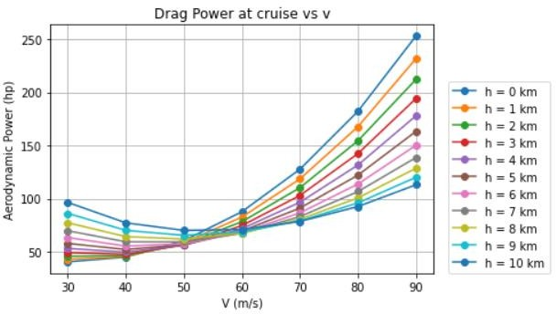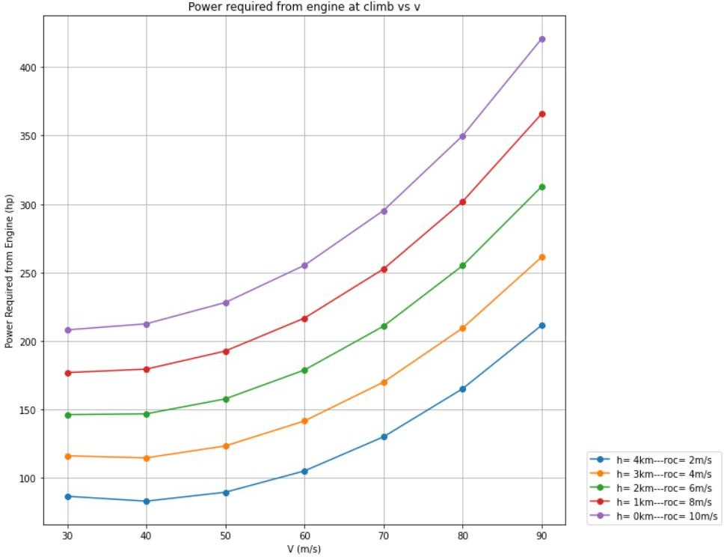

Tail Design

Step:1

Choose the following values of design coefficient and the Static Margin (S.M) as the initial estimates:

CL,design = 0.4

Step:2

Cm.vs Cl plot

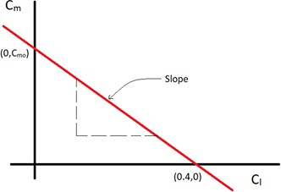

We know that,

ie. the -ve slope of this plot

𝐶𝑚0 = 0.06

Equation of the line:

SM= − 𝑑𝐶𝑚

𝑑𝐶𝐿

0.15== − (0−𝐶𝑚0)

0.04

𝐶𝑚 = −0.15𝐶𝐿 + 0.06

Step:3

Choosing the airfoil EPPLER E1212 for estimates, we have

𝐶𝐿𝛼 = 4.412

𝐶𝐿(𝛼=0) = 𝐶𝐿𝛼𝑤 ∗ |𝛼𝐿=0|

Use:

𝛼𝐿=0 = −2.5

𝐶𝐿(𝛼=0) = 0.2084

𝐶𝑚(𝛼=0) = 0.031

𝐶𝑚(𝛼=0) = 0.031

Taking only wing: By Pitching moment equation

𝑥𝑐𝑔 𝑥𝑎𝑐

𝐶𝑚(𝛼=0) = 𝐶𝑚𝑎𝑐 + 𝐶𝐿𝑜𝑤 [ 𝐶 − 𝑤 ]

For this

𝐶𝐿𝛼 𝑎𝑖𝑟𝑓𝑜𝑖𝑙 = 5.9/𝑟𝑎𝑑 ; AR=8 ; e=0.7



So,

𝐶𝐿𝛼 𝑤 =

5.9

5.9 = 4.43 /𝑟𝑎𝑑

1 + 𝜋 ∗ 0.7 ∗ 8

𝐶𝐿𝛼 𝑤

= 4.43 ∗ (1\*2.51) \* 𝜋

180

8

= 0.1932

𝐶𝑚𝑎𝑐 𝑤𝑖𝑛𝑔 = −0.08 ∗ 8 + 2 = −0.064

𝑐

𝑋𝑎𝑐 𝑤 𝑤𝑖𝑙𝑙 𝑏𝑒 𝑎𝑡 4

|  |  |  |
| --- | --- | --- |
| 𝑋𝑎𝑐 | 𝐶̅  = =  4 | 1.345 |
| 𝑤 | 4 |

Step:4: Locating the c.g.

Let the 𝑥𝑐𝑔 = 35% from L.E

𝑥𝑐𝑔 35

35

=

100

∗ 𝐶

𝑥𝑐𝑔 =

∗ 1.345 = 0.47075

100

Now using

𝑥𝑐𝑔

𝐶𝑚(𝛼=0) = 𝐶𝑚𝑎𝑐 + 𝐶𝐿𝑜𝑤 [ 𝐶 −

𝑥𝑎𝑐

]

𝑤

𝐶𝑚(𝛼=0) = −0.0524

= −0.064 + 0.1932[0.35 − 0.29]

This is not close to our desired value of 𝐶𝑚0

So, place the tail such that the following conditions are met

𝐶𝑚0 = 0.06

S.M. =15%

Pitching moment equation:

𝐶 = 𝐶

+ 𝐶

[ 𝑥𝑐𝑔 − 𝑥𝑎𝑐] +ℎ𝑉 𝐶

(𝜉

+ 𝑖

− 𝑖 )

where,

𝑚(𝛼=0)

𝑚𝑎𝑐

𝐿𝑜𝑤 𝐶 𝑤

𝐻 𝐿𝛼𝑡 𝑜

𝜔 𝑡

ℎ= tail efficiency factor 𝑖𝜔 = wing setting angle

𝑉𝐻 =tail volume ratio 𝐶𝐿𝛼𝑡 = lift curve slope of the tail

𝑖𝑡= tail setting angle

Present Values:-

𝜉𝑜

= 2𝐶𝐿𝑜 = downwash angle at ∝ =0

𝜋𝐴𝑅𝑒

𝐿

ℎ= 0.9 ; 𝑖𝜔 = 0 ; 𝑉𝐻 =0.6 ; 𝐶𝐿𝛼𝑡 = 3.8 /rad ;𝜉𝑜= 0.95 ; 𝑖𝑡= ? Substituting 𝐶𝑚0 = 0.06

-0.06 = -0.064 + 0.1932 (0.35-0.25) + 0.9\*0.6\*3.5[0.95 + 0 - 𝑖𝑡]

𝑖𝑡 = −2.225

Step:4: Neutral point calculations

𝐶 = 𝐶

+ 𝐶

[ 𝑥𝑐𝑔 − 𝑥𝑎𝑐] -ℎ𝑉 𝐶

(1 − 𝑑𝐶𝐿)

At Neutral Point

𝑚𝛼

𝑚𝑎𝑓

𝐿𝛼 𝐶 𝐶

𝐻 𝐿𝛼𝑡

𝑑𝛼

𝑥𝑐.𝑔 = 𝑥𝑁.𝑃 𝑎𝑡 𝐶𝑚𝛼 = 0

𝑋𝑁𝑃 = 𝑋𝑎𝑐 − 𝐶𝑚.𝑓 + ℎ𝑉

𝐶𝐿𝛼𝑡

(1 − 𝑑𝐶𝐿)

𝐶 𝐶

𝐶𝐿𝛼𝑤

𝐻 𝐶𝐿𝛼𝑤

𝑑𝛼

𝐶𝑚𝑎𝑓 = 0 (𝑓𝑢𝑠𝑒𝑙𝑎𝑔𝑒 𝑐𝑜𝑛𝑡𝑟𝑖𝑏𝑢𝑡𝑖𝑜𝑛)

𝑋𝑁𝑃

𝑐

= 0.6584

𝑋𝑁𝑃

𝐶

= 0.33625 0.9 ∗ 0.6 ∗

3.8

4.43

∗ (1 − 0.3041)

S.M = 𝑥̅̅𝑁̅̅.𝑃̅ - 𝑥̅̅𝑐̅̅.𝑔̅

= 0.6584 – 0.35.= 0.908

S.M. = 0.308 > 15% (required S.M)

We will keep changing 𝑥𝑐.𝑔 to get S.M < 15%: By Iteration

Let 𝑋𝑐𝑔 = 0.45: By repeating the calculation we get 𝑖

𝑡

𝐶

= − 1.51

S.M = 20 %

S.M = 𝑥̅̅𝑁̅̅.𝑃̅ - 𝑥̅̅𝑐̅̅.𝑔̅

= 0.65 – 0.45 = 0.20

For S.M=15%

𝑥̅̅𝑐̅̅.𝑔̅ = 0.65 -0.15 = 0.50

At this:

𝑥̅̅𝑐̅̅.𝑔̅ , 𝑖𝑡 = −1.3460

So, the tail angle should be (-1.346) to get 𝐶𝑚0 = 0.06. And 𝑥̅̅𝑐̅̅.𝑔̅ 𝑎𝑡 0.50 to get 15% static margin.

Fuselage and Landing gear:

Information and calculated and assumed from the previous reports are-

Xac = 0.33; Xcg = 0.5; Xnp = 0.65; c = 1.345; AR = 8; Vh (tail volume) = 0.6; b = 10.76

So, length of H tail = 25% of wing span = 2.69m; length of fuselage = 70% of b = 7.53m

Diameter of fuselage = (length of fuselage)/6 = 1.25m

Engine data from reference (including baggage, compartment and all): propellar length = 0.4m; cockpit length = 1.20m

Assuming high wing, rectangular in shape (for h tail also) for simplicity. 3 views of aircraft are

For landing gear, the most appropriate model for our aircraft is tricycle undercarriage design model. With a tricycle landing gear, the centre of gravity is ahead of the main wheels so aircraft is stable on the ground and can be landed safely. This model comprises of 3 wheels and these wheels form an isosceles triangle. For stability, CG of aircraft should be at the CG of isosceles triangle.

In the given diagram, main wheels are below the wing and front wheel is below the nose. Here the diameter of fuselage is 1.25m and hence the distance between two main wheels is 2.5m.

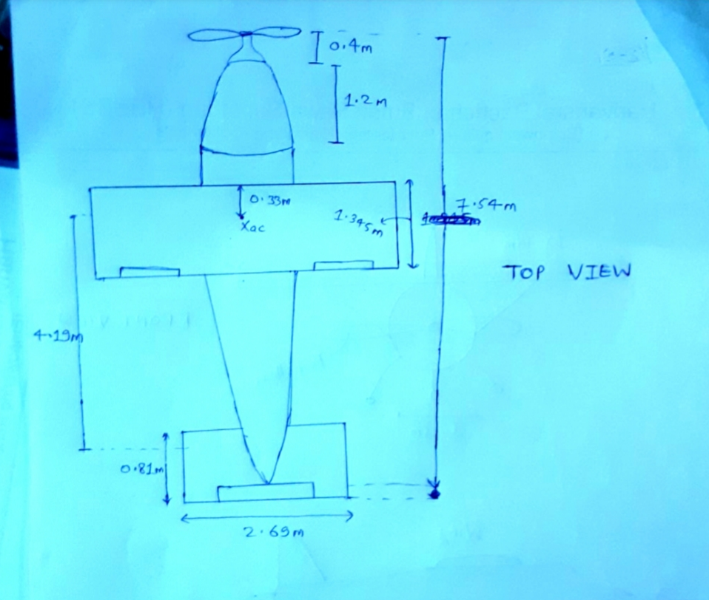

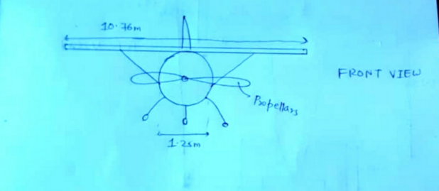

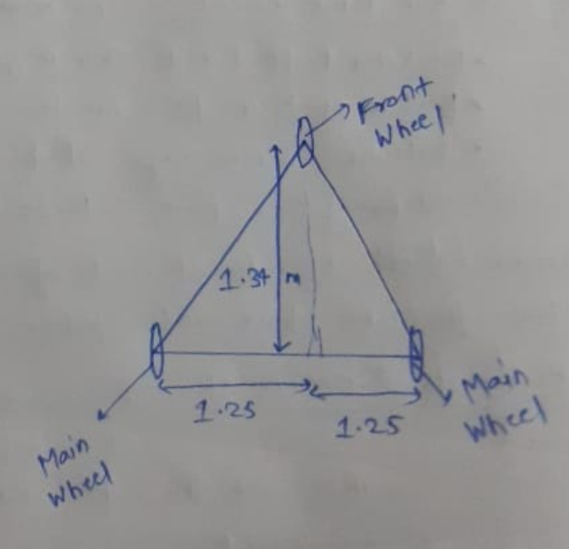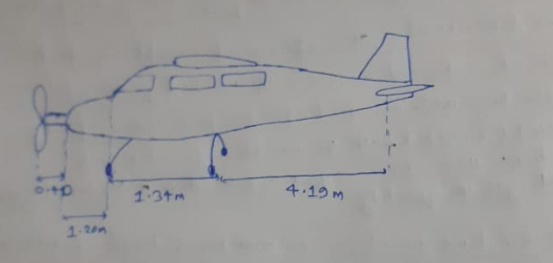

Estimated Parameters

Stability Derivatives

|  |  |  |
| --- | --- | --- |
| Parameter | Symbol | **Values** |
| Total Weight of Aircraft (kg) | W | 1370 |
| Cruise Velocity of Aircraft (m/s) | V | 50 |
| Ambient Air Density (kg/m3) | ρ | 1.225 |
| Position of Centre of Mass w.r.t. wing L.E. (m) | xcg | 0.672 |
| Wing Span (m) | b | 10.76 |
| Length of wing root chord (m) | cr | 1.345 |
| Length of wing tip chord (m) | ct | 1.345 |
| 2\*Length of each rectangular section / b | r | 1 |
| Wing airfoil | -- | NACA63-412 |
| Sectional lift curve slope of wing airfoil (rad.-1) | (CLα)wA | 5.81 |
| Zero lift angle of attack of wing airfoil (deg.) | αL0 | -3 |
| Coefficient of pitching moment at aerodynamic  centre of wing airfoil | (Cmac)wA | -0.08 |
| Wing setting angle (deg.) | iw | 0 |
| Sweep of wing (deg.) | (Λ)w | 0 |
| Body z-axis position of wing aerodynamic  centre (m) | zw | 0 |
| Span of each aileron (m) | ba | 1.076 |
| Aileron chord (m) | ca | 0.269 |
| Span of each flap (m) | bf | 0 |
| Flap chord (m) | cf | 0 |
| Horizontal Stabilizer Span (m) | bh | 2.69 |
| Length of horizontal stabilizer root chord (m) | crh | 0.81 |
| Length of horizontal stabilizer tip chord (m) | cth | 0.81 |
| Horizontal Stabilizer airfoil | -- | NACA0009 |
| Sectional lift curve slope of horizontal  stabilizer airfoil (rad.-1) | (CLα)hA | 5.61 |
| Tail setting angle (deg.) | it | -1.346 |
| Length of horizontal tail arm (m) | Lh | 4.19 |
| Horizontal tail volume efficiency | ηh | 0.9 |
| Elevator span (m) | be | 2.421 |
| Elevator chord (m) | ce | 0.372 |
| Vertical Stabilizer Span (m) | bv | 1.477 |
| Length of vertical stabilizer root chord (m) | (cr)v | 1.193 |
| Length of vertical stabilizer tip chord (m) | (ct)v | 0.715 |
| Vertical Stabilizer airfoil | -- | NACA0009 |
| Sectional lift curve slope of vertical stabilizer  airfoil (rad.-1) | (CLα)vA | 5.61 |

|  |  |  |
| --- | --- | --- |
| Rudder span (m) | br | 1.181 |
| Rudder chord (m) | cr | 0.286 |
| Length of vertical tail arm (m) | Lv | 4.3 |
| Vertical tail volume efficiency | ηv | 0.9 |
| Total length of Aircraft (m) | Lo | 7.53 |
| Length of cockpit (m) | Lcockpit |  |
| Maximum Width of cockpit (m) | Wcockpit | 1.25 |
| Minimum Width of tail boom (m) | Wboom |  |
| Maximum Depth of fuselage (m) | d | 1.25 |
| Incidence of the fuselage camber line (deg.) | if | 0 |
| Position of fuselage aerodynamic centre w.r.t.  wing L.E. (assumed) (m) | (xac)f |  |
| Radius of pusher/puller propeller (m) | -- | 0.952 |
| Landing gear dimension  (diameter\*width)(m\*m) | -- |  |

Wing

Wing area:

C:\Users\Ss-Brothers\Pictures\Screenshots\msedge_Hhs9o1JVRC.png

## S=14.47m2

Aspect ratio of wing,

C:\Users\Ss-Brothers\Pictures\Screenshots\msedge_Fn6Gs1qdAo.png

𝐴𝑅𝑤=8

Taper ratio of equivalent wing

C:\Users\Ss-Brothers\Pictures\Screenshots\msedge_5tcXVscfp3.png

𝜆𝑒𝑞=1

## 𝑐̅=1.345m

(Λ)w = 0O



𝐶𝐿𝑑𝑒𝑠𝑖𝑔𝑛 =0.605

## e =0.819 (NASA Report)

𝑤

𝐶𝐿𝛼𝑤A = =5.81(NACA63412)

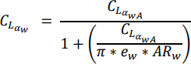

𝐶𝐿𝛼𝑤 =4.53 /rad



𝐶𝐿𝑜𝑤 = 0.237



𝐶𝑚𝑎𝑐w=-0.064

Area of ailerons: Sa=ca\*ba=0.289m2

Horizontal tail

Horizontal stabilizer area, Sh=ch\*bh

## Sh=2.178m2



ARh=3.3



Horizontal tail volume ratio,

Vh=0.53

Induced-angel span efficiency factor for horizontal tail,

## eh=0.841

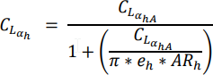

𝐶𝐿𝛼ℎ=3.5/rad

Downwash at zero angle of attack



## 𝜀o=0.018



𝛿𝜀/ 𝛿𝛼=0.3

Area of elevator,

*Se*=0.90m2

𝑆𝑒 = 𝑏𝑒 ∗ 𝑐𝑒

Vertical tail

𝜆𝑣=0.6

## 𝑆𝑣=1.41m2



𝑐 ̅̅𝑣̅=0.974m

𝐴𝑅𝑣=1.54

Vertical tail volume ratio,



𝑉𝑣 = 0.03

Induced-angle span efficiency factor for vertical tail is estimated to be,

𝑒𝑣 = 0.7

Sr=0.337m2

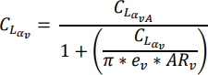

𝐶𝐿𝛼𝑣=2.63/rad

Area of rudder:

Fuselage



𝐶m𝛼(fus)=0.241

𝐶𝐿𝛼(fus)=0.064/rad



𝐶𝐿𝛼t=0.33

Longitudinal aerodynamics coefficients and stability and control derivatives



𝐶𝐿o=0.172



𝐶𝐿𝛼=4.85/rad



𝐶L𝛼 = 0.93/rad



## 𝐶𝐿q=4.91/rad



where, 

𝐶𝐿𝛿𝑒=0.331/rad

Pitch





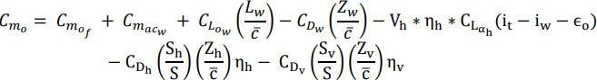

𝐶𝑚𝑜 =-0.084



𝐶𝑚𝛼 =-0.087/rad



𝐶𝑚𝛼 =-2.89/rad



𝐶𝑚𝑞 =-9.32/rad



𝐶𝑚𝛿𝑒 = -1.03/rad

Drag

𝐶𝐷𝑢 = 0

𝐶𝐷𝑝 =0.042



𝐶𝐷𝑜 =0.051



𝐶𝐷𝑎 =0.26/rad

𝐶𝐷𝛼 = 0

𝐶𝐷𝑞 = 0



𝐶𝐷𝛿𝑒 =0.034/rad

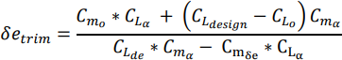

Trim

𝛿𝑒𝑡𝑟𝑖𝑚 =-0.089



𝛼𝑡𝑟𝑖𝑚 =0.088



𝐶𝐷𝑡𝑟𝑖𝑚 =8.646

Lateral aerodynamic coefficents and stability and control derivtives

Side Force

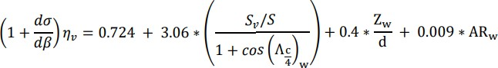

## (1 + 𝑑𝜎 /𝑑𝛽) 𝜂𝑣 =0.945

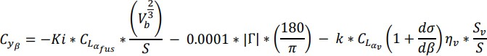

𝐶𝑦𝛽 =-0.177

𝐶𝑦𝑝 =0.1695



## 𝐶𝑦𝑟 =0.00436

𝐶𝑦𝛿𝑎 = 0



## 𝐶𝑦𝛿𝑟 =0.103

Roll

𝐶𝑙𝛽 =-0.1055



𝐶𝑙𝑝 =-0.568

𝐶𝑙𝑟 =0.16



𝐶𝑙𝛿𝑟 =0(Can be neglected)

Yaw

𝐶𝑛𝛽 =0.209

𝐶𝑛p=-0.401

𝐶𝑛𝑟 =-0.021



𝐶𝑛𝛿𝑟 =-0.0359