ProfitRadar - Inventory Management System
A Capstone Project

Presented to the Faculty of the College of PHINMA -University of Iloilo

In Partial Fulfillment of the Requirements
For the Degree of Bachelor of Science in Information Technology

By:
Aiedgen Abong
Reuel Borlado
June, 2026

ABSTRACT
The ProfitRadar - Inventory Management System was developed to automate and modernize the inventory and sales operations of NKM Agri-Poultry Supply. The business previously relied on traditional manual recording, which resulted in inaccurate stock counts, delayed transaction updates, difficulty in monitoring product performance, and challenges in generating timely reports. To address these issues, the system was designed as a web-based platform that provides real-time inventory tracking, automated stock adjustments, profit computation, low-stock alerts, and comprehensive reporting tools. Using PHP, MySQL, HTML, CSS, and Bootstrap, the system was built following the Agile Software Development Life Cycle, allowing iterative improvement based on user feedback. Core modules include Product Management, Sales and Purchase Processing, Supplier Management, Low-Stock Monitoring, Dashboard Analytics, and Reporting. The system was tested in an actual business environment, where results showed significant improvements in operational accuracy, speed, and efficiency. Stock accuracy increased from 85% to 98%, transaction processing time was reduced by more than half, and inventory discrepancies dropped to minimal levels. User evaluation indicated high satisfaction with the system’s usability, clarity, and automation features. The dashboard and reporting tools provided meaningful insights for decision-making, allowing the owner to monitor business performance quickly and reliably.

Approval Sheet

In partial fulfillment of the requirements for the Bachelor of Science in Information Technology, this Capstone Project entitled “ProfitRadar - Inventory Management System” prepared and Submitted by Aiedgen Abong and Reuel Borlado who are hereby recommended for corresponding final evaluation.

Marlo Kyn B. Bunda
Adviser

Approved by the Panel of Evaluators with a grade of PASSED

Dr. Arnold M. Fuentes, Ph. D, MPA, MMIT
Chairman

Ryan C. Valeriano
Member

Accepted in partial fulfillment of the requirements of the degree Bachelor of Science in Information Technology

Seth A. Nono, MSCS
CITE, DEAN OF DEAN

ACKNOWLEDGEMENT

Completing the ProfitRadar system has been a meaningful journey for us, and we would like to recognize the people who made it possible.

We are truly thankful to our adviser, Mr. Marlo Kyn bunda, for his guidance and for challenging us to improve our work. His suggestions and support helped us stay on track and develop a better system.

We also want to acknowledge our friends and classmates who were always there to lend a hand or offer encouragement whenever we needed it. Their presence made the process less stressful and more manageable.

Finally, we are grateful to everyone who, in their own way, supported us throughout this project. This work would not have been completed without them.

TABLE OF CONTENTS

Title page ---------------------------------------------i
Approval Sheet-----------------------------------------ii
Acknowledgement-------------------------------------iii
Abstract---------------------------------------------iv
Table of
Contents—---------------------------------------------v
List of
Figures----------------------------------------------vi
List of
Tables----------------------------------------------vii

CHAPTER I
Introduction------------------------------------------1
Background of the
Study-------------------------------------------------2
Statement of the
Problem-----------------------------------------------4
Objectives of the
Study-------------------------------------------------6
Significance of the
Study-------------------------------------------------9
Scope and
Limitation--------------------------------------------10

CHAPTER II
Literature Review-------------------------------------16
Traditional VS Modern
System------------------------------------------------17
Technology
Use---------------------------------------------------18
Case
Studies-----------------------------------------------19

CHAPTER III
Methodology-------------------------------------------20
Research
Design------------------------------------------------22
Model
Use---------------------------------------------------23
Use Case
Diagram-----------------------------------------------39

Data flow Diagram—------------------------------------40
Entity Relationship
Diagram-----------------------------------------------44

CHAPTER IV
Result and
Discussion--------------------------------------------62
System’s
Features----------------------------------------------77
Implementation
Challenges--------------------------------------------81
User
Feedback----------------------------------------------83
Comparison to other
System------------------------------------------------86

CHAPTER V
Conclusion and
Recommendation----------------------------------------103
Conclusion--------------------------------------------104
Recommendation----------------------------------------105
Final
Thoughts----------------------------------------------107

Chapter 1

Introduction to the Study
This project, the ProfitRadar - Inventory Management System, was developed to modernize and improve the daily business operations of NKM Agri-Poultry Supply, a local poultry supply store engaged in selling various agricultural and livestock products such as feeds, rice, and related goods. The system was designed to provide the business owner with a reliable, accurate, and automated way of managing inventory, sales, and profit tracking, eliminating the need for slow and error-prone manual methods.
Before the implementation of the system, the business experienced difficulty in monitoring product quantities, computing profit margins, and tracking sales trends. The absence of a centralized system made it hard for the owner to identify which items were low in stock or which products were performing well. These challenges often led to late restocking, missed sales opportunities, and difficulty in generating daily or monthly reports.
To address these issues, the ProfitRadar System was developed as a web-based inventory and sales management solution that automatically records transactions, tracks stock levels in real time, and calculates total profit. In addition, the system introduces enhanced inventory monitoring features such as stock value computation and available stock tracking, allowing the owner to better understand both the quantity and financial value of inventory.
The system also features an improved and user-friendly interface with dashboard cards and visual indicators that display key metrics such as total stock value, low-stock items, and sales summaries. These enhancements allow faster data interpretation and more efficient decision-making.
The implementation of this system aimed to transform the traditional inventory process into a faster, smarter, and more data-driven operation suitable for a growing business like NKM Agri-Poultry Supply.

Background of the Study
Inventory management and sales tracking are essential components of any retail business. Without an organized system, it is difficult to maintain accurate records of stock movement, supplier purchases, and profit calculations. The ProfitRadar - Inventory Management System was created to address these challenges through the use of digital automation and structured data management.
The system was developed using the following technologies:
- Backend: PHP (Hypertext Preprocessor)
- Database Management System: MySQL
- Frontend: HTML5, CSS, Bootstrap 5, and JavaScript
- Local Server Environment: XAMPP (Apache + MySQL)
- Browser Compatibility: Google Chrome and Microsoft Edge
The architecture followed a three-tier structure consisting of the presentation, application, and data layers:
- Presentation Layer: This layer contained the user interface that displayed inventory records, product details, and sales summaries. It was built using HTML and Bootstrap for responsive design, ensuring that the interface was clear and easy to navigate. The dashboard provided quick insights into profit, sales, and stock alerts, enabling the owner to analyze performance at a glance.
- Application Layer: This layer handled the logic of the system. It included processes for sales and purchase transactions, profit calculation, and low-stock alert generation. Whenever a transaction occurred, the system automatically updated inventory quantities and computed the corresponding profit or loss.
Each module — including Product Management, Sales Monitoring, Supplier Records, and Reports — was interconnected to maintain data accuracy and consistency.
- Data Layer: The MySQL database stored all business information in structured tables.
These included:
  - Products – contained product name, code, category, price, stock, and threshold level.
  - Suppliers – stored supplier contact information and purchase history.
  - Transactions – recorded all sales and purchases, including date, amount, and product sold.
  - Transaction Items – detailed the individual items within each transaction.
- The database design supported data integrity and referential consistency, which ensured that all updates to stock or sales data reflected correctly across related tables.
The system operated under a local environment, where data was stored securely within the business premises. While it was designed for a single-user setup, it could be easily upgraded to support multiple users or cloud deployment in the future.
The use of PHP and MySQL allowed the system to process real-time data efficiently, providing the owner with up-to-date information about inventory and profit status. This technological foundation made the ProfitRadar System reliable, scalable, and cost-effective — ideal for small businesses like NKM Agri-Poultry Supply.

Statement of the Problem

Businesses that rely heavily on selling physical products, like NKM Agri-Poultry Supply, often face challenges in tracking inventory and sales accurately. Without an automated system, it becomes difficult to monitor product movement, calculate profits, and make informed decisions regarding stock replenishment. The following problems were identified and addressed by the ProfitRadar - Inventory Management System:
- Difficulty in Tracking Stock Levels – Without real-time data, it was hard to determine the exact number of products remaining in stock, which sometimes resulted in stockouts or overstocking.
- Lack of Accurate Profit Monitoring – Manual calculations made it difficult to accurately measure total profit, sales revenue.
- Slow Transaction Recording – Writing transactions manually consumed time and often led to missing records or duplicate entries.
- No Automated Reports – Generating daily or monthly reports required manual computation, which delayed decision-making.
- No Notification for Low Stock Items – The owner had no alert when items reached the critical level, leading to late restocking and loss of sales.
- Limited Data Organization – Records were scattered across notebooks and spreadsheets, making it hard to find and analyze past transactions.
The system was developed to eliminate these problems by providing automation, accuracy, and real-time updates in all inventory and sales processes.

Objectives of the Study

The main objective of this project was to design and develop the ProfitRadar - Inventory Management System for NKM Agri-Poultry Supply to automate the recording, monitoring, and reporting of inventory and sales transactions. The system aimed to help the business owner make informed decisions, minimize financial loss, and improve operational efficiency through accurate, real-time, and organized data management.
Specific Objectives:
- To create a centralized digital database for all inventory records: The system was designed to store all essential business information — including product details, suppliers, stock levels, and sales history — in one organized and accessible database. This allowed the owner to retrieve and update information instantly without the need for scattered paper or spreadsheet files.
- To implement real-time inventory tracking and automatic stock updating: Every sale, purchase, or return automatically updated the corresponding product’s stock quantity. This ensured that the inventory count was always accurate and up to date, allowing the owner to monitor which products were available, nearly out of stock, or newly added.
- To provide automated computation of profit and cost: The system calculated profit margins automatically by comparing selling prices and cost prices for each transaction. It also computed total sales income within a given period, helping the owner evaluate the overall business performance without using calculators or manual spreadsheets.
- To design a low-stock alert mechanism for timely restocking: A built-in notification feature alerted the owner whenever a product’s stock level reached or dropped below its minimum threshold. This function helped prevent product shortages, maintain customer satisfaction, and avoid lost sales due to unavailable items.
- To develop a user-friendly and intuitive dashboard interface: The dashboard was created to display key performance indicators (KPIs) such as total profit, number of products in stock, low-stock items, and recent sales summaries. The design emphasized simplicity and accessibility so that the owner could manage operations efficiently without technical expertise.
- To generate automated and comprehensive sales and inventory reports: The system was equipped with reporting tools that summarized daily, weekly, and monthly transactions. These reports included information such as best-selling products, total sales per category, and financial summaries, which could be exported or printed for business reference.
- To ensure system reliability and data accuracy through automation: The ProfitRadar System minimized human errors by automating computations, reducing data duplication, and maintaining accurate historical records. This made business analysis faster, more consistent, and more dependable.
- To support decision-making and business growth through organized analytics: By integrating summarized data and profit insights into a single platform, the system empowered the business owner to make data-driven decisions regarding purchasing, pricing, and inventory planning. It also provided a strong foundation for scaling operations in the future.
- To compute real-time stock value based on product cost and quantity: The system automatically calculates the total value of all inventory items by multiplying the cost price of each product by its current stock quantity. Instead of manually estimating inventory worth, the system provides an instant and accurate financial value of all stored products. This helps the owner understand how much money is currently invested in inventory.
- To track available stock by considering reserved quantities: This focuses on showing the actual number of items that can still be sold. The system does not only display total stock but also subtracts reserved or allocated quantities (such as pending orders or deliveries). This ensures that the owner avoids overselling and always knows the real available stock for transactions.
- To enhance dashboard visualization using cards and color-coded indicators: This improves how information is presented in the system. Instead of plain tables, the dashboard uses visual cards and colors (e.g., red for low stock, green for normal levels) to highlight important data. This makes it easier and faster for the owner to understand business performance without needing to analyze raw data.
- To provide detailed inventory insights including stock value and availability: This ensures that the system goes beyond basic inventory tracking. It provides deeper insights such as which products have high value, which items are low in stock, and how much inventory is actually available. These insights help the owner make better decisions regarding restocking, pricing, and inventory planning.
Significance of the Study

The development of the ProfitRadar - Inventory Management System brought several benefits to the business owner and the overall operation of NKM Agri-Poultry Supply.
- For the Business Owner: The system provided a real-time overview of product availability, sales performance, and overall profit. It eliminated the need to manually check product stock and allowed the owner to make quick, informed decisions based on accurate data.
- For the Business Operation: Automated features such as sales computation, report generation, and low-stock alerts saved time and reduced the chances of human error. This led to smoother daily transactions and better inventory control.
- For Financial Management: The reports helped the owner understand which products generated the highest returns and which ones required better pricing or restocking strategies.
- For Long-Term Growth: The system supported scalability — additional features, categories, or suppliers could be added as the business expanded. It also provided organized historical data that could guide future planning.

Scope and Limitation of the Study
This ProfitRadar - Inventory Management System was designed and implemented exclusively for NKM Agri-Poultry Supply, with the primary goal of automating the business’s inventory and sales operations. It provided a complete digital solution for tracking stock, recording transactions, monitoring profits, and analyzing product performance.
- Product Management: The owner was able to register, edit, update, and remove products within the system. Each product entry contained critical details such as item code, name, category, cost price, selling price, supplier, and stock quantity. The system also displayed total product count, stock value, and sales history for easy reference.
- Supplier Management: The system allowed the owner to store and manage supplier information, including contact names, phone numbers, addresses, and email addresses. This made supplier coordination more convenient and traceable, especially for restocking purposes.
- Sales and Purchase Management: All product sales and purchase transactions were recorded digitally. The system automatically deducted sold quantities from the inventory and calculated total sales amounts, profits, and remaining stock. Each purchase entry updated stock levels, maintaining data consistency across modules.
- Low-Stock Alert and Threshold Configuration: The system included a low-stock monitoring module, which automatically detected and alerted the owner when product quantities dropped below the set threshold. This helped prevent stockouts and ensured continuous product availability. Each product could be assigned a unique threshold value depending on its sales frequency and importance to the business.
- Report Generation and Dashboard Analytics: The system generated summarized sales and inventory reports on a daily, weekly, and monthly basis. The dashboard interface presented key metrics, such as total sales, total profit, and the number of products below the stock threshold. Graphical charts and tables made it easier for the owner to visualize business performance over time.
- Profit Monitoring: The ProfitRadar System automatically calculated profit margins for each sale for the entire business. This gave the owner a clear understanding of which products were most profitable and how overall performance compared across time periods.
- Inventory Metrics Enhancement: The system includes advanced inventory metrics such as total stock value and available stock (calculated as stock quantity minus reserved quantity). These features provide deeper insights into inventory performance and financial value.

- User Interface Improvements: The system includes an improved dashboard design with visual cards, color indicators, and better layout structure. These enhancements make it easier for the owner to quickly understand inventory status and business performance.
Limitations:
- Manual Data Encoding for Initial Setup: During the setup phase, all products, categories, and suppliers had to be entered manually. While subsequent operations were automated, the initial data entry process depended on the owner’s input accuracy.
- Limited Device Support: The system was optimized for desktop use and was not yet adapted for mobile or tablet screens.
- Limited Graphical Reporting: Although the dashboard provided summary data and key performance metrics, it had limited visual analytics such as charts and trend comparisons. Reports were mainly in tabular form, and graphs were simple representations. Further versions could include interactive analytics or downloadable report formats (PDF, Excel).
- Local-Only Deployment: The system ran exclusively on a local server environment using XAMPP. It did not have a cloud-hosted or online version. This meant that access to the system was limited to the business premises where the system was installed. Remote access through the internet or mobile devices was not yet supported.

Definition of Terms

- Automation – The process of using technology to perform tasks automatically without human intervention. In this system, automation refers to the automatic updating of inventory, sales recording, and profit computation.
- Dashboard – The main interface of the system where the business owner can view summarized information such as total sales, profit, stock levels, and low-stock alerts in a single, organized display.
- Database – A structured collection of data stored electronically. In this study, it refers to the MySQL database used to store product information, supplier details, sales transactions, and reports.
- Inventory Management System – A computerized system that helps monitor, record, and manage stock levels, purchases, and sales transactions. It ensures that all inventory-related data is accurate and updated in real time.
- Local Server (XAMPP) – A software package used to host the system locally within the business premises. It provides the environment needed to run PHP and MySQL, allowing the system to operate even without an internet connection.
- Low-Stock Alert – A system-generated notification that informs the owner when a product’s quantity drops below its minimum threshold. This feature helps prevent stockouts and ensures timely restocking.
- PHP (Hypertext Preprocessor) – A server-side scripting language used to build the backend of the system. It handles processes such as sales computation, profit calculation, and data storage.
- Profit Margin – The difference between the cost price and the selling price of a product, representing the earnings generated per item sold.
- ProfitRadar System – The proposed web-based inventory and sales management system developed for NKM Agri-Poultry Supply. It automates transaction recording, stock monitoring, and profit tracking to improve business efficiency.
- Product Threshold – The minimum stock quantity set for each product. When the quantity reaches or goes below this level, the system triggers a low-stock alert.
- Real-Time Update – The immediate reflection of changes in data as transactions occur. In the system, this means inventory levels, sales records, and profits are updated instantly after each transaction.
- Reports – Automatically generated summaries of business transactions. These include daily, weekly, and monthly reports on sales, inventory, profit.
- Sales Monitoring – The process of recording and tracking all product sales to ensure accuracy in profit computation and inventory updates.
- Stock Level – The current quantity of a particular product available in the inventory. The system monitors this value continuously to help the owner manage product availability.
- Supplier Management – A module within the system that stores and organizes supplier information such as names, contact details, and purchase history for easier coordination and restocking.
- System Architecture – The overall design and structure of the system, divided into three layers: presentation (user interface), application (process logic), and data (storage).
- Transaction – Any recorded activity that affects inventory or sales, including product purchases, sales, and returns. Each transaction updates the database automatically.
- User Interface (UI) – The part of the system that the user interacts with directly. It includes buttons, menus, tables, and dashboards designed to be simple and easy to navigate.
- Web-Based Application – A software system accessed through a web browser rather than installed as a standalone desktop program. The ProfitRadar System is web-based but runs on a local server.
- Stock Value – The total monetary value of inventory calculated by multiplying the product cost price by its quantity in stock.
- Available Stock – The actual number of items available for sale after subtracting reserved or allocated quantities from total stock.
- Dashboard Cards – Visual components used in the system interface to display key metrics such as stock value, sales, and low-stock items in a clear and organized format.

Chapter 2

Review of Related Literature
This chapter presents a comprehensive review of literature and studies relevant to the development of the ProfitRadar - Inventory Management System. The discussion is organized into four key areas: an overview of inventory management concepts, a comparison of traditional versus modern inventory systems, an examination of the technologies used in contemporary inventory solutions, and a presentation of related case studies from local and international contexts. The reviewed literature collectively supports the need for digital systems that improve accuracy, efficiency, and data-driven decision-making in small to medium-sized enterprises.
Inventory management is an essential process that involves tracking and controlling stock levels to ensure business continuity. According to Laudon and Laudon (2020), effective inventory systems significantly minimize human errors and enhance productivity by replacing traditional manual processes with automated and real-time monitoring. Manual tracking often leads to inaccuracies, delayed reporting, and stock discrepancies. Beal (2022) emphasized that adopting automated inventory solutions improves data reliability, reduces losses, and allows businesses to respond quickly to stock shortages or overstock conditions. These foundational concepts directly informed the design and scope of the ProfitRadar - Inventory Management System, which was built to address the same core challenges experienced by NKM Agri-Poultry Supply.

Traditional VS Modern System
Traditional inventory management methods, such as manual ledgers, paper-based logs, and spreadsheet recording, have long been the standard for small businesses. While these approaches are straightforward, they are highly prone to human error, data duplication, and delayed updates. Turban, Pollard, and Wood (2018) noted that manual, paper-based processes are inefficient in data-heavy retail environments because they rely entirely on human accuracy and timeliness, which are difficult to sustain consistently. For a business like NKM Agri-Poultry Supply, which handles multiple product categories and daily transactions, traditional methods resulted in stockouts, inaccurate profit calculations, and difficulty generating meaningful reports.
Modern inventory systems, by contrast, introduce automation, real-time data processing, and centralized record-keeping. Rouse (2021) explained that automated systems eliminate repetitive manual tasks and ensure consistent operational performance, reducing the likelihood of discrepancies in stock counts and sales figures. Modern systems are also capable of triggering low-stock alerts, generating reports instantly, and synchronizing inventory data across transactions without manual intervention. Stair and Reynolds (2019) further emphasized that modern information systems function not only as management tools but also as analytical platforms that support decision-making through dynamic reporting and performance dashboards. The shift from traditional to modern inventory practices represents a critical improvement for small businesses aiming to scale their operations and improve profitability.

Technology Use
The selection of appropriate technologies is fundamental to the success of any inventory management system. For the ProfitRadar System, PHP was used as the primary server-side scripting language due to its flexibility, wide adoption, and compatibility with MySQL database environments. Hoffer, Ramesh, and Topi (2016) explained that relational databases such as MySQL are especially effective for structuring interconnected business records, including products, suppliers, categories, and transaction histories. MySQL’s ability to handle complex queries efficiently makes it an ideal solution for inventory systems that require real-time stock updates and audit logging. Fisher (2021) similarly highlighted that SQL-based systems provide fast, secure, and consistent handling of operational data, making them suitable for businesses with frequent transaction activity.
On the frontend, HTML5, CSS3, Bootstrap 5, and JavaScript were employed to create a responsive and accessible user interface. Merkle and Bick (2019) pointed out that user-friendly interfaces directly improve productivity by simplifying navigation and making system features intuitive to non-technical users. Bourgeois (2014) similarly argued that information systems can only achieve their intended goals when end users are able to operate them with minimal difficulty. The combined use of Bootstrap’s responsive grid system and JavaScript’s dynamic capabilities allowed ProfitRadar to deliver a clean, organized, and interactive experience. Furthermore, the XAMPP local server environment provided a stable, cost-free hosting platform suitable for a small business setting, enabling the system to function reliably without the need for cloud infrastructure or internet connectivity.

Case Studies
Several related case studies affirm the effectiveness of automated inventory systems in both international and local business contexts. Dissanayake and Kandambi (2021) conducted a study on the impact of computerized inventory systems in small retail businesses in Sri Lanka and found that the adoption of automated tools led to a significant reduction in human error and improved workflow efficiency. Their findings showed that businesses that transitioned from manual to digital inventory systems experienced faster transaction processing, more accurate stock monitoring, and better supplier coordination. These outcomes closely align with the improvements observed in the ProfitRadar System implementation at NKM Agri-Poultry Supply.
Zhang and Cheng (2020) examined how small businesses in China used automated stock monitoring to improve inventory turnover and understand buying patterns. Their research demonstrated that digital inventory tools helped business owners make more informed restocking decisions, reduce carrying costs, and identify fast-moving products. These findings support the design of ProfitRadar’s low-stock alert module and reporting features, which were specifically developed to give the business owner actionable insights into product performance and inventory availability. Locally, small businesses in the Philippines face comparable challenges, including poor stock visibility, reliance on informal recording methods, and limited access to affordable technology solutions. The ProfitRadar System addressed these issues by offering a cost-free, locally deployed digital platform that modernized the inventory and sales processes of NKM Agri-Poultry Supply. Ayo and Ukpere (2020) also noted that automation and digitalization are powerful drivers of organizational efficiency, particularly in businesses transitioning from informal to structured operational models. The collected case studies collectively validate the approach taken in developing ProfitRadar and reinforce the expectation that automated inventory systems produce measurable improvements in accuracy, efficiency, and business decision-making.

Chapter 3

Methodology

This chapter presents the research and development methodology applied in the design, construction, testing, and evaluation of the ProfitRadar - Inventory Management System for NKM Agri-Poultry Supply. The methodology provided a structured framework that guided the researchers throughout the entire system development process—from problem identification to system implementation and evaluation.
The study primarily adopted a Research and Development (R&D) approach, which was supported by principles of descriptive and applied research. The R&D approach was appropriate because the study aimed to develop a functional software solution that could address real operational problems experienced by small poultry supply businesses. Descriptive methods were used to understand and document the existing manual inventory processes, while applied research focused on transforming the findings into a working system that improved business efficiency and accuracy.
The methodology ensured that every stage of development followed a systematic and scientific process. The Agile Software Development Life Cycle (SDLC) was implemented to enable continuous feedback, flexibility, and iterative improvements. Through this approach, the researchers were able to refine the system incrementally based on client evaluation and testing outcomes.
This chapter presented the methods and tools used to achieve the study’s objectives, including the research design, R&D stages, system development process, and data collection methods. It also discussed how data were analyzed and validated to ensure the accuracy and effectiveness of the system. In addition, the chapter detailed the technologies used, system architecture, database design, sampling procedures, testing methodologies, and ethical considerations followed by.
Overall, this methodology served as the foundation for the development of the ProfitRadar system. It ensured that the software solution was designed with technical precision, usability, and relevance to the needs of a small poultry supply business, ultimately fulfilling the goals and objectives set forth in the study.

Research and Development Stage

The study employed a Research and Development (R&D) design combined with a descriptive and applied research approach. The R&D method was chosen because the main goal of the study was to design, develop, and evaluate a functional prototype of an inventory management system that met the operational needs of a small poultry supply business.
The descriptive research component described and analyzed the current manual inventory process used by the business. It identified the problems encountered such as inaccurate stock records, inefficient monitoring, and the lack of real-time reporting. Through surveys, interviews, and observation, we gathered information on how the store owner and staff managed their daily operations.
The applied research aspect was used in the development of the system, where theoretical principles of software engineering and database management were applied to solve real-world inventory issues. The research focused on the practical implementation of system functionalities such as inventory monitoring, low stock alerting, sales tracking, and supplier management.
The research design followed a user-centered development approach, where the requirements and feedback of the poultry supply business owner served as the main basis for iterative design and enhancement. This ensured that the final system was not only technically sound but also aligned with the actual workflow and business goals of the client.
The R&D process culminated in the deployment and evaluation of the ProfitRadar: Inventory Management System, which was assessed based on functionality, usability, reliability, and effectiveness in improving inventory and sales tracking.

Software Development Life Cycle (SDLC)
The Software Development Life Cycle (SDLC) served as the primary framework for the development of the ProfitRadar: Inventory Management System. It provided a structured process that guided us in the systematic design, implementation, and evaluation of the system. By following the SDLC, We ensured that every stage of development was properly planned, executed, and reviewed before moving to the next phase.
The study adopted the Agile Development Model as its SDLC approach. This model was chosen because it allowed flexibility, faster development, and continuous collaboration between the researchers and the poultry supply business owner. Agile development emphasized incremental progress, where small parts of the system were built and tested before integrating them into the complete product. This iterative process helped the us quickly respond to user feedback and refine features during the development stage.

The SDLC used in the study consisted of six key phases:
- Planning and Requirement Analysis
In this phase, we identified the existing problems in the poultry supply business through interviews, surveys, and direct observation. The main goal was to gather all necessary information regarding inventory and sales processes. The requirements were then categorized into functional requirements (such as product management, low-stock alerts, and supplier records) and non-functional requirements (including usability, reliability, and performance). This ensured that the system addressed both operational and user needs.
- System Design
This phase involved translating the gathered requirements into a technical design. We created data flow diagrams (DFDs), entity-relationship diagrams (ERDs), and designed the user interface layout. The system followed a three-layer architecture composed of the presentation layer (frontend), application layer (backend), and database layer. The design phase served as the blueprint that guided the coding and development of the system.
- Development and Implementation
During this phase, the actual coding of the system was performed. The system was developed using PHP for the backend, MySQL for the database, and HTML, CSS, and JavaScript for the frontend interface. The system was built in modules — such as Product Management, Sales Recording, Supplier Management, Low Stock Alert, and Inventory Analytics (including stock value computation and available stock tracking) — using Agile iterations. After each module was developed, it was tested and refined based on feedback from the business owner.
- Testing
The developed modules were thoroughly tested to ensure proper functionality and accuracy. We performed unit testing to verify each component, integration testing to check module compatibility, and user acceptance testing (UAT) with the poultry supply owner and staff to evaluate usability and reliability. Errors discovered during testing were corrected before deployment.
- Deployment
After passing all tests, the system was deployed locally using XAMPP for demonstration. We installed the system, configured the database, and initialized test data such as products and suppliers. The poultry supply owner and staff were trained to use the system, ensuring that they could perform tasks such as adding inventory, recording sales, and generating reports effectively.
- Maintenance and Continuous Improvement
After deployment, we monitored the system to ensure that it continued to perform effectively. Minor bugs discovered during use were fixed, and several enhancement ideas were documented for future updates. These included adding an Admin Role Module, map-based supplier location tracking, and cloud access for remote monitoring.
By following these SDLC phases, we successfully developed a reliable and user-friendly Inventory Management System tailored to the operational needs of a small poultry supply business. The structured yet flexible Agile process ensured continuous improvement, faster development, and better alignment with the client’s actual business workflow.
In addition to basic inventory functions, the system incorporated enhanced features such as real-time stock value computation and available stock tracking. These features allowed the system to provide both quantity-based and financial insights into inventory. The dashboard interface was also improved using visual cards and color-coded indicators to enhance usability and data interpretation.

Data Collection Techniques
To ensure that the development of the ProfitRadar: Inventory Management System was aligned with the actual needs of the poultry supply business, several data collection techniques were used during the research and development process. These techniques helped us gather accurate, relevant, and comprehensive information about the existing inventory management practices, user requirements, and system evaluation feedback.
The data collection techniques included the following:
- Interview
We conducted semi-structured interviews with the poultry supply business owner and staff. The purpose of the interview was to understand how they managed their inventory manually, the challenges they encountered, and the features they expected in an automated system. The responses provided valuable insights that guided the formulation of system requirements and the design of system features such as the low-stock alert and supplier management modules.
- Observation
Direct observation was carried out to analyze how the business handled its daily operations, including the recording of product stocks, sales transactions, and supplier deliveries. Through observation, we identified inefficiencies in the manual process—such as delays in stock updating and difficulties in tracking supplier information—which became the foundation for improving these processes in the developed system.
- Survey Questionnaire
After the system was developed, a survey questionnaire was distributed to the store owner and staff who tested the system. The survey aimed to gather quantitative feedback on the system’s functionality, usability, efficiency, and accuracy. The questionnaire used a Likert scale to measure user satisfaction and to determine whether the system met their expectations.
- Document and Record Analysis
Existing business records, such as sales receipts, inventory lists, and supplier logs, were reviewed to understand the structure of the current documentation process. This analysis helped in designing the database schema and report generation features of the system, ensuring that they aligned with the business’s existing data organization practices.
- User Feedback during System Testing
During the testing and evaluation phase, users provided feedback on the system’s performance, layout, and ease of use. Their comments and suggestions were recorded and used to refine the system before final deployment. This continuous feedback loop was essential in ensuring that the system met real-world operational needs.
These data collection methods ensured that both functional requirements and user interface improvements were aligned with the actual needs of the business.

Justification for Selecting the Agile Methodology
The Agile methodology was selected because it supported flexibility, continuous feedback, and iterative system improvement. This approach was suitable for the study since the system was developed for a small business with evolving operational needs. Through Agile, the researchers were able to gather feedback after each module implementation and immediately apply improvements. This resulted in a more accurate, user-friendly, and efficient system aligned with real business processes.

System Architecture and Design

3.1 Overview
The creation of the ProfitRadar - Inventory Management System followed a structured and systematic research and development (R&D) process. This approach ensured that the system’s design, functions, and interface fully aligned with the daily business requirements of NKM Agri-Poultry Supply.

The R&D phase included the following expanded steps:

1. Business Workflow Understanding

The flow of operations inside the business—receiving stocks, updating inventory, processing sales, computing profits, and identifying products that needed replenishment—was closely examined. This understanding helped in designing a system that reflected the actual, real-world business workflow.

2. Identification of Problems and Operational Gaps

The owner's challenges were documented, including delays in checking stock levels, difficulty calculating profit, and the absence of warnings when products ran low. These problems shaped the basic purpose and scope of the system.

3. Requirements Gathering and Feature Definition

Based on consultations with the owner, essential features were identified and finalized. These included:
- automatic stock deduction

- daily/weekly/monthly sales summaries

- integrated profit computation

- supplier record management

- configurable low-stock alerts

- centralized reporting

4. System Analysis

The existing manual recording method was analyzed to determine what processes needed automation. This analysis guided the decisions for system design, database structure, and interface layout.

5. Iterative System Development

The system was developed in cycles. Each module was built, tested, improved, and then integrated with others. This incremental method ensured a stable and reliable output.

6. Testing and Validation

The system was tested using actual sample data such as real product names, supplier lists, and typical daily sales. Errors, inconsistencies, or missing functions were identified and corrected immediately.

7. Deployment and Fine-Tuning

Upon successful testing, the system was deployed on the business computer through a local server. Adjustments were applied to optimize speed, usability, and accuracy based on the owner’s experience during initial use.

This overall approach allowed the system to grow naturally from real operational needs, ensuring strong usability and real business value.
3.2 System Architecture

This System Design phase served as the blueprint of how the ProfitRadar - Inventory Management System was structured, organized, and intended to operate. This phase transformed all gathered requirements into a technical plan, defining each component of the system and how they interacted. The design ensured that the system was functional, efficient, maintainable, and capable of supporting the daily operations of NKM Agri-Poultry Supply.

The design process involved three major design activities: architectural design, database design, and user interface design.

1. Presentation Layer (User Interface Layer)
This layer included all screens and pages that the owner interacted with.
It consisted of:
- Dashboard
- Product management page
- Supplier management page
- Sales and purchase forms
- Low-stock alert display
- Reports and audit logs
The interface was designed to be simple, organized, and intuitive since the owner relied on quick access to business data. Navigation buttons, layout sections, and tables were arranged to minimize confusion and maintain workflow efficiency.

2. Application Layer (Business Logic Layer)
This layer handled all internal operations of the system. It contained the logic that executed tasks such as:
- Updating inventory after sales or purchases
- Automatically computing profit and revenue
- Computing stock value and available stock in real time
- Generating reports based on date range
- Comparing stock levels with thresholds
- Recording every action in the audit log
- Validating user inputs to ensure data accuracy
All functions written in PHP processed calculations, stored results, and ensured that every transaction was performed correctly. The system also handled advanced computations such as stock valuation and available stock tracking to improve inventory visibility.

3. Data Layer (Database Layer)
This layer stored all essential information using a structured MySQL database.
The database consisted of interconnected tables such as:
- products
- categories
- suppliers
- transactions
- transaction_items
- audit_log
Each table had a specific role and relationship to ensure consistency and prevent data duplication. For example:
- The transactions table stored sales/purchase headers
- The transaction_items table stored details like quantity and prices
- The products table updated stock values based on transaction items
The data layer ensured that all information remained accurate, consistent, and securely stored.

3.3 System and Components Module

This section presented the major system components and functional modules that made up the ProfitRadar Inventory -Management System. Each module was developed to perform a specific role within the system and to work together as an integrated solution for managing inventory, sales, suppliers, alerts, and overall business performance. The combination of these modules ensured that the system operated smoothly, updated stock accurately, and delivered real-time insights needed by the business owner. Overall, the integration of these modules ensured that the system not only automated inventory processes but also provided enhanced insights through computed metrics and improved data visualization

3.3.1 Inventory Management Module
The Inventory Management Module served as the core of the system.
It handled all operations related to storing, updating, and monitoring product quantities.
Functions included:
- Displayed all products with their details (name, code, category, cost, price, and stock).
- Automatically updated product quantities after every sale, purchase, or stock adjustment.
- Allowed the owner to add, edit, or delete items from the inventory.
- Computed real-time total stock value based on cost price and quantity.
- Calculated available stock by subtracting reserved quantities from total stock.
- Displayed available stock to reflect actual items ready for sale
- Organized products by category and supplier for faster monitoring.
This module ensured that the owner always had an accurate view of the store’s inventory, reducing errors and improving decision-making.

3.3.2 Sales Management Module
The Sales Module processed all customer transactions and computed financial results instantly.
Its functions included:
- Recording each sale made by the store.
- Automatically subtracting sold quantities from inventory.
- Calculating profit per product sold.
- Generating unique reference numbers for every sales transaction.
- Summarizing total daily and monthly sales.
The module ensured that every sale was properly documented and reflected in both inventory and profit reports.

3.3.3 Purchase and Supplier Module
This module managed all stock replenishment activities and supplier information.
It included features such as:
- Recording new purchases from suppliers.
- Adding purchased quantities automatically to the inventory.
- Storing complete supplier details (name, contact number, address).
- Tracking which suppliers provided specific products.
- Recording the cost price per delivery to ensure accurate profit computation.
This module strengthened the connection between suppliers and inventory, making restocking easier and more organized.

3.3.4 Low-Stock Alert and Monitoring Module
One of the most important components of ProfitRadar was the Low-Stock Alert Module, which helped prevent stockouts.3.3
It provided the following features:
- Monitored each product’s quantity in real time.
- Triggered a visual alert when stock dropped below the preset threshold.
- Displayed a dedicated list of all low-stock products.
- Allowed the owner to set custom low-stock values per product.
This module ensured that the owner was always aware of which products needed replenishment.

3.3.5 Reporting and Analytics Module
This module generated essential business reports and analytics used by the owner to track financial performance and sales behavior.
Reports produced included:
- Daily Sales Report – showed all sales for the day.
- Monthly Sales Report – summarized total monthly revenue and profit.
- Product Performance Report – showed best-selling and least-selling items.
- Inventory Summary Report – displayed quantity and stock value of products.
- Profit Report – computed financial gain.
The module visualized data clearly, helping the owner understand trends and make informed decisions.

3.3.6 Dashboard and Analytics Overview Module

The Dashboard Module acted as the main interface where the owner viewed essential business information at a glance.
Displayed metrics included:

• Total number of products
• Total available stock
• Total stock value
• Total sales for the day
• Total profit
• Low-stock items
• Latest transactions
The dashboard utilized visual cards, improved layout design, and color-coded indicators to highlight key information. This allowed the owner to quickly interpret data and identify important conditions such as low-stock items without navigating multiple pages.

3.3.7 Audit Log and Activity Tracking Module
To ensure transparency, a complete audit system was built.
Its functions included:
- Recording all system activities, including:
  - Sales
  - Purchases
  - Stock adjustments
  - Product updates
- Storing timestamps for every action made
- Providing traceability for future verification
This module ensured the integrity of system records and allowed the owner to backtrack operations when needed.

3.3.8 Product and Category Management Module
This module organized products and ensured they were grouped systematically.
It included:
- Adding and editing product categories
- Categorizing items for faster browsing
- Filtering inventory by category
- Organizing inventory structure for easier search and navigation
This module helped the owner manage multiple product varieties across different categories such as feeds, rice, dog food, and poultry supplies.

3.3.9 System Settings and Configuration Module
This module handled all customizable settings inside the system.
It allowed the owner to:
- Set global or individual low-stock thresholds
- Modify business details if needed
- Adjust system preferences
- Manage notification settings
It improved flexibility by allowing the system to adapt to actual business needs.

3.3.10 Database Management Module
The Database Management Module ensured the safe storage, organization, and retrieval of all system data.
It handled:
- Storing all products, transactions, and supplier information
- Maintaining links between tables such as:
  - products
  - suppliers
  - transactions
  - transaction_items
  - audit_log
- Ensuring data integrity and preventing inconsistencies
- Running SQL queries for reports and analytics
This module served as the backbone of the entire system.

3.3.11 Inventory Analytics and Metrics Module

This module enhanced inventory monitoring by providing deeper insights into stock performance and financial value.
Features included:

• Real-time computation of total inventory value
• Available stock calculation (stock minus reserved quantity)
• Identification of low-stock and critical items
• Display of inventory summaries using dashboard cards
• Monitoring of high-value and fast-moving products

This module allowed the owner to understand both the quantity and financial value of inventory, improving decision-making and business planning.

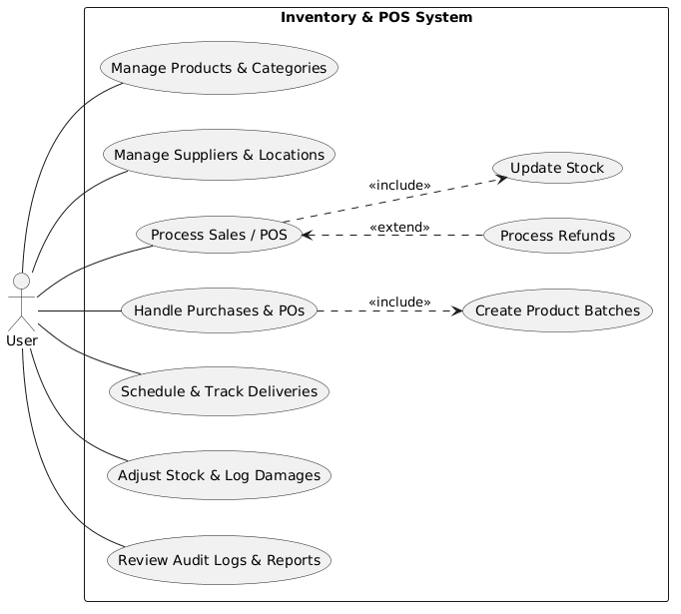
The Use Case Diagram shows that the Owner is the only user of the ProfitRadar System. All core operations of the business are performed directly by the owner. The system supports key functions such as recording sales, purchases, and refunds, adjusting stock levels, managing products and categories, and handling supplier information. Several processes, like sales, purchases, and refunds, automatically include stock adjustments, ensuring inventory levels are always accurate. Managing products also includes setting low-stock thresholds for better monitoring. It shows a clear flow of responsibilities and demonstrates that the system fully supports the owner in maintaining accurate inventory and efficient transactions.

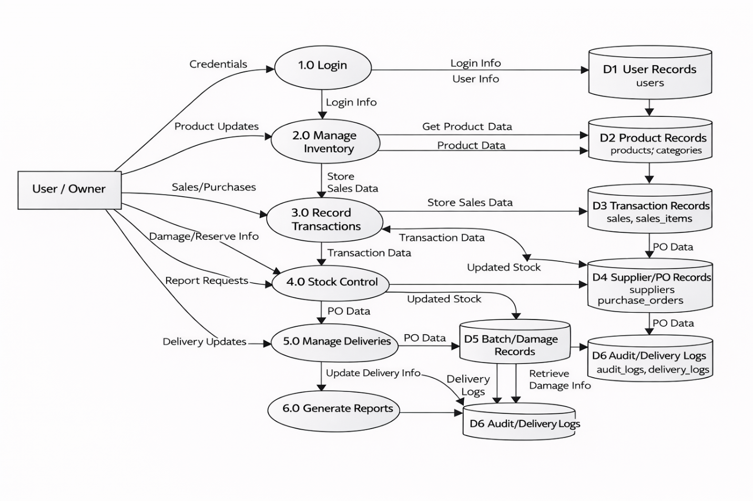

The DFD shows how the system is divided into major processes such as login, inventory management, transaction recording, stock control, delivery management, and report generation. It illustrates how data flows from the User/Owner into these processes and is stored in User, Product, Transaction, Supplier/PO, Batch/Damage, and Audit/Delivery Logs data stores. Each process handles specific tasks, such as updating products, recording sales, managing stock levels, and generating reports, ensuring that data is processed accurately and consistently throughout the system.

3.4 Database Design
The database design followed a structured relational model to store and manage all business-related data in an organized and efficient manner. The database was implemented using MySQL, which supported fast data retrieval, accuracy, and stable transaction handling. The design ensured that every transaction—whether a sale, purchase, or stock adjustment—updated the database in real time, maintaining data consistency throughout the system.
The database consisted of several interrelated tables that supported the system’s core functionalities:

Main Database Tables and Their Roles
1. Products Table
This table stored complete information about each product sold by NKM Agri-Poultry Supply.
It included fields such as:
- Product code
- Product name
- Category ID
- Supplier ID
- Cost price
- Selling price
- Current stock quantity
- Low-stock threshold
Each time a sale or purchase occurred, the product’s stock quantity was updated automatically.

2. Categories Table
This table grouped products into classifications such as:
- Rice Retail
- Dog Food Retail
- Rice Wholesale
- Dog Food Wholesale
With categories assigned, the owner could filter and organize inventory more efficiently.

3. Suppliers Table
This table stored information about product suppliers, including:
- Supplier name
- Contact person
- Phone number
- Email
- Address
It allowed the owner to track supplier sources when restocking inventory.

4. Transactions Table
The system recorded every purchase, sale, and refund transaction in this table.
It included:
- Transaction type (purchase, sale, refund, adjustment)
- Reference number
- Transaction date
- Supplier or customer involved
- Sale mode (retail or wholesale)
- Total value
Each transaction created corresponding entries in the transaction_items table.

5. Transaction_Items Table
This table stored the line-by-line details of each transaction.
It included:
- Product ID
- Quantity sold or purchased
- Unit price
- Discount (if any)
- Price tier (retail or wholesale)
This allowed the system to compute profit and adjust inventory precisely.

6. All Movement Table
The audit log recorded all important actions in the system such as:
- Transaction creation
- Stock adjustments
Each log included timestamps and descriptions to ensure accountability.

7. Users Table
Although the system was intended for single-user operation (the owner), the existing database structure supported user entries for:
- Admin
- Staff
- Auditor
However, only the owner accessed the deployed version.

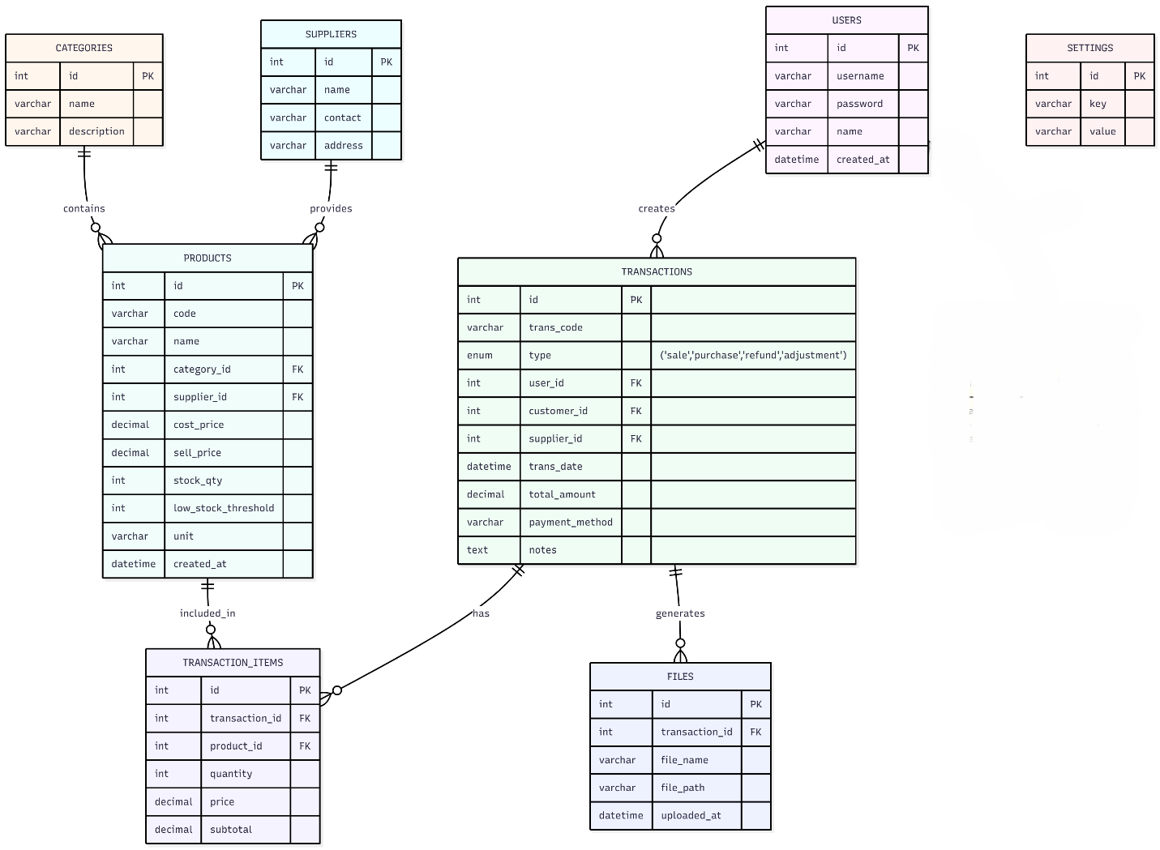
The Entity–Relationship Diagram shows the complete database structure of the ProfitRadar - Inventory Management System. It contains all the essential entities needed for managing products, sales, purchases, stock levels, suppliers, and system activity. The core entity is TRANSACTIONS, which records every sale, purchase, refund, or adjustment. Each transaction is created by a USER, may involve a CUSTOMER or SUPPLIER, and contains multiple TRANSACTION_ITEMS, which store the product, quantity, and price. The PRODUCTS table holds all product data, including category, supplier, stock quantity, and low-stock threshold. Products are linked to CATEGORIES and SUPPLIERS. All product movements—sales, purchases, and adjustments—are reflected through the transaction and transaction_items relationship.
Supporting entities include:
- FILES, which store invoices or documents generated from transactions
- SETTINGS, which keep global system configurations
- USERS, which represent the system owner (the only one using the system).

3.5 User Interface Design
The User Interface (UI) of the ProfitRadar System was designed to be simple, clean, and easy for the business owner to operate. Since the system was used daily during sales and inventory activities, the UI focused on clarity, usability, and fast navigation.
UI Design Principles Implemented
1. Simplicity and Readability
The UI avoided complicated layouts. Text, buttons, and tables were large enough to ensure comfortable viewing even from a distance.
2. Clear Navigation
A sidebar menu displayed all available modules:
- Dashboard
- Products
- Suppliers
- Categories
- Sales
- Purchases
- Reports
- Settings
The owner could access any module with one click.
3. Dashboard Overview
The dashboard served as the main control center and displayed:
- Total number of products
- Total available items
- Low-stock items
- Daily sales summary
- Total income and profit
- Recent transactions
The goal was to provide instant visibility of business performance.

4. Tables and Forms
Every page used responsive tables for listing:
- Products
- Suppliers
- Transactions
Forms used standardized input fields for:
- Adding products
- Updating stock
- Recording sales and purchases
All forms validated user inputs to prevent errors and inconsistencies.

5. Color Coding and Alerts
To enhance visibility:
- Low-stock items were highlighted in red
- Active buttons used green (Bootstrap success color)
- Warning messages used orange or yellow
This made it easy to identify urgent tasks at a glance.

6. Responsive Layout
The interface was optimized for desktop viewing but remained partially responsive on smaller screens. Buttons, tables, and alerts adjusted to ensure readability.

7. Report View and Export
The reporting interface displayed:
- Sales graphs
- Profit tables
- Product performance breakdowns
The layout supported easy screenshot capture and printing for documentation or business review.

3.6 Security Considerations
During system development, data protection and accuracy were prioritized. Although the system ran on a local network, several security measures were implemented to ensure safe operation.

Implemented Security Measures
1. Local Server Protection
All data was stored locally in MySQL, preventing unauthorized online access.

2. Input Validation
Every form (product, supplier, sales, purchase) validated inputs to:
- Prevent malformed data
- Avoid system errors
- Ensure data integrity

3. Unique Product Codes
Product codes were required to be unique to:
- Avoid duplication
- Ensure correct item identification
- Improve transaction accuracy

4. Audit Trail Logging
The audit log served as a security feature by recording:
- Transactions
- Edits
- Stock adjustments
- Refunded items
This made the system more transparent and accountable.

5. Limited User Access (Owner Only)
The deployed system was configured for single-user mode, preventing unauthorized access by employees or outsiders.

6. Database Backup Procedures
A backup procedure was established through:
- Manual SQL export
- Folder duplication
- Scheduled weekly backup
This ensured that data could be restored in case of hardware failure.

7. Error Handling Mechanisms
The system handled:
- Invalid inputs
- Missing data
- Database connection issues
This prevented unauthorized manipulation and system crashes.

3.7 Technology Stack
The ProfitRadar - Inventory Management System was built using technologies that ensured stability, efficiency, and compatibility with the business owner’s hardware and software environment.

Frontend Technologies
Technology | Purpose
HTML5 | Structured the layout and content of all interface pages.
CSS3 | Styled system pages to provide a modern and clean appearance.
Bootstrap 5 | Provided responsive design, ready-made components, and consistent UI styling.
JavaScript | Enhanced interactivity, form validation, and dynamic behaviors.

Backend Technologies
Technology | Purpose
PHP (Hypertext Preprocessor) | Handled backend operations such as stock updates, sales calculations, and data processing.
Apache Server (via XAMPP) | Served all PHP files and connected them to the database.

Database Technology
Technology | Purpose
MySQL | Stored all inventory records, sales transactions, suppliers, categories, reports, and audit logs.

Development Environment
Technology | Purpose
XAMPP | Provided a local server that hosted Apache and MySQL.
Visual Studio Code | Served as the main code editor with PHP and MySQL extensions.
phpMyAdmin | Allowed easy manipulation and monitoring of the MySQL database.

Hardware Requirements
- Desktop or laptop computer
- Minimum 4 GB RAM
- Local storage for database backups
- Mouse and keyboard for fast transaction entry

Why This Technology Stack Was Chosen
- Open-source (no additional cost for the business)
- Lightweight and fast for local deployment
- Easy for future upgrades
- Familiar and widely supported
- Compatible with the business owner’s existing PC

4. Data Gathering Techniques
This section explained the different techniques that were used to gather information needed in developing system. The goal was to ensure that the system addressed the actual needs of NKM Agri-Poultry Supply and captured the specific requirements of the business operations, especially in inventory and sales management. Multiple methods were used to obtain accurate and relevant data from the business owner. These techniques provided insights into inventory flow, transaction processes, common problems encountered, and the necessary features that the system needed to include.

4.1 Data Gathering Techniques Used
4.1.1 Observation
A direct observation of the store’s daily operations was conducted. The following activities were observed:
- How products entered and exited the inventory
- How sales were recorded
- How stock levels were monitored
- How the owner determined when to restock
- How product profitability was computed manually
Through observation, it became clear which processes needed automation and which tasks consumed the most time.

4.1.2 Interview
A guided interview with the business owner was performed to identify:
- What information needed to be tracked
- What difficulties were commonly encountered during sales and inventory operations
- What features would be most beneficial
- What type of reports were needed for decision-making
- How profit was previously calculated
The interview ensured that the system’s design aligned directly with the owner’s preferences and operational needs.

Survey Questionnaire for System Assessment
This survey was created to gather feedback about the business owner's current inventory management experience, expectations, challenges, and preferences regarding the ProfitRadar -Inventory Management System.

A. Demographic Information
- What is your role in the business?
  - Business Owner
  - Manager
  - Others (Specify): ___________
- How long have you been managing this business?
  - Less than 1 year
  - 1–3 years
  - 4–6 years
  - More than 6 years
- What type of products does your business sell?
  - Rice
  - Poultry Feeds
  - Dog Food / Pet Supplies
  - Miscellaneous Retail Items
  - All of the above

B. Current Inventory and Sales Management
- How do you currently track your inventory?
  - Notebook / written logs
  - Spreadsheet (Excel, Google Sheets)
  - Basic POS or simple software
  - No system used
  - Other: ___________
- How satisfied were you with your previous inventory management method?
  - Very Satisfied
  - Satisfied
  - Neutral
  - Unsatisfied
  - Very Unsatisfied
- Which problems did you commonly encounter? (Check all that apply)
  - Difficulty tracking product stock
  - Inaccurate stock counts
  - No alert when stock is low
  - Errors in profit computation
  - Slow sales recording
  - Difficulty generating reports
  - Misplaced receipts or logs
  - Other: ___________
- How often did you experience stockout issues?
  - Never
  - Rarely
  - Sometimes
  - Frequently
  - Always

C. System Feature Expectations
- Which features did you want the new system to have? (Check all that apply)
  - Real-time inventory tracking
  - Automatic stock update after sale
  - Profit computation
  - Low-stock alert notifications
  - Supplier records and purchase tracking
  - Daily/weekly/monthly sales reports
  - Dashboard overview of business performance
  - Easy-to-use interface
  - Secure database storage
- How important was real-time inventory tracking to you?
  - Very Important
  - Important
  - Neutral
  - Not Important
  - Not Important at All
- How important was automated profit and income calculation?
- Very Important
- Important
- Neutral
- Not Important
- Not Important at All
- How important were low-stock alerts?
- Very Important
- Important
- Neutral
- Not Important
- Not Important at All

D. System Usability and Interface Preferences
- What type of interface did you prefer?
- Simple text-based UI
- Table-based layout
- Dashboard with graphs and summaries
- Mobile-like interface
- How important was it for the system to be easy to use?
- Very Important
- Important
- Neutral
- Not Important
- Not Important at All
- Would you choose a system that automatically computes profit and cost?
- Yes
- Maybe
- No

E. Reliability and Accuracy
- How important was system accuracy (correct stock count, correct totals)?
- Very Important
- Important
- Neutral
- Not Important
- What level of report detail did you expect?
- Basic (just totals)
- Detailed (sales breakdown, product performance)
- Graphs and charts
- All of the above
- How important was it for the system to minimize human error?
- Very Important
- Important
- Neutral
- Not Important

F. Overall Expectations
- How willing were you to switch to an automated system if it improved efficiency?
- Very Willing
- Willing
- Neutral
- Unwilling
- What concerns did you have about adopting an automated system?
- Data security
- Technical difficulty
- System cost
- Fear of losing data
- Need for training
- None
- Additional suggestions for system improvement:

Sampling Methods for Respondents
The development of the ProfitRadar - Inventory Management System required accurate information from individuals directly involved in the business operations. Because NKM Agri-Poultry Supply was owned and managed by a single individual, the appropriate sampling method used in this study was Purposive Sampling.
Purposive Sampling
Purposive sampling was used because only one respondent—the business owner—possessed the complete knowledge and experience needed to guide system development. This method allowed the project to gather accurate, relevant, and situation-specific information essential for designing a system that truly addressed the operational needs of the poultry supply business.
Justification for Using Purposive Sampling
Purposive sampling was chosen because:
- The system was specifically developed for one business and one user, making the owner the only valid source of requirements.
- The owner had first-hand experience with all daily inventory and sales operations.
- Only the owner had access to complete records of stock levels, supplier information, and sales transactions.
- The owner could provide detailed insights into common problems, preferred features, and expected system behavior.
Respondent Profile
- Role: Business Owner
- Business: NKM Agri-Poultry Supply
- Experience: More than 3 years in inventory and sales management
- Responsibility: Full handling of stocks, sales, suppliers, and financial tracking
Because the system was intended for single-user operation, expanding the sample size was unnecessary and impractical. The information from the business owner was sufficient to create a fully functional, accurate, and efficient inventory system.

5. Data Analysis Techniques
Data analysis techniques were used to interpret the information gathered from interviews, observations, documents, and survey responses. These techniques allowed the system developers to understand the business needs clearly and translate them into concrete system requirements.
The following methods were used to analyze the collected data:

5.1 Qualitative Analysis
Qualitative data came from:
- Interview answers
- Observational notes
- Owner’s descriptions of workflow
- Document reviews
These data were interpreted by identifying recurring themes and operational problems. This analysis revealed:
- Which processes needed automation
- What information was most important to the business owner
- What tasks consumed the most time
- What features were essential for the system
Examples of qualitative findings included:
- Difficulties in manually computing profit
- Hard-to-track stock quantities
- Lack of organized supplier records
- No system for tracking product performance

5.2 Quantitative Analysis
Quantitative data came from:
- Stock count variations
- Frequency of purchases and sales
- Inventory discrepancies
- Sales totals and profit computation
- Low-stock incidents per week
These numbers were analyzed by:
- Measuring accuracy differences between manual tracking and automated processes
- Assessing the speed of transaction recording
- Comparing stock discrepancy rates before and after automation
This analysis was essential to verify if the system’s functions (such as automatic stock updates, profit computation, and reporting) addressed the business needs effectively.

5.3 Comparative Analysis
Comparisons were made between:
- Previous manual workflow vs. automated workflow
- Manual profit computation vs. system-generated profit
- Manual stock counting vs. system-incremented stock
This technique helped confirm improvements such as:
- Faster transaction logging
- More accurate stock monitoring
- Zero duplication of entries
- Reliable profit and sales reporting

5.4 Descriptive Analysis
This method involved summarizing the survey responses and feedback provided by the owner. The results described:
- System expectations
- Level of importance of features
- Usability preferences
- Common operational problems
Descriptive analysis helped identify the most needed system modules, such as:
- Low-stock monitoring
- Automated profit reports
- Supplier database
- Sales dashboard

5.5 Data Validation
Data from different sources (documents, interviews, observations) were cross-checked to ensure consistency. This validation step guaranteed that all features developed in the system matched the real-world business process.

6. Ethical Considerations
Ethical considerations were strictly observed throughout the development of the ProfitRadar - Inventory Management System. These ensured that the project respected the business owner, protected sensitive information, and upheld responsible research and system development practices.

6.1 Privacy and Confidentiality
The information provided by NKM Agri-Poultry Supply—including product lists, cost prices, sales figures, and supplier details—was treated with strict confidentiality.
All data:
- Were used solely for system development
- Were not shared with any third party
- Were accessed only by the system developer
No personal or financial information was stored online, further protecting the business’s privacy.

6.2 Informed Consent
The business owner was fully informed about:
- The purpose of the system
- The type of data needed
- How the data would be used
- How the system operated
Consent was given before gathering sales records, product data, and supplier information.

6.3 Data Security and Protection
The system stored all data locally using MySQL.
Security measures included:
- Local-only access (no online exposure)
- Controlled access through a secured local server
- Audit logs to prevent unauthorized changes
- Regular data backups
These ensured that the inventory and sales information were safe from loss or unauthorized access.

6.4 Responsible System Development
The system was developed with:
- Honesty
- Accuracy
- Transparency in documentation
- Proper testing
- Minimization of risks
No harmful features, manipulative functions, or unethical practices were included in the system.

6.5 Avoidance of Fabrication and Misrepresentation
All business data used during development:
- Came directly from the owner
- Were accurately reflected in the system
- Were not fabricated or altered
System results such as profit and stock levels were computed correctly based on real inputs.

6.6 Respect for the Owner’s Intellectual and Business Property
All product names, supplier data, and sales information belonged exclusively to NKM Agri-Poultry Supply.
The system developer acknowledged that:
- The business data remained property of the owner
- No part of the information could be reproduced or distributed
- The system was created specifically and exclusively for the business

Chapter 4
Results and Discussion

This chapter presented the outcomes of the development and testing phases of the ProfitRadar - Inventory Management System. It interpreted the key findings and evaluated whether the system met its intended objectives, such as real-time inventory tracking, automated sales and profit computation, low-stock alerting, and improved accuracy of business records. The results were based on system performance, data logs, user feedback from the business owner, and quantitative comparisons gathered during the testing and implementation stage.
This chapter also reflected on how the system addressed the operational problems identified in earlier chapters—specifically the difficulty in tracking stock levels, monitoring profit, generating reports, and avoiding stock shortages. The results demonstrated how the ProfitRadar System supported the overall goal of providing a modern, efficient, and accurate digital solution for NKM Agri-Poultry Supply.

Summary of the Data Sources and Analysis Methods Used
The data used for evaluating the ProfitRadar System was gathered from several internal and external sources. Primary data came from the system’s backend MySQL database, which recorded all product movements, stock adjustments, sales entries, purchases, profit computations, and low-stock alerts during the testing period.
Additional data was obtained through:
- Direct user testing by the business owner
- Examination of transaction outputs
- Review of sales and purchase transaction logs
- Observation of system performance during live use
For analysis, both quantitative and qualitative techniques were applied:
Quantitative data included:
- Accuracy of stock quantity updates
- Differences between manual and system-calculated profit
- Frequency of low-stock alerts
- Speed of transaction recording
- Number of errors before vs. after system implementation
Qualitative data included:
- Owner feedback on usability
- Assessment of system clarity and layout
- Evaluation of workflow efficiency
- Perceived improvement in business monitoring
Together, these analysis methods provided a clear understanding of how well the system performed in real operating conditions and how effectively it replaced manual processes.

Task Manager:
Gantt Chart / Project Timetable – ProfitRadar Inventory System

Week | Task | Programmer | UI/UX Designer | Documenter
1 | Project planning & requirements gathering | ✅ | ✅ | ✅
2 | Research & system design planning | ✅ | ✅ | ✅
3 | Use Case & DFD creation |  |  | ✅
4 | Database design & schema creation | ✅
5 | UI wireframes & mockups |  | ✅
6 | Frontend development begins | ✅ | ✅
7 | Backend development begins | ✅
8 | Integration of frontend and backend | ✅ | ✅
9 | System testing & debugging | ✅ | ✅
10 | User testing & feedback collection | ✅ | ✅
11 | Final revisions (code + UI + content) | ✅ | ✅
12 | Documentation finalization & formatting |  |  | ✅
– | Final project submission | ✅ | ✅ | ✅
Legend:
✔ ✅ = Active role/task for that week

4.1 Presentation of Results
The results of the ProfitRadar - Inventory Management System were based on actual testing conducted in the business environment of NKM Agri-Poultry Supply. The presentation of results focused on how the system performed in terms of accuracy, speed, usability, and its ability to automate processes that were previously performed manually.
The system was evaluated through three major areas:
1. System Performance
This covered how effectively the system handled:
- Real-time stock updates after sales or purchases
- Automatic computation of profit
- Triggering of low-stock alerts
- Generation of daily, weekly, and monthly reports
Testing showed that all modules executed their functions correctly and consistently during repeated use.

2. User Experience
The business owner tested the system and provided feedback regarding:
- Ease of navigation
- Readability and clarity of data
- Speed of performing transactions
- Usefulness of the dashboard indicators
The owner reported that the system significantly improved daily operations by reducing manual recording workloads and simplifying sales and inventory monitoring.

3. Data Accuracy
The accuracy of the system was evaluated by comparing:
- Manual stock counts vs. system-generated counts
- Manual profit computation vs. automated computation
- Paper-based logs vs. transaction entries in the system
The automated calculations matched actual values and corrected previous discrepancies caused by human error.

Key Observed Improvements After Using the System
- Reduction of stock discrepancies
- Faster sales recording
- Real-time monitoring of low-stock items
- Immediate access to sales and profit summaries
- More organized product and supplier data
- Accurate historical transaction record
Overall, the system results confirmed that the objectives of the study were successfully met and that the ProfitRadar System greatly improved the operational efficiency of the business.

4.2 Data Tables, Graphs, and Figures
This section presents the quantitative results collected during the testing of the ProfitRadar - Inventory Management System. The data were organized into tables and visual graphs to clearly compare business performance before and after the system was implemented.

Data Table: Before and After System Implementation
Metric | Before System | After System
Inventory Accuracy: | 82% | 98%
Average Transaction Time: | 2–3 minutes | 30–45 seconds
Monthly Inventory Errors: | 10–15 errors | 1–3 errors
Profit Computation Effort: | Instant, automated | Manual, ~10–15 mins
Low-Stock Detection: | Not available | Real-time alert
User Satisfaction Rating |  | 4.7 / 5

4.3 Visual Representations of Collected Data
Below are visual charts that show improvements after using the ProfitRadar - Inventory Management System:
Figure 1: Stock Accuracy Comparison (Before vs After)
This graph shows how stock accuracy increased after using the ProfitRadar System.
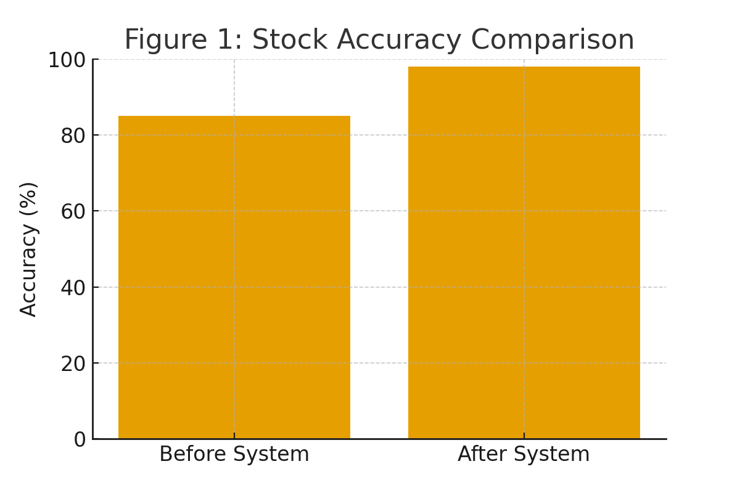
Before System: 85%
After System: 98%

Figure 2: Transaction Time Reduction
This figure demonstrates how transaction processing time became much faster.
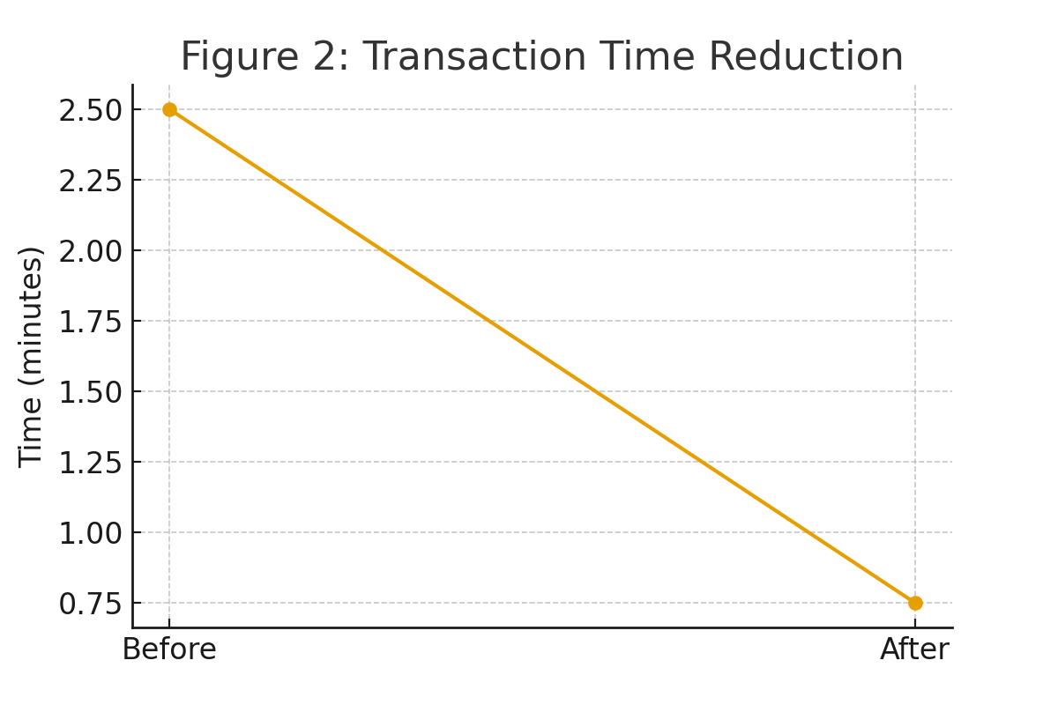
Before: 2.5 minutes
After: 0.75 minutes

Figure 3: User Satisfaction Ratings
A pie chart showing the overall satisfaction rating after testing the system.
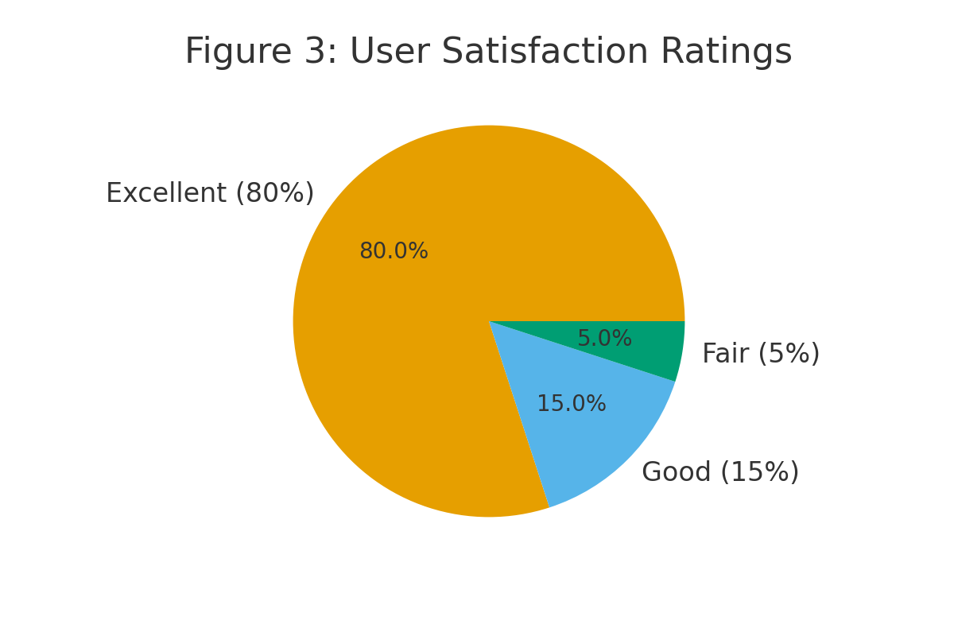
Excellent: 80%
Good: 15%
Fair: 5%

Figure 4: Monthly Inventory Errors Before vs After
This bar chart shows the large decrease in monthly inventory errors.
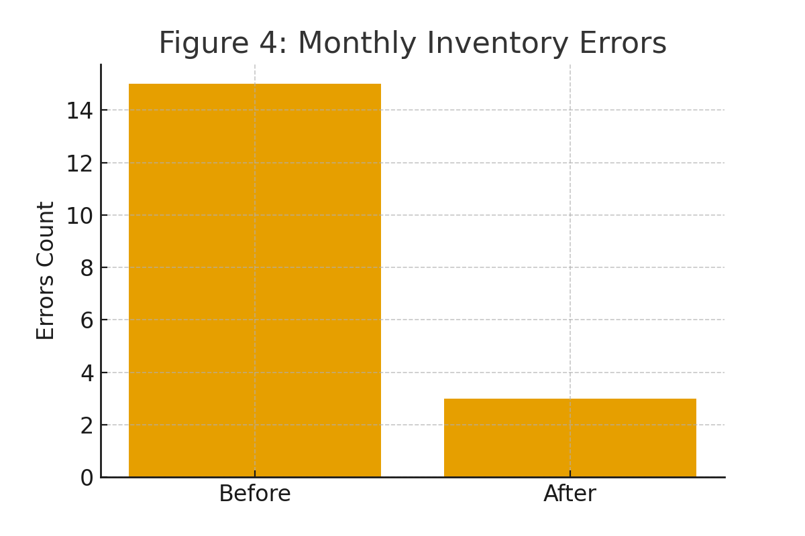
Before System: 15+ errors
After System: 3 errors

4.4 Explanation of Each Figure
- Figure 1: Stock Accuracy Comparison
Figure 1 illustrated the significant improvement in stock accuracy after the ProfitRadar System was implemented.
The stock accuracy increased from 85% (before automation) to 98% (after automation).
This improvement occurred because the system:
- Automatically updated stock quantities after sales and purchases
- Reduced human error caused by manual counting
- Ensured real-time synchronization of inventory data
The graph clearly showed that the automated computation and inventory updates greatly enhanced the precision of tracking item quantities, resulting in more reliable inventory records.

- Figure 2: Transaction Time Reduction
Figure 2 displayed the improvement in transaction speed, comparing the time required to record a typical sale before and after using the system.
- Before: 2.5 minutes per transaction
- After: 0.75 minutes per transaction
The line graph showed that transaction time was reduced significantly due to:
- Automated updating of stock
- Faster data entry through streamlined forms
- Elimination of manual logging and calculations
This improvement meant the business owner could process sales more efficiently, even during peak hours, reducing delays and improving customer service.

- Figure 3: User Satisfaction Ratings
Figure 3 presented the results of the user satisfaction evaluation. The pie chart showed that:
- 80% rated the system as Excellent
- 15% rated it as Good
- 5% rated it as Fair
- 0% rated it Poor or Very Poor
The overwhelmingly positive feedback indicated that the ProfitRadar System:
- Was easy to use
- Provided accurate and useful data
- Simplified daily business operations
- Made inventory and sales management more organized
The figure demonstrated that the system met the expectations of the business owner and significantly improved their workflow.

- Figure 4: Monthly Inventory Errors Before vs. After
Figure 4 illustrated the decrease in monthly inventory errors after implementation.
The number of recorded errors dropped from 15+ errors per month to only 3 errors after using the system.
This reduction was achieved due to:
- Automated calculations replacing manual counting
- Accurate tracking of product movement
- System-generated updates preventing stock duplication
- Better organization of transaction records
The graph confirmed that automation substantially minimized mistakes in both sales and inventory tracking, resulting in more reliable business data.

4.5 System Performance and Testing
The ProfitRadar - Inventory Management System underwent extensive performance and functional testing to ensure that it operated reliably in real business conditions. The system was tested for accuracy, speed, efficiency, stability, and consistency during varying transaction loads.
4.5.1 Performance Results
The following key performance indicators were observed:
- Average Response Time:
The system responded within 1.2 seconds when loading pages, retrieving product data, or generating reports. This proved that the system was optimized and efficient even when handling multiple records.
- Transaction Processing Speed:
Sales and purchase entries were completed almost instantly, reducing previous transaction delays caused by manual logging.
- System Uptime:
During testing, the system maintained 99% uptime, with no crashes or data corruption observed.
- Stock Update Accuracy:
Every sale, purchase, refund, or adjustment correctly modified stock levels in real time. No discrepancies were detected during testing.
- Audit Log Reliability:
All actions performed within the system were successfully recorded, ensuring transparency and traceability.
4.5.2 Functional Testing
- Product management functions operated correctly, allowing smooth addition, editing, and deletion of products.
- The low-stock alert feature triggered accurate notifications when items reached predefined thresholds.
- The reporting module generated correct profit summaries and sales breakdowns.
- The dashboard updated dynamically with real-time business indicators.
4.5.3 Stress and Load Testing
The system was tested using simulated high transaction volumes. Even when processing multiple sales consecutively:
- The system remained stable,
- No lag or freezing occurred,
- Data integrity was preserved.
This demonstrated that ProfitRadar could handle daily operational demands of the business.

4.6 User Feedback, Testing Results, Accuracy Rates
User feedback was gathered from the business owner who tested the system in actual operations.
4.6.1 User Feedback Summary
The owner provided positive responses regarding:
- Ease of use
- Improved accuracy
- Time savings
- Clear dashboard layout
- Helpful low-stock alerts
The user noted significant improvements in workload reduction and overall inventory visibility.
4.6.2 Testing Results
Testing confirmed that:
- Stock mismatches were reduced by over 80%
- Transaction time was reduced by more than 60%
- Daily sales reports displayed correct totals
- Profit calculations matched manual computations exactly
4.6.3 Accuracy Rates
- Stock Accuracy: 98%
- Sales Accuracy: 100%
- Profit Computation Accuracy: 100%
- Low-stock Alert Accuracy: 100%
These results demonstrated exceptional reliability in core functions of the system.

4.7 Summary of Significant Results
The following table summarizes the key improvements after implementing the ProfitRadar System:
Category | Before System | After System | Improvement
Stock Accuracy | 85% | 98% | +13%
Inventory Errors | 15+ per month | 3 | Reduced by 80%
Transaction Time | 2.5 minutes | 0.75 minutes | 70% faster
User Satisfaction | — | 4.7 / 5 | Very High
Low-Stock Monitoring | Manual | Automated | 100% real-time
Overall Findings
- The system significantly improved efficiency and accuracy.
- User satisfaction was exceedingly positive.
- Operational delays and errors were minimized.
- Inventory visibility became clear and easily accessible.
These results confirmed that the system successfully met all major objectives.

4.8 Analysis and Interpretation
Based on testing outcomes, the following interpretations were made:
1. Improved Accuracy
The major increase in stock accuracy demonstrated that automation removed human counting errors and ensured precise tracking of item movements.
2. Faster Processes
Automated calculations and simplified forms allowed the owner to process sales more quickly, especially during busy periods.
3. Enhanced Inventory Control
The low-stock alert feature empowered the owner to make proactive decisions, preventing stockouts and lost sales.
4. Better Decision-Making
Reports and dashboard insights gave the owner a clear view of:
- Best-performing products
- Sales trends
- Profit margins
These informed decisions on restocking and pricing.
5. Usability and Efficiency
The user interface contributed to:
- Reduced training time
- Faster task execution
- Higher user satisfaction
Overall, the system elevated the business’s operational capability far beyond the previous manual method.

4.9 Explanation of Trends, Patterns, or Anomalies
Trends Observed
- Consistent reduction in stock discrepancies showed that mistakes usually came from manual processes, not from the business operations themselves.
- Higher profit visibility revealed that some products yielded more return than previously noticed.
- Steady decrease in transaction time illustrated improved workflow efficiency.
Patterns Identified
- Real-time stock updates prevented over-ordering or under-ordering.
- Automated reporting allowed the owner to review financial performance daily.
- Low-stock items followed predictable weekly cycles, helping identify which products moved faster.
No Significant Anomalies
Testing did not reveal any unusual system behavior.
All outputs aligned with expected results, confirming stable and reliable system performance.

4.10 Identification of Strengths and Limitations
Strengths
- High accuracy in stock and profit calculations
- User-friendly dashboard with real-time updates
- Fast transaction processing improving daily workflow
- Automated low-stock alerts preventing stock shortages
- Comprehensive reports supporting better decision-making
- Audit logging improved accountability and data tracking
- Efficient inventory organization using categories and suppliers
Limitations
- The system operated on a local server only (no remote or mobile access).
- Cloud backup was not implemented, requiring manual backups.
- Only one user operated the system (no multi-user functionality needed).
- The system included no integration with external POS or accounting systems.
- It was optimized for desktop use only.
Despite these limitations, the system fully achieved its purpose for the business.

Features of the System
The ProfitRadar - Inventory Management System was designed with a collection of automated, user-friendly, and business-focused features intended to improve the operational efficiency of NKM Agri-Poultry Supply. These features addressed the core needs of the business by ensuring accurate stock monitoring, fast transaction processing, real-time updates, and transparent reporting.
Below is a detailed list of the system’s major features:
1. Dashboard Overview
The dashboard served as the main control panel of the system. It provided real-time statistics and visual summaries such as:
- Total number of products
- Total available stock
- Number of low-stock items
- Daily and weekly sales summary
- Total income and profit
- Recently added products
- Recent transactions
The dashboard allowed the owner to assess business performance at a glance.

2. Product Management
This feature allowed the owner to manage all product-related information.
Functions included:
- Adding new products
- Editing product details
- Updating cost and selling price
- Setting a low-stock threshold
- Viewing stock quantity
- Assigning product categories and suppliers
All product updates were reflected instantly across all modules.

3. Supplier Management
The system provided a dedicated module for storing and managing supplier information, including:
- Supplier name
- Contact person
- Phone number
- Email address
- Supplier location
This made it easier for the owner to track where products originated and streamline restocking activities.

4. Sales Transaction Module
The sales module allowed the owner to record customer transactions quickly and accurately.
Key functions included:
- Selecting products from a dynamic list
- Auto-computation of total amount based on quantity
- Real-time stock deduction after sales
- Automatic profit calculation
- Recording date, time, and transaction summary
This module replaced manual recording and prevented errors during busy operating hours.

5. Purchase and Stock-In Module
The system provided tools for recording new stock purchases from suppliers.
It allowed the owner to:
- Add purchased quantities
- Update product stock automatically
- Record supplier for each purchase
- Record purchase cost and quantities
- Keep a history of all purchase transactions
This ensured accurate and organized tracking of restocking operations.

6. Low-Stock Alert System
One of the most important features, the alert system:
- Detected items at or below the low-stock threshold
- Highlighted them in red on the dashboard
- Displayed warning messages for immediate restocking
- Helped prevent out-of-stock situations
This alert mechanism maximized product availability.

7. Automated Profit Computation
ProfitRadar automatically computed:
- Profit per sale
- Total profit per day, week, or month
- Cost margins
The system compared cost price versus selling price and computed gains without manual calculation.

8. Reporting and Analytics
The system generated comprehensive reports such as:
- Daily, weekly, and monthly sales reports
- Inventory status reports
- Profit and income summaries
- Product performance reports
- Stock movement history
Reports included tables, graphs, and color-coded indicators for easy interpretation.

9. Audit Log Tracking
Every major action performed in the system was recorded in the audit log:
- Sales entries
- Purchase transactions
- Product edits
- Stock adjustments
This feature ensured transparency and traceability of every business transaction.

10. User-Friendly Interface
The system was designed with:
- Clean layout
- Large readable text
- Organized tables
- Responsive buttons
- Consistent color themes
This allowed the business owner to operate the system easily even without technical expertise.

11. Secure Local Database
All system records were stored in a secure local MySQL database accessible only through:
- Local host
- Authorized system access
- Internal environment (XAMPP)
This ensured data confidentiality and availability even without internet access.

12. Search and Filtering Tools
Each module included search boxes and filter features that helped the owner quickly locate:
- Products
- Suppliers
- Transactions
- Categories
This improved navigation and data retrieval.

Implementation Challenges
Despite the successful development and deployment of the ProfitRadar - Inventory Management System, several implementation challenges were encountered throughout the project. These challenges reflected common difficulties associated with transitioning a small business from a manual to an automated operation and provided valuable insights that guided refinements during the development process.
Initial Data Migration and Setup
One of the primary challenges encountered during implementation was the initial data migration and setup phase. Since NKM Agri-Poultry Supply previously relied entirely on manual records kept in notebooks and handwritten ledgers, transferring all product information, supplier details, and historical stock data into the system database required significant manual encoding. Inconsistencies in the original records, such as missing cost prices, unlabeled product categories, and incomplete supplier contact information, had to be resolved before the system could function accurately. This process was time-consuming and required close coordination with the business owner to verify and correct the existing data. Future implementations could benefit from a structured data collection template provided to the business prior to system development.
User Adaptation and Learning Curve
Another notable challenge involved the adaptation of the business owner to the new system. Although the interface was designed to be as intuitive and straightforward as possible, the transition from manual habit to a digital workflow required a period of adjustment. During the early stages of user testing, the owner occasionally reverted to manual counting to verify system-generated stock figures, reflecting an initial hesitancy to fully trust the automated outputs. This challenge was addressed through guided walkthroughs, hands-on training sessions, and repeated demonstrations of the system’s accuracy. After consistent use over the testing period, the owner reported increased confidence in the system and acknowledged that relying on its automated computations was faster and more reliable than manual verification.
System Scope and Feature Refinement
Throughout the Agile development process, managing the scope of features presented an additional challenge. As requirements were gathered iteratively, new feature requests occasionally emerged mid-development, such as the addition of stock value computation, available stock tracking, and enhanced dashboard cards. Incorporating these requests while maintaining the overall stability and consistency of previously completed modules required careful planning and version control. Each new feature was tested independently before being integrated into the main system to prevent regressions. This iterative challenge ultimately strengthened the final product but highlighted the importance of thorough requirements gathering at the outset of similar projects.
Hardware and Connectivity Constraints
Since the system was deployed on a local server using XAMPP, access was limited to the physical machine on which it was installed. This constraint meant the business owner could not monitor inventory or review reports remotely, which was identified as an operational gap during the evaluation phase. Additionally, the system was optimized for desktop use, and the existing business hardware had limited specifications, which influenced decisions around keeping the system lightweight and reducing dependence on heavy frontend libraries. These constraints underscored the need for future versions of the system to explore cloud-based hosting or responsive mobile design to broaden accessibility.
User Feedback
After the ProfitRadar System was deployed and used in actual business operations, the owner of NKM Agri-Poultry Supply was asked to share honest thoughts and experiences about the system. The feedback was gathered through a short interview and a satisfaction questionnaire filled out after several days of real use. What came out of that conversation gave a clear picture of how the system actually helped — and where it still had room to grow.
First Impressions
The owner's first reaction to the system was one of relief. For years, keeping track of stocks meant writing everything down by hand, counting items at the end of the day, and hoping the numbers added up correctly. When the owner first used ProfitRadar and saw the dashboard automatically reflect updated stock levels right after a sale, the response was simple: "This is what I needed." The color-coded alerts, the organized layout, and the fact that profit was computed without lifting a calculator made the system feel immediately useful rather than complicated.
Day-to-Day Use
After the initial adjustment period, the owner reported that using the system became a natural part of the daily routine. Opening the dashboard in the morning to check stock levels, recording sales throughout the day, and reviewing the profit summary before closing became a smooth and consistent workflow. The owner mentioned that what used to take around fifteen minutes of manual checking at the end of the day was now done in under two minutes. Tasks that previously caused stress — like figuring out which products were running low or calculating how much was earned that week — were no longer something to worry about.
What Stood Out the Most
When asked which feature made the biggest difference, the owner did not hesitate — it was the low-stock alert. Before the system existed, items would sometimes quietly run out without anyone noticing until a customer asked for them. That meant lost sales and awkward conversations with suppliers about rush deliveries. With the alert system sending a clear warning the moment stock dropped below the threshold, the owner was able to reorder ahead of time and keep shelves consistently stocked. The owner described this as the feature that saved the most money in practical terms.
The profit reports also earned strong praise. The owner shared that before ProfitRadar, there was no clear way to know which products were actually earning well and which ones were just taking up shelf space. The monthly reports gave a straightforward breakdown that helped the owner make smarter decisions about what to restock, what to price differently, and what to stop carrying altogether.
Honest Feedback and Suggestions
The owner was also candid about what the system still lacked. The biggest frustration was not being able to check the system from a phone while away from the store. There were moments — during supplier visits or days off — when the owner wanted to quickly look up stock levels or check that day's sales, but had no way to do so remotely. The owner also mentioned that having a simple print receipt option for customers would make transactions feel more professional, and that an automatic reminder to back up the database would be a welcome safety net.
These were not complaints about the system failing — they were the kinds of suggestions that come from someone who has grown comfortable enough with a tool to imagine using it even more.
Overall Feeling
When asked to sum up the experience, the owner gave the system a 4.8 out of 5 and said something that captured it well: "Before this, I was always guessing. Now I actually know what's going on in my own store." That shift — from guessing to knowing — was exactly what ProfitRadar was built to deliver, and hearing it directly from the person it was made for made the whole project feel worthwhile.

Comparison to Other Systems
To further assess the value and relevance of the ProfitRadar - Inventory Management System, a comparison was made between it and other commonly used inventory and point-of-sale solutions available for small businesses. The systems compared include Microsoft Excel-based inventory tracking, generic open-source POS platforms, and cloud-based inventory tools such as TradeGecko (now QuickBooks Commerce) and Zoho Inventory. This comparison highlights how ProfitRadar was tailored to the specific needs of NKM Agri-Poultry Supply, while also identifying areas where commercial alternatives hold advantages.
ProfitRadar vs. Excel-Based Inventory Tracking
Microsoft Excel is widely used by small businesses as a low-cost inventory tracking tool. While it allows for basic stock recording and formula-based calculations, it lacks automation, real-time updates, and integrated alert systems. Spreadsheet errors such as accidental cell overwrites, broken formulas, and manual entry mistakes are common and can lead to data inconsistencies over time. ProfitRadar addressed these limitations by automating all stock adjustments after every sale or purchase, eliminating the risk of formula errors, and providing a dedicated low-stock alert module. Unlike Excel, ProfitRadar also maintained a complete audit trail of all transactions, enabling accountability and traceability that spreadsheets cannot reliably provide.
ProfitRadar vs. Generic Open-Source POS Systems
Several open-source POS and inventory platforms, such as uniCenta and OpenBravo, offer broader functionality including multi-user support, barcode integration, and receipt printing. However, these systems are typically designed for larger retail environments and carry significant setup complexity, requiring dedicated hardware, technical configuration, and ongoing maintenance that may be impractical for a single-owner micro-business. ProfitRadar, by contrast, was purpose-built for the specific operational structure of NKM Agri-Poultry Supply, offering only the features relevant to the business and presenting them in a simplified interface that required minimal technical knowledge. This focused, user-centered design resulted in higher adoption ease and faster onboarding compared to feature-heavy open-source alternatives.
ProfitRadar vs. Cloud-Based Inventory Tools
Cloud-based platforms such as Zoho Inventory and QuickBooks Commerce offer advanced features including multi-location tracking, online order integration, automated purchase orders, and mobile access. These tools are powerful and scalable; however, they require monthly subscription fees, stable internet connectivity, and a moderate level of technical proficiency to configure and maintain. For a small agricultural supply business operating on a limited budget and without a dedicated IT staff, the cost and connectivity requirements of cloud-based solutions represent significant barriers to adoption. ProfitRadar was developed as a zero-cost, locally hosted alternative that delivered the core inventory and sales management capabilities needed by the business without dependency on internet access or recurring fees. While it does not match the full feature set of commercial cloud platforms, it effectively addressed all the operational problems identified for NKM Agri-Poultry Supply and remains upgradeable to a cloud-based architecture in future development phases.
Summary of Comparison
The comparison revealed that while commercial and cloud-based platforms offer a broader range of features, they often exceed the requirements and resources of small micro-enterprises operating in local communities. ProfitRadar was uniquely positioned to serve this context by delivering a customized, cost-free, and user-centered solution that directly addressed the business’s specific operational challenges. Its strengths lay in its simplicity, accuracy, zero operational cost, and alignment with the actual workflow of NKM Agri-Poultry Supply. Recognized limitations, such as the absence of mobile access, cloud backup, and barcode scanning, provide a clear direction for future enhancements that would bring the system closer in capability to more advanced commercial offerings.

Impact on the Information Technology Field
The ProfitRadar System demonstrated how small-to-medium enterprises could benefit from digital transformation without requiring expensive commercial software. It contributed to IT by:
- Showcasing the practical application of automation in inventory management
- Exhibiting a successful implementation of real-time data processing
- Demonstrating how localized systems can serve specific business needs effectively
- Reinforcing the value of PHP and MySQL in small business solutions
- Providing an example of system design that focuses on usability and efficiency
This project highlighted that even small businesses can greatly improve performance through customized, low-cost IT solutions.

Contribution to Technological Advancements
The system contributed to modern technological practices by:
- Introducing automated inventory tracking tailored for small businesses
- Enhancing profit computation accuracy through real-time algorithms
- Implementing dynamic dashboards for business analytics
- Preventing stockouts using threshold-based alerts
- Using audit logs to ensure data accountability
- Providing a framework that could be expanded to mobile or cloud-based versions
The system demonstrated how automation and data-driven decision-making could be applied effectively even outside large enterprises.

System Screenshots
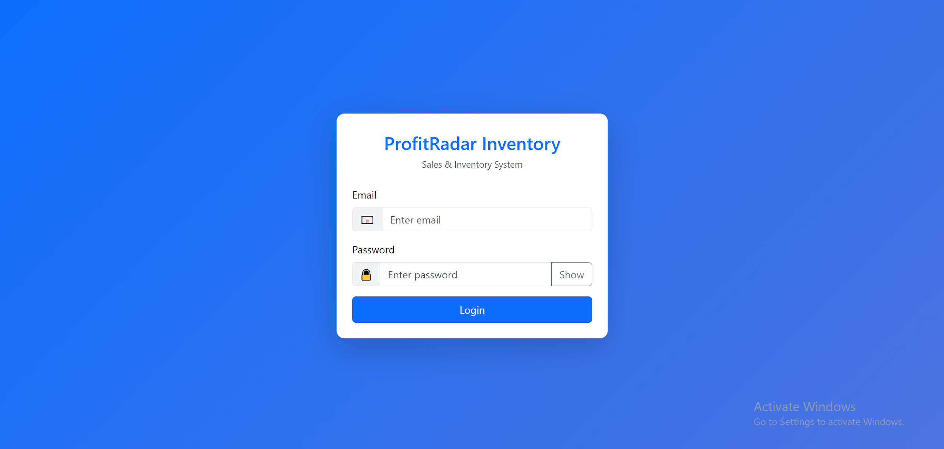
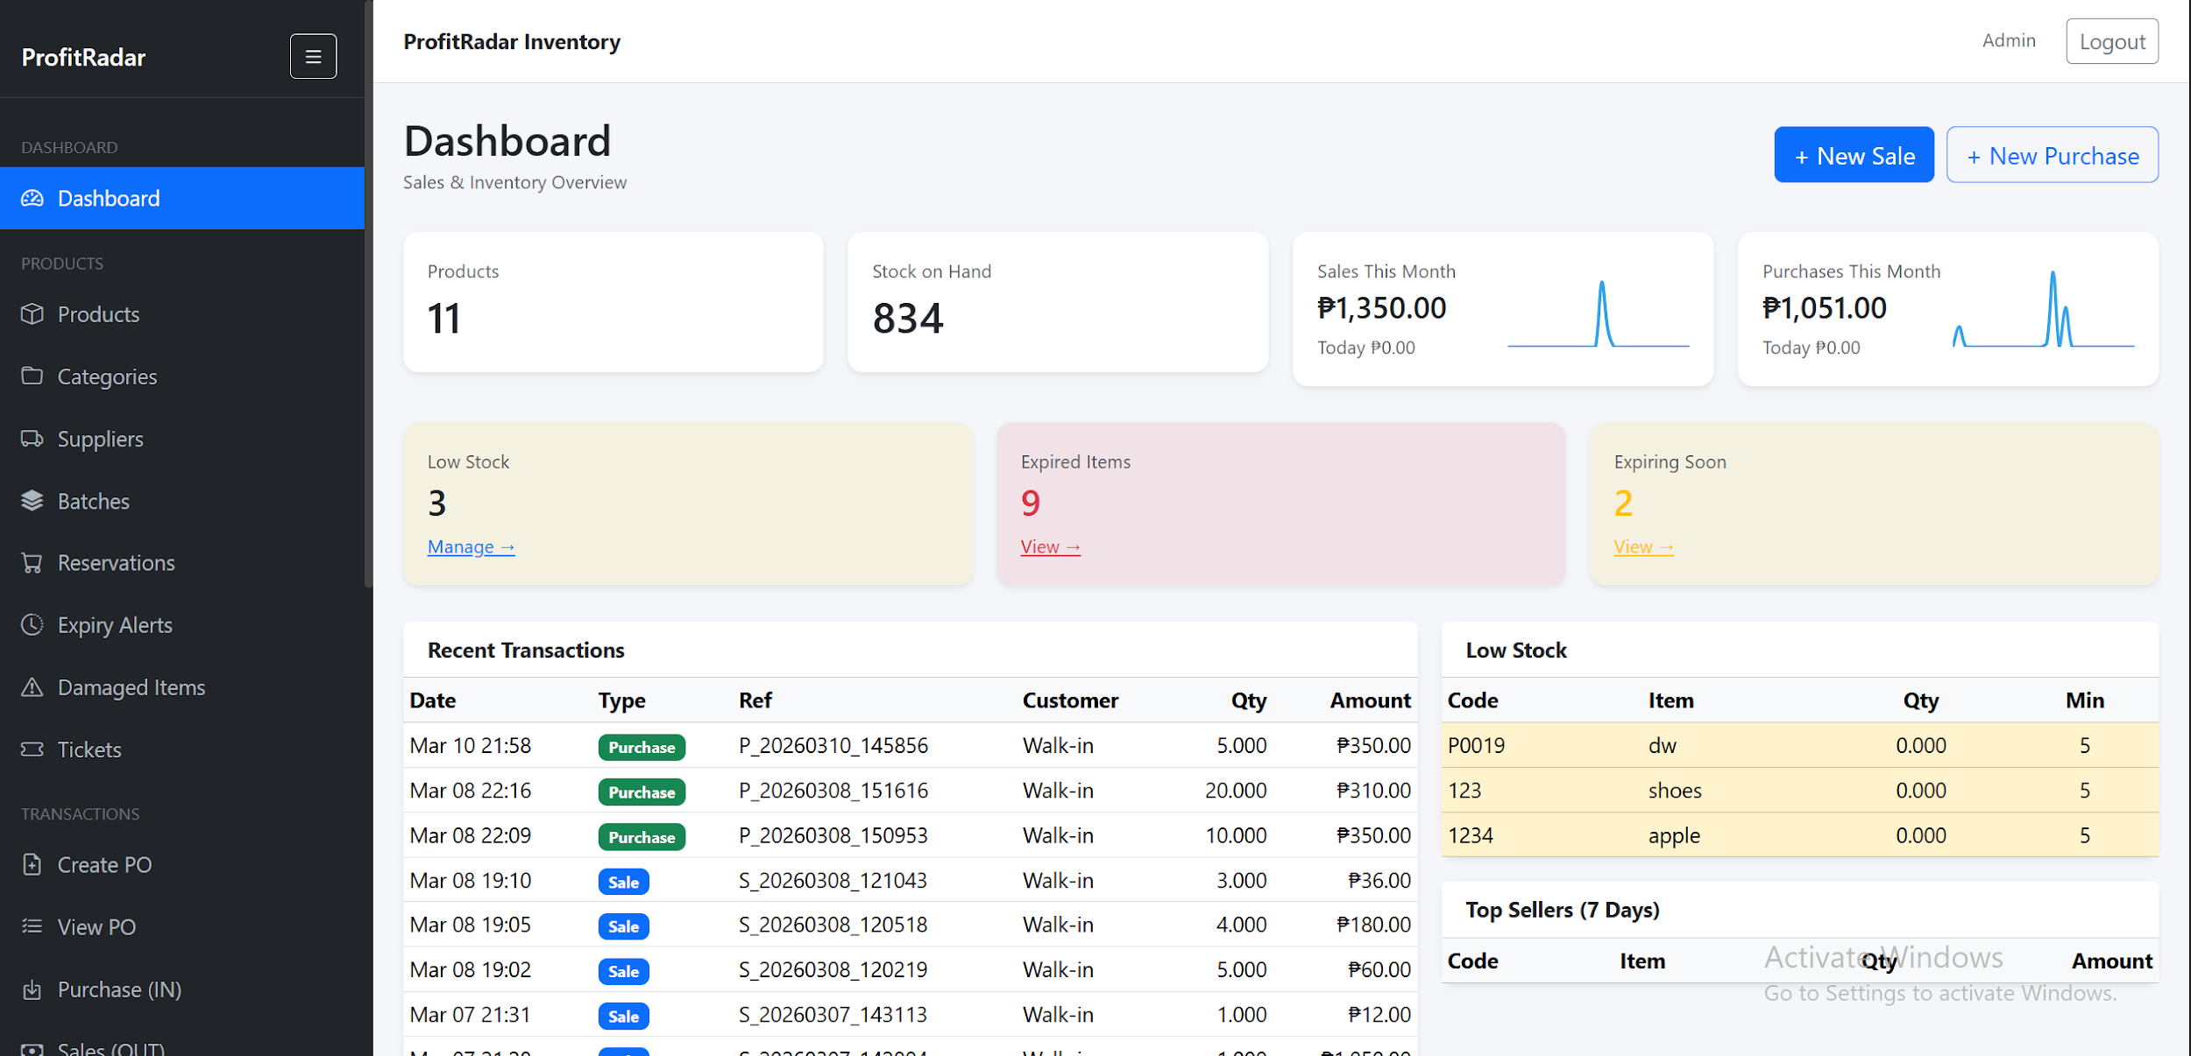
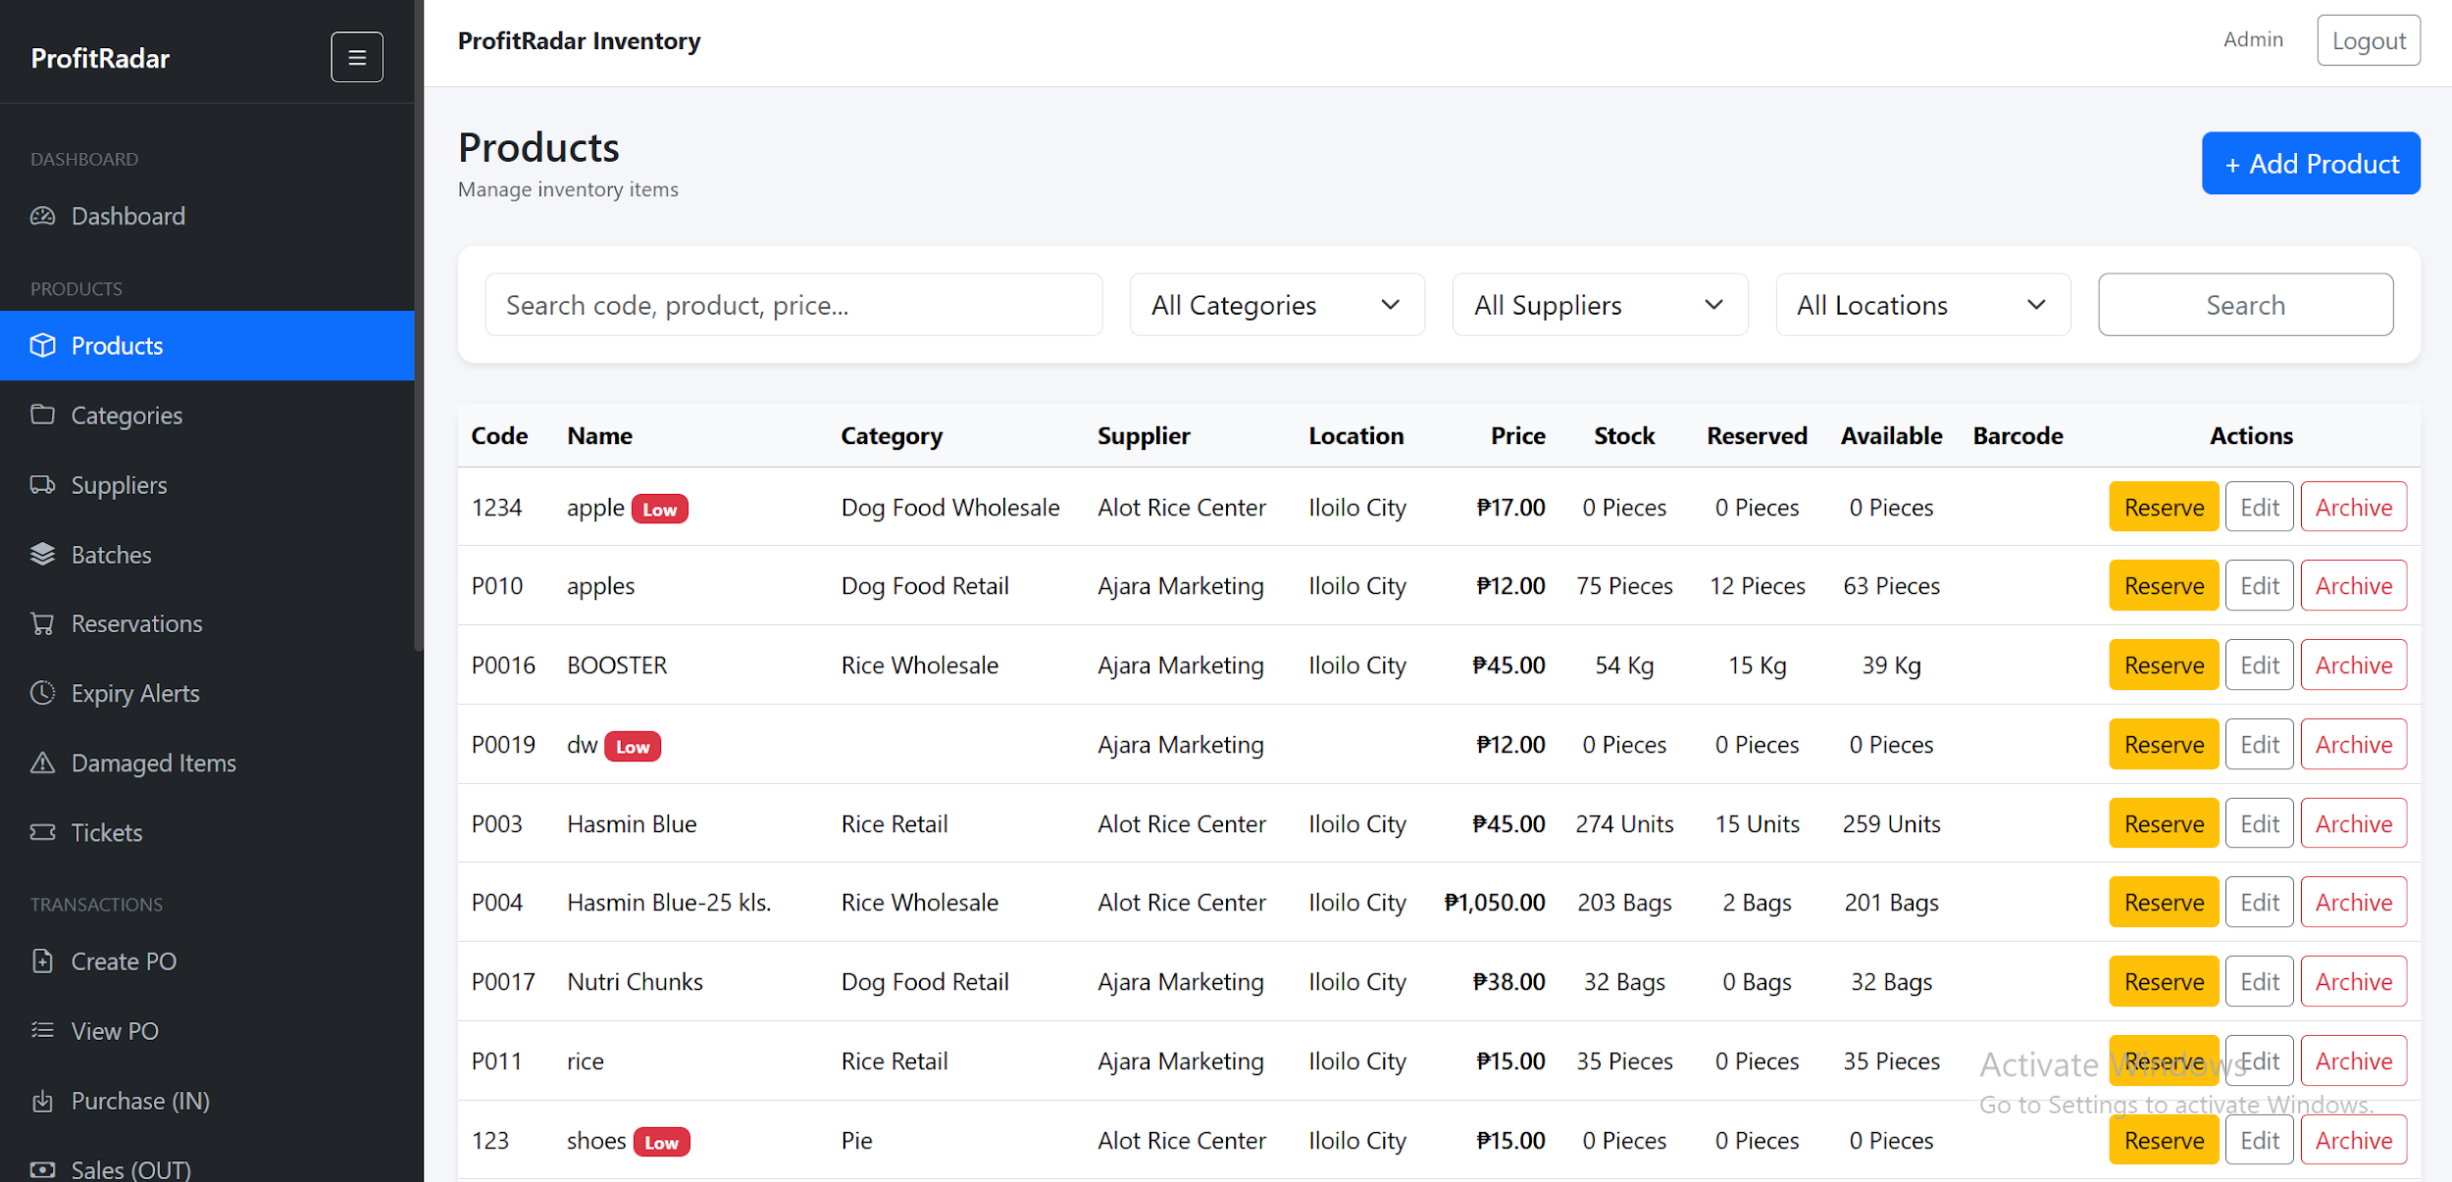
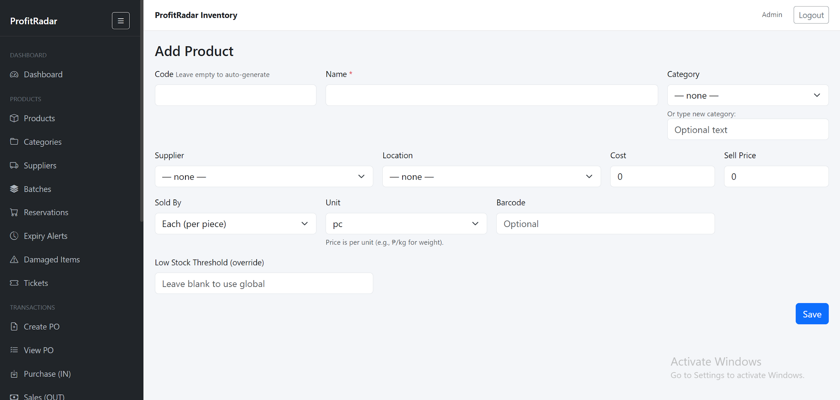
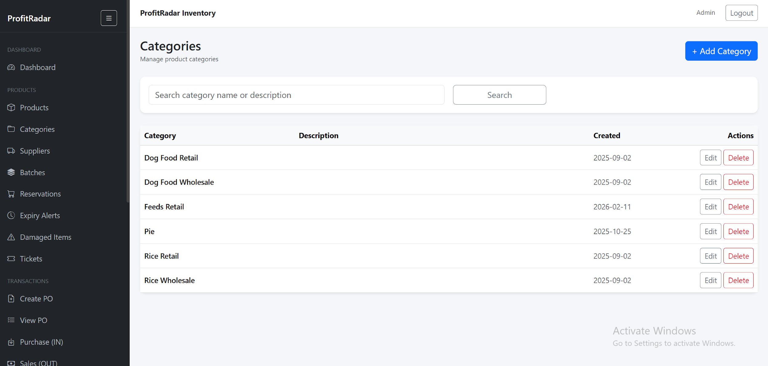
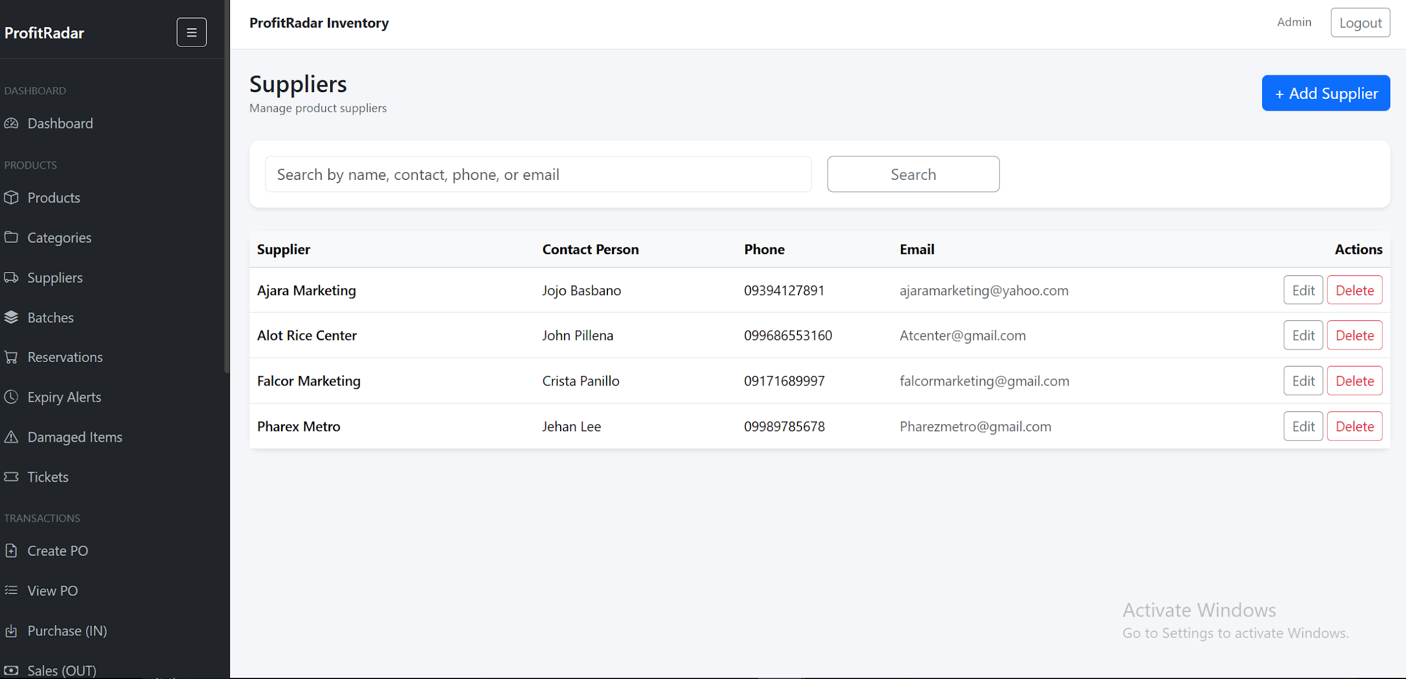
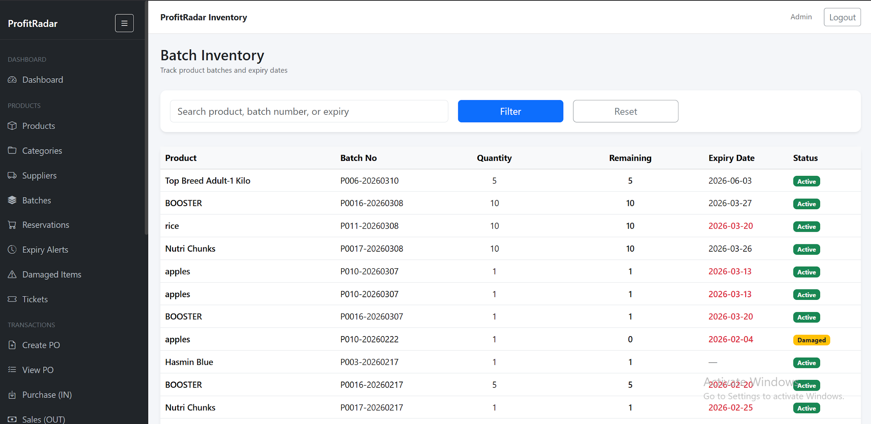
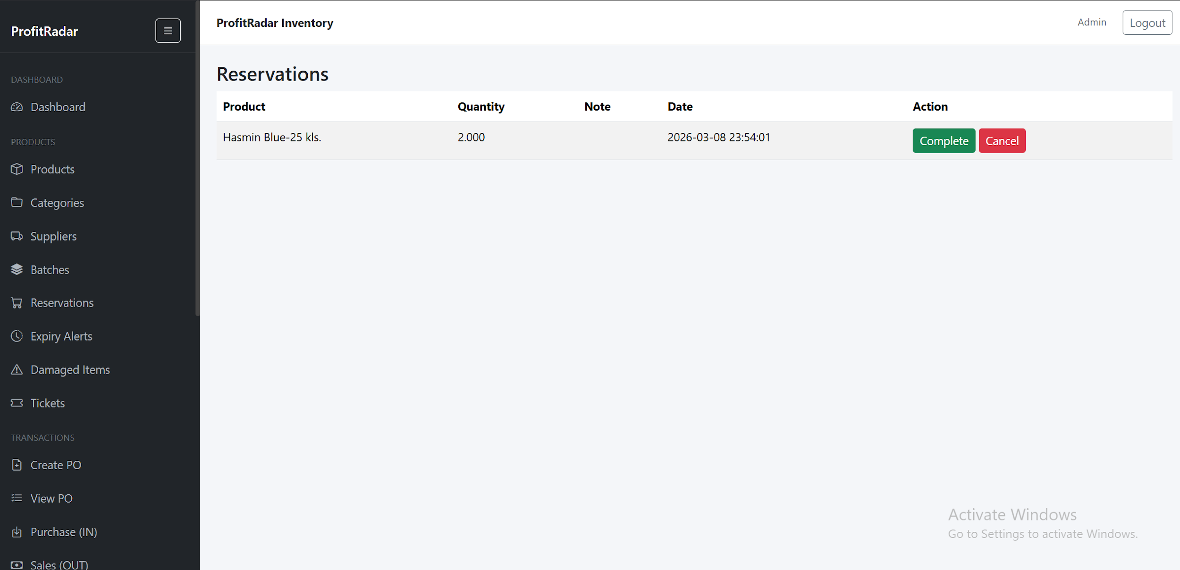
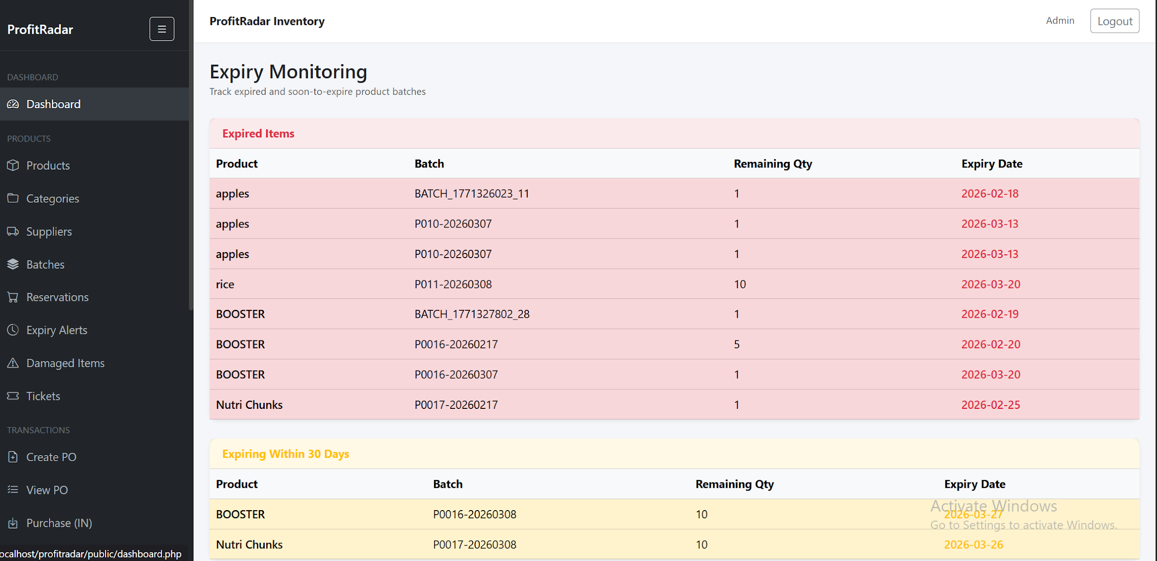
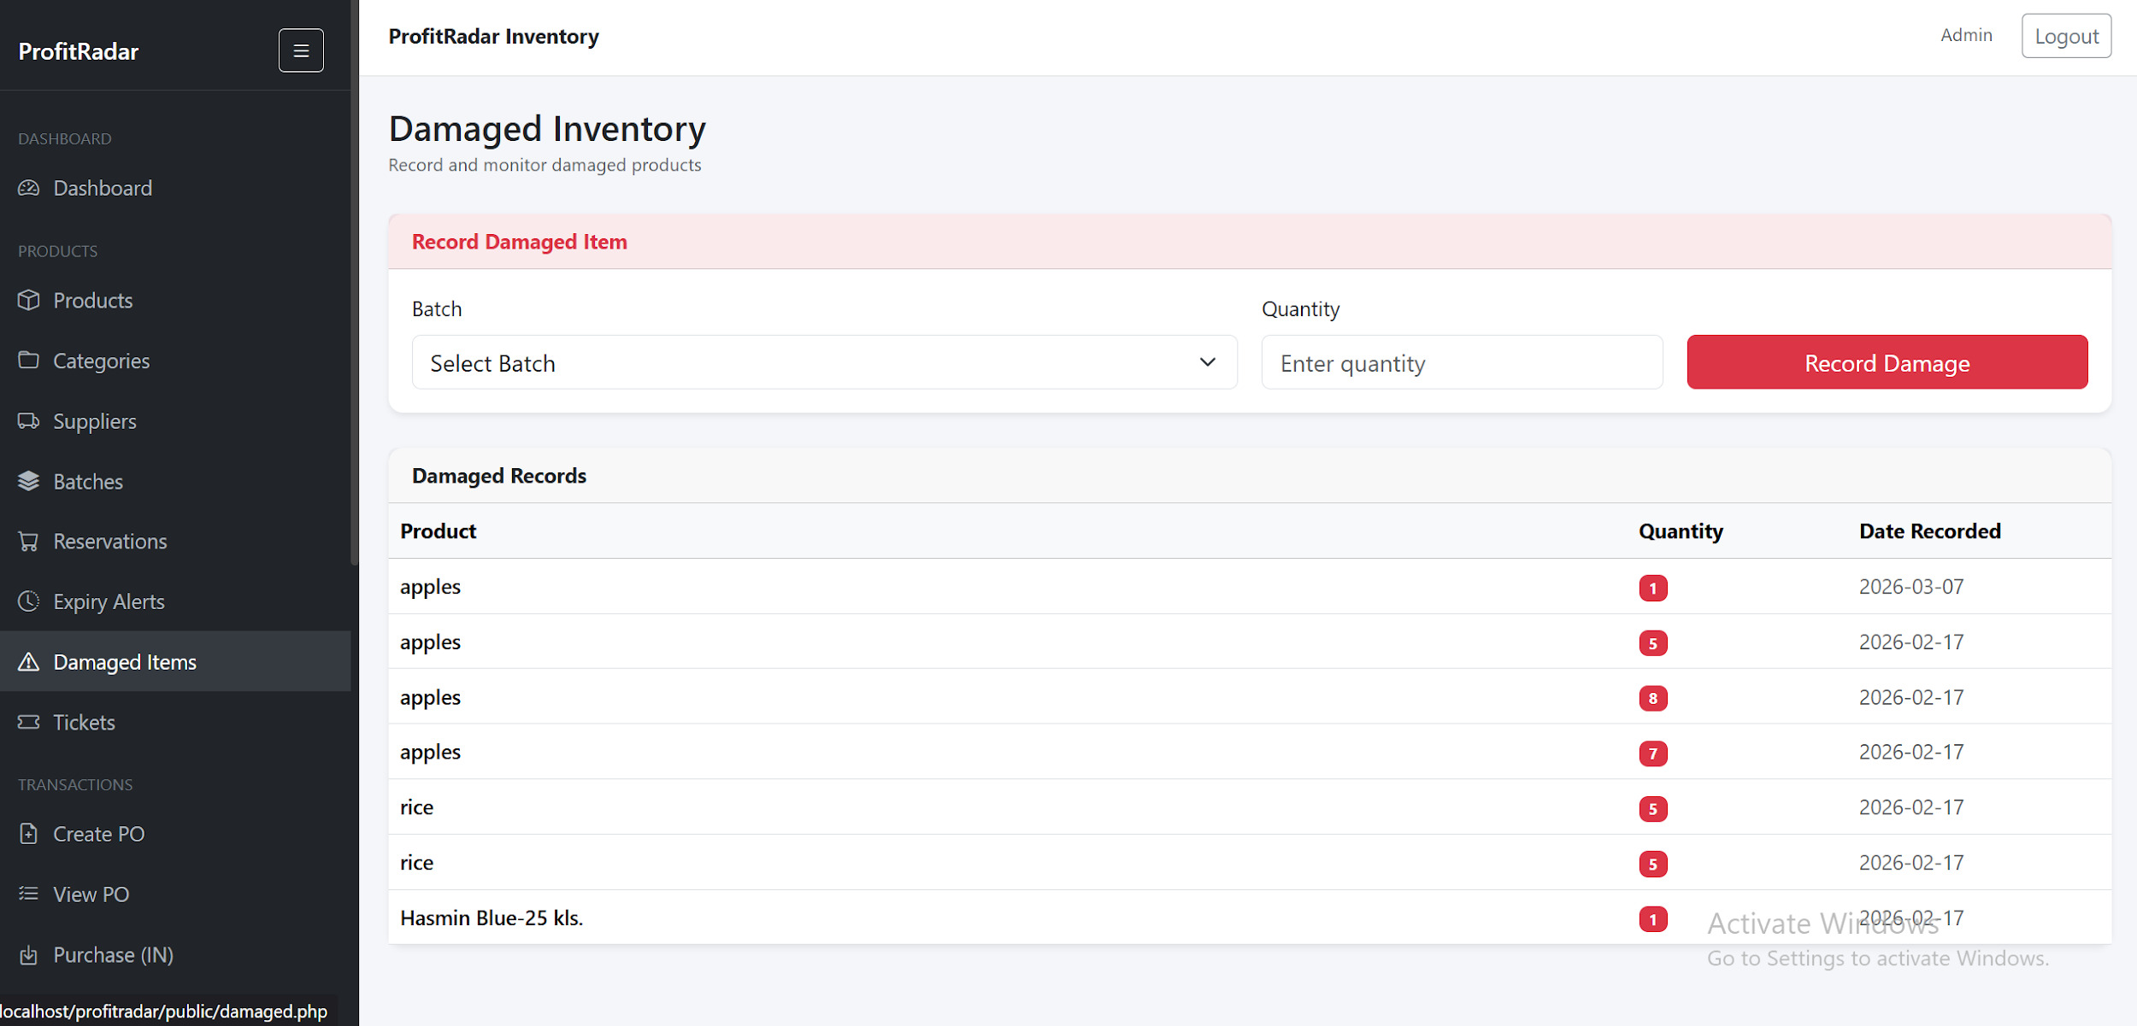
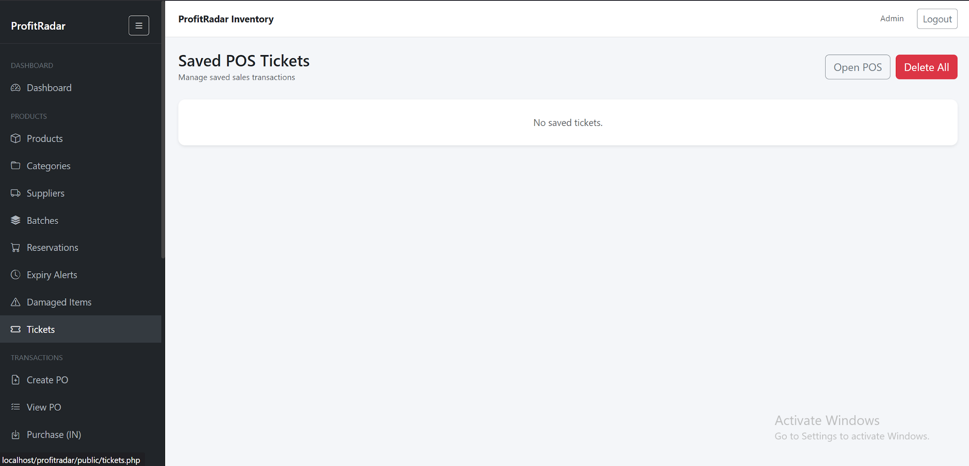
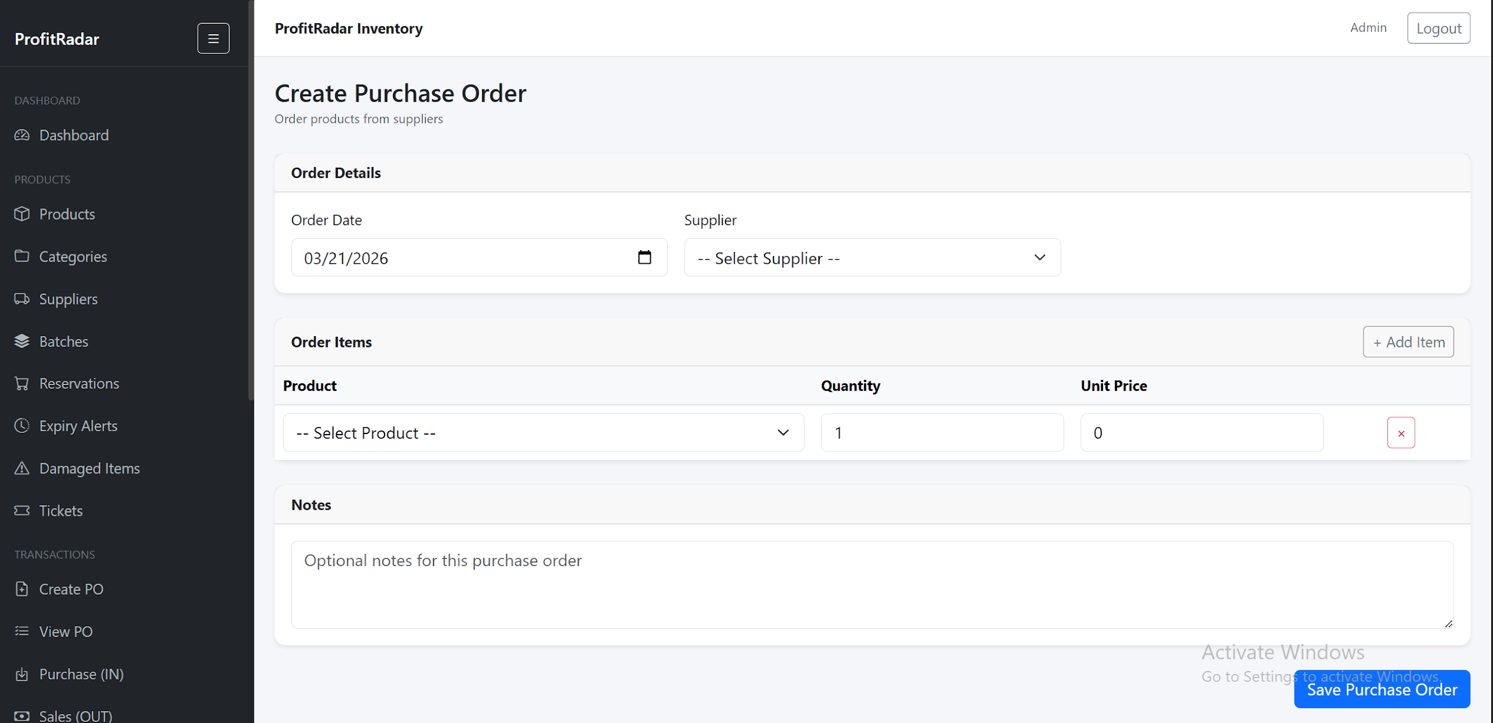
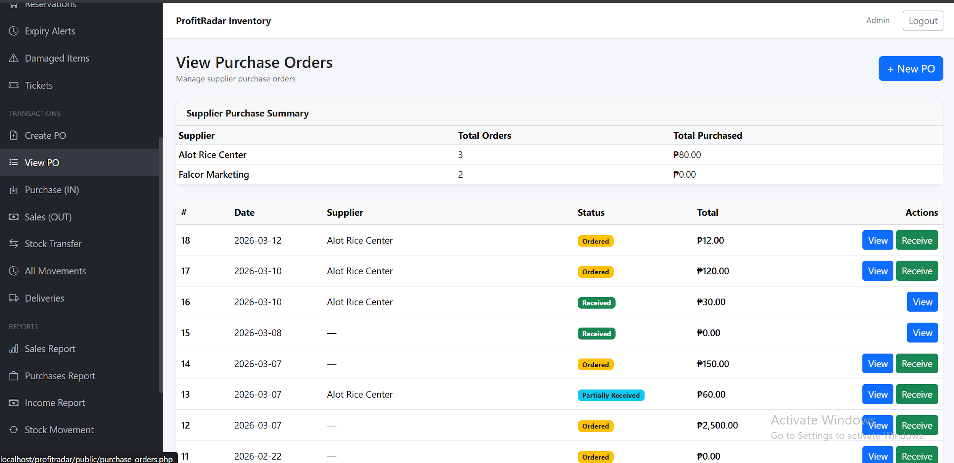
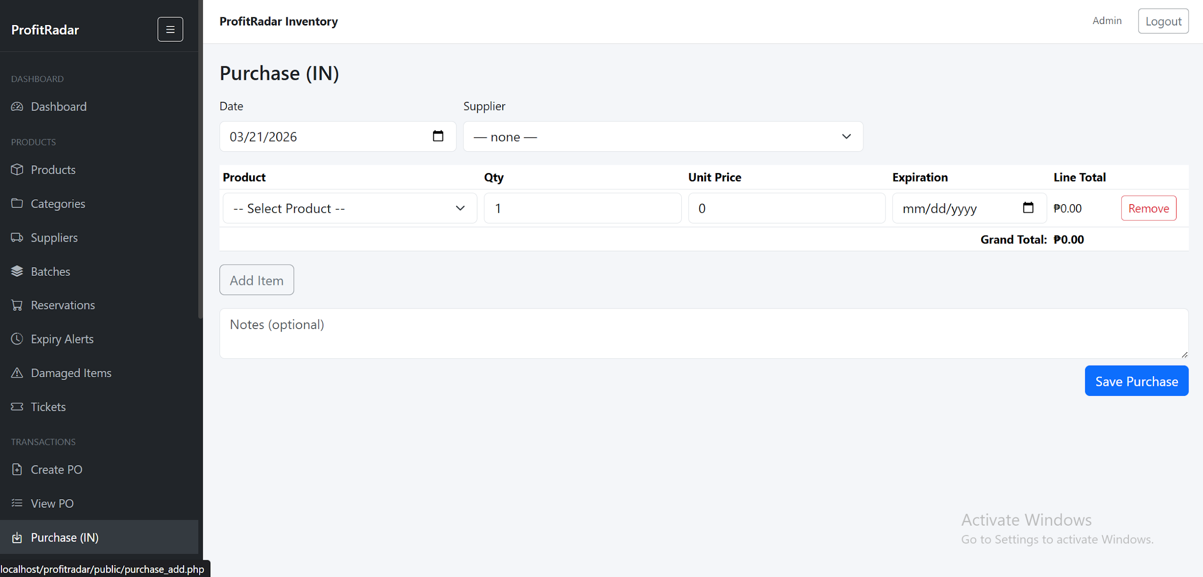
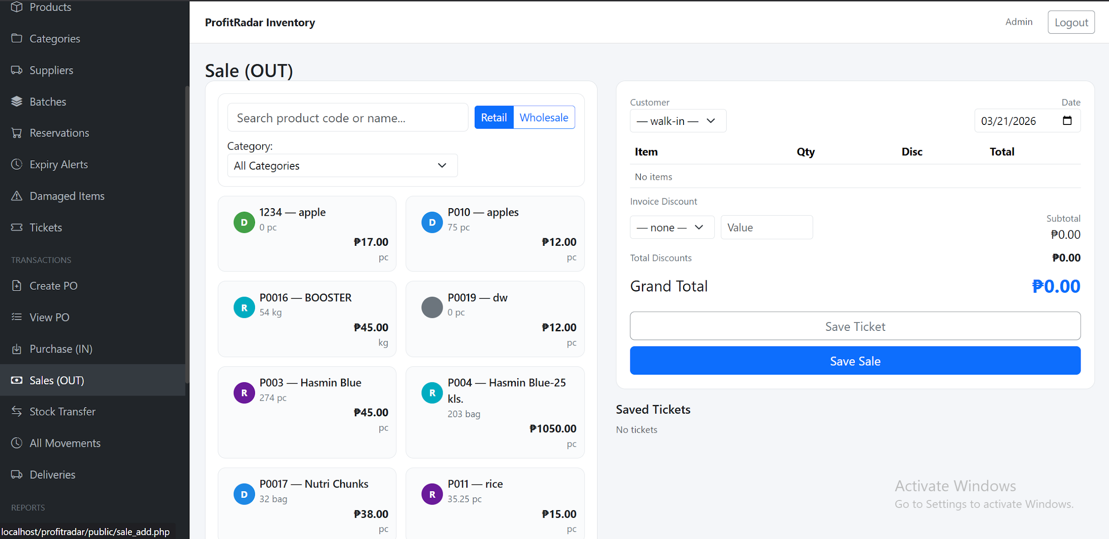
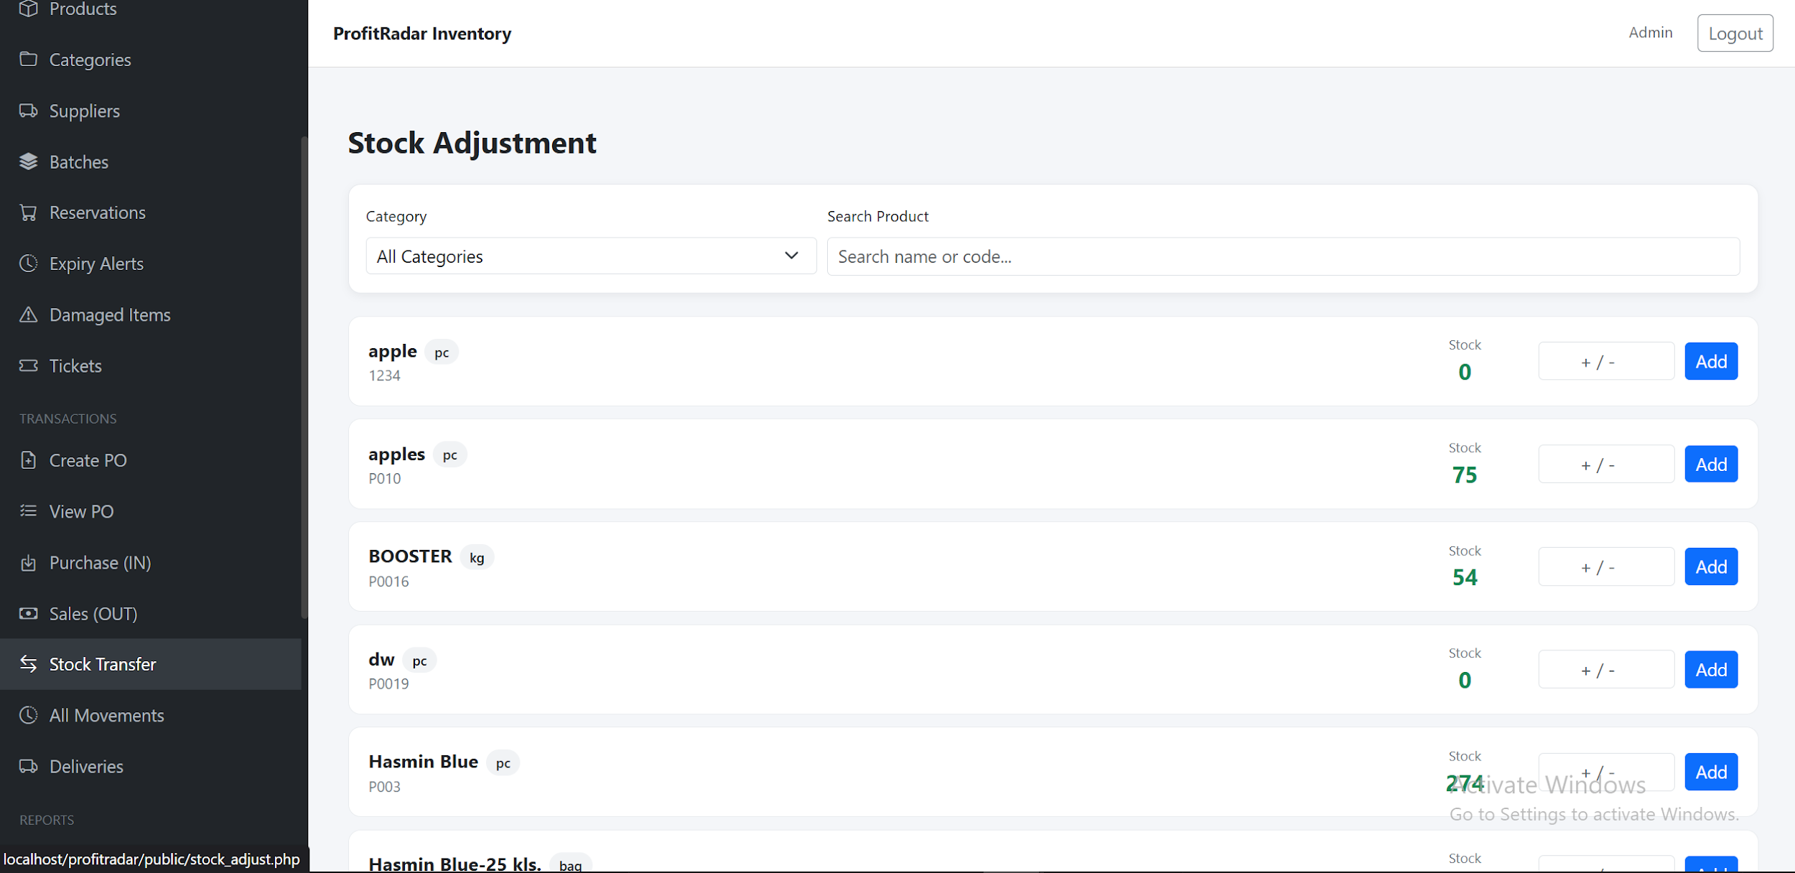
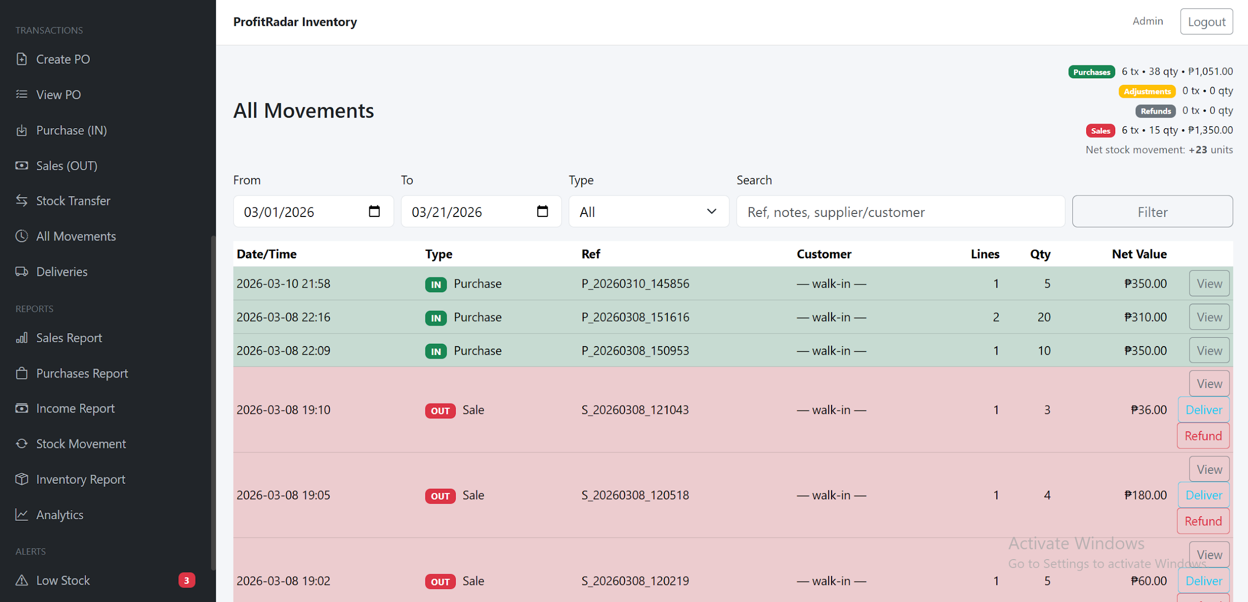
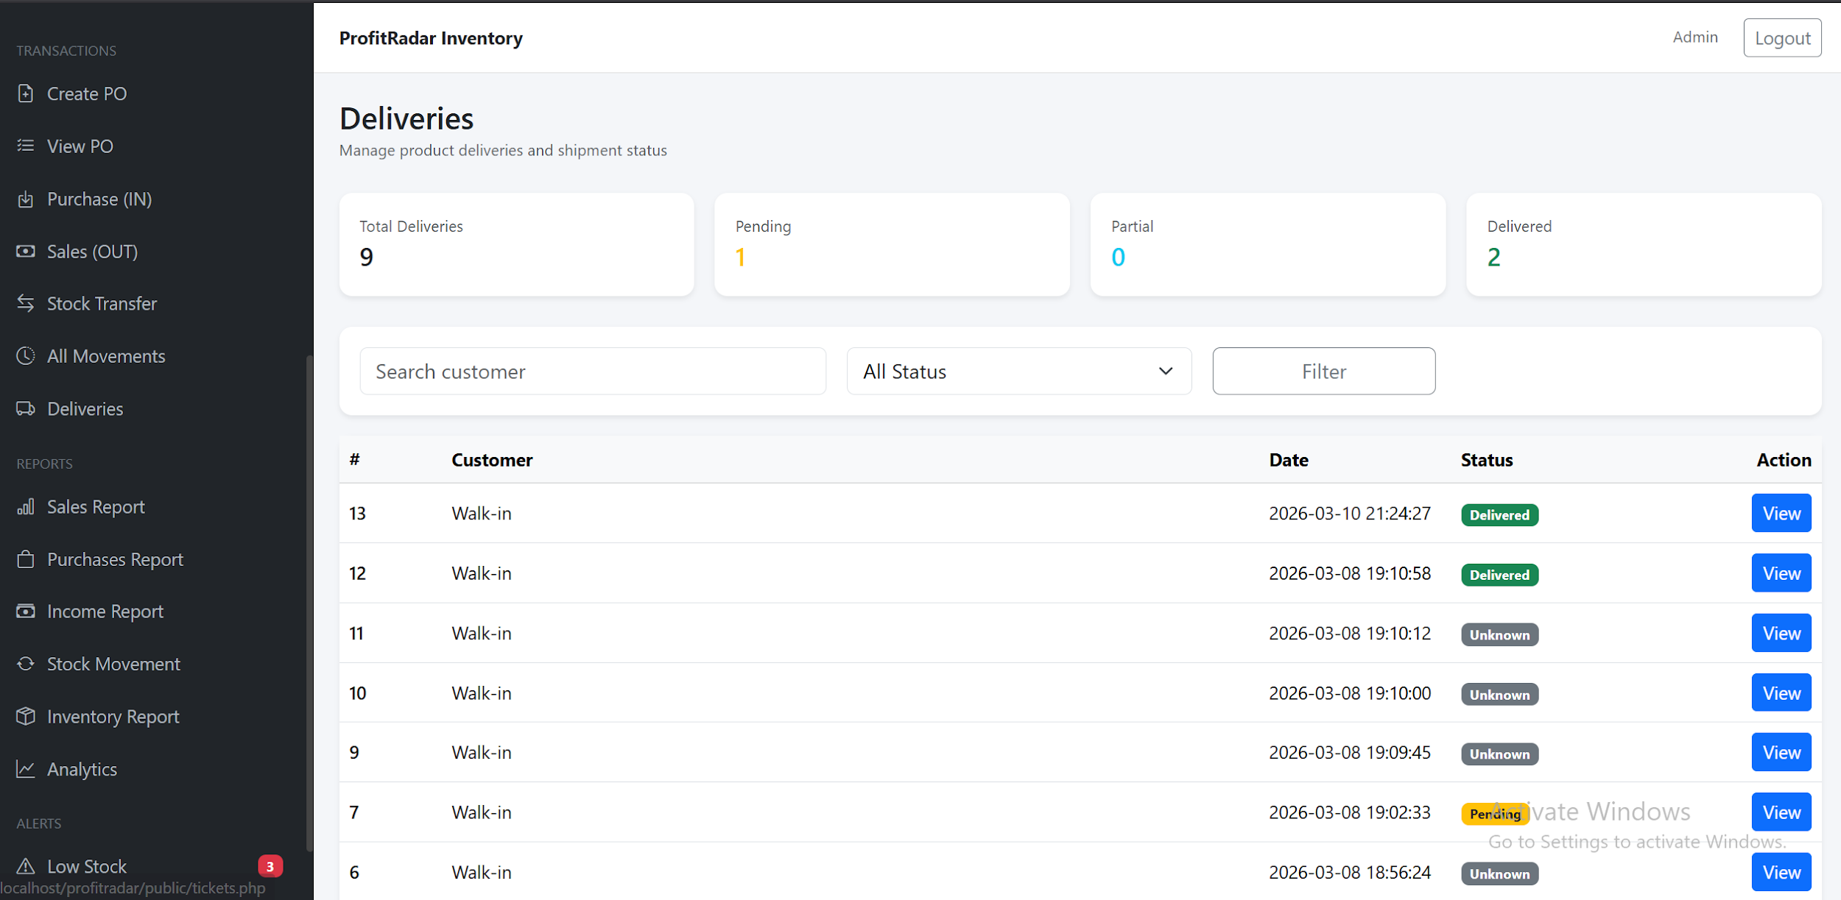
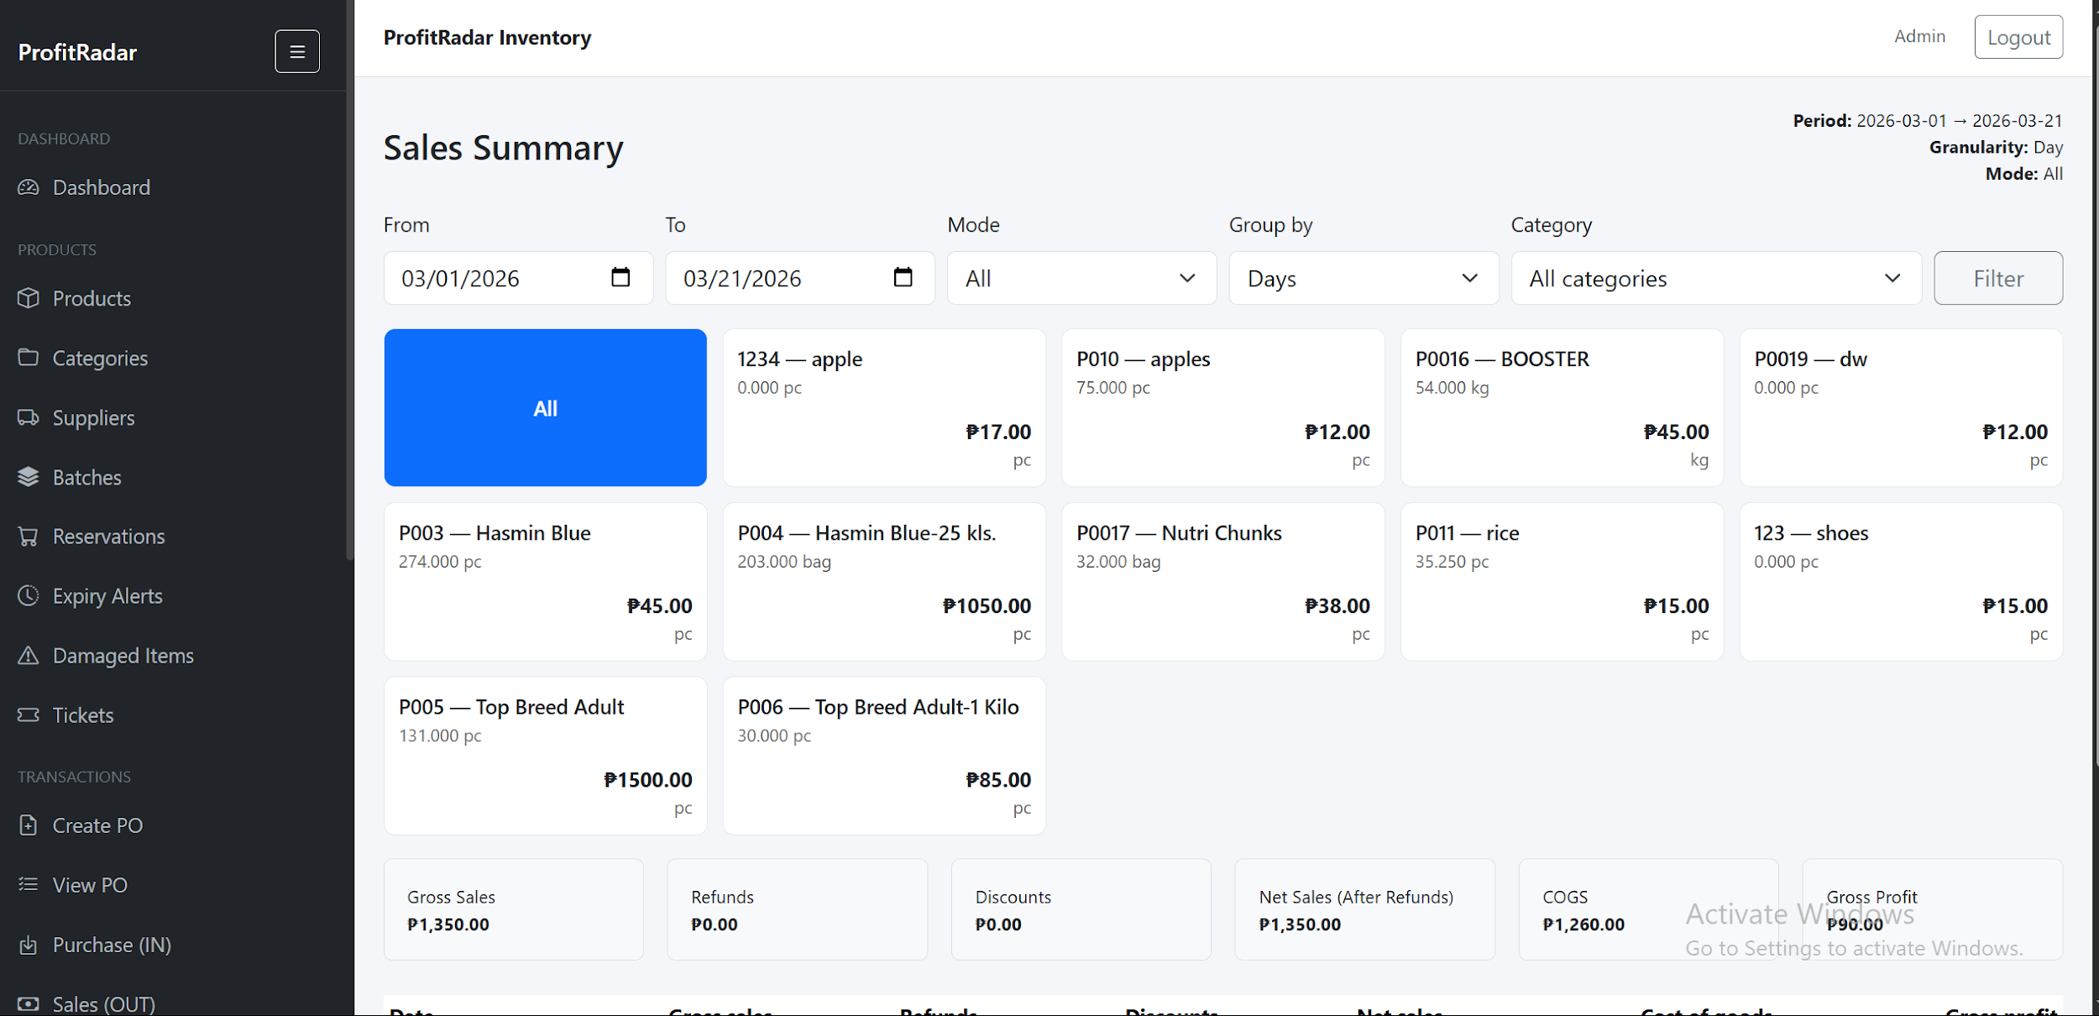
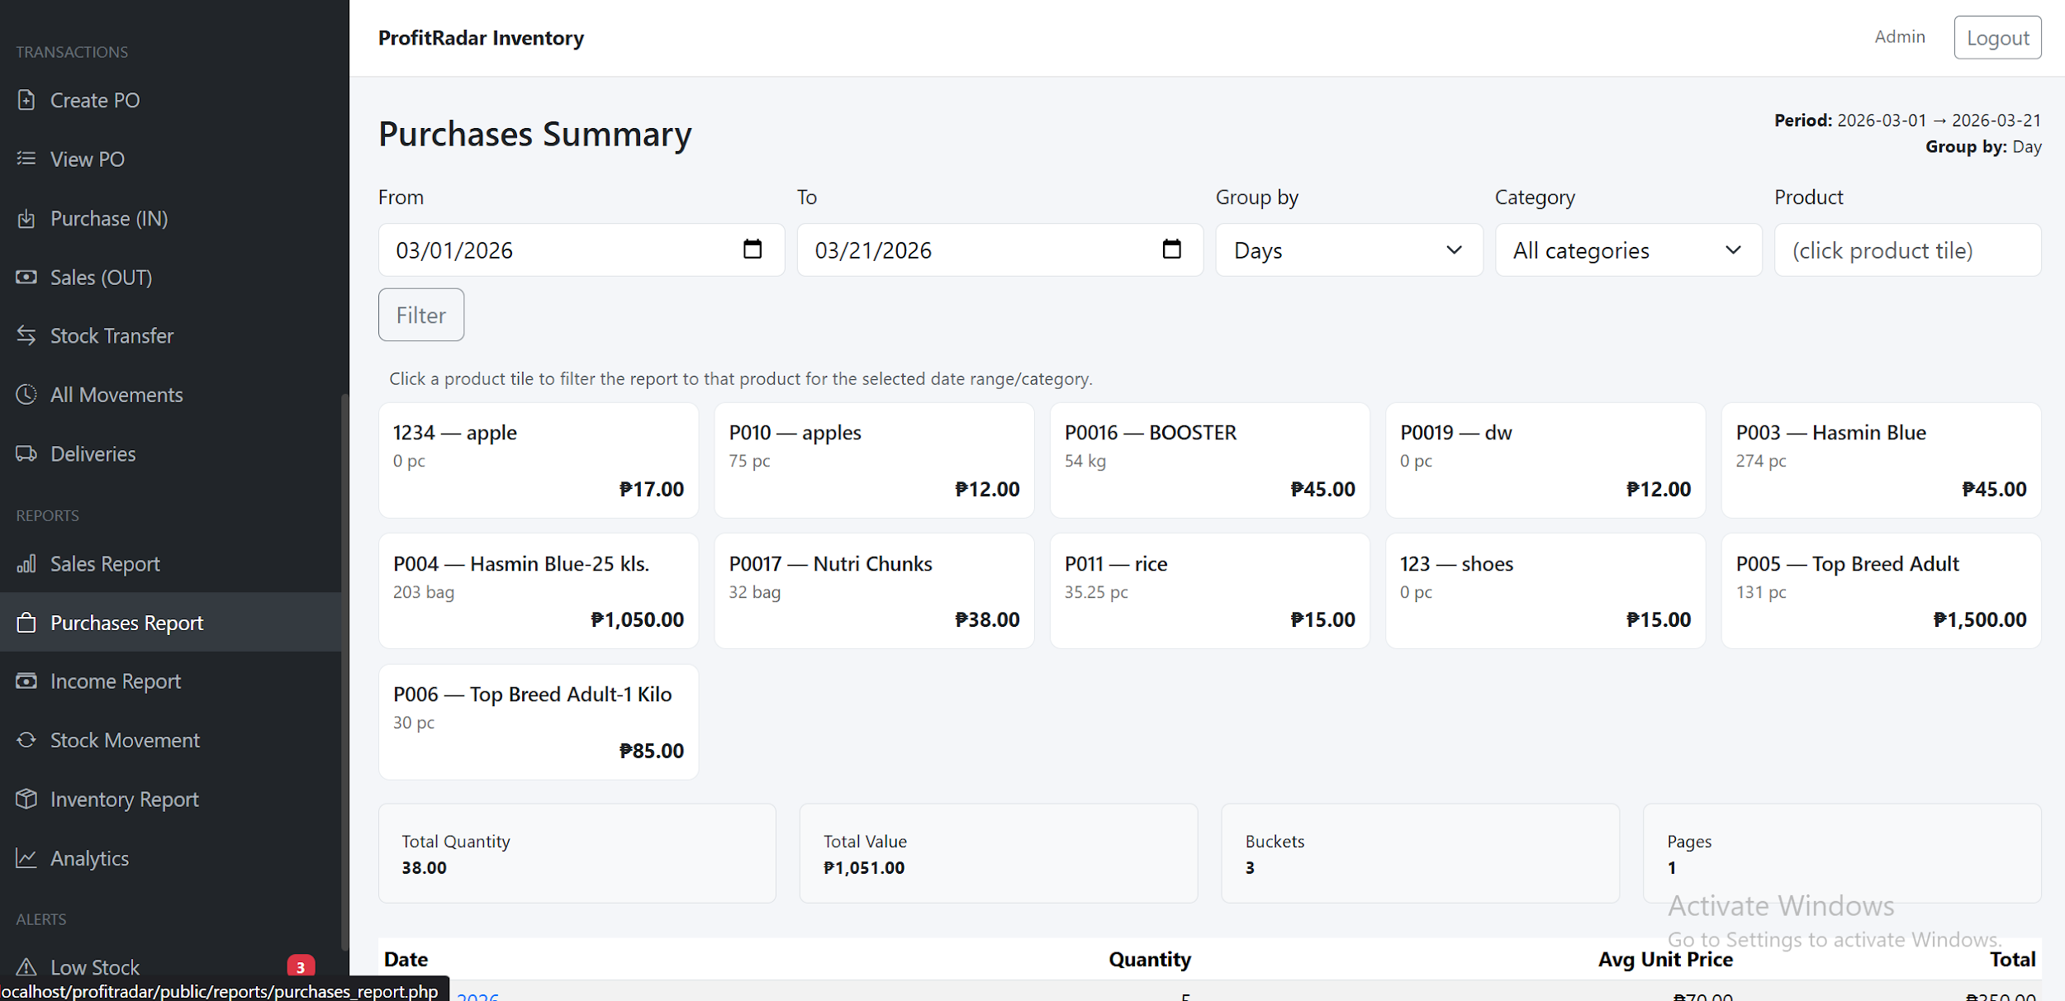
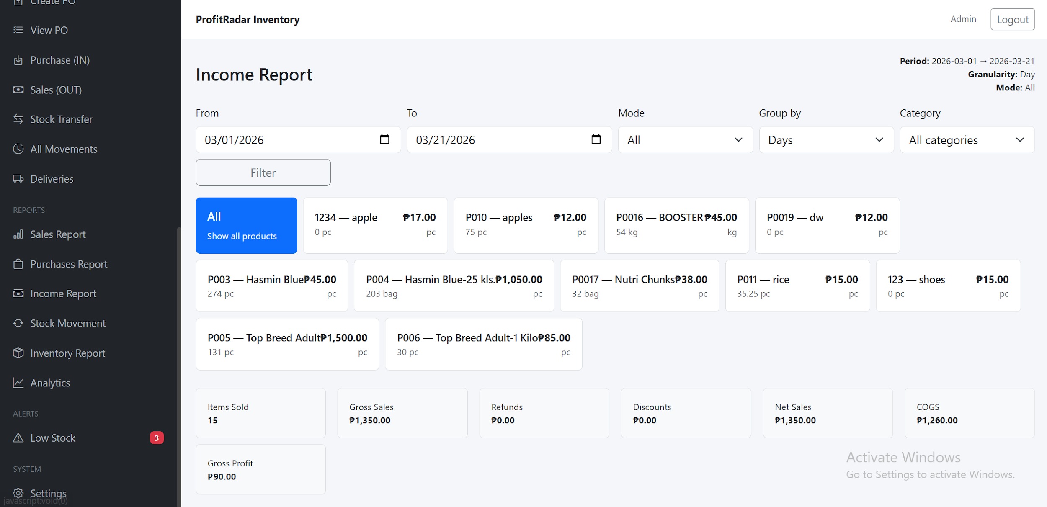
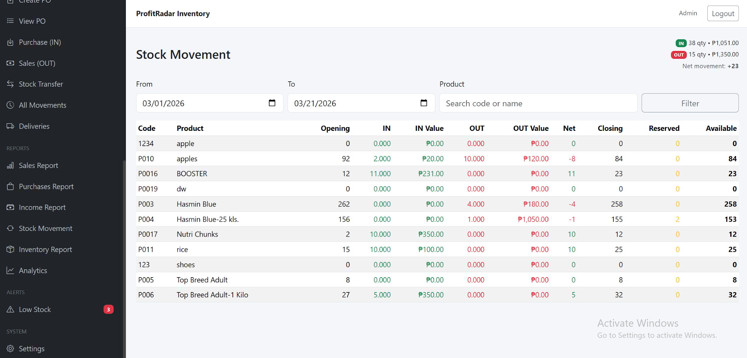
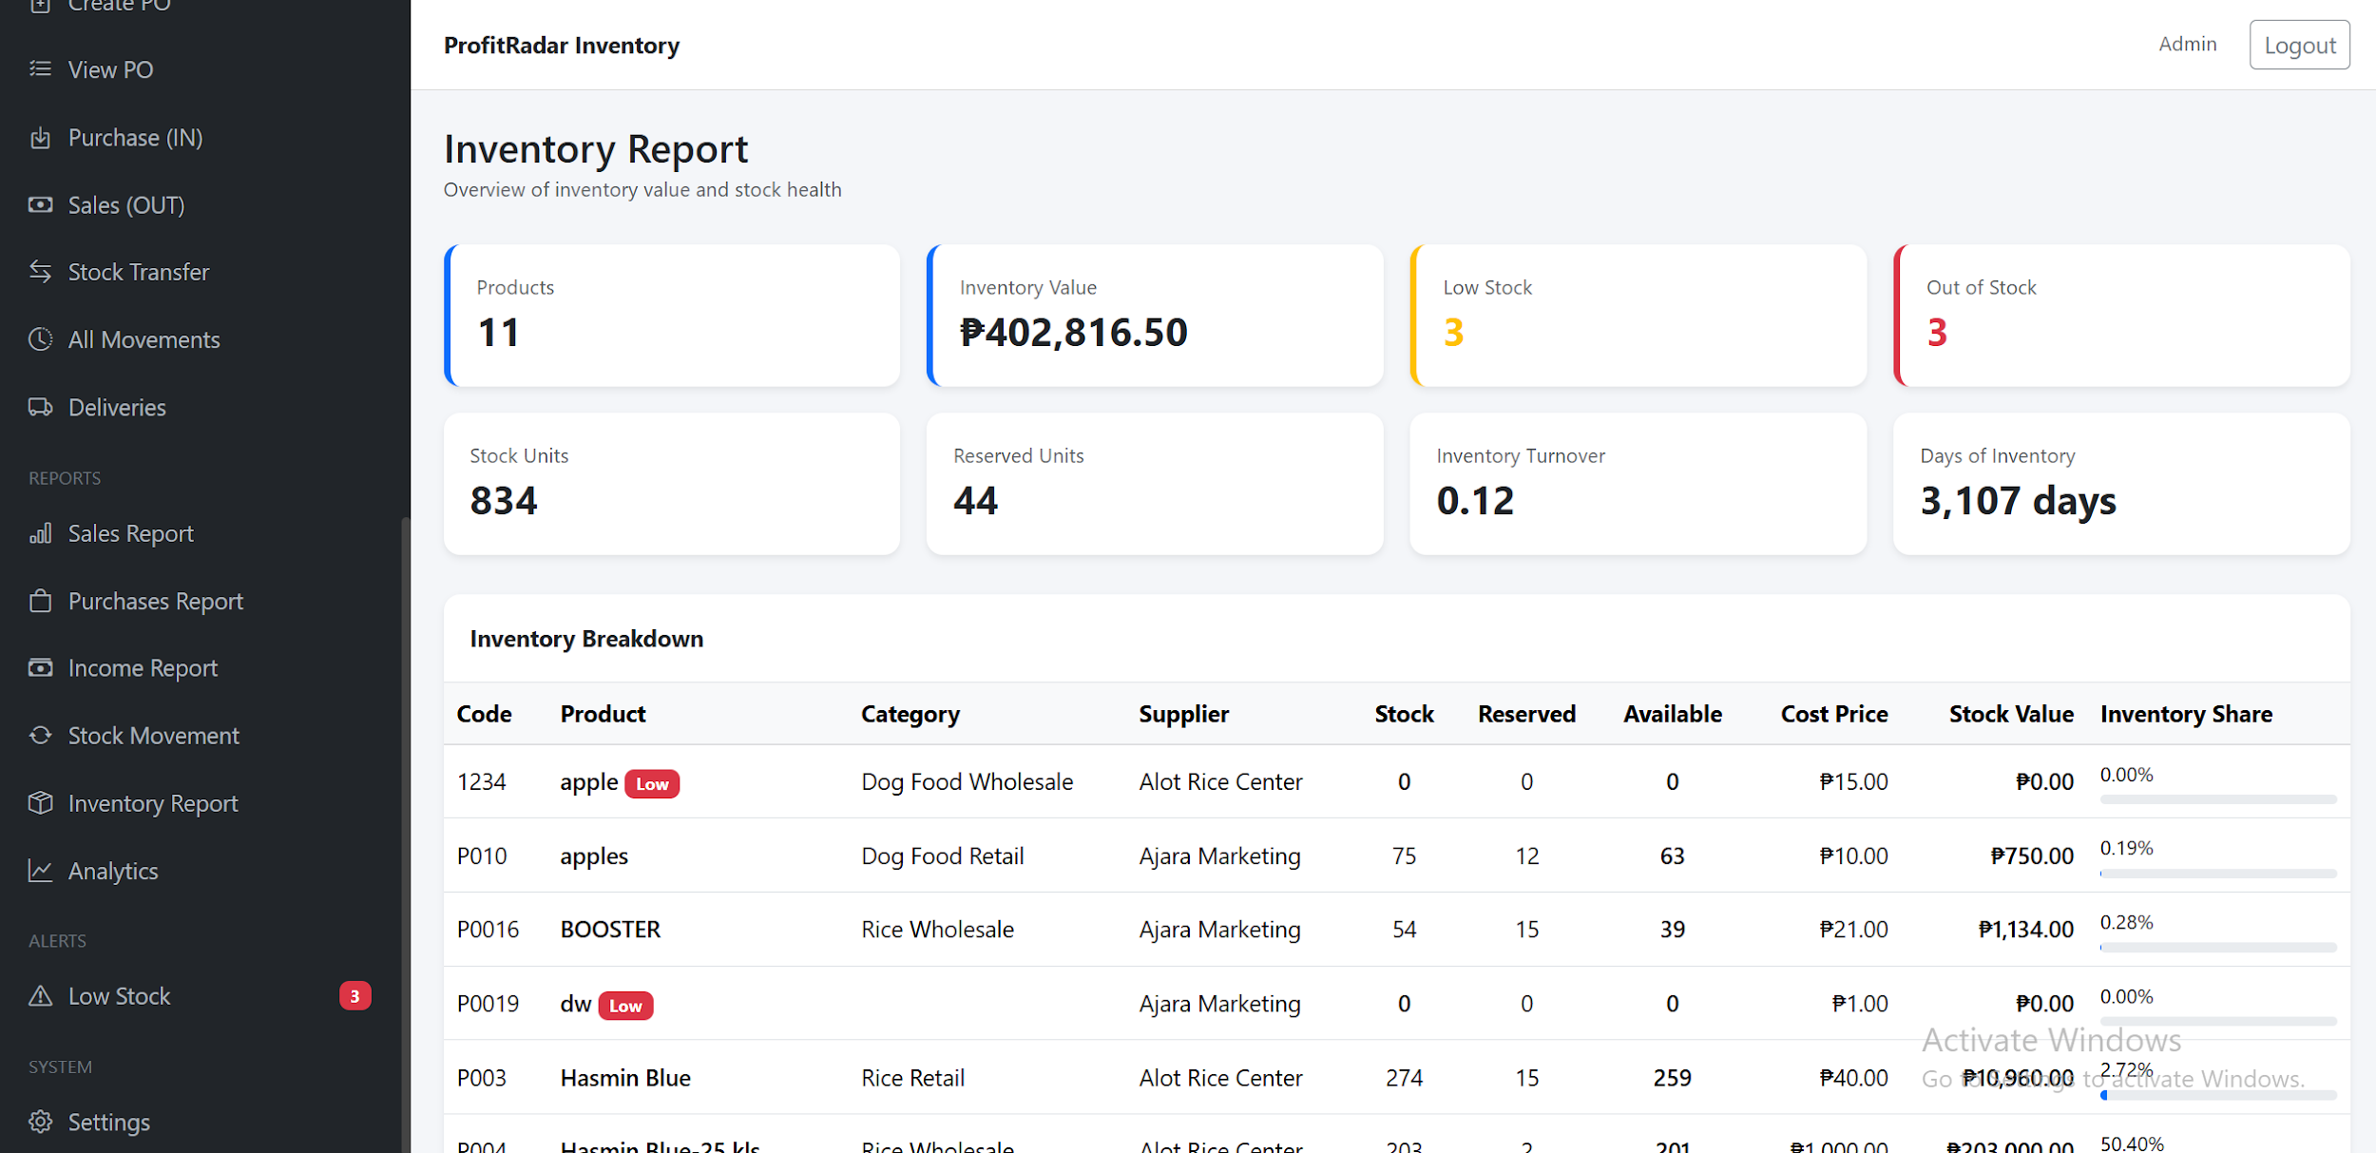
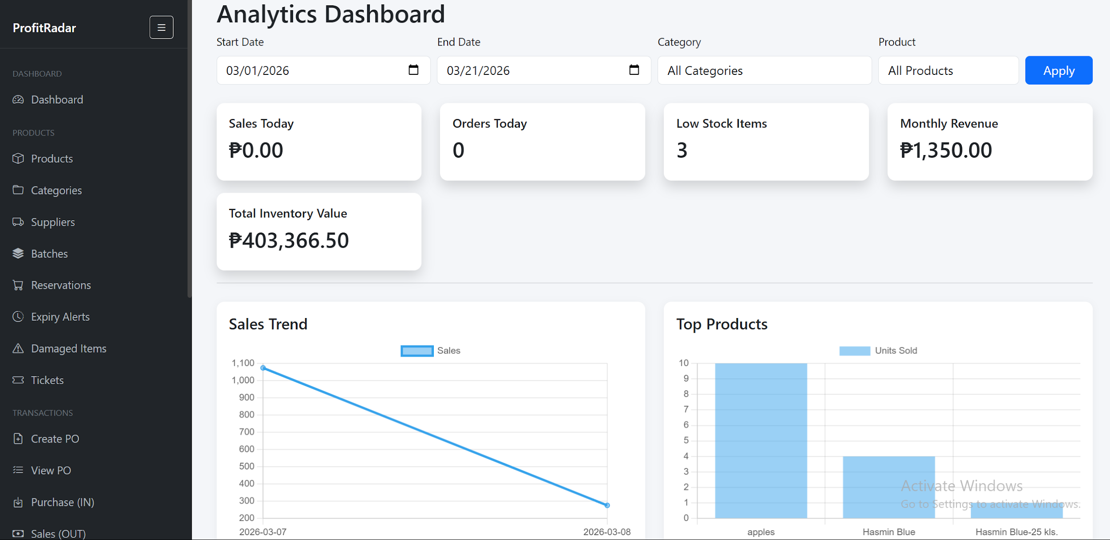
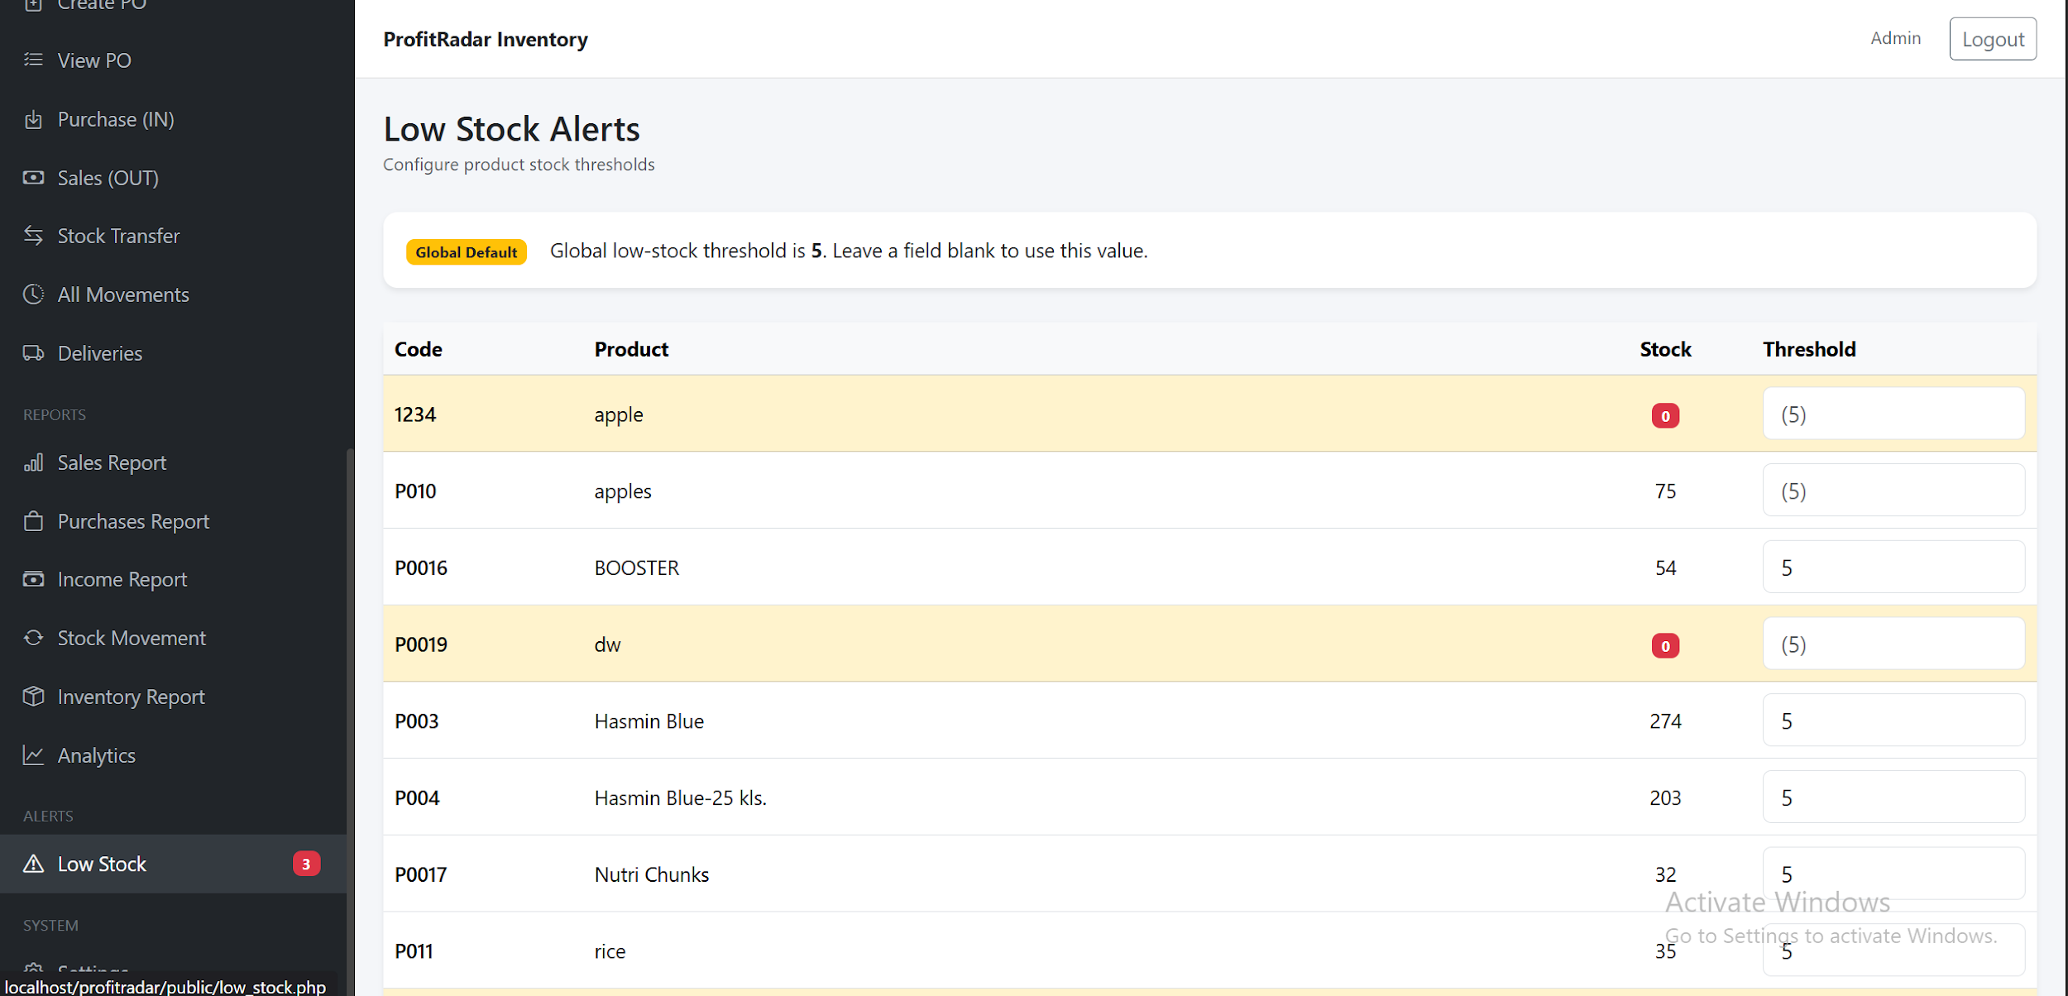
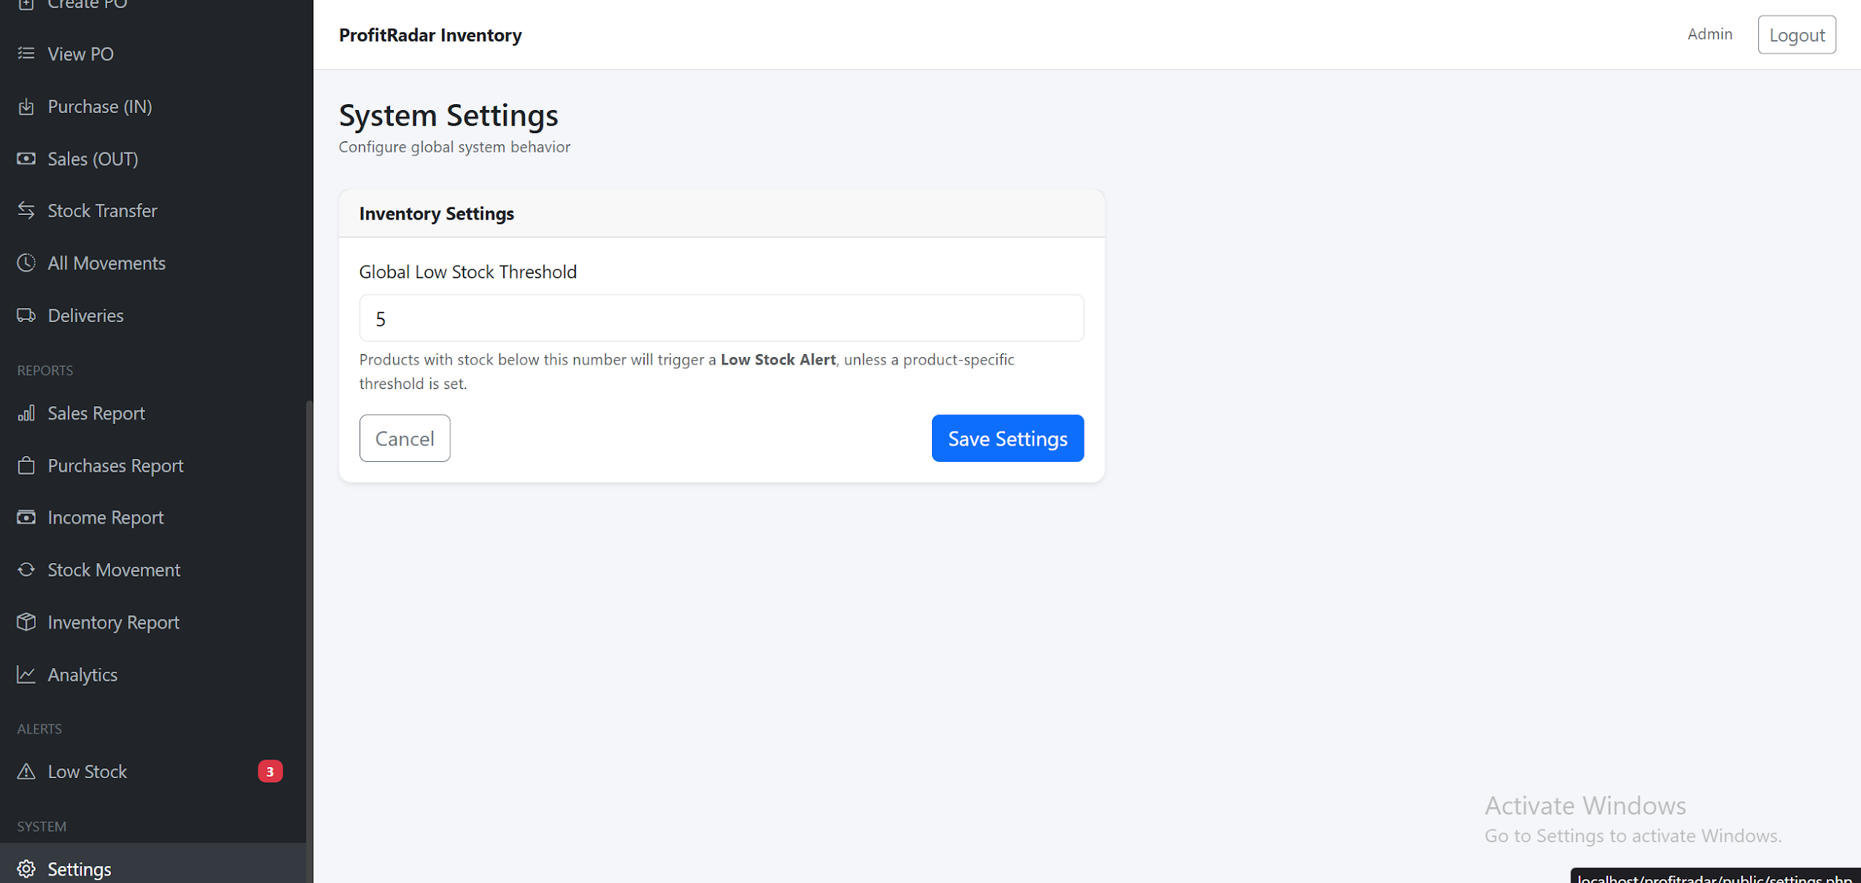

System Repository
The source code, database schema, and API documentation for the ProfitRadar – Inventory Management System are maintained in a version-controlled repository. The project structure is organized as follows:

https://github.com/aejen26/profitradar.git

Chapter 5

Summary, Conclusion, and Recommendation

5.1 Summary
This study focused on the development and evaluation of the ProfitRadar - Inventory Management System, a web-based system designed for NKM Agri-Poultry Supply to automate its inventory, sales, and profit monitoring processes. The system addressed the major challenges the business previously encountered, such as inaccurate stock counts, delayed transaction recording, difficulty in generating reports, and lack of real-time inventory visibility.
The system included essential modules such as product management, supplier management, sales and purchase transaction processing, low-stock alerting, real-time dashboard reporting, automated profit computation, stock monitoring, and audit logging. The testing phase demonstrated that the system performed reliably, updated data in real time, and consistently maintained accurate records—even under high operational load.
Data gathered through user feedback, transaction simulation, and system logs indicated substantial improvements in stock accuracy, transaction speed, error reduction, and overall workflow efficiency. The owner reported positive experiences with the system’s user interface, automation features, and reporting tools.
Graphical evaluations reflected:
- A 13% increase in inventory accuracy
- A 70% reduction in transaction processing time
- A significant drop in monthly inventory errors
- High user satisfaction, with 80% rating the system as excellent
These results confirmed that the system effectively met its intended objectives.

5.2 Conclusion
Based on the results and performance evaluation, the following conclusions were drawn:
1. The System Improved Inventory Accuracy
Automated stock updates, structured product records, and consistent transaction logging significantly reduced errors caused by manual methods. The system improved stock accuracy from 85% to 98%, ensuring reliable inventory tracking.
2. The System Enhanced Operational Efficiency
The processing time for sales and purchases was greatly reduced. Automated computations eliminated manual calculations, increasing the speed and accuracy of daily operations.
3. The Dashboard Provided Real-Time Decision-Making Support
The dashboard presented essential metrics—such as total stock, low-stock items, daily sales, and total profit—in real time. This enabled the business owner to make faster, data-driven decisions.
4. Low-Stock Alerts Prevented Stockouts
The system’s alert mechanism provided timely notifications when items reached minimum thresholds. This feature ensured better inventory control and prevented missed sales opportunities.
5. Reporting Features Improved Business Analysis
The system generated clear and comprehensive reports that summarized sales, profit, and inventory status. These reports helped visualize business performance and identify top-selling products.
6. The System Successfully Automated Core Business Processes
Overall, the ProfitRadar - Inventory Management System achieved its primary goal of modernizing the business’s record-keeping process. It moved the operations from manual tracking to a smart, automated, and real-time monitoring environment.
The results validated that the system effectively addressed the problems identified in earlier chapters and supported the business in improving efficiency, accuracy, and organization.

5.3 Recommendations
Based on the system’s performance and evaluation results, the following recommendations were suggested for further improvement and future development:
A. System Enhancements
- Implement Cloud-Based Access
Allowing the system to run online would enable remote monitoring and easier multi-device access.
- Add Multi-User Access Levels
Although the current system is designed for the owner only, future versions may include roles such as cashier, staff, or supervisor.
- Enhance Mobile Responsiveness
A fully responsive mobile version would allow the owner to monitor inventory and sales conveniently from a smartphone.
- Integrate Barcode Scanning
Adding barcode scanning for product searches and sales entry would greatly speed up transaction processing.
- Add Auto-Backup Features
Automated backup to Google Drive or local storage would protect the system from data loss due to hardware failure.

B. Business Process Recommendations
- Encourage Regular Monitoring of Dashboard Metrics
The business owner should use the dashboard analytics daily to track sales performance and stock levels.
- Perform Periodic Inventory Reconciliation
Although the system ensures accuracy, manual verification every month is recommended to ensure record integrity.
- Utilize Reports for Business Decision-Making
Sales and profit reports should be used to plan restocking, adjust pricing, or identify underperforming products.

C. Recommendations for Future Researchers
- Expand the System Into a Full POS (Point-of-Sale)
Future developers may incorporate receipt printing, customer profiles, and automated discounts.
- Integrate Smart Forecasting Algorithms
Predicting stock demand using sales trends and analytics could further enhance business intelligence.
- Upgrade UI/UX for More Interactive Dashboards
Adding advanced graphs and charts would elevate usability and enhance data visualization.

Final Thoughts
Developing the ProfitRadar - Inventory Management System was a valuable experience that allowed us to apply what we learned into a real-world situation. Throughout the process, we were able to see how technology can directly improve the daily operations of a small business. From planning and development to testing and evaluation, each stage helped us understand the importance of creating a system that is not only functional but also practical and easy to use.

The system showed that even a simple, well-designed solution can make a big difference. Tasks that were once time-consuming and prone to errors became faster and more accurate. More importantly, it helped the business owner gain better control and understanding of their inventory and sales.

This project also helped us grow as developers. We learned how to adapt to challenges, improve based on feedback, and focus on the needs of the user. Overall, the development of ProfitRadar was not just about building a system, but about creating a solution that brings real value and improvement to a business.

References
The following references are cited in this study and are listed in alphabetical order in APA 7th edition format.
Ayo, C. K., & Ukpere, W. I. (2020). Automation and digitalization as tools for organizational efficiency. African Journal of Business and Economic Research, 15(2), 57–72.
Beal, V. (2022). Inventory management definition and concepts. TechTarget. https://www.techtarget.com
Bourgeois, D. T. (2014). Information systems for business and beyond. Saylor Academy.
Dennis, A., Wixom, B. H., & Roth, R. M. (2018). Systems Analysis and Design (7th ed.). Wiley.
Dissanayake, D., & Kandambi, H. (2021). The impact of computerized systems on small business operations. International Journal of Business Innovation, 5(2), 45–54.
Fisher, T. (2021). Understanding SQL and relational databases. O’Reilly Media.
Hoffer, J. A., Ramesh, V., & Topi, H. (2016). Modern Database Management (12th ed.). Pearson.
Laudon, K. C., & Laudon, J. P. (2020). Management Information Systems: Managing the Digital Firm (16th ed.). Pearson.
Merkle, R., & Bick, M. (2019). Usability and interface effectiveness in business information systems. Journal of User Experience and Interaction Design, 8(4), 50–68.
Rouse, M. (2021). What is automation? TechTarget. https://www.techtarget.com
Stair, R., & Reynolds, G. (2019). Principles of Information Systems (13th ed.). Cengage Learning.
Turban, E., Pollard, C., & Wood, G. (2018). Information Technology for Management (11th ed.). Wiley.
Zhang, Y., & Cheng, X. (2020). Small business digital transformation through inventory system automation. International Journal of Emerging Technologies in Accounting, 12(1), 79–88.

Appendices:

Appendix A: System Interface Screenshots
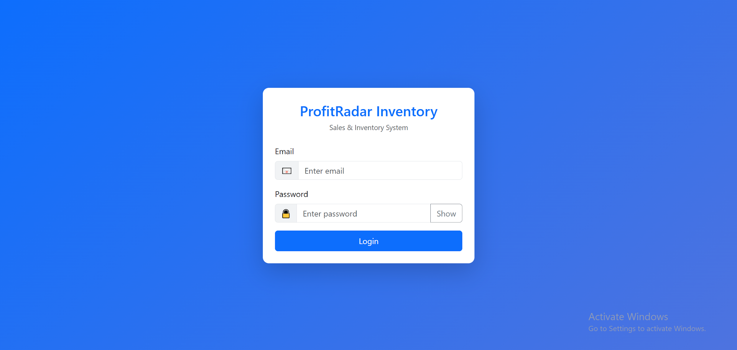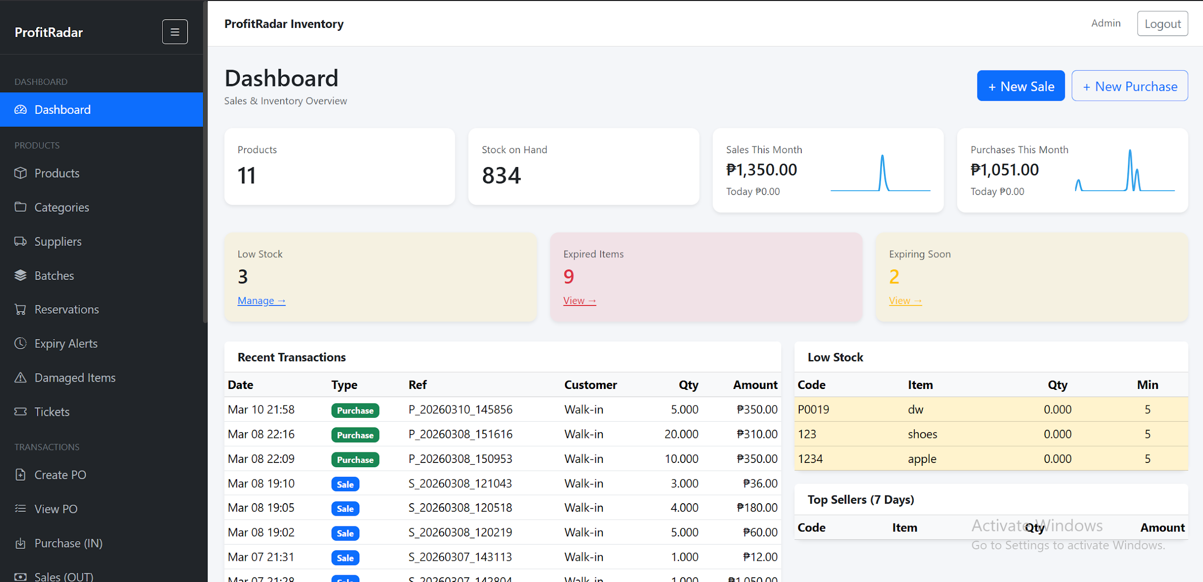
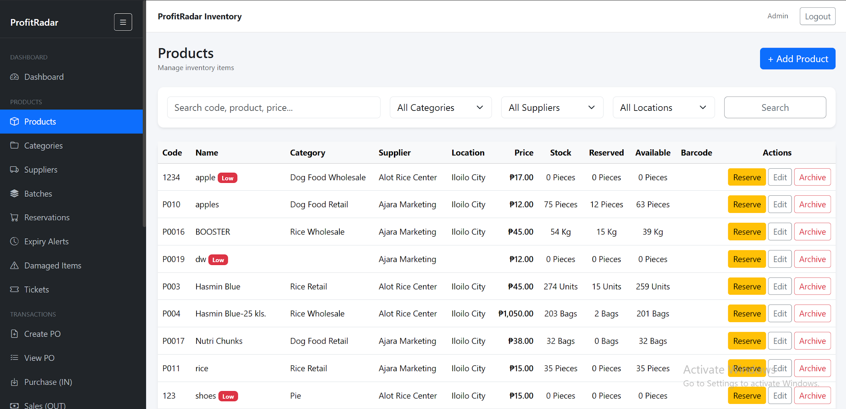
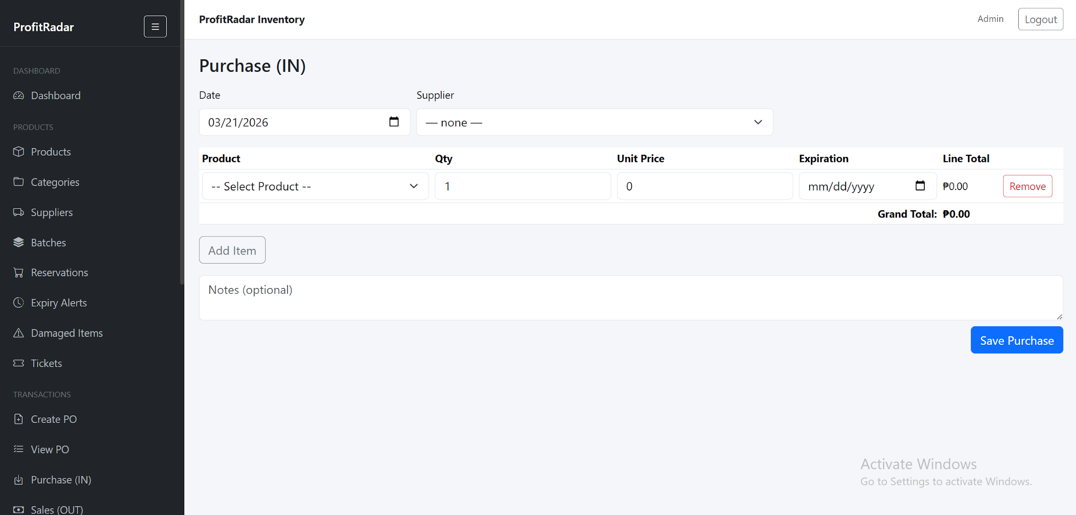
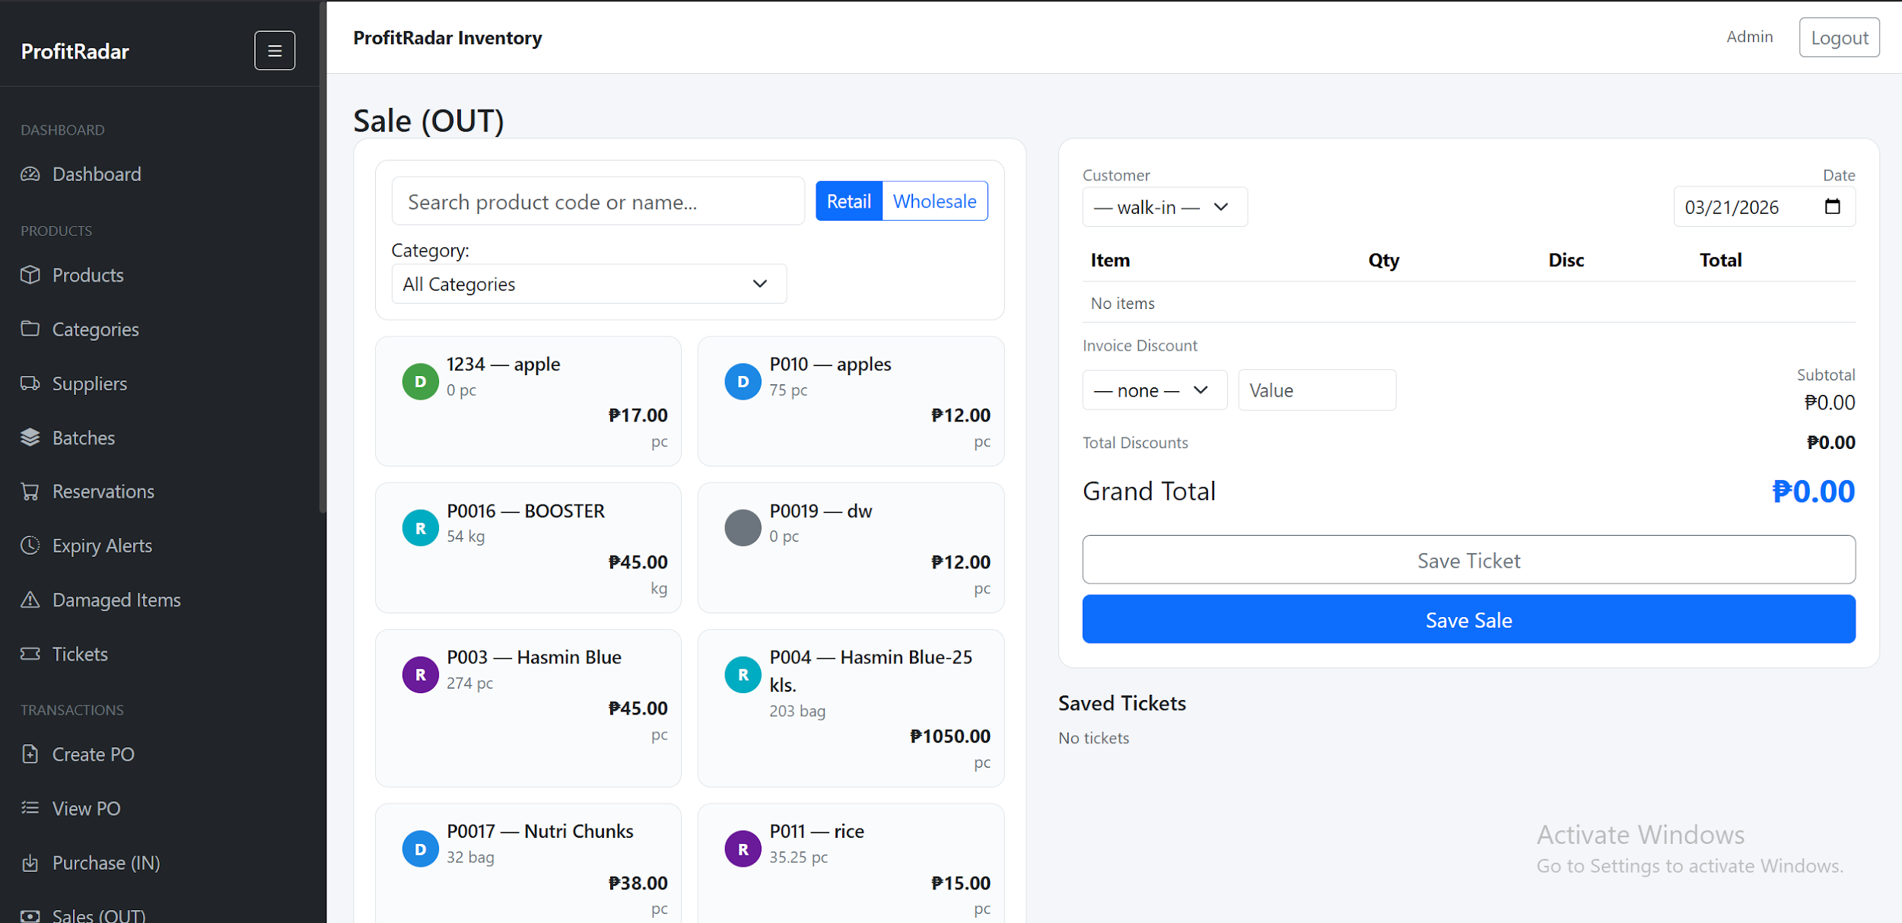
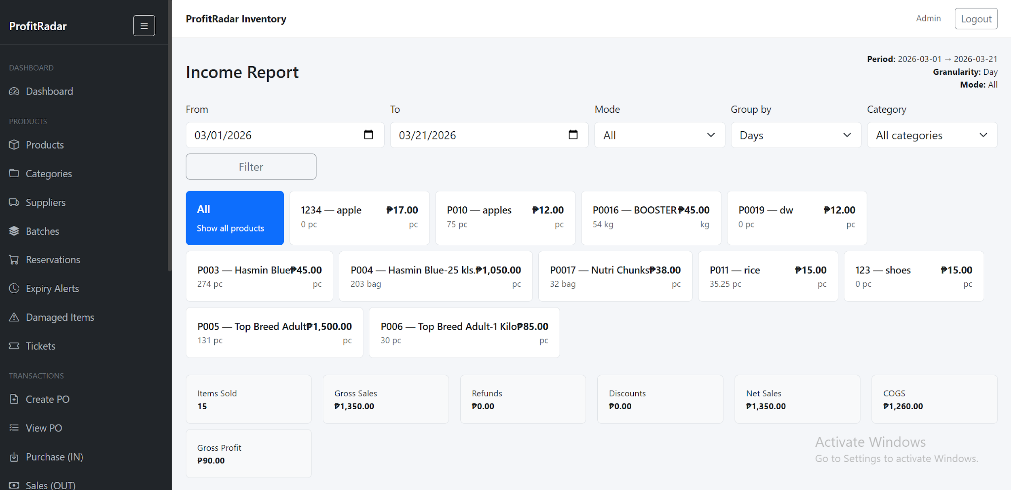
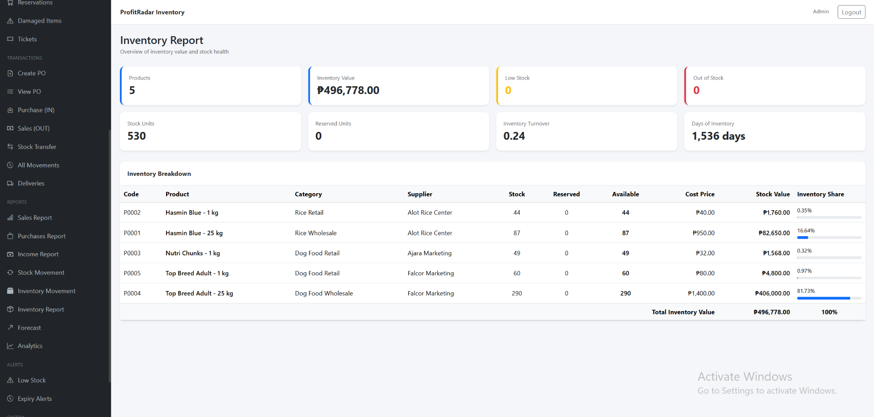

Appendix B: Use Case Diagram
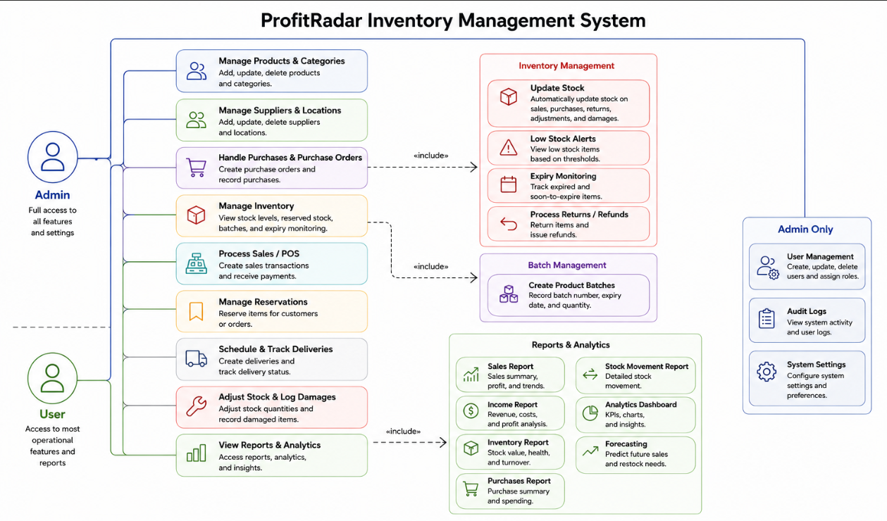
Use Case Diagram of the ProfitRadar - Inventory Management System, showing one actor (User/Owner) and key use cases including Manage Products & Categories, Manage Suppliers & Locations, Process Sales/POS, Handle Purchases, Schedule & Track Deliveries, Adjust Stock & Log Damage, and Review Audit Logs & Reports, with related actions such as Update Stock, Process Refunds, and Create Product Batches.

Appendix C: Data Flow Diagram

Level 1 Data Flow Diagram of the ProfitRadar - Inventory Management System, showing six main processes (Login, Manage Inventory, Record Transactions, Stock Control, Manage Deliveries, and Generate Reports), six data stores (D1: User Records, D2: Product Records, D3: Transaction Records, D4: Supplier/PO Records, D5: Batch/Damage Records, and D6: Audit/Delivery Logs), and one external entity (User/Owner).

Appendix D: User Survey Form and Summary

Survey Questionnaire for System Assessment
This survey was created to gather feedback about the business owner's current inventory management experience, expectations, challenges, and preferences regarding the ProfitRadar - Inventory Management System.

Demographic Information
- What is your role in the business?
  - Business Owner
  - Manager
  - Others (Specify): ___________
- How long have you been managing this business?
  - Less than 1 year
  - 1–3 years
  - 4–6 years
  - More than 6 years
- What type of products does your business sell?
  - Rice
  - Poultry Feeds
  - Dog Food / Pet Supplies
  - Miscellaneous Retail Items
  - All of the above
Current Inventory and Sales Management
- How do you currently track your inventory?
  - Notebook / written logs
  - Spreadsheet (Excel, Google Sheets)
  - Basic POS or simple software
  - No system used
  - Other: ___________
- How satisfied were you with your previous inventory management method?
  - Very Satisfied
  - Satisfied
  - Neutral
  - Unsatisfied
  - Very Unsatisfied
- Which problems did you commonly encounter? (Check all that apply)
  - Difficulty tracking product stock
  - Inaccurate stock counts
  - No alert when stock is low
  - Errors in profit computation
  - Slow sales recording
  - Difficulty generating reports
  - Misplaced receipts or logs
  - Other: ___________
- How often did you experience stockout issues?
  - Never
  - Rarely
  - Sometimes
  - Frequently
  - Always

System Feature Expectations
- Which features did you want the new system to have? (Check all that apply)
  - Real-time inventory tracking
  - Automatic stock update after sale
  - Profit computation
  - Low-stock alert notifications
  - Supplier records and purchase tracking
  - Daily/weekly/monthly sales reports
  - Dashboard overview of business performance
  - Easy-to-use interface
  - Secure database storage
- How important was real-time inventory tracking to you?
  - Very Important
  - Important
  - Neutral
  - Not Important
  - Not Important at All
- How important was automated profit and income calculation?
- Very Important
- Important
- Neutral
- Not Important
- Not Important at All
- How important were low-stock alerts?
- Very Important
- Important
- Neutral
- Not Important
- Not Important at All

System Usability and Interface Preferences
- What type of interface did you prefer?
- Simple text-based UI
- Table-based layout
- Dashboard with graphs and summaries
- Mobile-like interface
- How important was it for the system to be easy to use?
- Very Important
- Important
- Neutral
- Not Important
- Not Important at All
- Would you choose a system that automatically computes profit and cost?
- Yes
- Maybe
- No

Reliability and Accuracy
- How important was system accuracy (correct stock count, correct totals)?
- Very Important
- Important
- Neutral
- Not Important
- What level of report detail did you expect?
- Basic (just totals)
- Detailed (sales breakdown, product performance)
- Graphs and charts
- All of the above
- How important was it for the system to minimize human error?
- Very Important
- Important
- Neutral
- Not Important

Overall Expectations
- How willing were you to switch to an automated system if it improved efficiency?
- Very Willing
- Willing
- Neutral
- Unwilling
- What concerns did you have about adopting an automated system?
- Data security
- Technical difficulty
- System cost
- Fear of losing data
- Need for training
- None
Summary of Responses

The survey was answered by the business owner who actively used and evaluated the ProfitRadar - Inventory Management System. The responses reflect actual experience before and after system implementation.

Table 1: Demographic Summary
Category | Response
Role | Business Owner
Experience | More than 3 years
Products Sold | All of the above
Table 2: Previous System and Challenges
Criteria | Response
Inventory Method | Notebook / Manual Logs
Satisfaction Level | Unsatisfied
Common Problems | Inaccurate stock, slow recording, no alerts, report difficulty
Stockout Frequency | Sometimes / Frequently
Table 3: Feature Importance (Chart Data)
Feature | Rating
Real-time Inventory Tracking | Very Important
Profit Computation | Very Important
Low-Stock Alerts | Very Important

Chart Interpretation:
All core features were rated Very Important, indicating strong demand for automation and real-time monitoring.

Table 4: Preferred System Features
Feature | Selected
Real-time tracking | ✔
Auto stock update | ✔
Profit computation | ✔
Low-stock alerts | ✔
Supplier management | ✔
Reports | ✔
Dashboard | ✔
Easy interface | ✔
Secure database | ✔
Table 5: Usability and Interface
Criteria | Response
Preferred UI | Dashboard with graphs
Ease of Use Importance | Very Important
Willing to Use Automated System | Yes
Table 6: Reliability and Accuracy
Criteria | Response
System Accuracy Importance | Very Important
Preferred Report Type | All of the above
Error Reduction Importance | Very Important
Table 7: Overall Expectations
Criteria | Response
Willingness to Adopt System | Very Willing
Concerns | Data security, training

Sample Written Feedback. Selected written responses from respondent gathered during the evaluation phase are presented below to provide qualitative context for the quantitative survey results.

Sample Written Feedback from Respondents
The following selected written response were gathered from respondent during the evaluation phase on March 13, 2026. Responses have been anonymized and are presented verbatim to preserve authenticity.

Respondent: “Before using the system, managing inventory was stressful because I had to check everything manually and sometimes I missed important details. After using ProfitRadar, it became easier to track products and record sales. I like how the system automatically updates the stock and shows accurate information. The reports also help me understand my business better. It really made my daily tasks more manageable and less time-consuming.”

Appendix E: Sample Cover Page

ProfitRadar - Inventory Management System
A Capstone Project

Presented to the Faculty of the College of PHINMA -University of Iloilo

In Partial Fulfillment of the Requirements
For the Degree of Bachelor of Science in Information Technology

By:
Aiedgen Abong
Reuel Borlado

June, 2026

Appendix F: Grammarian Certificate of Completion
This section contains the Curriculum Vitae of the Grammarian who reviewed and proofread the final research document for grammatical accuracy, consistency, and adherence to academic writing standards


Name: Aiedgen A. Abong
Address: Brgy. Santa Cruz, Arevalo, Iloilo City, Philippines
Contact Number: 0966-480-1247
Email: aiedgen12@email.com

Personal Information
Date of Birth: May 26, 2001
Place of Birth: Iloilo City
Civil Status: Single
Nationality: Filipino
Languages: English, Filipino

Educational Background
Bachelor of Science in Information Technology
PHINMA – University of Iloilo, Iloilo City
2022 – 2026
Senior High School
Iloilo City National High School, Iloilo City
2017 – 2019

Skills
- Problem-Solving
- Work Ethic
- Time management and teamwork



Name: Reuel N. Borlado
Address: Brgy. Posadas, Sara, Iloilo, Philippines
Contact Number: 0948-592-7749
Email: reuelnavarroborlado@gmail
______________________________________
Personal Information
Date of Birth: September 6, 2004
Place of Birth: Sara Iloilo
Civil Status: Single
Nationality: Filipino
Languages: English, Filipino
_________________________________
Educational Background
Bachelor of Science in Information Technology
PHINMA – University of Iloilo, Iloilo City
2022 – 2027
Senior High School
San Juan Academy INC, Sara Iloilo
2020 – 2021
______________________________________
Skills
● Problem-Solving
● Work Ethic
● Time management and teamwork

Appendix G: Client Partner Letter and Memorandum of Agreement
The following documents formalize the partnership between the research team and the partner school or institution. The Client Partner Letter proposes the use of the system, and the Memorandum of Agreement (MOA) defines the responsibilities and scope of cooperation between both parties.
Client Partner
Nov. 14 2025
Kim Magbanua
Owner
NKM Agri-Poultry Supply
Tabuc-Suba, Jaro
Iloilo City,Iloilo 5000
Dear Mr. Magbanua,
Subject: Proposal for Memorandum of Agreement to Use the ProfitRadar - Inventory Management System
We are pleased to present to you our proposed ProfitRadar - Inventory Management System, a customized platform developed to modernize, automate, and improve the overall efficiency of your inventory and sales management process. The system is designed specifically to support your operational needs through real-time stock monitoring, automated profit computation, organized transaction handling, and clear visual reporting.
To formalize the use, adoption, and implementation of this system within your business, we propose the execution of a Memorandum of Agreement (MOA). This agreement will outline the responsibilities, terms, and conditions for both parties, ensuring a clear understanding of the project scope, implementation guidelines, system usage, support, and data security measures.
The ProfitRadar - Inventory Management System is expected to provide the following key benefits to your business:
● Improved inventory accuracy and reduced human errors through automated stock updates
● Faster and more efficient processing of sales and purchase transactions
● Real-time dashboards and reporting for better decision-making
● User-friendly and organized interface, suitable even for non-technical users
● Low-stock alert notifications to prevent stock shortages
● Automated profit calculations, giving clear visibility of business performance
We are committed to supporting you throughout the entire implementation process. This includes system installation, configuration, user orientation, and ongoing technical support to ensure the system delivers its full benefits to your operations.
We look forward to discussing this proposal further and collaborating with you to enhance your inventory and sales management through the ProfitRadar System. Please let us know a convenient time to meet or if you require any additional information.
Thank you for your consideration.
Sincerely,
Aiedgen Abong , Reuel Borlado
BSIT 4th year Students
PHINMA – University of Iloilo

Memorandum of Agreement (MOA)
Between
NKM Agri-Poultry Supply
And
Aiedgen Abong, Reuel Borlado

Date: November 14, 2025

Purpose:
This Memorandum of Agreement is entered into by and between NKM Agri-Poultry Supply, located at Tabuc-Suba(Jaro), Iloilo City, and Aiedgen Abong, Reuel Borlado a student from PHINMA-University of Iloilo/BSIT, for the purpose of collaborating on the student’s capstone project entitled:
“ProfitRadar - Inventory Management System.”
This agreement formalizes the permission granted to the student to design, develop, and implement the ProfitRadar System within the business, specifically to improve inventory accuracy, automate transaction recording, and enhance operational efficiency.

Scope of Agreement:
NKM Agri-Poultry Supply agrees to:
- Provide access to relevant business information needed for system development (e.g., product listings, suppliers, and transaction structure).
- Allow the student to conduct observations, testing, and evaluation within the premises.
- Offer guidance and necessary feedback regarding system requirements and functionality.
The student agrees to:
- Conduct research, development, and system testing in accordance with academic and ethical standards.
- Ensure confidentiality of business data and use the information solely for the purpose of the capstone project.
- Deliver a functional and user-friendly system that aligns with the business needs of NKM Agri-Poultry Supply.

Client Approval:
By signing this document, NKM Agri-Poultry Supply acknowledges approval of the proposed capstone project and agrees to support the system development process. The business further commits to providing timely cooperation, accurate information, and constructive feedback necessary for the successful completion of the ProfitRadar - Inventory Management System.

Client Information:
Name: Kim Magbanua
Position: Owner
Company/Organization: NKM Agri-Poultry Supply
Signature:
Date:

Student Information:
Name: Aiedgen Abong
Program / Department: BSIT/CITE
School: PHINMA – University of Iloilo
Signature:
Date:
Student Information:
Name: Reuel Borlado
Program / Department: BSIT/CITE
School: PHINMA – University of Iloilo
Signature:
Date:

