GWF_ArtifactImages_UnionBeltPlate

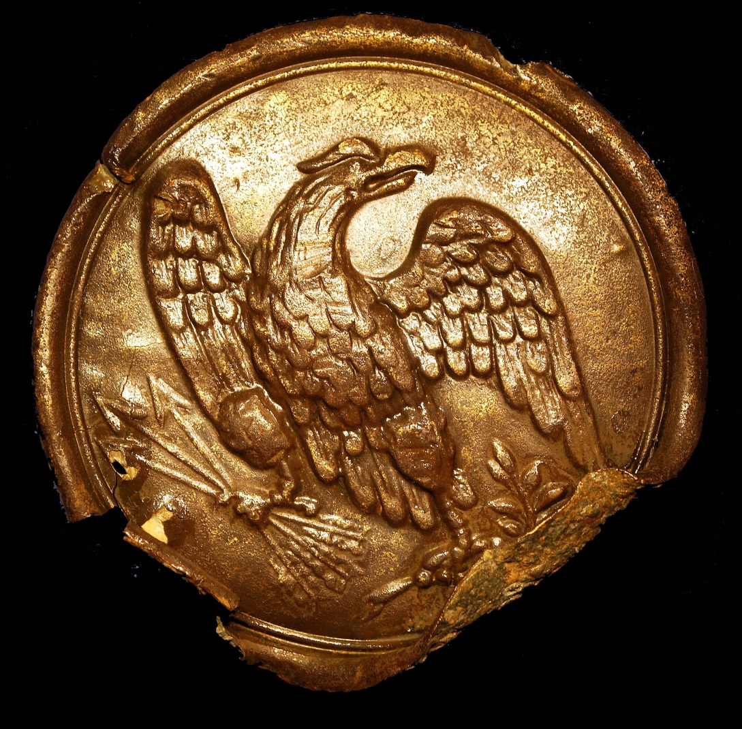

A Union Army Belt Plate recovered from Washington’s Boyhood Home, where Union Army corps were entrenched in 1862, and thousands of enslaved Americans crossed the Rappahannock to Stafford from Confederate-held Fredericksburg. Inspired by Parson Weem’s biography of Washington, Lincoln visited the home site on May 23, 1862. Photo taken Feb 8 2013.