GWF_SiteOverview_RobinRamey_WashingtonHouse24April2015

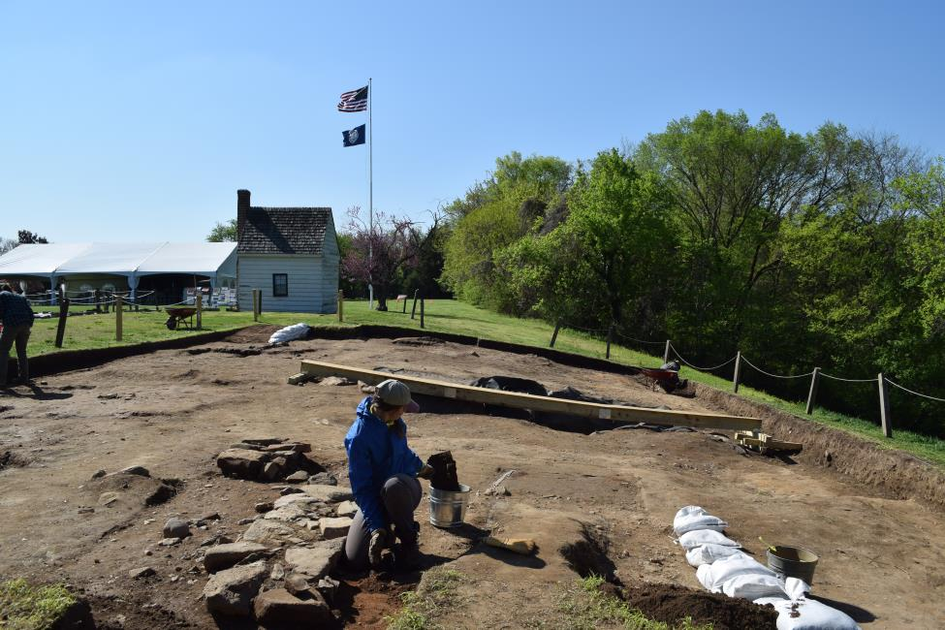

Robin Ramey exposing the Washington House (c. 1727- early 1800s) Foundations, 24 April 2015.